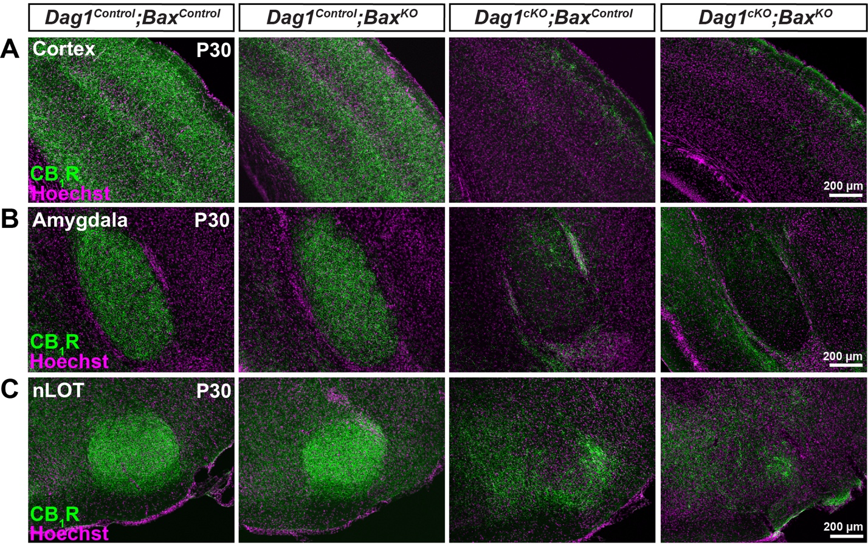
Figure S5. Constitutive deletion of Bax in Dag1^{cKO} mice does not rescue CB₁R+ terminals in the forebrain. (A-C) Coronal sections immunostained for CB₁R (green) and Hoechst (magenta) in the cortex (A), amygdala (B), and nucleus of the lateral olfactory tract (C) of P30 Dag1^{Control};Bax^{Control}, Dag1^{Control};Bax^{KO}, Dag1^{cKO};Bax^{Control} and Dag1^{cKO};Bax^{KO} mice.

