Rimonabant-mediated epigenetic remodelling in a neuronal cell line and rat brain tissue at therapeutically relevant concentrations
- Supplementary Information -

Sandra I Marques ^{a, b}, Matilde Barreiras de Moura ^{a, b}, Federica Panza ^{a, b}, Catarina Pereira-Teixeira ^{a, b}, Vladimir Stevanović ^{c}, Aleksandra Kovačević ^{c}, Miroslav Savić ^{c}, Helena Carmo ^{a, b}, Susana I Sá ^{d,e}, Félix Carvalho ^{a, b, #}, João Pedro Silva ^{a, b, #}
ªUCIBIO – Applied Molecular Biosciences Unit, Laboratory of Toxicology, Faculty of Pharmacy, University of Porto, 4050-313 Porto, Portugal;
^{b}i4HB – Institute for Health and Bioeconomy, Faculty of Pharmacy, University of Porto, 4050-313 Porto, Portugal;
^{c}Department of Pharmacology, Faculty of Pharmacy, University of Belgrade, Serbia;
^{d}Unit of Anatomy, Department of Biomedicine, Faculty of Medicine, University of Porto; ^{e}CINTESIS@RISE, Faculty of Medicine, University of Porto, Portugal

*Co-senior and corresponding authors:
João P. Silva, Félix Carvalho,
Associate Laboratory i4HB - Institute for Health and Bioeconomy, UCIBIO, Laboratory of Toxicology, Department of Biological Sciences, Faculty of Pharmacy, University of Porto, 4050-313, Porto, Portugal. E-mails: jpmsilva@ff.up.pt (JPS), felixdc@ff.up.pt (FC). Tel: +351 220428600

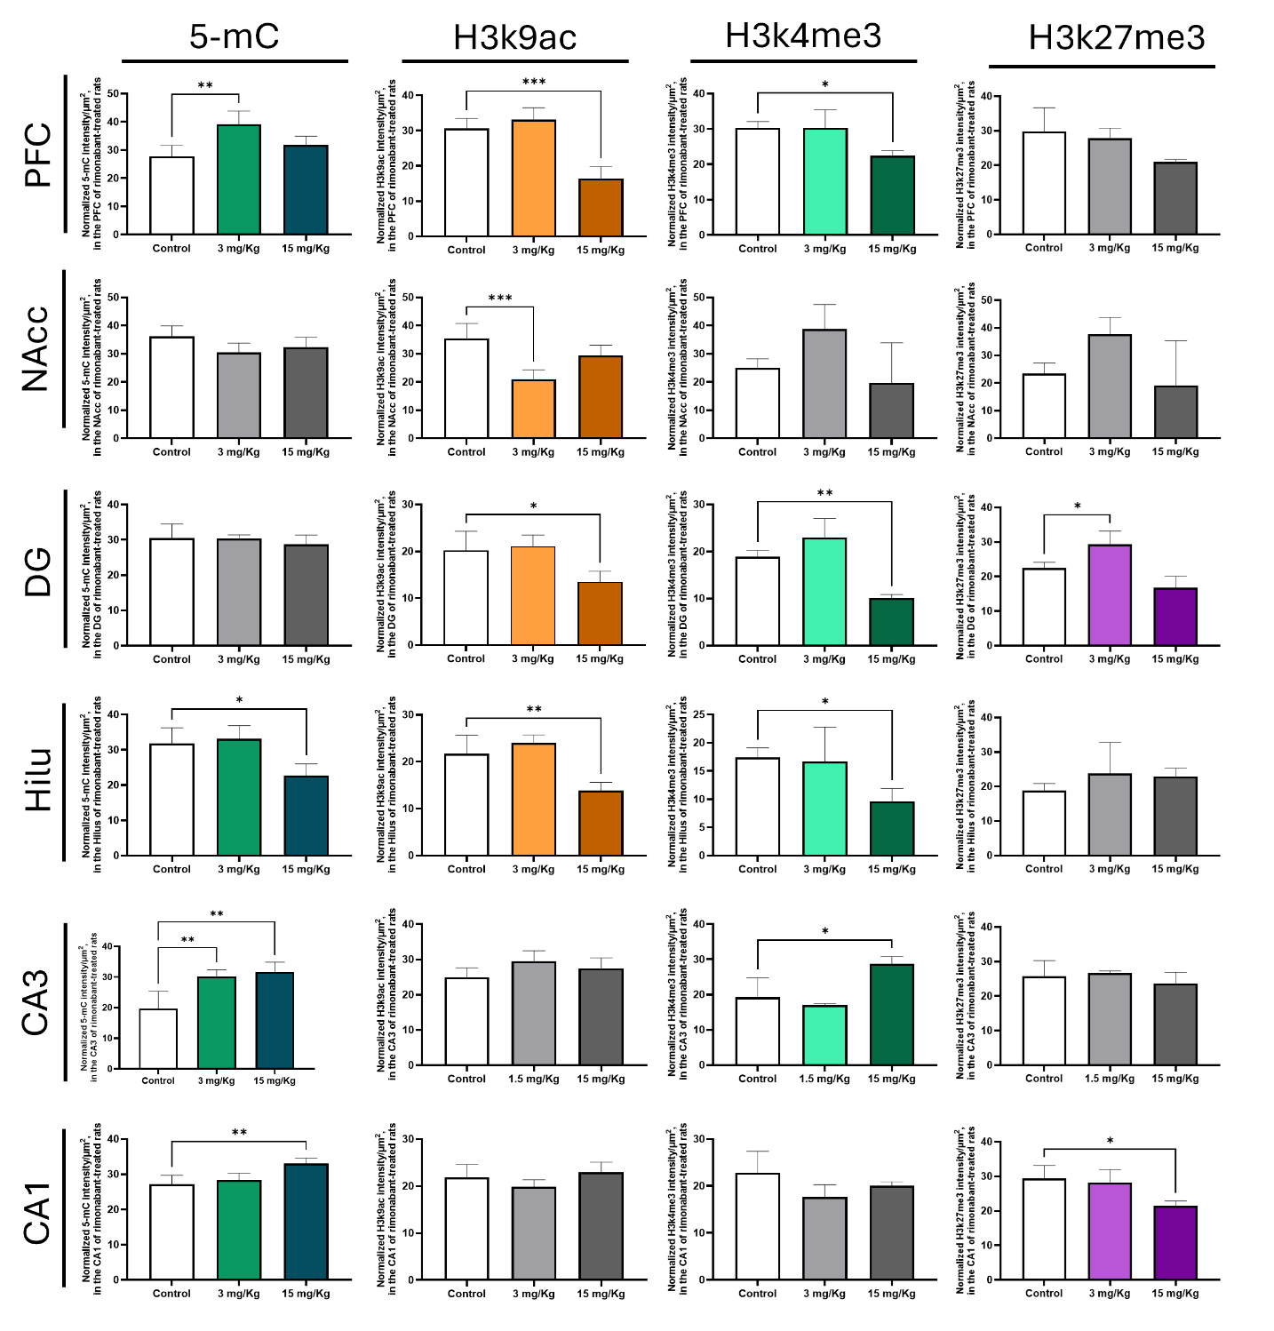
Figure SI-1 - Effects of rimonabant [Data from Figure 5 presented the expression in intensity per µm² of 5-mC, H3K9ac, H3K4me3 and H3K27me3]. Sprague-Dawley rats were administered 3 or 15 mg/kg rimonabant through oral gavage for 4 weeks. Levels of expression in PFC, NAcc, DG, Hilus, CA3 and CA1, were evaluated after 4 weeks of treatment. Each IF contained at least 5 animals per treatment group, and each region was photographed 3-7 times per animal. PFC: prefrontal cortex; NAcc: nucleus Accumbens; DG: dentate gyrus; H: Hilus; CA3; CA1. * < p 0.05, ** p < 0.01, *** < p 0.001, compared to the vehicle, using one-way ANOVA followed by Dunnett’s test.

