Supplementary Material
Evaluations of Skin Permeability of Cannabidiol and Its Topical Formulations by Skin Membrane Based Parallel Artificial Membrane Permeability Assay and Franz Cell Diffusion Assay

Riley D. Kirk‡, Toyosi Akanji‡, Huifang Li, Jie Shen, Saleh Allababidi, Navindra P. Seeram, Matthew J. Bertin*, Hang Ma*

Department of Biomedical and Pharmaceutical Sciences, College of Pharmacy, University of Rhode Island, Kingston, RI, USA
‡ Equal contribution
Short Title: Skin Permeability of CBD and its formulations
*Corresponding Authors:
Matthew J. Bertin, Ph.D.
Department of Biomedical and Pharmaceutical Sciences, University of Rhode Island
7 Greenhouse Rd, Kingston, RI 02881, USA
Tel: +1-(401)874-5016
E-mail: mbertin@uri.edu
Hang Ma, Ph.D.
Department of Biomedical and Pharmaceutical Sciences, University of Rhode Island
7 Greenhouse Rd, Kingston, RI 02881, USA
Tel: +1-(401)874-2711
E-mail: hang_ma@uri.edu

Table S1: Comparison of the skin permeability of reference compounds by in silico prediction (SwissADME) and in vitro model (PAMPA).
Reference compounds | Experimental  (PAMPA) | Prediction
Reference compounds | -Log Pe | -Log Kp  (cm/s) | Log Po/w | -Log S (ESOL) | -Log S (Ali)
Warfarin | -6.00 | -6.26 | 2.41 | -3.70 | -3.77
Piroxicam | -5.67 | -6.15 | 1.67 | -4.01 | -4.99
Verapamil | -5.65 | -6.38 | 4.50 | -4.46 | -4.83
Progesterone | -4.92 | -5.47 | 3.09 | -4.16 | -4.28

Figure S1.
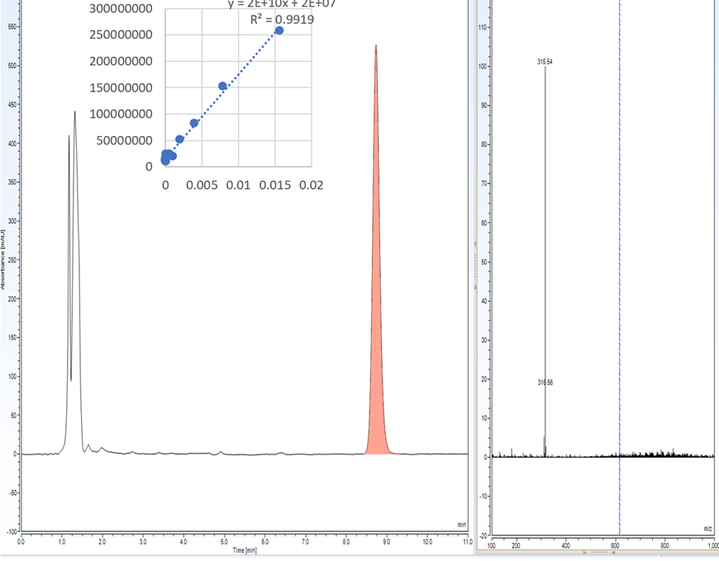
Figure S1. CBD PAMPA LC-MS Chromatogram. The passive permeability of CBD through a theoretical skin membrane was determined using the PAMPA assay. The presence of CBD in the acceptor buffer was determined through LC-MS analysis and confirmed with an m/z of 315. CBD was quantified using standard linear regression.

Figure S2. 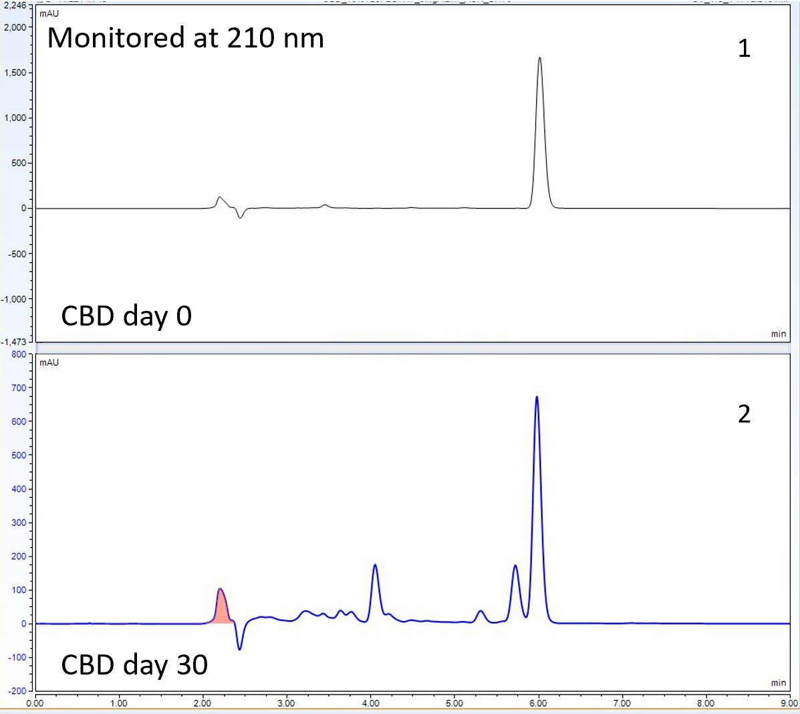
Figure S2. CBD stability test HPLC chromatogram. The stability of CBD in surfactant-buffer solution. The degradation of CBD in a surfactant-buffer solution was confirmed through HPLC analysis, using a standard elution time (6 min) and UV detection of 210 nm. CBD degradation was monitored from day 0 (1) to day 30 (2). Degradation of API was confirmed through reduction of CBD peak area and the accumulation of degradative product peaks eluting before CBD. CBD was quantified using standard linear regression.

Figure S3.
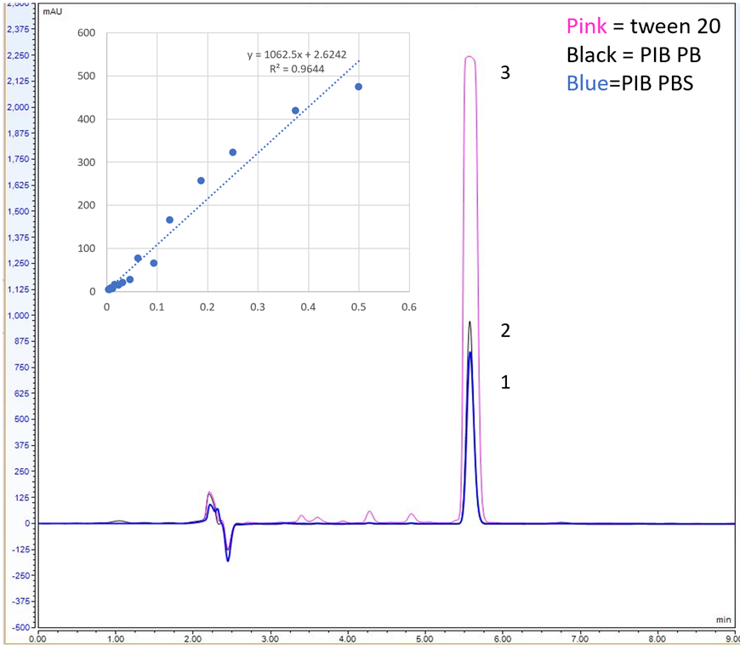
Figure S3. CBD solubility test HPLC chromatogram. CBD in a 10% (w/w) poly isobutene – PBS buffer solution (1), 10% (w/w) poly isobutene – PB buffer solution (2) and a 10% (w/w) Tween 20-PBS solution (3) were evaluated to determine the ideal surfactant solvent system to solubilize the API. The amount of CBD in solution was determined through HPLC analysis and quantified using standard linear regression.

Figure S4.
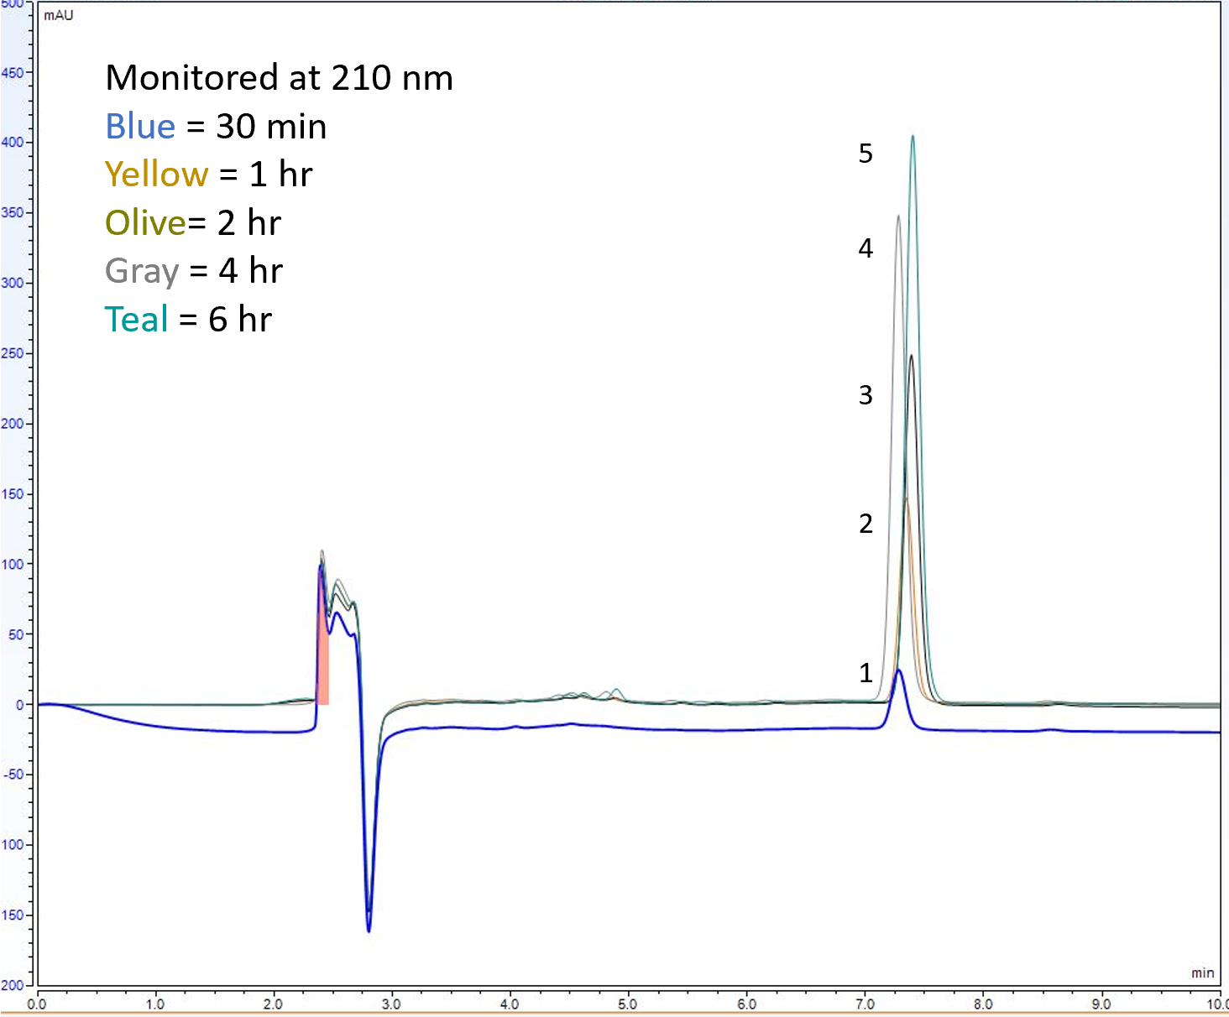
Figure S4.CBD IVRT HPLC chromatogram. CBD Showed passive permeability in the Franz Cell diffusion assay. The permeability profile of CBD through a synthetic skin membrane was determined using the Franz cell diffusion assay. The presence of CBD was confirmed through HPLC analysis, using the average elution time of ~7.2 min and UV detection of 210 nm. At each time point 30 min (1), 1 hour (2), 2 h (3), 4 h (4) and 6 h (6), CBD was quantified using standard linear regression.

Figure S5.
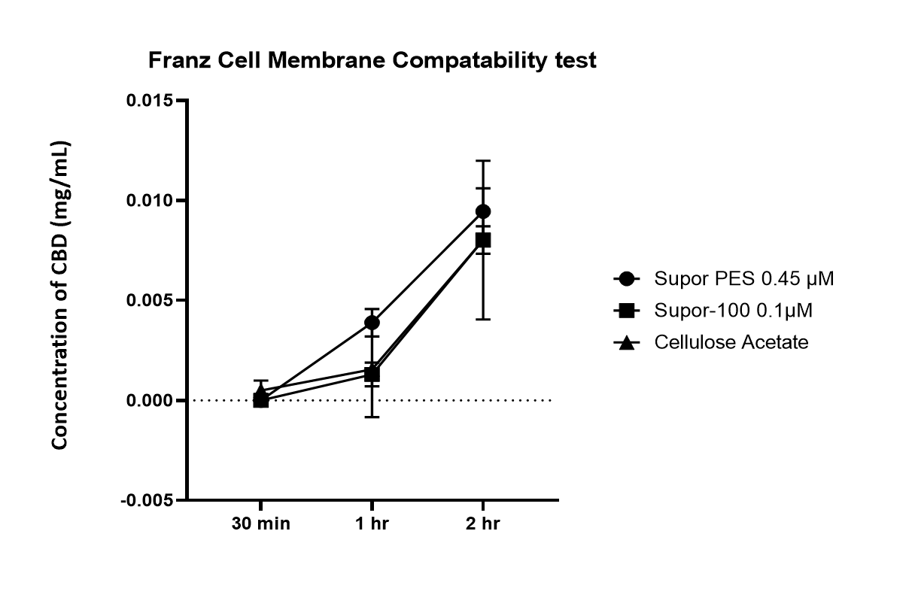
Figure S5: CBD compatibility test using the Franz cell assay (n=3). Receptor buffer was a 3% tween 20 in PBS solution at 32°C.

