Supplementary Material
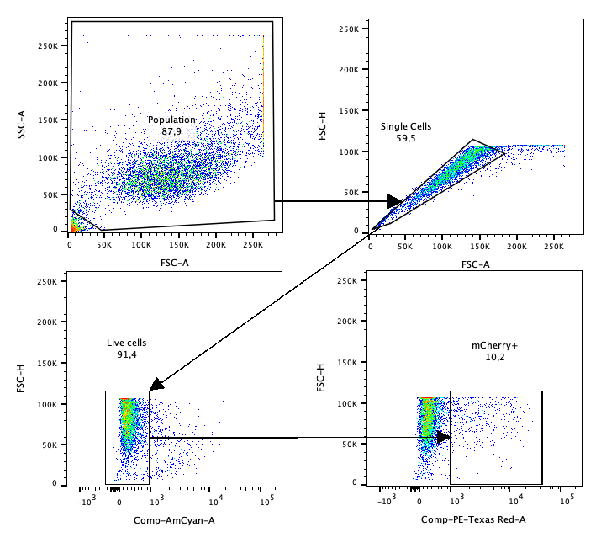

Supplemental Figure 1. Gating strategy for phagocytosis assay with using MH-S alveolar macrophages and mCherry+ E. coli.

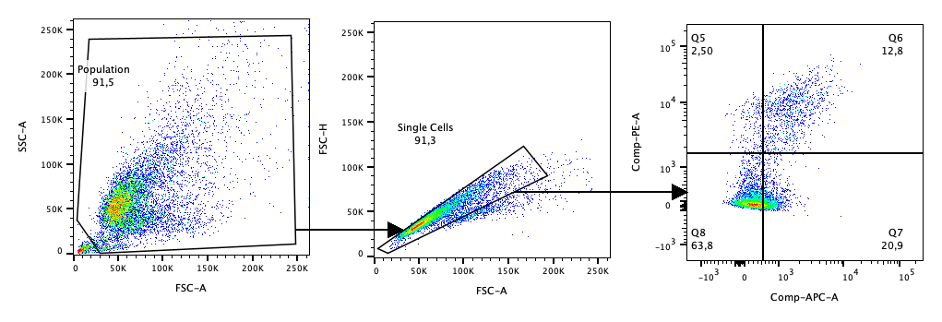
Supplemental Figure 2. Gating strategy for Annexin-V PI assay. Q6 and Q7 represent late and early apoptotic cells, respectively, while Q5 represents necrotic cells and Q8 contains live cells.

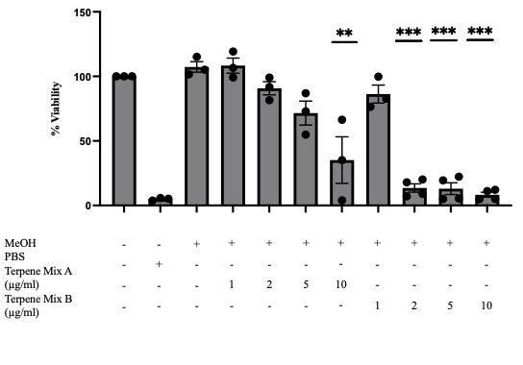

Supplemental Figure 3. Terpene mixes A and B have maximal non-toxic doses of 5µg ml⁻¹ and 1µg ml⁻¹, respectively, as demonstrated by MTT assay. Results are expressed as the mean ± SEM of 3-4 independent experiments; ns, not significant, **P < 0.01, ***P < 0.001.
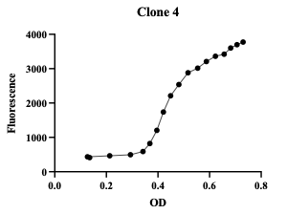
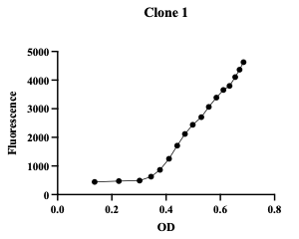
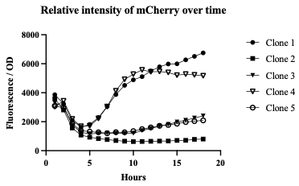

Supplemental Figure 4. Generation of an mCherry-expressing strain of K12 E. coli. A) Clones 1 (left) and 4 (right) demonstrated an increasing fluorescence at 620nm as their optical densities increased over time, suggesting successful uptake of the mCherry plasmid. B) Fluorescence at 620nm divided by the optical density measured over time, representing relative intensity of mCherry in each sample. Each graph represents one independent experiment.

