Supplementary Material

Bioaugmented bioremediation of metal-contaminated soils and sediments by hemp and giant reed
Andrea Ferrarini^{1*}, Alessandra Fracasso¹, Giulia Spini², Flavio Fornasier^{3,4}, Eren Taskin², Maria Chiara Fontanella², Gian Maria Beone², Stefano Amaducci¹, Edoardo Puglisi²
¹ Department of Sustainable Crop Production, Università Cattolica del Sacro Cuore, Via Emilia Parmense 84, 29122, Piacenza, Italy
² Department for Sustainable Food Process, Università Cattolica del Sacro Cuore, Via Emilia Parmense 84, 29122, Piacenza, Italy
³ CREA – Centro Viticoltura ed Enologia, Via Trieste 23, Gorizia, 34170 , Italy
⁴ SOLIOMICS srl, Via del Cotonificio, 129/B 33100 Udine, Italy

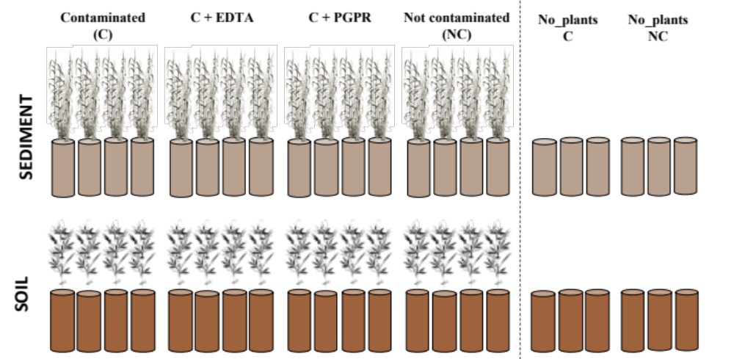
Figure S1 Experimental design of the greenhouse pot experiment under controlled conditions

Table S1 Effect of EDTA application on leachate Cr, Ni and Cu concentrations in the giant reed leaching experiment; brackets: ±S.E. DAS: days after sowing; DAT: days after EDTA treatments. DAT: days after transplanting. DAA_{n}: days after n-th EDTA application. Different lowercase letters indicate significant differences (Tukey’s test P<0.05) among treatments for each element over time. ANOVA has been run separately for giant reed and hemp.
DAT | DAA₁ (DAT:22) | DAA₂ (DAT:53) | Cr (ng L⁻¹) |  |  | Ni (mg L⁻¹) |  |  | Cu (mg L⁻¹)
DAT | DAA₁ (DAT:22) | DAA₂ (DAT:53) | C | PGPR | EDTA | C | PGPR | EDTA | C | PGPR | EDTA
17 | - | - | 2.16 a | 2.56 a | 2.03 a | 0.03 a | 0.03 a | 0.03 a | 0.02 a | 0.03 a | 0.02 a
17 | - | - | (0.18) | (0.11) | (0.25) | (0.00) | (0.01) | (0.00) | (0.00) | (0.01) | (0.00)
26 | 4 | - | 2.29 a | 2.10 a | 2.66 a | 0.03 a | 0.02 a | 6.85 a | 0.01 a | 0.01 a | 8.18 b
26 | 4 | - | (0.37) | (0.27) | (0.31) | (0.01) | (0.00) | (1.55) | (0.00) | (0.00) | (1.82)
38 | 16 | - | 3.14 a | 3.85 a | 2.92 a | 0.03 a | 0.03 a | 8.64 b | 0.02 a | 0.05 a | 8.78 b
38 | 16 | - | (0.60) | (0.20) | (0.37) | (0.01) | (0.01) | (1.49) | (0.01) | (0.01) | (2.18)
60 | 38 | 7 | 2.63 a | 2.68 a | 3.06 a | 0.05 a | 0.12 a | 20.42 c | 0.01 a | 0.06 a | 17.84 c
60 | 38 | 7 | (0.56) | (0.62) | (0.23) | (0.02) | (0.02) | (2.89) | (0.00) | (0.02) | (2.55)
Table S2 Average values of microbial biomass (ng dsDNA g soil) and soil enzymatic activities (nmol MUF or AMC h⁻¹ g_{soil} ⁻¹) in bulk (BS) and rhizosphere (RS) soil of giant reed and hemp at the end of experiment as affected by treatments. Enzymatic activities abbreviations: agluc: α-glucosidase, bgluc : β-glucosidase, alfaGAL: α-galactosidase, betaGAL: β-galactosidase, alfaMAN: α-mannosidase, betaMAN: β-mannosidase, uroni: β-D-glucuronidase, cell: β-1,4-glucanase, xilo: β-1,4-xylanase chit: N-acetyl-b-D-glucosaminidase, leu: leucine amino-peptidase, tryp: trypsin-like protease, acP and alkP: acid and alkaline phosphomonoesterase, bisP: phosphodiesterase, piroP: pyrophosphodiesterase, inositP: inositol-P phosphatase, aryS: arylsulfatase, nona: nonanoate esterase, palmit: palmitate esterase.

Crop | Soil | Treatment | Microbial biomass | C- acquiring enzymes
 |  |  |  | agluc | bgluc | alfaGAL | betaGAL | alfaMAN | betaMAN | uroni | xil | cell
Giant Reed | BS | NC | 2.16 | 0.16 | 3.05 | 0.34 | 0.57 | 0.42 | 0.90 | 2.66 | 0.64 | 0.26
Giant Reed | BS | C | 1.87 | 0.13 | 2.11 | 0.27 | 0.42 | 0.28 | 0.43 | 2.30 | 0.46 | 0.17
Giant Reed | BS | C+EDTA | 1.09 | 0.13 | 1.93 | 0.27 | 0.42 | 0.29 | 0.54 | 1.94 | 0.42 | 0.16
Giant Reed | BS | C+PGPR | 1.52 | 0.15 | 2.30 | 0.29 | 0.46 | 0.32 | 0.49 | 2.43 | 0.49 | 0.18
Giant Reed | RS | NC | 4.05 | 0.30 | 4.64 | 0.59 | 0.94 | 0.63 | 1.64 | 4.64 | 0.89 | 0.31
Giant Reed | RS | C | 3.38 | 0.18 | 2.54 | 0.36 | 0.56 | 0.37 | 0.96 | 2.82 | 0.54 | 0.19
Giant Reed | RS | C+EDTA | 2.18 | 0.16 | 2.56 | 0.33 | 0.52 | 0.35 | 0.92 | 2.56 | 0.49 | 0.17
Giant Reed | RS | C+PGPR | 2.75 | 0.20 | 2.81 | 0.39 | 0.61 | 0.41 | 1.07 | 3.03 | 0.59 | 0.20
Hemp | BS | NC | 10.91 | 0.74 | 8.60 | 0.35 | 0.55 | 0.42 | 0.90 | 3.75 | 1.21 | 0.53
Hemp | BS | C | 9.80 | 0.32 | 6.86 | 0.27 | 0.63 | 0.27 | 0.45 | 3.03 | 0.68 | 0.43
Hemp | BS | C+EDTA | 8.82 | 0.13 | 4.38 | 0.26 | 0.99 | 0.28 | 0.55 | 1.92 | 0.62 | 0.16
Hemp | BS | C+PGPR | 12.27 | 0.15 | 5.96 | 0.29 | 0.84 | 0.30 | 0.47 | 3.02 | 0.93 | 0.43
Hemp | RS | NC | 22.22 | 1.30 | 11.64 | 0.59 | 0.94 | 0.63 | 1.64 | 6.17 | 1.67 | 0.64
Hemp | RS | C | 15.87 | 0.43 | 9.04 | 0.36 | 0.83 | 0.37 | 0.96 | 4.32 | 0.63 | 0.48
Hemp | RS | C+EDTA | 14.65 | 0.16 | 6.06 | 0.33 | 1.20 | 0.35 | 0.92 | 2.97 | 0.59 | 0.17
Hemp | RS | C+PGPR | 19.50 | 0.20 | 8.56 | 0.39 | 1.11 | 0.41 | 1.07 | 3.78 | 0.64 | 0.49

Crop | Soil | Treatment | N- acquiring enzymes |  |  | P- acquiring enzymes |  |  |  |  | S- acq | Esterases
Crop | Soil | Treatment | leu | chit | trip | acP | alkP | piroP | bisP | inositP | aryS | nona | palmit
Giant Reed | BS | NC | 6.60 | 0.98 | 0.57 | 51.69 | 72.68 | 1.64 | 9.17 | 0.29 | 2.67 | 23.07 | 1.70
Giant Reed | BS | C | 6.37 | 0.95 | 0.62 | 27.19 | 45.56 | 0.97 | 4.50 | 0.20 | 1.03 | 19.65 | 0.90
Giant Reed | BS | C+EDTA | 4.26 | 0.62 | 0.54 | 26.75 | 48.23 | 0.99 | 4.47 | 0.20 | 0.87 | 17.49 | 0.60
Giant Reed | BS | C+PGPR | 5.26 | 0.77 | 0.56 | 27.16 | 53.12 | 0.71 | 4.70 | 0.14 | 0.96 | 17.98 | 0.78
Giant Reed | RS | NC | 10.58 | 1.39 | 0.81 | 116.86 | 163.43 | 3.60 | 20.55 | 0.65 | 5.89 | 53.23 | 3.76
Giant Reed | RS | C | 7.61 | 1.12 | 0.73 | 59.46 | 102.45 | 2.17 | 9.59 | 0.47 | 2.39 | 31.58 | 1.50
Giant Reed | RS | C+EDTA | 4.54 | 0.67 | 0.58 | 44.43 | 81.38 | 1.62 | 7.33 | 0.35 | 1.44 | 27.20 | 0.91
Giant Reed | RS | C+PGPR | 6.80 | 0.90 | 0.65 | 60.40 | 113.67 | 1.93 | 10.58 | 0.34 | 2.14 | 30.39 | 1.37
Hemp | BS | NC | 18.06 | 4.65 | 0.96 | 39.42 | 127.64 | 4.29 | 11.84 | 0.69 | 8.29 | 65.05 | 10.00
Hemp | BS | C | 14.64 | 3.93 | 1.04 | 34.92 | 93.69 | 2.41 | 6.48 | 0.60 | 5.50 | 42.28 | 8.19
Hemp | BS | C+EDTA | 7.43 | 2.48 | 0.77 | 27.98 | 90.95 | 1.58 | 7.52 | 0.33 | 5.99 | 40.39 | 8.74
Hemp | BS | C+PGPR | 14.83 | 3.11 | 0.97 | 28.86 | 97.94 | 1.66 | 8.36 | 0.63 | 5.95 | 43.21 | 8.33
Hemp | RS | NC | 27.08 | 6.68 | 1.51 | 89.36 | 260.93 | 9.35 | 30.55 | 1.57 | 18.79 | 97.48 | 23.62
Hemp | RS | C | 17.61 | 4.62 | 0.89 | 59.46 | 147.45 | 3.68 | 15.42 | 1.02 | 12.39 | 72.21 | 13.14
Hemp | RS | C+EDTA | 9.67 | 2.67 | 0.66 | 49.43 | 151.61 | 2.62 | 13.12 | 0.54 | 10.25 | 59.70 | 13.83
Hemp | RS | C+PGPR | 16.12 | 3.65 | 0.84 | 60.40 | 186.17 | 4.06 | 17.43 | 0.98 | 10.36 | 72.49 | 15.42
Table S3 Summary of significant differences (Bonferroni’s test, P: 0.05) in enzyme activities (grouped by element) among treatments for giant reed and hemp as assessed by Permutational multivariate analysis of variance (PERMANOVA).
 | Treatment | Rhizosphere soil |  |  |  |  |  |  |  | Bulk soil
 | Treatment | C | N | P | S | ester |  |  | C |  | N | P | S | ester
 | NC | a | a | a | a | a |  |  | a |  | a | a | a | a
 | C | b | b | b | b | b |  |  | b |  | b | b | b | b
 | C+PGPR | b | bc | b | b | b |  |  | ab |  | ab | b | b | b
 | C+EDTA | b | c | c | b | b |  |  | b |  | b | b | b | b
 | NC | ab | a | a | a | a |  |  | a |  | a | a | a | a
 | C | b | b | b | b | b |  |  | b |  | ab | b | b | b
 | C+PGPR | b | b | c | c | ab |  |  | b |  | b | b | b | bc
 | C+EDTA | c | c | d | bc | b |  |  | b |  | c | b | b | c

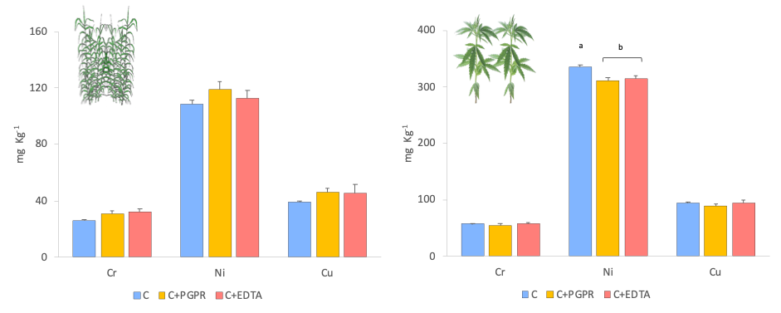
Fig. S2 Average of soil total HM concentration at the end of experiment .

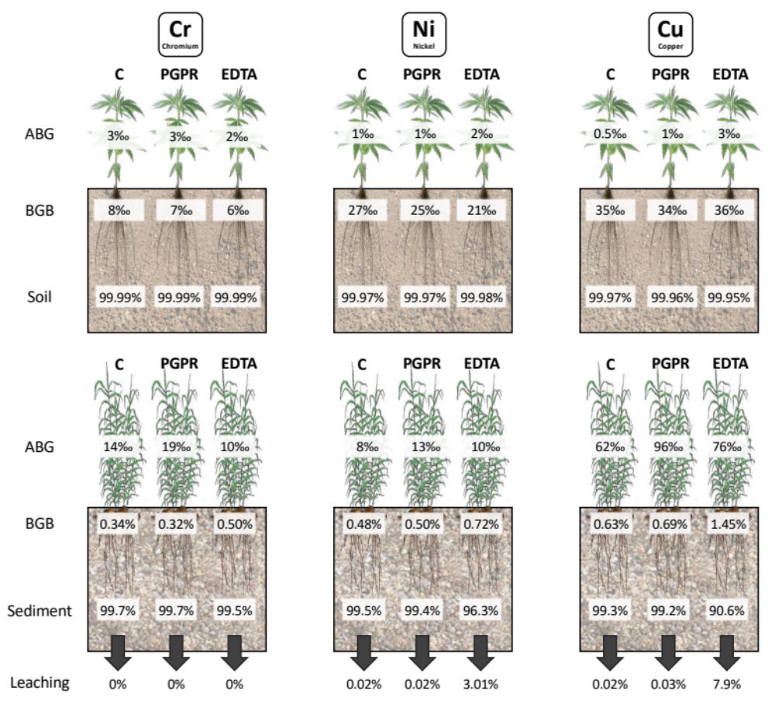
Fig S3 HMs mass balance (% and ‰) for giant reed and hemp at the end of experiment

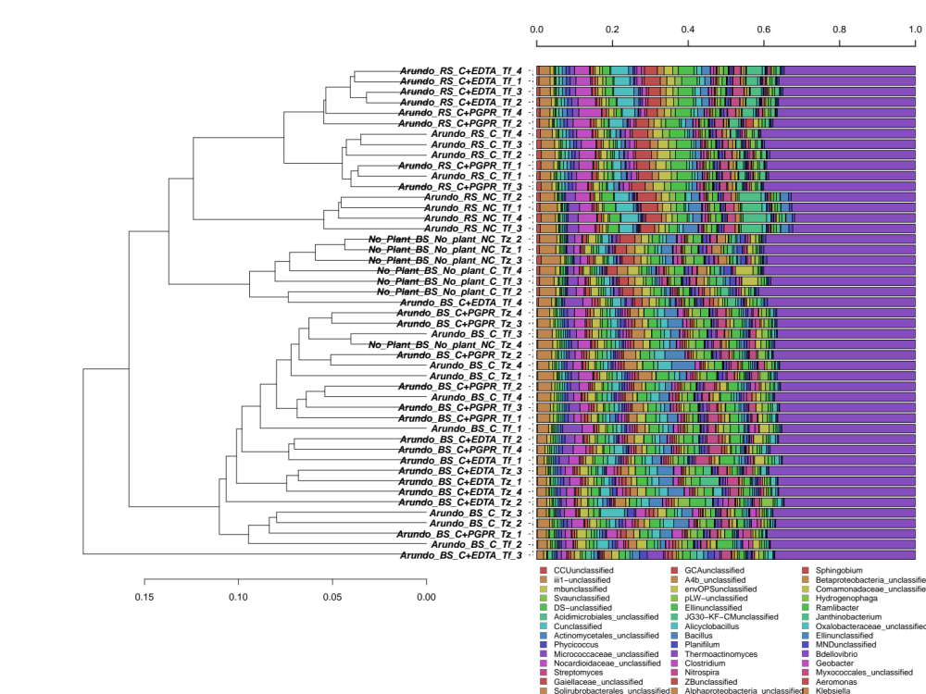
Figure S4 Hierarchical clustering at the genus level of sequences from giant reed experiment performed on contaminated sediment. Clusters were identified with the average linkage algorithm for taxa that contributed at least 5% to a single sample. BS: bulk sediment, RS: rhizosphere sediement, NC: sediment not contaminated, C: contaminated sediment, C + PGRP: contaminated sediment treated with PGPR, C + EDTA: contaminated sediment treated with EDTA.

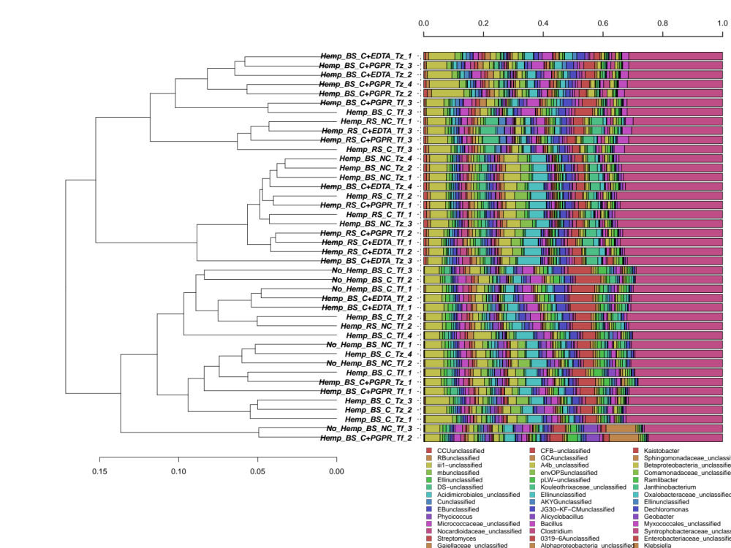
Figure S5 Hierarchical clustering at the genus level of sequences from hemo experiment performed on contaminated soil. Clusters were identified with the average linkage algorithm for taxa that contributed at least 5% to a single sample. BS: bulk soil, RS: rhizosphere soil, NC: soil not contaminated, C: contaminated soil, C + PGRP: contaminated soil treated with PGPR, C + EDTA: contaminated soil treated with EDTA.

