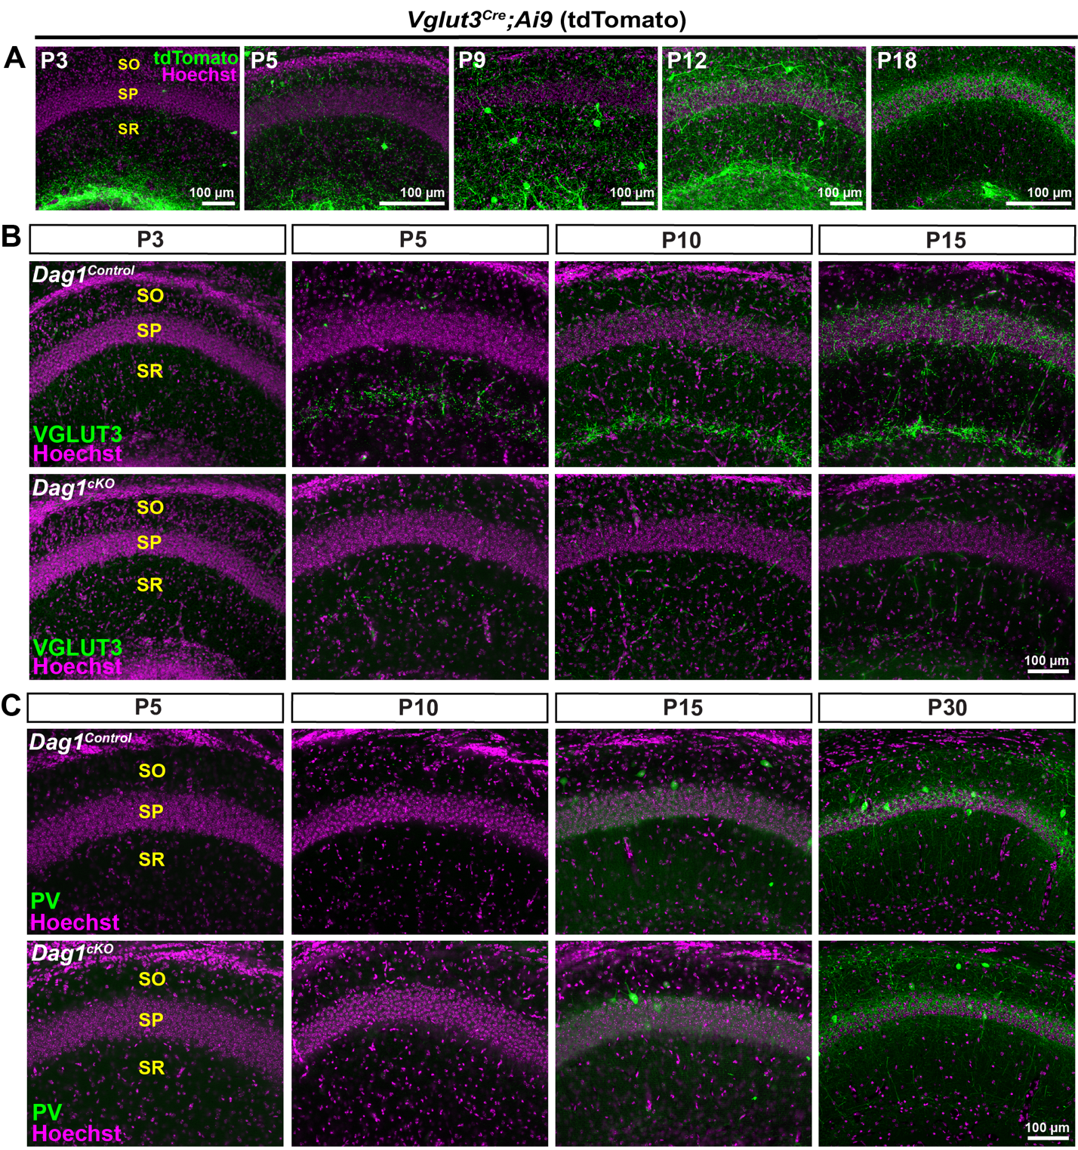
Figure S3. CCK+ interneuron markers are reduced postnatally in Dag1^{cKO} mice. (A) Images of hippocampal CA1 from VGLUT3^{Cre};Ai9 mice from P3-P18. Immunostaining for tdTomato (green) shows progressive increase in VGLUT3 expression in the pyramidal cell layer (SP, magenta). (B) Immunostaining for VGLUT3 in the CA1 of Dag1^{Control} (top panels) and Dag1^{cKO} mice (bottom panels) from P3-P15. Note the lack of VGLUT3 expression at all ages in Dag1^{cKO} mice. (C) Parvalbumin (PV) labeling is similar in the CA1 of Dag1^{Control} (top panels) and Dag1^{cKO} mice (bottom panels) from P5-P30.

