Supplement
Rendered scripts are made publicly available: osf.io/3qcrk
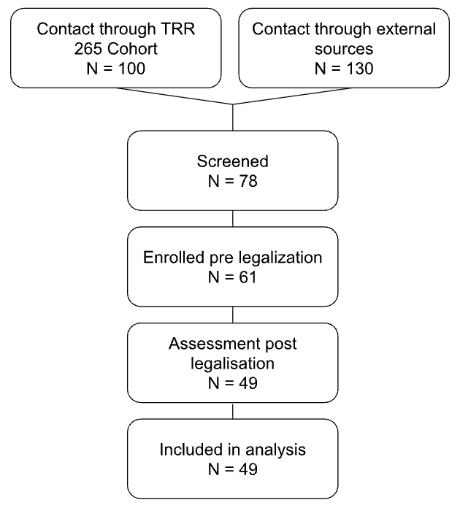
Supplement Figure S1. Flowchart of the recruitment process.
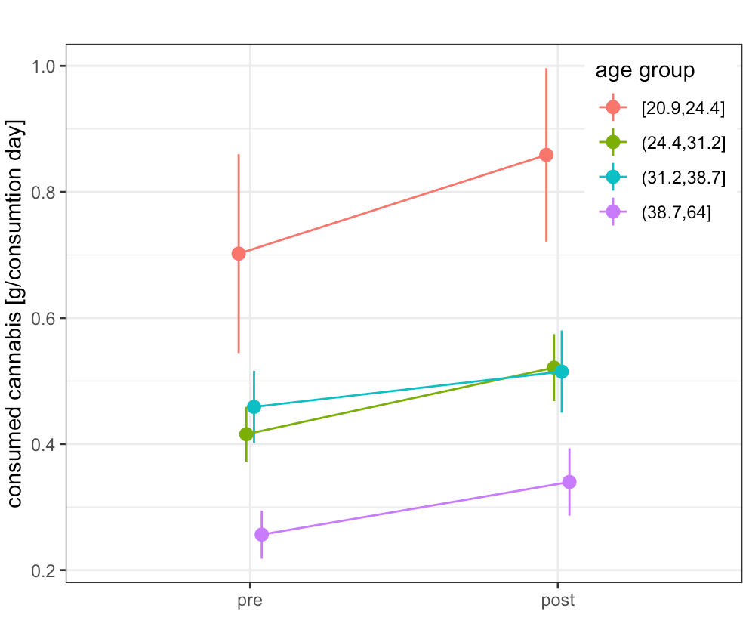
Supplement Figure S2. Differences of consumed Cannabis [g/consumption day] pre-/to post-legalization in four equal sized age groups (20.9-24.4; 24.4-31.2; 31.2-38.7; 38.7-64 years).

Supplement Table S2.
age_group | N | pre | post | diff
[20.9,24.4] | 11 | 0.70±0.16 | 0.86±0.14 | 0.16
[24.4,31.2] | 11 | 0.42±0.04 | 0.52±0.05 | 0.10
[31.2,38.7] | 11 | 0.46±0.06 | 0.51±0.07 | 0.05
[38.7,64] | 11 | 0.26±0.04 | 0.34±0.05 | 0.08

 | Consumption days  [model 1] |  |  |  | Consumed amounts  [model 2]
Predictors | β | 95%CI | z | p | β | 95%CI | z | p
(Grand mean) | 0.60 | 0.26 – 1.42 | -1.16 | 0.246 | -1.37 | -1.62 – -1.11 | -10.60 | <0.001
legalization [post] | 1.61 | 1.00 – 2.60 | 1.96 | 0.049 | 0.11 | -0.04 – 0.27 | 1.44 | 0.149
weekday [weekend] | 1.53 | 1.11 – 2.10 | 2.62 | 0.009 | 0.01 | -0.09 – 0.10 | 0.11 | 0.910
new year [start of year] | 1.65 | 1.15 – 2.36 | 2.74 | 0.006 | 0.07 | -0.03 – 0.17 | 1.35 | 0.178
holiday [holiday] | 0.51 | 0.28 – 0.91 | -2.29 | 0.022 | 0.01 | -0.19 – 0.21 | 0.07 | 0.945
age | 1.01 | 0.94 – 1.08 | 0.16 | 0.875 | -0.03 | -0.05 – -0.01 | -2.49 | 0.013
gender [man] | 1.00 | 0.19 – 5.17 | -0.00 | 0.998 | 0.08 | -0.39 – 0.55 | 0.34 | 0.732
legalization [post] × weekday [weekend] | 1.20 | 0.77 – 1.88 | 0.80 | 0.426 | 0.07 | -0.06 – 0.20 | 1.02 | 0.310
legalization [post] × new year [start of year] | 0.44 | 0.27 – 0.72 | -3.29 | 0.001 | 0.02 | -0.12 – 0.15 | 0.23 | 0.819
legalization [post] × holiday [holiday] | 3.97 | 1.70 – 9.24 | 3.20 | 0.001 | 0.17 | -0.09 – 0.42 | 1.28 | 0.200
legalization [post] × age | 1.01 | 0.98 – 1.03 | 0.50 | 0.620 | 0.01 | 0.00 – 0.02 | 2.81 | 0.005
legalization [post] × gender [man] | 0.89 | 0.54 – 1.46 | -0.48 | 0.633 | -0.17 | -0.32 – -0.01 | -2.13 | 0.034
location [outdoor] |  |  |  |  | -0.11 | -0.26 – 0.04 | -1.41 | 0.159
setting [public] |  |  |  |  | 0.36 | 0.18 – 0.54 | 4.00 | <0.001
group [group] |  |  |  |  | 0.20 | 0.10 – 0.31 | 3.73 | <0.001
legalization [post] × location [outdoor] |  |  |  |  | 0.21 | 0.05 – 0.36 | 2.59 | 0.010
legalization [post] × setting [public] |  |  |  |  | -0.50 | -0.71 – -0.28 | -4.52 | <0.001
legalization [post] × group [group] |  |  |  |  | -0.06 | -0.20 – 0.08 | -0.84 | 0.399
Random Effects
σ² | 3.29 |  |  |  | 0.25
τ₀₀ | 6.67 _{Subj} |  |  |  | 0.47 _{Subj}
ICC | 0.67 |  |  |  | 0.65
N | 48 _{Subj} |  |  |  | 43 _{Subj}
Observations | 2963 |  |  |  | 1140
Marginal R² / Conditional R² | 0.012 / 0.673 |  |  |  | 0.080 / 0.678
CI = Confidence Interval, ICC = Intraclass Correlation Coefficient, N = Number of random factor level

Notes. Differences of consumed Cannabis [g/consumption day] pre-/to post-legalization in different age groups. Participants between 38.7-64 years consumed 0.08 g (approximately a third joint more calculated for mixed Joints with ~0.25g/ Cannabis) more per day, whereas participants from 20.9-24.4 consumed 0.16g more per day (more than half a Joint more
Supplement Model S2.
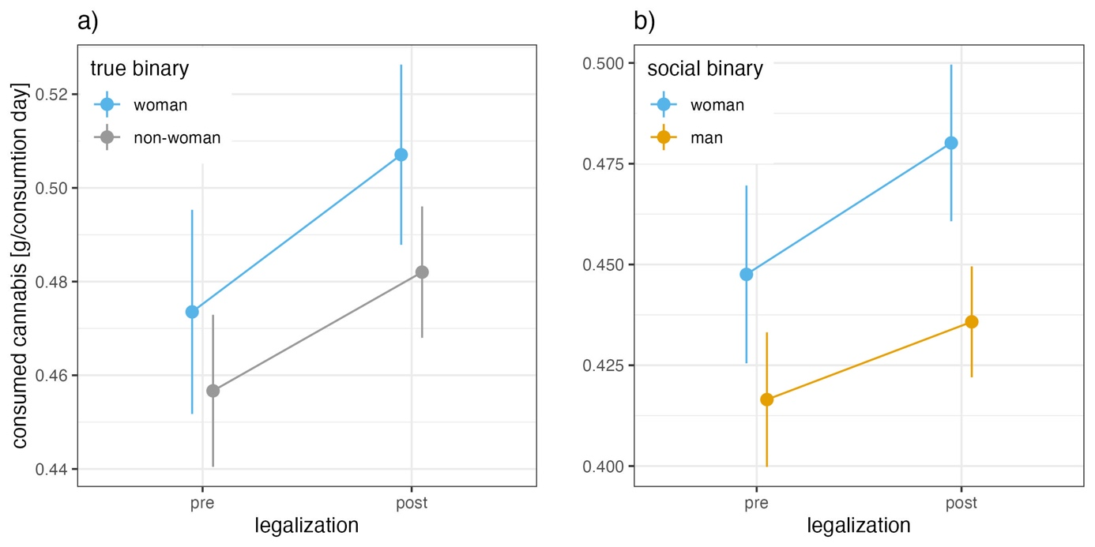

Supplement Figure S3: a) depicts consumed cannabis on consumption days mean ± CI comparing woman with non-woman pre to post legalization; b) depicts consumed cannabis on consumption days mean ± CI comparing woman with man pre to post legalization; Model predictors were used for both figures.

Supplement Table S3.
gender | pre | post
social binary
woman | 0.45±0.02 | 0.48±0.02
man | 0.42±0.02 | 0.44±0.01
true binary
woman | 0.47±0.02 | 0.51±0.02
non-woman | 0.46±0.02 | 0.48±0.01

