Supplementary Material

Impact of proestrus on gene expression in the medial preoptic area of mice
Csaba Vastagh* and Zsolt Liposits
* Correspondence: Corresponding Author: vastagh.csaba@koki.mta.hu

Supplementary Figures and Tables
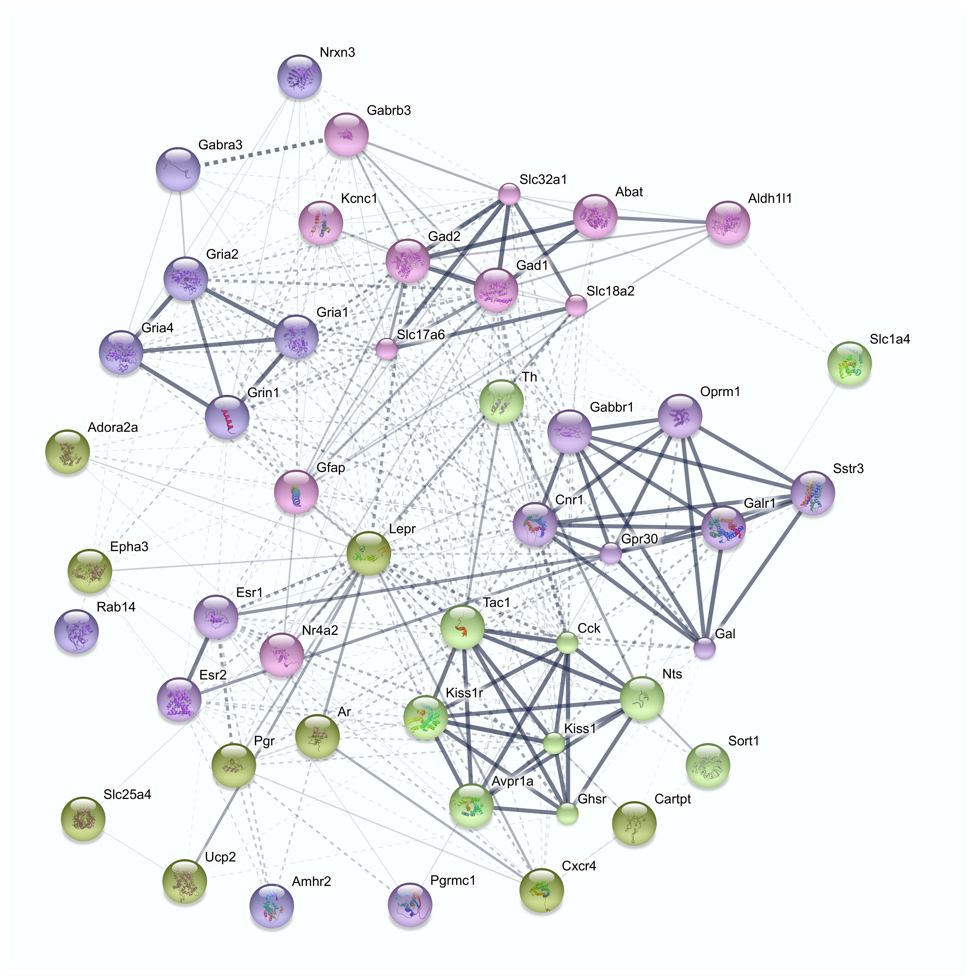
Supplementary Figure 1. Predicted interactions among proteins encoded by genes analyzed in the study using String 10 database and web resource (http://string-db.org). Interaction score was set to 0.15 (low confidence).

