Supplementary Material

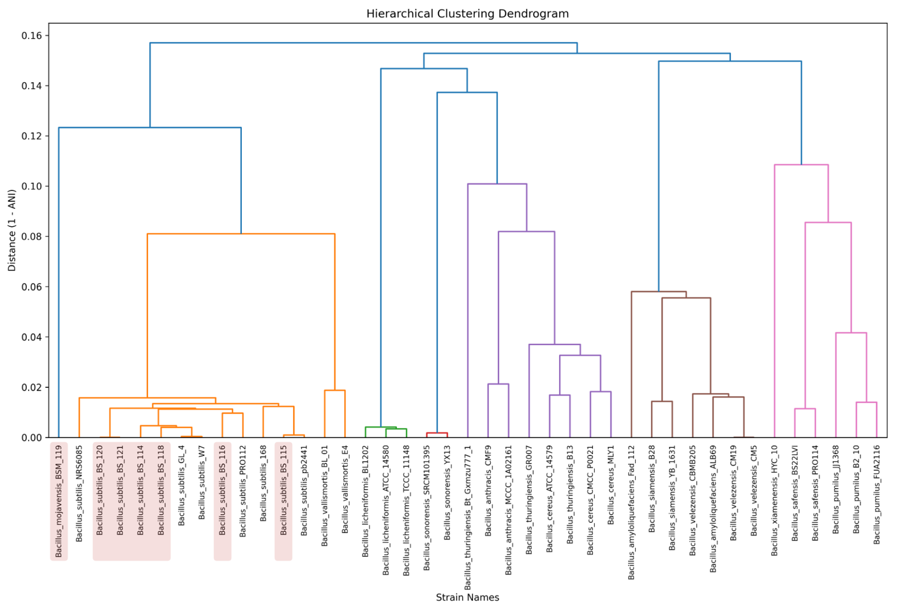
Supplementary Figure 1. Hierarchical dendrograms of selected bacillus strains based on distance matrix to compare relations
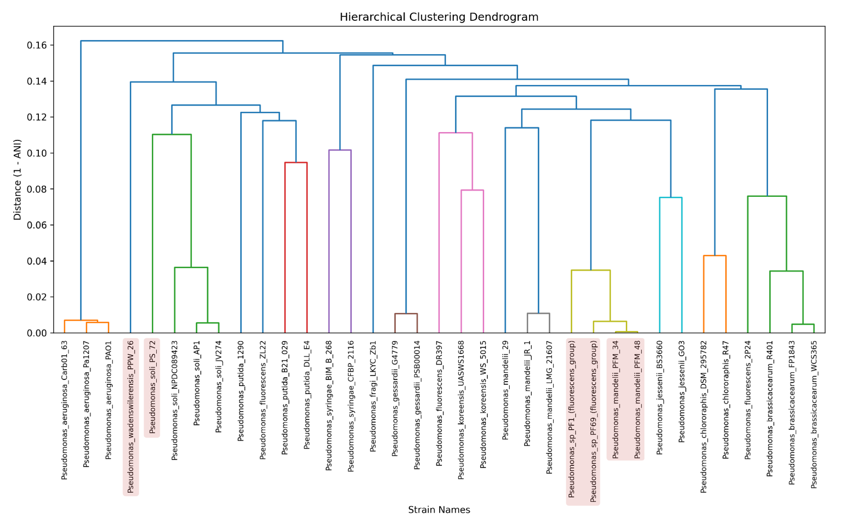
Supplementary Figure 2. Hierarchical dendrograms of selected pseudomonas strains based on distance matrix to compare relations

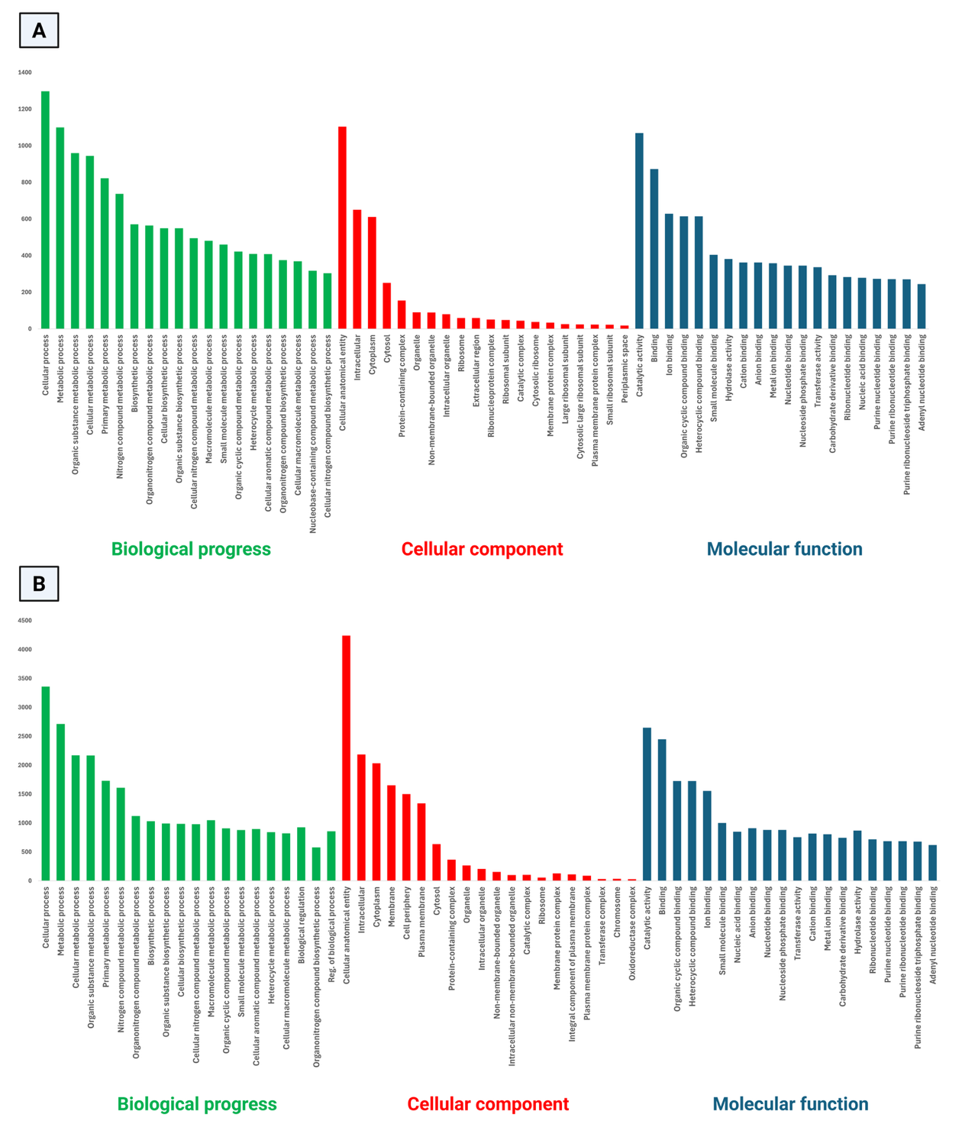
Supplementary Figure 3: Gene Ontology functional classification results of strains (A) BS-116 and (B) PPW-26, showing gene distribution across Biological Processes, Cellular Components, and Molecular Functions.

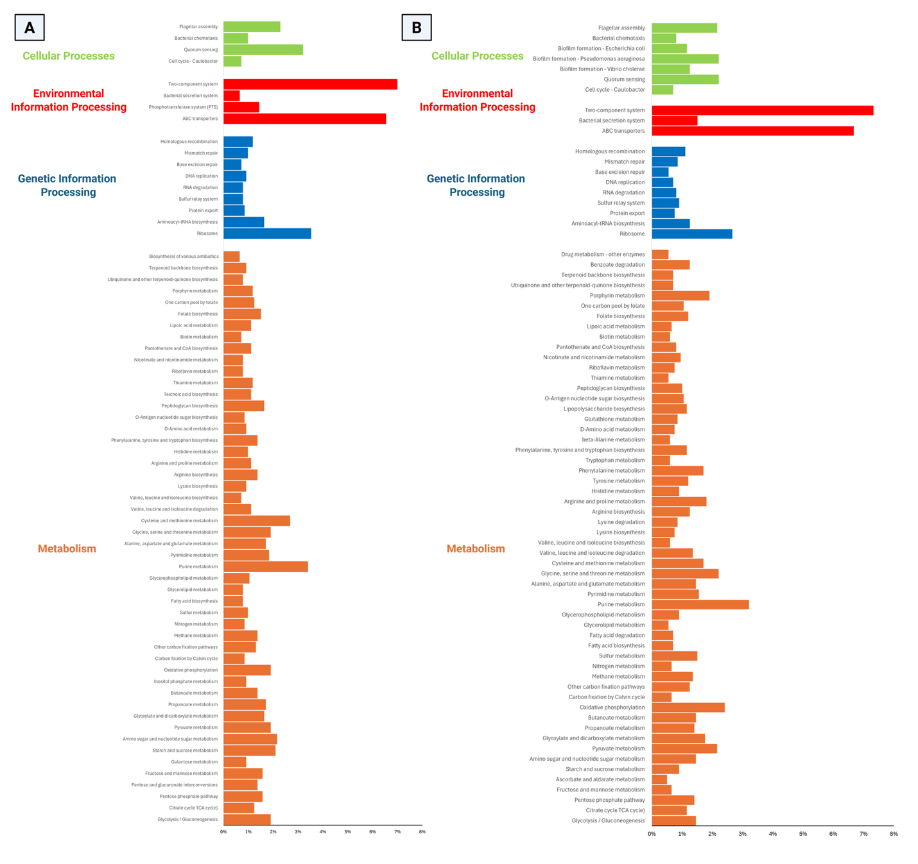
Supplementary Figure 4: KEGG pathway classiﬁcation map of top differentially expressed genes of strains (A) BS-116 and (B) PPW-26

