FIGURE S3 Chromatograms for 25 samples with positive detections. The concentrations (ppm of dried cannabis) and the number of ions detected are given for each analyte. The concentration in the extract (ng analyte/mL of extract) is converted into ppm of cannabis by: (x ng analyte/mL extract) × (15 mL extract/sample) × (1 sample/0.5 g cannabis) × (1 µg analyte/1,000 ng analyte) = µg analyte/g cannabis = ppm. Three ions were monitored for cocaine and methamphetamine while two ions were monitored for BZE and MDMA. Lastly, the agency that seized the sample is given as either High-Intensity Drug Trafficking Areas Task Force of the Maricopa County Sheriff’s Office (HIDTA) or U.S. Postal Inspection Service (USPIS).

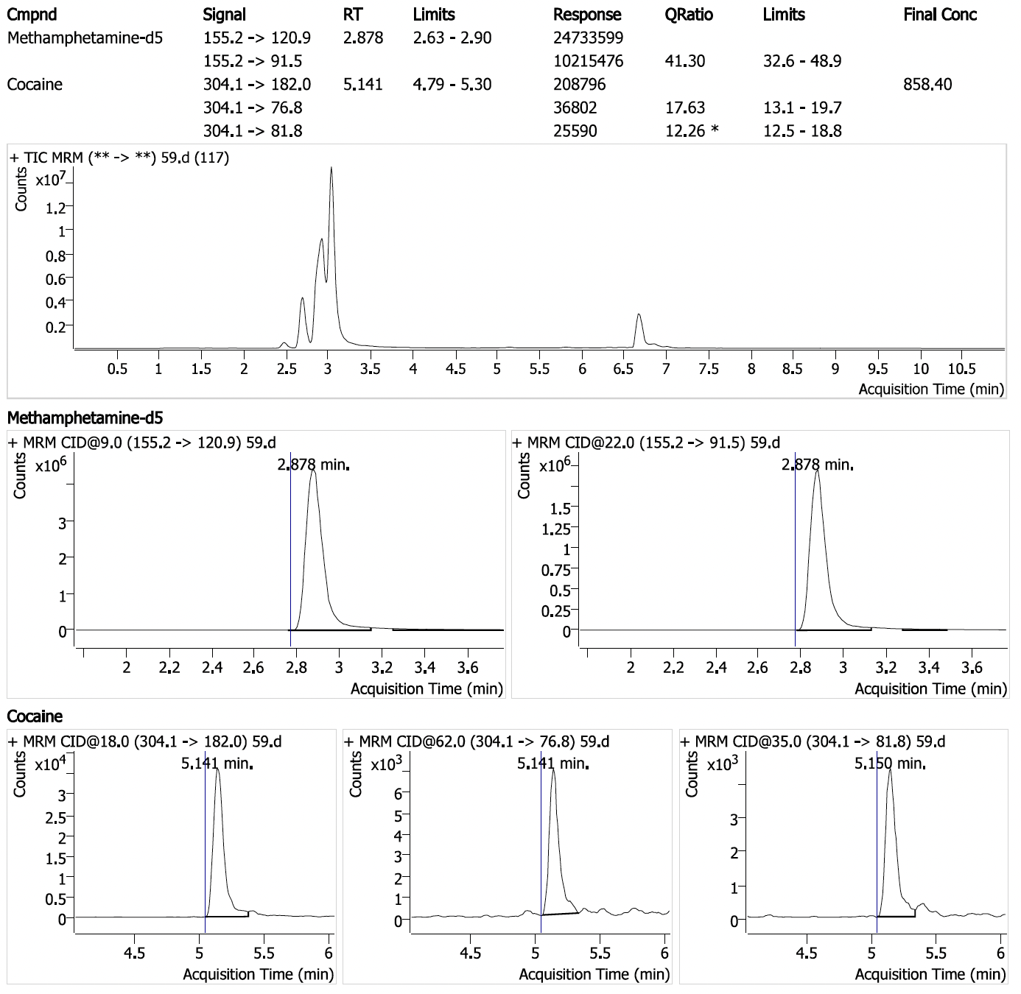
Positive sample #1: Cocaine (25.8 ppm with 3/3 ions detected) in sample seized by HIDTA.

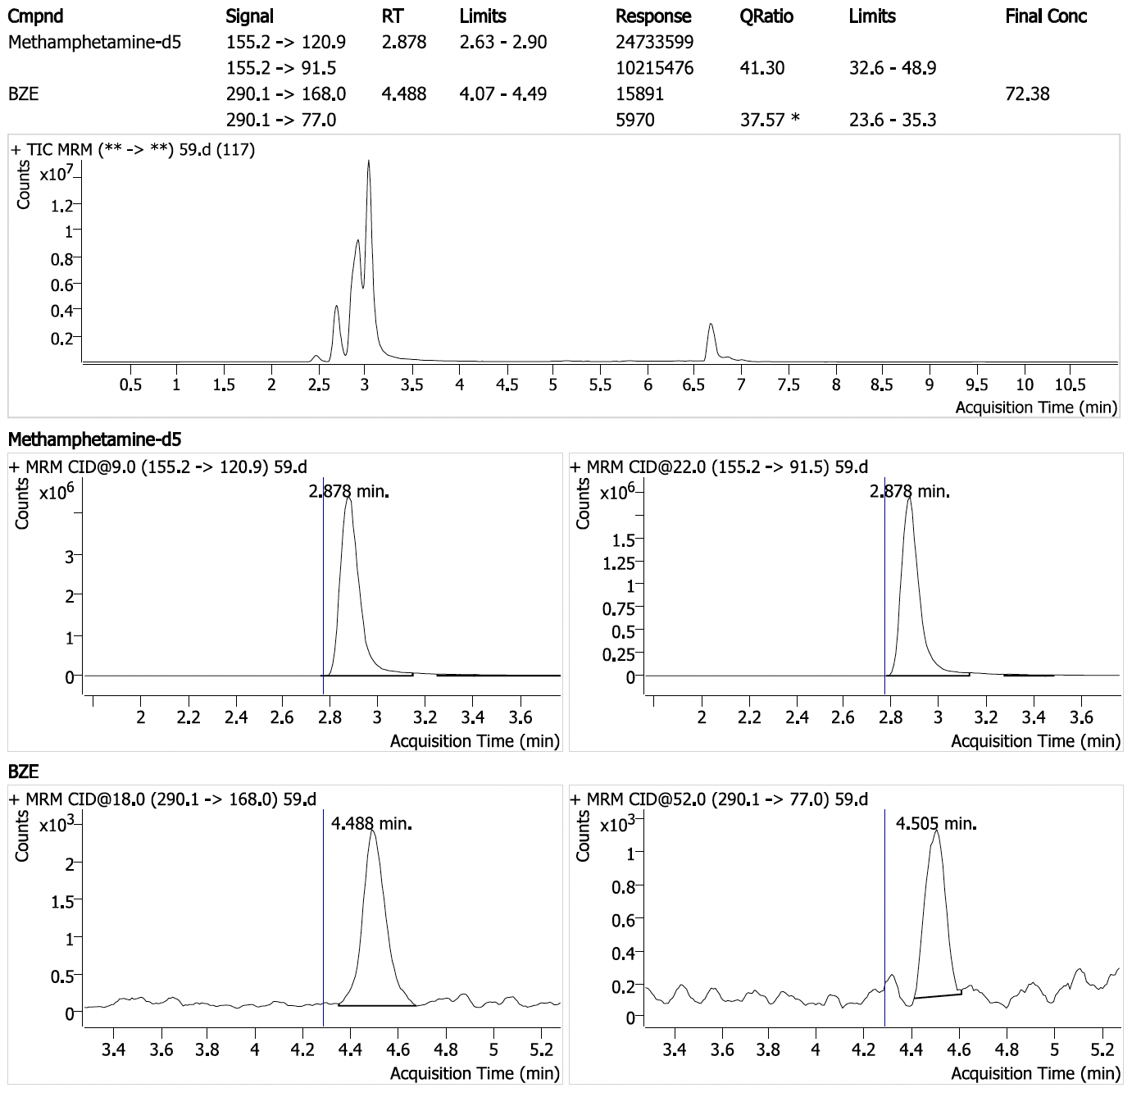
Positive sample #1 (cont.): Benzoylecgonine (2.17 ppm with 2/2 ions detected) in sample seized by HIDTA.

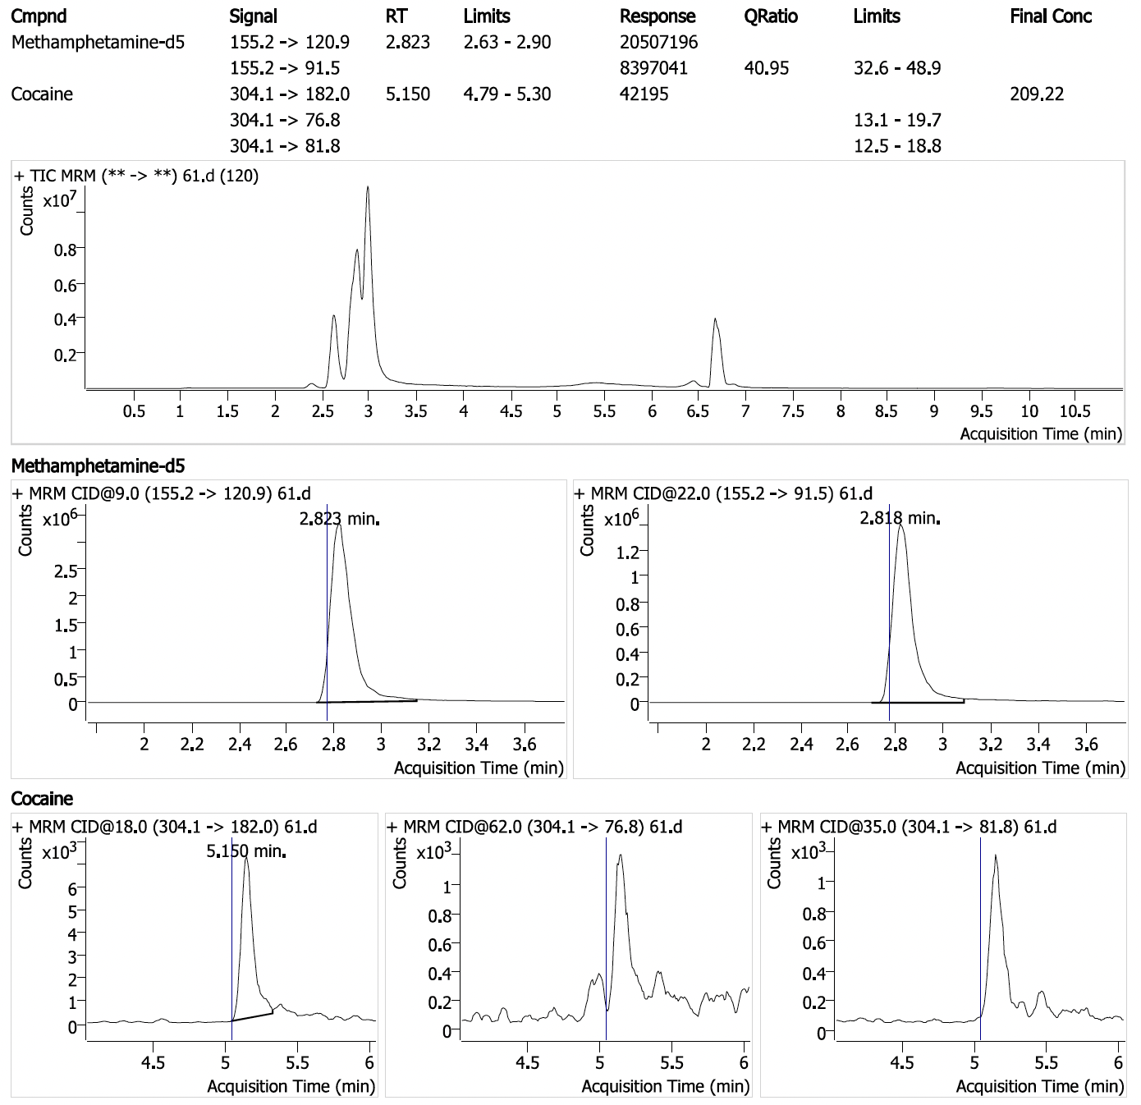
Positive sample #2: Cocaine (6.28 ppm with 1/3 ions detected) in sample seized by HIDTA.

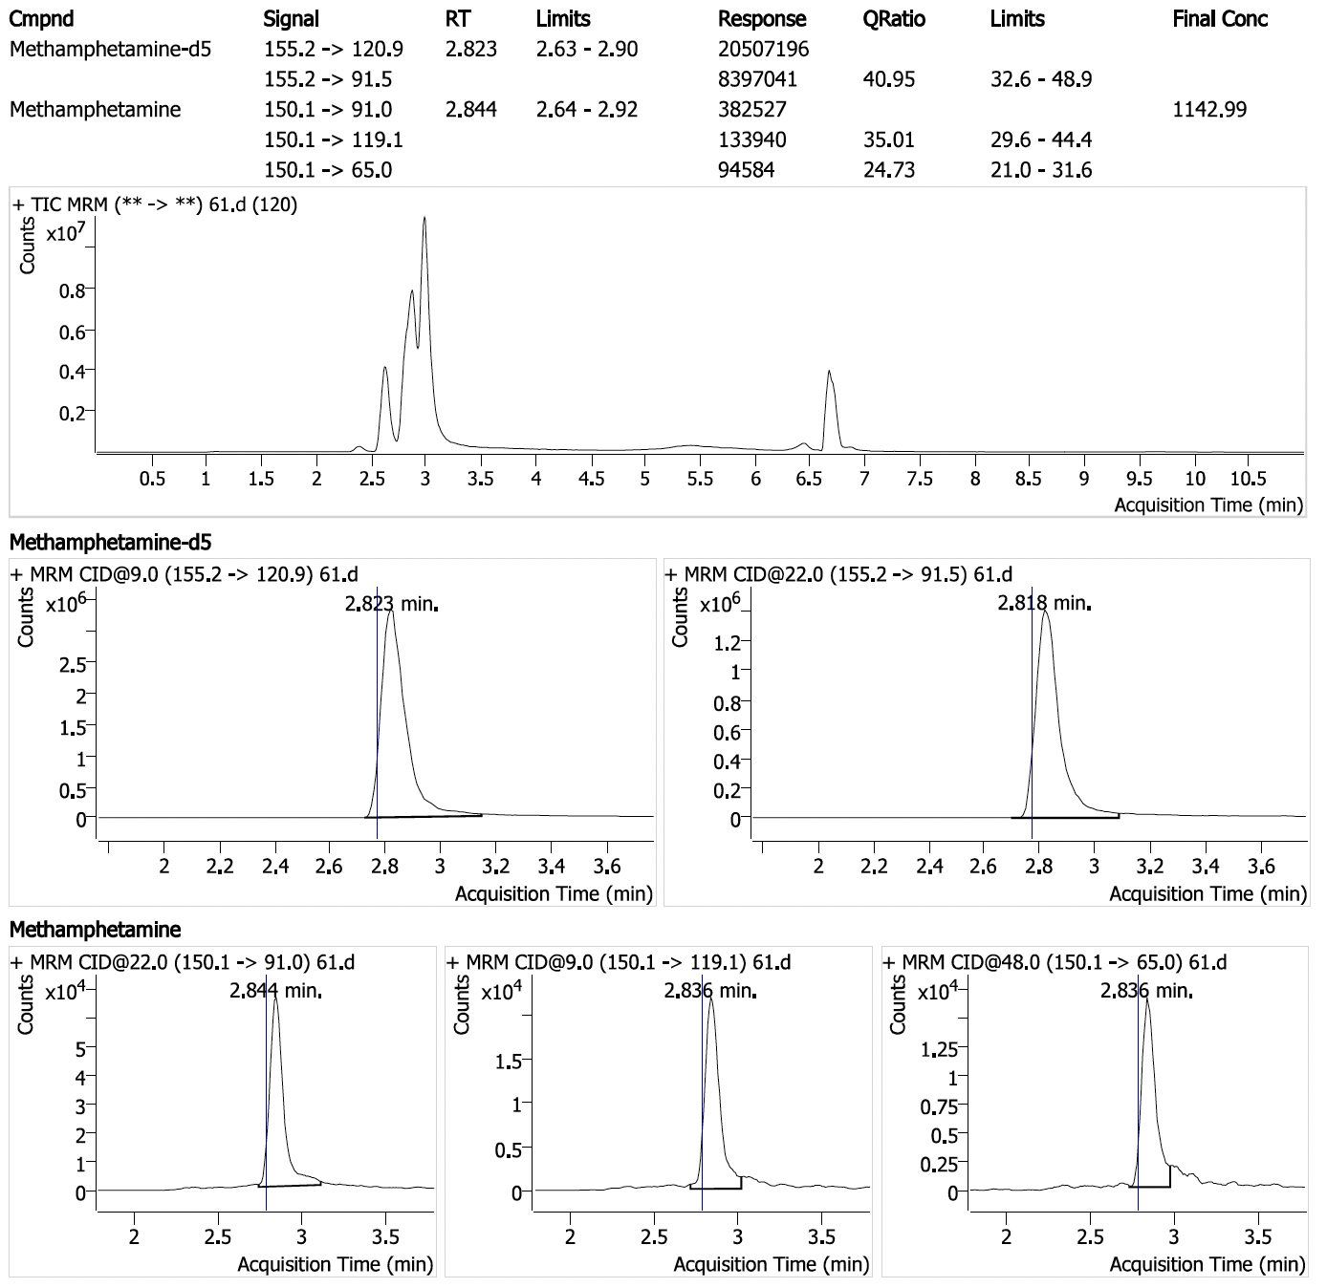
Positive sample #2 (cont.): Methamphetamine (34.3 ppm with 3/3 ions detected) in sample seized by HIDTA.

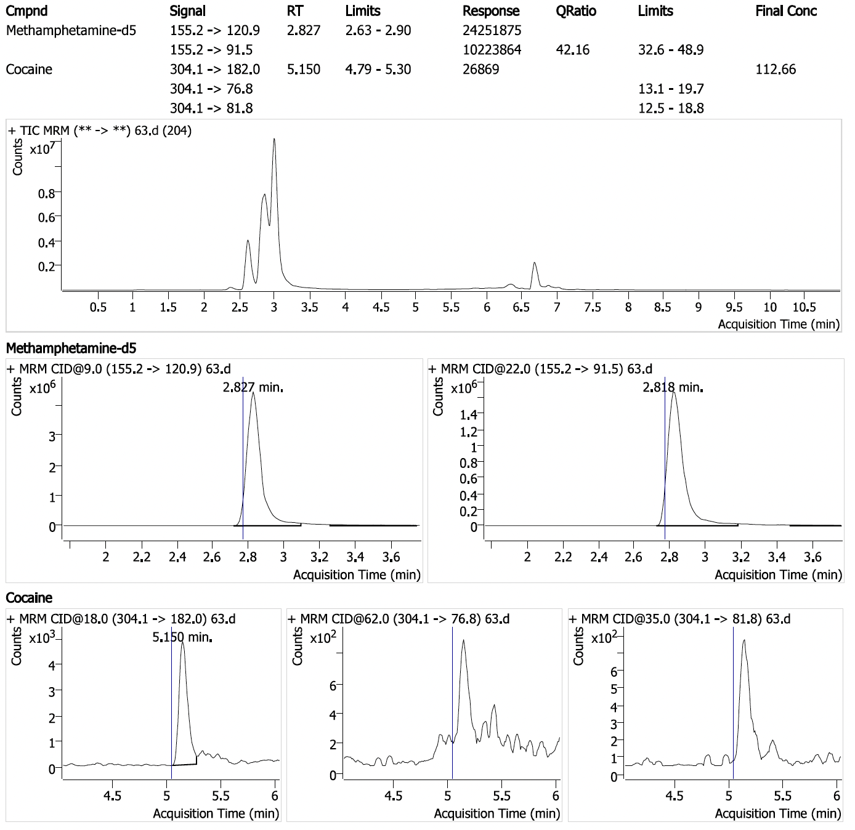
Positive sample #3: Cocaine (3.38 ppm with 1/3 ions detected) in sample seized by HIDTA.

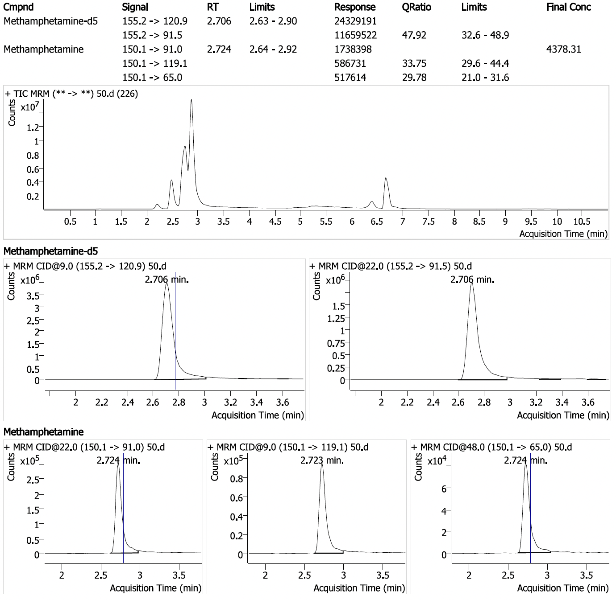
Positive sample #4: Methamphetamine (131 ppm with 3/3 ions detected) in sample seized by HIDTA.

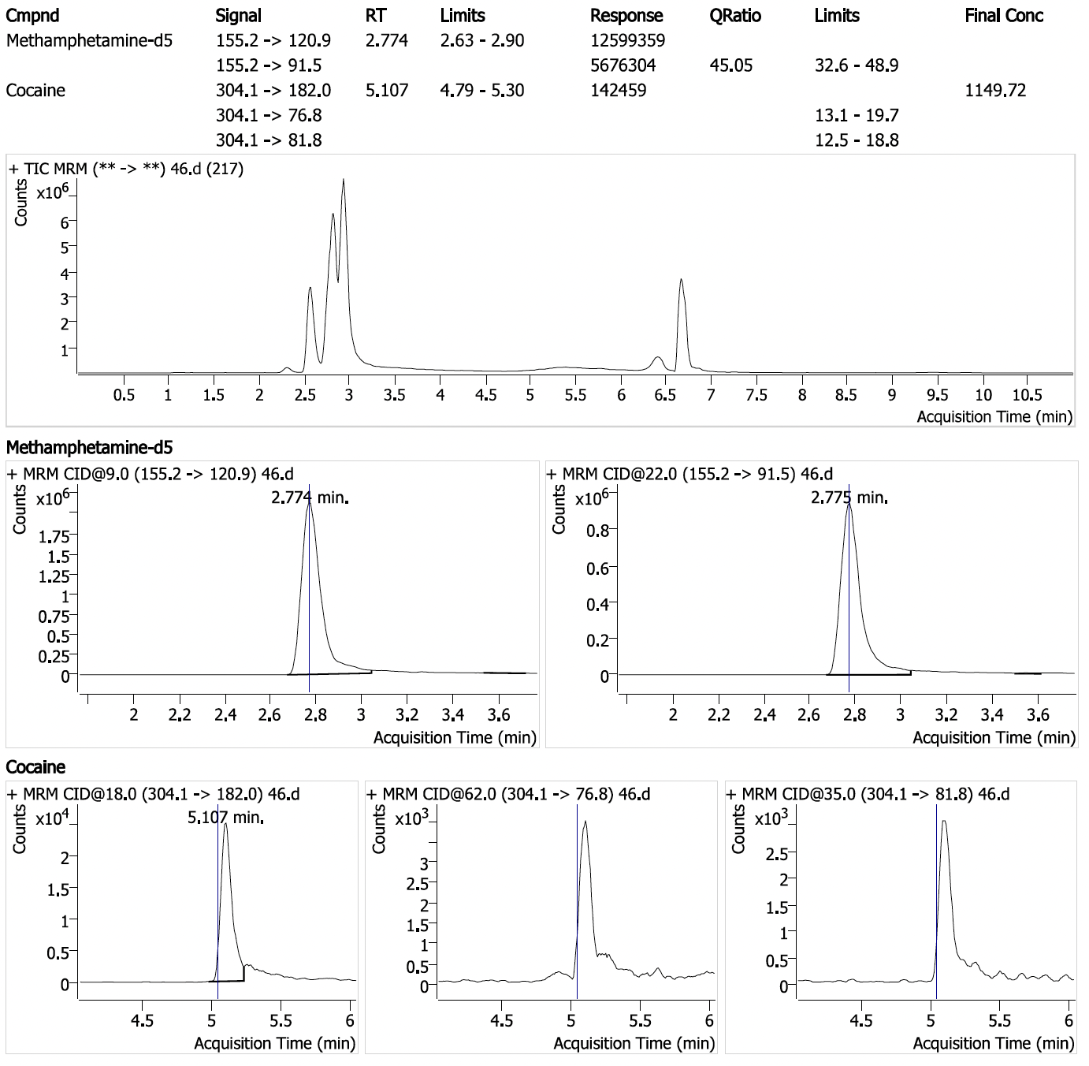
Positive sample #5: Cocaine (34.5 ppm with 1/3 ions detected) in sample seized by HIDTA.

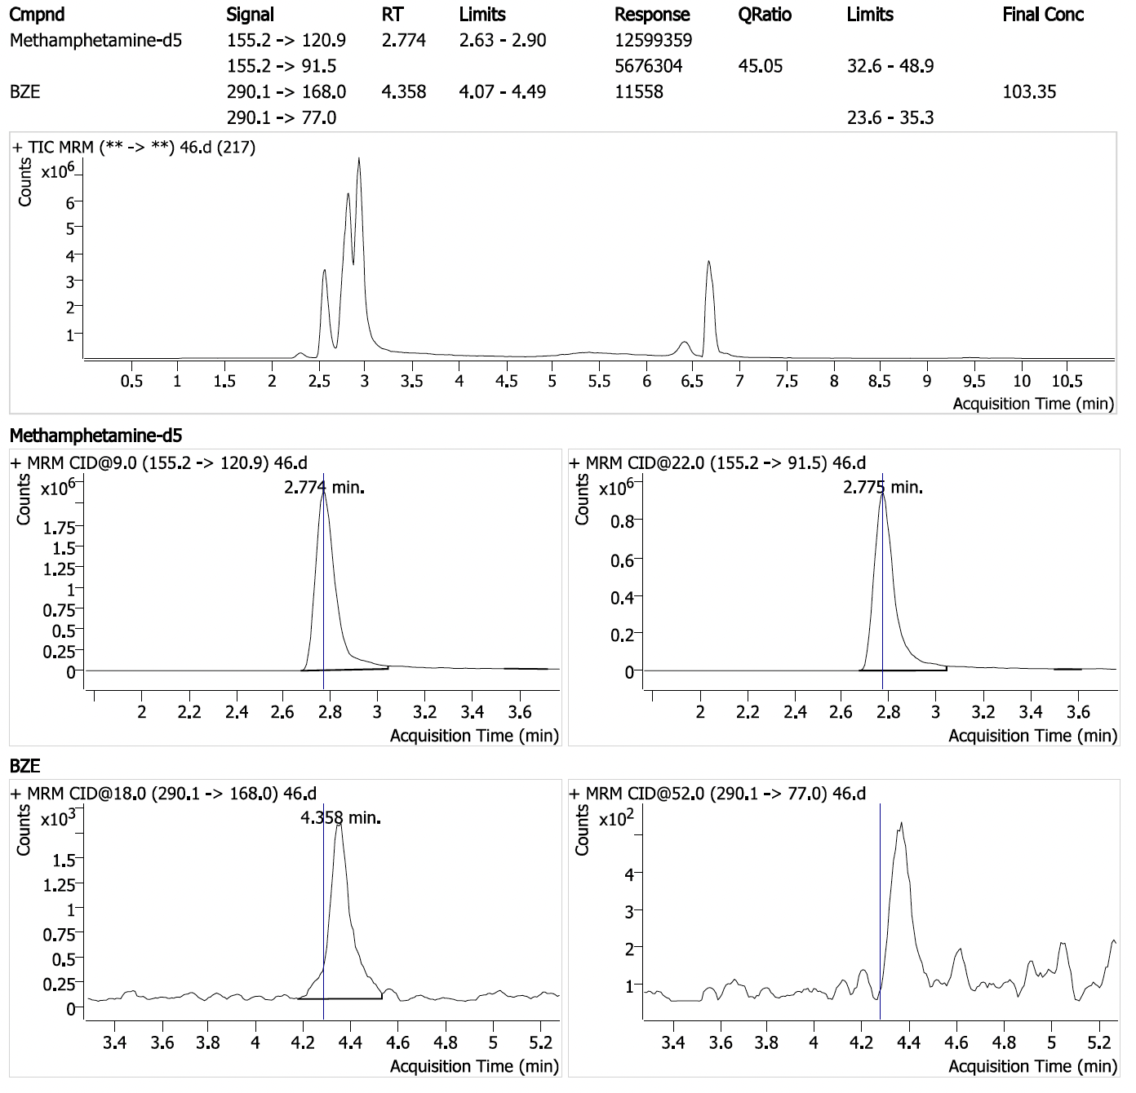
Positive sample #5 (cont.): Benzoylecgonine (3.11 ppm with 1/2 ions detected) in sample seized by HIDTA.

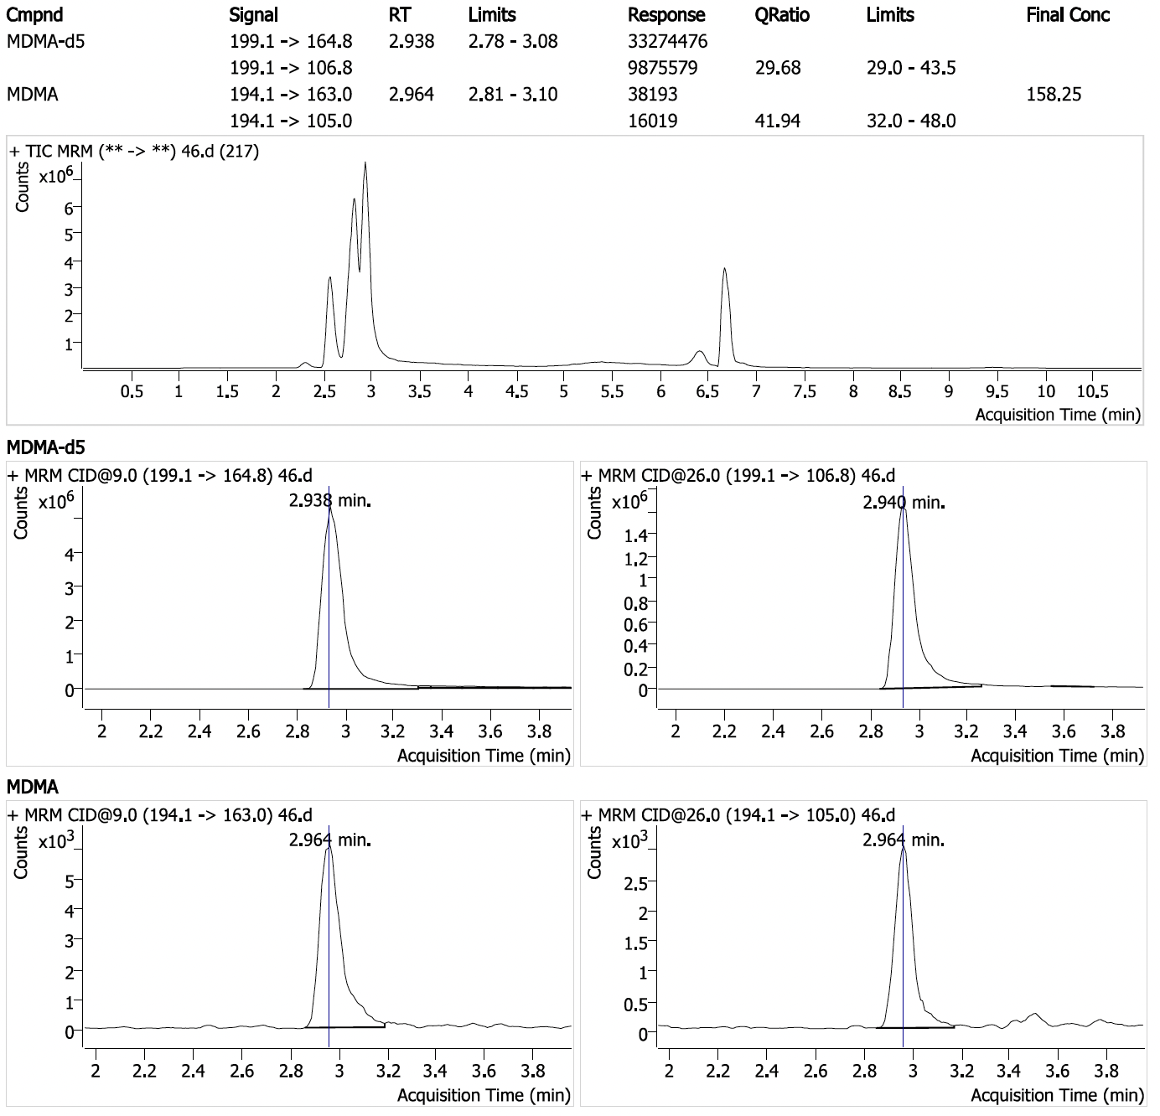
Positive sample #5 (cont.): 3,4-methylenedioxymethamphetamine (4.75 ppm with 2/2 ions detected) in sample seized by HIDTA.

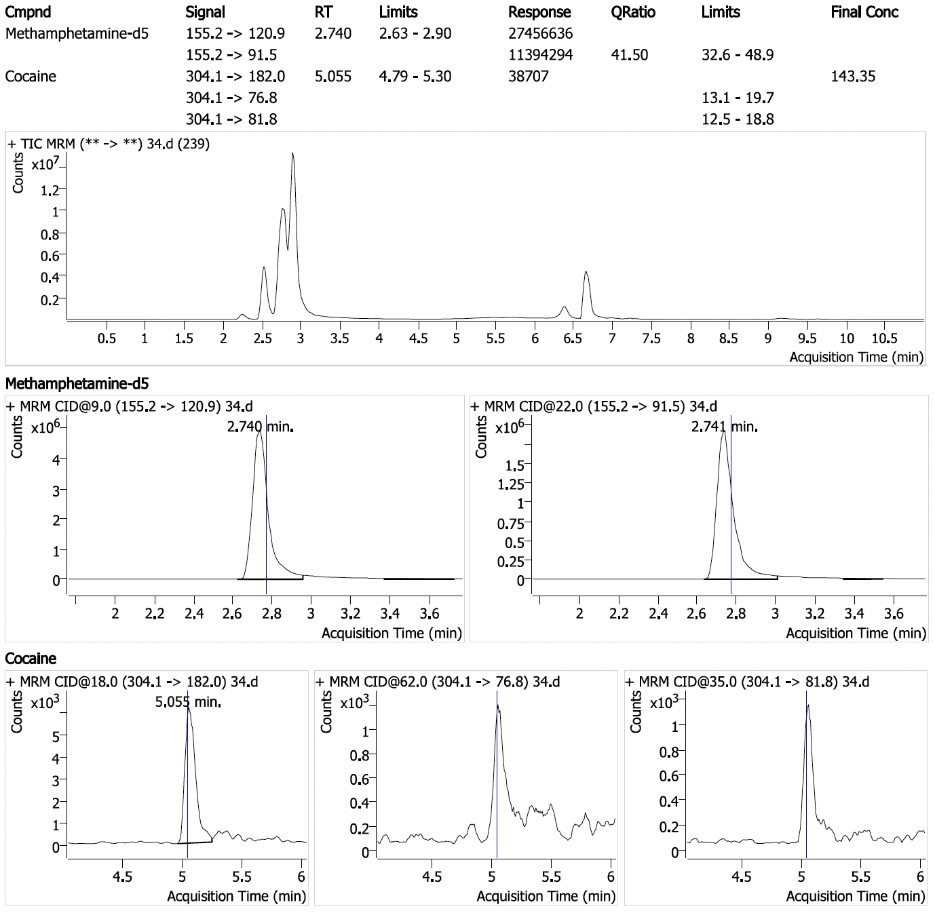
Positive sample #6: Cocaine (4.31 ppm with 1/3 ions detected) in sample seized by U.S. Postal Inspection Service.

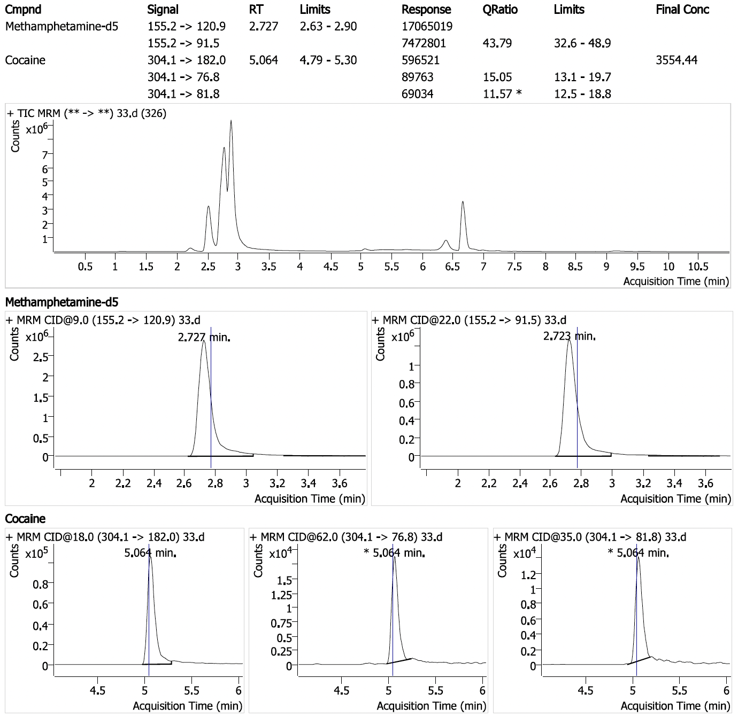
Positive sample #7: Cocaine (107 ppm with 3/3 ions detected) in sample seized by HIDTA.

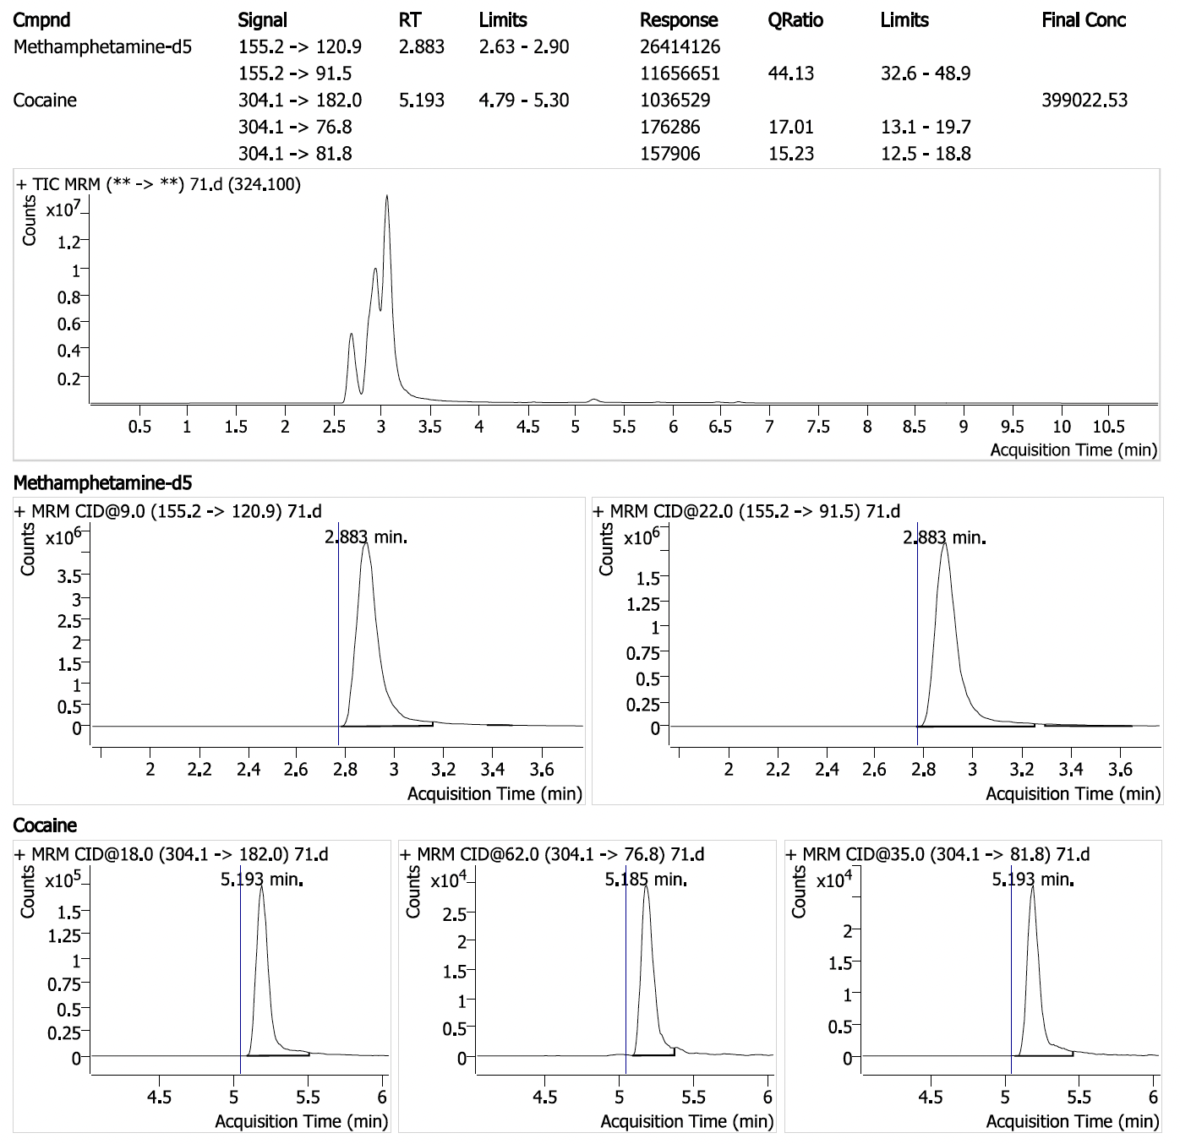
Positive sample #8: Cocaine (11,970 ppm with 3/3 ions detected) in sample seized by HIDTA. This sample was diluted 100-fold to get it within the calibration curve. All ions were detected when it was analyzed at higher concentrations
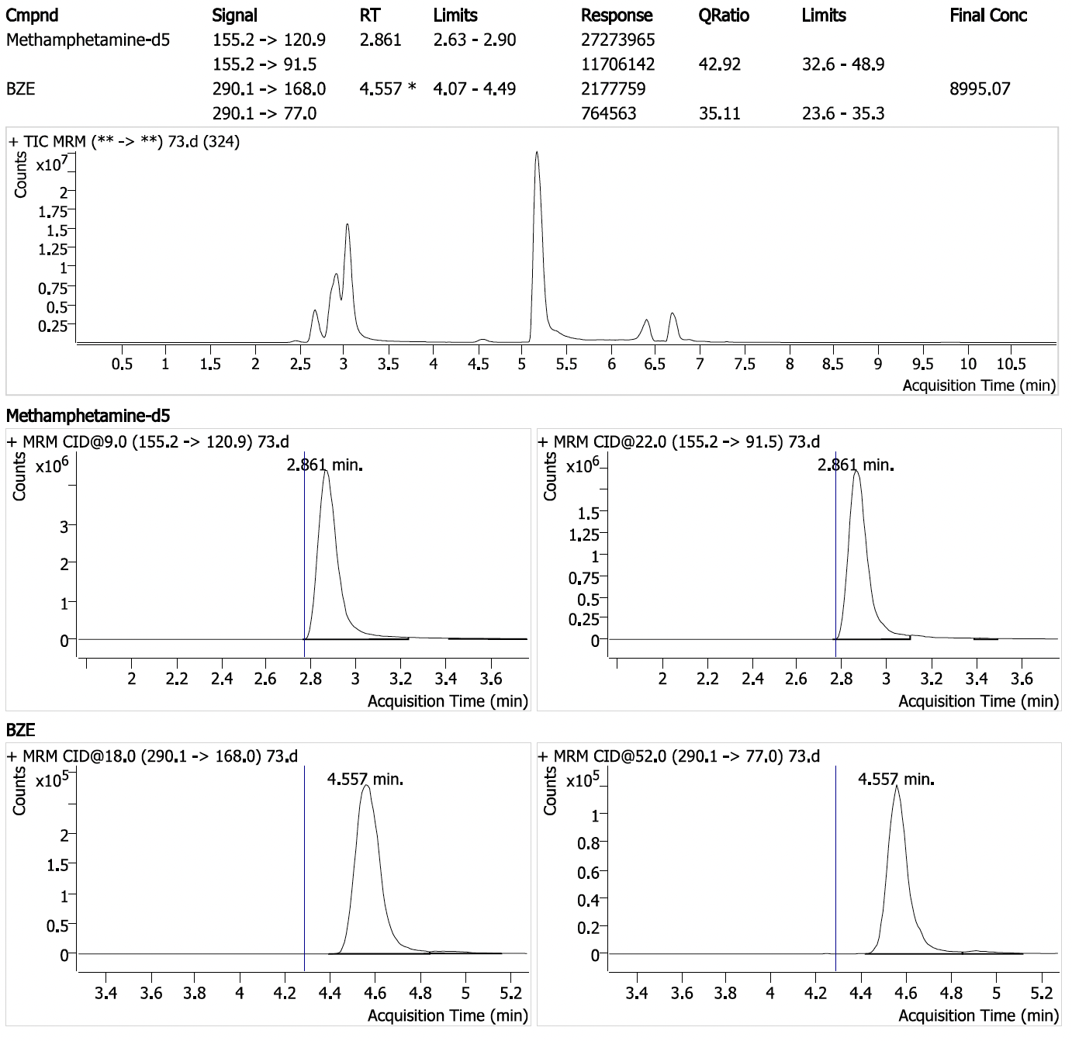
Positive sample #8 (cont.): Benzoylecgonine (270 ppm with 2/2 ions detected) in sample seized by HIDTA. This chromatogram was obtained from the undiluted analysis of Positive Sample #8. This chromatogram also shows the magnitude of the cocaine peak present. It is the largest peak in the Total Ion Chromatogram (TIC) eluting at 5.2 minutes.

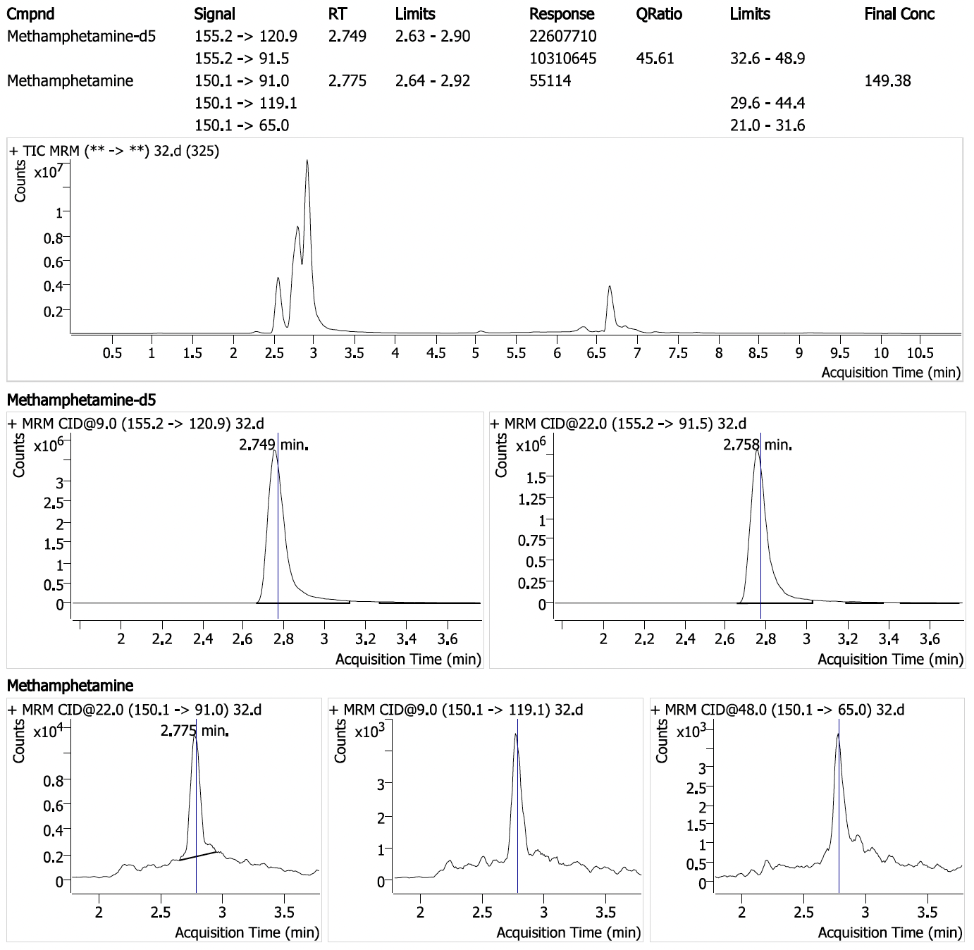
Positive sample #9: Methamphetamine (4.48 ppm with 1/3 ions detected) in sample seized by HIDTA.
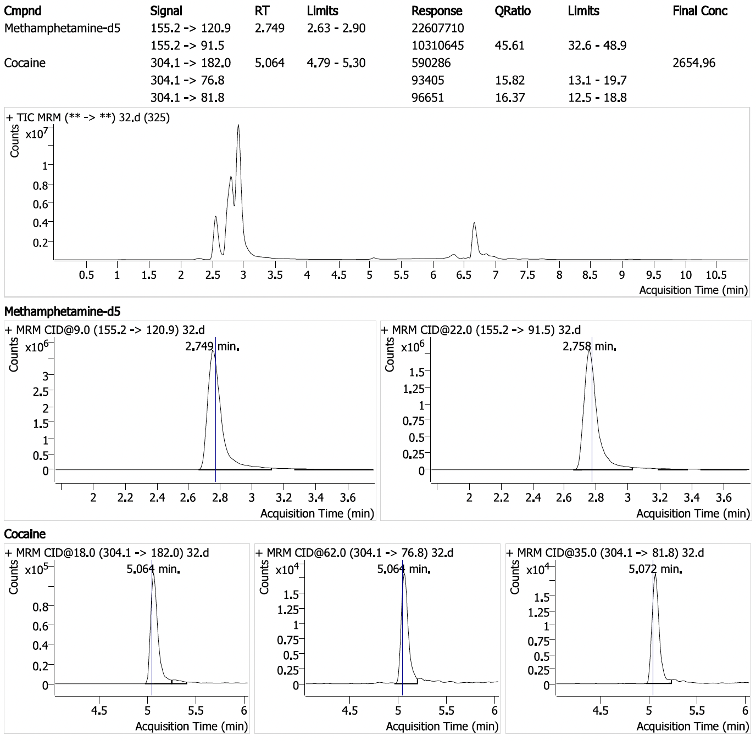
Positive sample #9 (cont.): Cocaine (79.7 ppm with 3/3 ions detected) in sample seized by HIDTA.
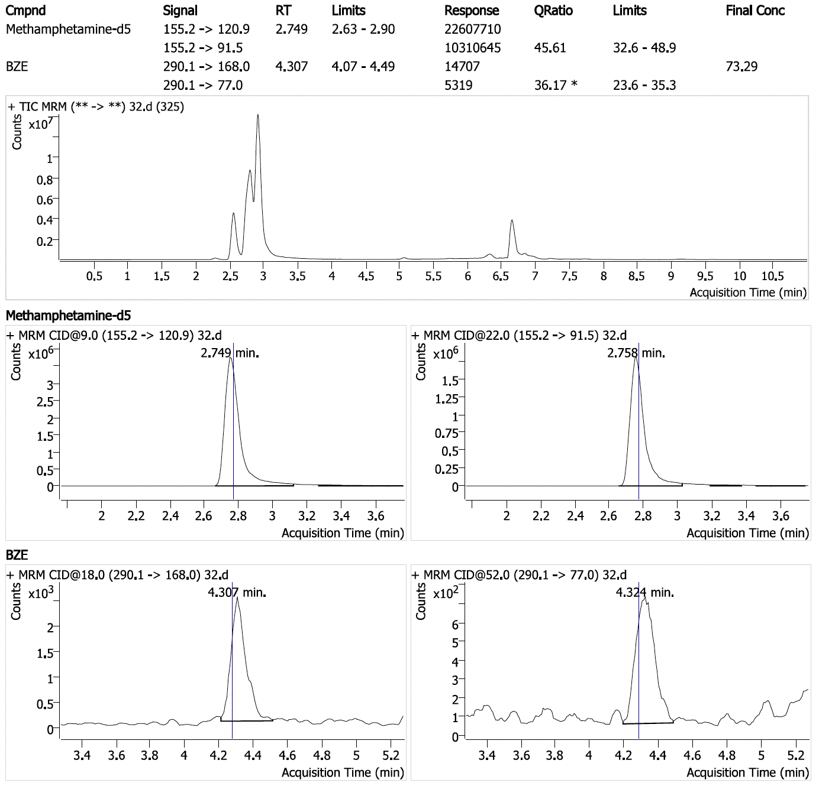
Positive sample #9 (cont.): Benzoylecgonine (2.20 ppm with 2/2 ions detected) in sample seized by HIDTA.

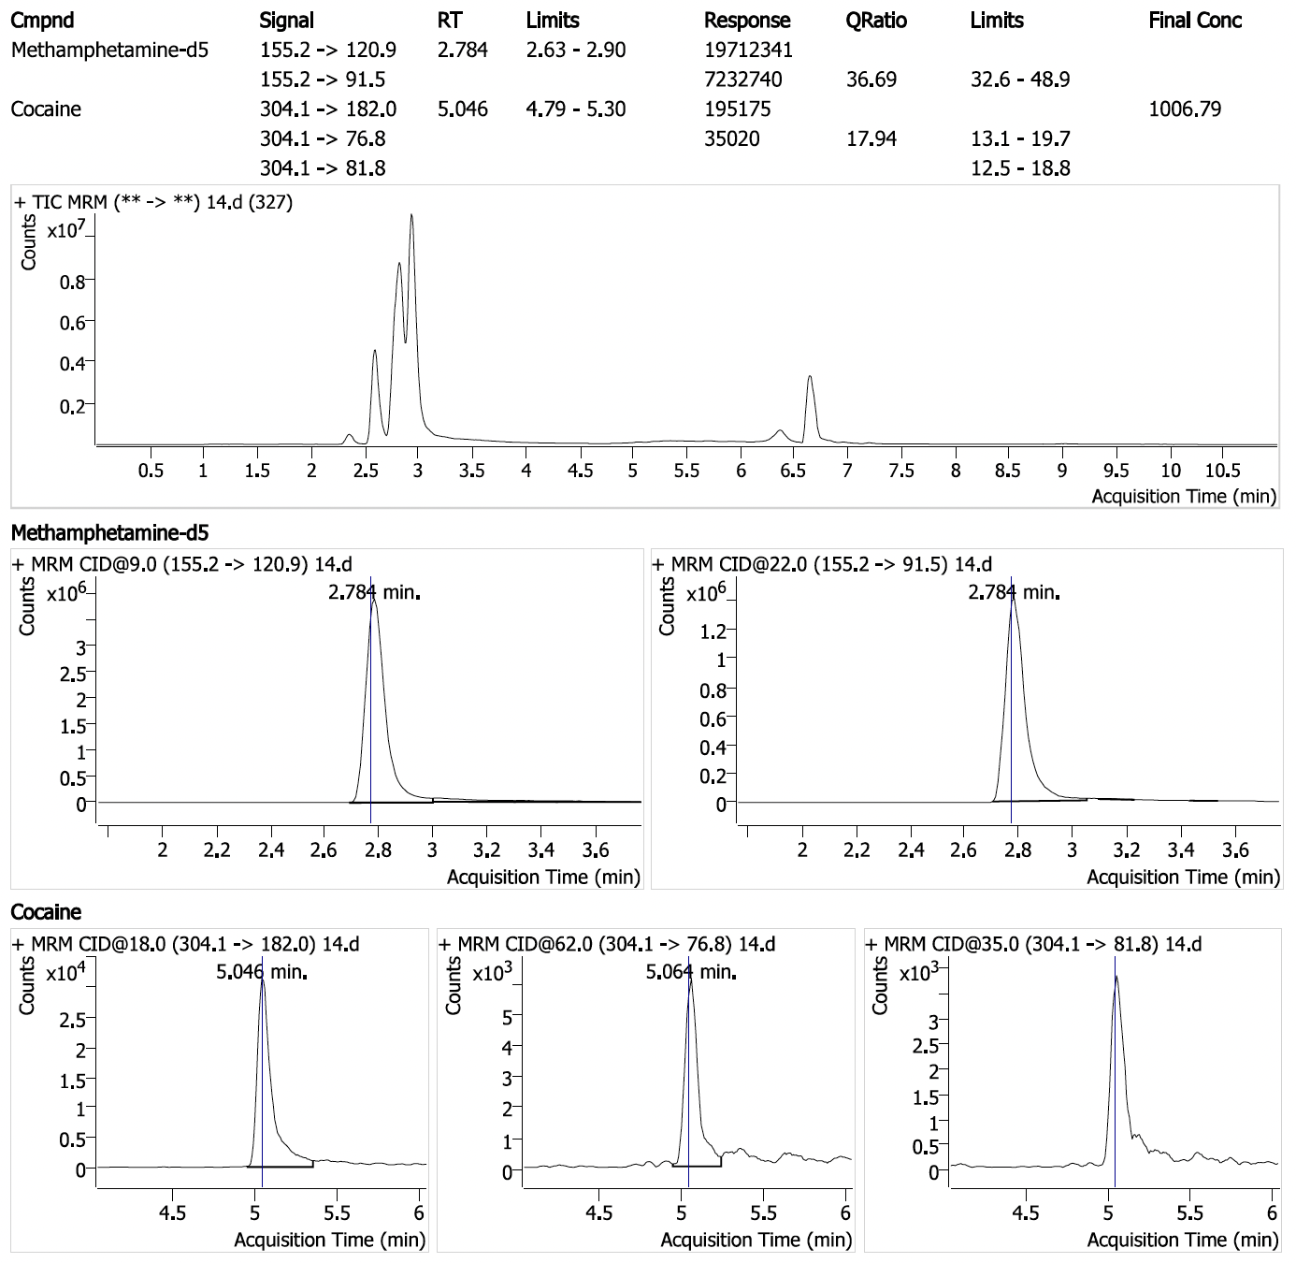
Positive sample #10: Cocaine (30.2 ppm with 2/3 ions detected) in sample seized by HIDTA.

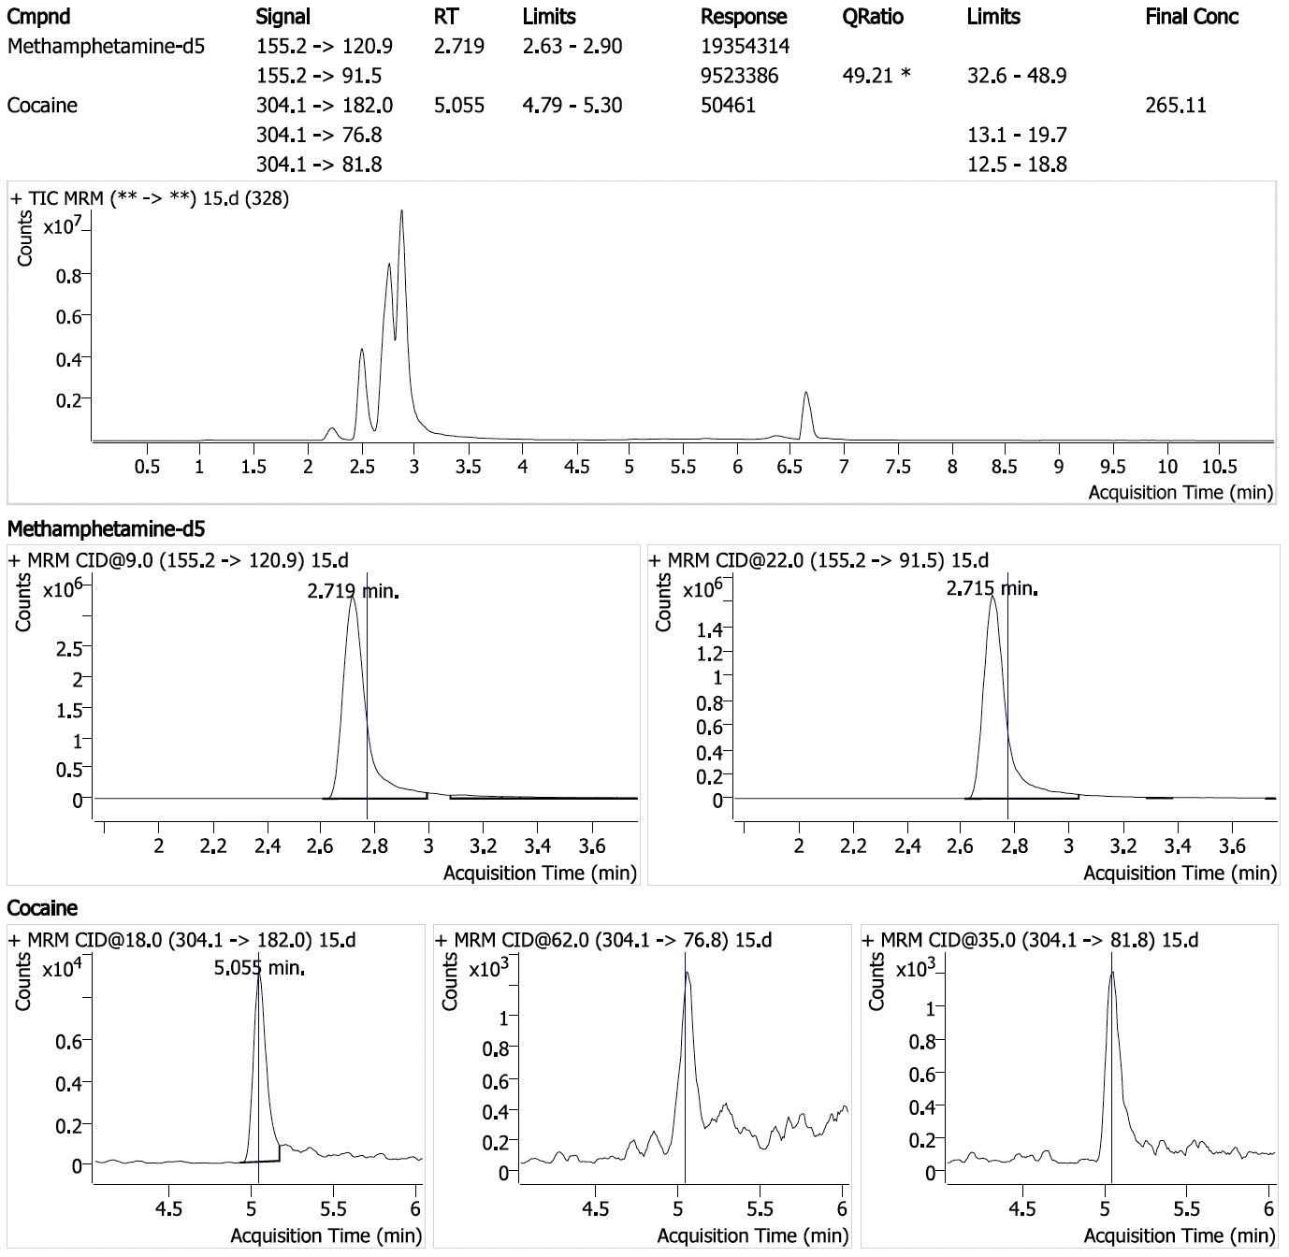
Positive sample #11: Cocaine (7.95 ppm with 1/3 ions detected) in sample seized by HIDTA.

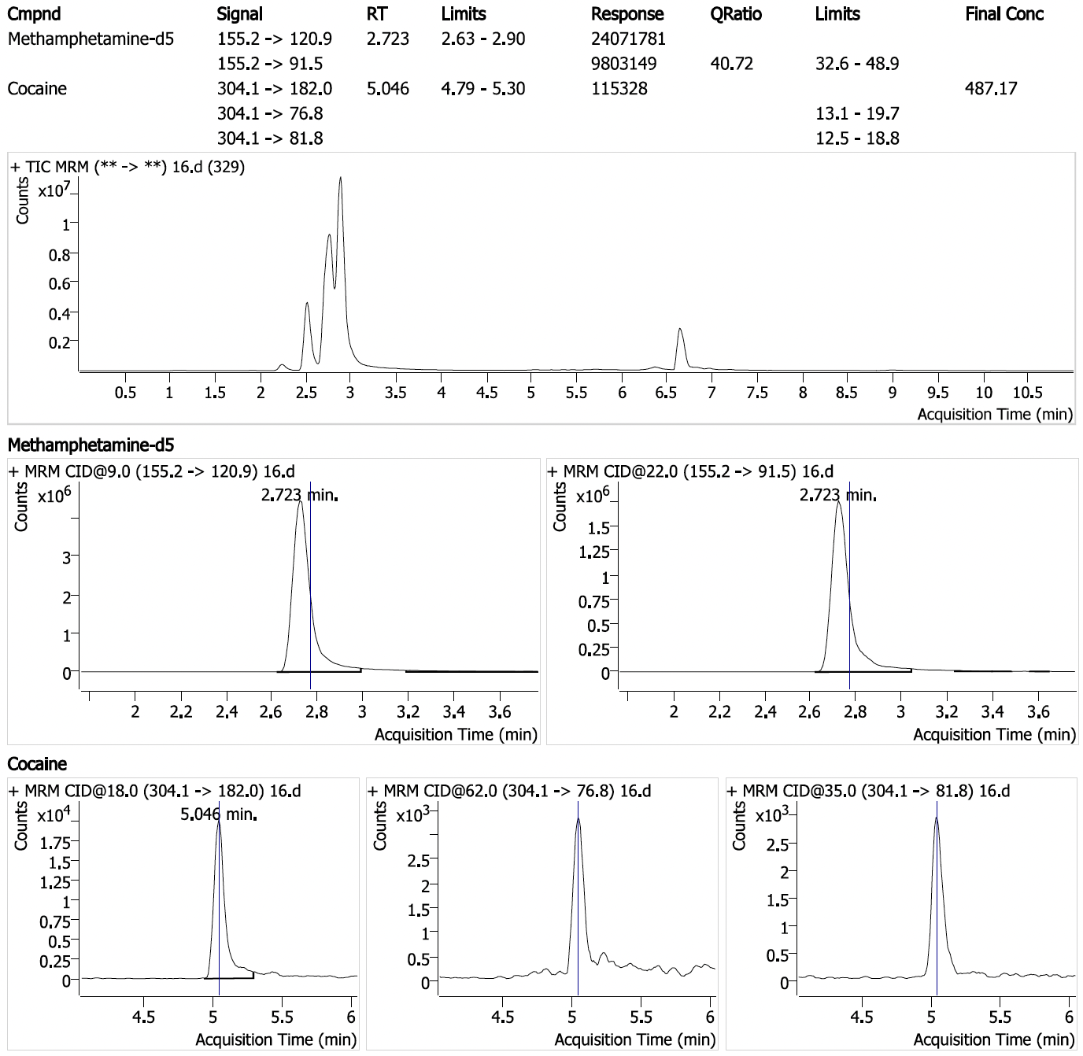
Positive sample #12: Cocaine (14.6 ppm with 1/3 ions detected) in sample seized by HIDTA.

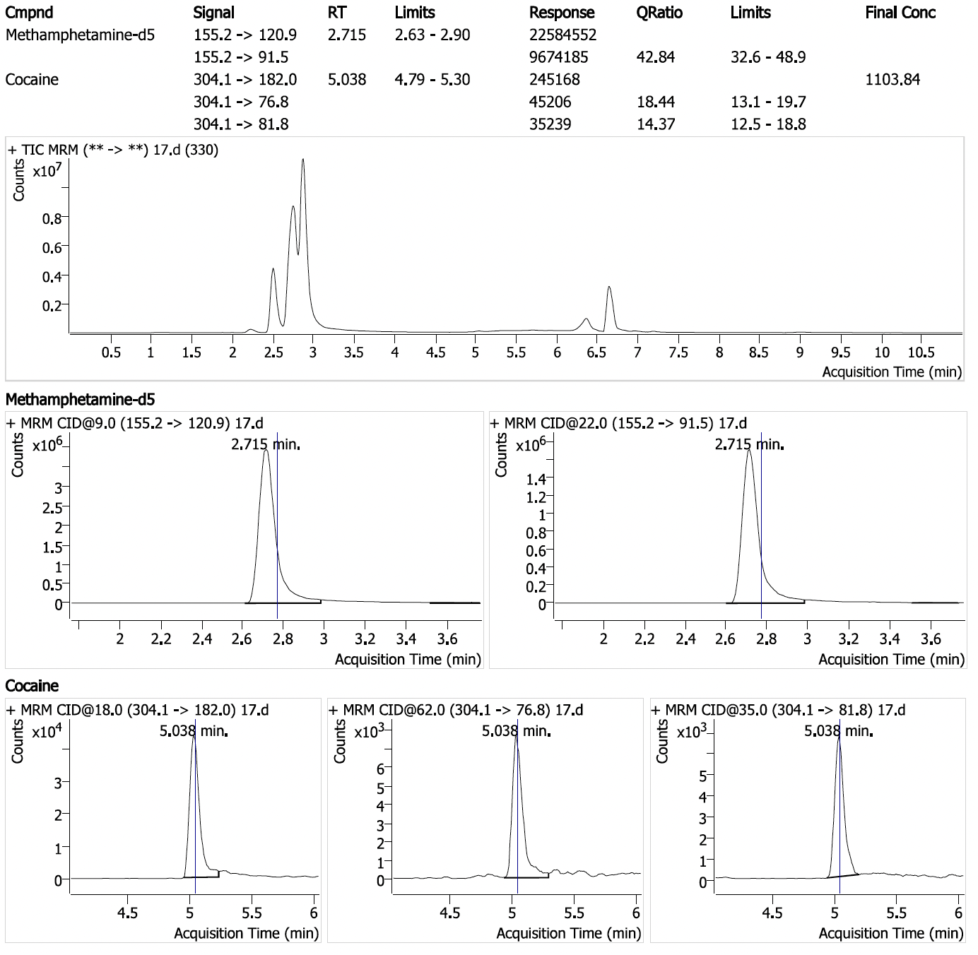
Positive sample #13: Cocaine (33.1 ppm with 3/3 ions detected) in sample seized by HIDTA.

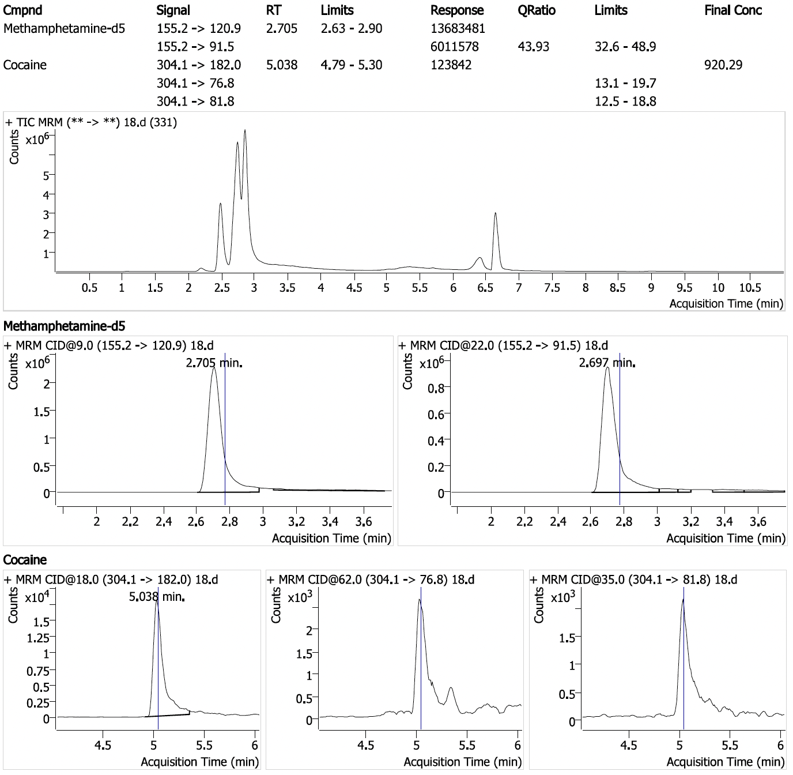
Positive sample #14: Cocaine (27.6 ppm with 1/3 ions detected) in sample seized by HIDTA.

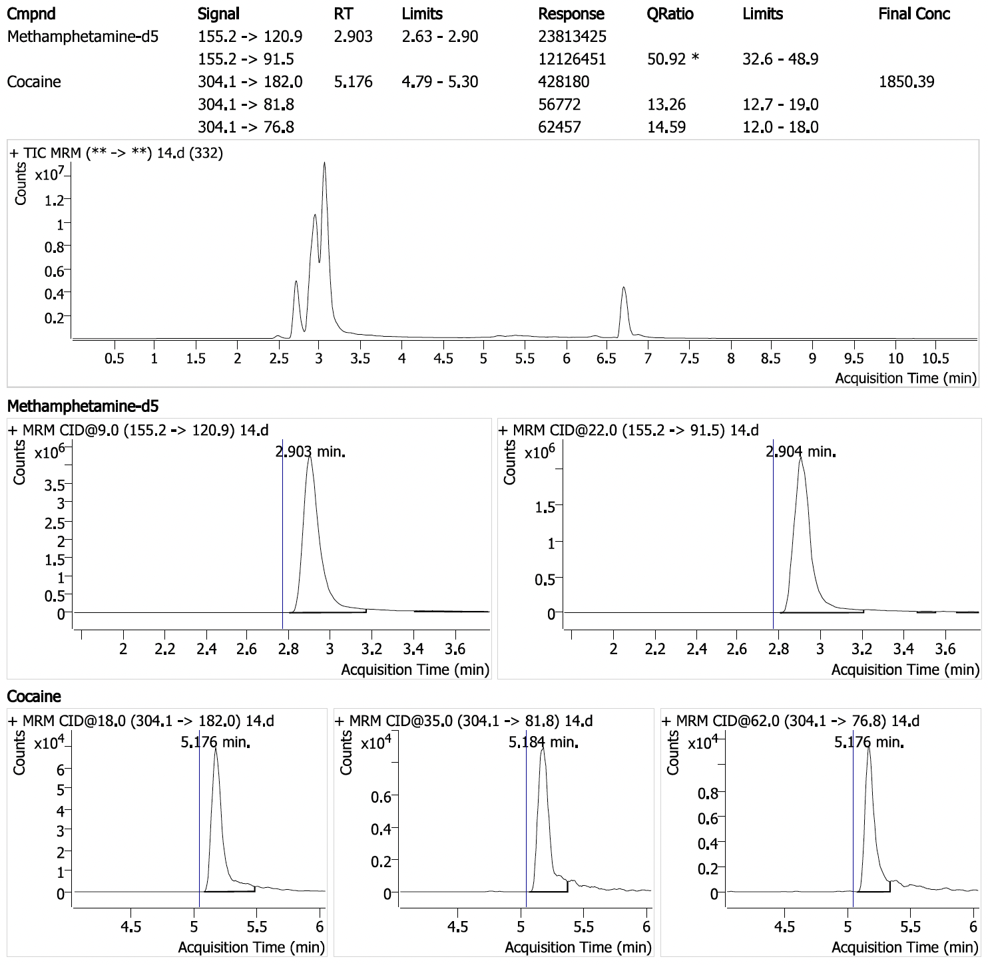
Positive sample #15: Cocaine (55.5 ppm with 3/3 ions detected) in sample seized by HIDTA.

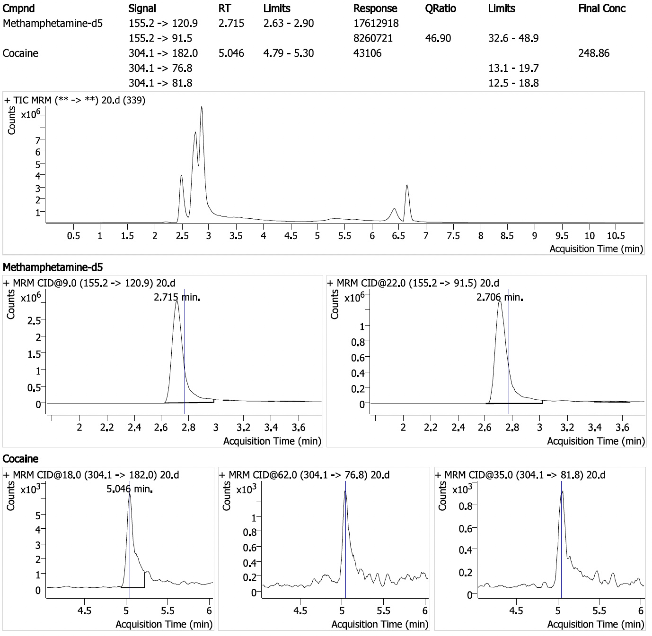
Positive sample #16: Cocaine (7.46 ppm with 1/3 ions detected) in sample seized by HIDTA.

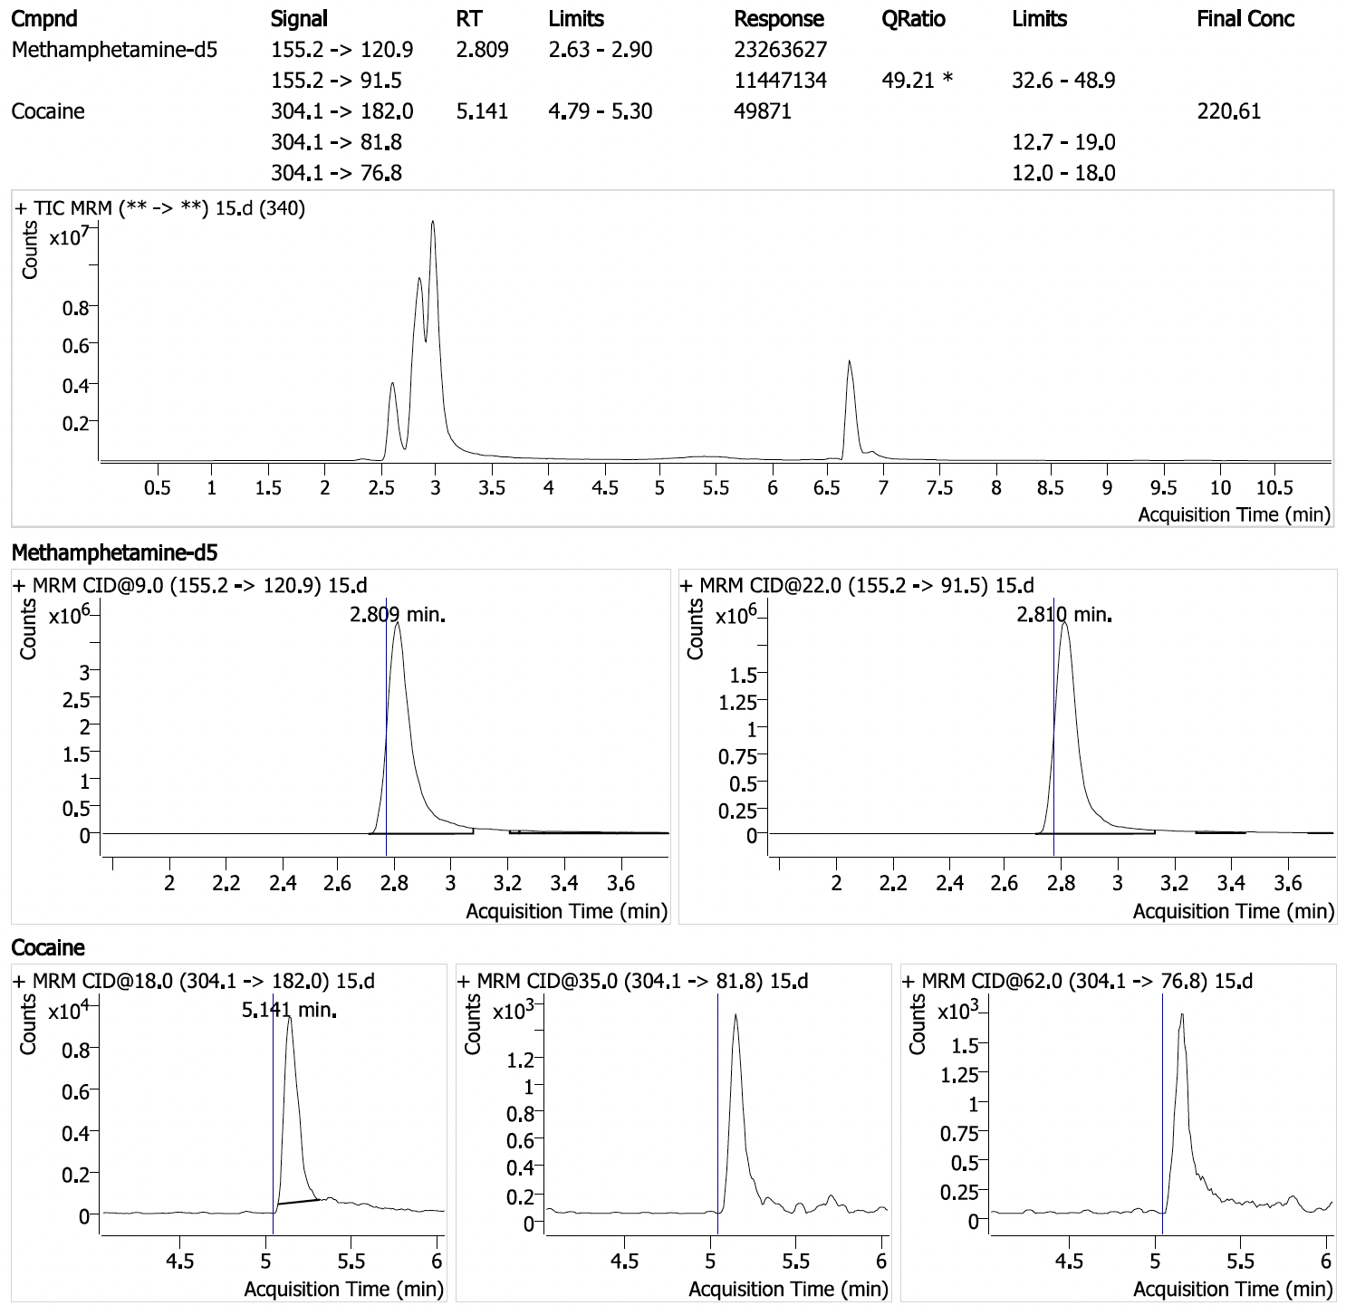
Positive sample #17: Cocaine (6.62 ppm with 1/3 ions detected) in sample seized by HIDTA.

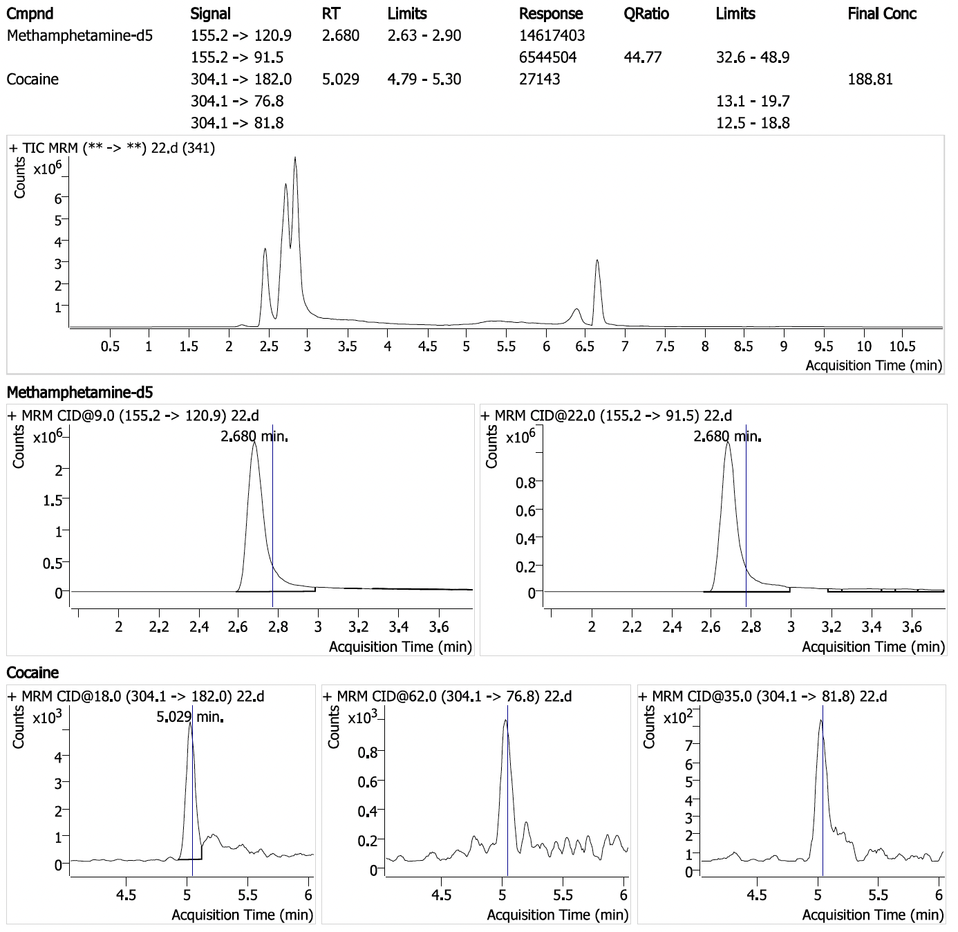
Positive sample #18: Cocaine (5.66 ppm with 1/3 ions detected) in sample seized by HIDTA.

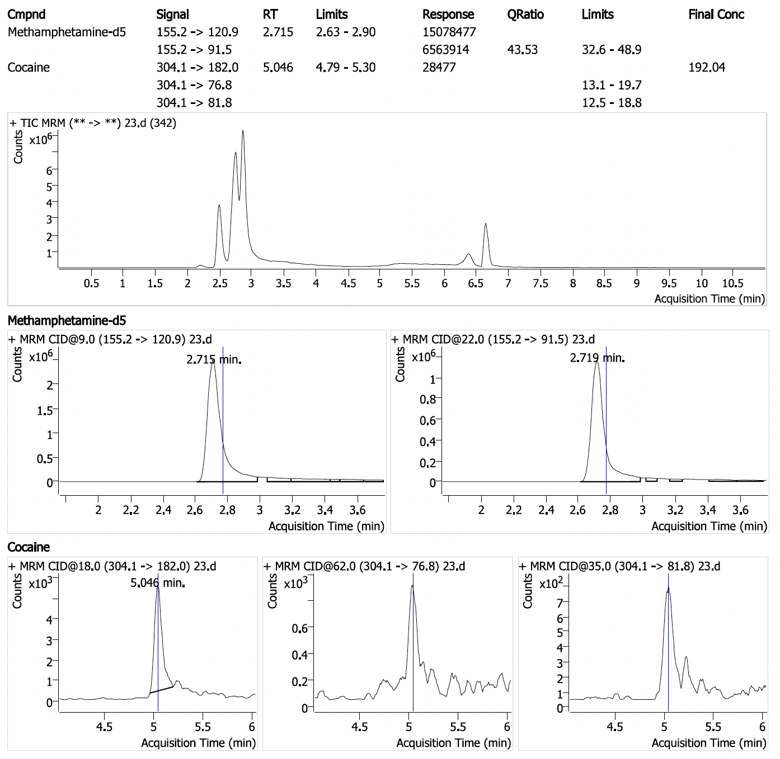
Positive sample #19: Cocaine (5.76 ppm with 1/3 ions detected) in sample seized by HIDTA.

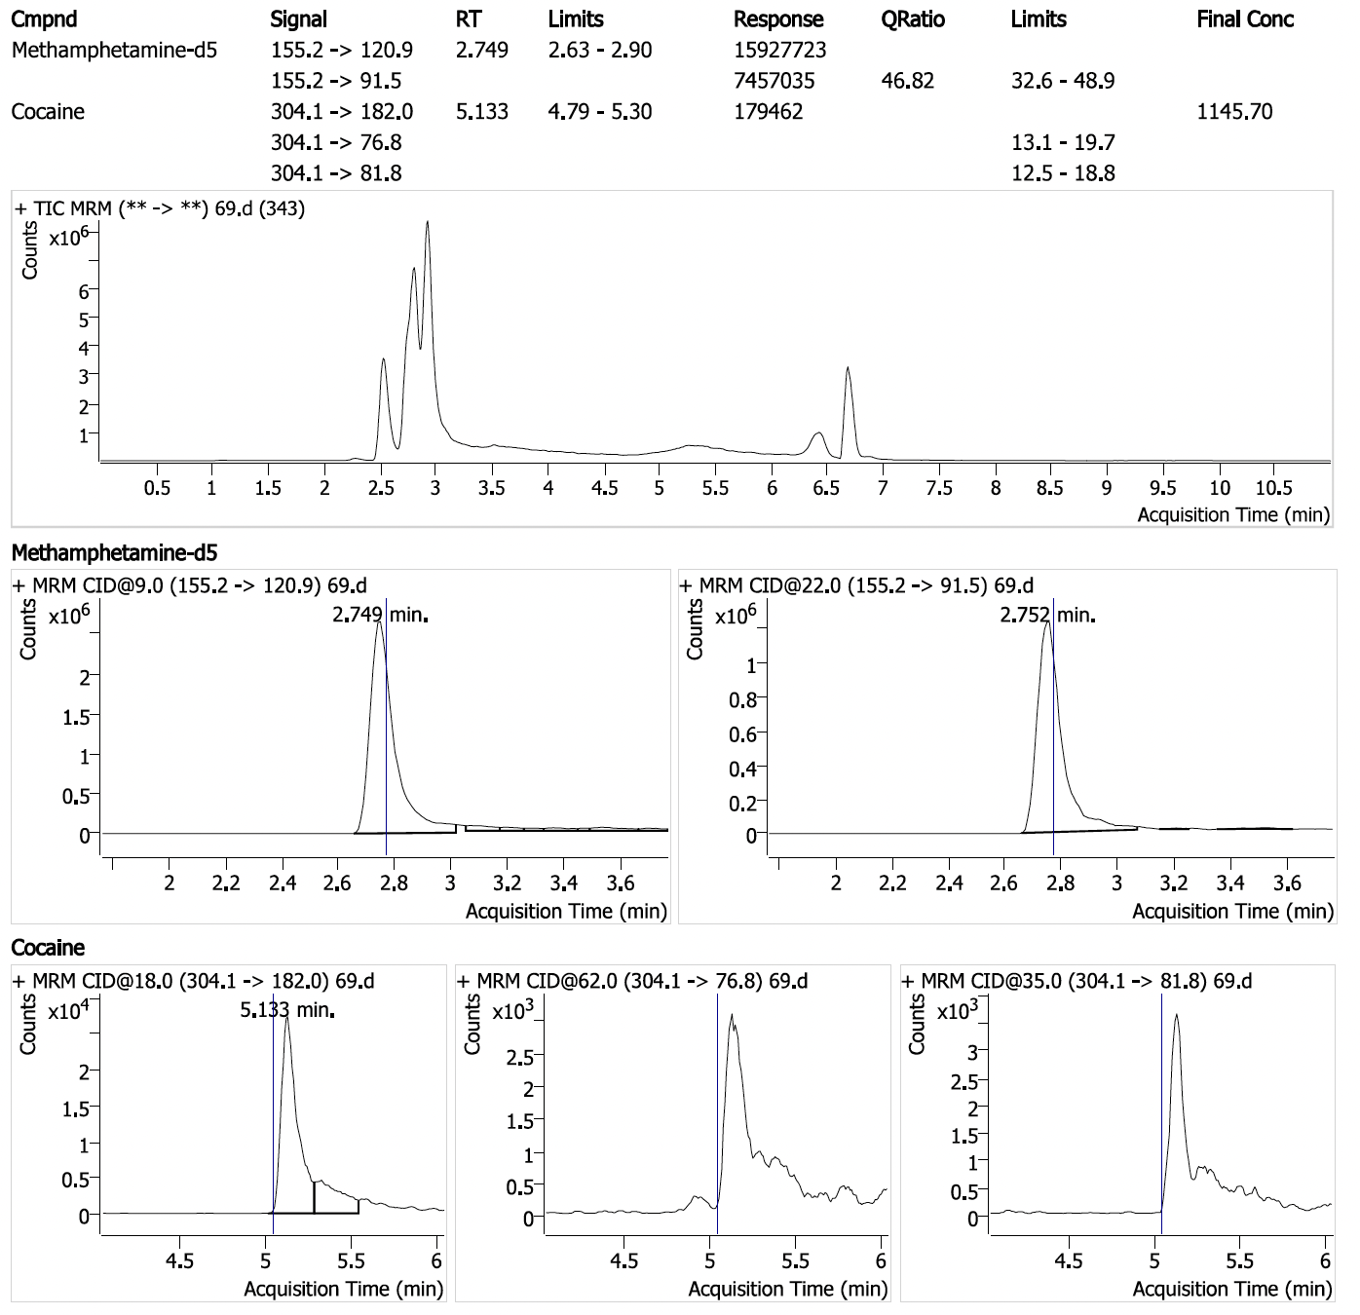
Positive sample #20: Cocaine (34.4 ppm with 1/3 ions detected) in sample seized by HIDTA.

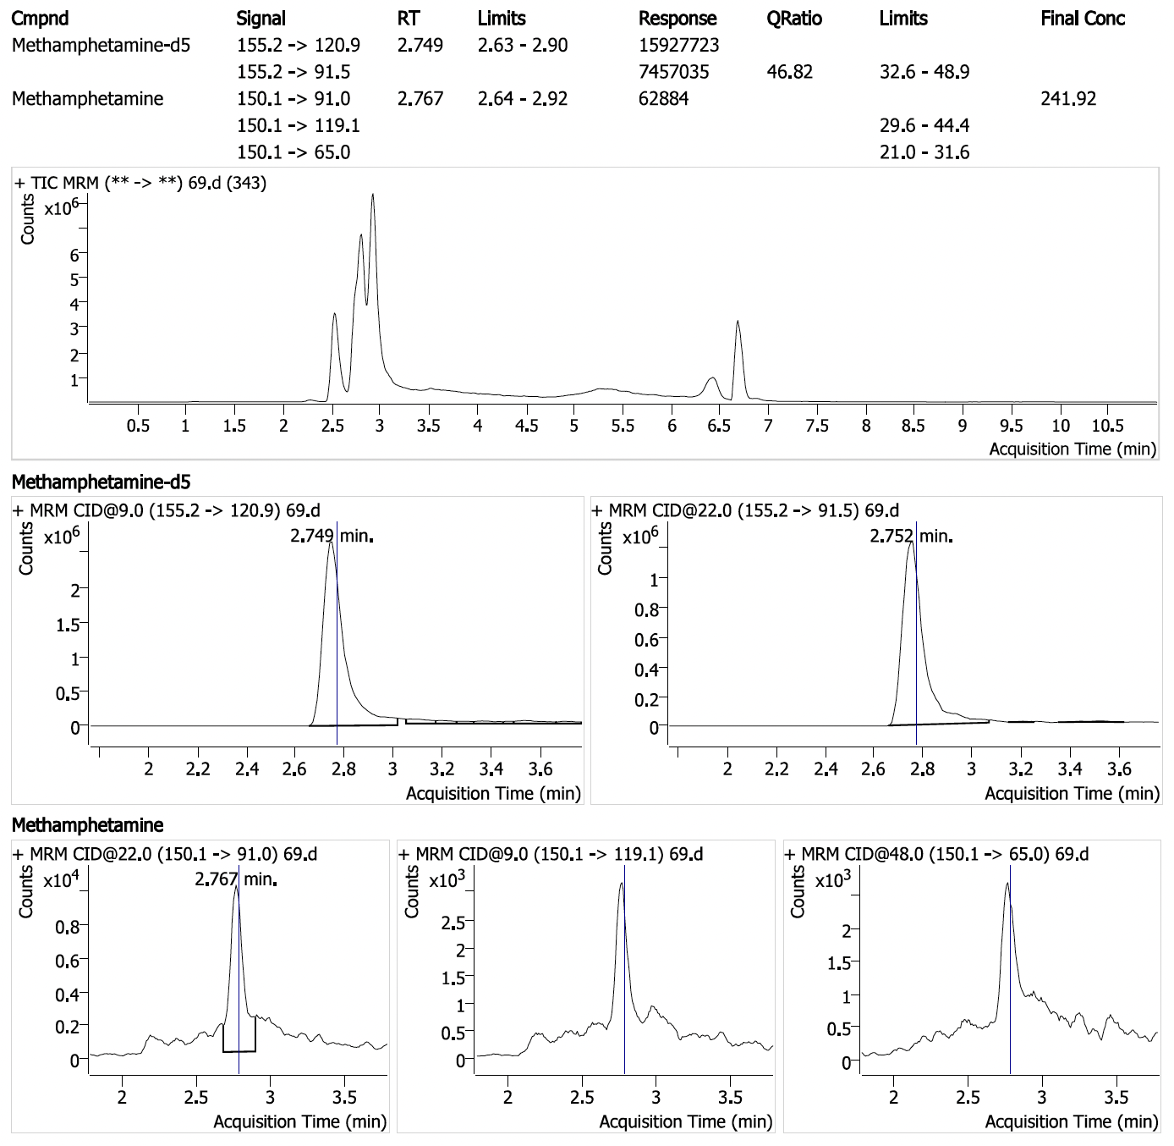
Positive sample #20 (cont.): Methamphetamine (7.26 ppm with 1/3 ions detected) in sample seized by HIDTA.

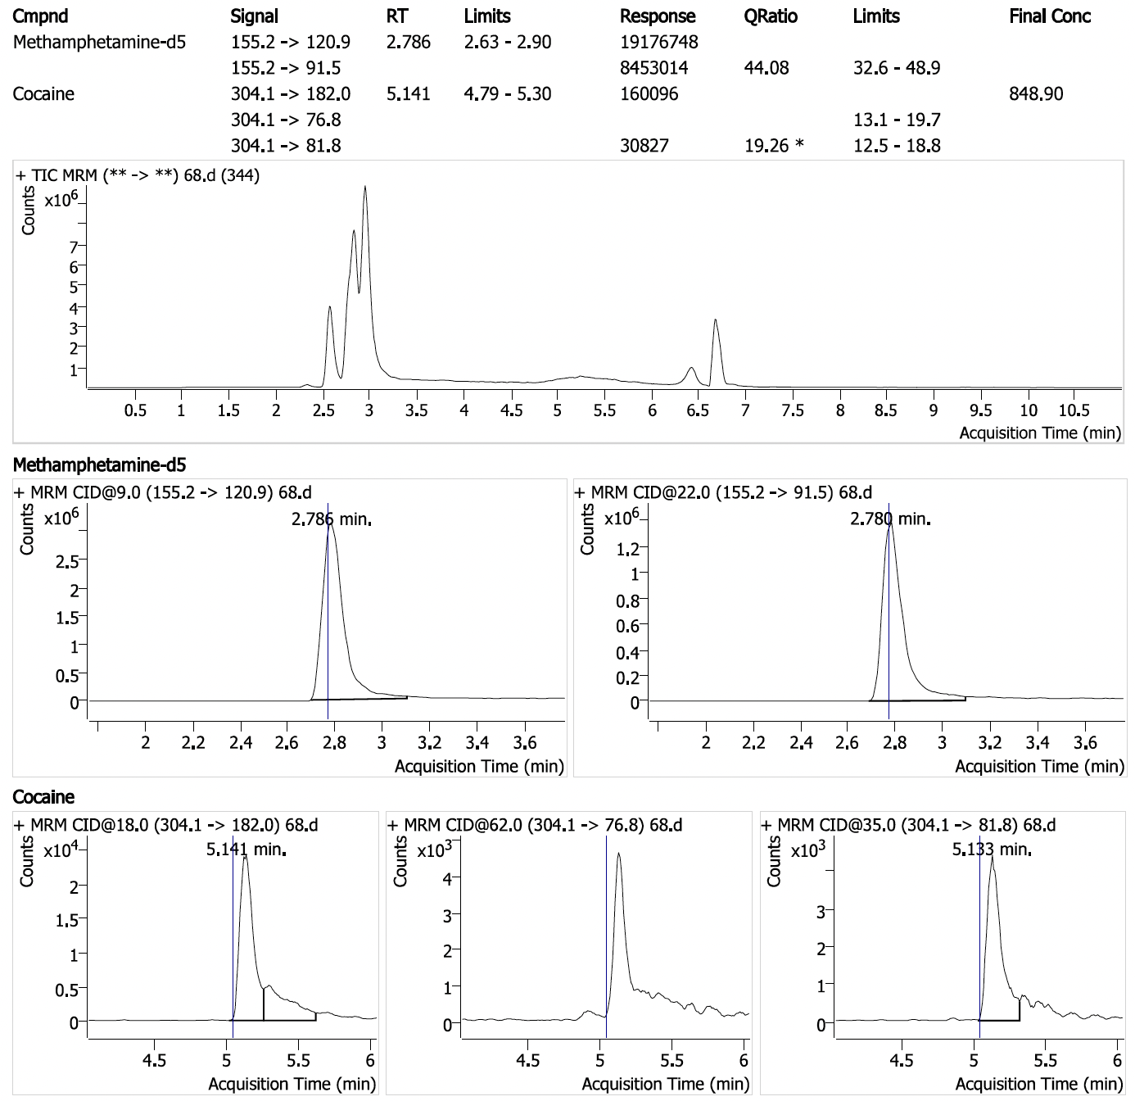
Positive sample #21: Cocaine (25.5 ppm with 2/3 ions detected) in sample seized by HIDTA.

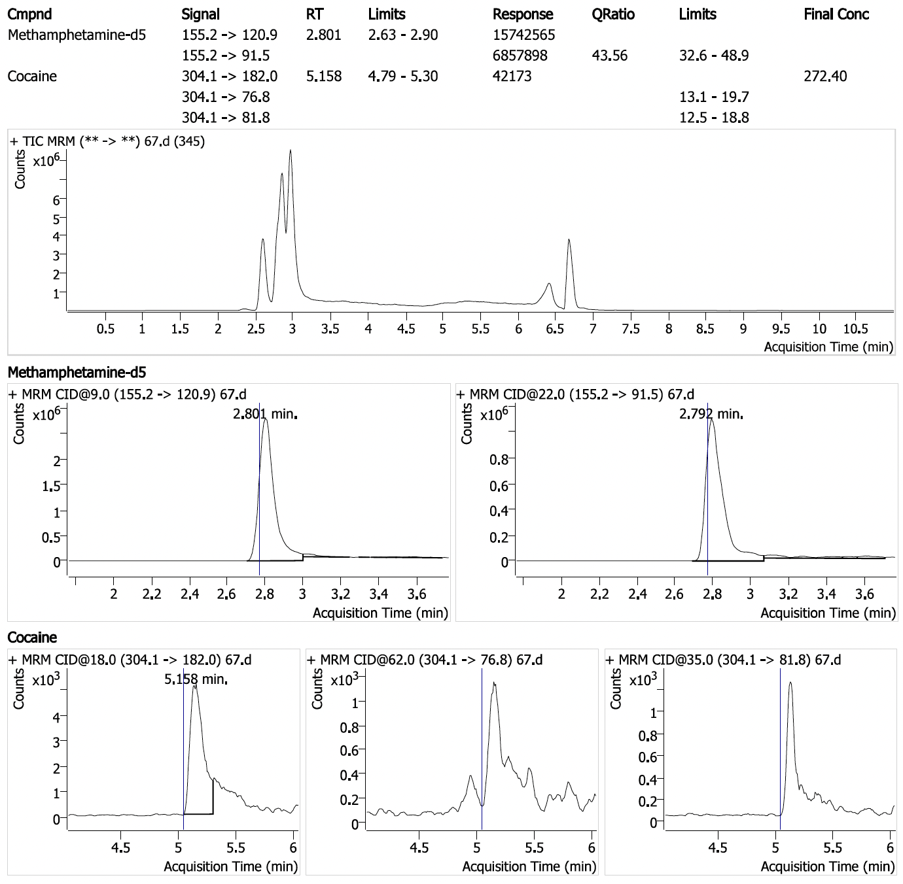
Positive sample #22: Cocaine (8.17 ppm with 1/3 ions detected) in sample seized by HIDTA.

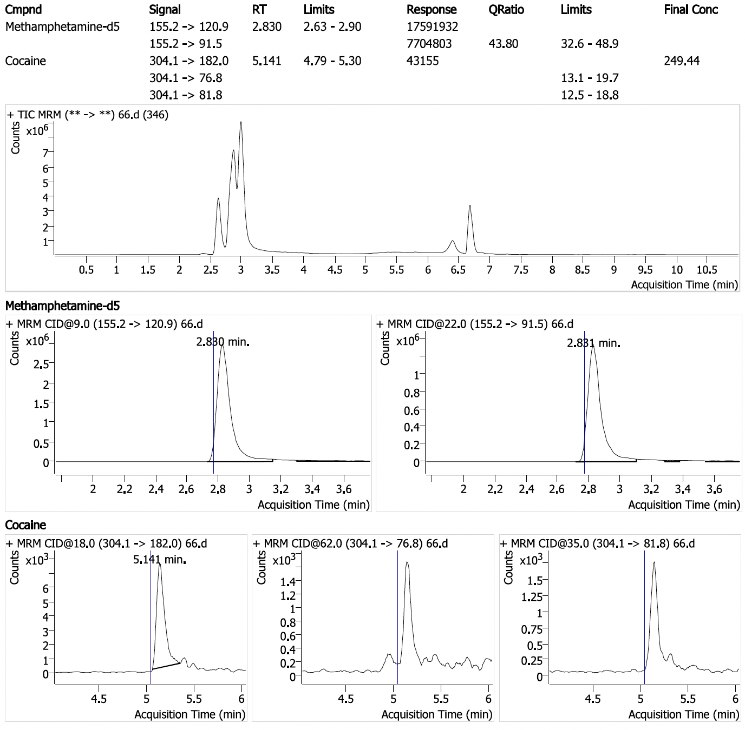
Positive sample #23: Cocaine (7.48 ppm with 1/3 ions detected) in sample seized by HIDTA.

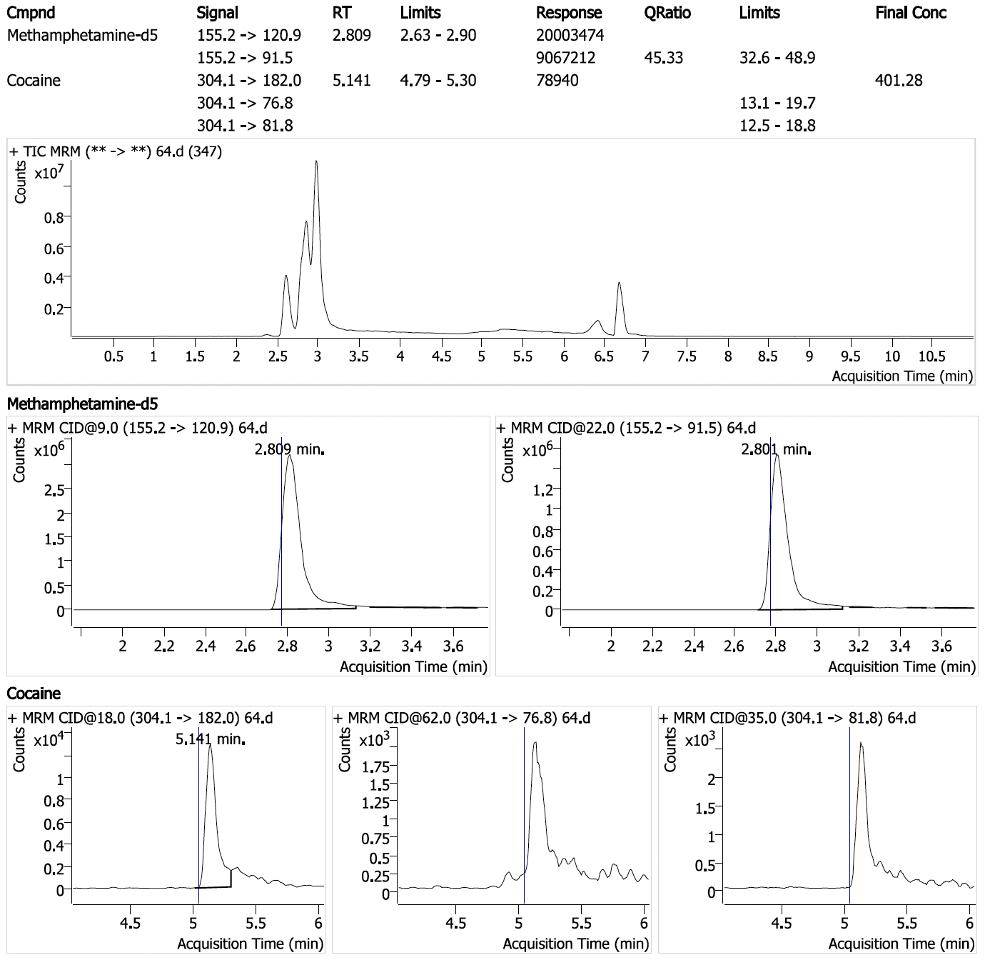
Positive sample #24: Cocaine (12.0 ppm with 1/3 ions detected) in sample seized by HIDTA.

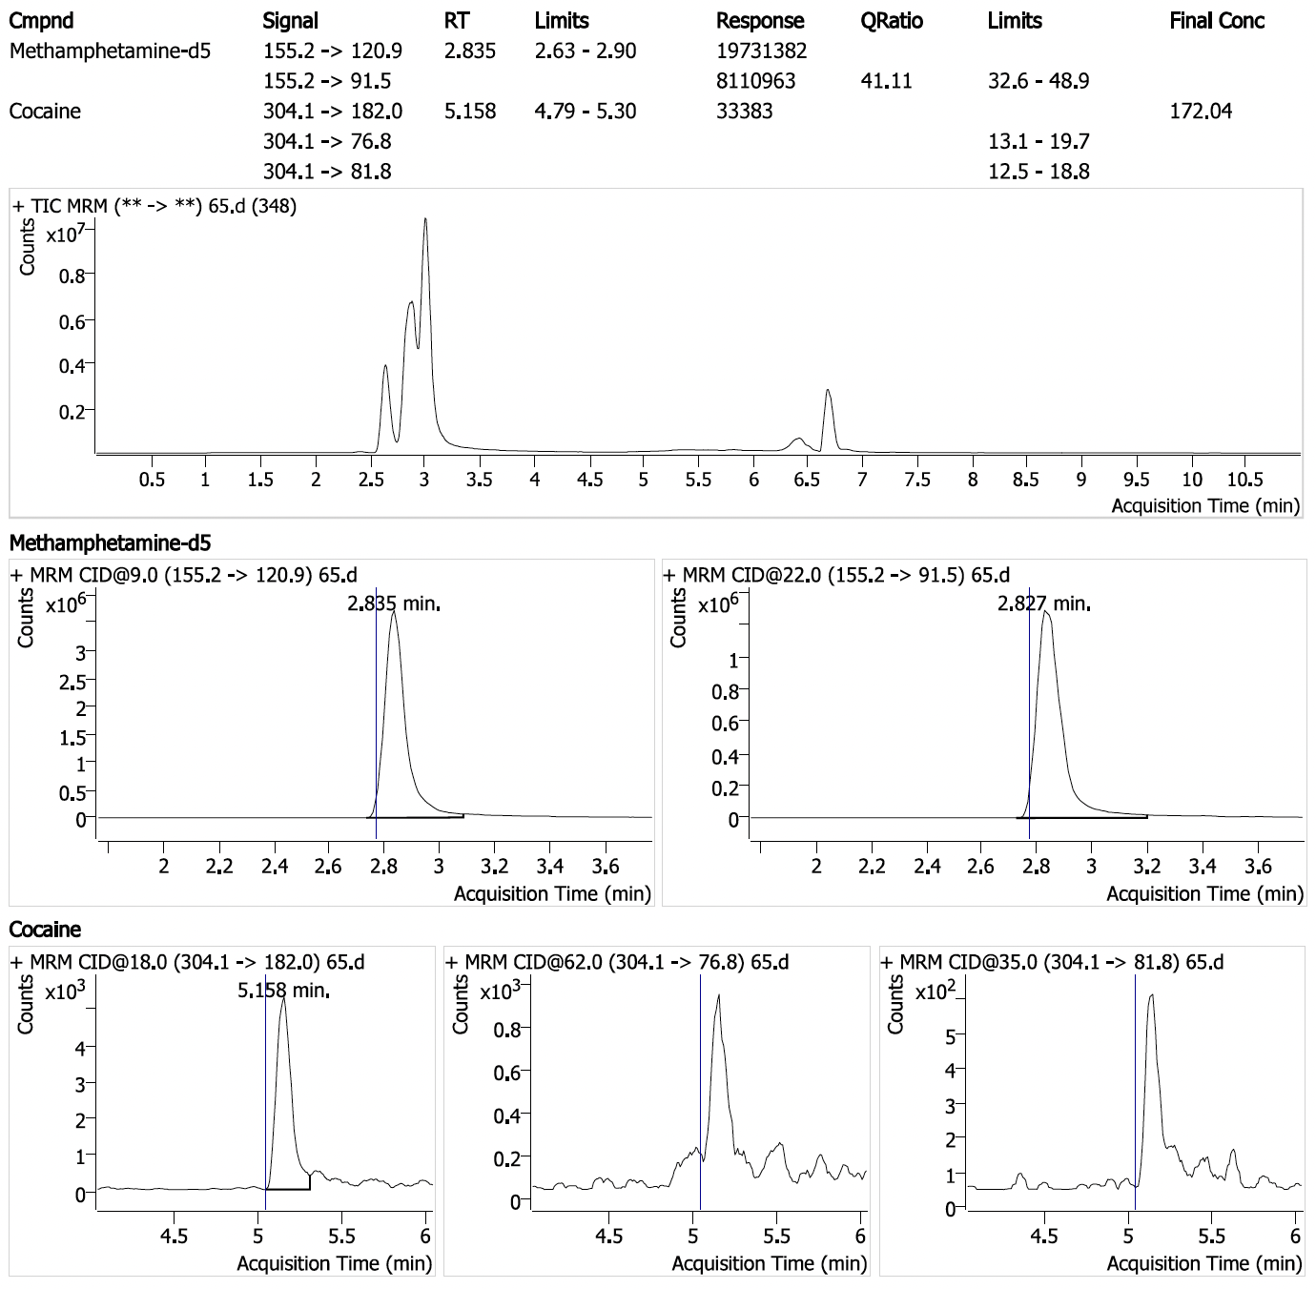
Positive sample #25: Cocaine (5.16 ppm with 1/3 ions detected) in sample seized by HIDTA.

