Supporting Information

Defining the cultured and uncultured bacterial fractions in Cannabis seeds

Carolina Lobato¹, Ahmed Abdelfattah², Gabriele Berg^{1,2,3}, and Tomislav Cernava^{1,4}

¹ Institute of Environmental Biotechnology, Graz University of Technology, Petersgasse 12, 8010 Graz, Austria.
² Leibniz Institute for Agricultural Engineering and Bioeconomy, Max-Eyth-Allee 100, 14 469 Potsdam, Germany.
³ Institute for Biochemistry and Biology, University of Potsdam, Karl-Liebknecht-Str. 24-25, 14 476 Potsdam OT Golm, Germany
⁴ School of Biological Sciences, Faculty of Environmental and Life Sciences, Highfield Campus, SO17 1BJ Southampton, UK

Corresponding author: tomislav.cernava@tugraz.at | +43 316 873 8312
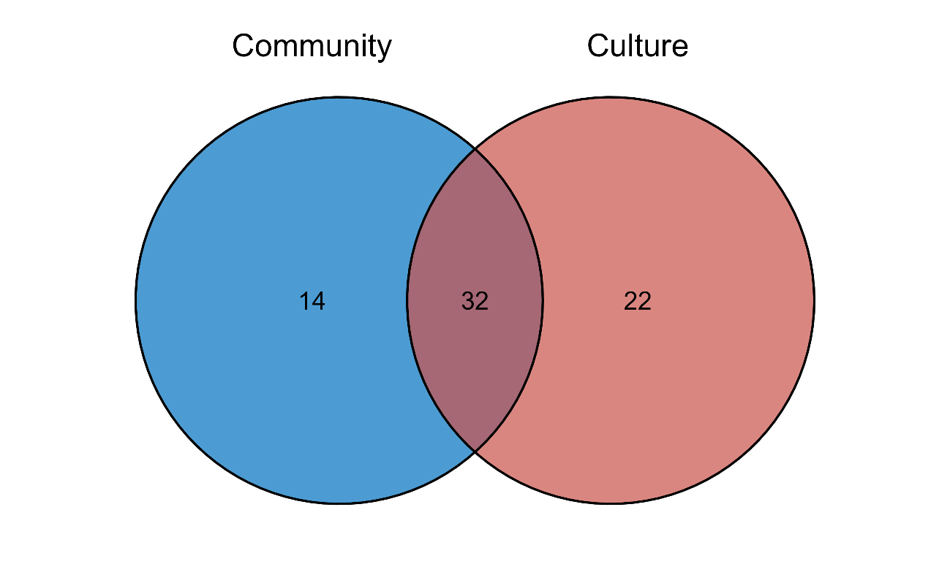
Figure S1 Unique and overlapping Cannabis seed accessions between this study and Lobato et al. 2024. Community refers to amplicon sequencing-based analyses and culture to the cultivation-based approach.

Figure S2 Mock and PCR negative control samples in the cultured dataset. Two Sphingomonas ASVs (ASV 94 and ASV 111) were detected as contaminants and removed from the dataset.
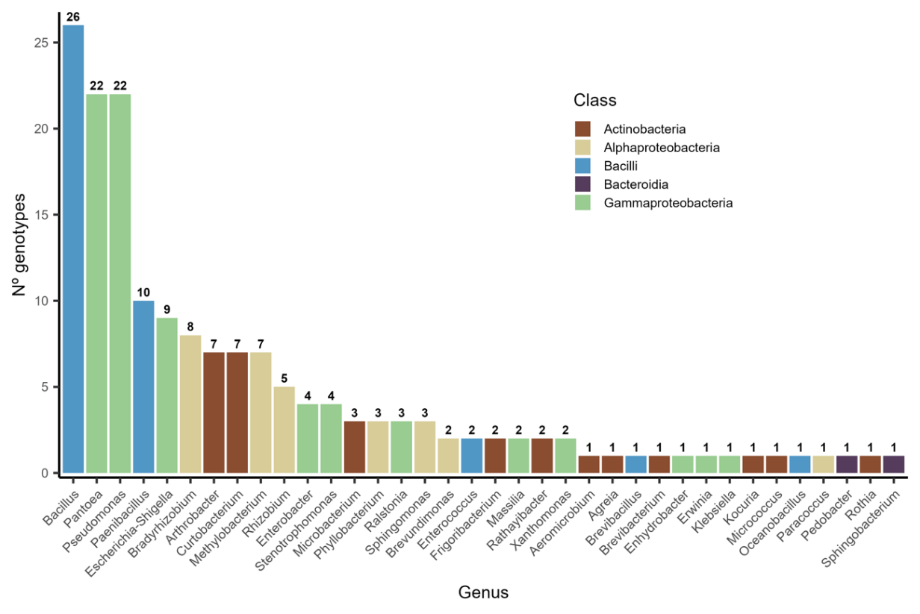Figure S3 Prevalence of isolates across genotypes at genus level. Colors indicate the taxonomical classes.

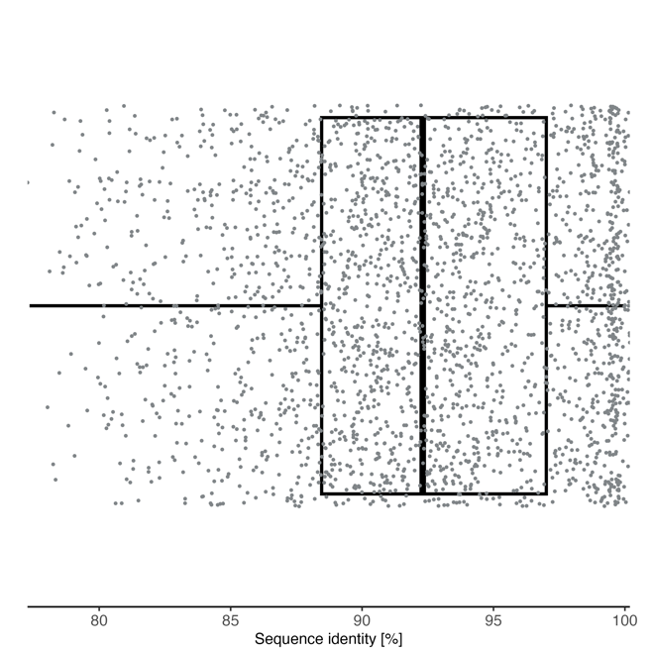
  - Figure S4 Sequence identity distribution of all assignments (n = 148 755) between the community ASVs (query) and cultured ASVs (database). Identity percentages were between 77.35% and 100% with a median of 92.31%, and Q1 and Q3 88.46% and 97%, respectively.
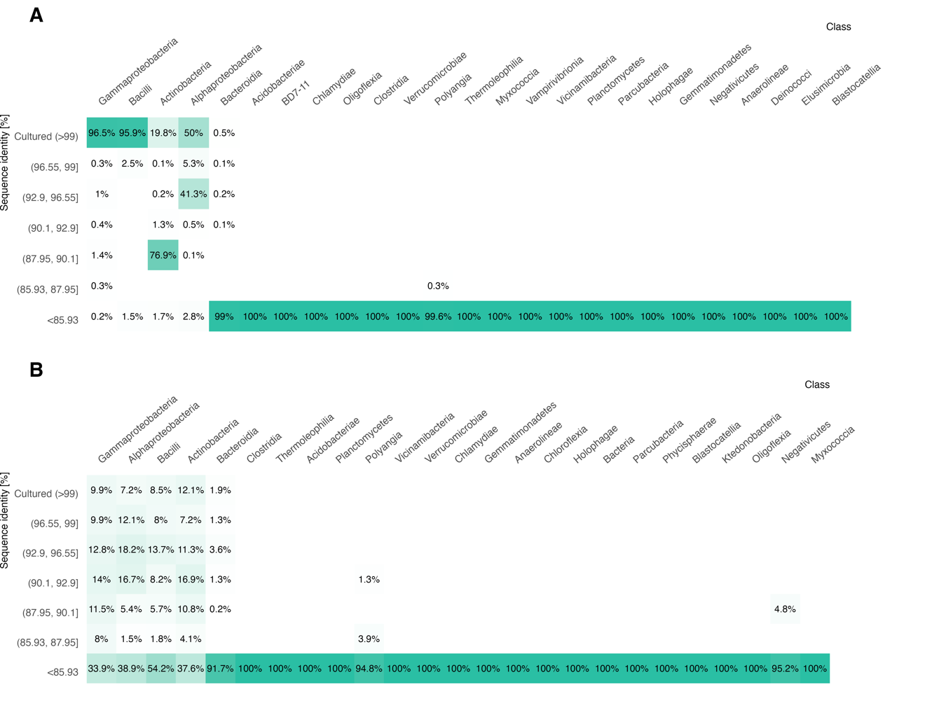Figure S5 Percentage of the mean relative abundance (A) and diversity (B) within the different bacterial classes covered by the ASVs matching the cultured taxa at different sequence identities.
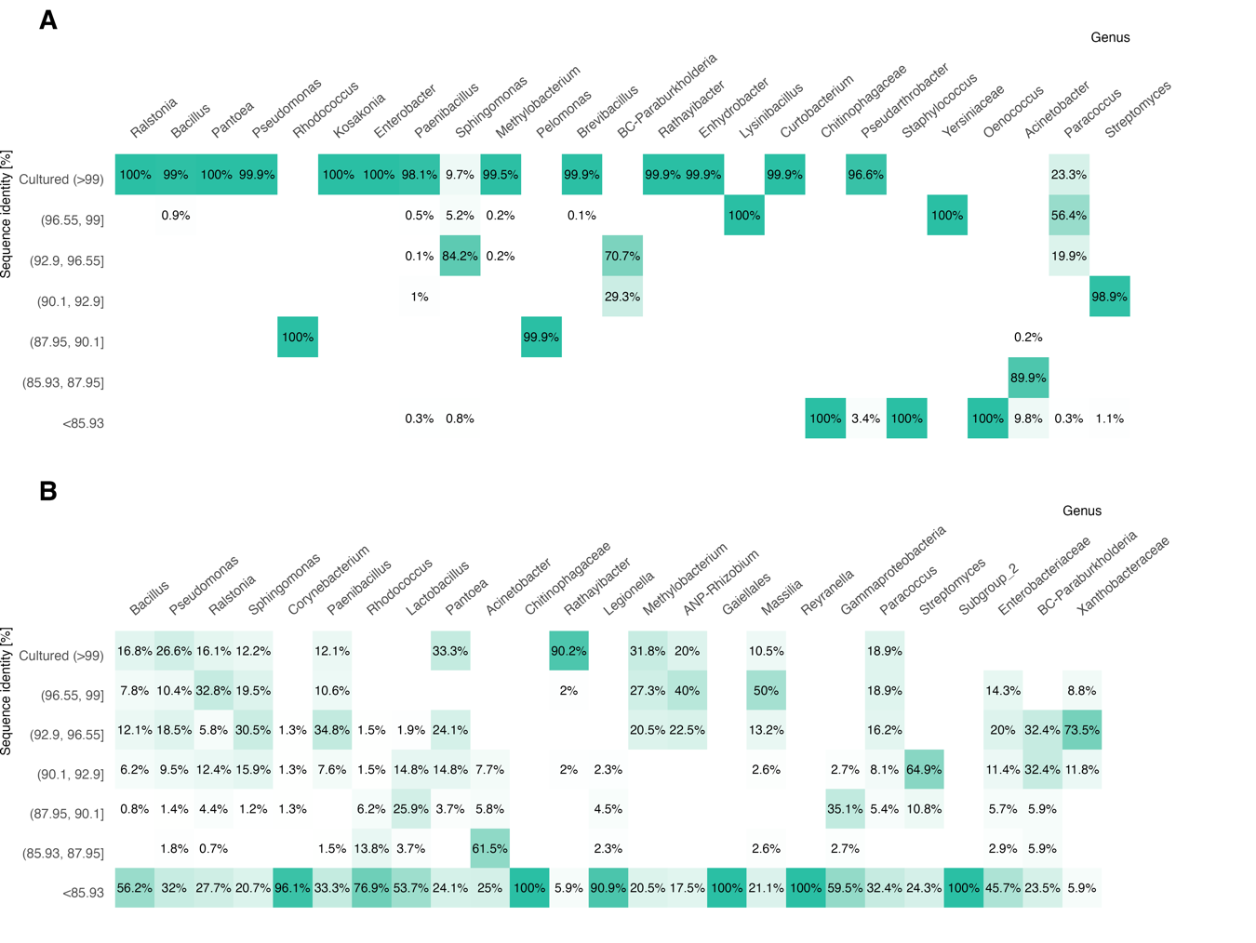Figure S6 Percentage of the mean relative abundance (A) and diversity (B) within the different bacterial genera covered by the ASVs matching the cultured taxa at different sequence identities.
  - 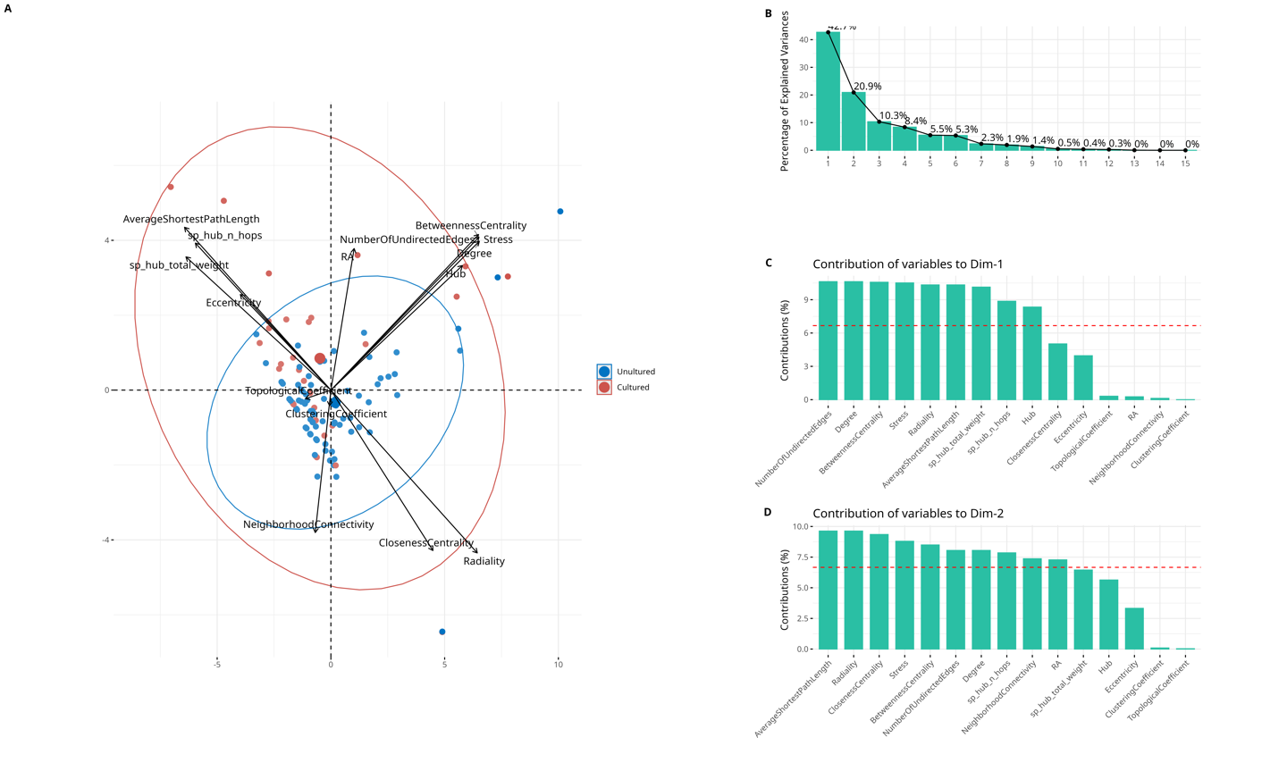Figure S7 Variance of the cultured and uncultured taxa in the co-occurrence network. (A) Principal component analysis (PCA) biplot describing the ASV distribution and the loading vectors of the different experimental variables. (B) Percentage of explained variances in the different dimensions. (C) Contribution of the experimental variables to the first dimension. (D) Contribution of the experimental variables to the second dimension.
Dim-2
Dim-1
42.7%

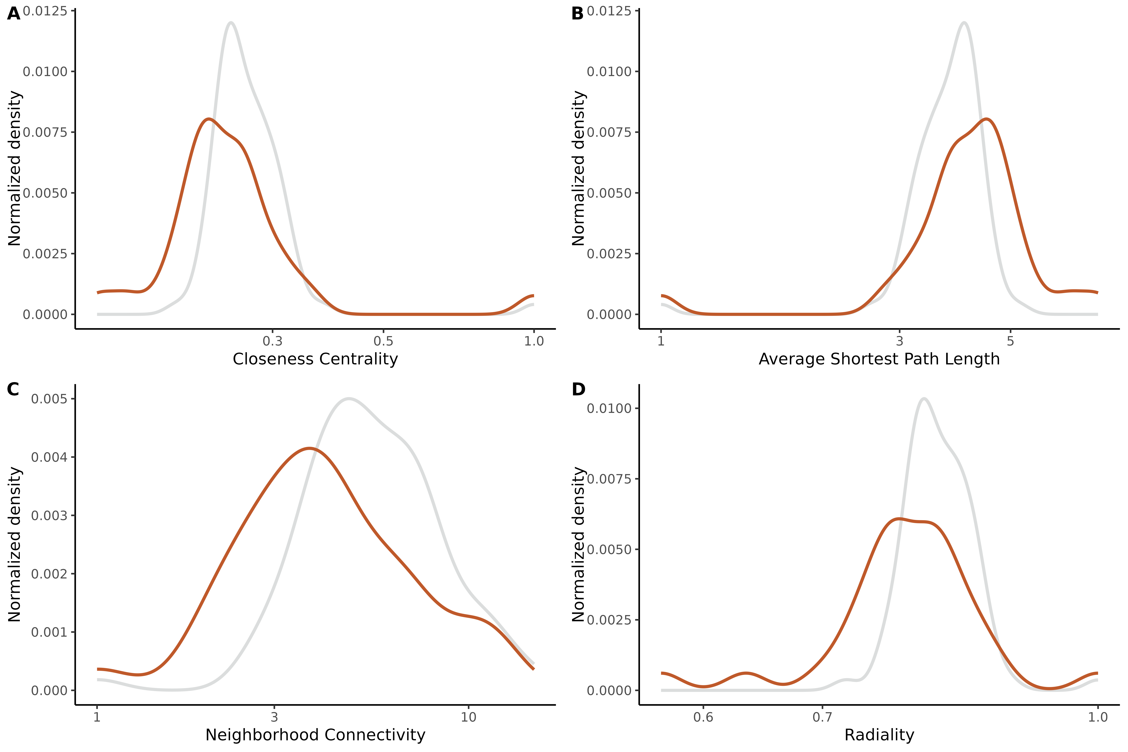
  - Figure S8 ASVs distribution according to different centrality measures in the cultured and uncultured fractions of the network. Closeness centrality (A), Average shortest path length (B), Neighborhood connectivity (C), and Radiality (D).

  - Table S1 Detailed information on the Cannabis genotypes used in this study and in Lobato et al., (2024). The color code refers to genotypes only investigated in this study (red), only in Lobato et al., 2024 (blue) or in both studies (purple).
Provider | Study / Code | Genotype | Origin | Accession | Species | Nº Isolations | Total Pure Cultures
CRI | C65 | Beniko | Poland | 1500003 | C. sativa ssp. sativa var. sativa | 1 | 20
CRI | C64 | Bialobrzeskie | Poland | 1500002 | C. sativa ssp. sativa var. sativa | 1 | 27
CRI | C66 | Fedora | France | 1500011 | C. sativa ssp. sativa var. sativa | 1 | 24
CRI | C67 | Finola | Finland | 1500019 | C. sativa ssp. sativa var. sativa | 2 | 50
Green House Seeds Co. | C77 | Arjan's Haze #3 | NA | GHSC052 | C. sativa ssp. indica var. indica | - | -
Green House Seeds Co. | C76 | The Church CBD | NA | GHSC005 | C. sativa ssp. indica var. indica | - | -
IPK | C54 | Bredemann P | Germany | CAN 62 | C. sativa ssp. sativa | - | -
IPK | C28 | RV Romania 94: 265 | Bulzestii de Sus, Romania | CAN 35 | C. sativa ssp. sativa | 1 | 21
IPK | C26 | RV Romania 94: 226 | Muntele Baisorii, Romania | CAN 33 | C. sativa ssp. sativa | 1 | 6
IPK | C27 | RV Romania 94: 239 | Baia de Aries, Romania | CAN 34 | C. sativa ssp. sativa | 1 | 29
IPK | C31 | RV Romania 94: 115 | Birsana, Romania | CAN 38 | C. sativa ssp. sativa | 2 | 25
IPK | C24 | RV Romania 94: 120 | Strimtura, Romania | CAN 31 | C. sativa ssp. sativa var. sativa | 1 | 4
IPK | C41 | Eletta Campana | Italy | CAN 48 | C. sativa ssp. sativa var. sativa | - | -
IPK | C59 | Fasamo | Germany | CAN 67 | C. sativa ssp. sativa var. sativa | 1 | 3
IPK | C44 | Fibridia | Germany | CAN 52 | C. sativa ssp. sativa var. sativa | 2 | 26
IPK | C37 | Fibrimon | Germany | CAN 44 | C. sativa ssp. sativa var. sativa | 2 | 36
IPK | C46 | Fibrimon 21 | Germany | CAN 54 | C. sativa ssp. sativa var. sativa | 1 | 28
IPK | C21 | Forose | NA | CAN 28 | C. sativa ssp. sativa | 1 | 21
IPK | C63 | Gelb | NA | CAN 100 | C. sativa ssp. sativa var. sativa | 1 | 7
IPK | C47 | Havelländer | Germany | CAN 55 | C. sativa ssp. sativa var. sativa | - | -
IPK | C36 | Hohenthürmer Gleichzeitig Reifender | Germany | CAN 43 | C. sativa ssp. sativa var. sativa | - | -
IPK | C62 | Kompolti | Hungary | CAN 70 | C. sativa ssp. sativa var. sativa | 1 | 26
IPK | C60 | Kompolti PZO | Hungary | CAN 68 | C. sativa ssp. sativa var. sativa | 1 | 4
IPK | C50 | Kongo Hemp | Spain | CAN 58 | C. sativa ssp. sativa var. sativa | 1 | 8
IPK | C38 | Krasnoyarskaya | Russia | CAN 45 | C. sativa ssp. sativa var. sativa | 2 | 28
IPK | C58 | Lovrin 110 | Romania | CAN 66 | C. sativa ssp. sativa var. sativa | - | -
IPK | C43 | NA Argentina | Argentina | CAN 51 | C. sativa ssp. sativa | - | -
IPK | C34 | NA BG Belgium | NA | CAN 41 | C. sativa ssp. | - | -
IPK | C32 | NA BG China | China | CAN 39 | C. sativa ssp. sativa | 1 | 16
IPK | C11 | NA BG Hungary | Hungary | CAN 17 | C. sativa ssp. sativa | 1 | 7
IPK | C33 | NA BG Italy | Carmagnola, Italy | CAN 40 | C. sativa ssp. | 1 | 7
IPK | C15 | NA BG Romania | Laşi, Romania | CAN 21 | C. sativa ssp. sativa | - | -
IPK | C30 | NA France | France | CAN 37 | C. sativa ssp. sativa | 1 | 29
IPK | C29 | NA Germany | NA | CAN 36 | C. sativa ssp.sativa | 1 | 7
IPK | C20 | NA Vacratot | NA | CAN 27 | C. sativa ssp. | 3 | 53
IPK | C49 | NA Syria | Syria | CAN 57 | C. sativa ssp. | 1 | 16
IPK | C56 | NA Turkey | Burdur, Turkey | CAN 64 | C. sativa ssp. sativa var. sativa | 1 | 9
IPK | C19 | Turkey NS | Turkey | CAN 26 | C. sativa ssp. | 1 | 24
IPK | C55 | Ramo | Germany | CAN 63 | C. sativa ssp. sativa var. sativa | 2 | 10
IPK | C16 | RV Georgia 86 | Shatili, Georgia | CAN 22 | C. sativa ssp. sativa var. spontanea | 1 | 9
IPK | C18 | RV Italy 84 | Apúlia, Italy | CAN 24 | C. sativa ssp. sativa | 2 | 11
IPK | C13 | RV Italy 88 | Cosenza, Italy | CAN 19 | C. sativa ssp. sativa | 1 | 13
IPK | C17 | RV Korea 87 | North Hwanghae, North Korea | CAN 23 | C. sativa ssp. sativa var. sativa | 3 | 25
IPK | C14 | RV Korea 85 | Kosong, North Korea | CAN 20 | C. sativa ssp. sativa | 1 | 16
IPK | C10 | RV Slovakia 77 | Uličské Krivé, Slovakia | CAN 16 | C. sativa ssp. sativa | 1 | 36
IPK | C52 | Schurig | Germany | CAN 60 | C. sativa ssp. sativa | 2 | 19
IPK | C71 | Superfibra | NA | CAN 49 | C. sativa ssp. | 1 | 1
Hanfama GmbH | C08 | Carmagnola | Italy | NA | C. sativa ssp. sativa var. sativa | 2 | 62
Hanfama GmbH | C73 | Félina 32 | France | NA | C. sativa ssp. sativa var. sativa | 1 | 20
Hanfama GmbH | C72 | Férimon | France | NA | C. sativa ssp. sativa var. sativa | 1 | 41
Hanfama GmbH | C74 | Futura 75 | France | NA | C. sativa ssp. sativa var. sativa | 1 | 10
Hanfama GmbH | C75 | Orion 33 | France | NA | C. sativa ssp. sativa var. sativa | 1 | 23
Hanfama GmbH | C09 | Santhica 27 | France | NA | C. sativa ssp. sativa var. sativa | 3 | 123
Hanfland GmbH | C01 | Fedora 17 | France | NA | C. sativa ssp. sativa var. sativa | 2 | 31
KFU Botanical Garden | C02 | Silvana x Manitoba Poison | Romania/South Africa | NA | C. sativa ssp. sativa var. sativa x ssp. indica var. indica | 1 | 12
LVMI Silava | C70 | Purini | Latvia | LVA02775 | C. sativa ssp. sativa | - | -
LVMI Silava | C69 | Vietejas | Latvia | LVA02701 | C. sativa ssp. sativa | 1 | 29
Plant Breeding and Acclimatization Institute | C83 | Bernburskie | Poland | 501000 | C. sativa ssp. sativa | 1 | 15
Plant Breeding and Acclimatization Institute | C04 | Dolnoslaskie | Poland | 166502 | C. sativa ssp. sativa | 1 | 12
Plant Breeding and Acclimatization Institute | C84 | Futura 77 | France | 501002 | C. sativa ssp. sativa | 1 | 11
Plant Breeding and Acclimatization Institute | C07 | Lizap 12 119 | Poland | 503007 | C. sativa ssp. sativa | 3 | 25
Plant Breeding and Acclimatization Institute | C06 | NA Poland | Poland | 166504 | C. sativa ssp. sativa | 1 | 17
Sensi Seeds | C87 | Afghani #1 | Afghanistan | 1500010 | C. sativa ssp. indica | 1 | 7
Sensi Seeds | C86 | Hindu Kush | Afghanistan | 1500001 | C. sativa ssp. indica
Sensi Seeds | C91 | Master Kush | Afghanistan | 1510002 | C. sativa ssp. indica var. indica | - | -
Sensi Seeds | C90 | Mexican Sativa | NA | 1500038 | C. sativa ssp. indica var. indica | 1 | 18
Sensi Seeds | C89 | Ruderalis Indica | NA | 1500034 | C. sativa ssp. indica var. indica x ssp. sativa var. spontanea | 1 | 13
Sensi Seeds | C88 | Skunk #1 | NA | 1500024 | C. sativa ssp. indica var. indica | - | -

  - Table S2 Detailed information on the media used for bacterial isolation.
Media | Composition | Amount / 1L dH₂O
NA | Nutrient Broth II (Sifin) | 15 g
NA | Agar (Roth) | 18 g
NA | Nystatin (Roth) — 25 mg/mL pure Ethyl alcohol | 1 mL
LB | Luria/Miller Broth (Roth) | 20 g
LB | Agar (Roth) | 18 g
LB | Nystatin (Roth) — 25 mg/mL pure Ethyl alcohol | 1 mL
TSA | Tryptic Soy Broth (Roth) | 30 g
TSA | Agar (Roth) | 18 g
TSA | Nystatin (Roth) — 25 mg/mL pure Ethyl alcohol | 1 mL
R2A | Reasoner's 2A agar (Roth) | 18 g
R2A | Nystatin (Roth) — 25 mg/mL pure Ethyl alcohol | 1 mL
Kings’s B | Proteose peptone (Roth) | 2 g
Kings’s B | K₂HPO_{4,} (Roth) | 0.15 g
Kings’s B | MgSO₄.xH₂O (Roth) | 0.15 g
Kings’s B | Glycerol >99.5 % (Roth) | 1 g
Kings’s B | Agar (Roth) | 15 g
Kings’s B | Nystatin (Roth) — 25 mg/mL pure Ethyl alcohol | 1 mL
PDA | Potato Dextrose Agar (Roth) | 26.5 g
PDA | Nystatin (Roth) — 25 mg/mL pure Ethyl alcohol | 1 mL
869 (1/10) | Tryptone/peptone (Roth) | 1 g
869 (1/10) | Yeast extract (Roth) | 0.5 g
869 (1/10) | NaCl (Roth) | 0.5 g
869 (1/10) | D-Glucose (Roth) | 0.1 g
869 (1/10) | CaCl₂.2H₂O (Roth) | 0.04 g
869 (1/10) | Cannabis extracts — Fedora 17 | 10 mL
869 (1/10) | Agar (Roth) | 18 g
869 (1/10) | Nystatin (Roth) — 25 mg/mL pure Ethyl alcohol | 1 mL
M9 | M9 minimal medium (Sigma-Aldrich) | 11.28 g
M9 | Cannabis extracts — Fedora 17 | 10 mL
M9 | Agar (Roth) | 18 g
M9 | Nystatin (Roth) — 25 mg/mL pure Ethyl alcohol | 1 mL

  - Table S3 Megablast alignment output from Galaxy between the community ASVs (query) and cultured ASVs (database) resulted in 148.755 assignments. The table describes the coverage length, number of mismatches, e-val and bitscore values for each assignment.
- See separate file Table S3.csv

  - Table S4 Differences in the mean relative abundance distribution assessed through Mann-Whitney-U-Test between A uncultured ASVs with different sequence identities to the cultured isolates and phylogenetically distant ASVs (< 85.93% sequence similarity to the isolates), and B uncultured ASVs and cultured ASVs. Significant differences (α = 0.05) are marked (*).
A |  | W | p-value
Uncultured (96.55, 99) | Uncultured (< 85.93) | 665021 | < 2.2e-16*
Uncultured (92.9, 96.55) | Uncultured (< 85.93) | 766269 | 0.00019*
Uncultured (90.1, 92.9) | Uncultured (< 85.93) | 722696 | 0.05558
Uncultured (87.95, 90.1) | Uncultured (< 85.93) | 448283 | 0.1724
Uncultured (85.93, 87.95) | Uncultured (< 85.93) | 258748 | 0.001163*
B |  | W | p-value
Uncultured (96.55, 99) | Cultured (>99) | 45997 | 3.279e-05*
Uncultured (92.9, 96.55) | Cultured (>99) | 46674 | < 2.2e-16*
Uncultured (90.1, 92.9) | Cultured (>99) | 43744 | < 2.2e-16*
Uncultured (87.95, 90.1) | Cultured (>99) | 26983 | < 2.2e-16*
Uncultured (85.93, 87.95) | Cultured (>99) | 16891 | 8.752e-12*
Uncultured (< 85.93) | Cultured (>99) | 705211 | < 2.2e-16*

