Region
Case fatality rate (%)
Event rate (%)

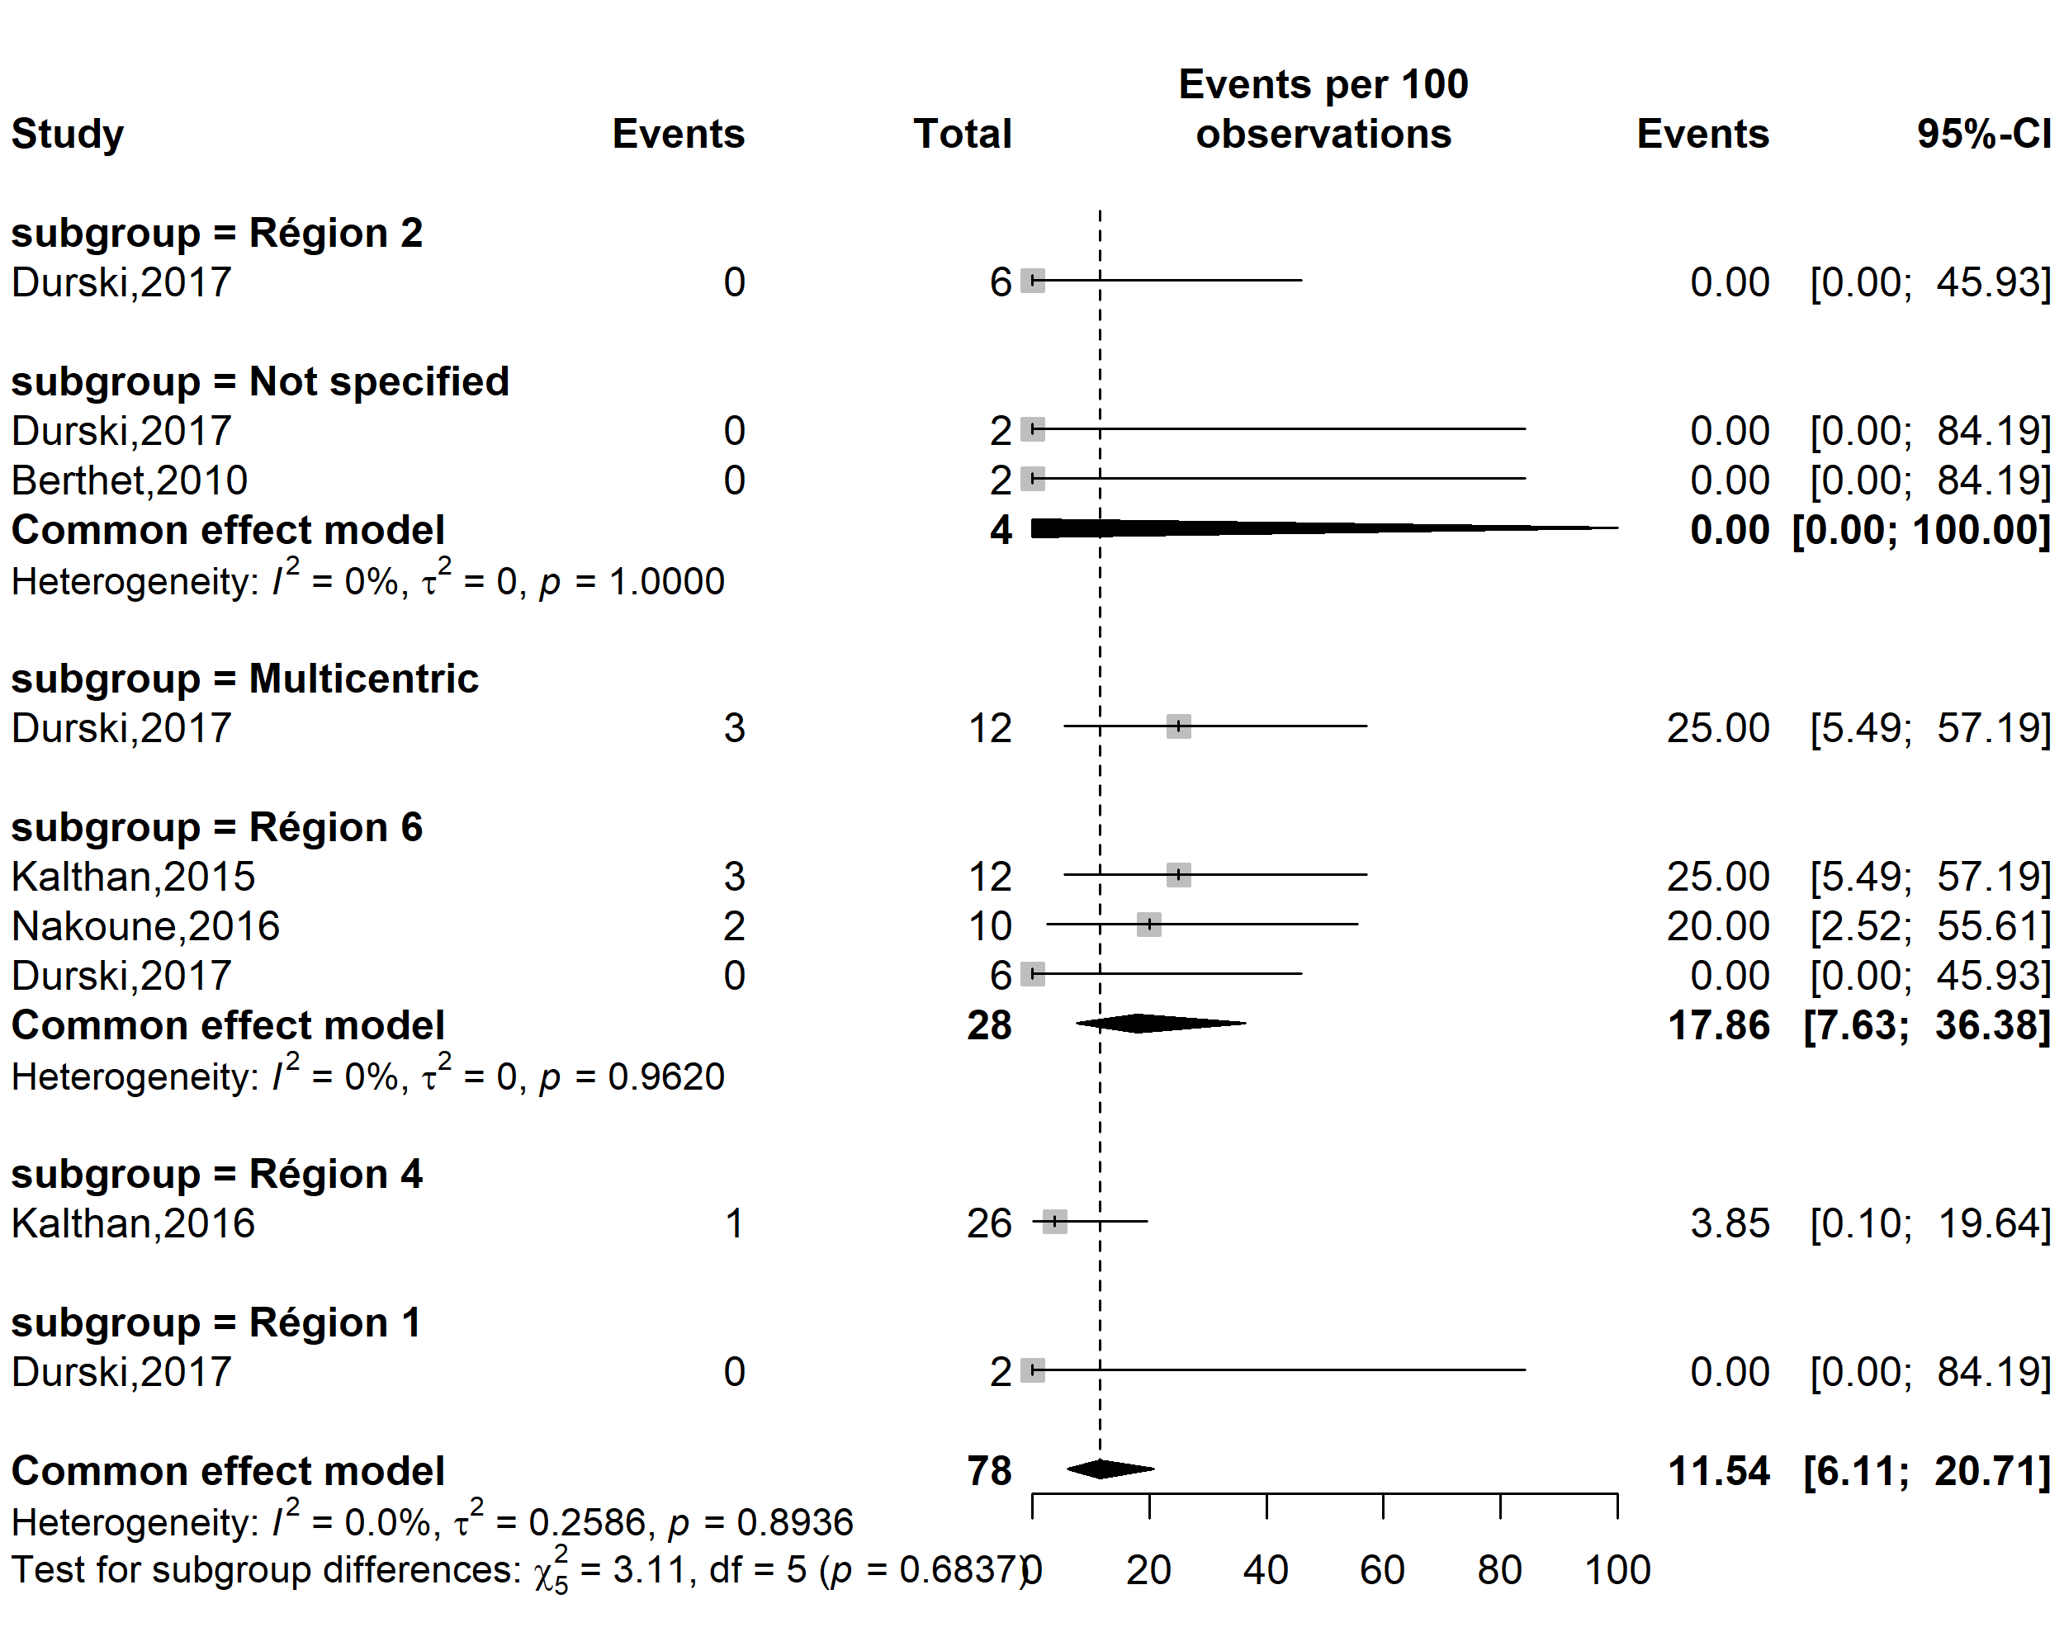
Supplementary Fig. 1 Pooled case fatality rate among confirmed Mpox cases by CAR’s regions

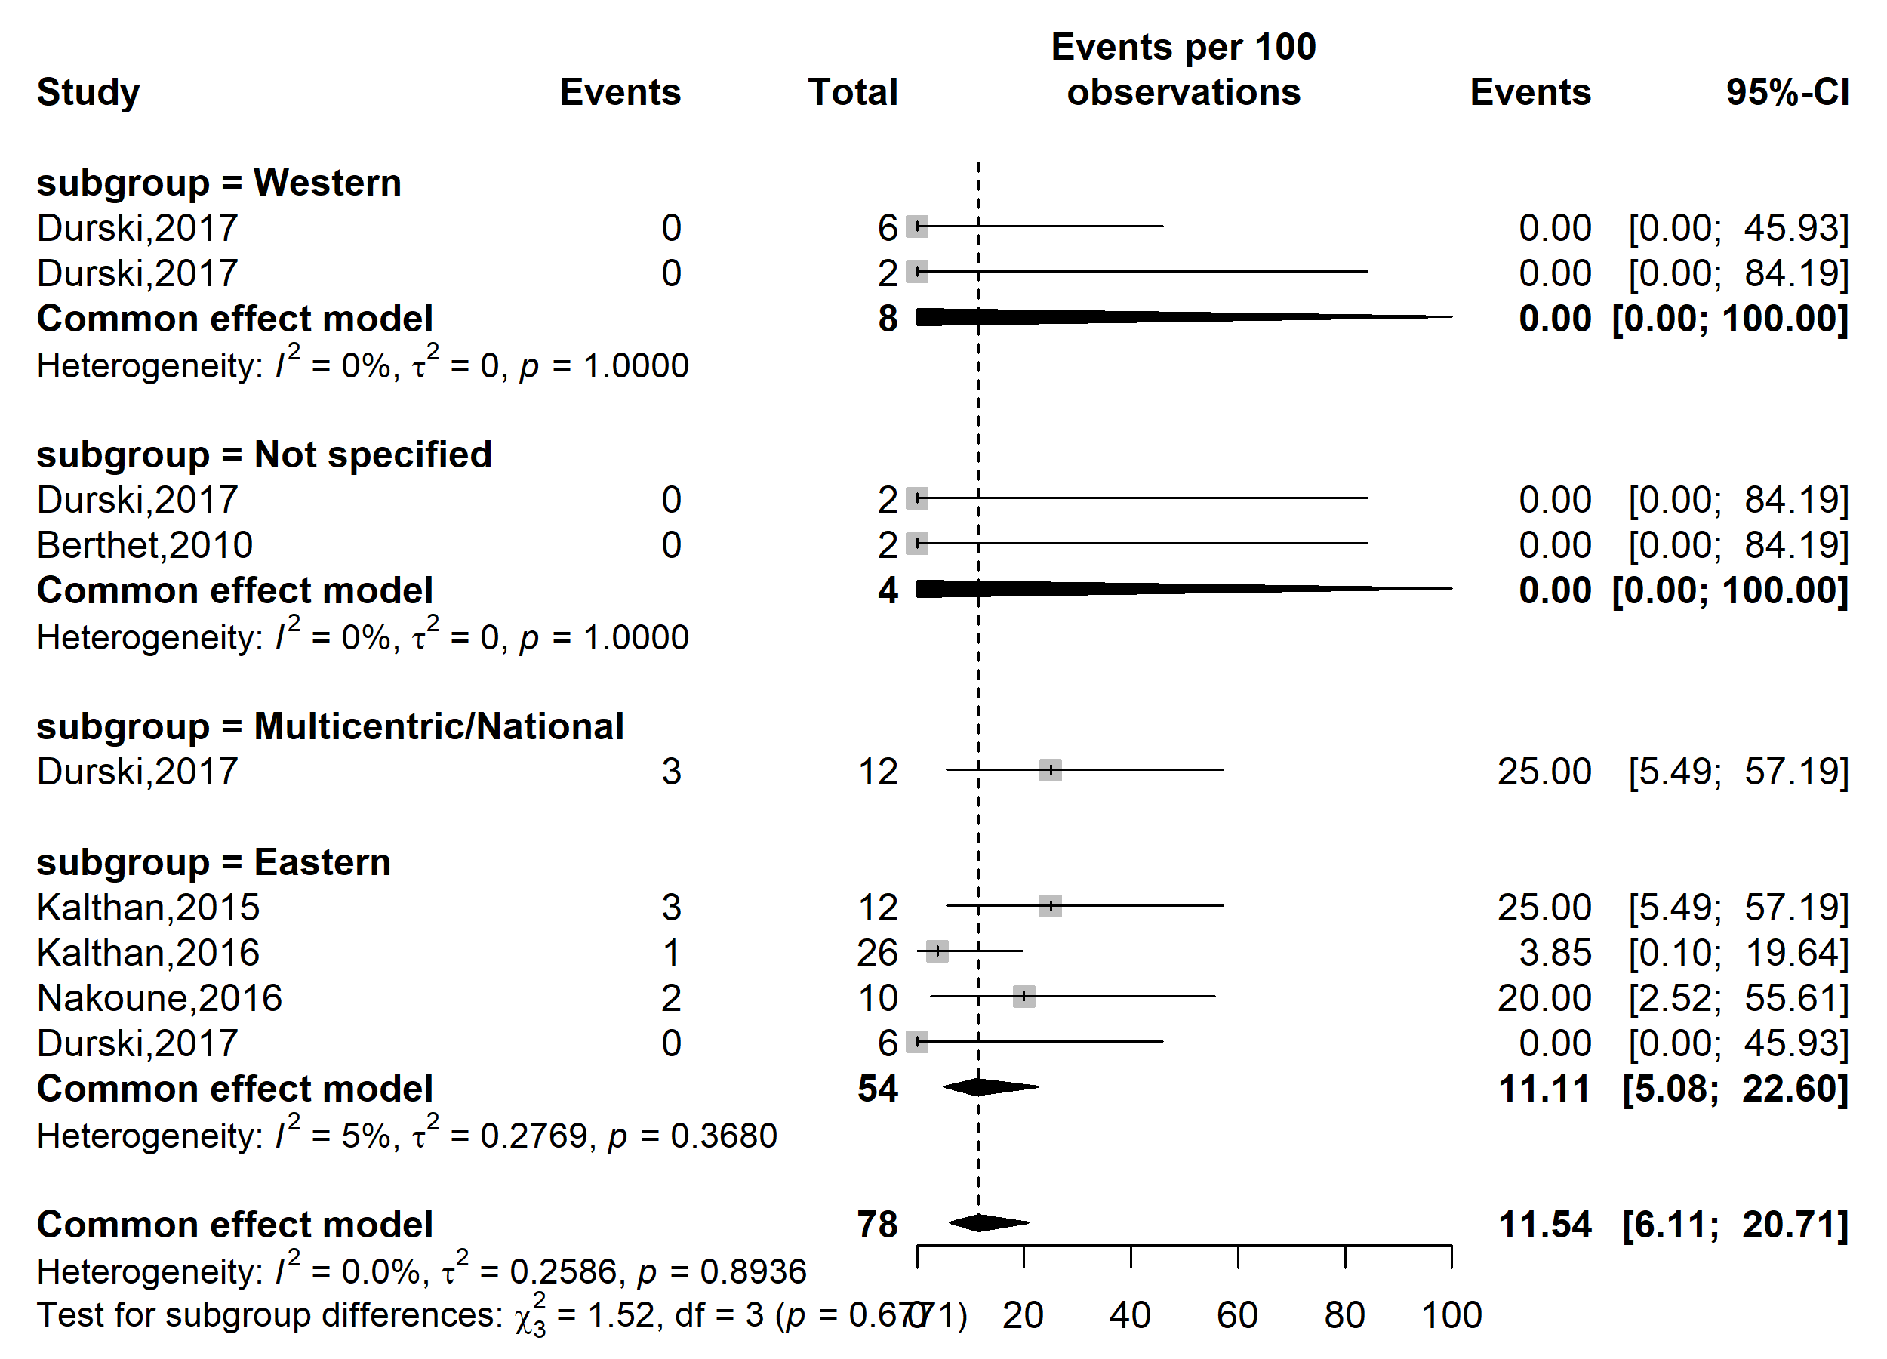
Case fatality rate (%)
Event rate (%)

Supplementary Fig. 2 Pooled case fatality rate by region location among confirmed Mpox cases in CAR (HCW: Healthcare worker)

Participant
Case fatality rate (%)
Event rate (%)

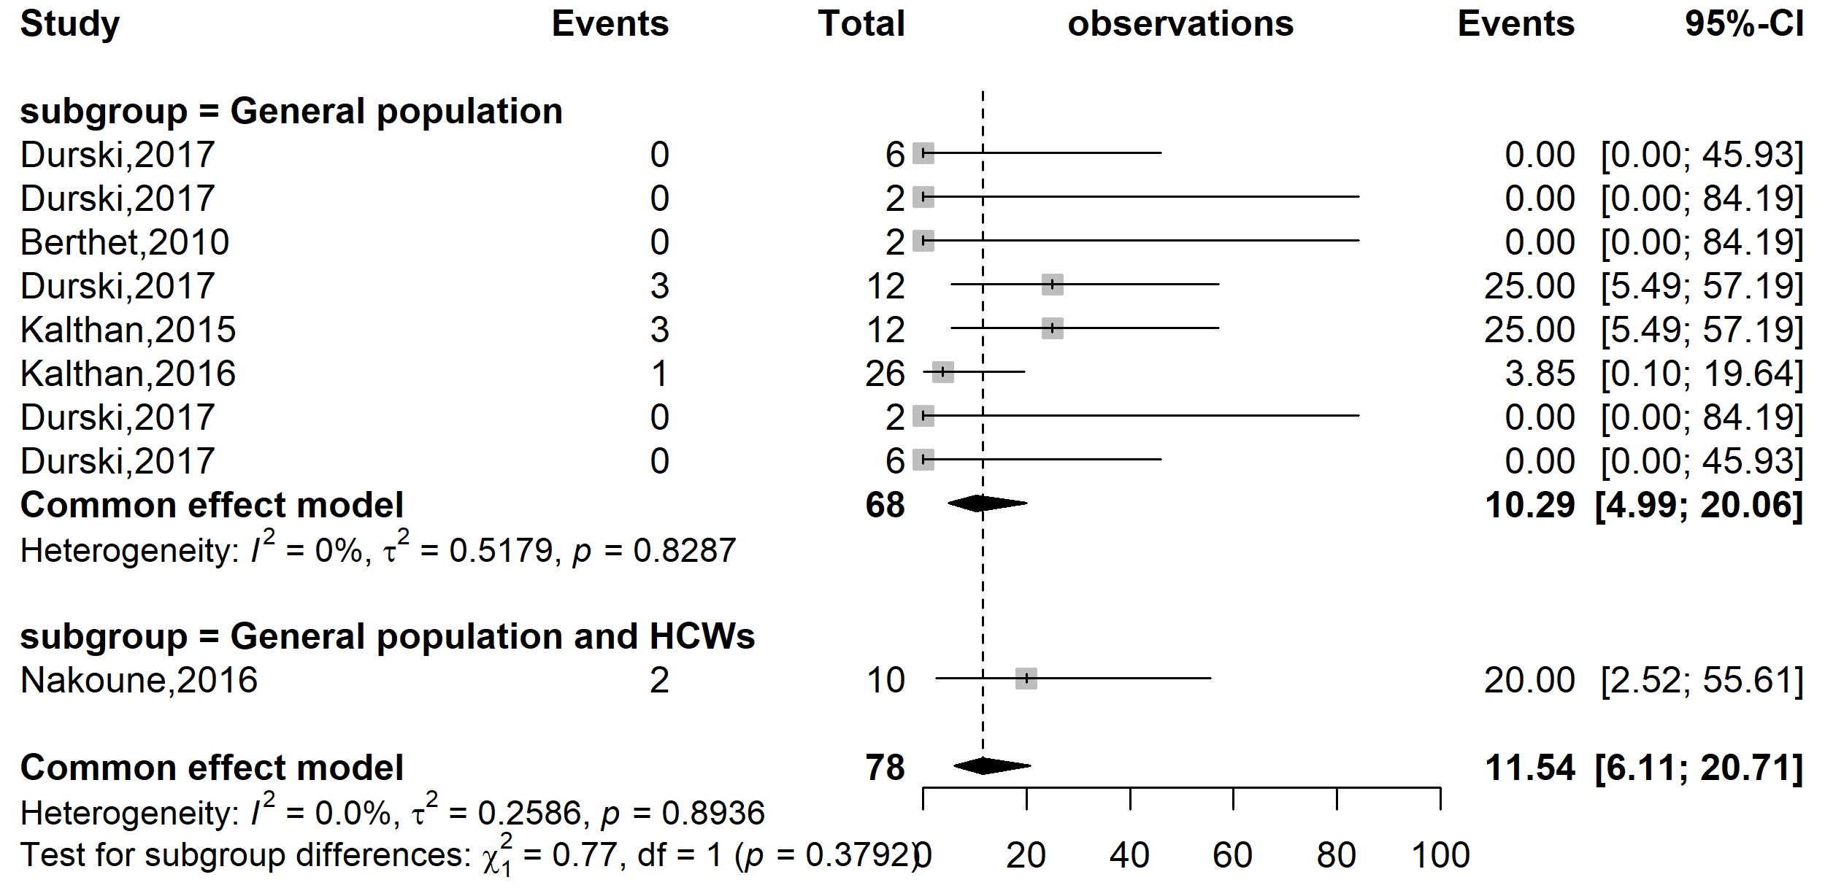
Supplementary Fig. 3 Pooled case fatality rate by type of participants involved among confirmed Mpox cases in CAR (HCWs: Healthcare workers)

Publication bias
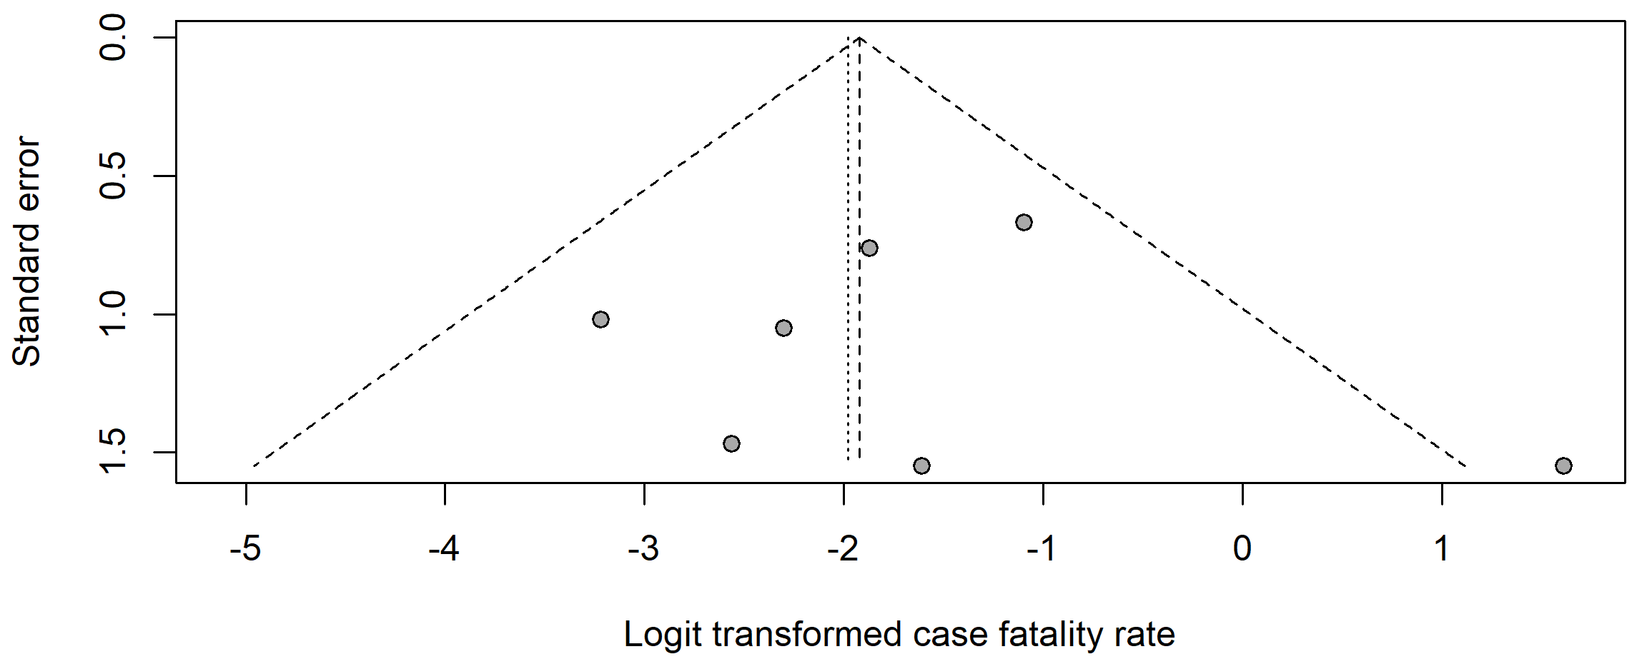
Supplementary Fig. 4 Funnel plot with pseudo 95% confidence limits and tests assessing the publication bias of studies included

Sensitivity analysis
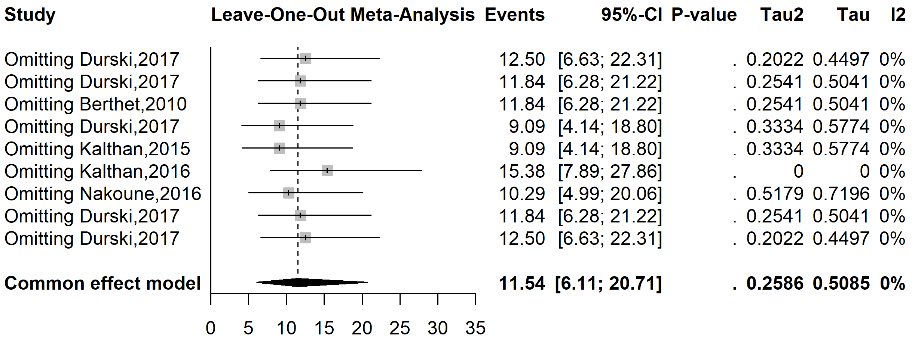
Supplementary Fig. 5 Sensitivity analysis of the confirmed Mpox case fatality rate pooled estimate in CAR

