Supplemental Table 1. Search Strategy
Pub Med | Search Terms
1 | ("Suicide"[MESH] OR suicid*[tw])
2 | ("Substance-Related Disorders"[MESH] OR "Alcoholism"[MESH] OR "Alcohol-Related Disorders"[MESH] OR "Alcohol Drinking"[MESH] OR substance*[tw] OR drug*[tw] OR opioid*[tw] OR opiate* [tw] OR alcohol*[tw] OR cocaine*[tw] OR marijuana*[tw] OR inhalant*[tw] OR phencyclidine*[tw] OR amphetamine*[tw] benzodiazepine* [tw] OR morphine*[tw] OR heroin*[tw] OR fentanyl*[tw] OR oxycodone*[tw] OR codeine*[tw] OR hydrocodone*[tw] OR methadone*[tw] OR MDMA[tw] OR methamphetamine*[tw])
3 | ("Mortality"[MESH] OR "Death"[MESH] OR "Fatal Outcome"[MESH] mortality [tw] OR fatal*[tw] OR death*[tw])
4 | #1 AND #2 AND #3
5 | (Animals[mesh] NOT humans[mesh])
6 | #4 NOT #5*
EMBASE | Search Terms
1 | ('suicide'/exp) OR (suicid*):ti,ab
2 | ('drug dependence'/exp) OR ('substance use'/exp) OR ('drug abuse'/exp) OR (substance* OR drug* OR opioid* OR opiate* OR alcohol* OR cocaine* OR marijuana* OR inhalant* OR phencyclidine* OR amphetamine* OR benzodiazepine* OR morphine* OR heroin* OR fentanyl* OR oxycodone* OR codeine* OR hydrocodone* OR methadone* OR mdma OR methamphetamine*):ti,ab
3 | ('mortality'/exp) OR ('death'/exp) OR (mortality OR death* OR fatal*):ti,ab
4 | #1 AND #2 AND #3
5 | animals'/exp NOT 'humans'/exp
6 | #4 NOT #5
7 | ([conference abstract]/lim OR [conference paper]/lim OR [editorial]/lim OR [erratum]/lim OR [letter]/lim OR [note]/lim OR [short survey]/lim)
8 | #6 NOT #7*
CINAHL | Search Terms
1 | (MH "Suicide+") OR TI suicid* OR AB suicid*
2 | (MH "substance use disorders+") OR (MH "alcohol drinking+") OR TI substance* OR TI drug* OR TI opioid* OR TI opiate* OR TI alcohol* OR TI cocaine* OR TI marijuana* OR TI inhalant* OR TI phencyclidine* OR TI amphetamine* benzodiazepine* OR TI morphine* OR TI heroin* OR TI fentanyl* OR TI oxycodone* OR TI codeine* OR TI hydrocodone* OR TI methadone* OR TI MDMA OR TI methamphetamine* OR AB substance* OR AB drug* OR AB opioid* OR AB opiate* OR AB alcohol* OR AB cocaine* OR AB marijuana* OR AB inhalant* OR AB phencyclidine* OR AB amphetamine* benzodiazepine* OR AB morphine* OR AB heroin* OR AB fentanyl* OR AB oxycodone* OR AB codeine* OR AB hydrocodone* OR AB methadone* OR AB MDMA OR AB methamphetamine*
3 | (MH "mortality+") OR TI mortality OR AB mortality OR (MH "death+") OR TI death* OR AB death* OR TI fatal* OR AB fatal*
4 | S1 AND S2 AND S3
5 | (MH "animals") NOT ("MH "humans")
6 | S4 NOT S5*
PsycINFO | Search Terms
1 | (MH "Suicide+") OR TI suicid* OR AB suicid*
2 | (MH "Substance Use Disorder+") OR (MH "drug usage+") OR TI substance* OR TI drug* OR TI opioid* OR TI opiate* OR TI alcohol* OR TI cocaine* OR TI marijuana* OR TI inhalant* OR TI phencyclidine* OR TI amphetamine* benzodiazepine* OR TI morphine* OR TI heroin* OR TI fentanyl* OR TI oxycodone* OR TI codeine* OR TI hydrocodone* OR TI methadone* OR TI MDMA OR TI methamphetamine* OR AB substance* OR AB drug* OR AB opioid* OR AB opiate* OR AB alcohol* OR AB cocaine* OR AB marijuana* OR AB inhalant* OR AB phencyclidine* OR AB amphetamine* benzodiazepine* OR AB morphine* OR AB heroin* OR AB fentanyl* OR AB oxycodone* OR AB codeine* OR AB hydrocodone* OR AB methadone* OR AB MDMA OR AB methamphetamine*
3 | (MH "Death and Dying+") OR TI mortality OR AB mortality OR TI death* OR AB death* OR TI fatal* OR AB fatal*
4 | S1 AND S2 AND S3
5 | (MH "Animals") NOT (MH "Humans")
6 | S4 NOT S5*
Cochrane | Search Terms
1 | ([mh Suicide] OR suicid*):ti,ab
2 | ([mh "Substance-Related Disorders"] OR [mh "Alcoholism"] OR [mh "Alcohol-Related Disorders"] OR [mh "Alcohol Drinking"] OR substance* OR drug* OR opioid* OR opiate* OR alcohol* OR cocaine* OR marijuana* OR inhalant* OR phencyclidine* OR amphetamine* benzodiazepine* OR morphine* OR heroin* OR fentanyl* OR oxycodone* OR codeine* OR hydrocodone* OR methadone* OR MDMA OR methamphetamine*):ti,ab
3 | ([mh Mortality] OR [mh Death] OR [mh "Fatal Outcome"] OR mortality OR fatal* OR death*):ti,ab
4 | #1 AND #2 AND #3
5 | ("Animals"[MESH]) NOT ("Humans" [MESH])
6 | #4 NOT #5*
* limit by date and language

Supplemental Table 2. Data Extraction Form
Study Characteristics
Study name (Author Year)
Study Title
Corresponding Author Email
Conflicts of Interest  Did the authors report conflicts of interest? | Yes
 | No
 | Other:
Country where study was conducted
Study Design | Prospective cohort study
Study Design | Retrospective cohort study
Describe follow-up method
Average Years of Follow-Up
Start of Follow-Up Period (year)
End of Follow-up Period (year)
Recruitment Method | Geographical catchment area
Recruitment Method | Data registry
Recruitment Method | Clinic patients
Recruitment Method | Random Digit Dialing
Recruitment Method | School
Recruitment Method | Other
Total Sample N
Study Population
Average Age at Recruitment
Developmental Period at Recruitment | Childhood (0-12)
Developmental Period at Recruitment | Adolescence (13-17)
Developmental Period at Recruitment | Young Adult (18-39)
Developmental Period at Recruitment | Adult (40-64)
Developmental Period at Recruitment | Elder (65+)
Racial Ethnic Composition of the Sample
White
N
%
N Suicides
% Suicides
Black
N
%
N Suicides
% Suicides
Asian/Pacific Islander
N
%
N Suicides
% Suicides
Latinx
N
%
N Suicides
% Suicides
Native/Indigenous
N
%
N Suicides
% Suicides
More than one race/ethnicity
N
%
N Suicides
% Suicides
Other
N
%
N Suicides
% Suicides
Unknown
N
%
N Suicides
% Suicides
Not Provided
N
%
N Suicides
% Suicides
Gender Composition of Sample
Male
N
%
N Suicides
% Suicides
Female
N
%
N Suicides
% Suicides
Transgender
N
%
N Suicides
% Suicides
Other
N
%
N Suicides
% Suicides
Unknown
N
%
N Suicides
% Suicides
Not Provided
N
%
N Suicides
% Suicides
Sexual Orientation of the Sample
Heterosexual
N
%
N Suicides
% Suicides
Bisexual
N
%
N Suicides
% Suicides
Homosexual
N
%
N Suicides
% Suicides
Other
N
%
N Suicides
% Suicides
Unknown
N
%
N Suicides
% Suicides
Methods
Substances Assessed | Alcohol
Substances Assessed | Tobacco
Substances Assessed | Cannabis
Substances Assessed | Cocaine
Substances Assessed | Amphetamines
Substances Assessed | Methamphetamine
Substances Assessed | Benzodiazepines
Substances Assessed | MDMA
Substances Assessed | Opioids: heroin, codeine, morphine
Substances Assessed | Synthetic opioids (e.g., fentanyl)
Substances Assessed | Mixed/Any Opioids
Substances Assessed | Inhalants
Substances Assessed | PCP
Substances Assessed | Mixed
Substances Assessed | Other:
Method of use | Smoked
Method of use | Vaped
Method of use | Inhaled (snort/sniff)
Method of use | Injected
Method of use | Ingested (eat/drink)
Method of use | Not specified
Method of use | Other:
Type(s) of Substance Use | Any use
Type(s) of Substance Use | Misuse
Type(s) of Substance Use | Diagnosed Use Disorder
Type(s) of Substance Use | Overdose
Type(s) of Substance Use | Treatment
How was substance use assessed? | Self-report
How was substance use assessed? | Interview
How was substance use assessed? | Medical Records
How was substance use assessed? | Service Utilization
How was substance use assessed? | Toxicology from bio sample
How was substance use assessed? | Other:
Outcomes assessed | Suicides
Outcomes assessed | Probable suicides
Outcomes assessed | Deaths of undetermined intent (do not extract data)
Outcomes assessed | Accidental Deaths (do not extract data)
Outcomes assessed | Homicides (do not extract data)
Outcomes assessed | All-cause mortality (do not extract data)
Observed and Expected Suicide Data
Any substance use
Alcohol
Subsample N
Observed Suicides
Expected Suicides
SMR
Male N
Male Observed Suicides
Male Expected Suicides
Male SMR
Female N
Female Observed Suicides
Female Expected Suicides
Female SMR
Tobacco
Subsample N
Observed Suicides
Expected Suicides
SMR
Male N
Male Observed Suicides
Male Expected Suicides
Male SMR
Female N
Female Observed Suicides
Female Expected Suicides
Female SMR
Cannabis
Subsample N
Observed Suicides
Expected Suicides
SMR
Male N
Male Observed Suicides
Male Expected Suicides
Male SMR
Female N
Female Observed Suicides
Female Expected Suicides
Female SMR
Cocaine
Subsample N
Observed Suicides
Expected Suicides
SMR
Male N
Male Observed Suicides
Male Expected Suicides
Male SMR
Female N
Female Observed Suicides
Female Expected Suicides
Female SMR
Amphetamines
Subsample N
Observed Suicides
Expected Suicides
SMR
Male N
Male Observed Suicides
Male Expected Suicides
Male SMR
Female N
Female Observed Suicides
Female Expected Suicides
Female SMR
Methamphetamines
Subsample N
Observed Suicides
Expected Suicides
SMR
Male N
Male Observed Suicides
Male Expected Suicides
Male SMR
Female N
Female Observed Suicides
Female Expected Suicides
Female SMR
Benzodiazepines
Subsample N
Observed Suicides
Expected Suicides
SMR
Male N
Male Observed Suicides
Male Expected Suicides
Male SMR
Female N
Female Observed Suicides
Female Expected Suicides
Female SMR
MDMA
Subsample N
Observed Suicides
Expected Suicides
SMR
Male N
Male Observed Suicides
Male Expected Suicides
Male SMR
Female N
Female Observed Suicides
Female Expected Suicides
Female SMR
Opioids: heroin, codeine, morphine
Subsample N
Observed Suicides
Expected Suicides
SMR
Male N
Male Observed Suicides
Male Expected Suicides
Male SMR
Female N
Female Observed Suicides
Female Expected Suicides
Female SMR
Synthetic Opioids
Subsample N
Observed Suicides
Expected Suicides
SMR
Male N
Male Observed Suicides
Male Expected Suicides
Male SMR
Female N
Female Observed Suicides
Female Expected Suicides
Female SMR
Mixed/Any Opioids
Subsample N
Observed Suicides
Expected Suicides
SMR
Male N
Male Observed Suicides
Male Expected Suicides
Male SMR
Female N
Female Observed Suicides
Female Expected Suicides
Female SMR
Inhalants
Subsample N
Observed Suicides
Expected Suicides
SMR
Male N
Male Observed Suicides
Male Expected Suicides
Male SMR
Female N
Female Observed Suicides
Female Expected Suicides
Female SMR
PCP
Subsample N
Observed Suicides
Expected Suicides
SMR
Male N
Male Observed Suicides
Male Expected Suicides
Male SMR
Female N
Female Observed Suicides
Female Expected Suicides
Female SMR
Mixed Substances
Subsample N
Observed Suicides
Expected Suicides
SMR
Male N
Male Observed Suicides
Male Expected Suicides
Male SMR
Female N
Female Observed Suicides
Female Expected Suicides
Female SMR
IV Drugs
Subsample N
Observed Suicides
Expected Suicides
SMR
Male N
Male Observed Suicides
Male Expected Suicides
Male SMR
Female N
Female Observed Suicides
Female Expected Suicides
Female SMR
Other:
Subsample N
Observed Suicides
Expected Suicides
SMR
Male N
Male Observed Suicides
Male Expected Suicides
Male SMR
Female N
Female Observed Suicides
Female Expected Suicides
Female SMR
Any Substance Use
Subsample N
Observed Suicides
Expected Suicides
SMR
Male N
Male Observed Suicides
Male Expected Suicides
Male SMR
Female N
Female Observed Suicides
Female Expected Suicides
Female SMR
Non-exposed Control Group
Subsample N
Observed Suicides
Expected Suicides
SMR
Male N
Male Observed Suicides
Male Expected Suicides
Male SMR
Female N
Female Observed Suicides
Female Expected Suicides
Female SMR
Substance Misuse
Alcohol
Subsample N
Observed Suicides
Expected Suicides
SMR
Male N
Male Observed Suicides
Male Expected Suicides
Male SMR
Female N
Female Observed Suicides
Female Expected Suicides
Female SMR
Tobacco
Subsample N
Observed Suicides
Expected Suicides
SMR
Male N
Male Observed Suicides
Male Expected Suicides
Male SMR
Female N
Female Observed Suicides
Female Expected Suicides
Female SMR
Cannabis
Subsample N
Observed Suicides
Expected Suicides
SMR
Male N
Male Observed Suicides
Male Expected Suicides
Male SMR
Female N
Female Observed Suicides
Female Expected Suicides
Female SMR
Cocaine
Subsample N
Observed Suicides
Expected Suicides
SMR
Male N
Male Observed Suicides
Male Expected Suicides
Male SMR
Female N
Female Observed Suicides
Female Expected Suicides
Female SMR
Amphetamines
Subsample N
Observed Suicides
Expected Suicides
SMR
Male N
Male Observed Suicides
Male Expected Suicides
Male SMR
Female N
Female Observed Suicides
Female Expected Suicides
Female SMR
Methamphetamines
Subsample N
Observed Suicides
Expected Suicides
SMR
Male N
Male Observed Suicides
Male Expected Suicides
Male SMR
Female N
Female Observed Suicides
Female Expected Suicides
Female SMR
Benzodiazepines
Subsample N
Observed Suicides
Expected Suicides
SMR
Male N
Male Observed Suicides
Male Expected Suicides
Male SMR
Female N
Female Observed Suicides
Female Expected Suicides
Female SMR
MDMA
Subsample N
Observed Suicides
Expected Suicides
SMR
Male N
Male Observed Suicides
Male Expected Suicides
Male SMR
Female N
Female Observed Suicides
Female Expected Suicides
Female SMR
Opioids: heroin, codeine, morphine
Subsample N
Observed Suicides
Expected Suicides
SMR
Male N
Male Observed Suicides
Male Expected Suicides
Male SMR
Female N
Female Observed Suicides
Female Expected Suicides
Female SMR
Synthetic Opioids
Subsample N
Observed Suicides
Expected Suicides
SMR
Male N
Male Observed Suicides
Male Expected Suicides
Male SMR
Female N
Female Observed Suicides
Female Expected Suicides
Female SMR
Mixed/Any Opioids
Subsample N
Observed Suicides
Expected Suicides
SMR
Male N
Male Observed Suicides
Male Expected Suicides
Male SMR
Female N
Female Observed Suicides
Female Expected Suicides
Female SMR
Inhalants
Subsample N
Observed Suicides
Expected Suicides
SMR
Male N
Male Observed Suicides
Male Expected Suicides
Male SMR
Female N
Female Observed Suicides
Female Expected Suicides
Female SMR
PCP
Subsample N
Observed Suicides
Expected Suicides
SMR
Male N
Male Observed Suicides
Male Expected Suicides
Male SMR
Female N
Female Observed Suicides
Female Expected Suicides
Female SMR
Mixed Substances
Subsample N
Observed Suicides
Expected Suicides
SMR
Male N
Male Observed Suicides
Male Expected Suicides
Male SMR
Female N
Female Observed Suicides
Female Expected Suicides
Female SMR
IV Drugs
Subsample N
Observed Suicides
Expected Suicides
SMR
Male N
Male Observed Suicides
Male Expected Suicides
Male SMR
Female N
Female Observed Suicides
Female Expected Suicides
Female SMR
Other:
Subsample N
Observed Suicides
Expected Suicides
SMR
Male N
Male Observed Suicides
Male Expected Suicides
Male SMR
Female N
Female Observed Suicides
Female Expected Suicides
Female SMR
Any Substance Use
Subsample N
Observed Suicides
Expected Suicides
SMR
Male N
Male Observed Suicides
Male Expected Suicides
Male SMR
Female N
Female Observed Suicides
Female Expected Suicides
Female SMR
Non-exposed Control Group
Subsample N
Observed Suicides
Expected Suicides
SMR
Male N
Male Observed Suicides
Male Expected Suicides
Male SMR
Female N
Female Observed Suicides
Female Expected Suicides
Female SMR
Substance Use Disorder
Alcohol
Subsample N
Observed Suicides
Expected Suicides
SMR
Male N
Male Observed Suicides
Male Expected Suicides
Male SMR
Female N
Female Observed Suicides
Female Expected Suicides
Female SMR
Tobacco
Subsample N
Observed Suicides
Expected Suicides
SMR
Male N
Male Observed Suicides
Male Expected Suicides
Male SMR
Female N
Female Observed Suicides
Female Expected Suicides
Female SMR
Cannabis
Subsample N
Observed Suicides
Expected Suicides
SMR
Male N
Male Observed Suicides
Male Expected Suicides
Male SMR
Female N
Female Observed Suicides
Female Expected Suicides
Female SMR
Cocaine
Subsample N
Observed Suicides
Expected Suicides
SMR
Male N
Male Observed Suicides
Male Expected Suicides
Male SMR
Female N
Female Observed Suicides
Female Expected Suicides
Female SMR
Amphetamines
Subsample N
Observed Suicides
Expected Suicides
SMR
Male N
Male Observed Suicides
Male Expected Suicides
Male SMR
Female N
Female Observed Suicides
Female Expected Suicides
Female SMR
Methamphetamines
Subsample N
Observed Suicides
Expected Suicides
SMR
Male N
Male Observed Suicides
Male Expected Suicides
Male SMR
Female N
Female Observed Suicides
Female Expected Suicides
Female SMR
Benzodiazepines
Subsample N
Observed Suicides
Expected Suicides
SMR
Male N
Male Observed Suicides
Male Expected Suicides
Male SMR
Female N
Female Observed Suicides
Female Expected Suicides
Female SMR
MDMA
Subsample N
Observed Suicides
Expected Suicides
SMR
Male N
Male Observed Suicides
Male Expected Suicides
Male SMR
Female N
Female Observed Suicides
Female Expected Suicides
Female SMR
Opioids: heroin, codeine, morphine
Subsample N
Observed Suicides
Expected Suicides
SMR
Male N
Male Observed Suicides
Male Expected Suicides
Male SMR
Female N
Female Observed Suicides
Female Expected Suicides
Female SMR
Synthetic Opioids
Subsample N
Observed Suicides
Expected Suicides
SMR
Male N
Male Observed Suicides
Male Expected Suicides
Male SMR
Female N
Female Observed Suicides
Female Expected Suicides
Female SMR
Mixed/Any Opioids
Subsample N
Observed Suicides
Expected Suicides
SMR
Male N
Male Observed Suicides
Male Expected Suicides
Male SMR
Female N
Female Observed Suicides
Female Expected Suicides
Female SMR
Inhalants
Subsample N
Observed Suicides
Expected Suicides
SMR
Male N
Male Observed Suicides
Male Expected Suicides
Male SMR
Female N
Female Observed Suicides
Female Expected Suicides
Female SMR
PCP
Subsample N
Observed Suicides
Expected Suicides
SMR
Male N
Male Observed Suicides
Male Expected Suicides
Male SMR
Female N
Female Observed Suicides
Female Expected Suicides
Female SMR
Mixed Substances
Subsample N
Observed Suicides
Expected Suicides
SMR
Male N
Male Observed Suicides
Male Expected Suicides
Male SMR
Female N
Female Observed Suicides
Female Expected Suicides
Female SMR
IV Drugs
Subsample N
Observed Suicides
Expected Suicides
SMR
Male N
Male Observed Suicides
Male Expected Suicides
Male SMR
Female N
Female Observed Suicides
Female Expected Suicides
Female SMR
Other:
Subsample N
Observed Suicides
Expected Suicides
SMR
Male N
Male Observed Suicides
Male Expected Suicides
Male SMR
Female N
Female Observed Suicides
Female Expected Suicides
Female SMR
Any Substance Use
Subsample N
Observed Suicides
Expected Suicides
SMR
Male N
Male Observed Suicides
Male Expected Suicides
Male SMR
Female N
Female Observed Suicides
Female Expected Suicides
Female SMR
Non-exposed Control Group
Subsample N
Observed Suicides
Expected Suicides
SMR
Male N
Male Observed Suicides
Male Expected Suicides
Male SMR
Female N
Female Observed Suicides
Female Expected Suicides
Female SMR
Overdose
Alcohol
Subsample N
Observed Suicides
Expected Suicides
SMR
Male N
Male Observed Suicides
Male Expected Suicides
Male SMR
Female N
Female Observed Suicides
Female Expected Suicides
Female SMR
Tobacco
Subsample N
Observed Suicides
Expected Suicides
SMR
Male N
Male Observed Suicides
Male Expected Suicides
Male SMR
Female N
Female Observed Suicides
Female Expected Suicides
Female SMR
Cannabis
Subsample N
Observed Suicides
Expected Suicides
SMR
Male N
Male Observed Suicides
Male Expected Suicides
Male SMR
Female N
Female Observed Suicides
Female Expected Suicides
Female SMR
Cocaine
Subsample N
Observed Suicides
Expected Suicides
SMR
Male N
Male Observed Suicides
Male Expected Suicides
Male SMR
Female N
Female Observed Suicides
Female Expected Suicides
Female SMR
Amphetamines
Subsample N
Observed Suicides
Expected Suicides
SMR
Male N
Male Observed Suicides
Male Expected Suicides
Male SMR
Female N
Female Observed Suicides
Female Expected Suicides
Female SMR
Methamphetamines
Subsample N
Observed Suicides
Expected Suicides
SMR
Male N
Male Observed Suicides
Male Expected Suicides
Male SMR
Female N
Female Observed Suicides
Female Expected Suicides
Female SMR
Benzodiazepines
Subsample N
Observed Suicides
Expected Suicides
SMR
Male N
Male Observed Suicides
Male Expected Suicides
Male SMR
Female N
Female Observed Suicides
Female Expected Suicides
Female SMR
MDMA
Subsample N
Observed Suicides
Expected Suicides
SMR
Male N
Male Observed Suicides
Male Expected Suicides
Male SMR
Female N
Female Observed Suicides
Female Expected Suicides
Female SMR
Opioids: heroin, codeine, morphine
Subsample N
Observed Suicides
Expected Suicides
SMR
Male N
Male Observed Suicides
Male Expected Suicides
Male SMR
Female N
Female Observed Suicides
Female Expected Suicides
Female SMR
Synthetic Opioids
Subsample N
Observed Suicides
Expected Suicides
SMR
Male N
Male Observed Suicides
Male Expected Suicides
Male SMR
Female N
Female Observed Suicides
Female Expected Suicides
Female SMR
Mixed/Any Opioids
Subsample N
Observed Suicides
Expected Suicides
SMR
Male N
Male Observed Suicides
Male Expected Suicides
Male SMR
Female N
Female Observed Suicides
Female Expected Suicides
Female SMR
Inhalants
Subsample N
Observed Suicides
Expected Suicides
SMR
Male N
Male Observed Suicides
Male Expected Suicides
Male SMR
Female N
Female Observed Suicides
Female Expected Suicides
Female SMR
PCP
Subsample N
Observed Suicides
Expected Suicides
SMR
Male N
Male Observed Suicides
Male Expected Suicides
Male SMR
Female N
Female Observed Suicides
Female Expected Suicides
Female SMR
Mixed Substances
Subsample N
Observed Suicides
Expected Suicides
SMR
Male N
Male Observed Suicides
Male Expected Suicides
Male SMR
Female N
Female Observed Suicides
Female Expected Suicides
Female SMR
IV Drugs
Subsample N
Observed Suicides
Expected Suicides
SMR
Male N
Male Observed Suicides
Male Expected Suicides
Male SMR
Female N
Female Observed Suicides
Female Expected Suicides
Female SMR
Other:
Subsample N
Observed Suicides
Expected Suicides
SMR
Male N
Male Observed Suicides
Male Expected Suicides
Male SMR
Female N
Female Observed Suicides
Female Expected Suicides
Female SMR
Any Substance Use
Subsample N
Observed Suicides
Expected Suicides
SMR
Male N
Male Observed Suicides
Male Expected Suicides
Male SMR
Female N
Female Observed Suicides
Female Expected Suicides
Female SMR
Non-exposed Control Group
Subsample N
Observed Suicides
Expected Suicides
SMR
Male N
Male Observed Suicides
Male Expected Suicides
Male SMR
Female N
Female Observed Suicides
Female Expected Suicides
Female SMR
Substance Use Treatment
Alcohol
Subsample N
Observed Suicides
Expected Suicides
SMR
Male N
Male Observed Suicides
Male Expected Suicides
Male SMR
Female N
Female Observed Suicides
Female Expected Suicides
Female SMR
Tobacco
Subsample N
Observed Suicides
Expected Suicides
SMR
Male N
Male Observed Suicides
Male Expected Suicides
Male SMR
Female N
Female Observed Suicides
Female Expected Suicides
Female SMR
Cannabis
Subsample N
Observed Suicides
Expected Suicides
SMR
Male N
Male Observed Suicides
Male Expected Suicides
Male SMR
Female N
Female Observed Suicides
Female Expected Suicides
Female SMR
Cocaine
Subsample N
Observed Suicides
Expected Suicides
SMR
Male N
Male Observed Suicides
Male Expected Suicides
Male SMR
Female N
Female Observed Suicides
Female Expected Suicides
Female SMR
Amphetamines
Subsample N
Observed Suicides
Expected Suicides
SMR
Male N
Male Observed Suicides
Male Expected Suicides
Male SMR
Female N
Female Observed Suicides
Female Expected Suicides
Female SMR
Methamphetamines
Subsample N
Observed Suicides
Expected Suicides
SMR
Male N
Male Observed Suicides
Male Expected Suicides
Male SMR
Female N
Female Observed Suicides
Female Expected Suicides
Female SMR
Benzodiazepines
Subsample N
Observed Suicides
Expected Suicides
SMR
Male N
Male Observed Suicides
Male Expected Suicides
Male SMR
Female N
Female Observed Suicides
Female Expected Suicides
Female SMR
MDMA
Subsample N
Observed Suicides
Expected Suicides
SMR
Male N
Male Observed Suicides
Male Expected Suicides
Male SMR
Female N
Female Observed Suicides
Female Expected Suicides
Female SMR
Opioids: heroin, codeine, morphine
Subsample N
Observed Suicides
Expected Suicides
SMR
Male N
Male Observed Suicides
Male Expected Suicides
Male SMR
Female N
Female Observed Suicides
Female Expected Suicides
Female SMR
Synthetic Opioids
Subsample N
Observed Suicides
Expected Suicides
SMR
Male N
Male Observed Suicides
Male Expected Suicides
Male SMR
Female N
Female Observed Suicides
Female Expected Suicides
Female SMR
Mixed/Any Opioids
Subsample N
Observed Suicides
Expected Suicides
SMR
Male N
Male Observed Suicides
Male Expected Suicides
Male SMR
Female N
Female Observed Suicides
Female Expected Suicides
Female SMR
Inhalants
Subsample N
Observed Suicides
Expected Suicides
SMR
Male N
Male Observed Suicides
Male Expected Suicides
Male SMR
Female N
Female Observed Suicides
Female Expected Suicides
Female SMR
PCP
Subsample N
Observed Suicides
Expected Suicides
SMR
Male N
Male Observed Suicides
Male Expected Suicides
Male SMR
Female N
Female Observed Suicides
Female Expected Suicides
Female SMR
Mixed Substances
Subsample N
Observed Suicides
Expected Suicides
SMR
Male N
Male Observed Suicides
Male Expected Suicides
Male SMR
Female N
Female Observed Suicides
Female Expected Suicides
Female SMR
IV Drugs
Subsample N
Observed Suicides
Expected Suicides
SMR
Male N
Male Observed Suicides
Male Expected Suicides
Male SMR
Female N
Female Observed Suicides
Female Expected Suicides
Female SMR
Other:
Subsample N
Observed Suicides
Expected Suicides
SMR
Male N
Male Observed Suicides
Male Expected Suicides
Male SMR
Female N
Female Observed Suicides
Female Expected Suicides
Female SMR
Any Substance Use
Subsample N
Observed Suicides
Expected Suicides
SMR
Male N
Male Observed Suicides
Male Expected Suicides
Male SMR
Female N
Female Observed Suicides
Female Expected Suicides
Female SMR
Non-exposed Control Group
Subsample N
Observed Suicides
Expected Suicides
SMR
Male N
Male Observed Suicides
Male Expected Suicides
Male SMR
Female N
Female Observed Suicides
Female Expected Suicides
Female SMR
Do we need to extract expected suicide data from the WHO site? | Yes
 | No
 | Other:

Supplemental Table 3. Newcastle-Ottawa Scale
Constructs
Representativeness of the exposed cohort | Truly representative of the average person who uses substances in the community
Representativeness of the exposed cohort | Somewhat representative of the average person who uses substances in the community
Representativeness of the exposed cohort | Selected groups of users (e.g., nurses, volunteers, etc)
Representativeness of the exposed cohort | No description of the derivation of the cohort.
Representativeness of the exposed cohort | Supporting text:
Selection of the non-exposed cohort | Drawn from the same community as the exposed cohort
Selection of the non-exposed cohort | Drawn from a different source
Selection of the non-exposed cohort | No description of the non-exposed cohort
Selection of the non-exposed cohort | Supporting text:
Ascertainment of exposure | Secure record (e.g., surgical records)
Ascertainment of exposure | Structured interview
Ascertainment of exposure | Written self-report
Ascertainment of exposure | No description
Ascertainment of exposure | Supporting text:
Demonstration that outcome of interest (i.e., suicide) was not present at the start of the study | Yes
 | No
 | Supporting text:
Comparability of cohorts on the basis of the design or analysis | Study controls for history of suicide attempts
 | Study controls for mental health diagnoses
 | Study controls for both a history of suicide attempts and mental health diagnoses
 | Study does not control for any important factors
 | Supporting text:
Assessment of outcome | Independent blind assessment
Assessment of outcome | Record linkage
Assessment of outcome | Self-report
Assessment of outcome | No description
Assessment of outcome | Supporting text:
Was follow up long enough for outcomes to occur?  Study should be excluded if follow-up was less than 2 years. | Yes
 | No
 | Supporting text:
Adequacy of follow up cohorts  Study should be excluded if > 10% lost to follow up. | Complete follow up: all subjects accounted for
 | Subjects lost to follow up unlikely to introduce bias: small number lost or description provided of those who were lost
 | No description of those lost
 | No statement
 | Supporting text:

Supplemental Figure 1. PRISMA Diagram²⁵
Identification
Studies screened (n = 10866)
Studies sought for retrieval (n = 205)
Studies assessed for eligibility (n = 205)
References removed (n = 6781)
Duplicates identified manually (n = 6)
Duplicates identified by Covidence (n = 6775)
Marked as ineligible by automation tools (n = 0)
Other reasons (n = )
Studies excluded (n = 10661)
Studies not retrieved (n = 0)
Studies excluded (n = 153)
Not in English (n = 3)
Not suicide death (n = 17)
Not a cohort study (n = 2)
< 2 years of follow up (n = 10)
Not a longitudinal study (n = 1)
No general pop control group (n = 19)
Not focused on substance misuse (n = 35)
Required data not available for extraction (n = 67)
Duplicate not previously identified (n=4)
Included

Studies included in review (n = 47)
Included studies ongoing (n = 0)
Studies awaiting classification (n = 0)
Screening
Studies from databases/registers (n = 17647)
Embase (n = 1853)
CINAHL (n = 431)
PsycINFO (n = 375)
PubMed (n = 135)
MEDLINE (n = 126)
Unspecified (n = 14724)

Supplemental Figure 2. Individual and pooled SMR estimates for any substance use*
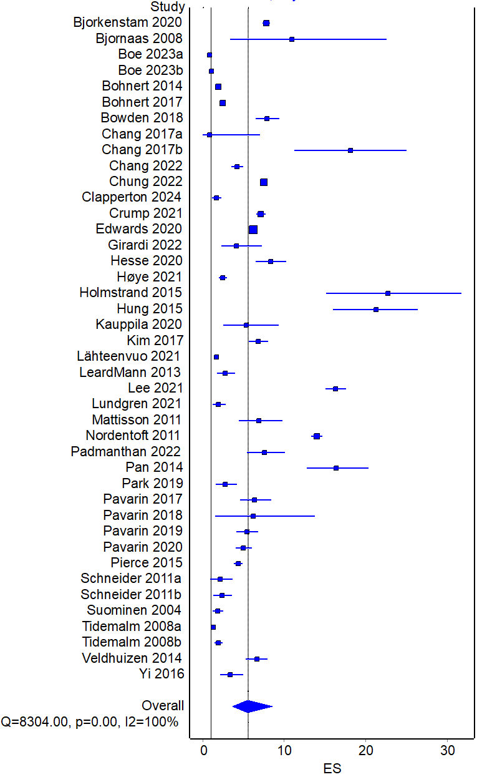
*One outlier excluded for ease of visualization: Pavarin 2008⁵⁸ (ES 50, 0-196)
Supplemental Figure 3. Any/unspecified use of alcohol or tobacco
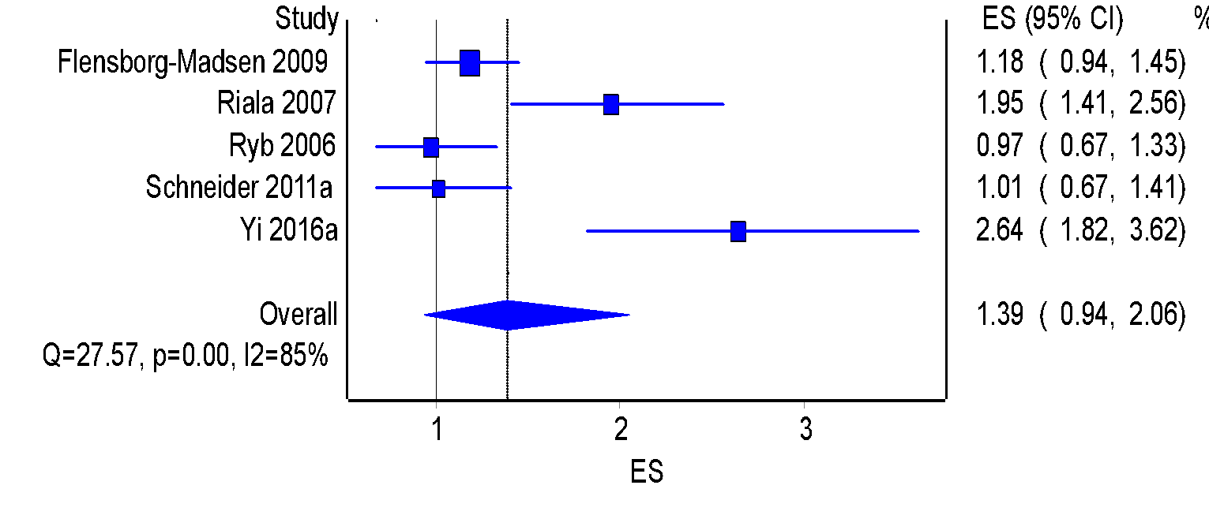

Supplemental Figure 4. Any substance use, stratified by sex
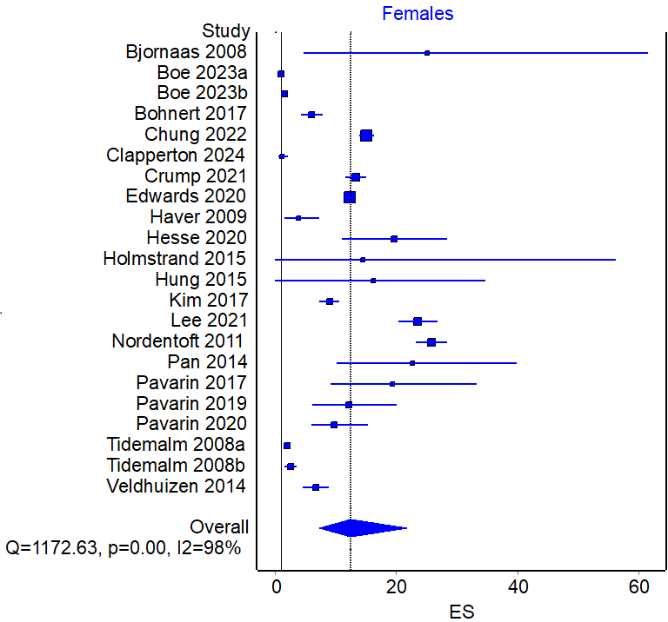
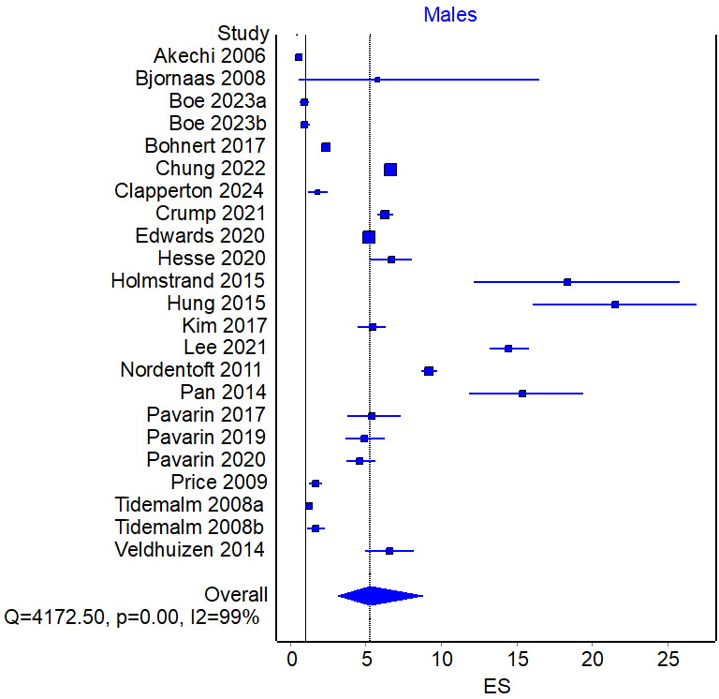

Supplemental Figure 5. Funnel plot of alcohol use overall and stratified by sex
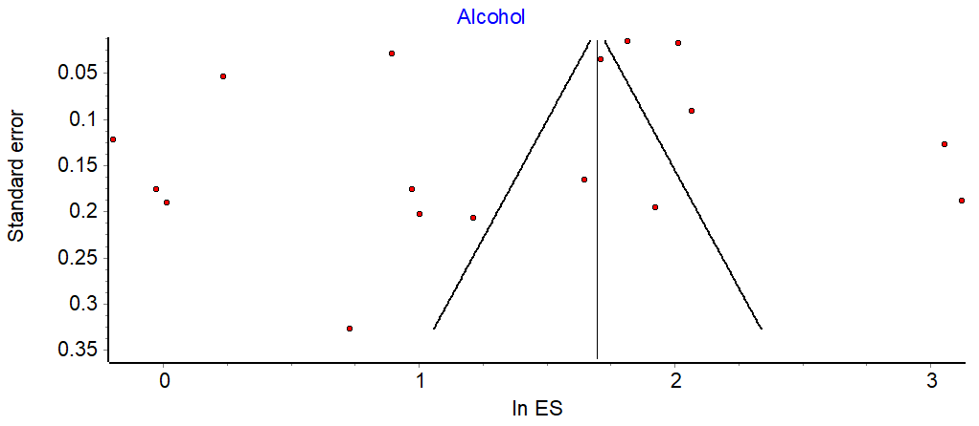
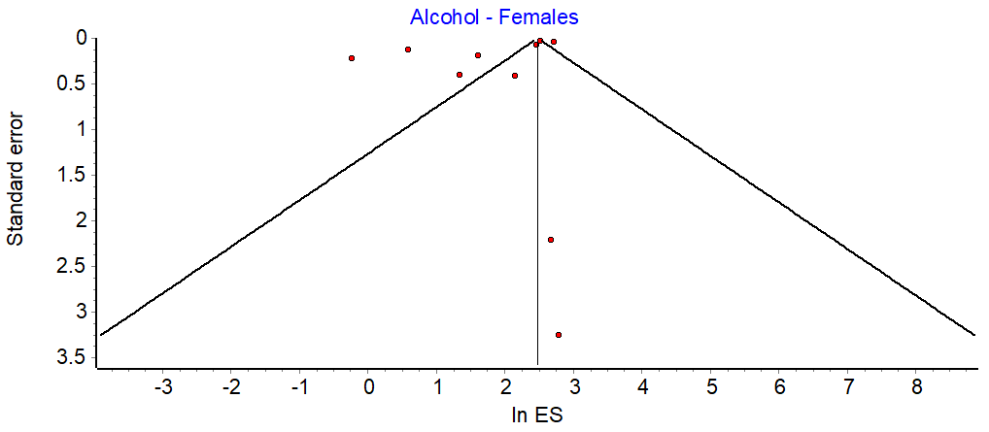
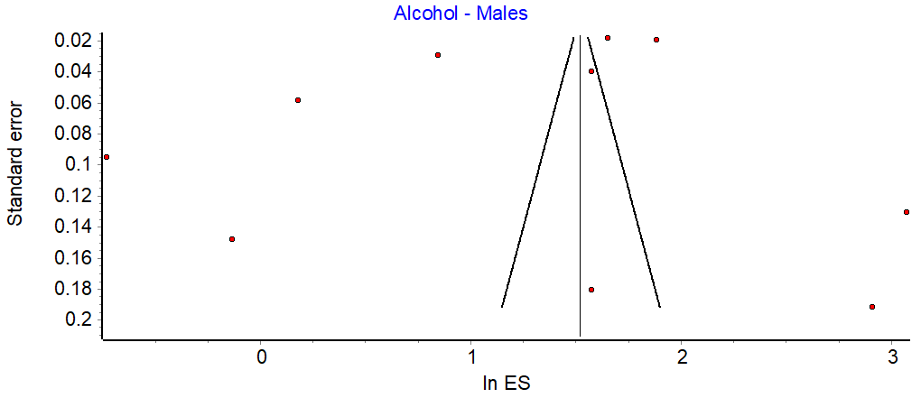

Supplemental Figure 6. Funnel plot of alcohol use and alcohol misuse

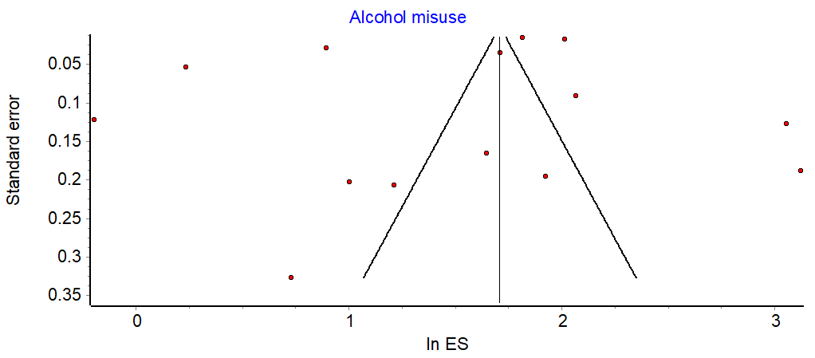

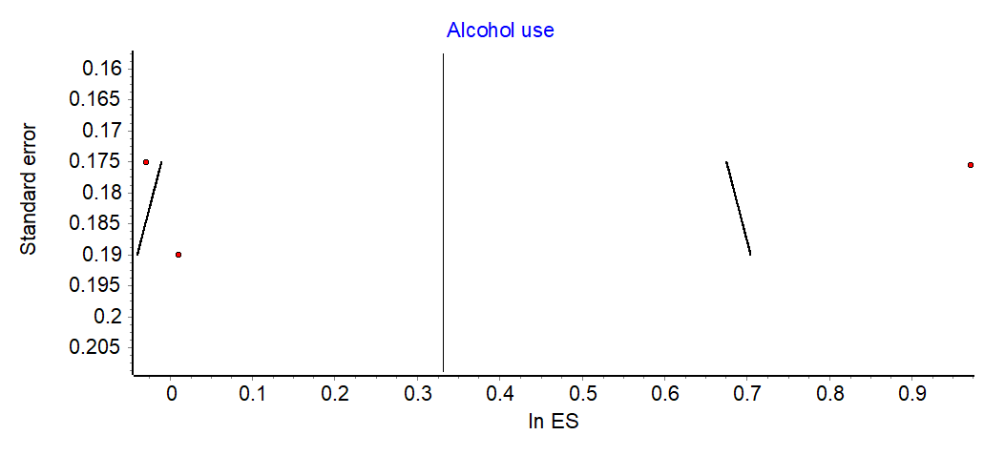

Supplemental Figure 7. Funnel plot of any substance use overall and stratified by sex
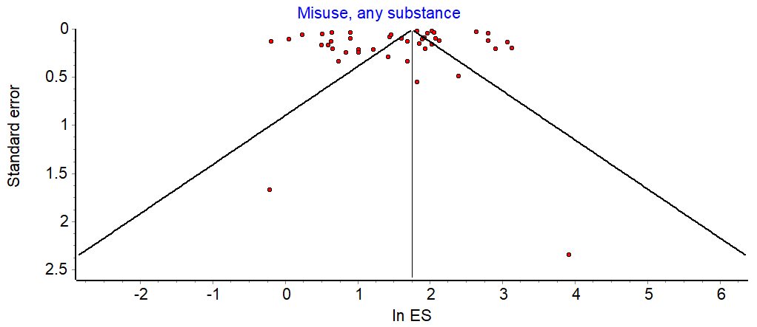
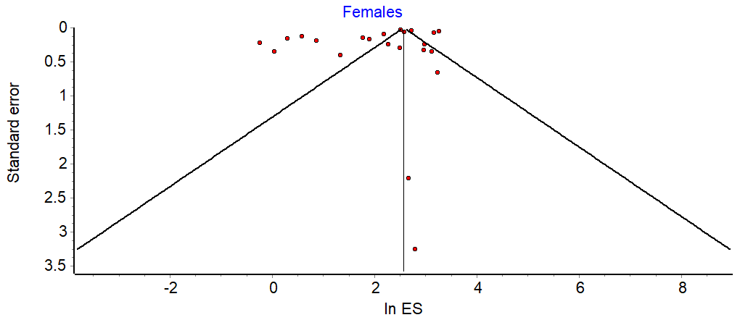
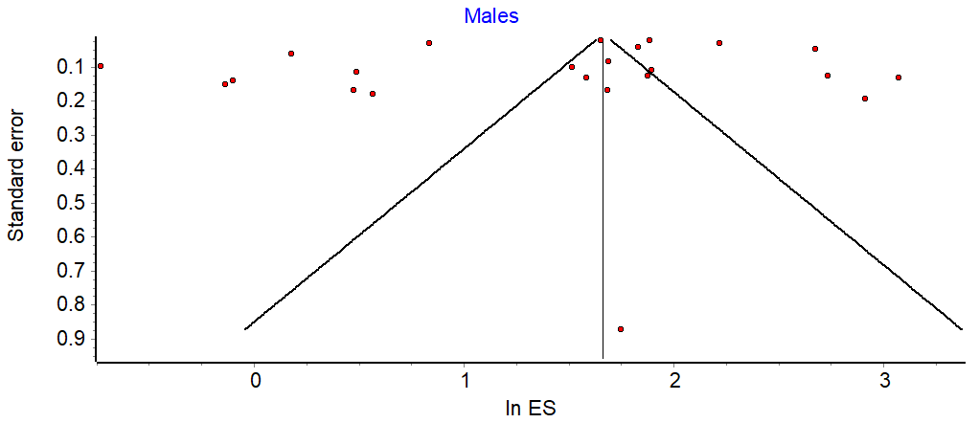

Supplemental Figure 8. Funnel plot of opioid use

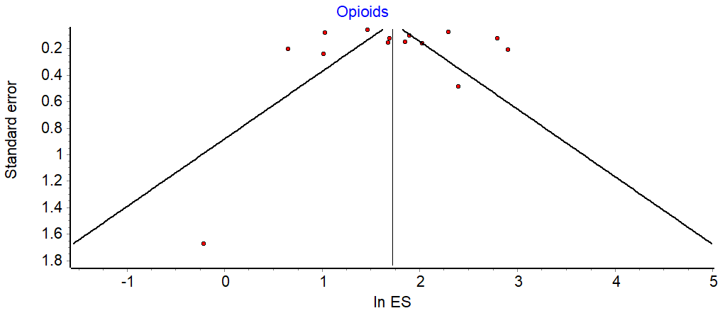

Supplemental Figure 9. Funnel plot of cannabis use

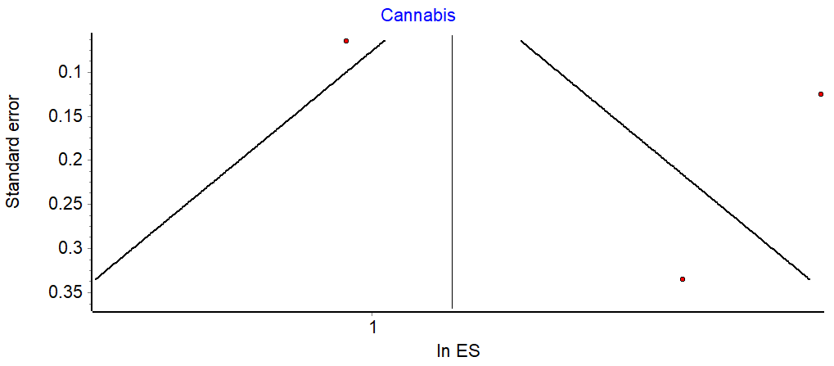

Supplemental Figure 10. Funnel plot of cocaine use

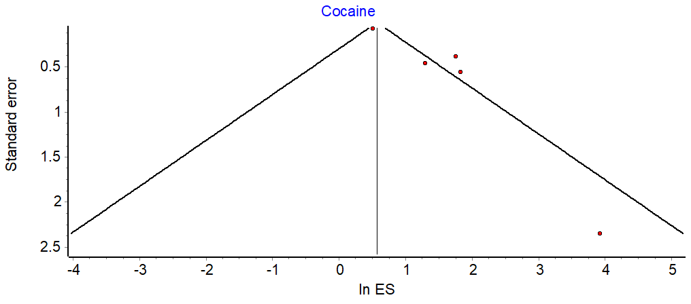

Supplemental Figure 11. Funnel plot of amphetamine use

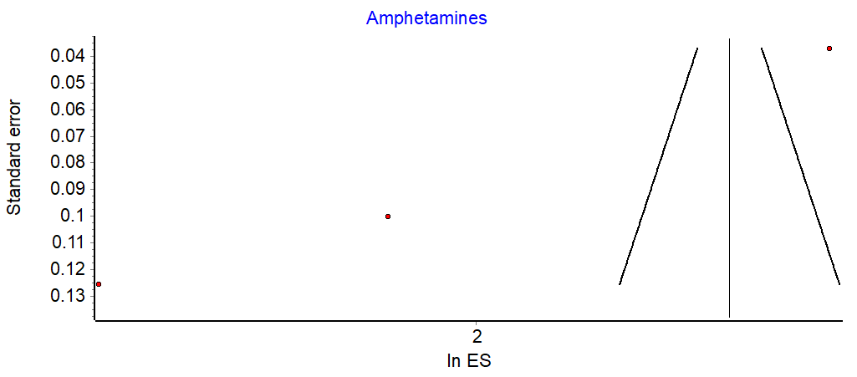

Supplemental Figure 12. Funnel plot of other types of substance use not previously included

