Regional Variations in Burden of Chronic Obstructive Pulmonary Disease in British Columbia
Jeenat Mehareen^{1,2}, Kayly Choy,^{1,2}, Yiwei Yin^{1,2}, Don D. Sin³, Mohsen Sadatsafavi^{1,2,4}

Appendices

Table of Contents

Figure A1: Retrospective Cohort Study Design 4
Table A1: COPD prevalence, incidence, all-cause hospitalization and all-cause mortality by geographic region, aged 35 or older, BC, 2010 to 2020 (combined) 5
Table A2: Rate ratios and 95% confidence interval for the unadjusted, adjusted and trend adjusted models for Prevalence 7
Table A3: Rate ratios and 95% confidence interval for the unadjusted, adjusted and trend adjusted models for Incidence 9
Table A4: Rate ratios and 95% confidence interval for the unadjusted, adjusted and trend adjusted models for all-cause hospitalization 11
Table A5: Rate ratios and 95% confidence interval for the unadjusted, adjusted and trend adjusted models for All-cause Mortality 13
Table A6: Number of COPD cases and Sex and age Standardized Prevalence (per 100,000 persons) in British Columbia, Canada, from 2001 to 2020, stratified by Health Service Delivery Area 15
Figure A2: Annual crude (a) and sex and age standardized (b) chronic obstructive pulmonary disease prevalence (per 100,000 persons) in British Columbia, Canada, from 2001 to 2020, stratified by Health Service Delivery Area 16
Table A7: Number of new COPD cases and Sex and age Standardized Incidence (per 100,000) in British Columbia, Canada, from 2001 to 2020, stratified by Health Service Delivery Area 17
Figure A3: Annual crude (a) and sex and age standardized (b) chronic obstructive pulmonary disease incidence rate (per 100,000 persons) in British Columbia, Canada, from 2001 to 2020, stratified by Health Service Delivery Area 18
Table A8: All-cause, COPD-specific and CVD-specific number of hospital admissions and sex and age standardized hospitalization rate (per 100,000 COPD patients) from 2001 to 2020, stratified by Health Service Delivery Area 19
Figure A4: Annual crude (a) and age- and sex-standardized (b) all-cause (i), COPD-specific (ii), and CVD-specific (iii) hospitalization rates (per 100,000 persons with COPD) in British Columbia, Canada, 2001–2020, stratified by Health Service Delivery Area. 22
Table A9: Crude mortality count and sex and age standardized mortality rate (per 100,000 COPD patient) from 2001 to 2020, stratified by Health Service Delivery Area 23
Figure A5: Annual crude (a) and age- and sex-standardized (b) all-cause (i), COPD-specific (ii), and CVD-specific (iii) mortality rates (per 100,000 persons with COPD) in British Columbia, Canada, 2001–2020, stratified by Health Service Delivery Area. 25
Figure A6: Rate ratios presented in a forest plot for the trend adjusted models for each primary outcome Prevalence (a), Incidence (b), All-cause hospitalization (c) and All-cause mortality (d). Confidence bands correspond to 95% CI. 26
Table A10: Average Length of Stay and In-hospital Mortality (COPD specific admission) from 2001 to 2020, stratified by Health Service Delivery Area 27
Table A11: Readmission Rate (28-day and 90-day) in COPD specific hospitalizations from 2001 to 2020, stratified by Health Service Delivery Area 28
Table A12: Treatment Classifications for COPD-related Therapies 29
Table A13: Long-acting medication use in COPD by geographic level, aged 35 or older, BC, 2010 to 2020 (combined) 30
Table A14: Number and proportion of long-acting medication users (%, among COPD patients) 31
Figure A7: Proportion of long-acting medication users (%, among COPD patients) in British Columbia, Canada, from 2001 to 2020, stratified by Health Service Delivery Area 32
Figure A8: Proportion of long-acting medication users (%) in British Columbia, Canada, from 2001 to 2020, stratified by Health Service Delivery Area 33
Table A15: Rate ratios and 95% confidence interval for the unadjusted, adjusted and trend adjusted models for medication use (long acting) 34
Figure A9: Rate ratios presented in a stacked forest plot for the adjusted (a) and trend adjusted (b) models for number of long-acting medication users. 36
Table A16: Number of Long-acting medication users by drug class 37
Table A17: Proportion of Long-acting medication users (%, among COPD patients) by drug class 40
Figure A10: Proportion of single therapy long-acting medication users (%, among COPD patients) of LAMA (a), LABA (b) and ICS (c) in British Columbia, Canada, from 2001 to 2020, stratified by Health Service Delivery Areas (HSDAs) 43
Figure A11: Proportion of combination therapies long-acting medication users (%, among COPD patients) of LAMA and LABA (a), ICS and LAMA (b), ICS and LABA (c) and ICS and LAMA and LABA (d) in British Columbia, Canada, from 2001 to 2020, stratified by Health Service Delivery Areas (HSDAs) 44

Index date
First eligible date when patient entered the cohort following case definition
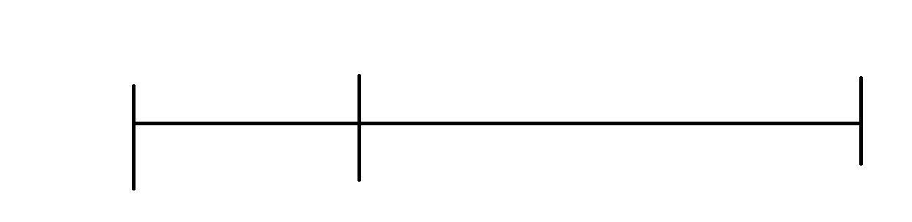
January 1, 2010
December 31, 2020
June 30, 2022
January 1, 1997
End of observation
Earliest date of death, last date of registration or end of study period

Observation Window

Case Ascertainment Window

Figure A1: Retrospective Cohort Study Design
Note: Results are presented for ‘Observation Window’ period defined as January 1, 2010, to December 31, 2020 (or latest available data

Table A1: COPD prevalence, incidence, all-cause hospitalization and all-cause mortality by geographic region, aged 35 or older, BC, 2010 to 2020 (combined)
Health Service Delivery Areas
Outcome | Total | Fraser South | Fraser North | Vancouver | South Vancouver Island | Okanagan | Central Vancouver Island | North Shore-Coast Garibaldi | Fraser East | Thompson Cariboo Shuswap | Richmond | North Vancouver Island | Northern Interior | Kootenay Boundary | East Kootenay | Northwest | Northeast | CV (%)
Population in 2020* | 3,065,668 | 502458 | 404076 | 401603 | 265752 | 263691 | 198734 | 195493 | 189822 | 152714 | 129122 | 88624 | 84414 | 56298 | 55606 | 42827 | 34434
Total person-year in the population* | 31,039,615 | 4946661 | 4116484 | 4151170 | 2668466 | 2613411 | 2000915 | 1994890 | 1882828 | 1559185 | 1329379 | 896659 | 898808 | 586344 | 562941 | 460619 | 370855
Total person-year at risk in the population | 28,925,909 | 4684930 | 3877426 | 3927398 | 2508063 | 2359997 | 1817126 | 1883568 | 1738095 | 1399543 | 1274055 | 819900 | 824730 | 531325 | 513555 | 427356 | 338842
Prevalence
Total person-year with diagnosed COPD | 2,113,706 | 261731 | 239058 | 223772 | 160403 | 253414 | 183789 | 111322 | 144733 | 159642 | 55324 | 76759 | 74078 | 55019 | 49386 | 33263 | 32013
Period Prevalence (%) | 6.8 | 5.3 | 5.8 | 5.4 | 6.0 | 9.7 | 9.2 | 5.6 | 7.7 | 10.2 | 4.2 | 8.6 | 8.2 | 9.4 | 8.8 | 7.2 | 8.6 | 24.9
Ranking of Period Prevalence^ |  | 15 | 12 | 14 | 11 | 2 | 8 | 13 | 9 | 1 | 16 | 5 | 7 | 3 | 4 | 10 | 6
Incidence
Number of new COPD Cases | 164,660 | 19198 | 18035 | 16419 | 12392 | 19020 | 14273 | 9279 | 11726 | 12798 | 4114 | 6383 | 6547 | 4287 | 4168 | 3009 | 3012
Cumulative Incidence (per 100,000 person-year at risk) | 569.2 | 409.8 | 465.1 | 418.1 | 494.1 | 805.9 | 785.5 | 492.6 | 674.6 | 914.4 | 322.9 | 778.5 | 793.8 | 806.9 | 811.6 | 704.1 | 888.9 | 29.3
Ranking of Cumulative Incidence^ |  | 15 | 13 | 14 | 11 | 5 | 7 | 12 | 10 | 1 | 16 | 8 | 6 | 4 | 3 | 9 | 2
Hospitalization
No of hospitalizations | 1,545,883 | 203308 | 173966 | 142433 | 109061 | 192174 | 118320 | 79673 | 117907 | 128479 | 34815 | 52805 | 60461 | 41228 | 40001 | 29803 | 21449
Cumulative Hospitalization (per 100,000 diagnosed COPD-patient year) | 73136.1 | 77678.2 | 72771.5 | 63650.9 | 67991.9 | 75834.0 | 64378.2 | 71569.9 | 81465.2 | 80479.4 | 62929.3 | 68793.2 | 81618.0 | 74934.1 | 80996.6 | 89598.1 | 67000.9 | 10.5
Ranking of Cumulative Hospitalization^ |  | 15 | 8 | 14 | 11 | 6 | 13 | 9 | 3 | 4 | 16 | 10 | 2 | 7 | 5 | 1 | 12
Mortality
Number of deaths (all-cause) | 106,474 | 13306 | 11252 | 10887 | 9069 | 14015 | 8743 | 5666 | 7271 | 8263 | 2340 | 3702 | 3593 | 2889 | 2637 | 1470 | 1371
Cumulative Mortality (per 100,000 diagnosed COPD-patient year) | 5037.3 | 5083.8 | 4706.8 | 4865.2 | 5653.9 | 5530.5 | 4757.1 | 5089.7 | 5023.7 | 5176.0 | 4229.6 | 4822.9 | 4850.3 | 5250.9 | 5339.6 | 4419.3 | 4282.6 | 8.3
Ranking of Cumulative Mortality^ |  | 7 | 13 | 10 | 1 | 2 | 12 | 6 | 8 | 4 | 16 | 11 | 9 | 5 | 3 | 15 | 14
Abbreviations: HSDA: Health Service Delivery Area; CV: Coefficient of Variation
Count and Rates are based on aggregated data from 2010-2020
* Based on Statistics Canada population age 35 year or older
^ Rankings are based on highest to lowest

Table A2: Rate ratios and 95% confidence interval for the unadjusted, adjusted and trend adjusted models for Prevalence
 | Unadjusted Model |  |  |  |  | Adjusted Model |  |  |  | Trend Adjusted Model
Term | p value | RR | 95% CI (lower) | 95% CI (upper) | p value |  | RR | 95% CI (lower) | 95% CI (upper) |  | p value | RR | 95% CI (lower) | 95% CI (upper)
(Intercept) | 0.000 | 0.092 | 0.075 | 0.112 | 0.000 |  | 0.012 | 0.010 | 0.014 |  | 0.000 | 0.013 | 0.011 | 0.015
HSDA11 | 0.013 | 1.441 | 1.081 | 1.922 | 0.236 |  | 0.923 | 0.809 | 1.054 |  | 0.040 | 0.860 | 0.745 | 0.993
HSDA12 | 0.014 | 1.436 | 1.077 | 1.915 | 0.627 |  | 0.970 | 0.859 | 1.096 |  | 0.476 | 0.953 | 0.836 | 1.087
HSDA13 | 0.014 | 1.437 | 1.077 | 1.916 | 0.000 |  | 1.194 | 1.115 | 1.278 |  | 0.000 | 1.193 | 1.094 | 1.301
HSDA14 | 0.001 | 1.614 | 1.210 | 2.153 | 0.000 |  | 1.231 | 1.121 | 1.351 |  | 0.025 | 1.133 | 1.016 | 1.264
HSDA21 | 0.138 | 1.243 | 0.932 | 1.658 | 0.000 |  | 1.165 | 1.107 | 1.227 |  | 0.011 | 1.099 | 1.022 | 1.183
HSDA22 | 0.281 | 1.172 | 0.879 | 1.562 | 0.000 |  | 1.152 | 1.106 | 1.199 |  | 0.003 | 1.107 | 1.036 | 1.184
HSDA31 | 0.163 | 0.815 | 0.611 | 1.087 | 0.000 |  | 0.746 | 0.712 | 0.781 |  | 0.000 | 0.744 | 0.693 | 0.800
HSDA32 | 0.821 | 1.034 | 0.775 | 1.379 | 0.087 |  | 0.953 | 0.902 | 1.007 |  | 0.270 | 0.958 | 0.889 | 1.034
HSDA33 | 0.911 | 0.984 | 0.738 | 1.312 | 0.000 |  | 0.736 | 0.673 | 0.805 |  | 0.000 | 0.703 | 0.634 | 0.780
HSDA41 | 0.785 | 0.961 | 0.720 | 1.281 | 0.000 |  | 0.879 | 0.841 | 0.919 |  | 0.000 | 0.833 | 0.778 | 0.893
HSDA42 | 0.093 | 1.279 | 0.959 | 1.706 | 0.000 |  | 1.203 | 1.129 | 1.281 |  | 0.006 | 1.121 | 1.034 | 1.216
HSDA43 | 0.069 | 1.306 | 0.979 | 1.742 | 0.008 |  | 1.094 | 1.024 | 1.168 |  | 0.954 | 1.002 | 0.923 | 1.089
HSDA51 | 0.062 | 1.316 | 0.987 | 1.755 | 0.243 |  | 0.943 | 0.854 | 1.041 |  | 0.000 | 0.816 | 0.731 | 0.912
HSDA52 | 0.007 | 1.490 | 1.118 | 1.987 | 0.000 |  | 1.262 | 1.183 | 1.347 |  | 0.050 | 1.088 | 1.000 | 1.183
HSDA53 | 0.000 | 1.728 | 1.296 | 2.305 | 0.000 |  | 1.283 | 1.146 | 1.435 |  | 0.009 | 1.181 | 1.043 | 1.338
HSDA23 (Ref)
Female |  |  |  |  | 0.000 |  | 0.892 | 0.880 | 0.905 |  | 0.000 | 0.891 | 0.880 | 0.903
Male (Ref)

50-64 years |  |  |  |  | 0.000 |  | 5.684 | 5.574 | 5.797 |  | 0.000 | 5.698 | 5.590 | 5.807
65-79 years |  |  |  |  | 0.000 |  | 14.152 | 13.853 | 14.458 |  | 0.000 | 14.203 | 13.912 | 14.501
>=80 years |  |  |  |  | 0.000 |  | 24.691 | 23.881 | 25.530 |  | 0.000 | 24.693 | 23.902 | 25.510
35-49 years (Ref)
Rural |  |  |  |  | 0.000 |  | 2.157 | 1.723 | 2.700 |  | 0.000 | 2.089 | 1.676 | 2.604
Neighborhood income quintile
2 |  |  |  |  | 0.000 |  | 0.484 | 0.341 | 0.687 |  | 0.000 | 0.493 | 0.349 | 0.695
3 |  |  |  |  | 0.002 |  | 0.555 | 0.380 | 0.811 |  | 0.010 | 0.613 | 0.423 | 0.889
4 |  |  |  |  | 0.003 |  | 0.582 | 0.406 | 0.835 |  | 0.006 | 0.609 | 0.427 | 0.870
5 (highest income quintile) |  |  |  |  | 0.809 |  | 1.040 | 0.755 | 1.433 |  | 0.776 | 0.955 | 0.694 | 1.314
Unknown |  |  |  |  | 0.361 |  | 1.543 | 0.608 | 3.914 |  | 0.217 | 1.775 | 0.714 | 4.413
Year |  |  |  |  |  |  |  |  |  |  | 0.000 | 0.982 | 0.975 | 0.990
HSDA11:year |  |  |  |  |  |  |  |  |  |  | 0.002 | 1.018 | 1.007 | 1.030
HSDA12:year |  |  |  |  |  |  |  |  |  |  | 0.172 | 1.008 | 0.997 | 1.020
HSDA13:year |  |  |  |  |  |  |  |  |  |  | 0.726 | 1.002 | 0.991 | 1.013
HSDA14:year |  |  |  |  |  |  |  |  |  |  | 0.002 | 1.018 | 1.007 | 1.029
HSDA21:year |  |  |  |  |  |  |  |  |  |  | 0.018 | 1.013 | 1.002 | 1.024
HSDA22:year |  |  |  |  |  |  |  |  |  |  | 0.217 | 1.007 | 0.996 | 1.018
HSDA31:year |  |  |  |  |  |  |  |  |  |  | 0.937 | 1.000 | 0.988 | 1.011
HSDA32:year |  |  |  |  |  |  |  |  |  |  | 0.895 | 0.999 | 0.989 | 1.010
HSDA33:year |  |  |  |  |  |  |  |  |  |  | 0.006 | 1.016 | 1.005 | 1.027
HSDA41:year |  |  |  |  |  |  |  |  |  |  | 0.029 | 1.012 | 1.001 | 1.023
HSDA42:year |  |  |  |  |  |  |  |  |  |  | 0.003 | 1.017 | 1.006 | 1.028
HSDA43:year |  |  |  |  |  |  |  |  |  |  | 0.001 | 1.020 | 1.009 | 1.031
HSDA51:year |  |  |  |  |  |  |  |  |  |  | 0.000 | 1.031 | 1.019 | 1.043
HSDA52:year |  |  |  |  |  |  |  |  |  |  | 0.000 | 1.033 | 1.021 | 1.044
HSDA53:year |  |  |  |  |  |  |  |  |  |  | 0.000 | 1.023 | 1.011 | 1.035
HSDA23: Year (Ref)
Reference levels of factor variables have a RR=1.00.
Adjusted variables for both adjusted and trend-adjusted models: Sex, Socio-Economic Status, Area of Residence, Age group.
Abbreviations: RR: Rate Ratio; HSDA: Health Service Delivery Area, CI: Confidence Interval, HSDA11: East Kootenay, HSDA 12: Kootenay Boundary, HSDA 13: Okanagan, HSDA 14: Thompson Cariboo Shuswap, HSDA 21: Fraser East, HSDA 22: Fraser North, HSDA 23: Fraser South, HSDA 31: Richmond, HSDA 32: Vancouver, HSDA 33: North Shore/Coast Garibaldi, HSDA 41: South Vancouver Island, HSDA 42: Central Vancouver Island, HSDA 43: North Vancouver Island, HSDA 51: Northwest, HSDA 52: Northern Interior, HSDA 53: Northeast.

Table A3: Rate ratios and 95% confidence interval for the unadjusted, adjusted and trend adjusted models for Incidence
 | Unadjusted Model |  |  |  | Adjusted Model |  |  |  |  | Trend Adjusted Model
Term | p value | RR | 95% CI (lower) | 95% CI (upper) | p value | RR | 95% CI (lower) | 95% CI (upper) | p value |  | RR | 95% CI (lower) | 95% CI (upper)
(Intercept) | 0.000 | 0.006 | 0.005 | 0.007 | 0.000 | 0.002 | 0.001 | 0.002 | 0.000 |  | 0.002 | 0.002 | 0.002
HSDA11 | 0.000 | 1.554 | 1.246 | 1.939 | 0.000 | 1.435 | 1.215 | 1.696 | 0.000 |  | 1.317 | 1.136 | 1.527
HSDA12 | 0.001 | 1.479 | 1.185 | 1.845 | 0.000 | 1.366 | 1.158 | 1.611 | 0.000 |  | 1.452 | 1.268 | 1.663
HSDA13 | 0.001 | 1.472 | 1.182 | 1.833 | 0.000 | 1.454 | 1.305 | 1.619 | 0.000 |  | 1.505 | 1.359 | 1.668
HSDA14 | 0.000 | 1.733 | 1.391 | 2.159 | 0.000 | 1.647 | 1.441 | 1.883 | 0.000 |  | 1.514 | 1.345 | 1.704
HSDA21 | 0.004 | 1.385 | 1.112 | 1.726 | 0.000 | 1.421 | 1.291 | 1.563 | 0.000 |  | 1.498 | 1.360 | 1.650
HSDA22 | 0.158 | 1.171 | 0.941 | 1.459 | 0.000 | 1.171 | 1.073 | 1.278 | 0.000 |  | 1.218 | 1.111 | 1.335
HSDA31 | 0.092 | 0.827 | 0.663 | 1.031 | 0.000 | 0.765 | 0.695 | 0.843 | 0.000 |  | 0.730 | 0.656 | 0.812
HSDA32 | 0.976 | 0.997 | 0.800 | 1.241 | 0.818 | 0.989 | 0.900 | 1.087 | 0.877 |  | 0.993 | 0.903 | 1.091
HSDA33 | 0.288 | 1.127 | 0.904 | 1.403 | 0.997 | 1.000 | 0.885 | 1.130 | 0.045 |  | 0.891 | 0.797 | 0.997
HSDA41 | 0.866 | 1.019 | 0.818 | 1.269 | 0.907 | 1.005 | 0.919 | 1.100 | 0.214 |  | 0.941 | 0.856 | 1.035
HSDA42 | 0.004 | 1.375 | 1.104 | 1.713 | 0.000 | 1.466 | 1.321 | 1.627 | 0.000 |  | 1.414 | 1.280 | 1.563
HSDA43 | 0.003 | 1.399 | 1.122 | 1.744 | 0.000 | 1.421 | 1.272 | 1.588 | 0.000 |  | 1.299 | 1.165 | 1.449
HSDA51 | 0.013 | 1.328 | 1.062 | 1.660 | 0.000 | 1.363 | 1.179 | 1.575 | 0.401 |  | 1.059 | 0.927 | 1.209
HSDA52 | 0.000 | 1.540 | 1.235 | 1.920 | 0.000 | 1.684 | 1.513 | 1.875 | 0.033 |  | 1.125 | 1.009 | 1.253
HSDA53 | 0.000 | 1.860 | 1.488 | 2.325 | 0.000 | 1.892 | 1.633 | 2.192 | 0.000 |  | 1.605 | 1.406 | 1.832
HSDA23 (Ref)

Female |  |  |  |  | 0.000 | 0.850 | 0.822 | 0.878 | 0.000 |  | 0.841 | 0.824 | 0.858
Male (Ref)
50-64 years |  |  |  |  | 0.000 | 3.195 | 3.048 | 3.348 | 0.000 |  | 3.207 | 3.112 | 3.304
65-79 years |  |  |  |  | 0.000 | 5.884 | 5.606 | 6.177 | 0.000 |  | 5.839 | 5.660 | 6.023
>=80 years |  |  |  |  | 0.000 | 8.017 | 7.621 | 8.434 | 0.000 |  | 8.101 | 7.836 | 8.375
35-49 years (Ref)
Rural |  |  |  |  | 0.024 | 1.336 | 1.039 | 1.718 | 0.000 |  | 1.481 | 1.239 | 1.769
Neighborhood income quintile
2 |  |  |  |  | 0.008 | 0.623 | 0.439 | 0.884 | 0.113 |  | 0.824 | 0.649 | 1.047
3 |  |  |  |  | 0.030 | 0.666 | 0.461 | 0.962 | 0.402 |  | 1.112 | 0.867 | 1.426
4 |  |  |  |  | 0.642 | 0.918 | 0.642 | 1.314 | 0.008 |  | 1.390 | 1.091 | 1.772
5 (highest income quintile) |  |  |  |  | 0.660 | 0.925 | 0.653 | 1.309 | 0.036 |  | 1.286 | 1.017 | 1.626
Unknown |  |  |  |  | 0.578 | 1.288 | 0.528 | 3.145 | 0.051 |  | 1.821 | 0.998 | 3.323
Year |  |  |  |  |  |  |  |  | 0.000 |  | 0.922 | 0.912 | 0.932
HSDA11:year |  |  |  |  |  |  |  |  | 0.480 |  | 1.007 | 0.988 | 1.025
HSDA12:year |  |  |  |  |  |  |  |  | 0.081 |  | 0.984 | 0.966 | 1.002
HSDA13:year |  |  |  |  |  |  |  |  | 0.410 |  | 0.993 | 0.978 | 1.009
HSDA14:year |  |  |  |  |  |  |  |  | 0.103 |  | 1.014 | 0.997 | 1.030
HSDA21:year |  |  |  |  |  |  |  |  | 0.400 |  | 0.993 | 0.977 | 1.009
HSDA22:year |  |  |  |  |  |  |  |  | 0.205 |  | 0.990 | 0.975 | 1.006
HSDA31:year |  |  |  |  |  |  |  |  | 0.048 |  | 1.018 | 1.000 | 1.037
HSDA32:year |  |  |  |  |  |  |  |  | 0.243 |  | 1.009 | 0.994 | 1.025
HSDA33:year |  |  |  |  |  |  |  |  | 0.052 |  | 1.016 | 1.000 | 1.033
HSDA41:year |  |  |  |  |  |  |  |  | 0.010 |  | 1.021 | 1.005 | 1.038
HSDA42:year |  |  |  |  |  |  |  |  | 0.647 |  | 1.004 | 0.988 | 1.020
HSDA43:year |  |  |  |  |  |  |  |  | 0.009 |  | 1.023 | 1.006 | 1.041
HSDA51:year |  |  |  |  |  |  |  |  | 0.000 |  | 1.055 | 1.035 | 1.076
HSDA52:year |  |  |  |  |  |  |  |  | 0.000 |  | 1.088 | 1.069 | 1.107
HSDA53:year |  |  |  |  |  |  |  |  | 0.009 |  | 1.026 | 1.007 | 1.046
HSDA23: Year (Ref)
Reference levels of factor variables have a RR=1.00.
Adjusted variables for both adjusted and trend-adjusted models: Sex, Socio-Economic Status, Area of Residence, Age group.
Abbreviations: RR: Rate Ratio; HSDA: Health Service Delivery Area, CI: Confidence Interval, HSDA11: East Kootenay, HSDA 12: Kootenay Boundary, HSDA 13: Okanagan, HSDA 14: Thompson Cariboo Shuswap, HSDA 21: Fraser East, HSDA 22: Fraser North, HSDA 23: Fraser South, HSDA 31: Richmond, HSDA 32: Vancouver, HSDA 33: North Shore/Coast Garibaldi, HSDA 41: South Vancouver Island, HSDA 42: Central Vancouver Island, HSDA 43: North Vancouver Island, HSDA 51: Northwest, HSDA 52: Northern Interior, HSDA 53: Northeast.

Table A4: Rate ratios and 95% confidence interval for the unadjusted, adjusted and trend adjusted models for all-cause hospitalization
 |  | Unadjusted Model |  |  |  | Adjusted Model |  |  |  | Trend Adjusted Model
Term | p value |  | RR | 95% CI (lower) | 95% CI (upper) | p value | RR | 95% CI (lower) | 95% CI (upper) | p value | RR | 95% CI (lower) | 95% CI (upper)
(Intercept) |  | 0.000 | 0.701 | 0.659 | 0.747 | 0.002 | 0.569 | 0.399 | 0.813 | 0.063 | 0.760 | 0.569 | 1.015
HSDA11 |  | 0.084 | 1.082 | 0.989 | 1.184 | 0.010 | 1.110 | 1.025 | 1.201 | 0.028 | 1.131 | 1.013 | 1.263
HSDA12 |  | 0.015 | 1.118 | 1.022 | 1.223 | 0.007 | 1.133 | 1.035 | 1.239 | 0.342 | 1.057 | 0.942 | 1.186
HSDA13 |  | 0.094 | 1.079 | 0.987 | 1.179 | 0.001 | 1.162 | 1.064 | 1.269 | 0.044 | 1.122 | 1.003 | 1.255
HSDA14 |  | 0.113 | 1.075 | 0.983 | 1.175 | 0.000 | 1.202 | 1.096 | 1.319 | 0.002 | 1.199 | 1.069 | 1.344
HSDA21 |  | 0.628 | 1.022 | 0.935 | 1.117 | 0.174 | 1.066 | 0.972 | 1.168 | 0.035 | 1.132 | 1.009 | 1.269
HSDA22 |  | 0.593 | 0.976 | 0.893 | 1.067 | 0.602 | 0.979 | 0.903 | 1.061 | 0.830 | 0.988 | 0.886 | 1.102
HSDA31 |  | 0.663 | 1.020 | 0.933 | 1.116 | 0.211 | 1.060 | 0.967 | 1.162 | 0.711 | 1.022 | 0.910 | 1.149
HSDA32 |  | 0.507 | 0.970 | 0.888 | 1.061 | 0.215 | 1.065 | 0.964 | 1.177 | 0.665 | 0.974 | 0.865 | 1.097
HSDA33 |  | 0.308 | 1.048 | 0.958 | 1.145 | 0.605 | 1.032 | 0.916 | 1.163 | 0.672 | 1.028 | 0.905 | 1.168
HSDA41 |  | 0.166 | 1.065 | 0.974 | 1.164 | 0.007 | 1.124 | 1.032 | 1.224 | 0.179 | 1.080 | 0.965 | 1.208
HSDA42 |  | 0.345 | 1.044 | 0.955 | 1.141 | 0.168 | 1.060 | 0.976 | 1.152 | 0.038 | 1.123 | 1.006 | 1.253
HSDA43 |  | 0.046 | 1.096 | 1.002 | 1.198 | 0.003 | 1.143 | 1.047 | 1.247 | 0.003 | 1.186 | 1.059 | 1.327
HSDA51 |  | 0.015 | 1.119 | 1.022 | 1.224 | 0.000 | 1.217 | 1.103 | 1.343 | 0.000 | 1.273 | 1.133 | 1.431
HSDA52 |  | 0.103 | 1.077 | 0.985 | 1.178 | 0.190 | 1.057 | 0.973 | 1.149 | 0.043 | 1.122 | 1.003 | 1.254
HSDA53 |  | 0.168 | 1.065 | 0.974 | 1.165 | 0.676 | 1.026 | 0.909 | 1.158 | 0.934 | 0.994 | 0.872 | 1.134
HSDA23 (Ref)
Female |  |  |  |  |  | 0.091 | 0.976 | 0.949 | 1.004 | 0.035 | 0.977 | 0.957 | 0.998
Male (Ref)
50-64 years |  |  |  |  |  | 0.000 | 0.915 | 0.878 | 0.953 | 0.000 | 0.943 | 0.914 | 0.973
65-79 years |  |  |  |  |  | 0.000 | 1.196 | 1.148 | 1.246 | 0.000 | 1.237 | 1.199 | 1.277
>=80 years |  |  |  |  |  | 0.000 | 1.351 | 1.296 | 1.407 | 0.000 | 1.368 | 1.326 | 1.412
35-49 years (Ref)
Rural |  |  |  |  |  | 0.241 | 1.328 | 0.826 | 2.135 | 0.388 | 0.847 | 0.582 | 1.234
Neighborhood income quintile
2 |  |  |  |  |  | 0.778 | 0.924 | 0.533 | 1.602 | 0.482 | 1.169 | 0.757 | 1.805
3 |  |  |  |  |  | 0.855 | 1.055 | 0.595 | 1.869 | 0.721 | 0.921 | 0.585 | 1.449
4 |  |  |  |  |  | 0.329 | 1.324 | 0.754 | 2.326 | 0.948 | 1.015 | 0.649 | 1.588
5 (highest income quintile) |  |  |  |  |  | 0.272 | 1.353 | 0.789 | 2.321 | 0.062 | 1.503 | 0.980 | 2.305
Unknown |  |  |  |  |  | 0.001 | 0.107 | 0.030 | 0.378 | 0.001 | 0.190 | 0.070 | 0.514
Year |  |  |  |  |  |  |  |  |  | 0.000 | 0.952 | 0.940 | 0.964
HSDA11:year |  |  |  |  |  |  |  |  |  | 0.487 | 0.993 | 0.975 | 1.012
HSDA12:year |  |  |  |  |  |  |  |  |  | 0.243 | 1.011 | 0.993 | 1.030
HSDA13:year |  |  |  |  |  |  |  |  |  | 0.753 | 1.003 | 0.985 | 1.021
HSDA14:year |  |  |  |  |  |  |  |  |  | 0.494 | 0.994 | 0.976 | 1.012
HSDA21:year |  |  |  |  |  |  |  |  |  | 0.060 | 0.983 | 0.965 | 1.001
HSDA22:year |  |  |  |  |  |  |  |  |  | 0.888 | 1.001 | 0.983 | 1.020
HSDA31:year |  |  |  |  |  |  |  |  |  | 0.336 | 1.009 | 0.991 | 1.028
HSDA32:year |  |  |  |  |  |  |  |  |  | 0.239 | 1.011 | 0.993 | 1.029
HSDA33:year |  |  |  |  |  |  |  |  |  | 0.517 | 0.994 | 0.976 | 1.012
HSDA41:year |  |  |  |  |  |  |  |  |  | 0.643 | 1.004 | 0.986 | 1.023
HSDA42:year |  |  |  |  |  |  |  |  |  | 0.103 | 0.985 | 0.967 | 1.003
HSDA43:year |  |  |  |  |  |  |  |  |  | 0.137 | 0.986 | 0.968 | 1.004
HSDA51:year |  |  |  |  |  |  |  |  |  | 0.143 | 0.986 | 0.967 | 1.005
HSDA52:year |  |  |  |  |  |  |  |  |  | 0.173 | 0.987 | 0.969 | 1.006
HSDA53:year |  |  |  |  |  |  |  |  |  | 0.740 | 1.003 | 0.985 | 1.022
HSDA23: Year (Ref)
Reference levels of factor variables have a RR=1.00.
Adjusted variables for both adjusted and trend-adjusted models: Sex, Socio-Economic Status, Area of Residence, Age group.
Abbreviations: RR: Rate Ratio; HSDA: Health Service Delivery Area, CI: Confidence Interval, HSDA11: East Kootenay, HSDA 12: Kootenay Boundary, HSDA 13: Okanagan, HSDA 14: Thompson Cariboo Shuswap, HSDA 21: Fraser East, HSDA 22: Fraser North, HSDA 23: Fraser South, HSDA 31: Richmond, HSDA 32: Vancouver, HSDA 33: North Shore/Coast Garibaldi, HSDA 41: South Vancouver Island, HSDA 42: Central Vancouver Island, HSDA 43: North Vancouver Island, HSDA 51: Northwest, HSDA 52: Northern Interior, HSDA 53: Northeast.

Table A5: Rate ratios and 95% confidence interval for the unadjusted, adjusted and trend adjusted models for All-cause Mortality
 | Unadjusted Model |  |  |  | Adjusted Model |  |  |  | Trend Adjusted Model
Term | p value | RR | 95% CI (lower) | 95% CI (upper) | p value | RR | 95% CI (lower) | 95% CI (upper) | p value | RR | 95% CI (lower) | 95% CI (upper)
(Intercept) | 0.000 | 0.046 | 0.037 | 0.056 | 0.000 | 0.008 | 0.007 | 0.008 | 0.000 | 0.007 | 0.007 | 0.008
HSDA11 | 0.560 | 1.092 | 0.813 | 1.466 | 0.057 | 1.095 | 0.997 | 1.203 | 0.095 | 1.112 | 0.982 | 1.259
HSDA12 | 0.460 | 1.117 | 0.832 | 1.500 | 0.015 | 1.114 | 1.021 | 1.215 | 0.063 | 1.121 | 0.994 | 1.264
HSDA13 | 0.879 | 1.023 | 0.765 | 1.367 | 0.210 | 1.034 | 0.981 | 1.090 | 0.400 | 1.035 | 0.955 | 1.122
HSDA14 | 0.705 | 1.058 | 0.791 | 1.415 | 0.036 | 1.073 | 1.005 | 1.145 | 0.311 | 1.050 | 0.956 | 1.154
HSDA21 | 0.942 | 1.011 | 0.756 | 1.352 | 0.071 | 1.044 | 0.996 | 1.095 | 0.981 | 1.001 | 0.922 | 1.086
HSDA22 | 0.602 | 0.926 | 0.693 | 1.237 | 0.000 | 0.912 | 0.878 | 0.948 | 0.008 | 0.906 | 0.842 | 0.974
HSDA31 | 0.216 | 0.830 | 0.618 | 1.115 | 0.000 | 0.795 | 0.754 | 0.839 | 0.215 | 0.939 | 0.849 | 1.038
HSDA32 | 0.625 | 0.930 | 0.696 | 1.243 | 0.013 | 0.945 | 0.905 | 0.988 | 0.020 | 0.912 | 0.844 | 0.985
HSDA33 | 0.654 | 0.935 | 0.699 | 1.253 | 0.019 | 0.930 | 0.876 | 0.988 | 0.341 | 0.955 | 0.870 | 1.050
HSDA41 | 0.811 | 1.036 | 0.775 | 1.386 | 0.463 | 1.016 | 0.974 | 1.060 | 0.730 | 0.987 | 0.914 | 1.065
HSDA42 | 0.835 | 0.970 | 0.725 | 1.297 | 0.257 | 0.973 | 0.928 | 1.020 | 0.371 | 0.964 | 0.890 | 1.044
HSDA43 | 0.955 | 0.992 | 0.740 | 1.330 | 0.744 | 1.010 | 0.953 | 1.070 | 0.625 | 1.024 | 0.931 | 1.127
HSDA51 | 0.944 | 1.011 | 0.751 | 1.360 | 0.363 | 1.041 | 0.955 | 1.135 | 0.069 | 1.133 | 0.991 | 1.296
HSDA52 | 0.560 | 1.091 | 0.814 | 1.461 | 0.000 | 1.132 | 1.070 | 1.198 | 0.039 | 1.107 | 1.005 | 1.219
HSDA53 | 0.701 | 1.060 | 0.789 | 1.423 | 0.032 | 1.100 | 1.008 | 1.200 | 0.002 | 1.237 | 1.083 | 1.413
HSDA23 (Ref)

Female |  |  |  |  | 0.000 | 0.807 | 0.794 | 0.821 | 0.000 | 0.807 | 0.794 | 0.821
Male (Ref)

50-64 years |  |  |  |  | 0.000 | 2.240 | 2.066 | 2.429 | 0.000 | 2.231 | 2.058 | 2.419
65-79 years |  |  |  |  | 0.000 | 5.400 | 4.986 | 5.849 | 0.000 | 5.377 | 4.964 | 5.824
>=80 years |  |  |  |  | 0.000 | 16.793 | 15.508 | 18.184 | 0.000 | 16.721 | 15.442 | 18.106
35-49 years (Ref)

Rural |  |  |  |  | 0.434 | 0.944 | 0.818 | 1.090 | 0.460 | 0.947 | 0.820 | 1.094
Neighborhood income quintile
2 |  |  |  |  | 0.919 | 1.008 | 0.857 | 1.186 | 0.574 | 1.048 | 0.890 | 1.235
3 |  |  |  |  | 0.042 | 1.213 | 1.007 | 1.461 | 0.012 | 1.271 | 1.054 | 1.533
4 |  |  |  |  | 0.035 | 1.235 | 1.015 | 1.502 | 0.071 | 1.201 | 0.985 | 1.464
5 (highest income quintile) |  |  |  |  | 0.926 | 0.991 | 0.811 | 1.210 | 0.830 | 1.022 | 0.836 | 1.250
Unknown |  |  |  |  | 0.337 | 1.262 | 0.785 | 2.027 | 0.185 | 1.377 | 0.858 | 2.211
Year |  |  |  |  |  |  |  |  | 0.610 | 1.002 | 0.994 | 1.010
HSDA11:year |  |  |  |  |  |  |  |  | 0.656 | 0.996 | 0.980 | 1.013
HSDA12:year |  |  |  |  |  |  |  |  | 0.840 | 0.998 | 0.983 | 1.014
HSDA13:year |  |  |  |  |  |  |  |  | 0.976 | 1.000 | 0.988 | 1.012
HSDA14:year |  |  |  |  |  |  |  |  | 0.578 | 1.004 | 0.991 | 1.016
HSDA21:year |  |  |  |  |  |  |  |  | 0.206 | 1.008 | 0.995 | 1.021
HSDA22:year |  |  |  |  |  |  |  |  | 0.774 | 1.002 | 0.990 | 1.014
HSDA31:year |  |  |  |  |  |  |  |  | 0.000 | 0.968 | 0.952 | 0.984
HSDA32:year |  |  |  |  |  |  |  |  | 0.256 | 1.007 | 0.995 | 1.019
HSDA33:year |  |  |  |  |  |  |  |  | 0.439 | 0.995 | 0.981 | 1.008
HSDA41:year |  |  |  |  |  |  |  |  | 0.355 | 1.006 | 0.993 | 1.019
HSDA42:year |  |  |  |  |  |  |  |  | 0.776 | 1.002 | 0.989 | 1.014
HSDA43:year |  |  |  |  |  |  |  |  | 0.706 | 0.997 | 0.983 | 1.012
HSDA51:year |  |  |  |  |  |  |  |  | 0.095 | 0.984 | 0.965 | 1.003
HSDA52:year |  |  |  |  |  |  |  |  | 0.538 | 1.005 | 0.990 | 1.020
HSDA53:year |  |  |  |  |  |  |  |  | 0.020 | 0.98 | 0.958 | 0.996
HSDA23:Year (Ref)
Reference levels of factor variables have a RR=1.00.
Adjusted variables for both adjusted and trend-adjusted models: Sex, Socio-Economic Status, Area of Residence, Age group.
Abbreviations: RR: Rate Ratio; HSDA: Health Service Delivery Area, CI: Confidence Interval, HSDA11: East Kootenay, HSDA 12: Kootenay Boundary, HSDA 13: Okanagan, HSDA 14: Thompson Cariboo Shuswap, HSDA 21: Fraser East, HSDA 22: Fraser North, HSDA 23: Fraser South, HSDA 31: Richmond, HSDA 32: Vancouver, HSDA 33: North Shore/Coast Garibaldi, HSDA 41: South Vancouver Island, HSDA 42: Central Vancouver Island, HSDA 43: North Vancouver Island, HSDA 51: Northwest, HSDA 52: Northern Interior, HSDA 53: Northeast.

Table A6: Number of COPD cases and Sex and age Standardized Prevalence (per 100,000 persons) in British Columbia, Canada, from 2001 to 2020, stratified by Health Service Delivery Area
Year | 2010 | 2011 |  | 2012 |  | 2013 |  | 2014 |  | 2015 |  | 2016 |  | 2017 |  | 2018 |  | 2019 |  | 2020 |  | 2010 | 2011 | 2012 | 2013 | 2014 | 2015 | 2016 | 2017 | 2018 | 2019 | 2020
Number of COPD cases |  |  |  |  |  |  |  |  |  |  |  |  |  |  |  |  |  |  |  |  |  | Sex and age Standardized Prevalence (per 100,000 persons)
Total | 161661 |  | 171768 |  | 179379 |  | 185680 |  | 191257 |  | 196587 |  | 200237 |  | 204300 |  | 207014 |  | 209150 |  | 209285 | 6882.8 | 7121.2 | 7213.3 | 7231.4 | 7215.4 | 7218.1 | 7173.1 | 7114.1 | 7005.0 | 6871.6 | 6682.0
HSDA11 | 3728 |  | 4008 |  | 4158 |  | 4308 |  | 4503 |  | 4673 |  | 4727 |  | 4778 |  | 4780 |  | 4837 |  | 4886 | 8199.0 | 8672.1 | 8744.4 | 8779.3 | 8883.1 | 8962.4 | 8829.0 | 8676.2 | 8420.4 | 8295.6 | 8167.7
HSDA12 | 4291 |  | 4638 |  | 4834 |  | 4981 |  | 5052 |  | 5106 |  | 5144 |  | 5225 |  | 5273 |  | 5287 |  | 5188 | 8550.0 | 9063.3 | 9198.1 | 9235.2 | 9134.8 | 9033.8 | 8903.1 | 8820.6 | 8681.6 | 8547.0 | 8197.4
HSDA13 | 19950 |  | 21001 |  | 21948 |  | 22604 |  | 22881 |  | 23328 |  | 23762 |  | 24198 |  | 24474 |  | 24601 |  | 24667 | 8551.6 | 8798.3 | 8967.7 | 8983.6 | 8804.6 | 8721.7 | 8641.6 | 8557.4 | 8413.5 | 8227.8 | 8018.1
HSDA14 | 12074 |  | 12924 |  | 13473 |  | 14010 |  | 14366 |  | 14596 |  | 14964 |  | 15378 |  | 15845 |  | 16044 |  | 15968 | 9338.5 | 9791.1 | 9929.0 | 10035.6 | 9990.0 | 9903.5 | 9893.1 | 9887.8 | 9898.7 | 9739.0 | 9454.9
HSDA21 | 10199 |  | 10980 |  | 11920 |  | 12534 |  | 12993 |  | 13497 |  | 13892 |  | 14483 |  | 14626 |  | 14773 |  | 14836 | 7188.9 | 7521.9 | 7886.6 | 8032.2 | 8031.6 | 8054.6 | 8028.4 | 8093.5 | 7928.1 | 7775.8 | 7593.8
HSDA22 | 18342 |  | 19688 |  | 20519 |  | 21176 |  | 21908 |  | 22511 |  | 22887 |  | 23161 |  | 22994 |  | 23004 |  | 22868 | 6802.1 | 7060.7 | 7107.2 | 7086.5 | 7066.7 | 7060.8 | 6998.6 | 6891.6 | 6659.8 | 6484.5 | 6270.8
HSDA23 | 20167 |  | 21237 |  | 22024 |  | 22774 |  | 23635 |  | 24519 |  | 25037 |  | 25450 |  | 25678 |  | 25699 |  | 25511 | 6050.5 | 6134.3 | 6118.1 | 6069.3 | 6068.4 | 6107.5 | 6050.4 | 5937.1 | 5792.9 | 5590.4 | 5351.4
HSDA31 | 4520 |  | 4690 |  | 4792 |  | 4886 |  | 5028 |  | 5174 |  | 5201 |  | 5213 |  | 5232 |  | 5297 |  | 5291 | 4785.7 | 4854.5 | 4833.3 | 4721.6 | 4698.3 | 4689.9 | 4598.6 | 4514.4 | 4422.6 | 4353.7 | 4246.5
HSDA32 | 18170 |  | 19033 |  | 19747 |  | 20185 |  | 20746 |  | 21277 |  | 21155 |  | 21059 |  | 20799 |  | 20775 |  | 20826 | 6141.3 | 6291.0 | 6360.9 | 6302.0 | 6320.0 | 6369.0 | 6257.1 | 6093.3 | 5874.4 | 5684.6 | 5556.5
HSDA33 | 8190 |  | 8800 |  | 9322 |  | 9681 |  | 10218 |  | 10682 |  | 10732 |  | 10824 |  | 10897 |  | 10987 |  | 10989 | 5232.4 | 5481.0 | 5647.7 | 5697.2 | 5836.6 | 5941.4 | 5857.0 | 5765.3 | 5660.9 | 5562.6 | 5411.1
HSDA41 | 12619 |  | 13209 |  | 13591 |  | 13964 |  | 14261 |  | 14540 |  | 14927 |  | 15419 |  | 15647 |  | 16170 |  | 16056 | 5509.3 | 5685.3 | 5709.1 | 5712.6 | 5669.0 | 5635.9 | 5646.6 | 5695.7 | 5636.6 | 5661.5 | 5466.5
HSDA42 | 13421 |  | 14371 |  | 15132 |  | 15837 |  | 16262 |  | 16672 |  | 17336 |  | 18107 |  | 18741 |  | 18894 |  | 19016 | 7578.2 | 7925.0 | 8104.4 | 8257.2 | 8220.5 | 8196.7 | 8283.1 | 8389.6 | 8419.1 | 8240.3 | 8057.2
HSDA43 | 5445 |  | 5918 |  | 6209 |  | 6484 |  | 6722 |  | 6957 |  | 7228 |  | 7583 |  | 7913 |  | 8151 |  | 8149 | 7420.8 | 7786.6 | 7890.6 | 7998.2 | 8006.1 | 8030.6 | 8084.8 | 8144.5 | 8210.4 | 8168.6 | 7912.2
HSDA51 | 2444 |  | 2577 |  | 2667 |  | 2840 |  | 3014 |  | 3145 |  | 3197 |  | 3248 |  | 3307 |  | 3358 |  | 3466 | 7666.4 | 7751.4 | 7801.9 | 8082.6 | 8351.8 | 8538.2 | 8510.3 | 8387.8 | 8347.7 | 8288.5 | 8309.4
HSDA52 | 5442 |  | 5828 |  | 6065 |  | 6324 |  | 6660 |  | 6839 |  | 6952 |  | 7004 |  | 7314 |  | 7663 |  | 7987 | 8673.1 | 8974.4 | 9062.0 | 9183.8 | 9407.7 | 9456.3 | 9405.8 | 9219.5 | 9344.9 | 9532.5 | 9721.7
HSDA53 | 2401 |  | 2600 |  | 2711 |  | 2778 |  | 2937 |  | 3027 |  | 3035 |  | 3038 |  | 3050 |  | 3194 |  | 3242 | 10272.2 | 10779.3 | 10877.2 | 10838.7 | 11231.6 | 11522.3 | 11485.5 | 11267.2 | 11073.0 | 11221.9 | 11063.2
Abbreviations: COPD: Chronic Obstructive Pulmonary Disease, HSDA: Health Services Delivery Area; HSDA11: East Kootenay, HSDA 12: Kootenay Boundary, HSDA 13: Okanagan, HSDA 14: Thompson Cariboo Shuswap, HSDA 21: Fraser East, HSDA 22: Fraser North, HSDA 23: Fraser South, HSDA 31: Richmond, HSDA 32: Vancouver, HSDA 33: North Shore/Coast Garibaldi, HSDA 41: South Vancouver Island, HSDA 42: Central Vancouver Island, HSDA 43: North Vancouver Island, HSDA 51: Northwest, HSDA 52: Northern Interior, HSDA 53: Northeast.

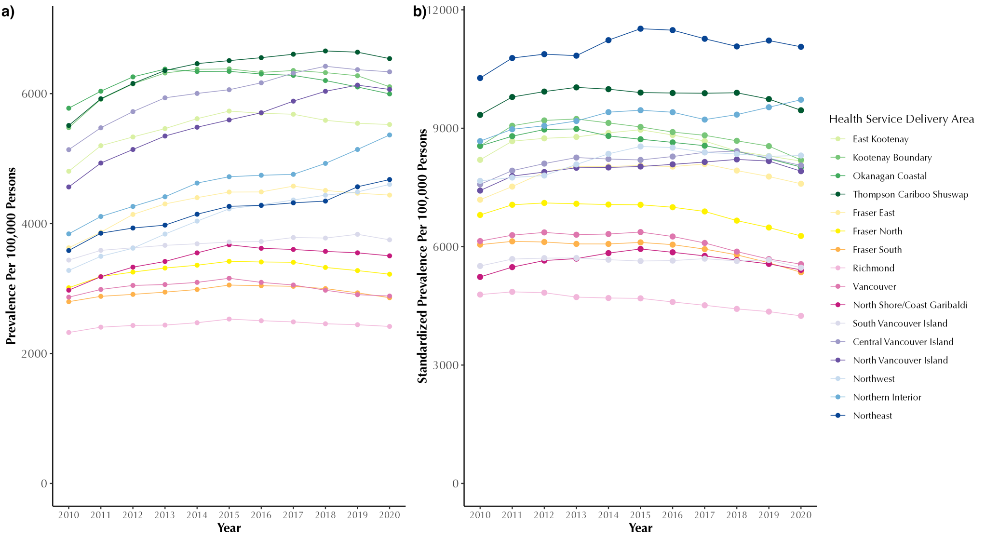

Figure A2: Annual crude (a) and sex and age standardized (b) chronic obstructive pulmonary disease prevalence (per 100,000 persons) in British Columbia, Canada, from 2001 to 2020, stratified by Health Service Delivery Area

Table A7: Number of new COPD cases and Sex and age Standardized Incidence (per 100,000) in British Columbia, Canada, from 2001 to 2020, stratified by Health Service Delivery Area
Year of Diagnosis
 | 2010 | 2011 | 2012 | 2013 | 2014 | 2015 | 2016 | 2017 | 2018 | 2019 | 2020 | 2010 | 2011 | 2012 | 2013 | 2014 | 2015 | 2016 | 2017 | 2018 | 2019 | 2020
 | Number of new COPD cases |  |  |  |  |  |  |  |  |  |  | Sex and age Standardized Incidence Rate (per 100,000 persons at risk)*
Total | 20229 | 18058 | 16321 | 15360 | 14994 | 14721 | 13680 | 13909 | 13684 | 13060 | 10807 | 570.9 | 499.8 | 440.9 | 403.9 | 383.5 | 368 | 334.2 | 331.1 | 317.2 | 293.5 | 236.5
HSDA11 | 512 | 472 | 387 | 391 | 407 | 413 | 358 | 326 | 316 | 314 | 272 | 770.8 | 711.6 | 564.3 | 554.5 | 565.9 | 562.6 | 467.3 | 414.8 | 393.1 | 380.7 | 321.4
HSDA12 | 575 | 577 | 434 | 411 | 359 | 359 | 340 | 339 | 366 | 320 | 207 | 783.5 | 777.6 | 582.8 | 541.9 | 460.6 | 448.8 | 416.5 | 414.7 | 428.5 | 377.4 | 239.3
HSDA13 | 2535 | 2130 | 2011 | 1809 | 1659 | 1738 | 1543 | 1456 | 1449 | 1440 | 1250 | 771.5 | 644.1 | 595.1 | 523.1 | 466.9 | 475.3 | 411.5 | 377 | 365 | 356 | 298.6
HSDA14 | 1544 | 1413 | 1207 | 1249 | 1198 | 1081 | 1022 | 1204 | 1133 | 1018 | 729 | 825 | 755 | 636.6 | 645.6 | 602.5 | 533.8 | 492.7 | 570.4 | 517.8 | 455.3 | 315.6
HSDA21 | 1552 | 1232 | 1366 | 1119 | 988 | 970 | 926 | 987 | 870 | 878 | 838 | 724.6 | 560.3 | 608.2 | 485 | 416.4 | 397.9 | 371.3 | 383.7 | 329.1 | 320.8 | 298.1
HSDA22 | 2365 | 2202 | 1796 | 1672 | 1642 | 1562 | 1521 | 1515 | 1355 | 1372 | 1033 | 571.4 | 514 | 409 | 365.6 | 350.4 | 328 | 312.3 | 303.1 | 264.5 | 257.3 | 188.7
HSDA23 | 2356 | 1979 | 1857 | 1782 | 1800 | 1793 | 1753 | 1682 | 1558 | 1438 | 1200 | 456.1 | 371.6 | 335.1 | 310.3 | 303.2 | 296.9 | 277.6 | 260.3 | 233.4 | 208 | 166.9
HSDA31 | 502 | 421 | 390 | 347 | 383 | 362 | 347 | 355 | 396 | 355 | 256 | 347.9 | 282.5 | 260.6 | 220.9 | 234.5 | 215.7 | 199.3 | 202.5 | 219.8 | 188 | 133.2
HSDA32 | 1947 | 1854 | 1706 | 1553 | 1437 | 1538 | 1357 | 1329 | 1410 | 1184 | 1104 | 426.6 | 401.4 | 360.5 | 323.1 | 290.4 | 305.9 | 266.1 | 255.1 | 264 | 214.1 | 193.2
HSDA33 | 990 | 1032 | 972 | 911 | 823 | 888 | 753 | 826 | 771 | 734 | 579 | 413.4 | 427 | 391.7 | 357.8 | 316.2 | 333.6 | 280.4 | 299.7 | 272.4 | 251.2 | 194.5
HSDA41 | 1538 | 1242 | 1097 | 1122 | 1187 | 1122 | 1025 | 1122 | 1075 | 998 | 864 | 450.3 | 362 | 311.6 | 311 | 321.2 | 296.9 | 263.9 | 282.2 | 265.3 | 241.5 | 204.4
HSDA42 | 1807 | 1528 | 1439 | 1351 | 1273 | 1226 | 1136 | 1257 | 1266 | 1077 | 913 | 692.1 | 578.9 | 535.5 | 492.6 | 452.4 | 425.8 | 385 | 415 | 405.7 | 340.5 | 281.6
HSDA43 | 712 | 698 | 549 | 539 | 630 | 567 | 546 | 546 | 606 | 581 | 409 | 642.3 | 616.1 | 470.7 | 453.5 | 514.3 | 447.9 | 425 | 412.9 | 438.6 | 414 | 287.9
HSDA51 | 305 | 260 | 256 | 295 | 345 | 272 | 252 | 241 | 232 | 281 | 270 | 548.2 | 501.1 | 481.5 | 527 | 590.3 | 474 | 435.1 | 401.1 | 388.7 | 449.6 | 438.3
HSDA52 | 601 | 644 | 544 | 574 | 573 | 553 | 537 | 482 | 584 | 793 | 662 | 614.7 | 635.7 | 523.4 | 546.7 | 533.5 | 515 | 493.9 | 431.4 | 500.6 | 640.2 | 540.8
HSDA53 | 357 | 351 | 290 | 216 | 283 | 273 | 249 | 238 | 277 | 265 | 213 | 982.1 | 918.8 | 704.3 | 552.3 | 697.1 | 717.4 | 630.9 | 599.2 | 655.4 | 612.2 | 461.4
* Rates are expressed as new cases per 100,000 persons at risk per year (equivalent to per 100,000 person-years at risk).
Abbreviations: COPD: Chronic Obstructive Pulmonary Disease, HSDA: Health Services Delivery Area; HSDA11: East Kootenay, HSDA 12: Kootenay Boundary, HSDA 13: Okanagan, HSDA 14: Thompson Cariboo Shuswap, HSDA 21: Fraser East, HSDA 22: Fraser North, HSDA 23: Fraser South, HSDA 31: Richmond, HSDA 32: Vancouver, HSDA 33: North Shore/Coast Garibaldi, HSDA 41: South Vancouver Island, HSDA 42: Central Vancouver Island, HSDA 43: North Vancouver Island, HSDA 51: Northwest, HSDA 52: Northern Interior, HSDA 53: Northeast.

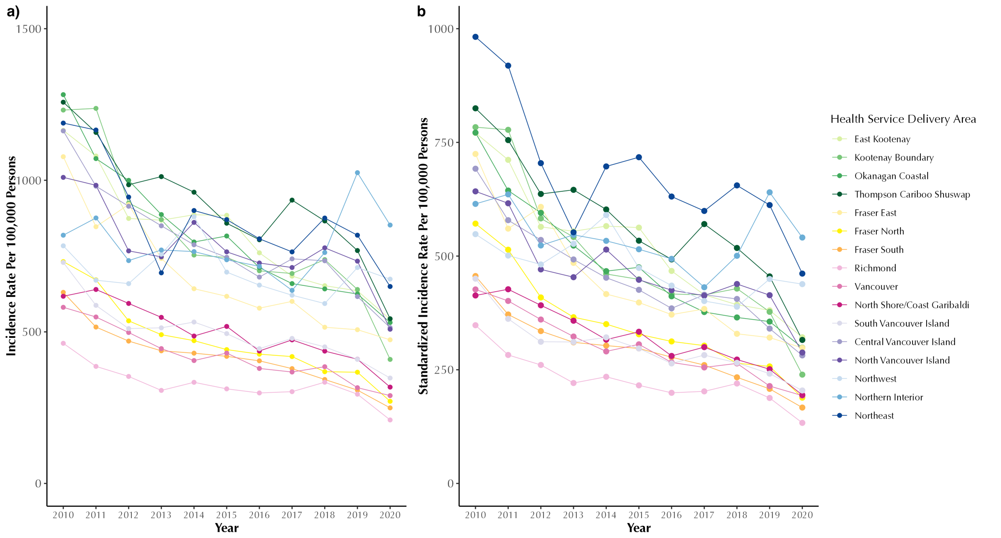

Figure A3: Annual crude (a) and sex and age standardized (b) chronic obstructive pulmonary disease incidence rate (per 100,000 persons) in British Columbia, Canada, from 2001 to 2020, stratified by Health Service Delivery Area
Rates are expressed as new cases per 100,000 persons at risk per year (equivalent to per 100,000 person-years at risk).

Table A8: All-cause, COPD-specific and CVD-specific number of hospital admissions and sex and age standardized hospitalization rate (per 100,000 COPD patients) from 2001 to 2020, stratified by Health Service Delivery Area
Admission Year
 | 2010 | 2011 | 2012 | 2013 | 2014 | 2015 | 2016 | 2017 | 2018 | 2019 | 2020 | 2010 | 2011 | 2012 | 2013 | 2014 | 2015 | 2016 | 2017 | 2018 | 2019 | 2020
 | Number of All-cause hospitalizations |  |  |  |  |  |  |  |  |  |  | Sex and age-standardized All-cause hospitalization rate (per 100,000 COPD patients)*
Total | 141580 | 145797 | 147532 | 149056 | 146880 | 146589 | 145109 | 141028 | 138170 | 134172 | 111744 | 93165.2 | 87530.8 | 82811.4 | 78038.6 | 73606.7 | 71700.1 | 69258.1 | 65491.5 | 60761.8 | 54878.3 | 43578.4
HSDA11 | 3800 | 3897 | 3848 | 3751 | 3894 | 4116 | 3706 | 3554 | 3405 | 3284 | 2746 | 114348.3 | 105627.4 | 106101.5 | 94365.6 | 81673.6 | 103769.7 | 81396.2 | 75011.8 | 72308.0 | 63326.8 | 49633.2
HSDA12 | 4017 | 4051 | 4082 | 4051 | 3961 | 3884 | 3693 | 3516 | 3628 | 3534 | 2811 | 100803.4 | 92574.6 | 82375.2 | 97470.4 | 83927.7 | 75882.9 | 82588.6 | 62311.8 | 57189.1 | 51165.4 | 43479.4
HSDA13 | 17965 | 18243 | 18361 | 18486 | 18255 | 18504 | 18251 | 16913 | 16882 | 16392 | 13922 | 98400.1 | 99175.6 | 91264.5 | 85921.7 | 80083.3 | 80079.0 | 76865.0 | 63073.7 | 62142.3 | 56132.1 | 44676.0
HSDA14 | 11582 | 12066 | 12062 | 12447 | 12381 | 12089 | 11748 | 11587 | 11850 | 11349 | 9318 | 104611.5 | 103901.4 | 101460.6 | 99191.4 | 80769.8 | 84139.8 | 84440.9 | 76475.6 | 71856.4 | 63609.7 | 48779.3
HSDA21 | 10908 | 10889 | 11434 | 11393 | 11108 | 11117 | 11069 | 10646 | 10470 | 10265 | 8608 | 112001.7 | 97038.2 | 91239.5 | 86466.7 | 76861.8 | 74029.0 | 78135.9 | 67551.6 | 61776.5 | 58268.6 | 46291.8
HSDA22 | 15577 | 16642 | 16547 | 16752 | 16444 | 16866 | 16312 | 15945 | 15296 | 15067 | 12518 | 87611.3 | 80239.1 | 76087.6 | 69778.3 | 65042.3 | 63502.6 | 60312.2 | 59048.7 | 54672.5 | 51786.3 | 41728.7
HSDA23 | 17824 | 18436 | 18989 | 19177 | 19267 | 19660 | 19461 | 19204 | 18664 | 18008 | 14618 | 84483.7 | 79945.6 | 81667.2 | 73888.7 | 73366.0 | 72395.4 | 68930.3 | 64375.9 | 61061.7 | 56837.1 | 43659.1
HSDA31 | 3290 | 3403 | 3314 | 3258 | 3288 | 3310 | 3435 | 3146 | 3135 | 2867 | 2369 | 61933.5 | 68018.6 | 56894.9 | 57015.8 | 63724.3 | 64097.9 | 65955.6 | 60351.2 | 57916.7 | 56458.0 | 37994.4
HSDA32 | 13527 | 13528 | 14287 | 14644 | 13817 | 13353 | 12944 | 12689 | 12441 | 11520 | 9683 | 75461.7 | 70618.1 | 68395.4 | 74479.8 | 70712.7 | 67118.4 | 62029.5 | 63566.4 | 61347.9 | 54065.9 | 44555.4
HSDA33 | 7674 | 7679 | 7590 | 8065 | 7330 | 7430 | 7430 | 7223 | 6997 | 6876 | 5379 | 96271.2 | 87436.5 | 76859.0 | 74224.2 | 69728.3 | 63868.4 | 62456.3 | 59161.7 | 50677.5 | 45674.1 | 37233.6
HSDA41 | 9603 | 10199 | 10290 | 10290 | 10564 | 10324 | 10391 | 10197 | 9734 | 9454 | 8015 | 90774.6 | 81701.1 | 79036.2 | 74350.4 | 80365.0 | 70783.5 | 68226.6 | 63967.3 | 58793.9 | 52245.7 | 40264.3
HSDA42 | 10325 | 10777 | 11238 | 11290 | 11230 | 10797 | 11132 | 11187 | 10500 | 10541 | 9303 | 93076.5 | 91864.8 | 81499.2 | 69285.5 | 66824.9 | 61077.7 | 59755.6 | 58815.6 | 51730.5 | 48335.8 | 40783.5
HSDA43 | 4806 | 5039 | 4838 | 4783 | 4766 | 4955 | 5082 | 4796 | 4620 | 4978 | 4142 | 113884.0 | 102333.4 | 101199.0 | 91278.9 | 85384.0 | 79009.6 | 67346.9 | 64915.7 | 53235.0 | 53226.2 | 44379.0
HSDA51 | 3008 | 3084 | 2736 | 2740 | 2738 | 2692 | 2749 | 2728 | 2682 | 2504 | 2142 | 150937.5 | 140920.5 | 132767.0 | 111122.4 | 92934.9 | 81597.0 | 101553.3 | 92827.1 | 79456.6 | 64175.0 | 51592.6
HSDA52 | 5373 | 5652 | 5783 | 5827 | 5698 | 5470 | 5597 | 5479 | 5578 | 5469 | 4535 | 130518.2 | 111357.9 | 105294.6 | 99180.3 | 92553.2 | 103947.6 | 102398.4 | 98051.0 | 83635.9 | 62741.4 | 45166.9
HSDA53 | 2106 | 2047 | 1957 | 1953 | 1992 | 1873 | 1962 | 2038 | 2064 | 1913 | 1544 | 93615.2 | 90665.8 | 85840.8 | 70441.4 | 66358.5 | 73944.6 | 66561.9 | 74225.0 | 68692.4 | 56739.6 | 42757.1
 | Number of COPD-specific hospitalizations |  |  |  |  |  |  |  |  |  |  | Sex and age-standardized COPD-specific hospitalization rate (per 100,000 COPD patients)*
Total | 8379 | 8942 | 8912 | 9423 | 9484 | 10032 | 9986 | 10527 | 9893 | 9347 | 6647 | 3749.2 | 3518.0 | 3264.5 | 3664.4 | 3484.8 | 3439.2 | 3435.0 | 3671.0 | 3396.5 | 3028.3 | 2179.7
HSDA11 | 200 | 212 | 256 | 278 | 285 | 315 | 252 | 292 | 258 | 225 | 181 | 3639.6 | 4044.8 | 3864.9 | 5220.7 | 3787.5 | 3768.6 | 3139.6 | 3877.7 | 4020.9 | 2974.4 | 3591.9
HSDA12 | 212 | 195 | 221 | 222 | 198 | 221 | 214 | 239 | 242 | 216 | 183 | 3845.8 | 2876.1 | 3415.1 | 3132.3 | 3078.0 | 2902.7 | 2648.8 | 3001.5 | 2853.2 | 2916.4 | 2638.6
HSDA13 | 1062 | 1074 | 1070 | 1056 | 1096 | 1132 | 1217 | 1281 | 1199 | 1162 | 851 | 3767.3 | 3765.6 | 3147.3 | 2964.9 | 2957.2 | 3123.2 | 3329.5 | 3991.8 | 3486.2 | 3025.6 | 2334.4
HSDA14 | 606 | 700 | 672 | 734 | 736 | 812 | 817 | 829 | 790 | 812 | 573 | 3530.1 | 3837.5 | 3093.2 | 3698.2 | 3089.0 | 3386.9 | 3555.6 | 3234.1 | 4164.4 | 3021.1 | 2353.5
HSDA21 | 595 | 611 | 708 | 751 | 786 | 757 | 807 | 842 | 703 | 653 | 510 | 4831.9 | 3998.7 | 4063.9 | 4533.9 | 4438.6 | 4298.8 | 4055.0 | 4202.1 | 3371.3 | 2912.6 | 2268.8
HSDA22 | 971 | 1028 | 977 | 1053 | 959 | 1099 | 1118 | 1101 | 988 | 907 | 616 | 3463.1 | 3416.1 | 2965.3 | 3179.0 | 2935.2 | 3007.5 | 3009.2 | 2923.0 | 2838.6 | 2540.1 | 1763.2
HSDA23 | 1040 | 1143 | 1203 | 1334 | 1405 | 1620 | 1590 | 1619 | 1460 | 1398 | 950 | 3653.8 | 3559.1 | 3711.1 | 4544.5 | 4170.1 | 4278.9 | 4583.4 | 4739.1 | 3463.6 | 3575.5 | 2401.4
HSDA31 | 194 | 229 | 191 | 186 | 217 | 224 | 254 | 240 | 255 | 208 | 118 | 2371.4 | 3483.5 | 2415.7 | 2069.7 | 3421.8 | 3719.1 | 2500.3 | 2283.6 | 3131.1 | 1892.5 | 1230.6
HSDA32 | 1023 | 997 | 948 | 1041 | 1050 | 975 | 928 | 1067 | 945 | 843 | 602 | 4707.9 | 3585.4 | 3435.4 | 4212.0 | 3985.0 | 3424.5 | 3711.4 | 4434.4 | 4151.9 | 3582.0 | 2396.7
HSDA33 | 468 | 498 | 433 | 476 | 472 | 462 | 422 | 464 | 414 | 429 | 267 | 3147.8 | 3289.9 | 2564.0 | 2768.4 | 3173.8 | 2736.3 | 2295.2 | 3198.1 | 2337.6 | 2727.0 | 1324.5
HSDA41 | 537 | 673 | 655 | 721 | 699 | 710 | 696 | 792 | 704 | 697 | 453 | 2512.3 | 3020.1 | 2681.8 | 3863.8 | 3744.9 | 3090.4 | 3046.0 | 3532.4 | 2724.4 | 3026.5 | 1981.2
HSDA42 | 601 | 616 | 645 | 636 | 667 | 630 | 652 | 735 | 733 | 666 | 495 | 2970.6 | 2759.6 | 2788.6 | 2467.4 | 2869.1 | 2577.1 | 2621.1 | 2730.7 | 2898.4 | 2158.0 | 1643.9
HSDA43 | 230 | 301 | 260 | 273 | 268 | 322 | 304 | 281 | 345 | 351 | 270 | 2716.9 | 3283.2 | 2452.3 | 3334.5 | 3826.1 | 4852.2 | 2664.6 | 2277.7 | 3203.0 | 3089.7 | 2121.9
HSDA51 | 158 | 168 | 169 | 179 | 136 | 171 | 134 | 159 | 195 | 155 | 126 | 5096.0 | 4197.7 | 5028.9 | 4606.3 | 2687.4 | 3477.7 | 2781.1 | 4891.8 | 3679.9 | 3299.5 | 2482.6
HSDA52 | 333 | 371 | 397 | 365 | 370 | 451 | 402 | 382 | 449 | 421 | 308 | 4435.4 | 4415.2 | 4340.0 | 3922.5 | 4021.3 | 4431.5 | 3769.4 | 3496.0 | 4340.4 | 4061.0 | 2619.3
HSDA53 | 135 | 107 | 94 | 110 | 132 | 123 | 171 | 193 | 194 | 184 | 136 | 5050.1 | 3406.3 | 2515.4 | 3964.0 | 3223.5 | 3121.6 | 4867.6 | 5296.8 | 4675.5 | 3865.0 | 2772.7
 | Number of CVD-specific hospitalizations |  |  |  |  |  |  |  |  |  |  | Sex and age-standardized CVD-specific hospitalization rate (per 100,000 COPD patients) *
Total | 19040 | 19068 | 18150 | 18190 | 18168 | 17626 | 17521 | 17343 | 16570 | 16194 | 14005 | 9157.4 | 8342.0 | 7187.4 | 6848.8 | 6785.3 | 6235.6 | 5886.6 | 5697.9 | 5172.9 | 5006.0 | 4250.3
HSDA11 | 459 | 481 | 420 | 437 | 434 | 494 | 464 | 440 | 381 | 366 | 351 | 9674.8 | 7552.6 | 7961.3 | 6600.9 | 6690.4 | 11621.9 | 7288.2 | 7303.1 | 4543.4 | 4990.3 | 4709.3
HSDA12 | 567 | 583 | 514 | 517 | 522 | 473 | 468 | 457 | 462 | 382 | 329 | 9600.3 | 10760.1 | 9184.9 | 9062.2 | 9774.6 | 6071.7 | 5523.5 | 5183.1 | 5044.3 | 3962.4 | 3569.7
HSDA13 | 2366 | 2313 | 2111 | 2135 | 2153 | 2132 | 2020 | 1973 | 1820 | 1822 | 1664 | 7864.2 | 7697.7 | 6777.6 | 7771.6 | 6244.7 | 5537.3 | 5430.4 | 5370.9 | 4929.6 | 4597.2 | 4050.4
HSDA14 | 1476 | 1492 | 1363 | 1430 | 1513 | 1378 | 1369 | 1406 | 1361 | 1302 | 1097 | 9581.6 | 8442.5 | 7932.8 | 8762.6 | 7223.9 | 8046.6 | 5880.7 | 6353.5 | 6295.5 | 5605.0 | 4889.1
HSDA21 | 1602 | 1589 | 1584 | 1587 | 1653 | 1584 | 1420 | 1460 | 1363 | 1367 | 1201 | 11875.3 | 11308.0 | 9565.5 | 8477.3 | 8535.5 | 8354.9 | 6697.6 | 6864.5 | 5729.2 | 5515.7 | 5097.8
HSDA22 | 2061 | 2141 | 2029 | 1975 | 1952 | 1949 | 2029 | 1885 | 1859 | 1735 | 1510 | 8505.5 | 7924.9 | 6546.5 | 6120.3 | 5684.2 | 6227.4 | 5572.7 | 4738.8 | 4742.0 | 4889.2 | 3718.4
HSDA23 | 2642 | 2620 | 2469 | 2519 | 2586 | 2502 | 2410 | 2600 | 2460 | 2351 | 1916 | 9993.3 | 9217.9 | 7588.9 | 7124.3 | 8015.4 | 6461.4 | 6483.3 | 6213.5 | 5593.0 | 5271.9 | 4502.7
HSDA31 | 503 | 423 | 469 | 445 | 489 | 464 | 472 | 405 | 385 | 374 | 290 | 6928.4 | 5430.9 | 7055.5 | 5852.6 | 5613.5 | 5493.5 | 6283.6 | 4053.7 | 4558.7 | 3760.8 | 2572.6
HSDA32 | 1643 | 1717 | 1639 | 1605 | 1578 | 1478 | 1493 | 1407 | 1312 | 1295 | 1074 | 6670.1 | 6343.6 | 5767.4 | 5399.3 | 5320.3 | 4398.3 | 4915.1 | 4952.9 | 4451.8 | 4059.2 | 3457.7
HSDA33 | 1034 | 1070 | 1008 | 1106 | 972 | 966 | 963 | 956 | 893 | 843 | 723 | 9134.0 | 8783.5 | 6999.0 | 7024.0 | 6333.9 | 5835.7 | 5262.0 | 5966.2 | 4150.5 | 4107.2 | 4235.0
HSDA41 | 1115 | 1072 | 1072 | 1077 | 1080 | 1024 | 1106 | 1080 | 1086 | 1114 | 993 | 6899.0 | 5025.3 | 4777.7 | 4833.0 | 4650.9 | 4521.3 | 4982.4 | 4672.2 | 4394.3 | 4800.1 | 3971.6
HSDA42 | 1425 | 1352 | 1404 | 1463 | 1307 | 1269 | 1368 | 1314 | 1302 | 1300 | 1236 | 8038.9 | 7121.0 | 6051.5 | 5776.9 | 5697.5 | 4812.2 | 5556.8 | 4882.0 | 4385.6 | 4126.8 | 3638.4
HSDA43 | 673 | 726 | 680 | 608 | 672 | 687 | 668 | 673 | 625 | 728 | 630 | 10147.4 | 12464.8 | 7442.3 | 8349.7 | 7472.2 | 8518.8 | 6098.9 | 6125.8 | 5254.0 | 6993.0 | 4639.9
HSDA51 | 439 | 450 | 398 | 358 | 357 | 334 | 366 | 360 | 296 | 277 | 237 | 14286.9 | 13097.5 | 21071.7 | 9391.8 | 10823.4 | 7200.9 | 7829.6 | 7050.9 | 6601.0 | 5407.2 | 4648.9
HSDA52 | 685 | 732 | 675 | 659 | 609 | 609 | 640 | 654 | 679 | 666 | 530 | 13522.0 | 10078.1 | 8775.5 | 8989.2 | 6940.0 | 6689.5 | 6035.6 | 7223.9 | 6817.4 | 5727.7 | 4753.7
HSDA53 | 321 | 284 | 294 | 241 | 275 | 273 | 246 | 260 | 254 | 252 | 217 | 12605.9 | 8785.5 | 9257.3 | 6524.8 | 8879.9 | 6338.2 | 6034.4 | 6448.9 | 6368.4 | 5959.4 | 5498.5
* Rates are expressed as hospitalizations per 100,000 persons with COPD per year (equivalent to per 100,000 COPD patient-years).
Abbreviations: COPD: Chronic Obstructive Pulmonary Disease, CVD: Cardio-vascular Disease; HSDA: Health Services Delivery Area; HSDA11: East Kootenay, HSDA 12: Kootenay Boundary, HSDA 13: Okanagan, HSDA 14: Thompson Cariboo Shuswap, HSDA 21: Fraser East, HSDA 22: Fraser North, HSDA 23: Fraser South, HSDA 31: Richmond, HSDA 32: Vancouver, HSDA 33: North Shore/Coast Garibaldi, HSDA 41: South Vancouver Island, HSDA 42: Central Vancouver Island, HSDA 43: North Vancouver Island, HSDA 51: Northwest, HSDA 52: Northern Interior, HSDA 53: Northeast
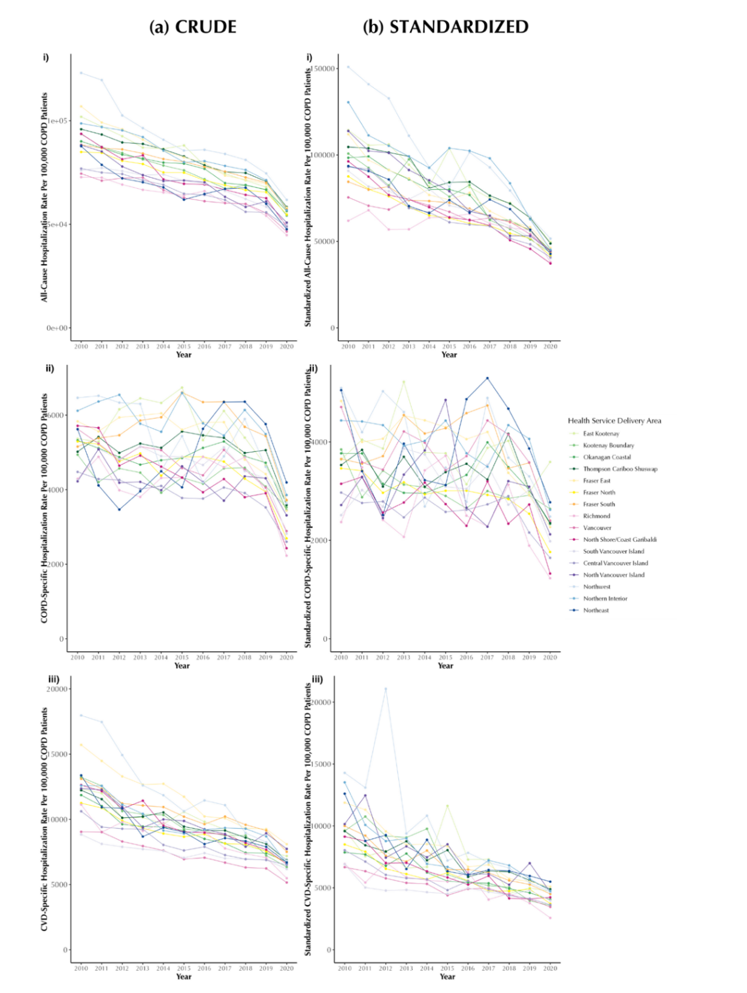

All-cause Hospitalization

COPD-Specific Hospitalization

CVD-specific Hospitalization

Figure A4: Annual crude (a) and age- and sex-standardized (b) all-cause (i), COPD-specific (ii), and CVD-specific (iii) hospitalization rates (per 100,000 persons with COPD) in British Columbia, Canada, 2001–2020, stratified by Health Service Delivery Area.
Rates are expressed as hospitalizations per 100,000 persons with COPD per year (equivalent to per 100,000 COPD patient-years).

Table A9: Crude mortality count and sex and age standardized mortality rate (per 100,000 COPD patient) from 2001 to 2020, stratified by Health Service Delivery Area
Year of Death
 | 2010 | 2011 | 2012 | 2013 | 2014 | 2015 | 2016 | 2017 | 2018 | 2019 | 2020 | 2010 | 2011 | 2012 | 2013 | 2014 | 2015 | 2016 | 2017 | 2018 | 2019 | 2020
 | Number of All-cause deaths |  |  |  |  |  |  |  |  |  |  | Sex and age-standardized All-cause mortality rate (per 100,000 COPD patients)
Total | 7871 | 8518 | 8802 | 9046 | 9371 | 9981 | 10171 | 10536 | 10652 | 10723 | 10941 | 2435.3 | 2406.2 | 2333.1 | 2325.0 | 2360.7 | 2418.1 | 2441.9 | 2414.3 | 2455.8 | 2394.9 | 2517.1
HSDA11 | 190 | 227 | 224 | 202 | 215 | 301 | 262 | 276 | 241 | 245 | 254 | 2405.4 | 2792.3 | 2462.4 | 2264.5 | 2341.3 | 3006.9 | 2797.0 | 2576.5 | 2501.0 | 2454.9 | 2530.6
HSDA12 | 237 | 223 | 249 | 262 | 263 | 253 | 266 | 266 | 274 | 315 | 281 | 3150.6 | 2324.4 | 2708.1 | 2686.9 | 2742.1 | 2559.4 | 2740.7 | 2456.8 | 2483.6 | 2536.0 | 2776.2
HSDA13 | 1106 | 1156 | 1219 | 1236 | 1157 | 1307 | 1353 | 1391 | 1356 | 1348 | 1386 | 2613.8 | 2411.3 | 2492.9 | 2453.9 | 2237.4 | 2614.8 | 2622.9 | 2490.3 | 2595.6 | 2360.5 | 2637.5
HSDA14 | 550 | 620 | 666 | 715 | 757 | 775 | 813 | 844 | 843 | 866 | 814 | 2398.6 | 2617.0 | 2639.7 | 2596.2 | 2810.7 | 3112.0 | 2906.6 | 2736.8 | 2575.1 | 2659.4 | 2604.6
HSDA21 | 489 | 493 | 557 | 568 | 645 | 693 | 703 | 774 | 746 | 843 | 760 | 2605.5 | 2170.4 | 2421.4 | 2372.9 | 2594.6 | 2459.7 | 2404.7 | 2999.6 | 2635.4 | 2859.5 | 2559.4
HSDA22 | 811 | 876 | 938 | 910 | 1004 | 1090 | 1077 | 1114 | 1152 | 1074 | 1206 | 2217.8 | 2147.5 | 2171.3 | 2109.6 | 2167.5 | 2200.7 | 2183.2 | 2039.3 | 2139.3 | 2240.6 | 2474.3
HSDA23 | 963 | 1061 | 1073 | 1097 | 1152 | 1289 | 1294 | 1286 | 1368 | 1330 | 1393 | 2376.8 | 2525.2 | 2359.7 | 2399.5 | 2279.0 | 2389.0 | 2351.8 | 2466.6 | 2449.5 | 2268.9 | 2370.3
HSDA31 | 217 | 226 | 222 | 214 | 191 | 206 | 218 | 192 | 220 | 211 | 223 | 2102.7 | 2016.4 | 2088.2 | 1843.3 | 1555.7 | 2308.9 | 1744.1 | 1426.3 | 3158.1 | 1641.7 | 1639.5
HSDA32 | 843 | 907 | 930 | 967 | 969 | 1025 | 1004 | 1096 | 1036 | 1005 | 1105 | 2256.7 | 2340.0 | 2168.0 | 2213.5 | 2149.5 | 2239.1 | 2402.3 | 2449.3 | 2569.2 | 2471.8 | 2789.3
HSDA33 | 417 | 445 | 471 | 482 | 511 | 565 | 515 | 580 | 557 | 578 | 545 | 2501.6 | 2142.2 | 2132.8 | 1948.8 | 2003.3 | 2797.5 | 1913.9 | 2150.5 | 2056.3 | 2051.9 | 2010.9
HSDA41 | 675 | 757 | 742 | 768 | 821 | 805 | 843 | 906 | 923 | 916 | 913 | 2241.0 | 2612.3 | 2317.9 | 2304.0 | 2925.9 | 2185.5 | 2625.8 | 2252.9 | 2393.4 | 2464.2 | 2571.3
HSDA42 | 629 | 670 | 665 | 749 | 797 | 774 | 846 | 842 | 917 | 905 | 949 | 2542.3 | 2318.5 | 2105.4 | 2222.2 | 2378.4 | 2180.9 | 2409.4 | 2293.9 | 2438.9 | 2162.2 | 2680.1
HSDA43 | 256 | 291 | 301 | 318 | 300 | 306 | 342 | 377 | 355 | 434 | 422 | 2490.5 | 2490.6 | 2405.0 | 2435.9 | 2332.8 | 2420.4 | 2236.9 | 2708.2 | 2209.5 | 2512.3 | 2445.2
HSDA51 | 112 | 140 | 112 | 132 | 133 | 123 | 139 | 137 | 140 | 144 | 158 | 2512.1 | 2950.7 | 2358.3 | 2652.2 | 2373.8 | 2022.5 | 2428.5 | 2188.5 | 2290.4 | 2574.1 | 2293.6
HSDA52 | 231 | 275 | 289 | 279 | 329 | 345 | 371 | 323 | 376 | 369 | 406 | 2683.0 | 2859.1 | 2670.4 | 2524.6 | 2721.2 | 2827.0 | 3047.8 | 2544.4 | 2827.0 | 2568.7 | 2894.1
HSDA53 | 116 | 124 | 113 | 124 | 127 | 124 | 125 | 132 | 143 | 131 | 112 | 3040.8 | 2905.0 | 2560.9 | 2699.4 | 2854.2 | 2550.1 | 2536.0 | 2540.3 | 2768.6 | 2439.6 | 2290.8
 | Number of COPD-specific deaths |  |  |  |  |  |  |  |  |  |  | Sex and age-standardized COPD-specific mortality rate (per 100,000 COPD patients)
Total | 1283 | 1364 | 1241 | 1368 | 1411 | 1542 | 1604 | 1607 | 1597 | 1567 | 1460 | 378.0 | 365.5 | 309.3 | 330.1 | 333.0 | 358.5 | 343.0 | 332.5 | 343.9 | 318.9 | 302.5
HSDA11 | 41 | 28 | 33 | 42 | 19 | 55 | 52 | 43 | 33 | 44 | 44 | 469.0 | 346.9 | 324.8 | 458.8 | 149.3 | 587.6 | 435.3 | 353.9 | 382.0 | 474.6 | 367.1
HSDA12 | 40 | 31 | 32 | 33 | 38 | 29 | 41 | 34 | 37 | 45 | 41 | 445.4 | 296.6 | 288.3 | 311.9 | 363.6 | 238.3 | 431.0 | 280.3 | 303.6 | 420.9 | 345.2
HSDA13 | 163 | 181 | 158 | 158 | 153 | 168 | 176 | 206 | 196 | 165 | 184 | 343.3 | 348.6 | 285.1 | 289.1 | 288.4 | 317.9 | 275.8 | 347.0 | 357.8 | 247.1 | 316.1
HSDA14 | 91 | 115 | 106 | 109 | 102 | 115 | 123 | 123 | 120 | 143 | 109 | 341.7 | 442.3 | 372.2 | 359.3 | 320.2 | 374.5 | 348.2 | 366.9 | 358.8 | 409.0 | 310.7
HSDA21 | 94 | 70 | 84 | 106 | 102 | 103 | 105 | 126 | 118 | 116 | 124 | 459.3 | 280.1 | 401.9 | 404.8 | 369.0 | 337.7 | 312.4 | 408.7 | 382.1 | 341.4 | 362.5
HSDA22 | 133 | 116 | 132 | 135 | 147 | 155 | 173 | 174 | 157 | 151 | 140 | 441.2 | 287.0 | 300.7 | 277.5 | 376.0 | 296.7 | 296.6 | 277.6 | 273.7 | 277.4 | 226.9
HSDA23 | 150 | 164 | 146 | 154 | 165 | 216 | 200 | 186 | 194 | 190 | 153 | 342.0 | 337.3 | 279.1 | 320.7 | 286.5 | 363.0 | 342.4 | 298.7 | 341.4 | 293.7 | 230.5
HSDA31 | 39 | 43 | 31 | 28 | 26 | 22 | 27 | 23 | 30 | 28 | 24 | 306.1 | 348.8 | 240.8 | 204.4 | 163.9 | 117.1 | 185.1 | 150.9 | 221.6 | 202.6 | 150.0
HSDA32 | 136 | 151 | 125 | 151 | 149 | 155 | 138 | 155 | 136 | 120 | 124 | 328.8 | 469.8 | 286.9 | 335.6 | 294.7 | 412.2 | 286.7 | 317.1 | 317.7 | 257.8 | 250.7
HSDA33 | 58 | 83 | 65 | 63 | 70 | 95 | 83 | 87 | 95 | 85 | 69 | 238.6 | 352.9 | 238.6 | 240.4 | 238.2 | 335.4 | 312.5 | 273.7 | 293.5 | 290.3 | 242.5
HSDA41 | 109 | 129 | 105 | 115 | 157 | 133 | 156 | 161 | 147 | 147 | 111 | 410.8 | 339.6 | 271.0 | 307.4 | 397.7 | 350.1 | 386.8 | 355.4 | 380.6 | 343.8 | 291.5
HSDA42 | 100 | 111 | 99 | 124 | 127 | 138 | 142 | 131 | 153 | 158 | 154 | 385.3 | 341.6 | 287.1 | 369.1 | 349.2 | 345.5 | 409.9 | 329.2 | 371.9 | 352.3 | 351.6
HSDA43 | 42 | 55 | 49 | 54 | 48 | 61 | 68 | 66 | 64 | 73 | 65 | 352.9 | 463.7 | 402.7 | 379.2 | 373.4 | 414.1 | 430.0 | 544.8 | 329.2 | 372.8 | 344.4
HSDA51 | 20 | 22 | 9 | 21 | 14 | 20 | 22 | 13 | 20 | 23 | 28 | 418.0 | 414.0 | 169.9 | 429.0 | 222.2 | 302.1 | 340.3 | 191.3 | 286.7 | 342.0 | 399.7
HSDA52 | 41 | 42 | 52 | 50 | 74 | 55 | 69 | 63 | 75 | 61 | 69 | 402.4 | 370.0 | 427.7 | 421.8 | 611.7 | 423.6 | 499.6 | 466.4 | 482.5 | 405.0 | 441.7
HSDA53 | 22 | 19 | 14 | 22 | 20 | 22 | 29 | 16 | 22 | 16 | 19 | 525.8 | 453.2 | 308.4 | 451.0 | 387.1 | 426.7 | 530.6 | 275.8 | 390.4 | 274.5 | 618.5
 | Number of CVD-specific deaths |  |  |  |  |  |  |  |  |  |  | Sex and age-standardized CVD-specific mortality rate (per 100,000 COPD patients)
Total | 2258 | 2288 | 2424 | 2449 | 2409 | 2609 | 2657 | 2757 | 2780 | 2690 | 2702 | 609.3 | 566.3 | 566.6 | 541.1 | 510.3 | 536.0 | 525.6 | 563.3 | 527.0 | 507.6 | 501.1
HSDA11 | 41 | 55 | 64 | 50 | 60 | 79 | 66 | 69 | 60 | 60 | 67 | 482.8 | 556.7 | 670.4 | 493.0 | 632.2 | 707.3 | 520.0 | 535.0 | 504.8 | 496.9 | 534.7
HSDA12 | 77 | 68 | 72 | 73 | 84 | 71 | 79 | 78 | 82 | 92 | 80 | 759.9 | 602.9 | 605.6 | 659.5 | 794.5 | 587.1 | 639.6 | 587.6 | 676.4 | 671.2 | 711.8
HSDA13 | 322 | 325 | 360 | 362 | 312 | 399 | 375 | 437 | 381 | 367 | 343 | 630.0 | 567.8 | 575.4 | 576.0 | 475.4 | 615.5 | 586.5 | 700.8 | 584.0 | 551.2 | 517.9
HSDA14 | 149 | 168 | 165 | 186 | 182 | 188 | 219 | 216 | 210 | 214 | 204 | 659.3 | 573.2 | 530.4 | 665.5 | 558.9 | 906.6 | 621.6 | 595.7 | 602.8 | 669.7 | 656.5
HSDA21 | 129 | 131 | 150 | 151 | 177 | 188 | 175 | 180 | 176 | 206 | 166 | 677.6 | 530.4 | 612.0 | 548.3 | 582.2 | 614.2 | 492.3 | 852.9 | 491.1 | 642.2 | 446.1
HSDA22 | 222 | 219 | 239 | 222 | 246 | 267 | 270 | 282 | 286 | 236 | 283 | 528.5 | 466.7 | 492.7 | 431.1 | 446.0 | 452.9 | 472.9 | 499.1 | 457.7 | 383.6 | 480.9
HSDA23 | 305 | 284 | 276 | 274 | 287 | 338 | 338 | 343 | 351 | 322 | 328 | 684.8 | 563.3 | 610.8 | 500.3 | 475.4 | 531.7 | 547.9 | 550.0 | 525.6 | 459.5 | 461.3
HSDA31 | 66 | 76 | 62 | 54 | 47 | 47 | 53 | 51 | 45 | 48 | 44 | 607.1 | 586.6 | 487.2 | 453.3 | 337.7 | 322.6 | 335.2 | 393.0 | 333.5 | 424.8 | 234.7
HSDA32 | 227 | 223 | 234 | 251 | 230 | 237 | 231 | 244 | 238 | 244 | 238 | 504.1 | 495.4 | 453.5 | 503.6 | 411.7 | 395.0 | 413.3 | 416.1 | 412.4 | 405.0 | 400.9
HSDA33 | 114 | 119 | 142 | 150 | 141 | 147 | 134 | 162 | 150 | 152 | 138 | 525.4 | 537.3 | 632.9 | 501.0 | 504.4 | 472.2 | 400.2 | 560.8 | 441.8 | 407.1 | 452.8
HSDA41 | 208 | 209 | 247 | 244 | 222 | 227 | 239 | 237 | 280 | 228 | 272 | 500.8 | 536.1 | 580.8 | 589.0 | 549.2 | 474.3 | 518.3 | 494.4 | 575.5 | 465.4 | 511.8
HSDA42 | 201 | 189 | 195 | 204 | 218 | 199 | 231 | 233 | 265 | 248 | 250 | 665.9 | 581.2 | 519.7 | 524.7 | 578.2 | 451.4 | 563.2 | 526.3 | 596.6 | 529.0 | 496.9
HSDA43 | 69 | 72 | 82 | 79 | 67 | 79 | 85 | 86 | 81 | 121 | 121 | 562.5 | 560.9 | 545.0 | 489.1 | 408.5 | 454.6 | 457.9 | 466.7 | 416.4 | 620.7 | 643.2
HSDA51 | 24 | 34 | 23 | 37 | 36 | 25 | 36 | 33 | 43 | 31 | 36 | 517.3 | 740.7 | 444.0 | 643.3 | 605.5 | 431.2 | 639.9 | 561.0 | 628.0 | 482.6 | 479.3
HSDA52 | 50 | 75 | 80 | 72 | 62 | 88 | 92 | 75 | 92 | 84 | 103 | 553.4 | 856.4 | 745.9 | 596.1 | 467.3 | 693.5 | 621.7 | 542.8 | 635.1 | 501.4 | 667.9
HSDA53 | 45 | 32 | 21 | 34 | 38 | 30 | 34 | 31 | 37 | 36 | 25 | 1100.7 | 774.2 | 419.4 | 729.7 | 740.3 | 555.6 | 698.4 | 579.3 | 626.0 | 590.6 | 385.2
* Rates are expressed as hospitalizations per 100,000 persons with COPD per year (equivalent to per 100,000 COPD patient-years).
Abbreviations: COPD: Chronic Obstructive Pulmonary Disease, CVD: Cardio-vascular Disease; HSDA: Health Services Delivery Area; HSDA11: East Kootenay, HSDA 12: Kootenay Boundary, HSDA 13: Okanagan, HSDA 14: Thompson Cariboo Shuswap, HSDA 21: Fraser East, HSDA 22: Fraser North, HSDA 23: Fraser South, HSDA 31: Richmond, HSDA 32: Vancouver, HSDA 33: North Shore/Coast Garibaldi, HSDA 41: South Vancouver Island, HSDA 42: Central Vancouver Island, HSDA 43: North Vancouver Island, HSDA 51: Northwest, HSDA 52: Northern Interior, HSDA 53: Northeast.

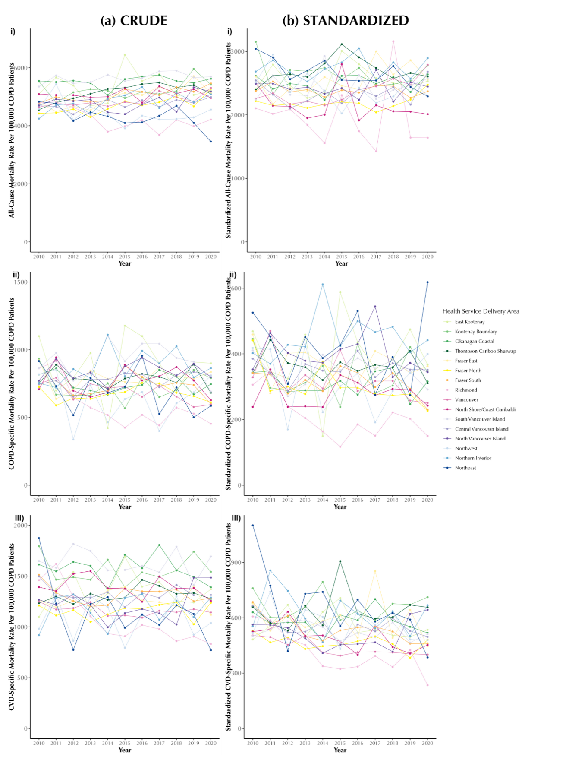
All-cause Mortality

COPD-specific Mortality

CVD-specific Mortality

Figure A5: Annual crude (a) and age- and sex-standardized (b) all-cause (i), COPD-specific (ii), and CVD-specific (iii) mortality rates (per 100,000 persons with COPD) in British Columbia, Canada, 2001–2020, stratified by Health Service Delivery Area.
Rates are expressed as mortality per 100,000 persons with COPD per year (equivalent to per 100,000 COPD patient-years

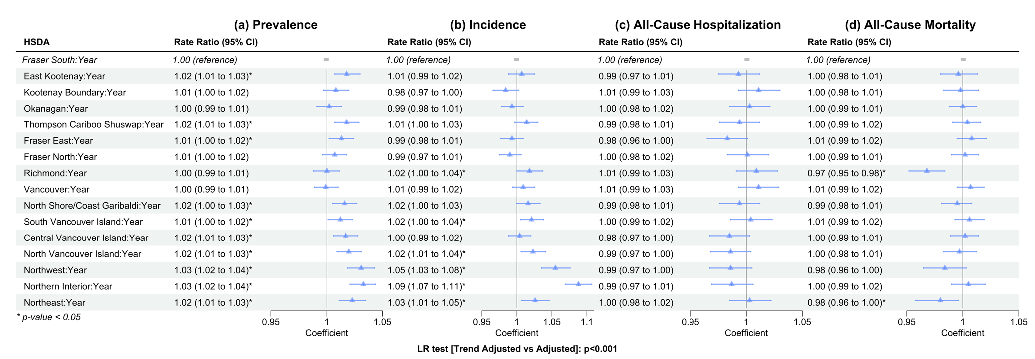
Figure A6: Rate ratios presented in a forest plot for the trend adjusted models for each primary outcome Prevalence (a), Incidence (b), All-cause hospitalization (c) and All-cause mortality (d). Confidence bands correspond to 95% CI.
Reference levels for HSDA: HSDA23 (Fraser South). Adjusted variables: Sex, Socio-Economic Status, Area of Residence, Age group.
Abbreviations: LR test: Likelihood-Ratio test; HSDA: Health Service Delivery Area, CI: Confidence Interval. Adjusted variables: Sex, Socio-Economic Status, Area of Residence, Age group. Abbreviations: LR test: Likelihood-Ratio test; HSDA: Health Service Delivery Area, CI: Confidence Interval

Table A10: Average Length of Stay and In-hospital Mortality (COPD specific admission) from 2001 to 2020, stratified by Health Service Delivery Area
Admission Year
 | Average Length of Stay (COPD specific admission) |  |  |  |  |  |  |  |  |  |  | In-Hospital Mortality Rate (per 100) (COPD specific admission)
 | 2010 | 2011 | 2012 | 2013 | 2014 | 2015 | 2016 | 2017 | 2018 | 2019 | 2020 | 2010 | 2011 | 2012 | 2013 | 2014 | 2015 | 2016 | 2017 | 2018 | 2019 | 2020
Total | 10.1 | 10.2 | 10.1 | 9.7 | 9.7 | 9.2 | 8.8 | 8.8 | 9.0 | 8.6 | 7.9 | 9.9 | 9.5 | 9.3 | 8.4 | 8.9 | 8.4 | 8.6 | 8.2 | 8.1 | 7.6 | 8.1
HSDA11 | 10.7 | 9.0 | 8.4 | 8.0 | 7.1 | 7.8 | 7.4 | 7.5 | 6.1 | 6.8 | 6.5 | 15.5 | 4.7 | 9.4 | 5.8 | 4.2 | 11.4 | 9.5 | 8.2 | 6.2 | 7.1 | 9.4
HSDA12 | 8.4 | 7.7 | 8.1 | 8.3 | 7.5 | 7.9 | 7.3 | 6.8 | 7.3 | 7.4 | 7.3 | 12.7 | 7.2 | 6.3 | 6.3 | 6.1 | 6.8 | 9.4 | 8.0 | 7.0 | 8.8 | 7.7
HSDA13 | 8.6 | 8.7 | 9.0 | 8.8 | 8.8 | 7.8 | 8.0 | 8.1 | 8.3 | 7.7 | 6.9 | 9.8 | 9.5 | 7.9 | 8.2 | 8.5 | 6.9 | 8.5 | 8.7 | 7.8 | 7.5 | 8.7
HSDA14 | 8.2 | 8.9 | 8.4 | 8.5 | 9.3 | 8.8 | 9.0 | 8.4 | 8.2 | 8.2 | 7.4 | 9.6 | 8.9 | 11.0 | 7.9 | 9.2 | 7.3 | 11.8 | 9.1 | 9.4 | 7.3 | 7.3
HSDA21 | 9.4 | 9.3 | 9.4 | 9.2 | 9.5 | 8.6 | 8.4 | 8.7 | 8.1 | 8.6 | 7.3 | 9.2 | 7.9 | 7.3 | 9.3 | 8.0 | 8.5 | 6.6 | 8.3 | 9.4 | 9.2 | 8.8
HSDA22 | 11.5 | 11.8 | 12.2 | 11.7 | 12.1 | 10.2 | 9.8 | 8.9 | 10.0 | 9.2 | 8.6 | 9.5 | 9.5 | 12.2 | 9.9 | 9.0 | 9.6 | 9.1 | 8.5 | 9.6 | 7.5 | 10.6
HSDA23 | 11.8 | 13.0 | 12.0 | 11.2 | 10.8 | 10.0 | 9.3 | 9.1 | 9.1 | 8.5 | 8.5 | 11.6 | 11.8 | 9.6 | 8.6 | 9.7 | 9.3 | 7.7 | 7.9 | 7.3 | 7.4 | 7.5
HSDA31 | 9.5 | 9.0 | 9.8 | 10.4 | 9.0 | 7.8 | 8.4 | 8.2 | 8.7 | 8.5 | 8.1 | 13.4 | 10.5 | 10.5 | 5.9 | 7.8 | 8.5 | 9.1 | 6.3 | 8.2 | 8.7 | 6.8
HSDA32 | 10.1 | 10.2 | 9.9 | 8.5 | 9.2 | 9.2 | 8.2 | 8.4 | 8.5 | 8.8 | 8.3 | 8.5 | 7.4 | 8.3 | 8.0 | 7.1 | 7.9 | 8.1 | 7.3 | 6.6 | 7.4 | 7.1
HSDA33 | 9.5 | 9.9 | 9.0 | 9.1 | 9.3 | 8.8 | 7.9 | 8.5 | 8.9 | 7.9 | 7.1 | 8.6 | 11.5 | 10.9 | 6.9 | 8.1 | 10.6 | 8.8 | 10.3 | 8.9 | 7.7 | 9.7
HSDA41 | 10.8 | 10.6 | 10.9 | 10.4 | 9.0 | 11.3 | 9.6 | 10.2 | 11.2 | 10.0 | 7.8 | 9.7 | 8.6 | 9.5 | 8.0 | 9.7 | 7.8 | 8.2 | 9.0 | 10.1 | 8.2 | 6.4
HSDA42 | 10.7 | 10.8 | 10.4 | 9.8 | 8.9 | 9.0 | 8.7 | 9.5 | 8.3 | 8.7 | 8.8 | 11.0 | 13.6 | 9.2 | 9.9 | 10.8 | 8.7 | 7.7 | 7.9 | 7.9 | 7.8 | 8.1
HSDA43 | 9.5 | 8.8 | 9.4 | 9.5 | 8.8 | 9.5 | 9.1 | 8.5 | 13.3 | 12.6 | 8.4 | 8.3 | 10.0 | 9.2 | 10.3 | 9.3 | 7.1 | 8.6 | 7.8 | 9.0 | 7.1 | 6.7
HSDA51 | 8.7 | 8.0 | 8.6 | 7.6 | 9.0 | 7.7 | 8.1 | 8.6 | 8.4 | 10.2 | 7.9 | 6.3 | 11.3 | 7.1 | 6.2 | 7.4 | 7.0 | 3.7 | 5.0 | 6.7 | 9.7 | 8.7
HSDA52 | 10.1 | 9.2 | 10.1 | 9.7 | 10.2 | 8.6 | 8.8 | 10.1 | 8.6 | 7.4 | 7.2 | 6.9 | 8.1 | 7.8 | 8.8 | 14.1 | 7.8 | 12.2 | 7.6 | 7.1 | 6.7 | 9.1
HSDA 53 | 11.4 | 9.8 | 11.7 | 10.4 | 13.5 | 8.9 | 9.8 | 9.1 | 11.1 | 7.3 | 9.4 | 11.1 | 7.5 | 7.5 | 7.3 | 9.9 | 6.5 | 8.2 | 3.6 | 6.7 | 7.1 | 2.9
Abbreviations: COPD: Chronic Obstructive Pulmonary Disease; HSDA11: East Kootenay, HSDA 12: Kootenay Boundary, HSDA 13: Okanagan, HSDA 14: Thompson Cariboo Shuswap, HSDA 21: Fraser East, HSDA 22: Fraser North, HSDA 23: Fraser South, HSDA 31: Richmond, HSDA 32: Vancouver, HSDA 33: North Shore/Coast Garibaldi, HSDA 41: South Vancouver Island, HSDA 42: Central Vancouver Island, HSDA 43: North Vancouver Island, HSDA 51: Northwest, HSDA 52: Northern Interior, HSDA 53: Northeast.

Table A11: Readmission Rate (28-day and 90-day) in COPD specific hospitalizations from 2001 to 2020, stratified by Health Service Delivery Area
Admit Year | Readmission rates (COPD specific readmission within 28 and 90 days)
Admit Year | 28-day Hospital Readmission Rate (%) |  |  |  |  |  |  |  |  |  |  | 90-day Hospital Readmission Rate (%)
Admit Year | 2010 | 2011 | 2012 | 2013 | 2014 | 2015 | 2016 | 2017 | 2018 | 2019 | 2020 | 2010 | 2011 | 2012 | 2013 | 2014 | 2015 | 2016 | 2017 | 2018 | 2019 | 2020
Total | 10.9 | 12.1 | 12.3 | 11.7 | 13.2 | 12.8 | 12.4 | 13.0 | 12.2 | 12.3 | 12.6 | 18.5 | 21.4 | 21.9 | 21.4 | 22.4 | 23.1 | 22.3 | 23.2 | 22.4 | 21.9 | 23.6
HSDA11 | 14.0 | 10.4 | 10.2 | 12.9 | 14.4 | 14.3 | 14.3 | 11.6 | 13.6 | 16.9 | 14.9 | 18.5 | 17.9 | 22.3 | 26.3 | 26.3 | 23.8 | 23.0 | 21.6 | 20.9 | 26.7 | 24.9
HSDA12 | 16.0 | 9.2 | 11.3 | 12.6 | 7.6 | 13.1 | 9.3 | 12.1 | 11.6 | 10.6 | 10.9 | 24.5 | 17.4 | 19.0 | 19.4 | 17.2 | 18.6 | 21.5 | 19.2 | 17.8 | 19.0 | 23.5
HSDA13 | 12.0 | 13.4 | 11.4 | 10.0 | 9.9 | 11.3 | 10.6 | 11.7 | 13.3 | 11.8 | 13.3 | 19.1 | 21.4 | 20.8 | 17.6 | 18.6 | 19.5 | 19.8 | 23.0 | 22.4 | 22.8 | 24.2
HSDA14 | 9.1 | 12.6 | 12.5 | 8.9 | 9.1 | 9.2 | 12.4 | 13.6 | 7.7 | 12.4 | 13.6 | 16.5 | 25.0 | 22.8 | 19.9 | 19.7 | 20.4 | 21.4 | 22.9 | 15.8 | 20.1 | 27.2
HSDA21 | 10.1 | 12.1 | 13.8 | 14.1 | 16.5 | 15.2 | 13.9 | 13.5 | 12.7 | 12.4 | 15.7 | 19.0 | 19.8 | 24.4 | 23.6 | 26.6 | 26.4 | 23.9 | 23.9 | 23.8 | 21.6 | 23.1
HSDA22 | 9.2 | 11.7 | 10.3 | 12.7 | 11.3 | 13.5 | 12.0 | 12.7 | 11.1 | 11.4 | 13.1 | 18.2 | 22.0 | 20.5 | 22.5 | 20.6 | 23.8 | 22.8 | 24.2 | 22.3 | 19.6 | 25.5
HSDA23 | 10.4 | 11.1 | 12.8 | 12.9 | 14.6 | 14.8 | 14.3 | 14.0 | 14.7 | 15.3 | 13.5 | 16.9 | 19.6 | 22.6 | 24.1 | 24.3 | 27.3 | 25.2 | 25.3 | 27.7 | 26.3 | 24.0
HSDA31 | 9.8 | 7.9 | 15.2 | 6.5 | 8.8 | 11.2 | 12.2 | 18.3 | 17.6 | 13.5 | 4.2 | 14.4 | 15.7 | 22.5 | 15.6 | 17.1 | 22.8 | 22.4 | 26.7 | 26.7 | 22.1 | 12.7
HSDA32 | 14.7 | 13.7 | 11.9 | 13.6 | 19.5 | 13.3 | 9.4 | 14.1 | 13.5 | 13.9 | 15.0 | 23.2 | 26.4 | 22.5 | 25.0 | 29.5 | 25.4 | 20.6 | 24.3 | 26.7 | 24.7 | 26.2
HSDA33 | 10.3 | 10.4 | 13.2 | 13.7 | 15.0 | 9.7 | 13.7 | 15.5 | 11.1 | 10.0 | 12.0 | 19.0 | 19.5 | 23.1 | 22.5 | 22.2 | 18.6 | 21.8 | 22.8 | 17.9 | 21.0 | 19.5
HSDA41 | 8.4 | 11.0 | 9.0 | 9.4 | 11.4 | 14.1 | 13.4 | 11.2 | 11.6 | 10.0 | 8.2 | 14.5 | 18.7 | 18.0 | 17.6 | 21.6 | 23.2 | 24.6 | 20.5 | 18.5 | 18.4 | 18.3
HSDA42 | 10.5 | 14.3 | 11.2 | 9.6 | 12.1 | 10.0 | 13.2 | 12.8 | 12.8 | 12.2 | 11.5 | 19.3 | 23.4 | 20.0 | 17.6 | 19.0 | 20.5 | 20.1 | 21.8 | 25.1 | 22.5 | 23.8
HSDA43 | 7.8 | 10.6 | 14.2 | 11.0 | 12.7 | 10.2 | 8.2 | 8.5 | 7.2 | 10.3 | 13.3 | 15.2 | 18.6 | 21.9 | 18.3 | 19.4 | 18.6 | 18.1 | 18.9 | 16.8 | 19.1 | 25.2
HSDA51 | 10.8 | 18.5 | 20.1 | 12.3 | 11.8 | 17.5 | 9.7 | 11.9 | 11.8 | 11.0 | 11.1 | 17.1 | 28.0 | 26.0 | 22.9 | 17.6 | 26.3 | 14.2 | 18.9 | 21.0 | 18.1 | 23.8
HSDA52 | 11.7 | 12.1 | 15.9 | 12.6 | 15.1 | 12.4 | 14.4 | 11.5 | 8.0 | 8.6 | 8.8 | 17.7 | 20.2 | 25.4 | 24.1 | 23.5 | 21.7 | 22.6 | 21.2 | 16.7 | 16.9 | 22.4
HSDA53 | 8.1 | 7.5 | 17.0 | 11.8 | 11.4 | 14.6 | 17.5 | 15.0 | 16.0 | 9.2 | 8.1 | 16.3 | 16.8 | 25.5 | 19.1 | 17.4 | 21.1 | 28.7 | 25.9 | 24.2 | 20.7 | 16.2
Abbreviations: COPD: Chronic Obstructive Pulmonary Disease; HSDA11: East Kootenay, HSDA 12: Kootenay Boundary, HSDA 13: Okanagan, HSDA 14: Thompson Cariboo Shuswap, HSDA 21: Fraser East, HSDA 22: Fraser North, HSDA 23: Fraser South, HSDA 31: Richmond, HSDA 32: Vancouver, HSDA 33: North Shore/Coast Garibaldi, HSDA 41: South Vancouver Island, HSDA 42: Central Vancouver Island, HSDA 43: North Vancouver Island, HSDA 51: Northwest, HSDA 52: Northern Interior, HSDA 53: Northeast.

Table A12: Treatment Classifications for COPD-related Therapies
Treatment Category | Full name of Treatment Category | DINPIN
ICS | Inhaled Glucocorticoid Steroid | 374407, 828521, 828548, 851752, 851760, 852074, 872334, 893633, 897353, 1949993, 1950002, 1978918, 1978926, 2079976, 2174731, 2174758, 2174766, 2174774, 2213583, 2213591, 2213605, 2213613, 2213710, 2213729, 2215039, 2215047, 2215055, 2216531, 2229099, 2237244, 2237245, 2237246, 2237247, 2242029, 2242030, 2244291, 2244292, 2244293, 2285606, 2285614, 2303671, 2243595, 2243596, 2438690, 2446561, 2446588, 2467895, 2467909, 2467917, 897353, 2494272, 2494280, 2465949, 2465957, 2285592, 2510987, 2526557, 2528428, 2503158, 2503166, 2503174, 2503115, 2503123, 2503131.
LABA | Long-acting beta agonists | 2136139, 2136147, 2211742, 2214261, 2230898, 2231129, 2237224, 2237225, 2376938, 2407868.
ICS+LABA | Inhaled corticosteroid and Long-acting beta agonists | 2240835, 2240836, 2240837, 2245126, 2245127, 2245385, 2245386, 2408872, 2444186, 2361744, 2361752, 2361760, 2248218, 2245217, 2474611, 2474638, 2474646, 2494507, 2494515, 2494523, 2495597, 2495600, 2495619, 2498685, 2498693, 2498707
LAMA | Long-acting muscarinic antagonist | 2246793, 2435381, 2423596, 2394936, 2409720
LAMA+LABA | Long-acting beta agonists and long-acting muscarinic antagonists | 2418401, 2418282, 2441888, 2439530
ICS+LAMA+LABA | Inhaled corticosteroid, long-acting muscarinic antagonist and long-acting beta agonists | 2474522, 2515776, 2501244

Table A13: Long-acting medication use in COPD by geographic level, aged 35 or older, BC, 2010 to 2020 (combined)
HSDA | Total Person-year with diagnosed COPD | Medication | Proportion of long-acting medication users
Total | 2,113,706 | 893070 | 42.2
Fraser South | 261731 | 115446 | 44.1
Fraser North | 239058 | 97402 | 40.7
Vancouver | 223772 | 87288 | 39
South Vancouver Island | 160403 | 71097 | 44.3
Okanagan | 253414 | 100763 | 39.8
Central Vancouver Island | 183789 | 75783 | 41.2
North Shore-Coast Garibaldi | 111322 | 49310 | 44.3
Fraser East | 144733 | 63537 | 43.9
Thompson Cariboo Shuswap | 159642 | 66354 | 41.6
Richmond | 55324 | 21883 | 39.6
North Vancouver Island | 76759 | 34879 | 45.4
Northern Interior | 74078 | 35878 | 48.4
Kootenay Boundary | 55019 | 23334 | 42.4
East Kootenay | 49386 | 20177 | 40.9
Northwest | 33263 | 15782 | 47.4
Northeast | 32013 | 13286 | 41.5
Abbreviations: COPD: Chronic Obstructive Pulmonary Disease; HSDA: Health Service Delivery Area
HSDAs are sorted based on the population in 2020
Long-Acting Medication contains: ICS, LAMA, LABA, ICS+LABA, LAMA+LABA, LAMA+LABA+ICS

Table A14: Number and proportion of long-acting medication users (%, among COPD patients)
Medication Year
 | Number of Users |  |  |  |  |  |  |  |  |  |  |  | Proportion of users (crude)
 | 2010 | 2011 | 2012 | 2013 | 2014 | 2015 | 2016 | 2017 | 2018 | 2019 | 2020 | 2010 |  | 2011 | 2012 | 2013 | 2014 | 2015 | 2016 | 2017 | 2018 | 2019 | 2020
Total | 77276 | 78751 | 78486 | 79536 | 80764 | 83022 | 83051 | 83190 | 82857 | 82970 | 83167 | 47.8 |  | 45.8 | 43.8 | 42.8 | 42.2 | 42.2 | 41.5 | 40.7 | 40.0 | 39.7 | 39.7
HSDA11 | 1595 | 1638 | 1636 | 1685 | 1775 | 1867 | 1917 | 1931 | 1992 | 2035 | 2106 | 42.8 |  | 40.9 | 39.3 | 39.1 | 39.4 | 40.0 | 40.6 | 40.4 | 41.7 | 42.1 | 43.1
HSDA12 | 1976 | 2013 | 2073 | 2091 | 2109 | 2151 | 2174 | 2169 | 2208 | 2170 | 2200 | 46.0 |  | 43.4 | 42.9 | 42.0 | 41.7 | 42.1 | 42.3 | 41.5 | 41.9 | 41.0 | 42.4
HSDA13 | 8878 | 8990 | 8892 | 8967 | 9120 | 9334 | 9285 | 9315 | 9283 | 9215 | 9484 | 44.5 |  | 42.8 | 40.5 | 39.7 | 39.9 | 40.0 | 39.1 | 38.5 | 37.9 | 37.5 | 38.4
HSDA14 | 5615 | 5772 | 5832 | 5986 | 6037 | 6128 | 6088 | 6125 | 6189 | 6249 | 6333 | 46.5 |  | 44.7 | 43.3 | 42.7 | 42.0 | 42.0 | 40.7 | 39.8 | 39.1 | 38.9 | 39.7
HSDA21 | 5620 | 5732 | 5706 | 5641 | 5759 | 5897 | 5838 | 5832 | 5798 | 5874 | 5840 | 55.1 |  | 52.2 | 47.9 | 45.0 | 44.3 | 43.7 | 42.0 | 40.3 | 39.6 | 39.8 | 39.4
HSDA22 | 8435 | 8618 | 8576 | 8536 | 8777 | 9092 | 9118 | 9185 | 9026 | 9038 | 9001 | 46.0 |  | 43.8 | 41.8 | 40.3 | 40.1 | 40.4 | 39.8 | 39.7 | 39.3 | 39.3 | 39.4
HSDA23 | 10093 | 10162 | 10137 | 10280 | 10457 | 10720 | 10715 | 10790 | 10695 | 10757 | 10640 | 50.0 |  | 47.9 | 46.0 | 45.1 | 44.2 | 43.7 | 42.8 | 42.4 | 41.7 | 41.9 | 41.7
HSDA31 | 1961 | 2005 | 1952 | 1933 | 1975 | 1995 | 2053 | 2019 | 2012 | 2016 | 1962 | 43.4 |  | 42.8 | 40.7 | 39.6 | 39.3 | 38.6 | 39.5 | 38.7 | 38.5 | 38.1 | 37.1
HSDA32 | 7846 | 7976 | 7944 | 7994 | 8008 | 8147 | 8000 | 8039 | 7880 | 7798 | 7656 | 43.2 |  | 41.9 | 40.2 | 39.6 | 38.6 | 38.3 | 37.8 | 38.2 | 37.9 | 37.5 | 36.8
HSDA33 | 4204 | 4361 | 4294 | 4462 | 4464 | 4576 | 4554 | 4617 | 4636 | 4588 | 4554 | 51.3 |  | 49.6 | 46.1 | 46.1 | 43.7 | 42.8 | 42.4 | 42.7 | 42.5 | 41.8 | 41.4
HSDA41 | 6439 | 6580 | 6420 | 6394 | 6368 | 6646 | 6568 | 6585 | 6433 | 6319 | 6345 | 51.0 |  | 49.8 | 47.2 | 45.8 | 44.7 | 45.7 | 44.0 | 42.7 | 41.1 | 39.1 | 39.5
HSDA42 | 6419 | 6569 | 6551 | 6750 | 6856 | 7010 | 7159 | 7062 | 7095 | 7130 | 7182 | 47.8 |  | 45.7 | 43.3 | 42.6 | 42.2 | 42.0 | 41.3 | 39.0 | 37.9 | 37.7 | 37.8
HSDA43 | 2911 | 3005 | 3026 | 3077 | 3141 | 3321 | 3342 | 3254 | 3247 | 3290 | 3265 | 53.5 |  | 50.8 | 48.7 | 47.5 | 46.7 | 47.7 | 46.2 | 42.9 | 41.0 | 40.4 | 40.1
HSDA51 | 1255 | 1259 | 1283 | 1369 | 1481 | 1529 | 1528 | 1507 | 1497 | 1522 | 1552 | 51.4 |  | 48.9 | 48.1 | 48.2 | 49.1 | 48.6 | 47.8 | 46.4 | 45.3 | 45.3 | 44.8
HSDA52 | 2871 | 2918 | 2976 | 3140 | 3221 | 3300 | 3350 | 3383 | 3507 | 3563 | 3649 | 52.8 |  | 50.1 | 49.1 | 49.7 | 48.4 | 48.3 | 48.2 | 48.3 | 47.9 | 46.5 | 45.7
HSDA53 | 1069 | 1069 | 1104 | 1149 | 1136 | 1235 | 1277 | 1297 | 1282 | 1339 | 1329 | 44.5 |  | 41.1 | 40.7 | 41.4 | 38.7 | 40.8 | 42.1 | 42.7 | 42.0 | 41.9 | 41.0
Abbreviations: COPD: Chronic Obstructive Pulmonary Disease; HSDA11: East Kootenay, HSDA 12: Kootenay Boundary, HSDA 13: Okanagan, HSDA 14: Thompson Cariboo Shuswap, HSDA 21: Fraser East, HSDA 22: Fraser North, HSDA 23: Fraser South, HSDA 31: Richmond, HSDA 32: Vancouver, HSDA 33: North Shore/Coast Garibaldi, HSDA 41: South Vancouver Island, HSDA 42: Central Vancouver Island, HSDA 43: North Vancouver Island, HSDA 51: Northwest, HSDA 52: Northern Interior, HSDA 53: Northeast.

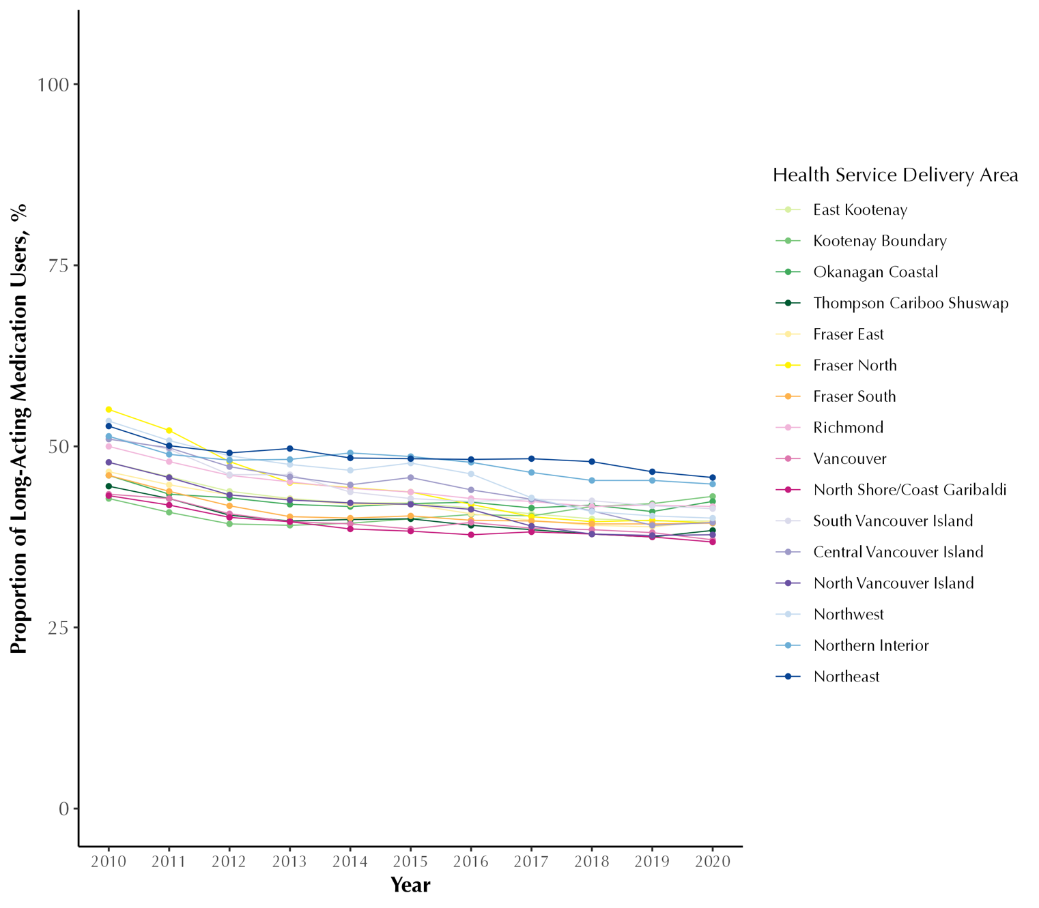
Figure A7: Proportion of long-acting medication users (%, among COPD patients) in British Columbia, Canada, from 2001 to 2020, stratified by Health Service Delivery Area
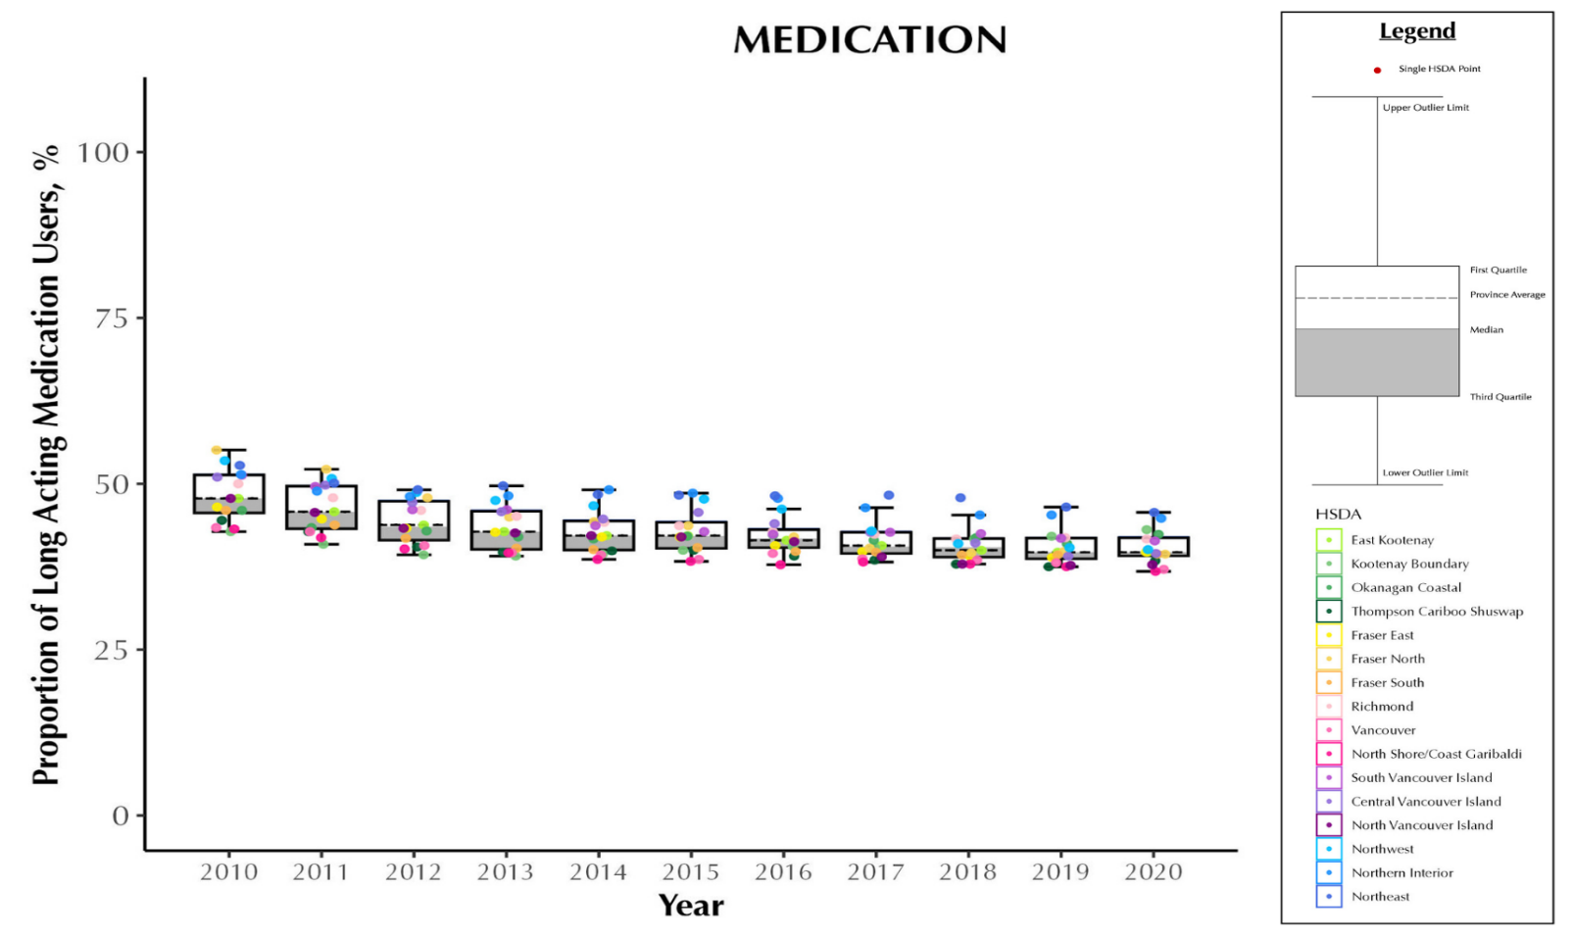

Figure A8: Proportion of long-acting medication users (%) in British Columbia, Canada, from 2001 to 2020, stratified by Health Service Delivery Area
Abbreviations: COPD: chronic obstructive pulmonary disease; Q1: quartile 1; Q3: quartile 3 Note: Each dot represents an HSDA. The horizontal line cutting through the plot is the overall provincial average. The median is the line separating the upper (white) and lower (dark grey) boxes

Table A15: Rate ratios and 95% confidence interval for the unadjusted, adjusted and trend adjusted models for medication use (long acting)
 | Unadjusted Model |  |  |  | Adjusted Model |  |  |  | Trend Adjusted Model
Term | p value | medication rate ratio | 95% CI (lower) | 95% CI (upper) | p value | medication rate ratio | 95% CI (lower) | 95% CI (upper) | p value | Medication rate ratio | 95% CI (lower) | 95% CI (upper)
(Intercept) | 0.000 | 0.495 | 0.479 | 0.511 | 0.000 | 0.366 | 0.337 | 0.398 | 0.000 | 0.353 | 0.327 | 0.381
HSDA11 | 0.350 | 1.024 | 0.975 | 1.075 | 0.233 | 1.044 | 0.973 | 1.120 | 0.068 | 0.927 | 0.854 | 1.006
HSDA12 | 0.115 | 1.040 | 0.991 | 1.092 | 0.000 | 1.121 | 1.056 | 1.190 | 0.336 | 1.036 | 0.964 | 1.113
HSDA13 | 0.096 | 1.040 | 0.993 | 1.090 | 0.004 | 1.064 | 1.020 | 1.111 | 0.360 | 1.027 | 0.970 | 1.086
HSDA14 | 0.004 | 1.072 | 1.023 | 1.123 | 0.004 | 1.093 | 1.029 | 1.161 | 0.123 | 1.055 | 0.986 | 1.129
HSDA21 | 0.259 | 1.027 | 0.980 | 1.077 | 0.000 | 1.109 | 1.068 | 1.151 | 0.000 | 1.185 | 1.123 | 1.250
HSDA22 | 0.049 | 0.954 | 0.911 | 1.000 | 0.099 | 0.971 | 0.937 | 1.006 | 0.129 | 0.961 | 0.912 | 1.012
HSDA31 | 0.233 | 0.971 | 0.925 | 1.019 | 0.122 | 1.032 | 0.992 | 1.073 | 0.822 | 0.993 | 0.938 | 1.052
HSDA32 | 0.056 | 0.956 | 0.912 | 1.001 | 0.858 | 1.004 | 0.962 | 1.048 | 0.412 | 0.977 | 0.924 | 1.033
HSDA33 | 0.049 | 1.049 | 1.000 | 1.099 | 0.057 | 0.940 | 0.883 | 1.002 | 0.056 | 0.933 | 0.869 | 1.002
HSDA41 | 0.001 | 1.082 | 1.032 | 1.134 | 0.000 | 1.090 | 1.051 | 1.130 | 0.000 | 1.123 | 1.065 | 1.185
HSDA42 | 0.711 | 1.009 | 0.963 | 1.057 | 0.755 | 1.007 | 0.965 | 1.050 | 0.213 | 1.037 | 0.980 | 1.097
HSDA43 | 0.000 | 1.093 | 1.042 | 1.147 | 0.000 | 1.139 | 1.089 | 1.190 | 0.000 | 1.190 | 1.121 | 1.263
HSDA51 | 0.000 | 1.134 | 1.079 | 1.191 | 0.000 | 1.201 | 1.122 | 1.286 | 0.000 | 1.160 | 1.076 | 1.250
HSDA52 | 0.000 | 1.154 | 1.100 | 1.210 | 0.000 | 1.215 | 1.163 | 1.269 | 0.000 | 1.183 | 1.116 | 1.254
HSDA53 | 0.571 | 1.014 | 0.966 | 1.065 | 0.151 | 0.946 | 0.876 | 1.021 | 0.000 | 0.854 | 0.785 | 0.929
HSDA23 (Ref)
Female |  |  |  |  | 0.000 | 1.095 | 1.080 | 1.110 | 0.000 | 1.103 | 1.090 | 1.116
Male (Ref)
50-64 years |  |  |  |  | 0.000 | 0.752 | 0.737 | 0.769 | 0.000 | 0.751 | 0.738 | 0.765
65-79 years |  |  |  |  | 0.000 | 0.776 | 0.759 | 0.793 | 0.000 | 0.771 | 0.756 | 0.786
>=80 years |  |  |  |  | 0.000 | 0.721 | 0.705 | 0.737 | 0.000 | 0.718 | 0.705 | 0.732
35-49 years (Ref)
Rural |  |  |  |  | 0.370 | 0.889 | 0.688 | 1.150 | 0.502 | 1.081 | 0.861 | 1.356
Neighborhood income quintile
2 |  |  |  |  | 0.000 | 2.783 | 1.987 | 3.897 | 0.000 | 4.013 | 2.992 | 5.383
3 |  |  |  |  | 0.000 | 2.293 | 1.588 | 3.313 | 0.000 | 3.097 | 2.250 | 4.265
4 |  |  |  |  | 0.000 | 2.964 | 2.072 | 4.241 | 0.000 | 3.494 | 2.547 | 4.793
5 (highest income quintile) |  |  |  |  | 0.000 | 4.276 | 3.008 | 6.078 | 0.000 | 4.790 | 3.527 | 6.505
Unknown |  |  |  |  | 0.028 | 4.296 | 1.170 | 15.783 | 0.003 | 5.489 | 1.770 | 17.022
Year |  |  |  |  |  |  |  |  | 0.000 | 0.981 | 0.975 | 0.987
HSDA11:year |  |  |  |  |  |  |  |  | 0.005 | 1.014 | 1.004 | 1.024
HSDA12:year |  |  |  |  |  |  |  |  | 0.048 | 1.010 | 1.000 | 1.019
HSDA13:year |  |  |  |  |  |  |  |  | 0.448 | 1.003 | 0.995 | 1.012
HSDA14:year |  |  |  |  |  |  |  |  | 0.793 | 0.999 | 0.990 | 1.008
HSDA21:year |  |  |  |  |  |  |  |  | 0.004 | 0.987 | 0.978 | 0.996
HSDA22:year |  |  |  |  |  |  |  |  | 0.657 | 1.002 | 0.993 | 1.011
HSDA31:year |  |  |  |  |  |  |  |  | 0.077 | 1.009 | 0.999 | 1.018
HSDA32:year |  |  |  |  |  |  |  |  | 0.082 | 1.008 | 0.999 | 1.016
HSDA33:year |  |  |  |  |  |  |  |  | 0.611 | 0.998 | 0.989 | 1.007
HSDA41:year |  |  |  |  |  |  |  |  | 0.220 | 0.995 | 0.986 | 1.003
HSDA42:year |  |  |  |  |  |  |  |  | 0.060 | 0.992 | 0.983 | 1.000
HSDA43:year |  |  |  |  |  |  |  |  | 0.006 | 0.987 | 0.978 | 0.996
HSDA51:year |  |  |  |  |  |  |  |  | 0.829 | 1.001 | 0.991 | 1.011
HSDA52:year |  |  |  |  |  |  |  |  | 0.543 | 1.003 | 0.994 | 1.012
HSDA53:year |  |  |  |  |  |  |  |  | 0.002 | 1.016 | 1.006 | 1.026
HSDA23: Year (Ref)
Reference levels of factor variables have a rate ratio=1.00.
Adjusted variables for both adjusted and trend-adjusted models: Sex, Socio-Economic Status, Area of Residence, Age group.
Abbreviations: HSDA: Health Service Delivery Area, CI: Confidence Interval, HSDA11: East Kootenay, HSDA 12: Kootenay Boundary, HSDA 13: Okanagan, HSDA 14: Thompson Cariboo Shuswap, HSDA 21: Fraser East, HSDA 22: Fraser North, HSDA 23: Fraser South, HSDA 31: Richmond, HSDA 32: Vancouver, HSDA 33: North Shore/Coast Garibaldi, HSDA 41: South Vancouver Island, HSDA 42: Central Vancouver Island, HSDA 43: North Vancouver Island, HSDA 51: Northwest, HSDA 52: Northern Interior, HSDA 53: Northeast.

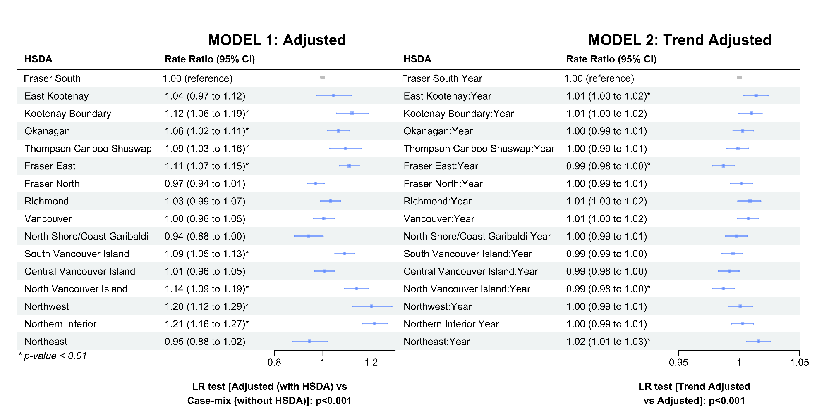

Figure A9: Rate ratios presented in a stacked forest plot for the adjusted (a) and trend adjusted (b) models for number of long-acting medication users.
Confidence bands correspond to 95% CI. HSDA11: East Kootenay, HSDA 12: Kootenay Boundary, HSDA 13: Okanagan, HSDA 14: Thompson Cariboo Shuswap, HSDA 21: Fraser East, HSDA 22: Fraser North, HSDA 23: Fraser South, HSDA 31: Richmond, HSDA 32: Vancouver, HSDA 33: North Shore/Coast Garibaldi, HSDA 41: South Vancouver Island, HSDA 42: Central Vancouver Island, HSDA 43: North Vancouver Island, HSDA 51: Northwest, HSDA 52: Northern Interior, HSDA 53: Northeast. Reference levels for HSDA: HSDA23 (Fraser South). Reference levels for HSDA: HSDA23 (Fraser South). Adjusted variables: Sex, Socio-Economic Status, Area of Residence, Age group. Abbreviations: LR test: Likelihood-Ratio test; HSDA: Health Service Delivery Area, CI: Confidence Interval. Adjusted variables: Sex, Socio-Economic Status, Area of Residence, Age group. Abbreviations: LR test: Likelihood-Ratio test; HSDA: Health Service Delivery Area, CI: Confidence Interval

Table A16: Number of Long-acting medication users by drug class
 | Medication Year
 | 2010 | 2011 | 2012 | 2013 | 2014 | 2015 | 2016 | 2017 | 2018 | 2019 | 2020 | 2010 | 2011 | 2012 | 2013 | 2014 | 2015 | 2016 | 2017 | 2018 | 2019 | 2020
 | COMBINATION THERAPY |  |  |  |  |  |  |  |  |  |  | SINGLE THERAPY
 | LAMA+LABA |  |  |  |  |  |  |  |  |  |  | LAMA
Total | 498 | 468 | 465 | 524 | 950 | 2078 | 4778 | 7119 | 9076 | 10148 | 10560 | 12089 | 13451 | 14204 | 15163 | 16526 | 17909 | 18507 | 18330 | 18628 | 18070 | 18726
HSDA11 | 12 | 8 | 7 | 8 | 15 | 26 | 84 | 144 | 271 | 359 | 390 | 227 | 292 | 291 | 313 | 345 | 395 | 428 | 495 | 566 | 567 | 553
HSDA12 | 36 | 30 | 25 | 31 | 26 | 43 | 177 | 259 | 328 | 389 | 416 | 471 | 497 | 533 | 534 | 534 | 566 | 610 | 536 | 583 | 533 | 570
HSDA13 | 156 | 146 | 150 | 145 | 172 | 340 | 718 | 1058 | 1311 | 1562 | 1678 | 2041 | 2207 | 2229 | 2363 | 2545 | 2738 | 2748 | 2556 | 2557 | 2446 | 2510
HSDA14 | 37 | 39 | 39 | 36 | 46 | 89 | 193 | 303 | 397 | 504 | 550 | 904 | 992 | 1045 | 1095 | 1132 | 1211 | 1291 | 1287 | 1331 | 1355 | 1501
HSDA21 | 27 | 23 | 26 | 37 | 82 | 173 | 332 | 486 | 603 | 661 | 667 | 721 | 764 | 800 | 862 | 962 | 1036 | 1029 | 1007 | 1117 | 1135 | 1141
HSDA22 | 29 | 25 | 28 | 32 | 119 | 293 | 588 | 851 | 1081 | 1133 | 1093 | 1264 | 1465 | 1580 | 1696 | 1878 | 2036 | 2104 | 2125 | 2064 | 1952 | 1937
HSDA23 | 40 | 36 | 42 | 58 | 139 | 345 | 720 | 998 | 1255 | 1343 | 1403 | 1292 | 1470 | 1584 | 1705 | 2048 | 2208 | 2269 | 2292 | 2341 | 2272 | 2311
HSDA31 | 11 | 15 | 8 | 8 | 28 | 53 | 146 | 173 | 203 | 223 | 226 | 304 | 327 | 332 | 369 | 391 | 432 | 447 | 389 | 416 | 406 | 391
HSDA32 | 27 | 30 | 30 | 43 | 106 | 234 | 556 | 755 | 905 | 992 | 1021 | 910 | 1108 | 1232 | 1393 | 1543 | 1642 | 1690 | 1645 | 1642 | 1569 | 1638
HSDA33 | 27 | 23 | 23 | 22 | 44 | 86 | 201 | 336 | 417 | 459 | 484 | 633 | 757 | 771 | 875 | 961 | 1012 | 1091 | 1159 | 1135 | 1109 | 1155
HSDA41 | 32 | 34 | 30 | 38 | 87 | 171 | 433 | 675 | 837 | 882 | 905 | 1187 | 1230 | 1294 | 1354 | 1407 | 1548 | 1509 | 1508 | 1489 | 1427 | 1418
HSDA42 | 33 | 35 | 29 | 32 | 40 | 128 | 363 | 615 | 770 | 825 | 836 | 1139 | 1244 | 1310 | 1329 | 1417 | 1524 | 1570 | 1521 | 1503 | 1420 | 1514
HSDA43 | 6 | <5 | 12 | 11 | 21 | 38 | 113 | 194 | 261 | 290 | 322 | 455 | 505 | 520 | 543 | 573 | 702 | 750 | 772 | 816 | 836 | 886
HSDA51 | <5 | <5 | <5 | 6 | 7 | 10 | 27 | 61 | 111 | 125 | 124 | 111 | 114 | 144 | 160 | 169 | 202 | 218 | 258 | 265 | 253 | 306
HSDA52 | 12 | 9 | <5 | 8 | 12 | 34 | 90 | 144 | 238 | 305 | 334 | 303 | 321 | 368 | 399 | 434 | 464 | 510 | 521 | 543 | 529 | 617
HSDA53 | 10 | 10 | 7 | 7 | 6 | 14 | 34 | 60 | 84 | 91 | 104 | 112 | 142 | 153 | 149 | 168 | 174 | 220 | 239 | 241 | 248 | 263
 | ICS+LAMA |  |  |  |  |  |  |  |  |  |  | LABA
Total | 1434 | 1546 | 1528 | 1563 | 1546 | 1618 | 1621 | 1531 | 1448 | 1481 | 1637 | 2205 | 2006 | 1831 | 1766 | 1909 | 1884 | 1480 | 1343 | 1227 | 1134 | 984
HSDA11 | 23 | 28 | 20 | 24 | 25 | 15 | 22 | 28 | 29 | 35 | 35 | 60 | 45 | 48 | 45 | 41 | 54 | 45 | 48 | 44 | 34 | 30
HSDA12 | 79 | 69 | 73 | 78 | 65 | 77 | 60 | 50 | 49 | 35 | 47 | 112 | 109 | 87 | 89 | 84 | 78 | 66 | 67 | 63 | 58 | 47
HSDA13 | 256 | 251 | 229 | 243 | 227 | 216 | 203 | 174 | 163 | 151 | 188 | 500 | 473 | 437 | 394 | 395 | 392 | 274 | 265 | 231 | 203 | 171
HSDA14 | 139 | 146 | 152 | 138 | 131 | 120 | 128 | 130 | 122 | 130 | 150 | 185 | 171 | 167 | 156 | 156 | 155 | 109 | 106 | 99 | 90 | 87
HSDA21 | 96 | 111 | 101 | 117 | 89 | 113 | 106 | 95 | 91 | 112 | 99 | 131 | 115 | 113 | 131 | 151 | 151 | 128 | 100 | 85 | 72 | 70
HSDA22 | 127 | 138 | 153 | 137 | 145 | 164 | 166 | 154 | 136 | 132 | 161 | 159 | 133 | 122 | 141 | 157 | 170 | 97 | 91 | 84 | 88 | 64
HSDA23 | 132 | 182 | 200 | 208 | 215 | 251 | 237 | 234 | 229 | 249 | 249 | 198 | 184 | 174 | 161 | 184 | 181 | 140 | 115 | 111 | 90 | 73
HSDA31 | 32 | 26 | 31 | 30 | 26 | 39 | 52 | 41 | 36 | 34 | 40 | 43 | 37 | 35 | 40 | 40 | 46 | 34 | 21 | 18 | 20 | 19
HSDA32 | 109 | 104 | 109 | 106 | 129 | 135 | 130 | 122 | 124 | 124 | 135 | 150 | 146 | 140 | 136 | 168 | 149 | 116 | 107 | 117 | 115 | 92
HSDA33 | 58 | 71 | 82 | 95 | 95 | 100 | 92 | 86 | 88 | 91 | 85 | 130 | 126 | 100 | 98 | 112 | 100 | 72 | 68 | 59 | 56 | 46
HSDA41 | 113 | 106 | 88 | 90 | 96 | 92 | 100 | 111 | 97 | 103 | 109 | 189 | 170 | 151 | 133 | 154 | 152 | 148 | 127 | 115 | 105 | 101
HSDA42 | 124 | 150 | 131 | 128 | 134 | 144 | 140 | 135 | 122 | 107 | 140 | 154 | 126 | 108 | 99 | 107 | 107 | 99 | 87 | 67 | 79 | 68
HSDA43 | 54 | 58 | 52 | 68 | 68 | 62 | 73 | 71 | 69 | 77 | 74 | 57 | 51 | 47 | 44 | 63 | 57 | 70 | 69 | 63 | 55 | 49
HSDA51 | 17 | 19 | 18 | 22 | 20 | 27 | 29 | 24 | 21 | 21 | 29 | 21 | 15 | 17 | 16 | 23 | 14 | 13 | 16 | 18 | 16 | 15
HSDA52 | 51 | 53 | 60 | 52 | 57 | 44 | 50 | 44 | 44 | 49 | 63 | 63 | 56 | 47 | 47 | 43 | 43 | 39 | 36 | 39 | 42 | 41
HSDA53 | 22 | 32 | 26 | 25 | 23 | 18 | 31 | 30 | 27 | 31 | 31 | 49 | 46 | 36 | 34 | 28 | 33 | 29 | 19 | 14 | 10 | 11
 | ICS+LABA |  |  |  |  |  |  |  |  |  |  | ICS
Total | 44622 | 45829 | 46608 | 47738 | 48496 | 49765 | 48911 | 47140 | 45105 | 43388 | 42751 | 32480 | 31839 | 30069 | 29479 | 28640 | 28769 | 27581 | 26590 | 25392 | 24253 | 22335
HSDA11 | 1031 | 1108 | 1110 | 1165 | 1241 | 1319 | 1302 | 1272 | 1179 | 1104 | 1090 | 520 | 491 | 454 | 439 | 459 | 438 | 458 | 405 | 426 | 454 | 427
HSDA12 | 996 | 1080 | 1159 | 1216 | 1237 | 1247 | 1208 | 1101 | 1111 | 1063 | 1010 | 868 | 841 | 820 | 778 | 747 | 745 | 702 | 666 | 614 | 542 | 505
HSDA13 | 5086 | 5251 | 5294 | 5353 | 5406 | 5614 | 5397 | 5171 | 4852 | 4554 | 4601 | 3379 | 3173 | 2983 | 2877 | 2735 | 2719 | 2560 | 2519 | 2418 | 2252 | 2227
HSDA14 | 2808 | 3002 | 3067 | 3286 | 3317 | 3427 | 3414 | 3414 | 3334 | 3278 | 3311 | 2738 | 2678 | 2609 | 2547 | 2467 | 2434 | 2262 | 2206 | 2147 | 2014 | 1831
HSDA21 | 3044 | 3096 | 3215 | 3185 | 3211 | 3332 | 3297 | 3186 | 3092 | 3025 | 2973 | 2660 | 2701 | 2525 | 2417 | 2390 | 2377 | 2280 | 2196 | 2054 | 1968 | 1835
HSDA22 | 5215 | 5310 | 5425 | 5388 | 5533 | 5600 | 5573 | 5341 | 5019 | 4822 | 4724 | 3277 | 3167 | 2915 | 2824 | 2796 | 2887 | 2714 | 2685 | 2502 | 2422 | 2263
HSDA23 | 5944 | 5933 | 6048 | 6184 | 6284 | 6393 | 6244 | 6020 | 5703 | 5547 | 5455 | 4352 | 4286 | 4060 | 4069 | 3914 | 3903 | 3761 | 3651 | 3471 | 3383 | 3062
HSDA31 | 1221 | 1278 | 1229 | 1214 | 1266 | 1266 | 1252 | 1186 | 1123 | 1106 | 1115 | 724 | 744 | 682 | 639 | 644 | 619 | 655 | 643 | 610 | 580 | 515
HSDA32 | 4640 | 4694 | 4762 | 4894 | 4865 | 4866 | 4668 | 4544 | 4289 | 4105 | 3930 | 3480 | 3369 | 3200 | 3068 | 2869 | 2893 | 2735 | 2635 | 2530 | 2376 | 2099
HSDA33 | 2731 | 2841 | 2860 | 2957 | 2954 | 2981 | 2896 | 2826 | 2776 | 2718 | 2680 | 1505 | 1491 | 1384 | 1412 | 1404 | 1403 | 1349 | 1318 | 1318 | 1231 | 1128
HSDA41 | 4032 | 4069 | 4079 | 4069 | 4057 | 4222 | 4096 | 3842 | 3588 | 3442 | 3408 | 2244 | 2320 | 2105 | 2005 | 1945 | 2034 | 1945 | 1853 | 1728 | 1630 | 1510
HSDA42 | 3728 | 3838 | 3889 | 4089 | 4160 | 4262 | 4275 | 3992 | 3892 | 3667 | 3601 | 2587 | 2536 | 2420 | 2437 | 2398 | 2391 | 2373 | 2250 | 2197 | 2127 | 1942
HSDA43 | 1576 | 1649 | 1676 | 1723 | 1800 | 1909 | 1883 | 1821 | 1744 | 1688 | 1617 | 1316 | 1310 | 1264 | 1262 | 1213 | 1241 | 1226 | 1100 | 1055 | 1002 | 872
HSDA51 | 630 | 647 | 660 | 721 | 786 | 812 | 837 | 835 | 810 | 746 | 736 | 656 | 648 | 628 | 649 | 668 | 694 | 649 | 604 | 542 | 538 | 495
HSDA52 | 1366 | 1453 | 1509 | 1645 | 1705 | 1807 | 1871 | 1852 | 1850 | 1793 | 1786 | 1558 | 1514 | 1462 | 1468 | 1461 | 1431 | 1309 | 1272 | 1293 | 1264 | 1200
HSDA53 | 527 | 534 | 588 | 608 | 629 | 667 | 653 | 687 | 698 | 692 | 670 | 573 | 530 | 522 | 550 | 501 | 532 | 568 | 561 | 466 | 456 | 408
 | LAMA+LABA+ICS
Total | 9518 | 10494 | 11299 | 12304 | 12953 | 14020 | 14864 | 15425 | 16379 | 18256 | 19326
HSDA11 | 194 | 225 | 231 | 245 | 280 | 307 | 353 | 414 | 456 | 556 | 599
HSDA12 | 310 | 345 | 394 | 429 | 421 | 447 | 490 | 503 | 505 | 555 | 554
HSDA13 | 1581 | 1691 | 1737 | 1850 | 1936 | 2034 | 2152 | 2201 | 2194 | 2311 | 2498
HSDA14 | 660 | 727 | 771 | 860 | 886 | 942 | 997 | 1095 | 1217 | 1340 | 1480
HSDA21 | 578 | 593 | 680 | 701 | 741 | 788 | 853 | 886 | 994 | 1198 | 1251
HSDA22 | 1107 | 1313 | 1362 | 1500 | 1526 | 1697 | 1749 | 1839 | 1944 | 2128 | 2208
HSDA23 | 1161 | 1230 | 1344 | 1480 | 1655 | 1808 | 1971 | 2018 | 2148 | 2388 | 2480
HSDA31 | 234 | 244 | 258 | 300 | 302 | 332 | 340 | 321 | 344 | 351 | 370
HSDA32 | 815 | 935 | 1073 | 1215 | 1292 | 1416 | 1399 | 1399 | 1483 | 1593 | 1612
HSDA33 | 450 | 545 | 596 | 677 | 705 | 750 | 822 | 850 | 889 | 981 | 1039
HSDA41 | 824 | 860 | 920 | 983 | 998 | 1069 | 1127 | 1107 | 1120 | 1227 | 1290
HSDA42 | 843 | 938 | 1007 | 1032 | 1077 | 1158 | 1173 | 1219 | 1331 | 1557 | 1662
HSDA43 | 348 | 397 | 412 | 447 | 496 | 558 | 609 | 642 | 660 | 752 | 806
HSDA51 | 91 | 94 | 108 | 122 | 133 | 155 | 178 | 224 | 266 | 323 | 372
HSDA52 | 226 | 252 | 285 | 330 | 357 | 402 | 473 | 502 | 570 | 657 | 737
HSDA53 | 85 | 95 | 105 | 120 | 138 | 142 | 158 | 190 | 240 | 321 | 353
Abbreviations: HSDA11: East Kootenay, HSDA 12: Kootenay Boundary, HSDA 13: Okanagan, HSDA 14: Thompson Cariboo Shuswap, HSDA 21: Fraser East, HSDA 22: Fraser North, HSDA 23: Fraser South, HSDA 31: Richmond, HSDA 32: Vancouver, HSDA 33: North Shore/Coast Garibaldi, HSDA 41: South Vancouver Island, HSDA 42: Central Vancouver Island, HSDA 43: North Vancouver Island, HSDA 51: Northwest, HSDA 52: Northern Interior, HSDA 53: Northeast. ICS: Inhaled Corticosteroids; LAMA: Long-Acting Muscarinic Antagonists; LABA: Long-Acting Beta-Agonists

Table A17: Proportion of Long-acting medication users (%, among COPD patients) by drug class
 | Medication Year
 | 2010 | 2011 | 2012 | 2013 | 2014 | 2015 | 2016 | 2017 | 2018 | 2019 | 2020 | 2010 | 2011 | 2012 | 2013 | 2014 | 2015 | 2016 | 2017 | 2018 | 2019 | 2020
 | COMBINATION THERAPY |  |  |  |  |  |  |  |  |  |  | SINGLE THERAPY
 | LAMA+LABA |  |  |  |  |  |  |  |  |  |  | LAMA
Total | 0.3 | 0.3 | 0.3 | 0.3 | 0.5 | 1.1 | 2.4 | 3.5 | 4.4 | 4.9 | 5.0 | 7.5 | 7.8 | 7.9 | 8.2 | 8.6 | 9.1 | 9.2 | 9.0 | 9.0 | 8.6 | 8.9
HSDA11 | 0.3 | 0.2 | 0.2 | 0.2 | 0.3 | 0.6 | 1.8 | 3.0 | 5.7 | 7.4 | 8.0 | 6.1 | 7.3 | 7.0 | 7.3 | 7.7 | 8.5 | 9.1 | 10.4 | 11.8 | 11.7 | 11.3
HSDA12 | 0.8 | 0.6 | 0.5 | 0.6 | 0.5 | 0.8 | 3.4 | 5.0 | 6.2 | 7.4 | 8.0 | 11.0 | 10.7 | 11.0 | 10.7 | 10.6 | 11.1 | 11.9 | 10.3 | 11.1 | 10.1 | 11.0
HSDA13 | 0.8 | 0.7 | 0.7 | 0.6 | 0.8 | 1.5 | 3.0 | 4.4 | 5.4 | 6.3 | 6.8 | 10.2 | 10.5 | 10.2 | 10.5 | 11.1 | 11.7 | 11.6 | 10.6 | 10.4 | 9.9 | 10.2
HSDA14 | 0.3 | 0.3 | 0.3 | 0.3 | 0.3 | 0.6 | 1.3 | 2.0 | 2.5 | 3.1 | 3.4 | 7.5 | 7.7 | 7.8 | 7.8 | 7.9 | 8.3 | 8.6 | 8.4 | 8.4 | 8.4 | 9.4
HSDA21 | 0.3 | 0.2 | 0.2 | 0.3 | 0.6 | 1.3 | 2.4 | 3.4 | 4.1 | 4.5 | 4.5 | 7.1 | 7.0 | 6.7 | 6.9 | 7.4 | 7.7 | 7.4 | 7.0 | 7.6 | 7.7 | 7.7
HSDA22 | 0.2 | 0.1 | 0.1 | 0.2 | 0.5 | 1.3 | 2.6 | 3.7 | 4.7 | 4.9 | 4.8 | 6.9 | 7.4 | 7.7 | 8.0 | 8.6 | 9.0 | 9.2 | 9.2 | 9.0 | 8.5 | 8.5
HSDA23 | 0.2 | 0.2 | 0.2 | 0.3 | 0.6 | 1.4 | 2.9 | 3.9 | 4.9 | 5.2 | 5.5 | 6.4 | 6.9 | 7.2 | 7.5 | 8.7 | 9.0 | 9.1 | 9.0 | 9.1 | 8.8 | 9.1
HSDA31 | 0.2 | 0.3 | 0.2 | 0.2 | 0.6 | 1.0 | 2.8 | 3.3 | 3.9 | 4.2 | 4.3 | 6.7 | 7.0 | 6.9 | 7.6 | 7.8 | 8.3 | 8.6 | 7.5 | 8.0 | 7.7 | 7.4
HSDA32 | 0.1 | 0.2 | 0.2 | 0.2 | 0.5 | 1.1 | 2.6 | 3.6 | 4.4 | 4.8 | 4.9 | 5.0 | 5.8 | 6.2 | 6.9 | 7.4 | 7.7 | 8.0 | 7.8 | 7.9 | 7.6 | 7.9
HSDA33 | 0.3 | 0.3 | 0.2 | 0.2 | 0.4 | 0.8 | 1.9 | 3.1 | 3.8 | 4.2 | 4.4 | 7.7 | 8.6 | 8.3 | 9.0 | 9.4 | 9.5 | 10.2 | 10.7 | 10.4 | 10.1 | 10.5
HSDA41 | 0.3 | 0.3 | 0.2 | 0.3 | 0.6 | 1.2 | 2.9 | 4.4 | 5.3 | 5.5 | 5.6 | 9.4 | 9.3 | 9.5 | 9.7 | 9.9 | 10.6 | 10.1 | 9.8 | 9.5 | 8.8 | 8.8
HSDA42 | 0.2 | 0.2 | 0.2 | 0.2 | 0.2 | 0.8 | 2.1 | 3.4 | 4.1 | 4.4 | 4.4 | 8.5 | 8.7 | 8.7 | 8.4 | 8.7 | 9.1 | 9.1 | 8.4 | 8.0 | 7.5 | 8.0
HSDA43 | 0.1 | 0.1 | 0.2 | 0.2 | 0.3 | 0.5 | 1.6 | 2.6 | 3.3 | 3.6 | 4.0 | 8.4 | 8.5 | 8.4 | 8.4 | 8.5 | 10.1 | 10.4 | 10.2 | 10.3 | 10.3 | 10.9
HSDA51 | 0.1 | 0.0 | 0.1 | 0.2 | 0.2 | 0.3 | 0.8 | 1.9 | 3.4 | 3.7 | 3.6 | 4.5 | 4.4 | 5.4 | 5.6 | 5.6 | 6.4 | 6.8 | 7.9 | 8.0 | 7.5 | 8.8
HSDA52 | 0.2 | 0.2 | 0.1 | 0.1 | 0.2 | 0.5 | 1.3 | 2.1 | 3.3 | 4.0 | 4.2 | 5.6 | 5.5 | 6.1 | 6.3 | 6.5 | 6.8 | 7.3 | 7.4 | 7.4 | 6.9 | 7.7
HSDA53 | 0.4 | 0.4 | 0.3 | 0.3 | 0.2 | 0.5 | 1.1 | 2.0 | 2.8 | 2.8 | 3.2 | 4.7 | 5.5 | 5.6 | 5.4 | 5.7 | 5.7 | 7.2 | 7.9 | 7.9 | 7.8 | 8.1
 | ICS+LAMA |  |  |  |  |  |  |  |  |  |  | LABA
Total | 0.9 | 0.9 | 0.9 | 0.8 | 0.8 | 0.8 | 0.8 | 0.7 | 0.7 | 0.7 | 0.8 | 1.4 | 1.2 | 1.0 | 1.0 | 1.0 | 1.0 | 0.7 | 0.7 | 0.6 | 0.5 | 0.5
HSDA11 | 0.6 | 0.7 | 0.5 | 0.6 | 0.6 | 0.3 | 0.5 | 0.6 | 0.6 | 0.7 | 0.7 | 1.6 | 1.1 | 1.2 | 1.0 | 0.9 | 1.2 | 1.0 | 1.0 | 0.9 | 0.7 | 0.6
HSDA12 | 1.8 | 1.5 | 1.5 | 1.6 | 1.3 | 1.5 | 1.2 | 1.0 | 0.9 | 0.7 | 0.9 | 2.6 | 2.4 | 1.8 | 1.8 | 1.7 | 1.5 | 1.3 | 1.3 | 1.2 | 1.1 | 0.9
HSDA13 | 1.3 | 1.2 | 1.0 | 1.1 | 1.0 | 0.9 | 0.9 | 0.7 | 0.7 | 0.6 | 0.8 | 2.5 | 2.3 | 2.0 | 1.7 | 1.7 | 1.7 | 1.2 | 1.1 | 0.9 | 0.8 | 0.7
HSDA14 | 1.2 | 1.1 | 1.1 | 1.0 | 0.9 | 0.8 | 0.9 | 0.8 | 0.8 | 0.8 | 0.9 | 1.5 | 1.3 | 1.2 | 1.1 | 1.1 | 1.1 | 0.7 | 0.7 | 0.6 | 0.6 | 0.5
HSDA21 | 0.9 | 1.0 | 0.8 | 0.9 | 0.7 | 0.8 | 0.8 | 0.7 | 0.6 | 0.8 | 0.7 | 1.3 | 1.0 | 0.9 | 1.0 | 1.2 | 1.1 | 0.9 | 0.7 | 0.6 | 0.5 | 0.5
HSDA22 | 0.7 | 0.7 | 0.7 | 0.6 | 0.7 | 0.7 | 0.7 | 0.7 | 0.6 | 0.6 | 0.7 | 0.9 | 0.7 | 0.6 | 0.7 | 0.7 | 0.8 | 0.4 | 0.4 | 0.4 | 0.4 | 0.3
HSDA23 | 0.7 | 0.9 | 0.9 | 0.9 | 0.9 | 1.0 | 0.9 | 0.9 | 0.9 | 1.0 | 1.0 | 1.0 | 0.9 | 0.8 | 0.7 | 0.8 | 0.7 | 0.6 | 0.5 | 0.4 | 0.4 | 0.3
HSDA31 | 0.7 | 0.6 | 0.6 | 0.6 | 0.5 | 0.8 | 1.0 | 0.8 | 0.7 | 0.6 | 0.8 | 1.0 | 0.8 | 0.7 | 0.8 | 0.8 | 0.9 | 0.7 | 0.4 | 0.3 | 0.4 | 0.4
HSDA32 | 0.6 | 0.5 | 0.6 | 0.5 | 0.6 | 0.6 | 0.6 | 0.6 | 0.6 | 0.6 | 0.6 | 0.8 | 0.8 | 0.7 | 0.7 | 0.8 | 0.7 | 0.5 | 0.5 | 0.6 | 0.6 | 0.4
HSDA33 | 0.7 | 0.8 | 0.9 | 1.0 | 0.9 | 0.9 | 0.9 | 0.8 | 0.8 | 0.8 | 0.8 | 1.6 | 1.4 | 1.1 | 1.0 | 1.1 | 0.9 | 0.7 | 0.6 | 0.5 | 0.5 | 0.4
HSDA41 | 0.9 | 0.8 | 0.6 | 0.6 | 0.7 | 0.6 | 0.7 | 0.7 | 0.6 | 0.6 | 0.7 | 1.5 | 1.3 | 1.1 | 1.0 | 1.1 | 1.0 | 1.0 | 0.8 | 0.7 | 0.6 | 0.6
HSDA42 | 0.9 | 1.0 | 0.9 | 0.8 | 0.8 | 0.9 | 0.8 | 0.7 | 0.7 | 0.6 | 0.7 | 1.1 | 0.9 | 0.7 | 0.6 | 0.7 | 0.6 | 0.6 | 0.5 | 0.4 | 0.4 | 0.4
HSDA43 | 1.0 | 1.0 | 0.8 | 1.0 | 1.0 | 0.9 | 1.0 | 0.9 | 0.9 | 0.9 | 0.9 | 1.0 | 0.9 | 0.8 | 0.7 | 0.9 | 0.8 | 1.0 | 0.9 | 0.8 | 0.7 | 0.6
HSDA51 | 0.7 | 0.7 | 0.7 | 0.8 | 0.7 | 0.9 | 0.9 | 0.7 | 0.6 | 0.6 | 0.8 | 0.9 | 0.6 | 0.6 | 0.6 | 0.8 | 0.4 | 0.4 | 0.5 | 0.5 | 0.5 | 0.4
HSDA52 | 0.9 | 0.9 | 1.0 | 0.8 | 0.9 | 0.6 | 0.7 | 0.6 | 0.6 | 0.6 | 0.8 | 1.2 | 1.0 | 0.8 | 0.7 | 0.6 | 0.6 | 0.6 | 0.5 | 0.5 | 0.5 | 0.5
HSDA53 | 0.9 | 1.2 | 1.0 | 0.9 | 0.8 | 0.6 | 1.0 | 1.0 | 0.9 | 1.0 | 1.0 | 2.0 | 1.8 | 1.3 | 1.2 | 1.0 | 1.1 | 1.0 | 0.6 | 0.5 | 0.3 | 0.3
 | ICS+LABA |  |  |  |  |  |  |  |  |  |  | ICS
Total | 27.6 | 26.7 | 26.0 | 25.7 | 25.4 | 25.3 | 24.4 | 23.1 | 21.8 | 20.7 | 20.4 | 20.1 | 18.5 | 16.8 | 15.9 | 15.0 | 14.6 | 13.8 | 13.0 | 12.3 | 11.6 | 10.7
HSDA11 | 27.7 | 27.6 | 26.7 | 27.0 | 27.6 | 28.2 | 27.5 | 26.6 | 24.7 | 22.8 | 22.3 | 13.9 | 12.3 | 10.9 | 10.2 | 10.2 | 9.4 | 9.7 | 8.5 | 8.9 | 9.4 | 8.7
HSDA12 | 23.2 | 23.3 | 24.0 | 24.4 | 24.5 | 24.4 | 23.5 | 21.1 | 21.1 | 20.1 | 19.5 | 20.2 | 18.1 | 17.0 | 15.6 | 14.8 | 14.6 | 13.6 | 12.7 | 11.6 | 10.3 | 9.7
HSDA13 | 25.5 | 25.0 | 24.1 | 23.7 | 23.6 | 24.1 | 22.7 | 21.4 | 19.8 | 18.5 | 18.7 | 16.9 | 15.1 | 13.6 | 12.7 | 12.0 | 11.7 | 10.8 | 10.4 | 9.9 | 9.2 | 9.0
HSDA14 | 23.3 | 23.2 | 22.8 | 23.5 | 23.1 | 23.5 | 22.8 | 22.2 | 21.0 | 20.4 | 20.7 | 22.7 | 20.7 | 19.4 | 18.2 | 17.2 | 16.7 | 15.1 | 14.3 | 13.6 | 12.6 | 11.5
HSDA21 | 29.8 | 28.2 | 27.0 | 25.4 | 24.7 | 24.7 | 23.7 | 22.0 | 21.1 | 20.5 | 20.0 | 26.1 | 24.6 | 21.2 | 19.3 | 18.4 | 17.6 | 16.4 | 15.2 | 14.0 | 13.3 | 12.4
HSDA22 | 28.4 | 27.0 | 26.4 | 25.4 | 25.3 | 24.9 | 24.4 | 23.1 | 21.8 | 21.0 | 20.7 | 17.9 | 16.1 | 14.2 | 13.3 | 12.8 | 12.8 | 11.9 | 11.6 | 10.9 | 10.5 | 9.9
HSDA23 | 29.5 | 27.9 | 27.5 | 27.2 | 26.6 | 26.1 | 24.9 | 23.7 | 22.2 | 21.6 | 21.4 | 21.6 | 20.2 | 18.4 | 17.9 | 16.6 | 15.9 | 15.0 | 14.3 | 13.5 | 13.2 | 12.0
HSDA31 | 27.0 | 27.2 | 25.6 | 24.8 | 25.2 | 24.5 | 24.1 | 22.8 | 21.5 | 20.9 | 21.1 | 16.0 | 15.9 | 14.2 | 13.1 | 12.8 | 12.0 | 12.6 | 12.3 | 11.7 | 10.9 | 9.7
HSDA32 | 25.5 | 24.7 | 24.1 | 24.2 | 23.5 | 22.9 | 22.1 | 21.6 | 20.6 | 19.8 | 18.9 | 19.2 | 17.7 | 16.2 | 15.2 | 13.8 | 13.6 | 12.9 | 12.5 | 12.2 | 11.4 | 10.1
HSDA33 | 33.3 | 32.3 | 30.7 | 30.5 | 28.9 | 27.9 | 27.0 | 26.1 | 25.5 | 24.7 | 24.4 | 18.4 | 16.9 | 14.8 | 14.6 | 13.7 | 13.1 | 12.6 | 12.2 | 12.1 | 11.2 | 10.3
HSDA41 | 32.0 | 30.8 | 30.0 | 29.1 | 28.4 | 29.0 | 27.4 | 24.9 | 22.9 | 21.3 | 21.2 | 17.8 | 17.6 | 15.5 | 14.4 | 13.6 | 14.0 | 13.0 | 12.0 | 11.0 | 10.1 | 9.4
HSDA42 | 27.8 | 26.7 | 25.7 | 25.8 | 25.6 | 25.6 | 24.7 | 22.0 | 20.8 | 19.4 | 18.9 | 19.3 | 17.6 | 16.0 | 15.4 | 14.7 | 14.3 | 13.7 | 12.4 | 11.7 | 11.3 | 10.2
HSDA43 | 28.9 | 27.9 | 27.0 | 26.6 | 26.8 | 27.4 | 26.1 | 24.0 | 22.0 | 20.7 | 19.8 | 24.2 | 22.1 | 20.4 | 19.5 | 18.0 | 17.8 | 17.0 | 14.5 | 13.3 | 12.3 | 10.7
HSDA51 | 25.8 | 25.1 | 24.7 | 25.4 | 26.1 | 25.8 | 26.2 | 25.7 | 24.5 | 22.2 | 21.2 | 26.8 | 25.1 | 23.5 | 22.9 | 22.2 | 22.1 | 20.3 | 18.6 | 16.4 | 16.0 | 14.3
HSDA52 | 25.1 | 24.9 | 24.9 | 26.0 | 25.6 | 26.4 | 26.9 | 26.4 | 25.3 | 23.4 | 22.4 | 28.6 | 26.0 | 24.1 | 23.2 | 21.9 | 20.9 | 18.8 | 18.2 | 17.7 | 16.5 | 15.0
HSDA53 | 21.9 | 20.5 | 21.7 | 21.9 | 21.4 | 22.0 | 21.5 | 22.6 | 22.9 | 21.7 | 20.7 | 23.9 | 20.4 | 19.3 | 19.8 | 17.1 | 17.6 | 18.7 | 18.5 | 15.3 | 14.3 | 12.6
 | LAMA+LABA+ICS
Total | 5.9 | 6.1 | 6.3 | 6.6 | 6.8 | 7.1 | 7.4 | 7.6 | 7.9 | 8.7 | 9.2
HSDA11 | 5.2 | 5.6 | 5.6 | 5.7 | 6.2 | 6.6 | 7.5 | 8.7 | 9.5 | 11.5 | 12.3
HSDA12 | 7.2 | 7.4 | 8.2 | 8.6 | 8.3 | 8.8 | 9.5 | 9.6 | 9.6 | 10.5 | 10.7
HSDA13 | 7.9 | 8.1 | 7.9 | 8.2 | 8.5 | 8.7 | 9.1 | 9.1 | 9.0 | 9.4 | 10.1
HSDA14 | 5.5 | 5.6 | 5.7 | 6.1 | 6.2 | 6.5 | 6.7 | 7.1 | 7.7 | 8.4 | 9.3
HSDA21 | 5.7 | 5.4 | 5.7 | 5.6 | 5.7 | 5.8 | 6.1 | 6.1 | 6.8 | 8.1 | 8.4
HSDA22 | 6.0 | 6.7 | 6.6 | 7.1 | 7.0 | 7.5 | 7.6 | 7.9 | 8.5 | 9.3 | 9.7
HSDA23 | 5.8 | 5.8 | 6.1 | 6.5 | 7.0 | 7.4 | 7.9 | 7.9 | 8.4 | 9.3 | 9.7
HSDA31 | 5.2 | 5.2 | 5.4 | 6.1 | 6.0 | 6.4 | 6.5 | 6.2 | 6.6 | 6.6 | 7.0
HSDA32 | 4.5 | 4.9 | 5.4 | 6.0 | 6.2 | 6.7 | 6.6 | 6.6 | 7.1 | 7.7 | 7.7
HSDA33 | 5.5 | 6.2 | 6.4 | 7.0 | 6.9 | 7.0 | 7.7 | 7.9 | 8.2 | 8.9 | 9.5
HSDA41 | 6.5 | 6.5 | 6.8 | 7.0 | 7.0 | 7.4 | 7.6 | 7.2 | 7.2 | 7.6 | 8.0
HSDA42 | 6.3 | 6.5 | 6.7 | 6.5 | 6.6 | 6.9 | 6.8 | 6.7 | 7.1 | 8.2 | 8.7
HSDA43 | 6.4 | 6.7 | 6.6 | 6.9 | 7.4 | 8.0 | 8.4 | 8.5 | 8.3 | 9.2 | 9.9
HSDA51 | 3.7 | 3.6 | 4.0 | 4.3 | 4.4 | 4.9 | 5.6 | 6.9 | 8.0 | 9.6 | 10.7
HSDA52 | 4.2 | 4.3 | 4.7 | 5.2 | 5.4 | 5.9 | 6.8 | 7.2 | 7.8 | 8.6 | 9.2
HSDA53 | 3.5 | 3.7 | 3.9 | 4.3 | 4.7 | 4.7 | 5.2 | 6.3 | 7.9 | 10.1 | 10.9
Abbreviations: HSDA: Health Service Delivery Area; HSDA11: East Kootenay, HSDA 12: Kootenay Boundary, HSDA 13: Okanagan, HSDA 14: Thompson Cariboo Shuswap, HSDA 21: Fraser East, HSDA 22: Fraser North, HSDA 23: Fraser South, HSDA 31: Richmond, HSDA 32: Vancouver, HSDA 33: North Shore/Coast Garibaldi, HSDA 41: South Vancouver Island, HSDA 42: Central Vancouver Island, HSDA 43: North Vancouver Island, HSDA 51: Northwest, HSDA 52: Northern Interior, HSDA 53: Northeast. ICS: Inhaled Corticosteroids; LAMA: Long-Acting Muscarinic Antagonists; LABA: Long-Acting Beta-Agonists

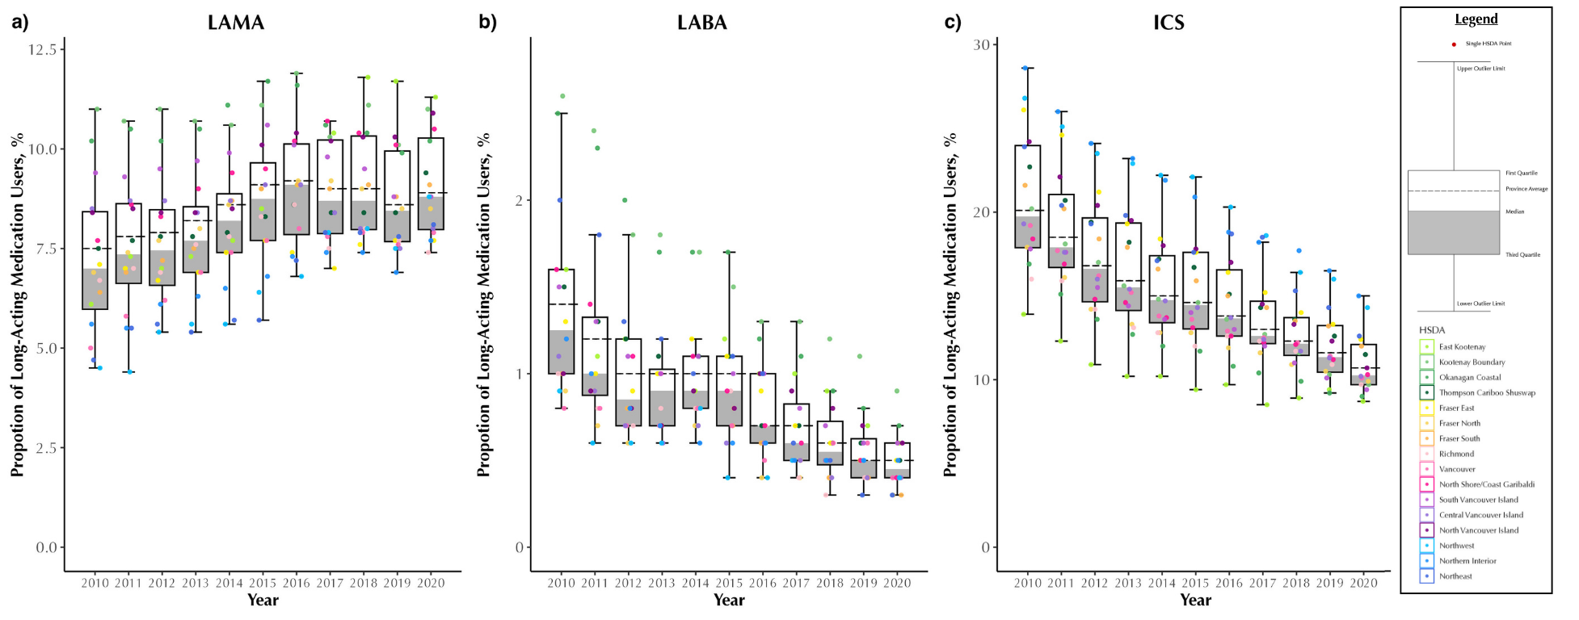

Figure A10: Proportion of single therapy long-acting medication users (%, among COPD patients) of LAMA (a), LABA (b) and ICS (c) in British Columbia, Canada, from 2001 to 2020, stratified by Health Service Delivery Areas (HSDAs)
Abbreviations: COPD: chronic obstructive pulmonary disease, ICS: Inhaled Corticosteroids, LABA: Long-Acting Beta Agonists, LAMA: Long-Acting Muscarinic Antagonists; Q1: quartile 1; Q3: quartile 3 Note: Each dot represents an HSDA. The horizontal line cutting through the plot is the overall provincial average. The median is the line separating the upper (white) and lower (dark grey) boxes

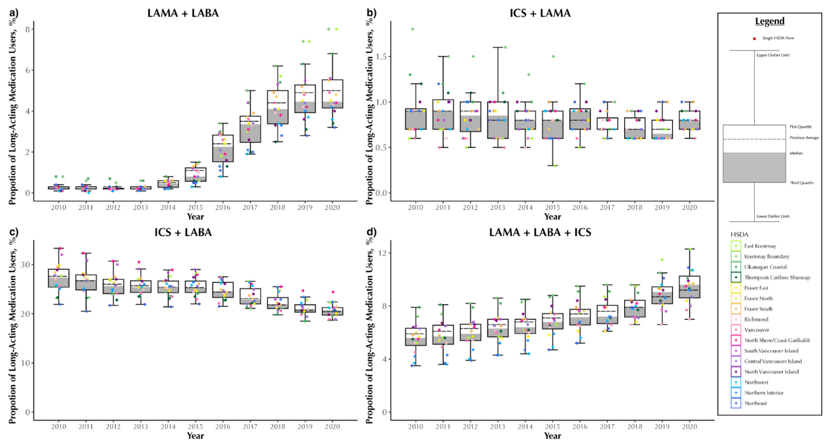

Figure A11: Proportion of combination therapies long-acting medication users (%, among COPD patients) of LAMA and LABA (a), ICS and LAMA (b), ICS and LABA (c) and ICS and LAMA and LABA (d) in British Columbia, Canada, from 2001 to 2020, stratified by Health Service Delivery Areas (HSDAs)
Combination therapies are based on either single inhalers containing multiple ingredients or from separate inhalers with 14 days of overlap. Abbreviations: COPD: chronic obstructive pulmonary disease, ICS: Inhaled Corticosteroids, LABA: Long-Acting Beta Agonists, LAMA: Long-Acting Muscarinic Antagonists; Q1: quartile 1; Q3: quartile 3 Note: Each dot represents an HSDA. The horizontal line cutting through the plot is the overall provincial average. The median is the line separating the upper (white) and lower (dark grey) boxes

