Supporting Information for

Synthesis and pharmacological evaluation of newly detected synthetic cannabinoid receptor agonists AB-4CN-BUTICA, MMB-4CN-BUTINACA, MDMB-4F-BUTICA, MDMB-4F-BUTINACA and their analogues

Eric Sparkes,^{1,2} Rochelle Boyd,^{1,3} Shuli Chen,⁴ Jack W. Markham,^{1,2,5} Jia Lin Luo,^{1,3} Tahira Foyzun,⁶ Humayra Zaman,⁶ Charlotte Fletcher,^{1,3} Ross Ellison,⁷ Iain S. McGregor,^{1,3} Marina J. Santiago,⁶ Felcia Lai,⁵ Roy R. Gerona,⁷ Mark Connor,⁶ David E. Hibbs,⁵ Elizabeth A. Cairns,^{1,3} Michelle Glass,⁴ Adam Ametovski,^{1,2†} Samuel D. Banister^{1,2†}

¹The Lambert Initiative for Cannabinoid Therapeutics, Brain and Mind Centre, The University of Sydney, NSW 2050, Australia;
²School of Chemistry, Faculty of Science, The University of Sydney, NSW 2006, Australia;
³School of Psychology, Faculty of Science, The University of Sydney, NSW 2006, Australia;
⁴Department of Pharmacology and Toxicology, University of Otago, Dunedin 9016, New Zealand
⁵School of Pharmacy, Faculty of Medicine and Health, The University of Sydney, NSW 2006, Australia;
⁶Macquarie Medical School, Macquarie University, Sydney, NSW 2109, Australia;
⁷Clinical Toxicology and Environmental Biomonitoring Laboratory, University of California, San Francisco, CA 94143, USA;

Contents
Synthesis and characterization for newly described compounds 1
General procedure A: amidation of 1-alkylindole-3-carboxyic acids, 1-alkyl-1H-indazole-3-carboxylic acids and 1-alkyl-1H-pyrrolo[2,3-b]pyridine-3-carboxylic acid. 1
(S)-N-(1-amino-3-methyl-1-oxobutan-2-yl)-1-(4-cyanobutyl)-1H-indole-3-carboxamide (5, AB-4CN-BUTICA). 1
(S)-N-(1-amino-3,3-dimethyl-1-oxobutan-2-yl)-1-(4-cyanobutyl)-1H-indole-3-carboxamide (9, ADB-4CN-BUTICA). 2
(S)-N-(1-amino-1-oxo-3-phenylpropan-2-yl)-1-(4-cyanobutyl)-1H-indole-3-carboxamide (10, APP-4CN-BUTICA). 2
(S)-N-(1-amino-3,3-dimethyl-1-oxobutan-2-yl)-1-(4-cyanobutyl)-1H-indazole-3-carboxamide (12, ADB-4CN-BUTINACA). 3
(S)-N-(1-amino-1-oxo-3-phenylpropan-2-yl)-1-(4-cyanobutyl)-1H-indazole-3-carboxamide (13, APP-4CN-BUTINACA). 3
(S)-N-(1-amino-3-methyl-1-oxobutan-2-yl)-1-(4-cyanobutyl)-1H-pyrrolo[2,3-b]pyridine-3-carboxamide (14, AB-4CN-BUT7AICA). 4
(S)-N-(1-amino-3,3-dimethyl-1-oxobutan-2-yl)-1-(4-cyanobutyl)-1H-pyrrolo[2,3-b]pyridine-3-carboxamide (15, ADB-4CN-BUT7AICA). 4
(S)-N-(1-amino-1-oxo-3-phenylpropan-2-yl)-1-(4-cyanobutyl)-1H-pyrrolo[2,3-b]pyridine-3-carboxamide (16, APP-4CN-BUT7AICA). 5
methyl (S)-2-(1-(4-cyanobutyl)-1H-indole-3-carboxamido)-3,3-dimethylbutanoate (18, MDMB-4CN-BUTICA). 5
methyl (1-(4-cyanobutyl)-1H-indole-3-carbonyl)-L-phenylalaninate (19, MPP-4CN-BUTICA). 6
methyl (S)-2-(1-(4-cyanobutyl)-1H-indazole-3-carboxamido)-3,3-dimethylbutanoate (20, MDMB-4CN-BUTINACA). 7
methyl (1-(4-cyanobutyl)-1H-indazole-3-carbonyl)-L-phenylalaninate (21, MPP-4CN-BUTINACA). 7
methyl (S)-2-(1-(4-cyanobutyl)-1H-pyrrolo[2,3-b]pyridine-3-carboxamido)-3,3-dimethylbutanoate (23, MDMB-4CN-BUT7AICA). 8
methyl (1-(4-cyanobutyl)-1H-pyrrolo[2,3-b]pyridine-3-carbonyl)-L-phenylalaninate (24, MPP-4CN-BUT7AICA). 8
(S)-N-(1-amino-3-methyl-1-oxobutan-2-yl)-1-(4-fluorobutyl)-1H-indole-3-carboxamide (25, AB-4F-BUTICA). 9
(S)-N-(1-amino-3,3-dimethyl-1-oxobutan-2-yl)-1-(4-fluorobutyl)-1H-indole-3-carboxamide (26, ADB-4F-BUTICA). 9
(S)-N-(1-amino-1-oxo-3-phenylpropan-2-yl)-1-(4-fluorobutyl)-1H-indole-3-carboxamide (27, APP-4F-BUTICA). 10
(S)-N-(1-amino-3-methyl-1-oxobutan-2-yl)-1-(4-fluorobutyl)-1H-indazole-3-carboxamide (28, AB-4F-BUTINACA). 10
(S)-N-(1-amino-3,3-dimethyl-1-oxobutan-2-yl)-1-(4-fluorobutyl)-1H-indazole-3-carboxamide (29, ADB-4F-BUTINACA). 11
(S)-N-(1-amino-1-oxo-3-phenylpropan-2-yl)-1-(4-fluorobutyl)-1H-indazole-3-carboxamide (30, APP-4F-BUTINACA). 12
(S)-N-(1-amino-3-methyl-1-oxobutan-2-yl)-1-(4-fluorobutyl)-1H-pyrrolo[2,3-b]pyridine-3-carboxamide (31, AB-4F-BUT7AICA). 12
(S)-N-(1-amino-3,3-dimethyl-1-oxobutan-2-yl)-1-(4-fluorobutyl)-1H-pyrrolo[2,3-b]pyridine-3-carboxamide (32, ADB-4F-BUT7AICA). 13
(S)-N-(1-amino-1-oxo-3-phenylpropan-2-yl)-1-(4-fluorobutyl)-1H-pyrrolo[2,3-b]pyridine-3-carboxamide (33, APP-4F-BUT7AICA). 13
methyl (1-(4-fluorobutyl)-1H-indole-3-carbonyl)-L-valinate (34, MMB-4F-BUTICA). 14
methyl (1-(4-fluorobutyl)-1H-indole-3-carbonyl)-L-phenylalaninate (35, MPP-4F-BUTICA). 14
methyl (1-(4-fluorobutyl)-1H-indazole-3-carbonyl)-L-valinate (36, MMB-4F-BUTINACA). 15
methyl (1-(4-fluorobutyl)-1H-indazole-3-carbonyl)-L-phenylalaninate (37, MPP-4F-BUTINACA). 16
methyl (1-(4-fluorobutyl)-1H-pyrrolo[2,3-b]pyridine-3-carbonyl)-L-valinate (38, MMB-4F-BUT7AICA). 16
methyl (S)-2-(1-(4-fluorobutyl)-1H-pyrrolo[2,3-b]pyridine-3-carboxamido)-3,3-dimethylbutanoate (39, MDMB-4F-BUT7AICA). 17
methyl (1-(4-fluorobutyl)-1H-pyrrolo[2,3-b]pyridine-3-carbonyl)-L-phenylalaninate (40, MPP-4F-BUT7AICA). 17
methyl 1-(4-fluorobutyl)-1H-pyrrolo[2,3-b]pyridine-3-carboxylate (49, 4F-BUT7AICA COOMe). 18
1-(4-fluorobutyl)-1H-pyrrolo[2,3-b]pyridine-3-carboxylic acid (53, 4F-BUT7AICA COOH). 19
¹H NMR, ¹³C NMR, LC-UV and UV spectra for newly described compounds. 20
Figure S1. ¹H (400 MHz, DMSO-d₆) and ¹³C (101 MHz, DMSO-d₆) NMR spectra for (S)-N-(1-amino-3-methyl-1-oxobutan-2-yl)-1-(4-cyanobutyl)-1H-indole-3-carboxamide (AB-4CN-BUTICA, 5). 20
Figure S2. ¹H (400 MHz, DMSO-d₆) and ¹³C (101 MHz, DMSO-d₆) NMR spectra for (S)-N-(1-amino-3,3-dimethyl-1-oxobutan-2-yl)-1-(4-cyanobutyl)-1H-indole-3-carboxamide (ADB-4CN-BUTICA, 9). 21
Figure S3. ¹H (400 MHz, DMSO-d₆) and ¹³C (101 MHz, DMSO-d₆) NMR spectra for (S)-N-(1-amino-1-oxo-3-phenylpropan-2-yl)-1-(4-cyanobutyl)-1H-indole-3-carboxamide (APP-4CN-BUTICA, 10). 22
Figure S4. ¹H (400 MHz, CD₃OD) and ¹³C (101 MHz, CD₃OD) NMR spectra for (S)-N-(1-amino-3-methyl-1-oxobutan-2-yl)-1-(4-cyanobutyl)-1H-indazole-3-carboxamide (AB-4CN-BUTINACA, 11). 23
Figure S5. ¹H (400 MHz, CD₃OD) and ¹³C (101 MHz, CD₃OD) NMR spectra for (S)-N-(1-amino-3,3-dimethyl-1-oxobutan-2-yl)-1-(4-cyanobutyl)-1H-indazole-3-carboxamide (ADB-4CN-BUTINACA, 12). 24
Figure S6. ¹H (400 MHz, CDCl₃) and ¹³C (101 MHz, DMSO-d₆) NMR spectra for (S)-N-(1-amino-1-oxo-3-phenylpropan-2-yl)-1-(4-cyanobutyl)-1H-indazole-3-carboxamide (APP-4CN-BUTINACA, 13). 25
Figure S7. ¹H (400 MHz, DMSO-d₆) and ¹³C (101 MHz, DMSO-d₆) NMR spectra for (S)-N-(1-amino-3-methyl-1-oxobutan-2-yl)-1-(4-cyanobutyl)-1H-pyrrolo[2,3-b]pyridine-3-carboxamide (AB-4CN-BUT7AICA, 14). 26
Figure S8. ¹H (400 MHz, DMSO-d₆) and ¹³C (101 MHz, DMSO-d₆) NMR spectra for (S)-N-(1-amino-3,3-dimethyl-1-oxobutan-2-yl)-1-(4-cyanobutyl)-1H-pyrrolo[2,3-b]pyridine-3-carboxamide (ADB-4CN-BUT7AICA, 15). 27
Figure S9. ¹H (400 MHz, CD₃OD) and ¹³C (101 MHz, DMSO-d₆) NMR spectra for (S)-N-(1-amino-1-oxo-3-phenylpropan-2-yl)-1-(4-cyanobutyl)-1H-pyrrolo[2,3-b]pyridine-3-carboxamide (APP-4CN-BUT7AICA, 16). 28
Figure S10. ¹H (400 MHz, CDCl₃) and ¹³C (101 MHz, CD₃OD) NMR spectra for methyl (1-(4-cyanobutyl)-1H-indole-3-carbonyl)-L-valinate (MMB-4CN-BUTICA, 17). 29
Figure S11. ¹H (400 MHz, DMSO-d₆) and ¹³C (101 MHz, CD₃OD) NMR spectra for methyl (S)-2-(1-(4-cyanobutyl)-1H-indole-3-carboxamido)-3,3-dimethylbutanoate (MDMB-4CN-BUTICA, 18). 30
Figure S12. ¹H (400 MHz, CDCl₃) and ¹³C (101 MHz, DMSO-d₆) NMR spectra for methyl (1-(4-cyanobutyl)-1H-indole-3-carbonyl)-L-phenylalaninate (MPP-4CN-BUTICA, 19). 31
Figure S13. ¹H (400 MHz, DMSO-d₆) and ¹³C (101 MHz, CD₃OD) NMR spectra for methyl (1-(4-cyanobutyl)-1H-indazole-3-carbonyl)-L-valinate (MMB-4CN-BUTINACA, 6). 32
Figure S14. ¹H (400 MHz, DMSO-d₆) and ¹³C (101 MHz, DMSO-d₆) NMR spectra for methyl (S)-2-(1-(4-cyanobutyl)-1H-indazole-3-carboxamido)-3,3-dimethylbutanoate (MDMB-4CN-BUTINACA, 20). 33
Figure S15. ¹H (400 MHz, CDCl₃) and ¹³C (101 MHz, CD₃OD) NMR spectra for methyl (1-(4-cyanobutyl)-1H-indazole-3-carbonyl)-L-phenylalaninate (MPP-4CN-BUTINACA, 21). 34
Figure S16. ¹H (400 MHz, CDCl₃) and ¹³C (101 MHz, DMSO-d₆) NMR spectra for methyl (1-(4-cyanobutyl)-1H-pyrrolo[2,3-b]pyridine-3-carbonyl)-L-valinate (MMB-4CN-BUT7AICA, 22). 35
Figure S17. ¹H (400 MHz, CD₃OD) and ¹³C (101 MHz, CD₃OD) NMR spectra for methyl (S)-2-(1-(4-cyanobutyl)-1H-pyrrolo[2,3-b]pyridine-3-carboxamido)-3,3-dimethylbutanoate (MDMB-4CN-BUT7AICA, 23). 36
Figure S18. ¹H (400 MHz, CDCl₃) and ¹³C (101 MHz, CD₃OD) NMR spectra for methyl (1-(4-cyanobutyl)-1H-pyrrolo[2,3-b]pyridine-3-carbonyl)-L-phenylalaninate (MPP-4CN-BUT7AICA, 24). 37
Figure S19. ¹H (400 MHz, DMSO-d₆) and ¹³C (101 MHz, DMSO-d₆) NMR spectra for (S)-N-(1-amino-3-methyl-1-oxobutan-2-yl)-1-(4-fluorobutyl)-1H-indole-3-carboxamide (AB-4F-BUTICA, 25). 38
Figure S20. ¹H (400 MHz, DMSO-d₆) and ¹³C (101 MHz, CDCl₃) NMR spectra for (S)-N-(1-amino-3,3-dimethyl-1-oxobutan-2-yl)-1-(4-fluorobutyl)-1H-indole-3-carboxamide (ADB-4F-BUTICA, 26). 39
Figure S21. ¹H (400 MHz, CDCl₃) and ¹³C (101 MHz, DMSO-d₆) NMR spectra for (S)-N-(1-amino-1-oxo-3-phenylpropan-2-yl)-1-(4-fluorobutyl)-1H-indole-3-carboxamide (APP-4F-BUTICA, 27). 40
Figure S22. ¹H (400 MHz, CD₃OD) and ¹³C (101 MHz, CD₃OD) NMR spectra for (S)-N-(1-amino-3-methyl-1-oxobutan-2-yl)-1-(4-fluorobutyl)-1H-indazole-3-carboxamide (AB-4F-BUTINACA, 28). 41
Figure S23. ¹H (400 MHz, CD₃OD) and ¹³C (101 MHz, CDCl₃) NMR spectra for (S)-N-(1-amino-3,3-dimethyl-1-oxobutan-2-yl)-1-(4-fluorobutyl)-1H-indazole-3-carboxamide (ADB-4F-BUTINACA, 29). 42
Figure S24. ¹H (400 MHz, DMSO-d₆) and ¹³C (101 MHz, DMSO-d₆) NMR spectra for (S)-N-(1-amino-1-oxo-3-phenylpropan-2-yl)-1-(4-fluorobutyl)-1H-indazole-3-carboxamide (APP-4F-BUTINACA, 30). 43
Figure S25. ¹H (400 MHz, CD₃OD) and ¹³C (101 MHz, CD₃OD) NMR spectra for (S)-N-(1-amino-3-methyl-1-oxobutan-2-yl)-1-(4-fluorobutyl)-1H-pyrrolo[2,3-b]pyridine-3-carboxamide (AB-4F-BUT7AICA, 31). 44
Figure S26. ¹H (400 MHz, CDCl₃) and ¹³C (101 MHz, CD₃OD) NMR spectra for (S)-N-(1-amino-3,3-dimethyl-1-oxobutan-2-yl)-1-(4-fluorobutyl)-1H-pyrrolo[2,3-b]pyridine-3-carboxamide (ADB-4F-BUT7AICA, 32). 45
Figure S27. ¹H (400 MHz, DMSO-d₆) and ¹³C (101 MHz, DMSO-d₆) NMR spectra for (S)-N-(1-amino-1-oxo-3-phenylpropan-2-yl)-1-(4-fluorobutyl)-1H-pyrrolo[2,3-b]pyridine-3-carboxamide (APP-4F-BUT7AICA, 33). 46
Figure S28. ¹H (400 MHz, CDCl₃) and ¹³C (101 MHz, CD₃OD) NMR spectra for methyl (1-(4-fluorobutyl)-1H-indole-3-carbonyl)-L-valinate (MMB-4F-BUTICA, 34). 47
Figure S29. ¹H (400 MHz, DMSO-d₆) and ¹³C (101 MHz, DMSO-d₆) NMR spectra for methyl (S)-2-(1-(4-fluorobutyl)-1H-indole-3-carboxamido)-3,3-dimethylbutanoate (MDMB-4F-BUTICA, 7). 48
Figure S30. ¹H (400 MHz, CDCl₃) and ¹³C (101 MHz, CD₃OD) NMR spectra for methyl (1-(4-fluorobutyl)-1H-indole-3-carbonyl)-L-phenylalaninate (MPP-4F-BUTICA, 35). 49
Figure S31. ¹H (400 MHz, DMSO-d₆) and ¹³C (101 MHz, CD₃OD) NMR spectra for methyl (1-(4-fluorobutyl)-1H-indazole-3-carbonyl)-L-valinate (MMB-4F-BUTINACA, 36). 50
Figure S32. ¹H (400 MHz, DMSO-d₆) and ¹³C (101 MHz, DMSO-d₆) NMR spectra for methyl (S)-2-(1-(4-fluorobutyl)-1H-indazole-3-carboxamido)-3,3-dimethylbutanoate (MDMB-4F-BUTINACA, 8). 51
Figure S33. ¹H (400 MHz, CDCl₃) and ¹³C (101 MHz, CD₃OD) NMR spectra for methyl (1-(4-fluorobutyl)-1H-indazole-3-carbonyl)-L-phenylalaninate (MPP-4F-BUTINACA, 37). 52
Figure S34. ¹H (400 MHz, DMSO-d₆) and ¹³C (101 MHz, CD₃OD) NMR spectra for methyl (1-(4-fluorobutyl)-1H-pyrrolo[2,3-b]pyridine-3-carbonyl)-L-valinate (MMB-4F-BUT7AICA¸38). 53
Figure S35. ¹H (400 MHz, DMSO-d₆) and ¹³C (101 MHz, CD₃OD) NMR spectra for methyl (S)-2-(1-(4-fluorobutyl)-1H-pyrrolo[2,3-b]pyridine-3-carboxamido)-3,3-dimethylbutanoate (MDMB-4F-BUT7AICA, 39). 54
Figure S36. ¹H (400 MHz, CDCl₃) and ¹³C (101 MHz, CD₃OD) NMR spectra for methyl (1-(4-fluorobutyl)-1H-pyrrolo[2,3-b]pyridine-3-carbonyl)-L-phenylalaninate (MPP-4F-BUT7AICA, 40). 55
Figure S37. ¹H (400 MHz, CDCl₃) and ¹³C (101 MHz, CDCl₃) NMR spectra for methyl 1-(4-fluorobutyl)-1H-pyrrolo[2,3-b]pyridine-3-carboxylate (4F-BUT7AICA COOMe, 49). 56
Figure S38. ¹H (400 MHz, DMSO-d₆) and ¹³C (75 MHz, DMSO-d₆) NMR spectra for 1-(4-fluorobutyl)-1H-pyrrolo[2,3-b]pyridine-3-carboxylic acid (4F-BUT7AICA COOH, 53). 57
Figure S39. LC-UV chromatogram for (S)-N-(1-amino-3-methyl-1-oxobutan-2-yl)-1-(4-cyanobutyl)-1H-indole-3-carboxamide (AB-4CN-BUTICA, 5). 58
Figure S40. LC-UV chromatogram for (S)-N-(1-amino-3,3-dimethyl-1-oxobutan-2-yl)-1-(4-cyanobutyl)-1H-indole-3-carboxamide (ADB-4CN-BUTICA, 9). 58
Figure S41. LC-UV chromatogram for (S)-N-(1-amino-1-oxo-3-phenylpropan-2-yl)-1-(4-cyanobutyl)-1H-indole-3-carboxamide (APP-4CN-BUTICA, 10). 59
Figure S42. LC-UV chromatogram for (S)-N-(1-amino-3-methyl-1-oxobutan-2-yl)-1-(4-cyanobutyl)-1H-indazole-3-carboxamide (AB-4CN-BUTINACA, 11). 59
Figure S43. LC-UV chromatogram for (S)-N-(1-amino-3,3-dimethyl-1-oxobutan-2-yl)-1-(4-cyanobutyl)-1H-indazole-3-carboxamide (ADB-4CN-BUTINACA, 12). 60
Figure S44. LC-UV chromatogram for (S)-N-(1-amino-1-oxo-3-phenylpropan-2-yl)-1-(4-cyanobutyl)-1H-indazole-3-carboxamide (APP-4CN-BUTINACA, 13). 60
Figure S45. LC-UV chromatogram for (S)-N-(1-amino-3-methyl-1-oxobutan-2-yl)-1-(4-cyanobutyl)-1H-pyrrolo[2,3-b]pyridine-3-carboxamide (AB-4CN-BUT7AICA, 14). 61
Figure S46. LC-UV chromatogram for (S)-N-(1-amino-3,3-dimethyl-1-oxobutan-2-yl)-1-(4-cyanobutyl)-1H-pyrrolo[2,3-b]pyridine-3-carboxamide (ADB-4CN-BUT7AICA, 15). 61
Figure S47. LC-UV chromatogram for (S)-N-(1-amino-1-oxo-3-phenylpropan-2-yl)-1-(4-cyanobutyl)-1H-pyrrolo[2,3-b]pyridine-3-carboxamide (APP-4CN-BUT7AICA, 16). 62
Figure S48. LC-UV chromatogram for methyl (1-(4-cyanobutyl)-1H-indole-3-carbonyl)-L-valinate (MMB-4CN-BUTICA, 17). 62
Figure S49. LC-UV chromatogram for methyl (S)-2-(1-(4-cyanobutyl)-1H-indole-3-carboxamido)-3,3-dimethylbutanoate (MDMB-4CN-BUTICA, 18). 63
Figure S50. LC-UV chromatogram for methyl (1-(4-cyanobutyl)-1H-indole-3-carbonyl)-L-phenylalaninate (MPP-4CN-BUTICA, 19). 63
Figure S51. LC-UV chromatogram for methyl (1-(4-cyanobutyl)-1H-indazole-3-carbonyl)-L-valinate (MMB-4CN-BUTINACA, 6). 64
Figure S52. LC-UV chromatogram for methyl (S)-2-(1-(4-cyanobutyl)-1H-indazole-3-carboxamido)-3,3-dimethylbutanoate (MDMB-4CN-BUTINACA, 20). 64
Figure S53. LC-UV chromatogram for methyl (1-(4-cyanobutyl)-1H-indazole-3-carbonyl)-L-phenylalaninate (MPP-4CN-BUTINACA, 21). 65
Figure S54. LC-UV chromatogram for methyl (1-(4-cyanobutyl)-1H-pyrrolo[2,3-b]pyridine-3-carbonyl)-L-valinate (MMB-4CN-BUT7AICA, 22). 65
Figure S55. LC-UV chromatogram for methyl (S)-2-(1-(4-cyanobutyl)-1H-pyrrolo[2,3-b]pyridine-3-carboxamido)-3,3-dimethylbutanoate (MDMB-4CN-BUT7AICA, 23). 66
Figure S56. LC-UV chromatogram for methyl (1-(4-cyanobutyl)-1H-pyrrolo[2,3-b]pyridine-3-carbonyl)-L-phenylalaninate (MPP-4CN-BUT7AICA, 24). 66
Figure S57. LC-UV chromatogram for (S)-N-(1-amino-3-methyl-1-oxobutan-2-yl)-1-(4-fluorobutyl)-1H-indole-3-carboxamide (AB-4F-BUTICA, 25). 67
Figure S58. LC-UV chromatogram for (S)-N-(1-amino-3,3-dimethyl-1-oxobutan-2-yl)-1-(4-fluorobutyl)-1H-indole-3-carboxamide (ADB-4F-BUTICA, 26). 67
Figure S59. LC-UV chromatogram for (S)-N-(1-amino-1-oxo-3-phenylpropan-2-yl)-1-(4-fluorobutyl)-1H-indole-3-carboxamide (APP-4F-BUTICA, 27). 68
Figure S60. LC-UV chromatogram for (S)-N-(1-amino-3-methyl-1-oxobutan-2-yl)-1-(4-fluorobutyl)-1H-indazole-3-carboxamide (AB-4F-BUTINACA, 28). 68
Figure S61. LC-UV chromatogram for (S)-N-(1-amino-3,3-dimethyl-1-oxobutan-2-yl)-1-(4-fluorobutyl)-1H-indazole-3-carboxamide (ADB-4F-BUTINACA, 29). 69
Figure S62. LC-UV chromatogram for (S)-N-(1-amino-1-oxo-3-phenylpropan-2-yl)-1-(4-fluorobutyl)-1H-indazole-3-carboxamide (APP-4F-BUTINACA, 30). 69
Figure S63. LC-UV chromatogram for (S)-N-(1-amino-3-methyl-1-oxobutan-2-yl)-1-(4-fluorobutyl)-1H-pyrrolo[2,3-b]pyridine-3-carboxamide (AB-4F-BUT7AICA, 31). 70
Figure S64. LC-UV chromatogram for (S)-N-(1-amino-3,3-dimethyl-1-oxobutan-2-yl)-1-(4-fluorobutyl)-1H-pyrrolo[2,3-b]pyridine-3-carboxamide (ADB-4F-BUT7AICA, 32). 70
Figure S65. LC-UV chromatogram for (S)-N-(1-amino-1-oxo-3-phenylpropan-2-yl)-1-(4-fluorobutyl)-1H-pyrrolo[2,3-b]pyridine-3-carboxamide (APP-4F-BUT7AICA, 33). 71
Figure S66. LC-UV chromatogram for methyl (1-(4-fluorobutyl)-1H-indole-3-carbonyl)-L-valinate (MMB-4F-BUTICA, 34). 71
Figure S67. LC-UV chromatogram for methyl (S)-2-(1-(4-fluorobutyl)-1H-indole-3-carboxamido)-3,3-dimethylbutanoate (MDMB-4F-BUTICA, 7). 72
Figure S68. LC-UV chromatogram for methyl (1-(4-fluorobutyl)-1H-indole-3-carbonyl)-L-phenylalaninate (MPP-4F-BUTICA, 35). 72
Figure S69. LC-UV chromatogram for methyl (1-(4-fluorobutyl)-1H-indazole-3-carbonyl)-L-valinate (MMB-4F-BUTINACA, 36). 73
Figure S70. LC-UV chromatogram for methyl (S)-2-(1-(4-fluorobutyl)-1H-indazole-3-carboxamido)-3,3-dimethylbutanoate (MDMB-4F-BUTINACA, 8). 73
Figure S71. LC-UV chromatogram for methyl (1-(4-fluorobutyl)-1H-indazole-3-carbonyl)-L-phenylalaninate (MPP-4F-BUTINACA, 37). 74
Figure S72. LC-UV chromatogram for methyl (1-(4-fluorobutyl)-1H-pyrrolo[2,3-b]pyridine-3-carbonyl)-L-valinate (MMB-4F-BUT7AICA, 38). 74
Figure S73. LC-UV chromatogram for methyl (S)-2-(1-(4-fluorobutyl)-1H-pyrrolo[2,3-b]pyridine-3-carboxamido)-3,3-dimethylbutanoate (MDMB-4F-BUT7AICA, 39). 75
Figure S74. LC-UV chromatogram for methyl (1-(4-fluorobutyl)-1H-pyrrolo[2,3-b]pyridine-3-carbonyl)-L-phenylalaninate (MPP-4F-BUT7AICA, 40). 75
Figure S75. UV spectrum for (S)-N-(1-amino-3-methyl-1-oxobutan-2-yl)-1-(4-cyanobutyl)-1H-indole-3-carboxamide (AB-4CN-BUTICA, 5). 76
Figure S76. UV spectrum for (S)-N-(1-amino-3,3-dimethyl-1-oxobutan-2-yl)-1-(4-cyanobutyl)-1H-indole-3-carboxamide (ADB-4CN-BUTICA, 9). 76
Figure S77. UV spectrum for (S)-N-(1-amino-1-oxo-3-phenylpropan-2-yl)-1-(4-cyanobutyl)-1H-indole-3-carboxamide (APP-4CN-BUTICA, 10). 76
Figure S78. UV spectrum for (S)-N-(1-amino-3,3-dimethyl-1-oxobutan-2-yl)-1-(4-cyanobutyl)-1H-indazole-3-carboxamide (ADB-4CN-BUTINACA, 12). 77
Figure S79. UV spectrum for (S)-N-(1-amino-1-oxo-3-phenylpropan-2-yl)-1-(4-cyanobutyl)-1H-indazole-3-carboxamide (APP-4CN-BUTINACA, 13). 77
Figure S80. UV spectrum for (S)-N-(1-amino-3-methyl-1-oxobutan-2-yl)-1-(4-cyanobutyl)-1H-pyrrolo[2,3-b]pyridine-3-carboxamide (AB-4CN-BUT7AICA, 14). 77
Figure S81. UV spectrum for (S)-N-(1-amino-3,3-dimethyl-1-oxobutan-2-yl)-1-(4-cyanobutyl)-1H-pyrrolo[2,3-b]pyridine-3-carboxamide (ADB-4CN-BUT7AICA, 15). 78
Figure S82. UV spectrum for (S)-N-(1-amino-1-oxo-3-phenylpropan-2-yl)-1-(4-cyanobutyl)-1H-pyrrolo[2,3-b]pyridine-3-carboxamide (APP-4CN-BUT7AICA, 16). 78
Figure S83. UV spectrum for methyl (S)-2-(1-(4-cyanobutyl)-1H-indole-3-carboxamido)-3,3-dimethylbutanoate (MDMB-4CN-BUTICA, 18). 78
Figure S84. UV spectrum for methyl (1-(4-cyanobutyl)-1H-indole-3-carbonyl)-L-phenylalaninate (MPP-4CN-BUTICA, 19). 79
Figure S85. UV spectrum for methyl (S)-2-(1-(4-cyanobutyl)-1H-indazole-3-carboxamido)-3,3-dimethylbutanoate (MDMB-4CN-BUTINACA, 20). 79
Figure S86. UV spectrum for methyl (1-(4-cyanobutyl)-1H-indazole-3-carbonyl)-L-phenylalaninate (MPP-4CN-BUTINACA, 21). 79
Figure S87. UV spectrum for methyl (S)-2-(1-(4-cyanobutyl)-1H-pyrrolo[2,3-b]pyridine-3-carboxamido)-3,3-dimethylbutanoate (MDMB-4CN-BUT7AICA, 23). 80
Figure S88. UV spectrum for methyl (1-(4-cyanobutyl)-1H-pyrrolo[2,3-b]pyridine-3-carbonyl)-L-phenylalaninate (MPP-4CN-BUT7AICA, 24). 80
Figure S89. UV spectrum for (S)-N-(1-amino-3-methyl-1-oxobutan-2-yl)-1-(4-fluorobutyl)-1H-indole-3-carboxamide (AB-4F-BUTICA, 25). 80
Figure S90. UV spectrum for (S)-N-(1-amino-3,3-dimethyl-1-oxobutan-2-yl)-1-(4-fluorobutyl)-1H-indole-3-carboxamide (ADB-4F-BUTICA, 26). 81
Figure S91. UV spectrum for (S)-N-(1-amino-1-oxo-3-phenylpropan-2-yl)-1-(4-fluorobutyl)-1H-indole-3-carboxamide (APP-4F-BUTICA, 27). 81
Figure S92. UV spectrum for (S)-N-(1-amino-3-methyl-1-oxobutan-2-yl)-1-(4-fluorobutyl)-1H-indazole-3-carboxamide (AB-4F-BUTINACA, 28). 81
Figure S93. UV spectrum for (S)-N-(1-amino-3,3-dimethyl-1-oxobutan-2-yl)-1-(4-fluorobutyl)-1H-indazole-3-carboxamide (ADB-4F-BUTINACA, 29). 82
Figure S94. UV spectrum for (S)-N-(1-amino-1-oxo-3-phenylpropan-2-yl)-1-(4-fluorobutyl)-1H-indazole-3-carboxamide (APP-4F-BUTINACA, 30). 82
Figure S95. UV spectrum for (S)-N-(1-amino-3-methyl-1-oxobutan-2-yl)-1-(4-fluorobutyl)-1H-pyrrolo[2,3-b]pyridine-3-carboxamide (AB-4F-BUT7AICA, 31). 82
Figure S96. UV spectrum for (S)-N-(1-amino-3,3-dimethyl-1-oxobutan-2-yl)-1-(4-fluorobutyl)-1H-pyrrolo[2,3-b]pyridine-3-carboxamide (ADB-4F-BUT7AICA, 32). 83
Figure S97. UV spectrum for (S)-N-(1-amino-1-oxo-3-phenylpropan-2-yl)-1-(4-fluorobutyl)-1H-pyrrolo[2,3-b]pyridine-3-carboxamide (APP-4F-BUT7AICA, 33). 83
Figure S98. UV spectrum for methyl (1-(4-fluorobutyl)-1H-indole-3-carbonyl)-L-valinate (MMB-4F-BUTICA, 34). 83
Figure S99. UV spectrum for methyl (1-(4-fluorobutyl)-1H-indole-3-carbonyl)-L-phenylalaninate (MPP-4F-BUTICA, 35). 84
Figure S100. UV spectrum for methyl (1-(4-fluorobutyl)-1H-indazole-3-carbonyl)-L-valinate (MMB-4F-BUTINACA, 36). 84
Figure S101. UV spectrum for methyl (1-(4-fluorobutyl)-1H-indazole-3-carbonyl)-L-phenylalaninate (MPP-4F-BUTINACA, 37). 84
Figure S102. UV spectrum for methyl (1-(4-fluorobutyl)-1H-pyrrolo[2,3-b]pyridine-3-carbonyl)-L-valinate (MMB-4F-BUT7AICA, 38). 85
Figure S103. UV spectrum for methyl (S)-2-(1-(4-fluorobutyl)-1H-pyrrolo[2,3-b]pyridine-3-carboxamido)-3,3-dimethylbutanoate (MDMB-4F-BUT7AICA, 39). 85
Figure S104. UV spectrum for methyl (1-(4-fluorobutyl)-1H-pyrrolo[2,3-b]pyridine-3-carbonyl)-L-phenylalaninate (MPP-4F-BUT7AICA, 40). 85
Table T1. Strain energy calculations of compounds 5-40 87
Calculated binding poses 89
Figure S105. Computationally predicted binding modes of 11 (orange) and 28 (green) overlayed at the CB₁ (PDB:6N4B) receptor. 89
Figure S106. Computationally predicted binding modes of 13 (orange) and 30 (green) overlayed at the CB₁ (PDB:6N4B) receptor. 90
Figure S107. Computationally predicted binding modes of 9 (orange) and 26 (green) overlayed at the CB₁ (PDB:6N4B) receptor. 91
Figure S108. Computationally predicted binding modes of 15 (orange) and 32 (green) overlayed at the CB₁ (PDB:6N4B) receptor. 92
Figure S109. Computationally predicted binding modes of 23 (orange) and 39 (green) overlayed at the CB₁ (PDB:6N4B) receptor. 93
Figure S110. Computationally predicted binding modes of 18 (orange) and 7 (green) overlayed at the CB₁ (PDB:6N4B) receptor. 94
Figure S111. Computationally predicted binding modes of 11 (orange) and 28 (green) overlayed at the CB₂ (PDB:6PT0) receptor. 95
Figure S112. Computationally predicted binding modes of 13 (orange) and 30 (green) overlayed at the CB₂ (PDB:6PT0) receptor. 96
Figure S113. Computationally predicted binding modes of 9 (orange) and 26 (green) overlayed at the CB₂ (PDB:6PT0) receptor. 97
Figure S114. Computationally predicted binding modes of 15 (orange) and 32 (green) overlayed at the CB₂ (PDB:6PT0) receptor. 98
Figure S115. Computationally predicted binding modes of 23 (orange) and 39 (green) overlayed at the CB₂ (PDB:6PT0) receptor. 99
Figure S116. Computationally predicted binding modes of 18 (orange) and 7 (green) overlayed at the CB₂ (PDB:6PT0) receptor. 100

Synthesis and characterization for newly described compounds

General procedure A: amidation of 1-alkylindole-3-carboxyic acids, 1-alkyl-1H-indazole-3-carboxylic acids and 1-alkyl-1H-pyrrolo[2,3-b]pyridine-3-carboxylic acid.
To a solution of the appropriate 1-alkylindole-3-carboxyic acid (44 or 45, 0.50 mmol), 1-alkyl-1H-indazole-3-carboxylic acid (50 or 51, 0.50 mmol) or 1-alkyl-1H-pyrrolo[2,3-b]pyridine-3-carboxylic acid (52 or 53, 0.50 mmol), the suitable amine reactant (0.55 mmol, 1.1 equiv.), HOBt·H₂O (0.55 mmol, 1.1 equiv.) and EDC·HCl (0.75 mmol, 1.5 equiv.) in DMF (3 mL) was added. Et₃N (1.65 mmol, 3.3 equiv.) was added dropwise and the mixture was stirred for 18 h. The mixture was poured onto H₂O (80 mL), extracted with EtOAc (3 × 20 mL), and the combined organic layers were washed with H₂O (2 × 40 mL), brine (40 mL), dried over Na₂SO₄, and the solvent evaporated under reduced pressure. The products were obtained following purification by flash chromatography.

(S)-N-(1-amino-3-methyl-1-oxobutan-2-yl)-1-(4-cyanobutyl)-1H-indole-3-carboxamide (5, AB-4CN-BUTICA).
Subjecting 1-(4-cyanobutyl)-1H-indole-3-carboxylic acid (48, 97 mg, 0.40 mmol) and (S)-2-amino-3-methylbutanamide hydrochloride (66 mg, 0.43 mmol) to general procedure A furnished, following purification by flash chromatography (CH₂Cl₂:MeOH 100:0 to 80:20), 9 as a white powder (72 mg, 53%). R_{f} 0.03 (hexane:EtOAc 1:1); m.p. 177–180 °C; ¹H NMR (400 MHz, DMSO-d₆) δ 8.25 (s, 1H), 8.13 – 8.08 (m, 1H), 7.57 (d, J = 8.2 Hz, 1H), 7.49 (d, J = 9.1 Hz, 1H), 7.47 (brs, 1H), 7.25 – 7.12 (m, 2H), 7.06 (brs, 1H), 4.35 (dd, J = 8.9, 7.0 Hz, 1H), 4.26 (td, J = 6.9, 2.0 Hz, 2H), 2.55 (t, J = 7.1 Hz, 2H), 2.08 (sext., J = 6.8 Hz, 1H), 1.95 – 1.83 (m, 2H), 1.63 – 1.51 (m, 2H), 0.93 (dd, J = 6.8, 3.0 Hz, 6H); ¹³C NMR (101 MHz, DMSO-d₆) δ 174.0, 164.5, 136.5, 131.7, 126.9, 122.4, 121.5, 121.1, 120.9, 110.8, 110.0, 57.8, 45.5, 30.9, 29.2, 22.7, 20.0, 18.9, 16.3; ѵ_{max} (cm⁻¹): 3293, 1620, 1514, 1466, 1394, 1269, 1231, 1163, 802, 741, 663, 617, 562; HRMS (ESI, +ive) C₁₉H₂₄N₄O₂ theoretical mass 340.1899, experimental exact mass 340.1906 (mass error 2.03 ppm).

(S)-N-(1-amino-3,3-dimethyl-1-oxobutan-2-yl)-1-(4-cyanobutyl)-1H-indole-3-carboxamide (9, ADB-4CN-BUTICA).
Subjecting 1-(4-cyanobutyl)-1H-indole-3-carboxylic acid (44, 97 mg, 0.40 mmol) and (S)-2-amino-3,3-dimethylbutanamide hydrochloride (72 mg, 0.45 mmol) to general procedure A furnished, following purification by flash chromatography (CH₂Cl₂:MeOH 100:0 to 90:10), 9 as a white solid (97 mg, 69%). R_{f} 0.54 (hexane:EtOAc 1:4); m.p. 101–103 °C; ¹H NMR (400 MHz, DMSO-d₆) δ 8.30 (s, 1H), 8.07 (d, J = 7.8 Hz, 1H), 7.58 (d, J = 8.1 Hz, 1H), 7.56 (s, 1H), 7.26 – 7.13 (m, 3H), 7.11 (s, 1H), 4.47 (d, J = 9.5 Hz, 1H), 4.29 – 4.23 (m, 2H), 2.55 (t, J = 7.1 Hz, 2H), 1.95 – 1.84 (m, 2H), 1.56 (m, 2H), 1.01 (s, 9H); ¹³C NMR (101 MHz, DMSO-d₆) δ 172.5, 163.7, 136.1, 131.5, 126.3, 122.0, 120.8, 120.8, 120.5, 110.5, 109.5, 59.1, 45.1, 34.1, 28.8, 26.9, 22.3, 15.8; ѵ_{max} (cm⁻¹): 3192, 2955, 1613, 1535, 1464, 1394, 1227, 1166, 746; HRMS (ESI, +ive) C₂₀H₂₆N₄O₂ theoretical mass 354.2056, experimental exact mass 354.2049 (mass error 1.7 ppm).

(S)-N-(1-amino-1-oxo-3-phenylpropan-2-yl)-1-(4-cyanobutyl)-1H-indole-3-carboxamide (10, APP-4CN-BUTICA).
Subjecting 1-(4-cyanobutyl)-1H-indole-3-carboxylic acid (44, 97 mg, 0.40 mmol) and (S)-2-amino-3-phenylpropanamide hydrochloride (69 mg, 0.34 mmol) to general procedure A furnished, following purification by flash chromatography (CH₂Cl₂:MeOH 100:0 to 85:15), 10 as a white solid (91 mg, 59%). R_{f} 0.03 (hexane:EtOAc 1:1); m.p. 84–85 °C; ¹H NMR (400 MHz, DMSO-d₆) δ 8.12 (s, 1H), 8.02 (d, J = 8.1 Hz, 1H), 7.87 (d, J = 8.5 Hz, 1H), 7.54 (d, J = 8.2 Hz, 1H), 7.51 (brs, 1H), 7.33 (dd, J = 8.1, 1.4 Hz, 2H), 7.24 (t, J = 7.6 Hz, 2H), 7.21 – 7.10 (m, 3H), 7.08 (brs, 1H), 4.71 – 4.62 (m, 1H), 4.25 (t, J = 6.9 Hz, 2H), 3.11 (dd, J = 13.7, 4.6 Hz, 1H), 2.95 (dd, J = 13.7, 9.9 Hz, 1H), 2.55 (t, J = 7.1 Hz, 2H), 1.92 – 1.82 (m, 2H), 1.61 – 1.51 (m, 2H); ¹³C NMR (101 MHz, DMSO-d₆) δ 173.8, 163.9, 138.6, 136.0, 131.1, 129.2, 128.0, 126.4, 126.1, 122.0, 121.1, 120.6, 120.5, 110.3, 109.5, 53.8, 45.1, 37.6, 28.8, 22.3, 15.8; ѵ_{max} (cm⁻¹): 3311, 1671, 1614, 1536, 1463, 1394, 1272, 1228, 1166, 746, 699, 509; HRMS (ESI, +ive) C₂₃H₂₄N₄O₂ theoretical mass 388.1899, experimental exact mass 388.1906 (mass error 1.79 ppm).

(S)-N-(1-amino-3,3-dimethyl-1-oxobutan-2-yl)-1-(4-cyanobutyl)-1H-indazole-3-carboxamide (12, ADB-4CN-BUTINACA).
Subjecting 1-(4-cyanobutyl)-1H-indazole-3-carboxylic acid (50, 297 mg, 1.22 mmol) and (S)-2-amino-3,3-dimethylbutanamide hydrochloride (223 mg, 1.34 mmol) to general procedure A furnished, following purification by flash chromatography (CH₂Cl₂:MeOH 100:0 to 93:7), 12 as a white solid (383 mg, 89%). R_{f} 0.43 (hexane:EtOAc 2:8); m.p. 82–86 °C; ¹H NMR (400 MHz, CD₃OD) δ 8.22 (dd, J = 8.3, 1.4 Hz, 1H), 7.68 (d, J = 8.5 Hz, 1H), 7.48 (dd, J = 8.4, 6.9 Hz, 1H), 7.30 (dd, J = 8.2, 6.8 Hz, 1H), 4.57 (t, J = 6.9 Hz, 2H), 4.54 (s, 1H), 2.53 – 2.46 (m, 2H), 2.11 (quin, J = 7.1 Hz, 2H), 1.67 (quin, J = 7.3 Hz, 2H), 1.10 (s, 9H); ¹³C NMR (101 MHz, CD₃OD) δ 175.1, 164.0, 142.5, 137.8, 128.2, 124.0, 123.9, 123.0, 120.8, 111.0, 61.0, 35.6, 29.7, 27.2, 23.9, 16.9; ѵ_{max} (cm⁻¹): 3327, 3199, 2956, 2248, 1650, 1525, 1491, 1397, 1367, 1314, 1208, 1169, 1133, 1005, 931, 826, 776, 750, 664, 561, 548, 527, 510; HRMS (ESI, +ive) C₁₉H₂₅N₅O₂ theoretical mass 355.2008, experimental exact mass 355.2015 (mass error 2.02 ppm).

(S)-N-(1-amino-1-oxo-3-phenylpropan-2-yl)-1-(4-cyanobutyl)-1H-indazole-3-carboxamide (13, APP-4CN-BUTINACA).
Subjecting 1-(4-cyanobutyl)-1H-indazole-3-carboxylic acid (50, 80 mg, 0.33 mmol) and (S)-2-amino-3-phenylpropanamide hydrochloride (70 mg, 0.35 mmol) to general procedure A furnished, following purification by flash chromatography (CH₂Cl₂:MeOH 100:0 to 90:10), 13 as a colorless oil (117 mg, 91%). R_{f} 0.10 (hexane:EtOAc 1:1); ¹H NMR (400 MHz, CDCl₃) δ 8.30 (dt, J = 8.2, 1.0 Hz, 1H), 7.49 (d, J = 8.0 Hz, 1H), 7.45 – 7.37 (m, 2H), 7.34 – 7.23 (m, 6H), 5.97 (brs, 1H), 5.37 (brs, 1H), 4.96 – 4.87 (m, 1H), 4.42 (t, J = 6.7 Hz, 2H), 3.30 (dd, J = 13.9, 6.5 Hz, 1H), 3.30 (dd, J = 13.9, 6.5 Hz, 1H), 2.35 (t, J = 7.0 Hz, 2H), 2.17 – 2.07 (m, 2H), 1.68 – 1.58 (m, 2H); ¹³C NMR (101 MHz, DMSO-d₆) δ 172.6, 161.2, 140.5, 137.6, 136.6, 129.3, 128.0, 126.7, 126.3, 122.5, 122.0, 121.7, 120.5, 110.3, 53.2, 47.8, 37.7, 28.5, 22.2, 15.8; ѵ_{max} (cm⁻¹): 3307, 3195, 2928, 2247, 1645, 1574, 1525, 1490, 1454, 1402, 1307, 1214, 1168, 1133, 1030, 1005, 912, 841, 775, 749, 700, 564, 519; HRMS (ESI, +ive) C₂₂H₂₃N₅O₂ theoretical mass 389.1852, experimental exact mass 389.1846 (mass error 1.5 ppm).

(S)-N-(1-amino-3-methyl-1-oxobutan-2-yl)-1-(4-cyanobutyl)-1H-pyrrolo[2,3-b]pyridine-3-carboxamide (14, AB-4CN-BUT7AICA).
Subjecting 1-(4-cyanobutyl)-1H-pyrrolo[2,3-b]pyridine-3-carboxylic acid (52, 98 mg, 0.40 mmol) and (S)-2-amino-3-methylbutanamide hydrochloride (65 mg, 0.43 mmol) to general procedure A furnished, following purification by flash chromatography (CH₂Cl₂:MeOH 100:0 to 90:10), 14 as a white solid (68 mg, 50%). R _{f} 0.27 (hexane:EtOAc 1:4); m.p. 181–182 °C; ¹H NMR (400 MHz, DMSO-d₆) δ 8.47 (s, 1H), 8.42 (dd, J = 7.9, 1.6 Hz, 1H), 8.32 (dd, J = 4.7, 1.6 Hz, 1H), 7.70 (d, J = 8.9 Hz, 1H), 7.48 (brs, 1H), 7.22 (dd, J = 7.9, 4.6 Hz, 1H), 7.07 (brs, 1H), 4.42 – 4.25 (m, 3H), 2.56 (t, J = 7.1 Hz, 2H), 2.09 (h, J = 6.8 Hz, 1H), 1.99 – 1.88 (m, 2H), 1.61 – 1.51 (m, 2H), 0.94 (dd, J = 6.8, 1.8 Hz, 6H); ¹³C NMR (101 MHz, DMSO-d₆) δ 173.4, 163.5, 147.1, 143.3, 131.2, 129.5, 120.5, 118.9, 117.2, 108.1, 57.5, 43.3, 30.4, 28.8, 22.3, 19.5, 18.5, 15.8; ѵ_{max} (cm⁻¹): 3363, 3196, 2955, 1634, 1571, 1534, 1513, 1452, 1426, 1352, 1293, 1265, 1212, 1166, 1136, 871, 799, 773, 747, 655, 574; HRMS (ESI, +ive) C₁₈H₂₃N₅O₂ theoretical mass 341.1852, experimental exact mass 341.1857 (mass error 1.51 ppm).

(S)-N-(1-amino-3,3-dimethyl-1-oxobutan-2-yl)-1-(4-cyanobutyl)-1H-pyrrolo[2,3-b]pyridine-3-carboxamide (15, ADB-4CN-BUT7AICA).
Subjecting 1-(4-cyanobutyl)-1H-pyrrolo[2,3-b]pyridine-3-carboxylic acid (52, 99 mg, 0.41 mmol) and (S)-2-amino-3,3-dimethylbutanamide hydrochloride (71 mg, 0.45 mmol) to general procedure A furnished, following purification by flash chromatography (CH₂Cl₂:MeOH 100:0 to 90:10), 15 as a white solid (95 mg, 65%). R _{f} 0.42 (hexane:EtOAc 1:4); m.p. 93–94 °C; ¹H NMR (400 MHz, DMSO-d₆) δ 8.54 (s, 1H), 8.40 (dd, J = 7.9, 1.6 Hz, 1H), 8.32 (dd, J = 4.7, 1.6 Hz, 1H), 7.55 (s, 1H), 7.40 (d, J = 9.5 Hz, 1H), 7.23 (dd, J = 7.9, 4.7 Hz, 1H), 7.10 (s, 1H), 4.47 (d, J = 9.5 Hz, 1H), 4.41 – 4.25 (m, 2H), 2.56 (t, J = 7.1 Hz, 2H), 2.00 – 1.88 (m, 2H), 1.60 – 1.49 (m, 2H), 1.01 (s, 9H); ¹³C NMR (101 MHz, DMSO-d₆) δ 172.3, 163.3, 147.2, 143.3, 131.5, 129.3, 120.5, 118.8, 117.2, 108.0, 59.3, 43.4, 34.1, 28.7, 26.9, 22.3, 15.8; ѵ_{max} (cm⁻¹): 3324, 2956, 1673, 1616, 1535, 1426, 1398, 1259, 1164, 1131, 800, 775, 749, 543, 507; HRMS (ESI, +ive) C₁₉H₂₅N₅O₂ theoretical mass 355.2008, experimental exact mass 355.2012 (mass error 1.02 ppm).

(S)-N-(1-amino-1-oxo-3-phenylpropan-2-yl)-1-(4-cyanobutyl)-1H-pyrrolo[2,3-b]pyridine-3-carboxamide (16, APP-4CN-BUT7AICA).
Subjecting 1-(4-cyanobutyl)-1H-pyrrolo[2,3-b]pyridine-3-carboxylic acid (52, 100 mg, 0.41 mmol) and (S)-2-amino-3-phenylpropanamide hydrochloride (69 mg, 0.35 mmol) to general procedure A furnished, following purification by flash chromatography (CH₂Cl₂:MeOH 100:0 to 90:10), 16 as a white solid (67 mg, 42%). R_{f} 0.31 (hexane:EtOAc 1:4); m.p. 182–184 °C; ¹H NMR (400 MHz, CD₃OD) δ 8.33 – 8.28 (m, 2H), 8.06 (s, 1H), 7.35 – 7.16 (m, 6H), 4.90 – 4.86 (m, 1H), 4.38 (t, J = 7.0 Hz, 2H), 3.29 – 3.26 (m, 1H), 3.07 (dd, J = 13.9, 8.9 Hz, 2H), 2.50 (t, J = 7.1 Hz, 2H), 2.07 – 1.98 (m, 2H), 1.68 – 1.59 (m, 2H); ¹³C NMR (101 MHz, DMSO-d₆) δ 173.6, 163.4, 147.0, 143.3, 138.5, 131.1, 129.5, 129.2, 128.0, 126.2, 120.5, 118.7, 117.2, 108.2, 53.8, 43.4, 37.6, 28.8, 22.3, 15.8; ѵ_{max} (cm⁻¹): 3439, 3311, 3200, 2928, 2236, 1672, 1621, 1608, 1571, 1528, 1507, 1450, 1425, 1398, 1357, 1336, 1309, 1282, 1247, 1208, 1166, 1127, 1043, 1029, 863, 799, 774, 742, 724, 704, 633, 614, 565, 525; HRMS (ESI, +ive) C₂₂H₂₃N₅O₂ theoretical mass 389.1852, experimental exact mass 389.1846 (mass error 1.5 ppm).

methyl (S)-2-(1-(4-cyanobutyl)-1H-indole-3-carboxamido)-3,3-dimethylbutanoate (18, MDMB-4CN-BUTICA).
Subjecting 1-(4-cyanobutyl)-1H-indole-3-carboxylic acid (44, 242 mg, 1.00 mmol) and methyl (S)-2-amino-3,3-dimethylbutanoate hydrochloride (200 mg, 1.10 mmol) to general procedure A furnished, following purification by flash chromatography (hexane:EtOAc 90:10 to 60:40), 18 as a white solid (154 mg, 42%). R_{f} 0.30 (hexane:EtOAc 1:1); m.p. 124–127 °C; ¹H NMR (400 MHz, DMSO-d₆) δ 8.39 (s, 1H), 8.12 – 8.06 (m, 1H), 7.63 (d, J = 8.8 Hz, 1H), 7.57 (d, J = 8.2 Hz, 1H), 7.25 – 7.17 (m, 1H), 7.16 – 7.11 (m, 1H), 4.49 (d, J = 8.7 Hz, 1H), 4.26 (t, J = 7.1 Hz, 2H), 3.66 (s, 3H), 2.56 (t, J = 7.1 Hz, 2H), 1.90 (quin., J = 7.1 Hz, 2H), 1.58 (quin., J = 7.2 Hz, 2H), 1.03 (s, 9H); ¹³C NMR (101 MHz, CD₃OD) δ 174.3, 167.0, 148.7, 144.7, 132.5, 131.4, 120.9, 120.9, 118.7, 109.6, 59.5, 52.5, 45.1, 31.9, 30.3, 23.8, 19.6, 19.1, 16.9; ѵ_{max} (cm⁻¹): 3439, 2957, 2245, 1964, 1729, 1638, 1529, 1501, 1467, 1428, 1395, 1378, 1341, 1312, 1255, 1239, 1217, 1191, 1164, 1129, 1116, 1012, 997, 942, 920, 862, 829, 772, 752, 690, 626, 607, 565, 533, 520, 511; HRMS (ESI, +ive) C₂₁H₂₇N₃O₃ theoretical mass 369.2052, experimental exact mass 369.2060 (mass error 1.95 ppm).

methyl (1-(4-cyanobutyl)-1H-indole-3-carbonyl)-L-phenylalaninate (19, MPP-4CN-BUTICA).
Subjecting 1-(4-cyanobutyl)-1H-indole-3-carboxylic acid (44, 242 mg, 1.00 mmol) and methyl (S)-2-amino-3-phenylpropanoate hydrochloride (237 mg, 1.10 mmol) to general procedure A furnished, following purification by flash chromatography (hexane:EtOAc 80:20 to 40:60), 19 as a white solid (337 mg, 84%). R_{f} 0.19 (hexane:EtOAc 1:1); m.p. 144–146 °C; ¹H NMR (400 MHz, CDCl₃) δ 7.79 – 7.74 (m, 1H), 7.67 (s, 1H), 7.36 (m, 1H), 7.32 – 7.25 (m, 4H), 7.24 – 7.21 (m, 1H), 7.18 (m, 2H), 6.42 (d, J = 7.5 Hz, 1H), 5.17 (dt, J = 7.5, 5.6 Hz, 1H), 4.20 (t, J = 6.8 Hz, 2H), 3.78 (s, 3H), 3.34 (dd, J = 13.8, 5.8 Hz, 1H), 3.26 (dd, J = 13.8, 5.4 Hz, 1H), 2.33 (t, J = 7.0 Hz, 2H), 2.08 – 1.99 (m, 2H), 1.69 – 1.61 (m, 2H); ¹³C NMR (75 MHz, DMSO-d₆) δ 172.7, 164.2, 137.8, 136.0, 131.1, 129.1, 128.2, 126.5, 122.1, 121.2, 120.7, 120.5, 110.3, 109.1, 53.6, 51.8, 45.1, 36.6, 28.8, 22.3, 15.8; ѵ_{max}: (cm⁻¹): 3322, 2950, 2245, 1734, 1620, 1546, 1524, 1466, 1388, 1340, 1283, 1223, 1168, 1132, 1118, 1083, 1034, 1013, 988, 920, 872, 830, 779, 751, 703, 668, 606, 577, 534, 516; HRMS (ESI, +ive) C₂₄H₂₅N₃O₃ theoretical mass 403.1896, experimental exact mass 403.1890 (mass error 1.5 ppm).

methyl (S)-2-(1-(4-cyanobutyl)-1H-indazole-3-carboxamido)-3,3-dimethylbutanoate (20, MDMB-4CN-BUTINACA).
Subjecting 1-(4-cyanobutyl)-1H-indazole-3-carboxylic acid (50, 124 mg, 0.50 mmol) and methyl (S)-2-amino-3,3-dimethylbutanoate hydrochloride (96 mg, 0.52 mmol) to general procedure A furnished, following purification by flash chromatography (hexane:EtOAc 88:12 to 75:25), 20 as a colorless oil (118 mg, 64%). R_{f} 0.56 (hexane:EtOAc 1:1); ¹H NMR (400 MHz, DMSO-d₆) δ 8.13 (d, J = 8.2 Hz, 1H), 7.86 – 7.80 (m, 1H), 7.64 (d, J = 9.2 Hz, 1H), 7.49 (ddd, J = 8.4, 6.9, 1.1 Hz, 1H), 7.30 (ddd, J = 7.8, 6.9, 0.8 Hz, 1H), 4.57 (t, J = 7.0 Hz, 2H), 4.49 (d, J = 9.3 Hz, 1H), 3.70 (s, 3H), 2.56 (t, J = 7.2 Hz, 2H), 2.02 – 1.93 (m, 2H), 1.65 – 1.50 (m, 2H), 1.02 (s, 9H).¹³C NMR (101 MHz, DMSO-d₆) δ 171.3, 161.5, 140.7, 136.1, 126.9, 122.8, 121.9, 121.5, 120.5, 110.5, 59.4, 51.8, 47.9, 34.2, 28.4, 26.4, 22.2, 15.7; ѵ_{max} (cm⁻¹): 2955, 1734, 1666, 1522, 1490, 1331, 1213, 1164, 1134, 1038, 1004, 925, 835, 775, 750, 563; HRMS (ESI, +ive) C₂₀H₂₆N₄O₃ theoretical mass 370.2005, experimental exact mass 370.2012 (mass error 1.84 ppm).

methyl (1-(4-cyanobutyl)-1H-indazole-3-carbonyl)-L-phenylalaninate (21, MPP-4CN-BUTINACA).
Subjecting 1-(4-cyanobutyl)-1H-indazole-3-carboxylic acid (50, 122 mg, 0.50 mmol) and methyl (S)-2-amino-3-phenylpropanoate hydrochloride (129 mg, 0.60 mmol) to general procedure A furnished, following purification by flash chromatography (hexane:EtOAc 90:10 to 40:60), 21 as a white solid (173 mg, 86%). R_{f} 0.39 (hexane:EtOAc 1:1); m.p. 82.5–84.5 °C; ¹H NMR (400 MHz, CDCl₃) δ 8.44 – 8.24 (m, 1H), 7.49 – 7.37 (m, 3H), 7.32 – 7.18 (m, 6H), 5.13 (dt, J = 8.1, 6.0 Hz, 1H), 4.44 (t, J = 6.7 Hz, 2H), 3.75 (s, 3H), 3.33 – 3.22 (m, 2H), 2.37 (t, J = 7.0 Hz, 2H), 2.18 – 2.07 (m, 2H), 1.73 – 1.59 (m, 2H); ¹³C NMR (101 MHz, CD₃OD) δ 173.7, 167.6, 138.0, 132.7, 127.8, 123.8, 122.5, 121.9, 120.9, 111.4, 110.6, 61.8, 52.3, 46.8, 35.5, 30.2, 27.2, 23.9, 17.0; ѵ_{max}: (cm⁻¹): 3362, 2950, 2243, 1750, 1737, 1656, 1642, 1524, 1492, 1456, 1438, 1411, 1353, 1318, 1282, 1234, 1206, 1171, 1134, 1066, 1039, 1000, 983, 913, 861, 843, 780, 757, 739, 699, 653, 620, 570, 523; HRMS (ESI, +ive) C₂₃H₂₄N₄O₃ theoretical mass 404.1848, experimental exact mass 404.1856 (mass error 1.82 ppm).

methyl (S)-2-(1-(4-cyanobutyl)-1H-pyrrolo[2,3-b]pyridine-3-carboxamido)-3,3-dimethylbutanoate (23, MDMB-4CN-BUT7AICA).
Subjecting 1-(4-cyanobutyl)-1H-pyrrolo[2,3-b]pyridine-3-carboxylic acid (52, 243 mg, 1.00 mmol) and methyl (S)-2-amino-3,3-dimethylbutanoate hydrochloride (200 mg, 1.10 mmol) to general procedure A furnished, following purification by flash chromatography (hexane:EtOAc 60:40 to 50:50), 23 as a colorless oil (106 mg, 29%). R_{f} 0.50 (hexane:EtOAc 1:4); ¹H NMR (300 MHz, CD₃OD) δ 8.45 (dd, J = 8.0, 1.6 Hz, 1H), 8.33 (dd, J = 4.8, 1.6 Hz, 1H), 8.29 (s, 1H), 7.25 (dd, J = 8.0, 4.8 Hz, 1H), 4.63 (s, 1H), 4.49 – 4.35 (m, 2H), 3.76 (s, 3H), 2.51 (t, J = 7.1 Hz, 2H), 2.12 – 1.99 (m, 2H), 1.73 – 1.58 (m, 2H), 1.10 (s, 9H); ¹³C NMR (75 MHz, CD₃OD) δ 173.5, 166.8, 148.7, 144.7, 132.6, 131.3, 120.8, 118.7, 109.5, 61.9, 52.2, 45.1, 35.5, 30.3, 27.3, 23.8, 16.9; ѵ_{max} (cm⁻¹): 3331, 2954, 2248, 1738, 1615, 1568, 1536, 1480, 1426, 1400, 1371, 1329, 1266, 1214, 1163, 1132, 1038, 1013, 988, 920, 869, 834, 804, 783, 755, 631, 578; HRMS (ESI, +ive) C₂₀H₂₆N₄O₃ theoretical mass 370.2005, experimental exact mass 370.2000 (mass error 1.2 ppm).

methyl (1-(4-cyanobutyl)-1H-pyrrolo[2,3-b]pyridine-3-carbonyl)-L-phenylalaninate (24, MPP-4CN-BUT7AICA).
Subjecting 1-(4-cyanobutyl)-1H-pyrrolo[2,3-b]pyridine-3-carboxylic acid (52, 243 mg, 1.00 mmol) and methyl (S)-2-amino-3-phenylpropanoate hydrochloride (237 mg, 1.10 mmol) to general procedure A furnished, following purification by flash chromatography (hexane:EtOAc 80:20 to 50:50), 24 as a white solid (248 mg, 61%). R_{f} 0.56 (hexane:EtOAc 1:4); m.p. 102–105 °C; ¹H NMR (400 MHz, CDCl₃) δ 8.35 (dd, J = 4.7, 1.5 Hz, 1H), 8.15 (d, J = 8.0 Hz, 1H), 7.75 (s, 1H), 7.34 – 7.27 (m, 3H), 7.21 – 7.13 (m, 3H), 6.34 (d, J = 7.5 Hz, 1H), 5.14 (dt, J = 7.5, 5.5 Hz, 1H), 4.39 (t, J = 6.9 Hz, 2H), 3.79 (s, 3H), 3.33 (dd, J = 13.9, 5.8 Hz, 1H), 3.26 (dd, J = 13.9, 5.3 Hz, 1H), 2.41 (t, J = 7.1 Hz, 2H), 2.15 – 1.99 (m, 2H), 1.75 – 1.58 (m, 2H); ¹³C NMR (101 MHz, CD₃OD) δ 174.1, 166.7, 148.6, 144.7, 138.5, 132.4, 131.3, 130.2, 129.6, 127.9, 120.8, 120.6, 118.6, 109.6, 55.3, 52.8, 45.1, 38.4, 30.3, 23.8, 16.9; ѵ_{max} (cm⁻¹): 3365, 2949, 2249, 1732, 1656, 1619, 1541, 1451, 1426, 1398, 1378, 1283, 1216, 1162, 1134, 1083, 1033, 991, 919, 872, 841, 803, 780, 752, 702, 612, 579, 535, 525, 504; HRMS (ESI, +ive) C₂₃H₂₄N₄O₃ theoretical mass 404.1848, experimental exact mass 404.1858 (mass error 2.31 ppm).

(S)-N-(1-amino-3-methyl-1-oxobutan-2-yl)-1-(4-fluorobutyl)-1H-indole-3-carboxamide (25, AB-4F-BUTICA).
Subjecting 1-(4-fluorobutyl)-1H-indole-3-carboxylic acid (45, 94 mg, 0.40 mmol) and (S)-2-amino-3-methylbutanamide hydrochloride (65 mg, 0.43 mmol) to general procedure A furnished, following purification by flash chromatography (CH₂Cl₂:MeOH 100:0 to 90:10), 25 as a white powder (50 mg, 38%). R_{f} 0.17 (hexane:EtOAc 1:4); m.p. 225–227 °C; ¹H NMR (400 MHz, DMSO-d₆) δ 8.27 (s, 1H), 8.12 – 8.08 (m, 1H), 7.57 – 7.54 (m, 1H), 7.50 (d, J = 8.9 Hz, 1H), 7.47 (brs, 1H), 7.25 – 7.16 (m, 1H), 7.18 – 7.10 (m, 1H), 7.05 (brs, 1H), 4.47 (dt, J = 47.4, 6.0 Hz, 3H), 4.34 (dd, J = 8.9, 7.0 Hz, 1H), 4.25 (td, J = 7.0, 2.7 Hz, 2H), 2.15 – 2.02 (m, 1H), 1.96 – 1.84 (m, 2H), 1.74 – 1.58 (m, 2H), 0.93 (dd, J = 6.8, 2.9 Hz, 6H); ¹³C NMR (101 MHz, DMSO-d₆) δ 173.6, 164.0, 136.1, 131.3, 126.5, 121.9, 121.1, 120.7, 110.3, 109.5, 83.4 (d, ¹J_{CF} = 161.8 Hz), 57.4, 45.4, 30.4, 27.2 (d, ²J_{CF} = 19.6 Hz), 25.6 (d, ³J_{CF} = 5.0 Hz), 19.5, 18.5; ѵ_{max} (cm⁻¹): 3367, 3288, 3194, 2957, 1649, 1620, 1530, 1515, 1468, 1433, 1395, 1343, 1302, 1269, 1236, 1172, 1155, 1134, 1054, 1013, 975, 940, 876, 838, 805, 780, 766, 741, 670, 616, 565, 540, 511; HRMS (ESI, +ive) C₁₈H₂₄FN₃O₂ theoretical mass 333.1853 experimental exact mass 333.1848 (mass error 1.3 ppm).

(S)-N-(1-amino-3,3-dimethyl-1-oxobutan-2-yl)-1-(4-fluorobutyl)-1H-indole-3-carboxamide (26, ADB-4F-BUTICA).
Subjecting 1-(4-fluorobutyl)-1H-indole-3-carboxylic acid (45, 94 mg, 0.42 mmol) and (S)-2-amino-3,3-dimethylbutanamide hydrochloride (69 mg, 0.42 mmol) to general procedure A furnished, following purification by flash chromatography (CH₂Cl₂:MeOH 100:0 to 90:10), 26 as a white powder (87 mg, 63%). R_{f} 0.28 (hexane:EtOAc 1:4); m.p. 92–94 °C; ¹H NMR (400 MHz, DMSO-d₆) δ 8.31 (s, 1H), 8.07 (d, J = 7.8 Hz, 1H), 7.77 – 7.50 (m, 2H), 7.25 – 7.13 (m, 3H), 7.10 (brs, 1H), 4.47 (d, J = 9.5 Hz, 1H), 4.46 (dt, J = 47.4, 6.0 Hz, 2H), 4.30 – 4.21 (m, 2H), 1.90 (quin., J = 7.2 Hz, 2H), 1.73 – 1.57 (m, 2H), 1.01 (s, 9H); ¹³C NMR (101 MHz, CDCl₃) δ 173.3, 165.1, 136.7, 131.6, 125.6, 122.8, 121.9, 120.5, 110.9, 110.4, 83.6 (d, ¹J_{CF} = 165.7 Hz), 59.9, 46.6, 34.9, 27.8 (d, ²J_{CF} = 20.1 Hz), 27.0, 26.4 (d, ³J_{CF} = 4.0 Hz); ѵ_{max} (cm⁻¹): 3185, 2960, 1613, 1535, 1464, 1394, 1231, 1180, 1122, 1012, 745, 520; HRMS (ESI, +ive) C₁₉H₂₆FN₃O₂ theoretical mass 347.2009 experimental exact mass 347.2002 (mass error 1.9 ppm).

(S)-N-(1-amino-1-oxo-3-phenylpropan-2-yl)-1-(4-fluorobutyl)-1H-indole-3-carboxamide (27, APP-4F-BUTICA).
Subjecting 1-(4-fluorobutyl)-1H-indole-3-carboxylic acid (45, 94 mg, 0.40 mmol) and (S)-2-amino-3-phenylpropanamide hydrochloride (85 mg, 0.43 mmol) to general procedure A furnished, following purification by flash chromatography (CH₂Cl₂:MeOH 100:0 to 90:10), 27 as a white powder (99 mg, 65%). R_{f} 0.17 (hexane:EtOAc 1:4); m.p. 102–104 °C; ¹H NMR (400 MHz, CDCl₃) δ 7.78 (d, J = 7.9 Hz, 1H), 7.70 (s, 1H), 7.40 – 7.19 (m, 6H), 6.67 (s, 2H), 6.19 (brs, 1H), 5.42 (brs, 1H), 4.98 (q, J = 6.8 Hz, 1H), 4.45 (dt, J = 47.2, 5.7 Hz, 2H), 4.18 (t, J = 7.0 Hz, 2H), 3.35 (dd, J = 13.9, 6.2 Hz, 1H), 3.20 (dd, J = 13.9, 7.6 Hz, 1H), 2.00 (quin., J = 7.2 Hz, 2H), 1.79 – 1.59 (m, 2H); ¹³C NMR (101 MHz, DMSO-d₆) δ 173.8, 164.0, 138.6, 136.0, 131.1, 129.2, 128.0, 126.5, 126.1, 121.9, 121.1, 120.6, 110.3, 109.4, 83.4 (d, ¹J_{CF} = 161.8 Hz), 53.8, 45.4, 37.6, 27.2 (d, ²J_{CF} = 19.6 Hz), 25.6 (d, ³J_{CF} = 5.1 Hz); ѵ_{max} (cm⁻¹): 3310, 1671, 1614, 1536, 1464, 1393, 1273, 1234, 1179, 1123, 1013, 745, 699, 562; HRMS (ESI, +ive) C₂₂H₂₄FN₃O₂ theoretical mass 381.1853 experimental exact mass 381.1845 (mass error 1.8 ppm).

(S)-N-(1-amino-3-methyl-1-oxobutan-2-yl)-1-(4-fluorobutyl)-1H-indazole-3-carboxamide (28, AB-4F-BUTINACA).
Subjecting 1-(4-fluorobutyl)-1H-indazole-3-carboxylic acid (51, 119 mg, 0.50 mmol) and (S)-2-amino-3-methylbutanamide hydrochloride (84 mg, 0.55 mmol) to general procedure A furnished, following purification by flash chromatography (CH₂Cl₂:MeOH 100:0 to 97:3), 28 as a white powder (154 mg, 91%). R_{f} 0.56 (CH₂Cl₂:MeOH 9:1); m.p. 188–190 °C; ¹H NMR (400 MHz, CD₃OD) δ 8.21 (d, J = 8.2 Hz, 1H), 7.66 (d, J = 8.6 Hz, 1H), 7.47 (t, J = 7.7 Hz, 1H), 7.29 (t, J = 7.6 Hz, 1H), 4.59 – 4.48 (m, 4H), 4.39 (t, J = 5.9 Hz, 1H), 2.21 (h, J = 6.8 Hz, 1H), 2.09 (quin., J = 7.3 Hz, 2H), 1.81 – 1.62 (m, 2H); ¹³C NMR (101 MHz, CD₃OD) δ 176.2, 164.5, 142.5, 137.7, 128.1, 123.9, 123.9, 123.0, 111.0, 84.4 (d, ¹J_{CF} = 164.1 Hz), 59.0, 49.9, 32.8, 28.8 (d, ²J_{CF} = 20.1 Hz), 26.9 (d, ³J_{CF} = 4.8 Hz), 19.8, 18.5 ѵ_{max} (cm⁻¹): 3435, 3284, 2952, 1664, 1632, 1539, 1478, 1447, 1407, 1324, 1295, 1235, 1176, 1053, 1020, 935, 891, 807, 771, 744, 597, 518; HRMS (ESI, +ive) C₁₇H₂₃FN₄O₂ theoretical mass 334.1805 experimental exact mass 334.1812 (mass error 2.01 ppm).

(S)-N-(1-amino-3,3-dimethyl-1-oxobutan-2-yl)-1-(4-fluorobutyl)-1H-indazole-3-carboxamide (29, ADB-4F-BUTINACA).
Subjecting 1-(4-fluorobutyl)-1H-indazole-3-carboxylic acid (51, 116 mg, 0.50 mmol) and (S)-2-amino-3,3-dimethylbutanamide hydrochloride (88 mg, 0.53 mmol) to general procedure A furnished, following purification by flash chromatography (CH₂Cl₂:MeOH 100:0 to 90:10), 29 as a white powder (156 mg, 91%). R_{f} 0.61 (CH₂Cl₂:MeOH 9:1); m.p. 77–79 °C; ¹H NMR (400 MHz, CD₃OD) δ 8.19 (d, J = 8.4 Hz, 1H), 7.64 (d, J = 8.5 Hz, 1H), 7.45 (t, J = 8.2, 7.1 Hz, 1H), 7.27 (t, J = 7.5 Hz, 1H), 4.58 – 4.49 (m, 3H), 4.42 (dt, J = 47.4, 5.8 Hz, 2H), 2.07 (quin., J = 7.3 Hz, 2H), 1.79 – 1.57 (m, 2H), 1.08 (s, 9H); ¹³C NMR (101 MHz, CDCl₃) δ 173.0, 162.7, 141.0, 136.9, 127.0, 123.0, 122.9, 122.7, 109.4, 83.6 (d, ¹J_{CF} = 165.4 Hz), 59.8, 49.1, 34.8, 27.8 (d, ²J_{CF} = 20.1 Hz), 26.9, 26.0 (d, ³J_{CF} = 4.4 Hz); ѵ_{max} (cm⁻¹): 3347, 2962, 1650, 1526, 1490, 1366, 1316, 1214, 1174, 1132, 1000, 776, 749, 595; HRMS (ESI, +ive) C₁₈H₂₅FN₄O₂ theoretical mass 348.1962 experimental exact mass 348.1970 (mass error 2.42 ppm).

(S)-N-(1-amino-1-oxo-3-phenylpropan-2-yl)-1-(4-fluorobutyl)-1H-indazole-3-carboxamide (30, APP-4F-BUTINACA).
Subjecting 1-(4-fluorobutyl)-1H-indazole-3-carboxylic acid (51, 80 mg, 0.34 mmol) and (S)-2-amino-3-phenylpropanamide hydrochloride (71 mg, 0.36 mmol) to general procedure A furnished, following purification by flash chromatography (CH₂Cl₂:MeOH 100:0 to 93:7), 30 as a white powder (128 mg, 99%). R_{f} 0.26 (hexane:EtOAc 1:1); m.p. 100–103 °C; ¹H NMR (400 MHz, DMSO-d₆) δ 8.11 (dt, J = 8.2, 1.0 Hz, 1H), 7.93 (d, J = 8.3 Hz, 1H), 7.78 (dt, J = 8.6, 0.9 Hz, 1H), 7.68 – 7.59 (brs, 1H), 7.50 – 7.37 (m, 1H), 7.32 – 7.11 (m, 6H), 4.75 (td, J = 8.2, 5.0 Hz, 1H), 4.62 – 4.46 (m, 2H), 4.45 (dt, J = 47.4, 5.9 Hz, 2H), 3.16 (dd, J = 13.8, 5.1 Hz, 1H), 3.08 (dd, J = 13.8, 8.1 Hz, 1H), 2.00 – 1.87 (m, 2H), 1.74 – 1.54 (m, 2H); ¹³C NMR (101 MHz, DMSO-d₆) δ 172.6, 161.2, 140.5, 137.6, 136.5, 129.3, 128.0, 126.6, 126.3, 122.47, 122.0, 121.7, 110.4, 83.4 (d, ¹J_{CF} = 161.8 Hz), 53.2, 48.2, 37.7, 27.1 (d, ²J_{CF} = 19.6 Hz), 25.4 (d, ³J_{CF} = 5.2 Hz); ѵ_{max} (cm⁻¹): 3346, 1691, 1645, 1529, 1490, 1393, 1175, 1030, 775, 745, 699, 566; HRMS (ESI, +ive) C₂₁H₂₃FN₄O₂ theoretical mass 382.1805 experimental exact mass 382.1812 (mass error 1.83 ppm).

(S)-N-(1-amino-3-methyl-1-oxobutan-2-yl)-1-(4-fluorobutyl)-1H-pyrrolo[2,3-b]pyridine-3-carboxamide (31, AB-4F-BUT7AICA).
Subjecting 1-(4-fluorobutyl)-1H-pyrrolo[2,3-b]pyridine-3-carboxylic acid (53, 71 mg, 0.30 mmol) and (S)-2-amino-3-methylbutanamide hydrochloride (50 mg, 0.32 mmol) to general procedure A furnished, following purification by flash chromatography (CH₂Cl₂:MeOH 100:0 to 97:3), 31 as a white powder (80 mg, 80%). R_{f} 0.29 (hexane:EtOAc 1:1); low melting solid; ¹H NMR (400 MHz, CD₃OD) δ 8.45 (dd, J = 8.0, 1.6 Hz, 1H), 8.31 (dd, J = 4.8, 1.6 Hz, 1H), 8.22 (s, 1H), 7.23 (dd, J = 7.9, 4.8 Hz, 1H), 4.45 (d, J = 7.4 Hz, 1H), 4.43 (dt, J = 47.5, 6.0 Hz, 4H), 2.26 – 2.11 (m, 1H), 2.08 – 1.96 (m, 2H), 1.79 – 1.61 (m, 2H), 1.06 (dd, J = 6.8, 1.8 Hz, 6H); ¹³C NMR (101 MHz, CD₃OD) δ 176.8, 166.8, 148.6, 144.5, 132.6, 131.2, 120.8, 118.6, 109.5, 84.4 (d, ¹J_{CF} = 164.2 Hz), 59.8, 45.7, 32.0, 28.8 (d, ²J_{CF} =20.1 Hz), 27.4 (d, ³J_{CF} = 4.8 Hz), 19.9, 19.0; ѵ_{max} (cm⁻¹): 3286, 1650, 1622, 1532, 1426, 1313,1268, 1233, 1175, 1137, 1058, 1023, 800, 777, 752, 674, 570; HRMS (ESI, +ive) C₁₇H₂₃FN₄O₂ theoretical mass 334.1805 experimental exact mass 334.1810 (mass error 1.51 ppm).

(S)-N-(1-amino-3,3-dimethyl-1-oxobutan-2-yl)-1-(4-fluorobutyl)-1H-pyrrolo[2,3-b]pyridine-3-carboxamide (32, ADB-4F-BUT7AICA).
Subjecting 1-(4-fluorobutyl)-1H-pyrrolo[2,3-b]pyridine-3-carboxylic acid (53, 71 mg, 0.30 mmol) and (S)-2-amino-3,3-dimethylbutanamide hydrochloride (54 mg, 0.32 mmol) to general procedure A furnished, following purification by flash chromatography (CH₂Cl₂:MeOH 99:1 to 96:4), 32 as a white powder (79 mg, 75%). R_{f} 0.40 (hexane:EtOAc 1:1); m.p. 95–96 °C; ¹H NMR (400 MHz, CDCl₃) δ 8.43 – 8.31 (m, 2H), 7.84 (s, 1H), 7.23 (dd, J = 7.9, 4.8 Hz, 1H), 6.70 (d, J = 9.1 Hz, 1H), 6.21 (brs, 1H), 5.68 (brs, 1H), 4.64 (d, J = 9.2 Hz, 1H), 4.44 (dt, J = 47.3, 5.8 Hz, 2H), 4.44 – 4.36 (m, 2H), 2.05 (quin., J = 7.3 Hz, 2H), 1.88 – 1.61 (m, 2H), 1.14 (s, 9H); ¹³C NMR (101 MHz, CD₃OD) δ 175.6, 166.4, 148.7, 144.6, 132.7, 131.0, 120.6, 118.6, 109.6, 84.4 (d, ¹J_{CF} = 164.2 Hz), 61.5, 35.4, 28.8 (d, ²J_{CF} = 20.1 Hz), 27.4 (d, ³J_{CF} = 4.8 Hz), 27.3; ѵ_{max} (cm⁻¹): 3194, 2960, 1674, 1619, 1535, 1427, 1398, 1260, 1179, 1135, 801, 775, 749, 615; HRMS (ESI, +ive) C₁₈H₂₅FN₄O₂ theoretical mass 348.1962 experimental exact mass 348.1968 (mass error 1.85 ppm).

(S)-N-(1-amino-1-oxo-3-phenylpropan-2-yl)-1-(4-fluorobutyl)-1H-pyrrolo[2,3-b]pyridine-3-carboxamide (33, APP-4F-BUT7AICA).
Subjecting 1-(4-fluorobutyl)-1H-pyrrolo[2,3-b]pyridine-3-carboxylic acid (53, 81 mg, 0.34 mmol) and (S)-2-amino-3-phenylpropanamide hydrochloride (73 mg, 0.36 mmol) to general procedure A furnished, following purification by flash chromatography (CH₂Cl₂:MeOH 100:0 to 93:7), 33 as a white powder (116 mg, 89%). R_{f} 0.62 (hexane:EtOAc 1:1); m.p. 153–154 °C; ¹H NMR (300 MHz, DMSO-d₆) δ 8.36 – 8.26 (m, 3H), 8.07 (d, J = 8.5 Hz, 1H), 7.54 (brs, 1H), 7.37 – 7.31 (m, 2H), 7.24 (t, J = 7.4 Hz, 2H), 7.21 – 7.12 (m, 2H), 7.09 (brs, 1H), 4.71 – 4.62 (m, 1H), 4.47 (dt, J = 47.7, 6.1 Hz, 2H), 4.35 – 4.24 (m, 2H), 3.16 – 2.89 (m, 2H), 1.99 – 1.85 (m, 2H), 1.74 – 1.55 (m, 2H); ¹³C NMR (101 MHz, DMSO-d₆) δ 173.6, 163.4, 147.1, 143.3, 138.6, 131.1, 129.4, 129.2, 128.0, 126.2, 118.7, 117.1, 108.1, 84.2, 82.6, 53.8, 43.7, 37.5, 27.3, 27.1, 25.6, 25.6; ѵ_{max} (cm⁻¹): 3205, 1677, 1606, 1572, 1538, 1424, 1397, 1304, 1272, 1177, 1139, 1030, 908, 845, 807, 784, 750, 700, 580; HRMS (ESI, +ive) C₂₁H₂₃FN₄O₂ theoretical mass 382.1805 experimental exact mass 382.1799 (mass error 1.6 ppm).

methyl (1-(4-fluorobutyl)-1H-indole-3-carbonyl)-L-valinate (34, MMB-4F-BUTICA).
Subjecting 1-(4-fluorobutyl)-1H-indole-3-carboxylic acid (45, 235 mg, 1.00 mmol) and methyl (S)-2-amino-3-methylbutanoate hydrochloride (168 mg, 1.05 mmol) to general procedure A furnished, following purification by flash chromatography (hexane:EtOAc 90:10 to 60:40), 34 as a white powder (241 mg, 69%). R_{f} 0.41 (hexane:EtOAc 1:1); m.p. 111–114 °C; ¹H NMR (400 MHz, CDCl₃) δ 8.05 – 7.95 (m, 1H), 7.76 (s, 1H), 7.43 – 7.35 (m, 1H), 7.33 – 7.27 (m, 2H), 6.48 (d, J = 8.7 Hz, 1H), 4.87 (dd, J = 8.7, 4.8 Hz, 1H), 4.46 (dt, J = 47.2, 5.7 Hz, 2H), 4.22 (t, J = 7.1 Hz, 2H), 3.79 (s, 3H), 2.38 – 2.24 (m, 1H), 2.03 (quin., J = 7.2 Hz, 2H), 1.80 – 1.64 (m, 2H), 1.04 (dd, J = 9.7, 6.8 Hz, 6H); ¹³C NMR (101 MHz, CD₃OD) δ 174.4, 168.0, 138.0, 132.5, 128.0, 123.7, 122.4, 122.1, 111.2, 110.5, 84.5 (d, ¹J_{CF} = 164.1 Hz), 59.34, 52.5, 47.3, 32.0, 28.8 (d, ²J_{CF} = 20.1 Hz), 27.3 (d, ³J_{CF} = 4.6 Hz),19.6, 19.1; ѵ_{max} (cm⁻¹): 3327, 2965, 1737, 1626, 1530, 1510, 1467, 1391, 1343, 1323, 1280, 1230, 1198, 1175, 1146, 1123, 1055, 1011, 983, 940, 898, 840, 812, 780, 768, 751, 635, 612, 567, 541, 510; HRMS (ESI, +ive) C₁₉H₂₅FN₂O₃ theoretical mass 348.1849 experimental exact mass 348.1857 (mass error 2.29 ppm).

methyl (1-(4-fluorobutyl)-1H-indole-3-carbonyl)-L-phenylalaninate (35, MPP-4F-BUTICA).
Subjecting 1-(4-fluorobutyl)-1H-indole-3-carboxylic acid (45, 235 mg, 1.00 mmol) and methyl (S)-2-amino-3-phenylpropanoate hydrochloride (216 mg, 1.05 mmol) to general procedure A furnished, following purification by flash chromatography (hexane:EtOAc 95:5 to 50:50), 35 as a white powder (381 mg, 96%). R_{f} 0.38 (hexane:EtOAc 1:1); m.p. 124–126 °C; ¹H NMR (400 MHz, CDCl₃) δ 7.77 (d, J = 7.8 Hz, 1H), 7.71 (s, 1H), 7.44 – 7.36 (m, 1H), 7.34 – 7.25 (m, 4H), 7.22 – 7.15 (m, 3H), 6.41 (d, J = 7.5 Hz, 1H), 5.21 – 5.12 (m, 1H), 4.46 (dt, J = 47.2, 5.7 Hz, 2H), 4.20 (t, J = 7.0 Hz, 2H), 3.78 (s, 3H), 3.34 (dd, J = 13.8, 5.8 Hz, 1H), 3.27 (dd, J = 13.8, 5.3 Hz, 1H), 2.02 (quin., J = 7.2 Hz, 2H), 1.79 – 1.62 (m, 2H); ¹³C NMR (101 MHz, CD₃OD) δ 174.2, 167.7, 138.5, 137.9, 132.5, 130.3, 129.5, 127.9, 127.7, 123.7, 122.3, 122.0, 111.2, 110.5, 84.5 (d, ¹J_{CF} = 164.1 Hz), 55.3, 52.7, 47.2, 38.4, 28.8 (d, ²J_{CF} = 20.0 Hz), 27.2 (d, ³J_{CF} = 4.7 Hz); ѵ_{max} (cm⁻¹): 3306, 3027, 2951, 1737, 1624, 1542, 1524, 1496, 1467, 1453, 1389, 1341, 1281, 1244, 1217, 1183, 1126, 1081, 1056, 1035, 1001, 938, 902, 886, 871, 849, 827, 747, 703, 682, 619, 570, 540, 509; HRMS (ESI, +ive) theoretical mass C₂₃H₂₅FN₂O₃ theoretical mass 396.1849 experimental exact mass 396.1856 (mass error 1.65 ppm).

methyl (1-(4-fluorobutyl)-1H-indazole-3-carbonyl)-L-valinate (36, MMB-4F-BUTINACA).
Subjecting 1-(4-fluorobutyl)-1H-indazole-3-carboxylic acid (51, 237 mg, 1.00 mmol) and methyl (S)-2-amino-3-methylbutanoate hydrochloride (179 mg, 1.07 mmol) to general procedure A furnished, following purification by flash chromatography (hexane:EtOAc 85:15 to 80:20), 36 as a colorless oil (273 mg, 68%). R_{f} 0.57 (hexane:EtOAc 1:1); ¹H NMR (400 MHz, DMSO-d₆) δ 8.13 (dt, J = 8.2, 1.0 Hz, 1H), 8.09 (d, J = 8.3 Hz, 1H), 7.81 (d, J = 8.6, 0.9 Hz, 1H), 7.47 (ddd, J = 8.5, 6.9, 1.1 Hz, 1H), 7.29 (ddd, J = 8.2, 6.9, 0.9 Hz, 1H), 4.56 (t, J = 7.2 Hz, 2H), 4.47 (dt, J = 47.3, 6.1 Hz, 3H), 4.45 – 4.41 (m, 1H), 3.69 (s, 3H), 2.26 (h, J = 6.8 Hz, 1H), 1.98 (quin., J = 7.3 Hz, 2H), 1.76 – 1.54 (m, 2H), 0.96 (t, J = 6.7 Hz, 6H); ¹³C NMR (101 MHz, CD₃OD) δ 173.7, 164.6, 142.4, 137.6, 128.1, 124.0, 123.9, 123.0, 111.1, 84.4 (d, ¹J_{CF} = 164.1 Hz), 58.7, 52.7, 50.0, 32.3, 28.8 (d, ²J_{CF} = 20.1 Hz), 26.9 (d, ³J_{CF} = 4.8 Hz), 19.6, 18.6; ѵ_{max} (cm⁻¹): 3415, 2963, 1738, 1665, 1574, 1523, 1490, 1469, 1437, 1391, 1309, 1264, 1205, 1173, 1004, 940, 903, 814, 788, 776, 750, 669, 547; HRMS (ESI, +ive) C₁₈H₂₄FN₃O₃ theoretical mass 349.1802 experimental exact mass 349.1796 (mass error 1.6 ppm).

methyl (1-(4-fluorobutyl)-1H-indazole-3-carbonyl)-L-phenylalaninate (37, MPP-4F-BUTINACA).
Subjecting 1-(4-fluorobutyl)-1H-indazole-3-carboxylic acid (51, 118 mg, 0.50 mmol) and methyl (S)-2-amino-3-phenylpropanoate hydrochloride (119 mg, 0.55 mmol) to general procedure A furnished, following purification by flash chromatography (hexane:EtOAc 90:10 to 80:20), 37 as a colorless oil (133 mg, 68%). R_{f} 0.74 (hexane:EtOAc 1:1); ¹H NMR (400 MHz, CDCl₃) δ 8.34 (dt, J = 8.2, 1.0 Hz, 1H), 7.50 – 7.37 (m, 3H), 7.32 – 7.18 (m, 6H), 5.13 (dt, J = 8.2, 6.0 Hz, 1H), 4.46 (dt, J = 47.3, 5.9 Hz, 2H), 4.43 (t, J = 7.0 Hz, 2H), 3.75 (s, 3H), 3.35 – 3.18 (m, 2H), 2.15 – 2.04 (m, 2H), 1.79 – 1.62 (m, 2H); ¹³C NMR (101 MHz, CD₃OD) δ 173.5, 164.4, 142.4, 138.0, 137.5, 130.4, 129.6, 128.0, 123.9, 123.9, 122.9, 111.0, 84.4 (d, ¹J_{CF} = 164.0 Hz), 54.7, 52.9, 49.8, 38.5, 28.7 (d, ²J_{CF} = 20.0 Hz), 26.8 (d, ³J_{CF} = 4.8 Hz); ѵ_{max} (cm⁻¹): 3409, 2953, 1739, 1660, 1574, 1524, 1490, 1444, 1405, 1349, 1320, 1207, 1172, 1134, 1077, 1004, 940, 903, 840, 788, 774, 749, 700, 564; HRMS (ESI, +ive) C₂₂H₂₄FN₃O₃ theoretical mass 397.1802 experimental exact mass 397.1810 (mass error 2.04 ppm).

methyl (1-(4-fluorobutyl)-1H-pyrrolo[2,3-b]pyridine-3-carbonyl)-L-valinate (38, MMB-4F-BUT7AICA).
Subjecting 1-(4-fluorobutyl)-1H-pyrrolo[2,3-b]pyridine-3-carboxylic acid (53, 119 mg, 0.50 mmol) and methyl (S)-2-amino-3-methylbutanoate hydrochloride (88 mg, 0.53 mmol) to general procedure A furnished, following purification by flash chromatography (hexane:EtOAc 88:12 to 75:25), 38 as a white powder (145 mg, 83%). R_{f} 0.36 (hexane:EtOAc 1:1); m.p. 81–82 °C; ¹H NMR (400 MHz, DMSO-d₆) δ 8.49 (s, 1H), 8.41 (dd, J = 7.9, 1.7 Hz, 1H), 8.32 (dd, J = 4.7, 1.6 Hz, 1H), 8.13 (d, J = 8.0 Hz, 1H), 7.21 (dd, J = 7.9, 4.7 Hz, 1H), 4.48 (dt, J = 47.4, 6.0 Hz, 2H), 4.39 – 4.27 (m, 3H), 3.66 (s, 3H), 2.15 (h, J = 6.8 Hz, 1H), 2.00 – 1.89 (m, 2H), 1.75 – 1.57 (m, 2H), 0.97 (dd, J = 20.1, 6.8 Hz, 6H); ¹³C NMR (101 MHz, CD₃OD) δ 174.2, 167.1, 148.6, 144.6, 132.6, 131.4, 121.0, 118.6, 109.4, 84.4 (d, ¹J_{CF} = 164.2 Hz), 59.5, 52.5, 45.7, 31.9, 28.8 (d, ²J_{CF} = 20.1 Hz), 27.4 (d, ³J_{CF} = 4.7 Hz), 19.6, 19.2; ѵ_{max} (cm⁻¹): 3331, 2967, 1728, 1619, 1538, 1519, 1423, 1385, 1313, 1256, 1200, 1147, 1049, 984, 903, 857, 809, 785, 750, 637; HRMS (ESI, +ive) C₁₈H₂₄FN₃O₃ theoretical mass 349.1802 experimental exact mass 349.1807 (mass error 1.40 ppm).

methyl (S)-2-(1-(4-fluorobutyl)-1H-pyrrolo[2,3-b]pyridine-3-carboxamido)-3,3-dimethylbutanoate (39, MDMB-4F-BUT7AICA).
Subjecting 1-(4-fluorobutyl)-1H-pyrrolo[2,3-b]pyridine-3-carboxylic acid (53, 118 mg, 0.50 mmol) and methyl (S)-2-amino-3,3-dimethylbutanoate hydrochloride (96 mg, 0.53 mmol) to general procedure A furnished, following purification by flash chromatography (hexane:EtOAc 85:15 to 60:40), 39 as a white powder (143 mg, 79%). R_{f} 0.49 (hexane:EtOAc 1:1); m.p. 56–58 °C; ¹H NMR (400 MHz, DMSO-d₆) δ 8.62 (s, 1H), 8.40 (dd, J = 7.9, 1.7 Hz, 1H), 8.32 (dd, J = 4.7, 1.6 Hz, 1H), 7.84 (d, J = 8.7 Hz, 1H), 7.21 (dd, J = 7.9, 4.7 Hz, 1H), 4.49 (dt, J = 47.4, 6.0 Hz, 2H), 4.49 (d, J = 8.7 Hz, 1H), 4.41 – 4.27 (m, 2H), 3.66 (s, 3H), 2.03 – 1.91 (m, 2H), 1.76 – 1.59 (m, 2H), 1.04 (s, 9H); ¹³C NMR (101 MHz, CD₃OD) δ 173.5, 166.8, 148.6, 144.6, 132.7, 131.3, 120.9, 118.6, 109.3, 84.4 (d, ¹J_{CF} = 164.2 Hz), 61.8, 52.3, 45.7, 35.5, 28.8 (d, ²J_{CF} = 20.0 Hz), 27.4 (d, ³J_{CF} = 4.8 Hz), 27.3; ѵ_{max} (cm⁻¹): 3309, 2962, 1736, 1612, 1568, 1536, 1512, 1427, 1401, 1369, 1303, 1268, 1212, 1161, 1134, 1030, 900, 809, 777, 752, 634, 566; HRMS (ESI, +ive) C₁₉H₂₆FN₃O₃ theoretical mass 363.1958 experimental exact mass 363.1952 (mass error 1.6 ppm).

methyl (1-(4-fluorobutyl)-1H-pyrrolo[2,3-b]pyridine-3-carbonyl)-L-phenylalaninate (40, MPP-4F-BUT7AICA).
Subjecting 1-(4-fluorobutyl)-1H-pyrrolo[2,3-b]pyridine-3-carboxylic acid (53, 118 mg, 0.50 mmol) and methyl (S)-2-amino-3-phenylpropanoate hydrochloride (129 mg, 0.60 mmol) to general procedure A furnished, following purification by flash chromatography (hexane:EtOAc 90:10 to 75:25), 40 as a white powder (175 mg, 88%). R_{f} 0.67 (hexane:EtOAc 1:4); m.p. 109–112 °C; ¹H NMR (400 MHz, CDCl₃) δ 8.37 (dd, J = 4.8, 1.5 Hz, 1H), 8.15 (dd, J = 8.0, 1.6 Hz, 1H), 7.77 (s, 1H), 7.34 – 7.26 (m, 4H), 7.21 – 7.14 (m, 3H), 6.32 (d, J = 7.5 Hz, 1H), 5.19 – 5.11 (m, 1H), , 4.45 (dt, J = 47.3, 5.9 Hz, 2H), 4.38 (d, J = 7.1 Hz, 2H), 3.79 (s, 3H), 3.33 (dd, J = 13.8, 5.8 Hz, 1H), 3.26 (dd, J = 13.8, 5.3 Hz, 1H), 2.10 – 1.98 (m, 2H), 1.80 – 1.63 (m, 2H); ¹³C NMR (101 MHz, CD₃OD) δ 173.5, 164.4, 142.4, 138.0, 137.5, 130.4, 129.6, 128.0, 123.9, 123.9, 122.9, 111.0, 84.4 (d, ¹J_{CF} = 164.0 Hz), 54.7, 52.9, 49.8, 38.5, 28.7 (d, ²J_{CF} = 20.0 Hz), 26.8 (d, ³J_{CF} = 4.8 Hz); ѵ_{max} (cm⁻¹): 3291, 3029, 2949, 1737, 1621, 1548, 1523, 1496, 1450, 1427, 1400, 1378, 1285, 1225, 1181, 1139, 1082, 1033, 998, 899, 872, 839, 802, 780, 754, 702, 620, 580, 558, 541; HRMS (ESI, +ive) C₂₂H₂₄FN₃O₃ theoretical mass 397.1802 experimental exact mass 397.1807 (mass error 1.27 ppm).

methyl 1-(4-fluorobutyl)-1H-pyrrolo[2,3-b]pyridine-3-carboxylate (49, 4F-BUT7AICA COOMe).
A solution of methyl 1H-pyrrolo[2,3-b]pyridine-3-carboxylate (1.76 g, 10.0 mmol) in DMF (30 mL) was cooled to 0 °C, following which NaH (60% dispersion in mineral oil, 440 mg, 11.0 mmol) was added portion wise. The mixture was allowed to warm to room temperature over 1 h, after which it was cooled to 0 °C, before 1-bromo-4-fluorobutane (1.18 mL, 11.0 mmol) was added dropwise. The solution was then warmed to room temperature and left to stir for 18 h, following which in was poured onto H₂O (600 mL), extracted with EtOAc (3 × 100 mL), with the organic layers combined, washed with H₂O (2 × 200 mL), brine (200 mL) and dried over Na₂SO₄. The solution was then concentrated in vacuo and subjected to flash chromatography (hexane:EtOAc 90:10 to 75:25), with the product concentrated and dried in vacuo, furnishing 49 as a white solid (2.02 g, 81%). R_{f} 0.74 (hexane:EtOAc 1:1), m.p. 66–67 °C, ¹H NMR (400 MHz, CDCl₃) δ 8.46 (dd, J = 7.9, 1.6 Hz, 1H), 8.38 (dd, J = 4.8, 1.6 Hz, 1H), 7.96 (s, 1H), 7.31 – 7.22 (m, 1H), 4.46 (dt, J = 47.1, 5.7 Hz, 2H), 4.45 – 4.43 (m, 2H), 3.92 (s, 3H), 2.06 (quin., J = 7.3 Hz, 2H), 1.81 – 1.64 (m, 2H); ¹³C NMR (101 MHz, CDCl₃) δ 164.9, 147.3, 143.5, 134.2, 130.8, 119.6, 118.1, 106.1, 83.6 (d, ¹J_{CF} = 165.5 Hz), 51.4, 45.1, 27.7 (d, ²J_{CF} = 20.1 Hz), 26.5 (d, ³J_{CF} = 4.5 Hz); HRMS (ESI +ive) C₁₃H₁₅FN₂O₂ theoretical mass 250.1118 experimental exact mass 250.1113 (mass error 0.3 ppm).

1-(4-fluorobutyl)-1H-pyrrolo[2,3-b]pyridine-3-carboxylic acid (53, 4F-BUT7AICA COOH).
To a solution of methyl 1-(4-fluorobutyl)-1H-pyrrolo[2,3-b]pyridine-3-carboxylate (684 mg, 2.73 mmol) in MeOH (50 mL) was added aqueous sodium hydroxide (1 M, 37.3 mL, 37.3 mmol), which was stirred for 48 h. Solvent was then removed in vacuo, H₂O (50 mL) was added, acidified with hydrochloric acid (1 M, pH 2), extracted with EtOAc (3 × 50 mL), with the organic layers combined and dried over MgSO₄. Solvent was then removed in vacuo, furnishing 53 as a white powder (633 mg, 98%). R_{f} 0.30 (hexane:EtOAc 1:1); m.p. 213–215 °C (decomp.); ¹H NMR (400 MHz, DMSO-d₆) δ 12.26 (brs, 1H), 8.36 – 8.27 (m, 3H), 7.26 (dd, J = 7.8, 4.7 Hz, 1H), 4.41 (dt, J = 47.4, 6.1 Hz, 2H), 4.41 – 4.33 (m, 2H), 1.99 – 1.84 (m, 2H), 1.70 – 1.50 (m, 2H); ¹³C NMR (75 MHz, DMSO-d₆) δ 165.2, 147.4, 143.5, 135.3, 129.2, 118.8, 117.8, 105.2, 83.3 (d, ¹J_{CF} = 161.9 Hz), 43.95, 27.12 (d, ²J_{CF} = 19.6 Hz), 25.51 (d, ³J_{CF} = 5.1 Hz); HRMS (ESI +ive) C₁₂H₁₃FN₂O₂ theoretical mass 236.0961 experimental exact mass 236.0956 (mass error 0.3 ppm).

¹H NMR, ¹³C NMR, LC-UV and UV spectra for newly described compounds.

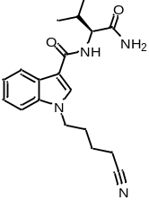Figure S1. ¹H (400 MHz, DMSO-d₆) and ¹³C (101 MHz, DMSO-d₆) NMR spectra for (S)-N-(1-amino-3-methyl-1-oxobutan-2-yl)-1-(4-cyanobutyl)-1H-indole-3-carboxamide (AB-4CN-BUTICA, 5).
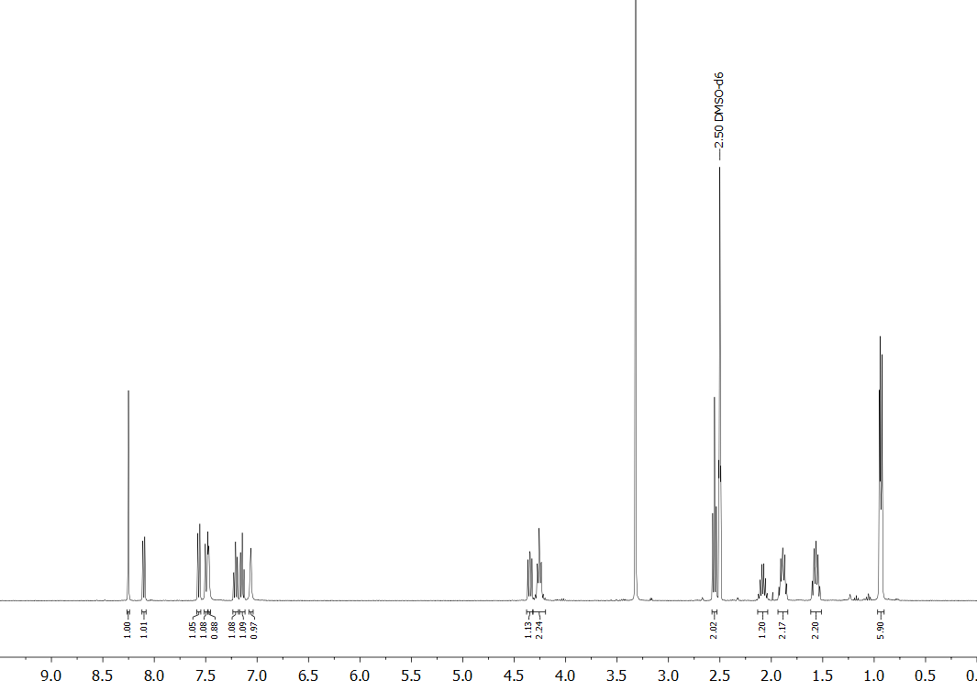
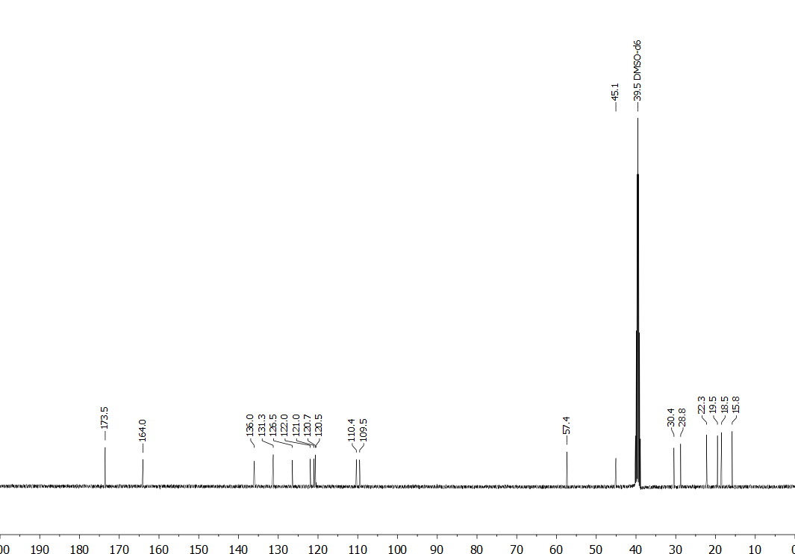

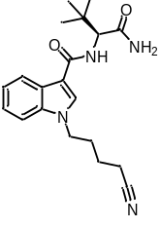Figure S2. ¹H (400 MHz, DMSO-d₆) and ¹³C (101 MHz, DMSO-d₆) NMR spectra for (S)-N-(1-amino-3,3-dimethyl-1-oxobutan-2-yl)-1-(4-cyanobutyl)-1H-indole-3-carboxamide (ADB-4CN-BUTICA, 9).
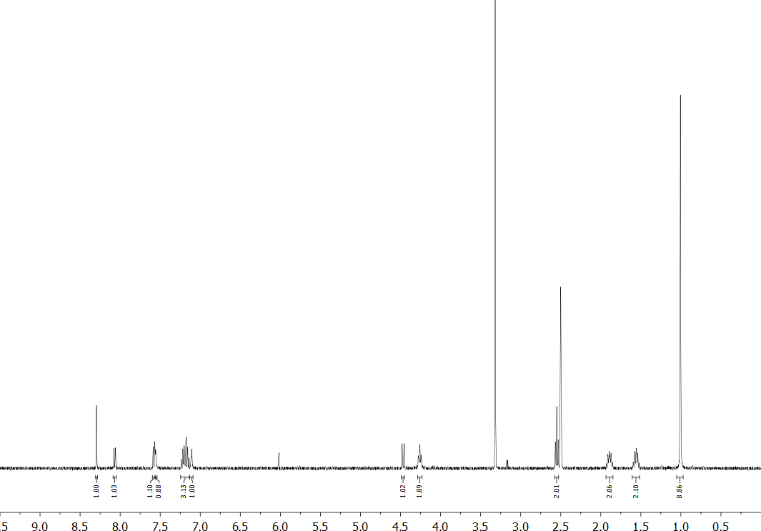
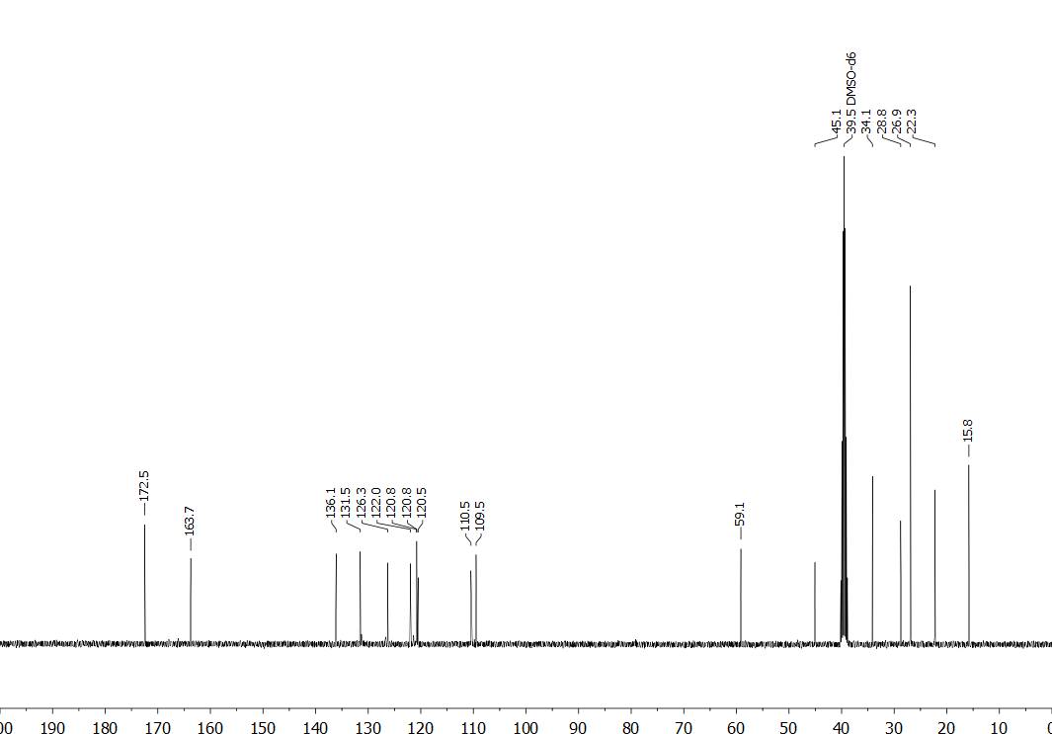

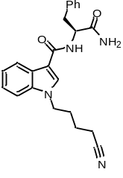Figure S3. ¹H (400 MHz, DMSO-d₆) and ¹³C (101 MHz, DMSO-d₆) NMR spectra for (S)-N-(1-amino-1-oxo-3-phenylpropan-2-yl)-1-(4-cyanobutyl)-1H-indole-3-carboxamide (APP-4CN-BUTICA, 10).
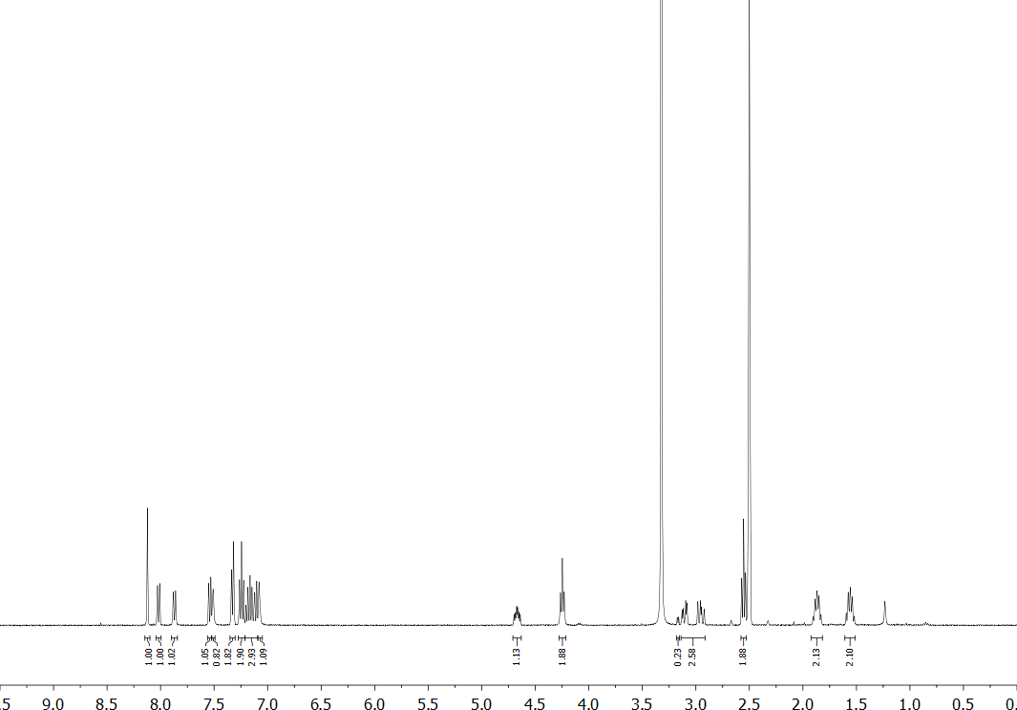
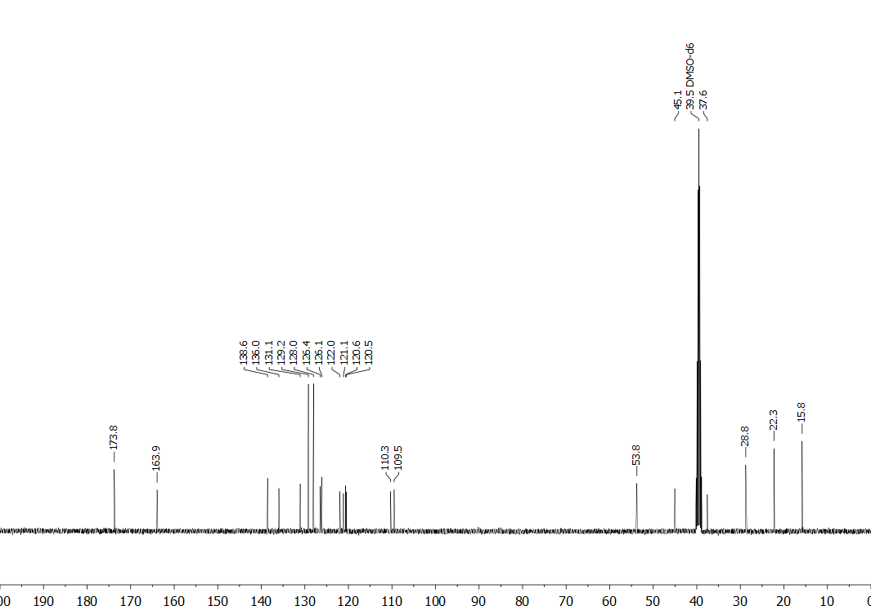

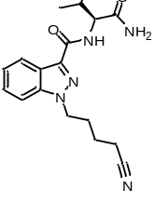Figure S4. ¹H (400 MHz, CD₃OD) and ¹³C (101 MHz, CD₃OD) NMR spectra for (S)-N-(1-amino-3-methyl-1-oxobutan-2-yl)-1-(4-cyanobutyl)-1H-indazole-3-carboxamide (AB-4CN-BUTINACA, 11).
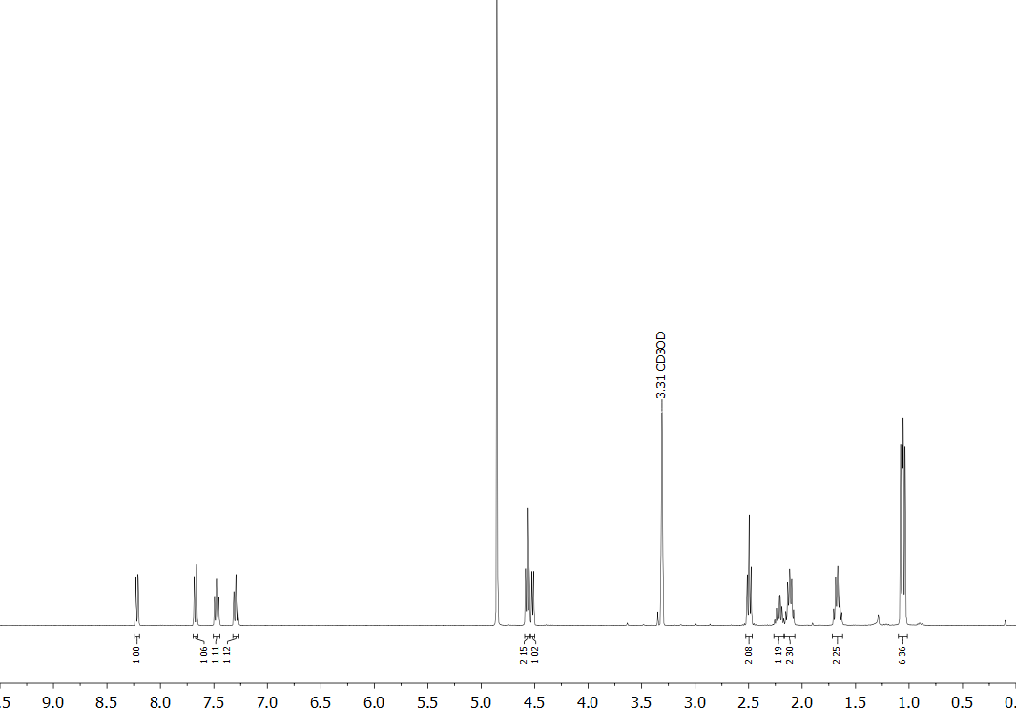
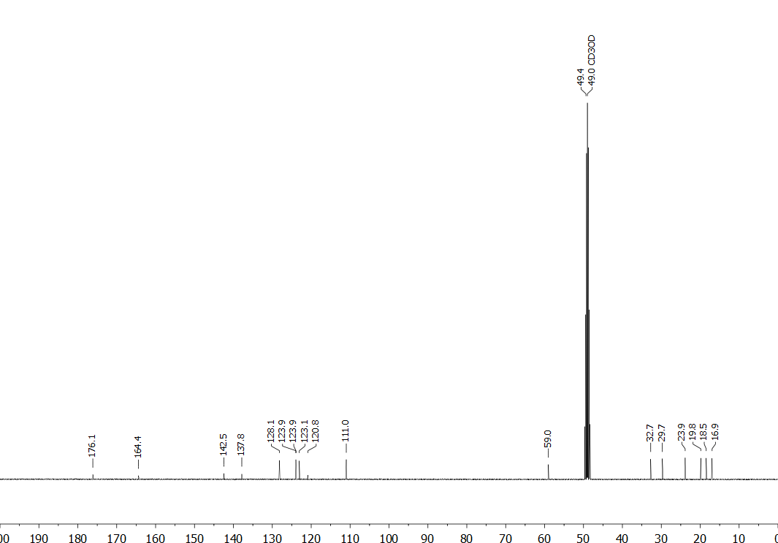

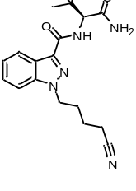Figure S5. ¹H (400 MHz, CD₃OD) and ¹³C (101 MHz, CD₃OD) NMR spectra for (S)-N-(1-amino-3,3-dimethyl-1-oxobutan-2-yl)-1-(4-cyanobutyl)-1H-indazole-3-carboxamide (ADB-4CN-BUTINACA, 12).
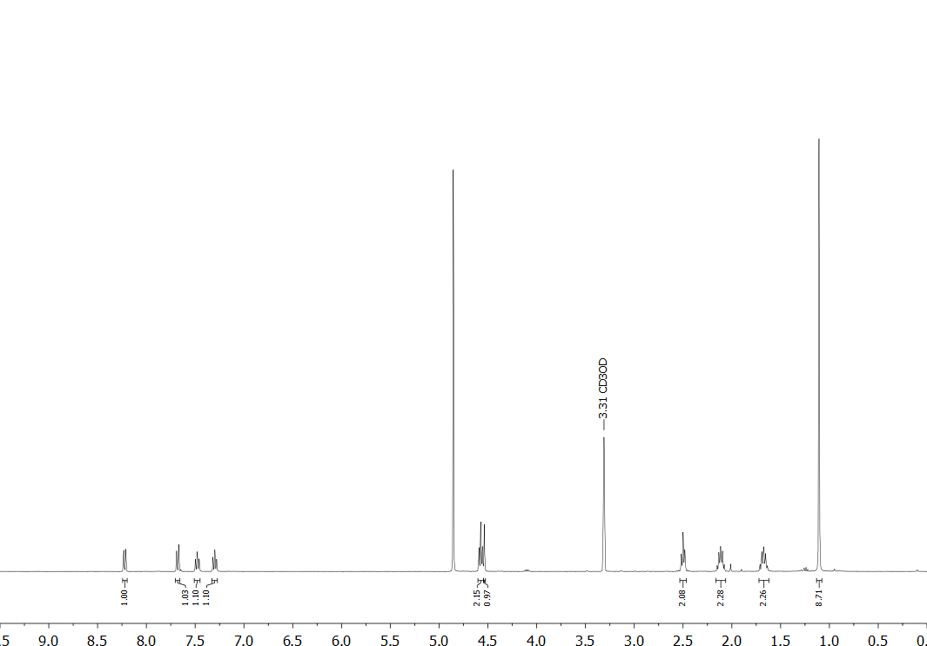
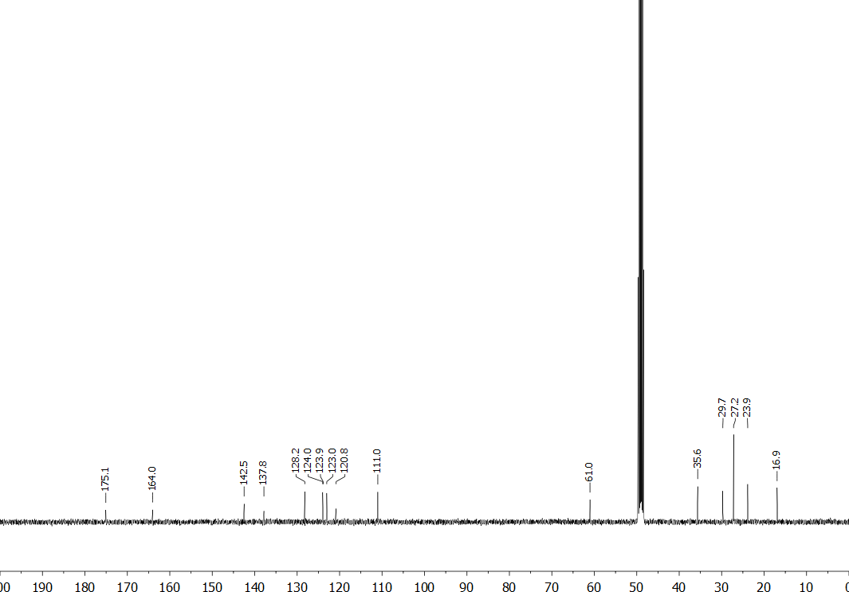

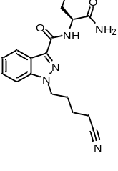Figure S6. ¹H (400 MHz, CDCl₃) and ¹³C (101 MHz, DMSO-d₆) NMR spectra for (S)-N-(1-amino-1-oxo-3-phenylpropan-2-yl)-1-(4-cyanobutyl)-1H-indazole-3-carboxamide (APP-4CN-BUTINACA, 13).
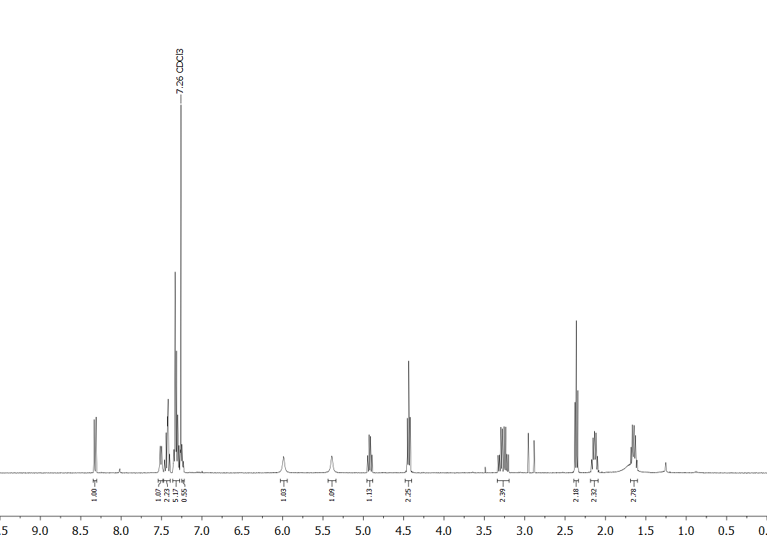
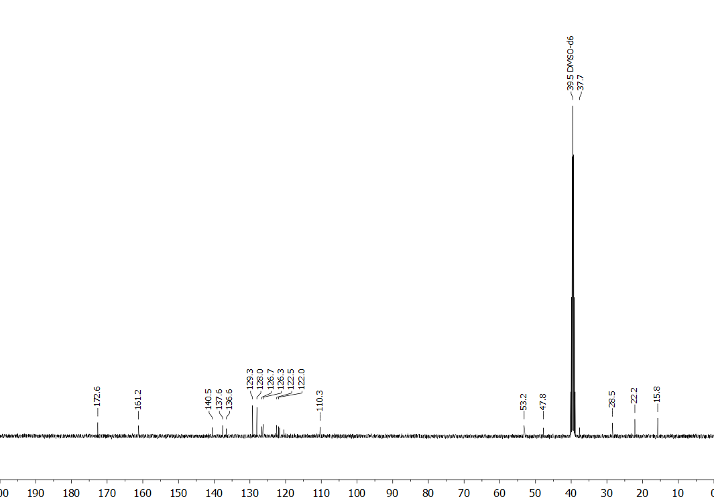

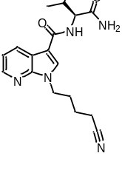Figure S7. ¹H (400 MHz, DMSO-d₆) and ¹³C (101 MHz, DMSO-d₆) NMR spectra for (S)-N-(1-amino-3-methyl-1-oxobutan-2-yl)-1-(4-cyanobutyl)-1H-pyrrolo[2,3-b]pyridine-3-carboxamide (AB-4CN-BUT7AICA, 14).
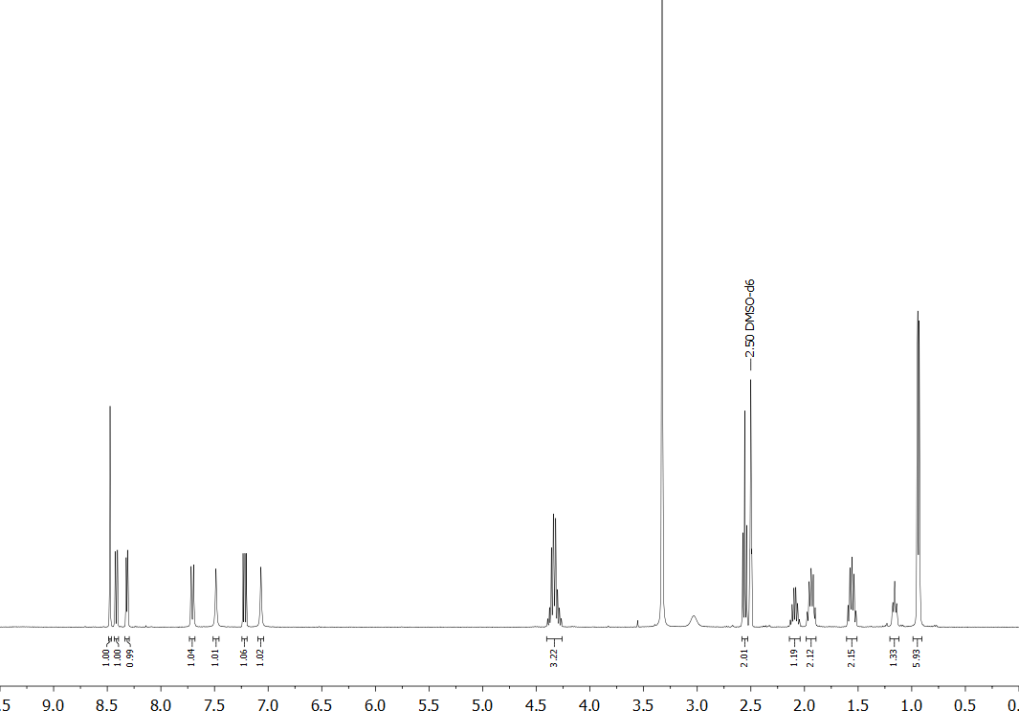
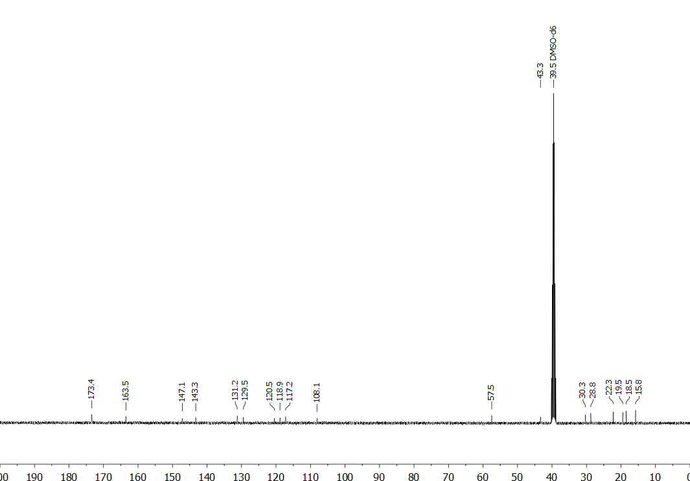

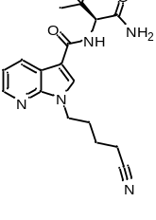Figure S8. ¹H (400 MHz, DMSO-d₆) and ¹³C (101 MHz, DMSO-d₆) NMR spectra for (S)-N-(1-amino-3,3-dimethyl-1-oxobutan-2-yl)-1-(4-cyanobutyl)-1H-pyrrolo[2,3-b]pyridine-3-carboxamide (ADB-4CN-BUT7AICA, 15).
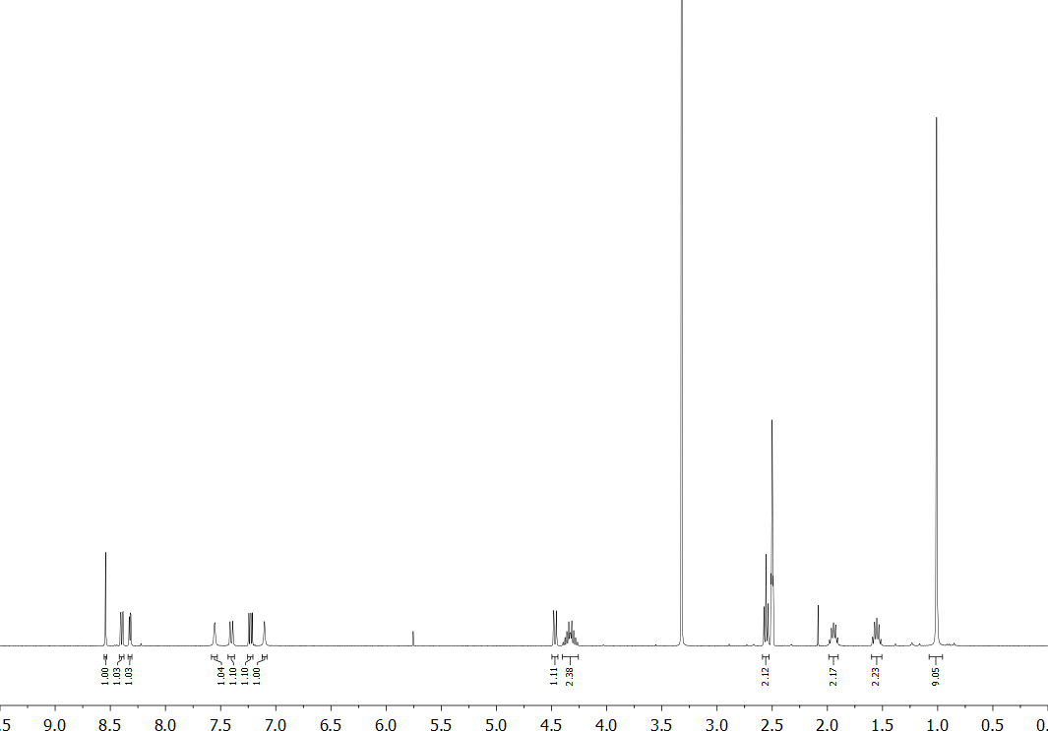
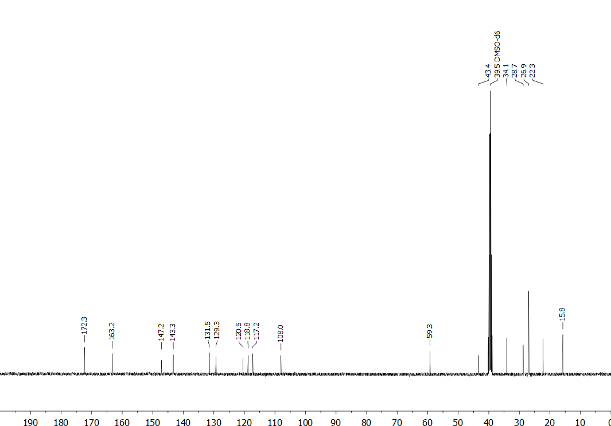

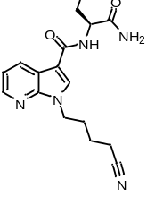Figure S9. ¹H (400 MHz, CD₃OD) and ¹³C (101 MHz, DMSO-d₆) NMR spectra for (S)-N-(1-amino-1-oxo-3-phenylpropan-2-yl)-1-(4-cyanobutyl)-1H-pyrrolo[2,3-b]pyridine-3-carboxamide (APP-4CN-BUT7AICA, 16).
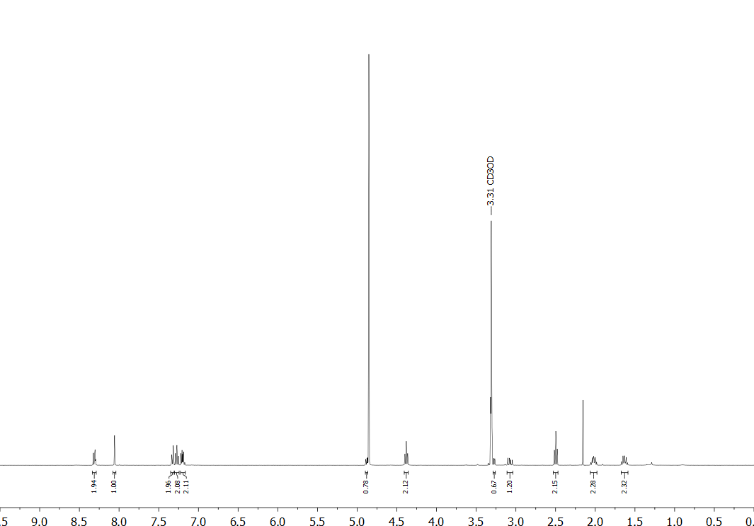
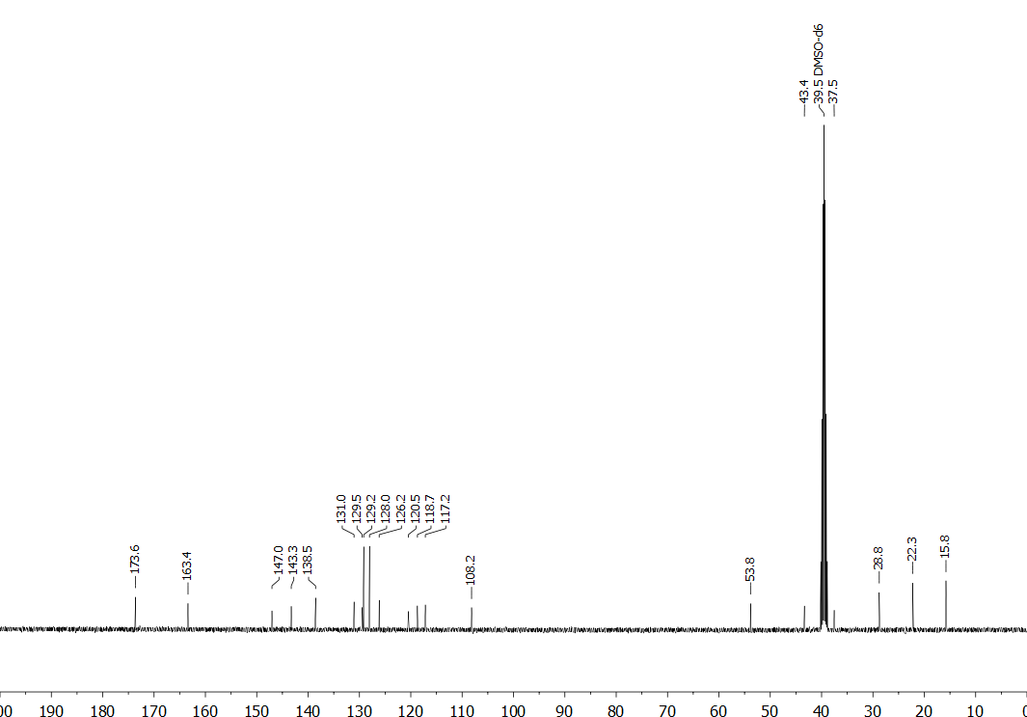

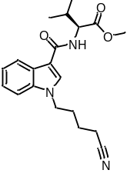Figure S10. ¹H (400 MHz, CDCl₃) and ¹³C (101 MHz, CD₃OD) NMR spectra for methyl (1-(4-cyanobutyl)-1H-indole-3-carbonyl)-L-valinate (MMB-4CN-BUTICA, 17).
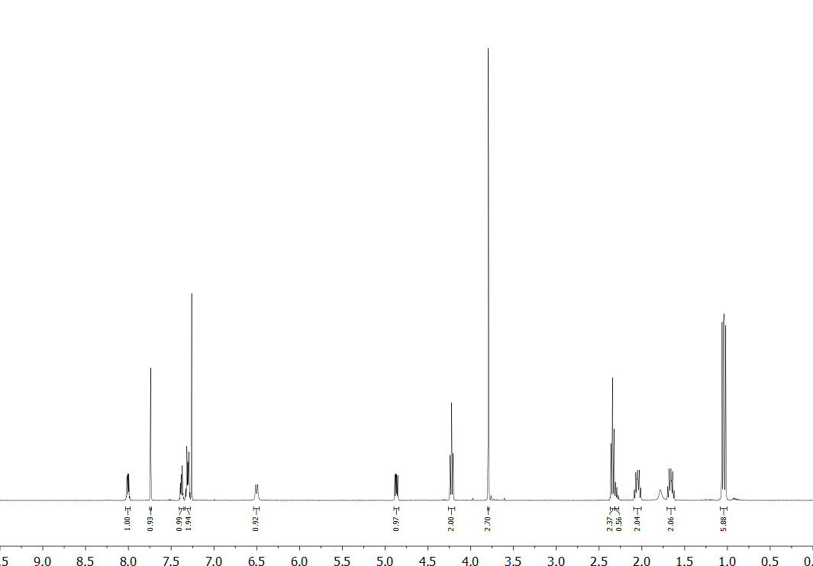
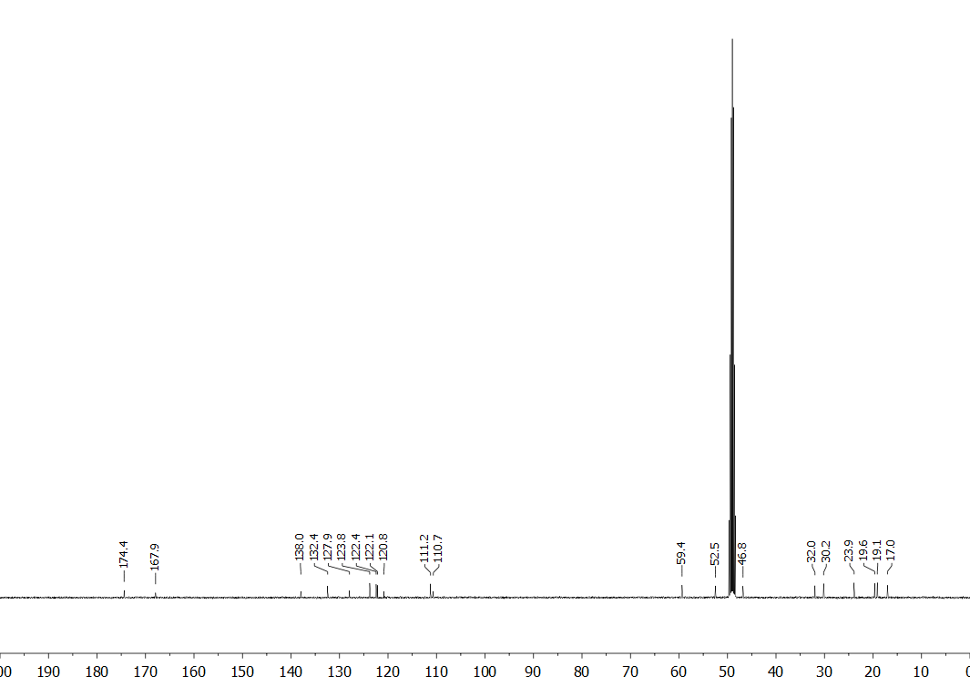

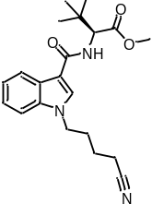Figure S11. ¹H (400 MHz, DMSO-d₆) and ¹³C (101 MHz, CD₃OD) NMR spectra for methyl (S)-2-(1-(4-cyanobutyl)-1H-indole-3-carboxamido)-3,3-dimethylbutanoate (MDMB-4CN-BUTICA, 18).
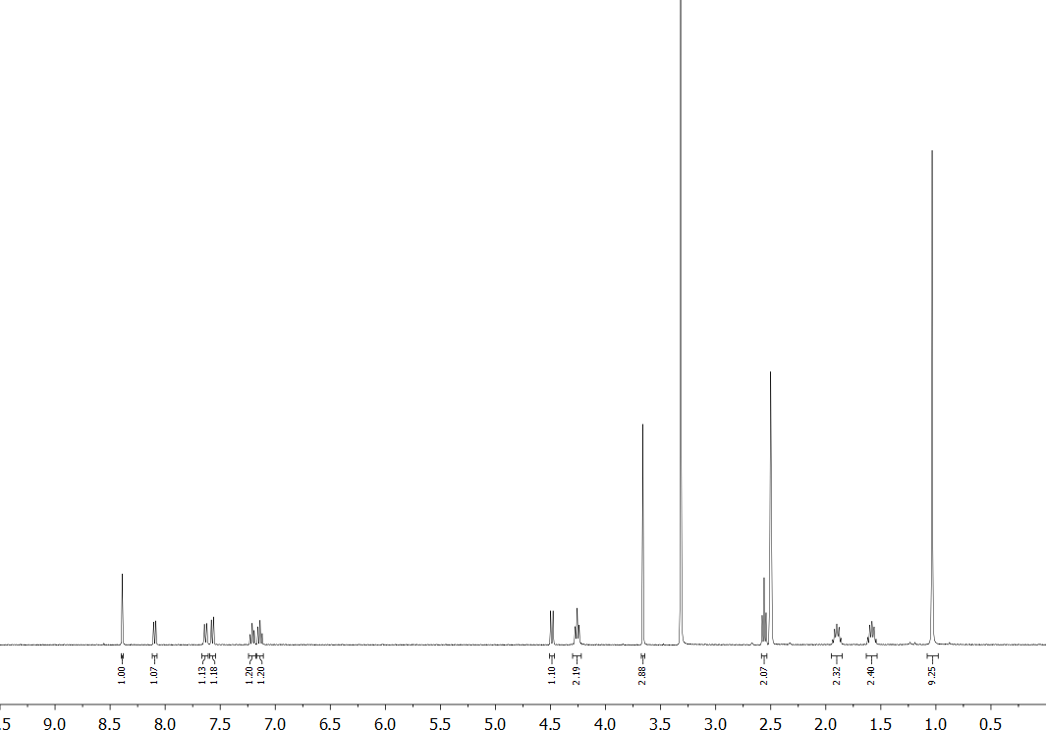
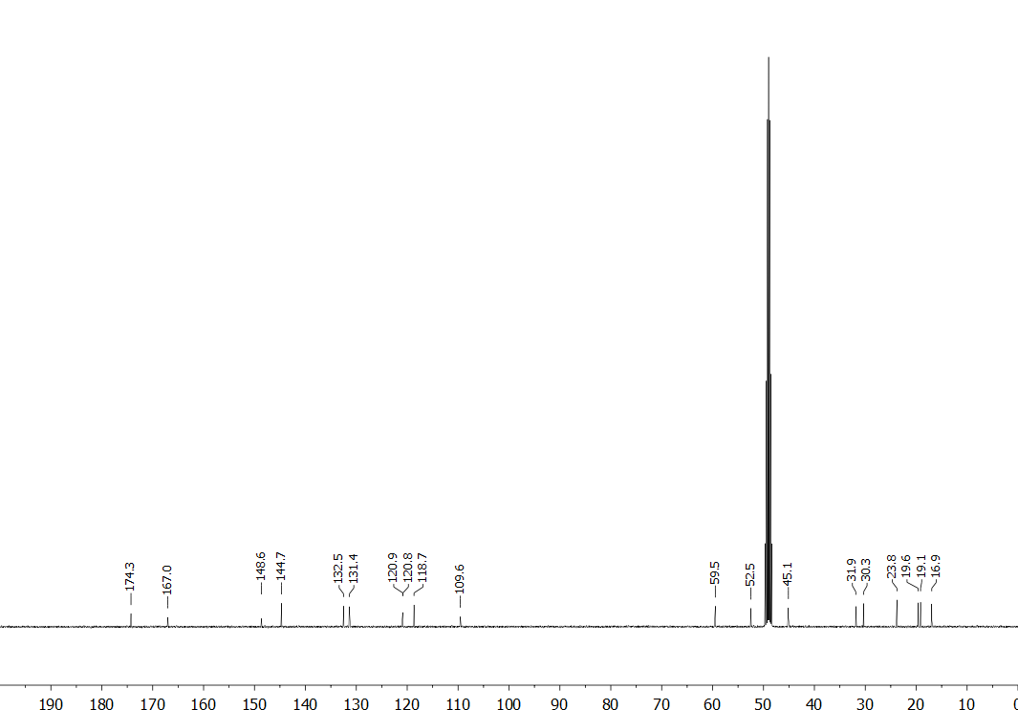

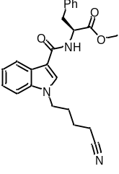Figure S12. ¹H (400 MHz, CDCl₃) and ¹³C (101 MHz, DMSO-d₆) NMR spectra for methyl (1-(4-cyanobutyl)-1H-indole-3-carbonyl)-L-phenylalaninate (MPP-4CN-BUTICA, 19).
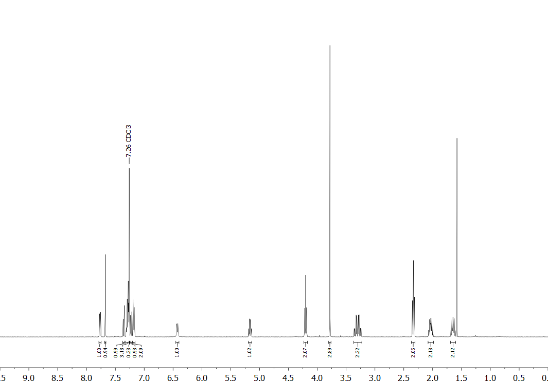
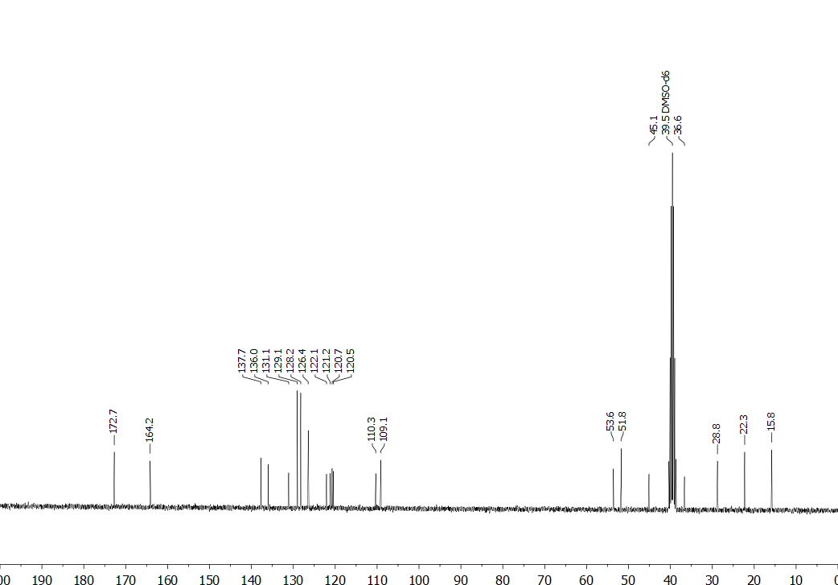

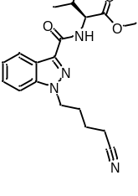Figure S13. ¹H (400 MHz, DMSO-d₆) and ¹³C (101 MHz, CD₃OD) NMR spectra for methyl (1-(4-cyanobutyl)-1H-indazole-3-carbonyl)-L-valinate (MMB-4CN-BUTINACA, 6).
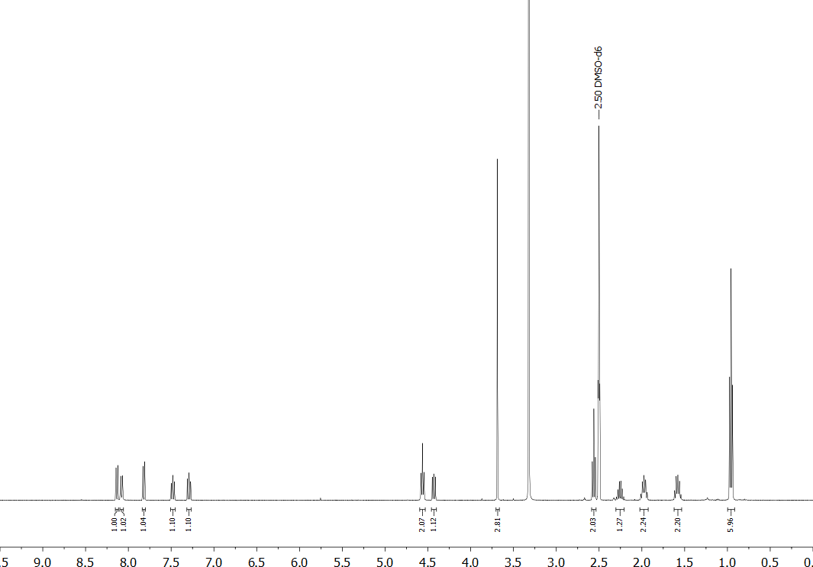
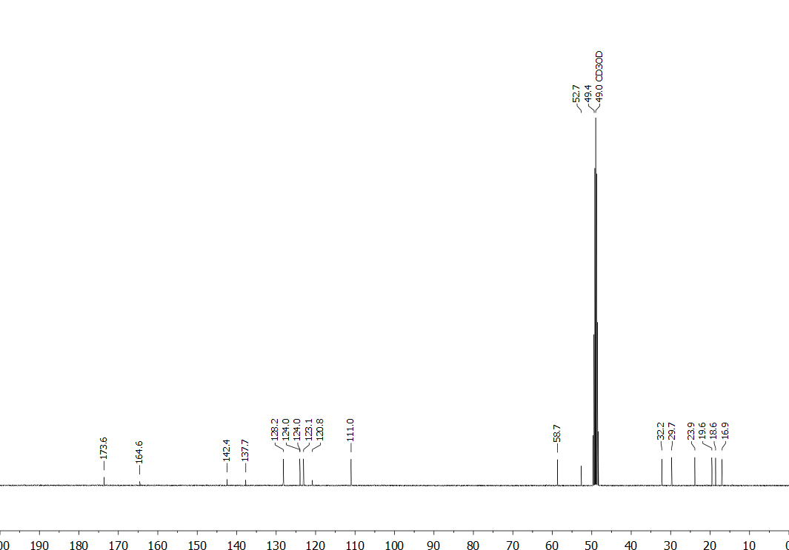

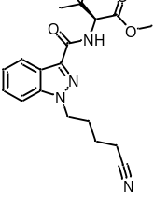Figure S14. ¹H (400 MHz, DMSO-d₆) and ¹³C (101 MHz, DMSO-d₆) NMR spectra for methyl (S)-2-(1-(4-cyanobutyl)-1H-indazole-3-carboxamido)-3,3-dimethylbutanoate (MDMB-4CN-BUTINACA, 20).
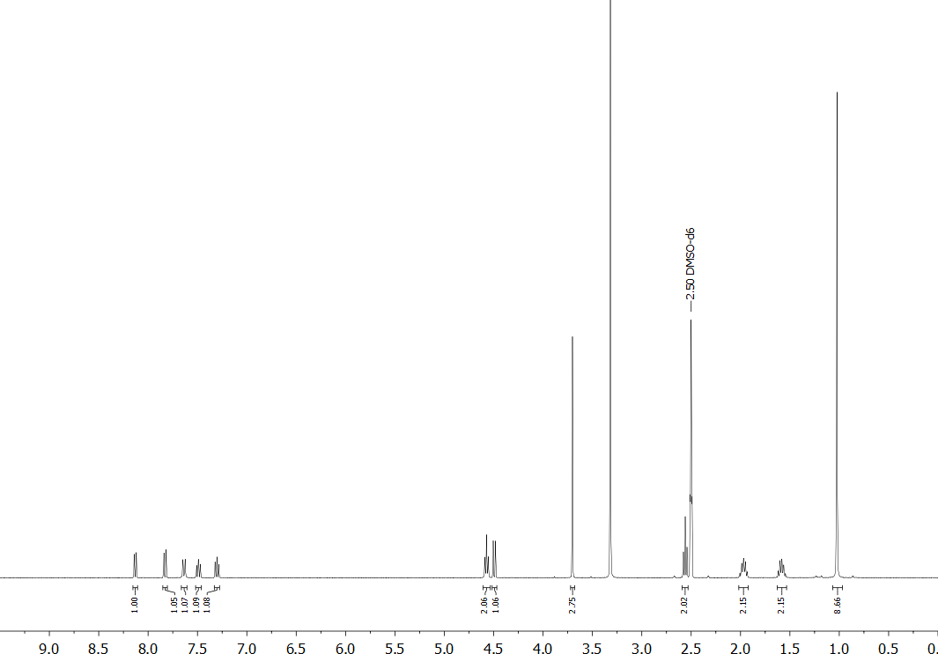
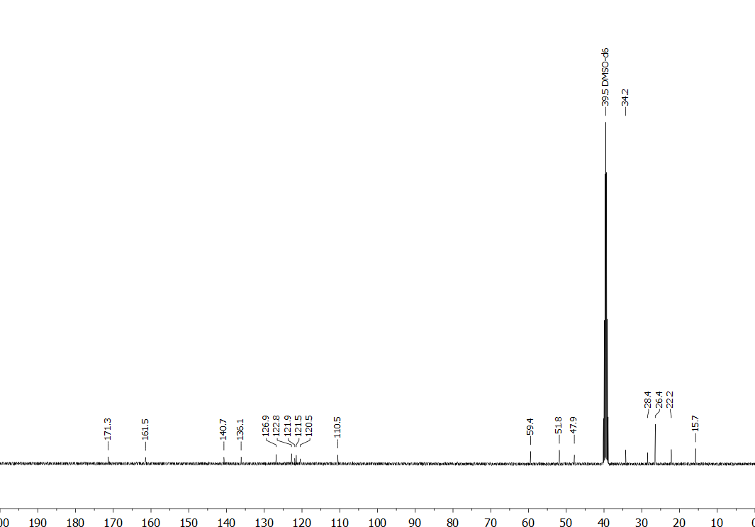

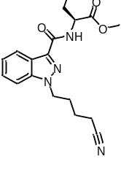Figure S15. ¹H (400 MHz, CDCl₃) and ¹³C (101 MHz, CD₃OD) NMR spectra for methyl (1-(4-cyanobutyl)-1H-indazole-3-carbonyl)-L-phenylalaninate (MPP-4CN-BUTINACA, 21).
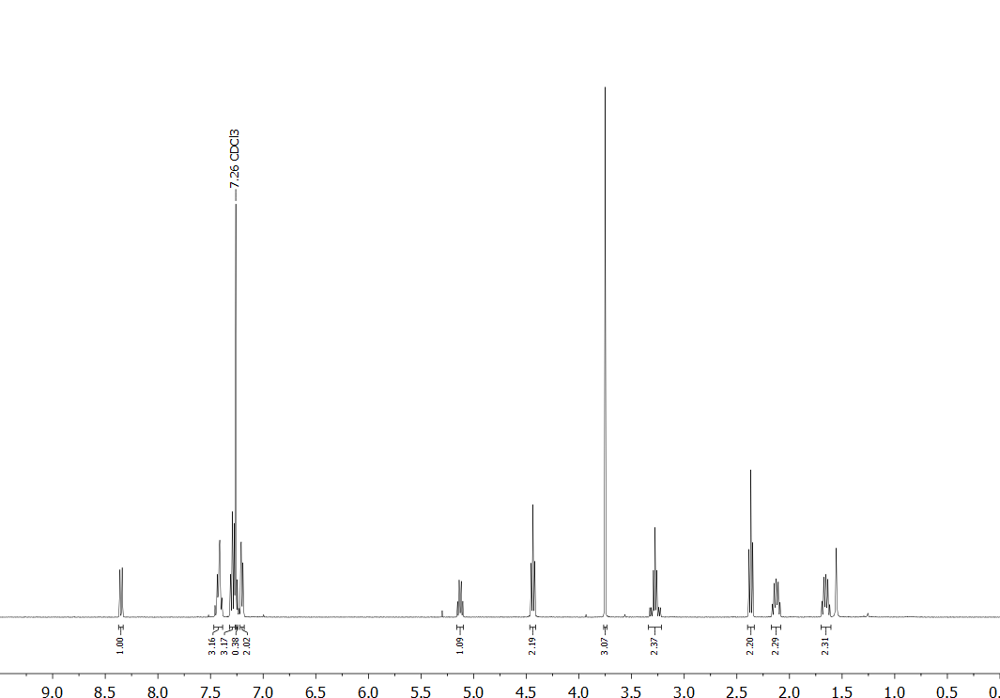
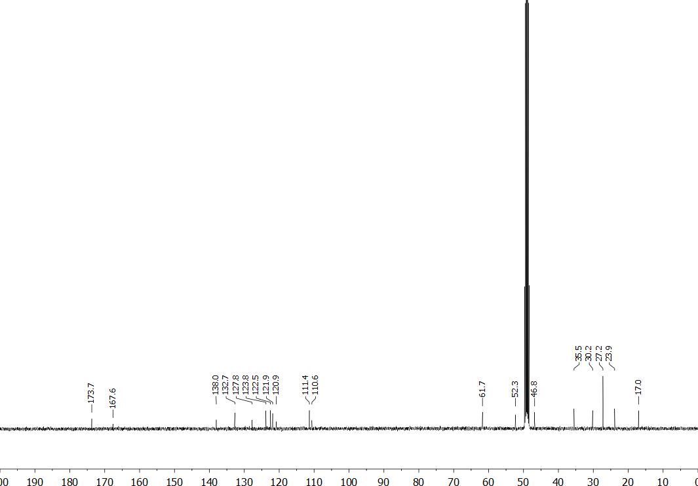

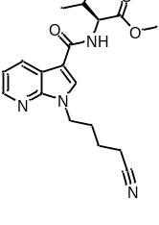Figure S16. ¹H (400 MHz, CDCl₃) and ¹³C (101 MHz, DMSO-d₆) NMR spectra for methyl (1-(4-cyanobutyl)-1H-pyrrolo[2,3-b]pyridine-3-carbonyl)-L-valinate (MMB-4CN-BUT7AICA, 22).
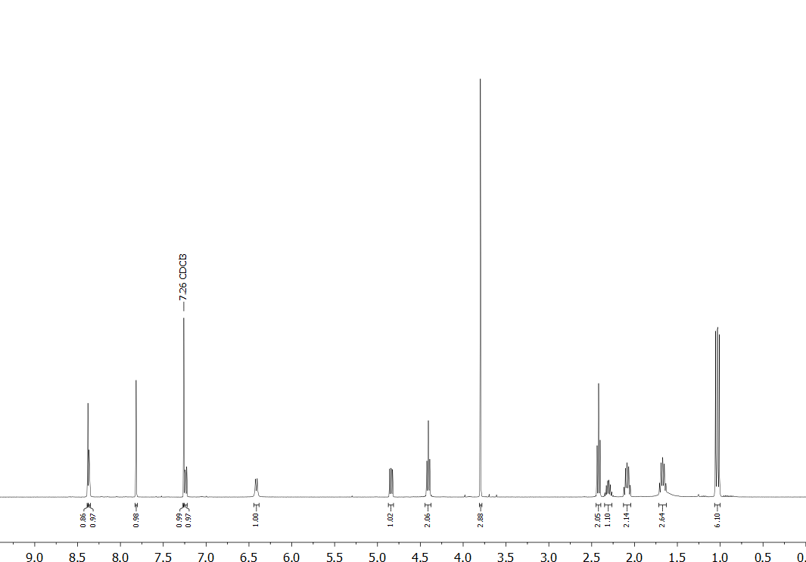
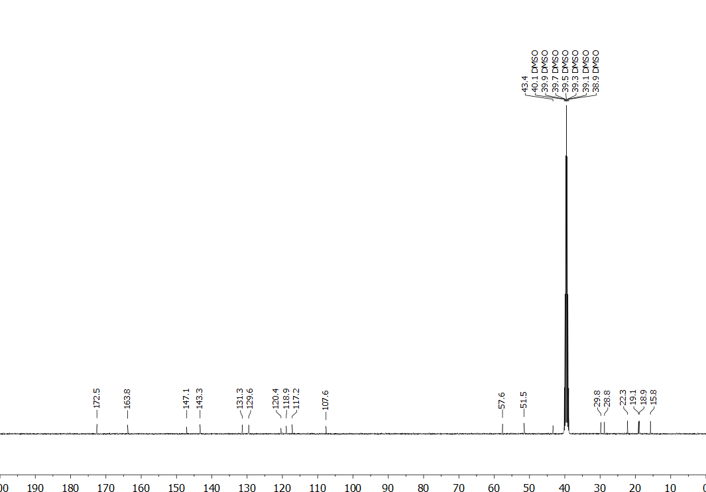

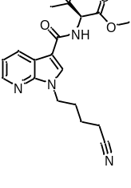Figure S17. ¹H (400 MHz, CD₃OD) and ¹³C (101 MHz, CD₃OD) NMR spectra for methyl (S)-2-(1-(4-cyanobutyl)-1H-pyrrolo[2,3-b]pyridine-3-carboxamido)-3,3-dimethylbutanoate (MDMB-4CN-BUT7AICA, 23).
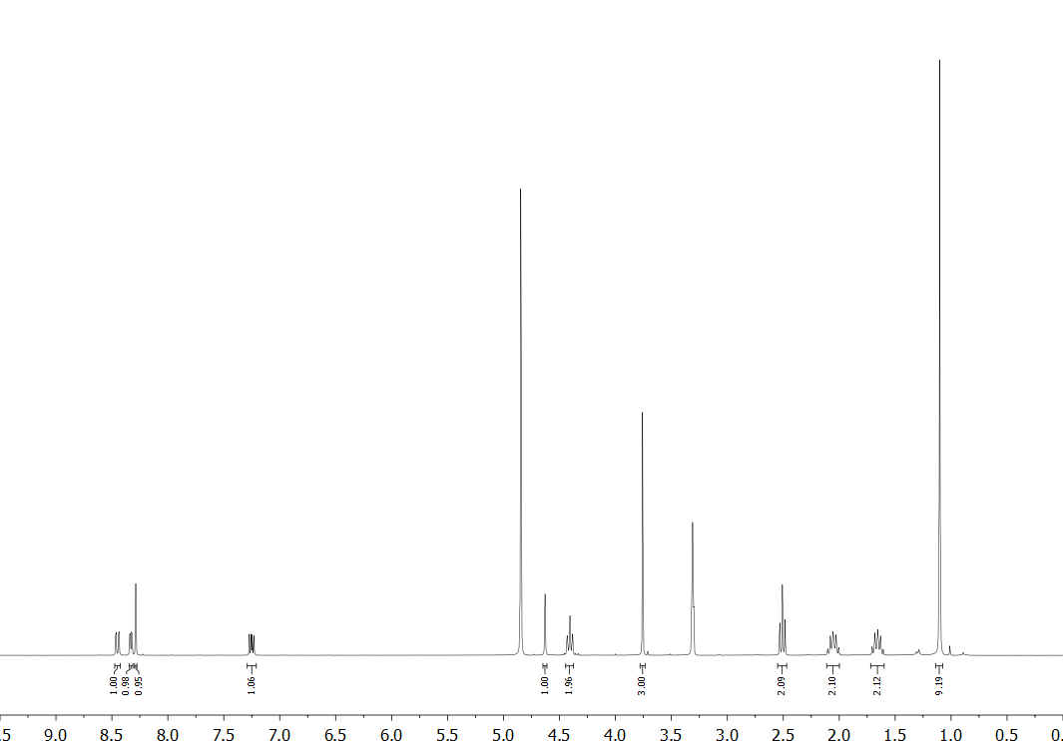
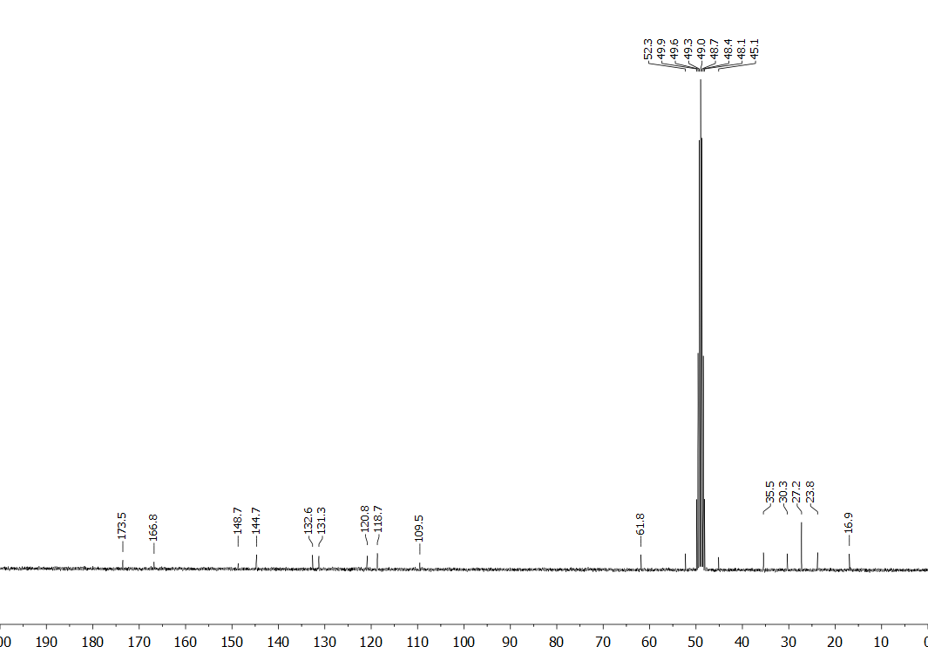

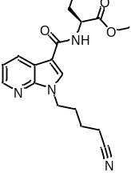Figure S18. ¹H (400 MHz, CDCl₃) and ¹³C (101 MHz, CD₃OD) NMR spectra for methyl (1-(4-cyanobutyl)-1H-pyrrolo[2,3-b]pyridine-3-carbonyl)-L-phenylalaninate (MPP-4CN-BUT7AICA, 24).
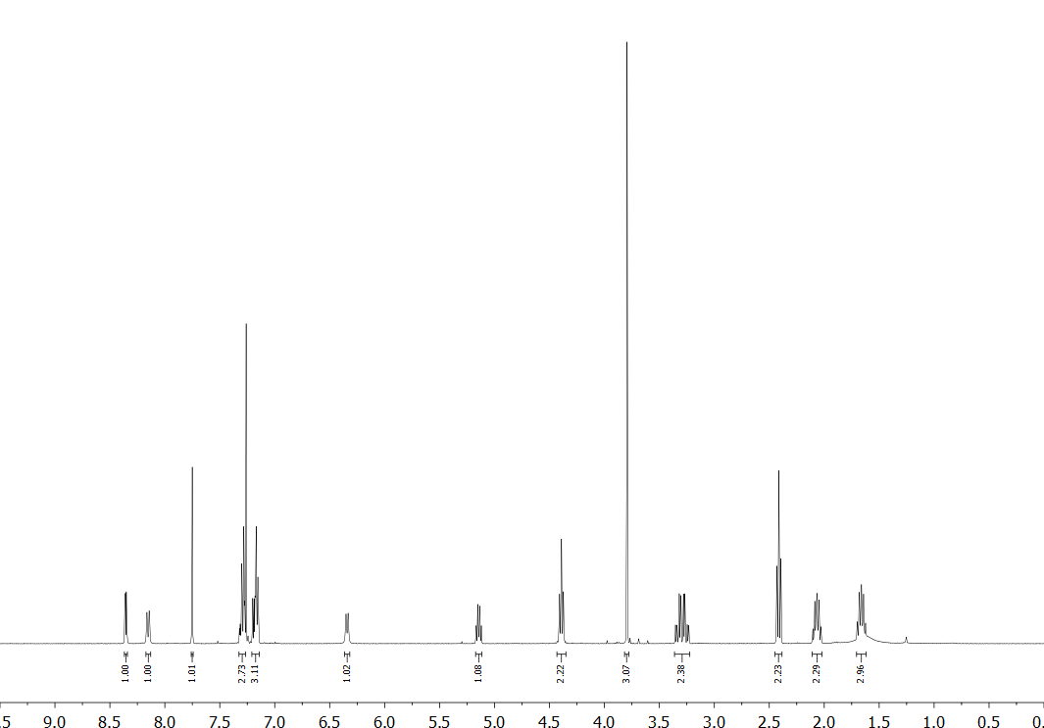
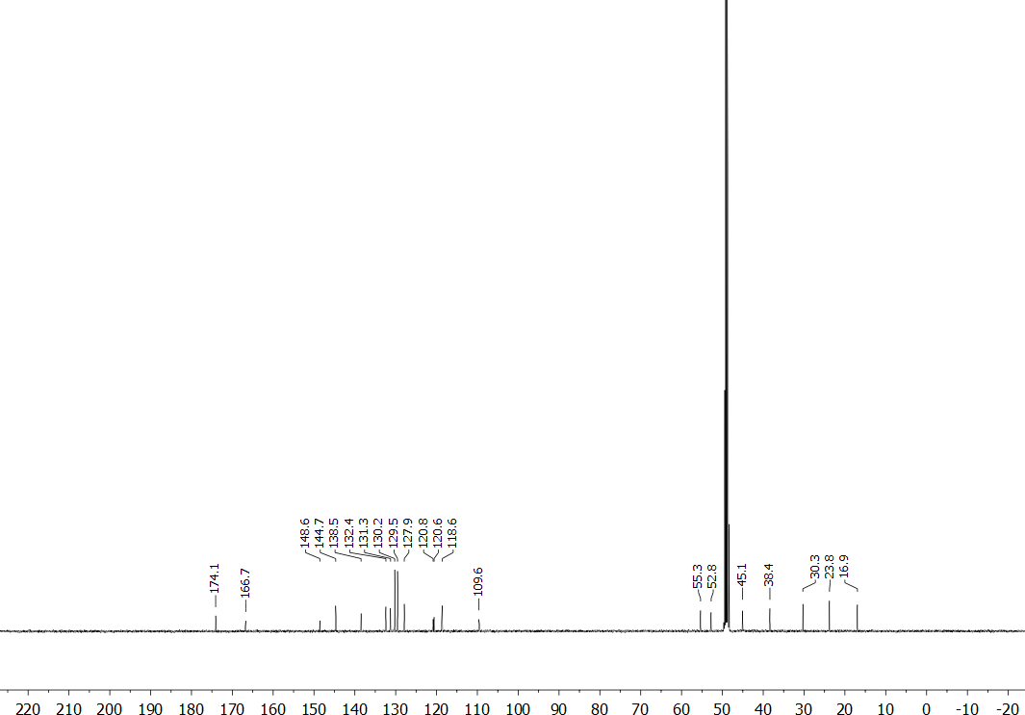

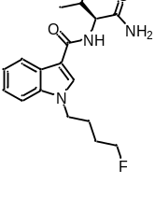Figure S19. ¹H (400 MHz, DMSO-d₆) and ¹³C (101 MHz, DMSO-d₆) NMR spectra for (S)-N-(1-amino-3-methyl-1-oxobutan-2-yl)-1-(4-fluorobutyl)-1H-indole-3-carboxamide (AB-4F-BUTICA, 25).
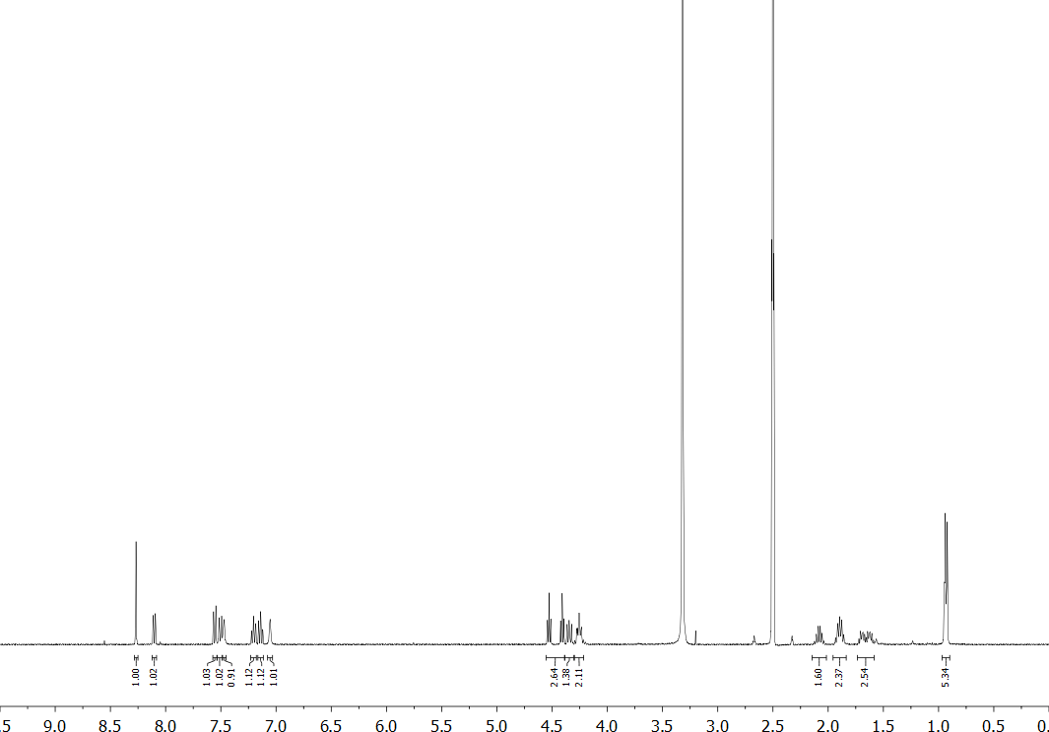
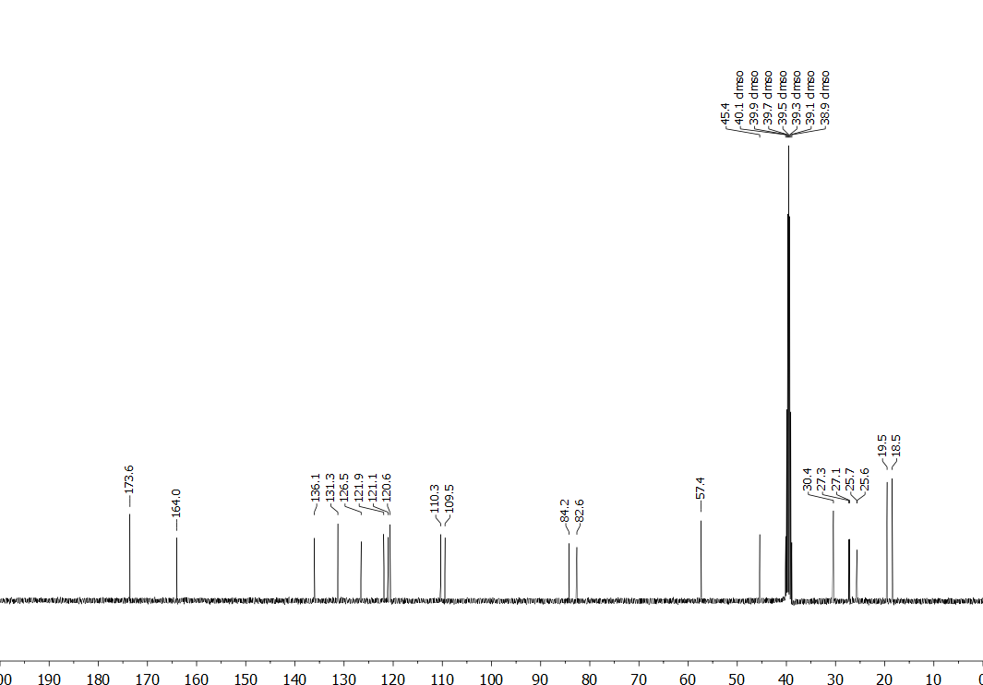

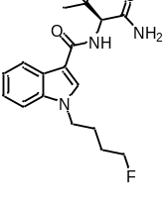Figure S20. ¹H (400 MHz, DMSO-d₆) and ¹³C (101 MHz, CDCl₃) NMR spectra for (S)-N-(1-amino-3,3-dimethyl-1-oxobutan-2-yl)-1-(4-fluorobutyl)-1H-indole-3-carboxamide (ADB-4F-BUTICA, 26).
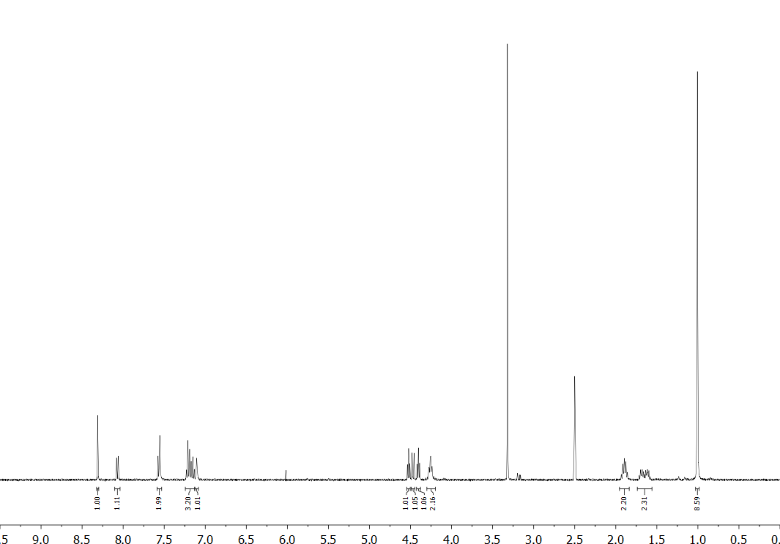
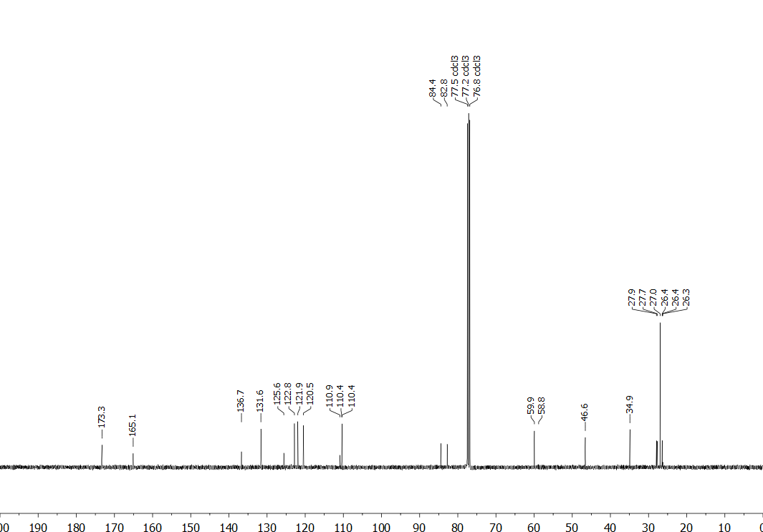

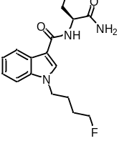Figure S21. ¹H (400 MHz, CDCl₃) and ¹³C (101 MHz, DMSO-d₆) NMR spectra for (S)-N-(1-amino-1-oxo-3-phenylpropan-2-yl)-1-(4-fluorobutyl)-1H-indole-3-carboxamide (APP-4F-BUTICA, 27).
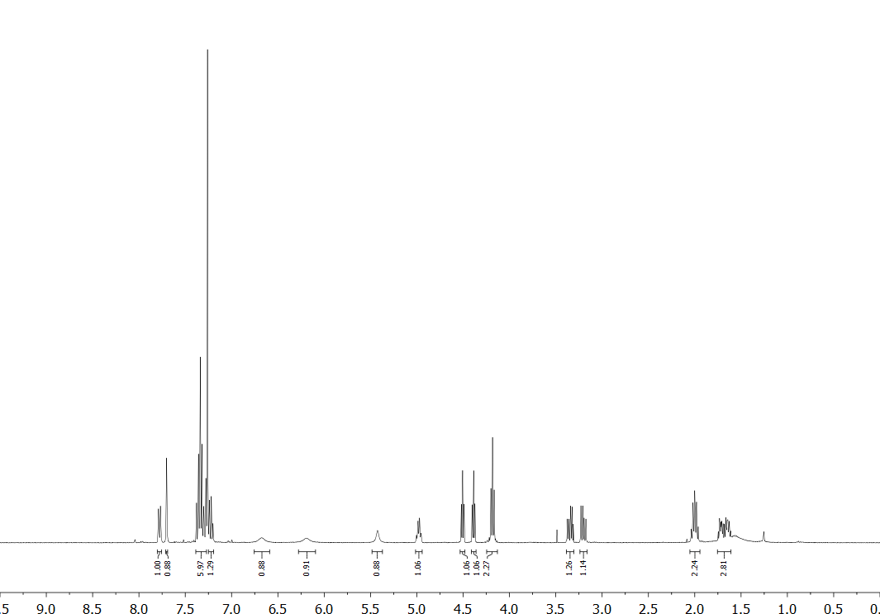
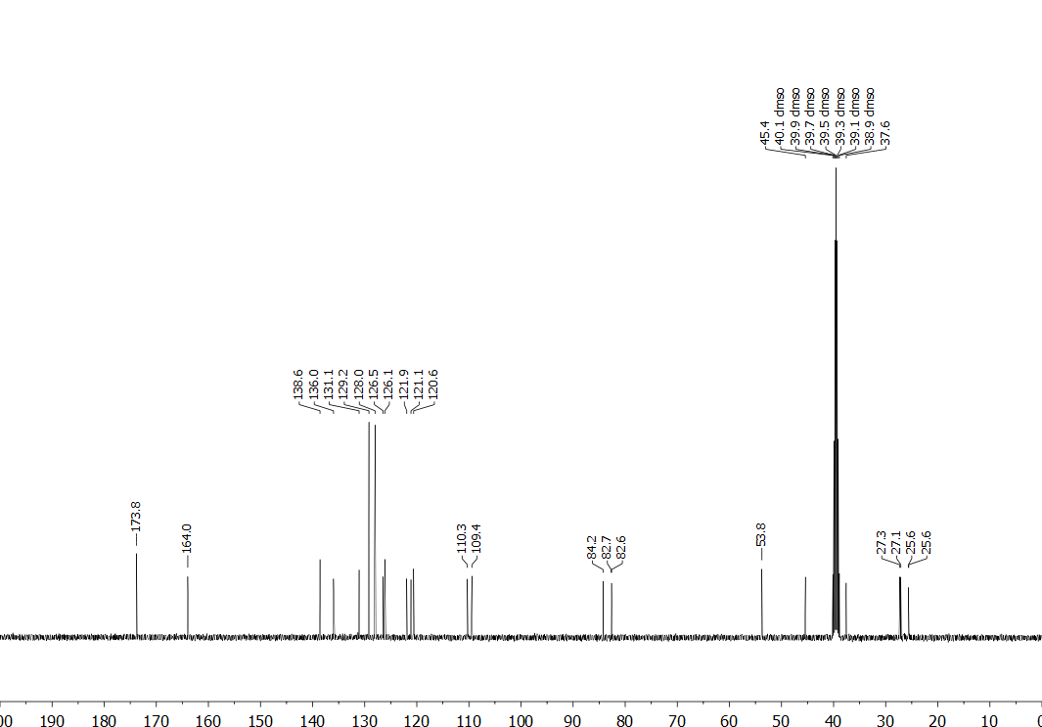

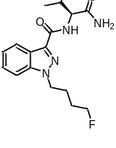Figure S22. ¹H (400 MHz, CD₃OD) and ¹³C (101 MHz, CD₃OD) NMR spectra for (S)-N-(1-amino-3-methyl-1-oxobutan-2-yl)-1-(4-fluorobutyl)-1H-indazole-3-carboxamide (AB-4F-BUTINACA, 28).
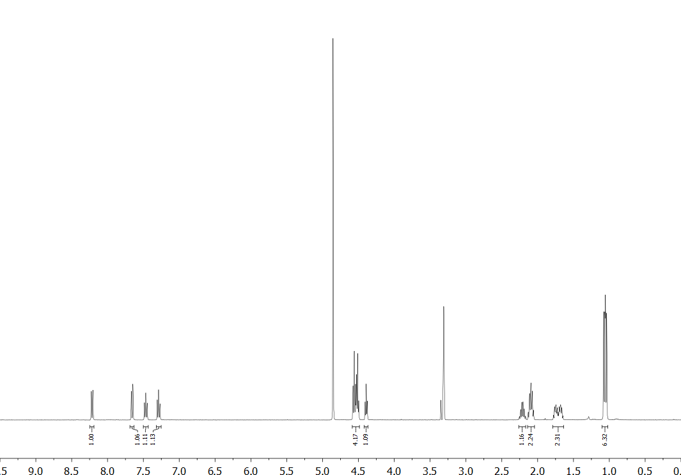
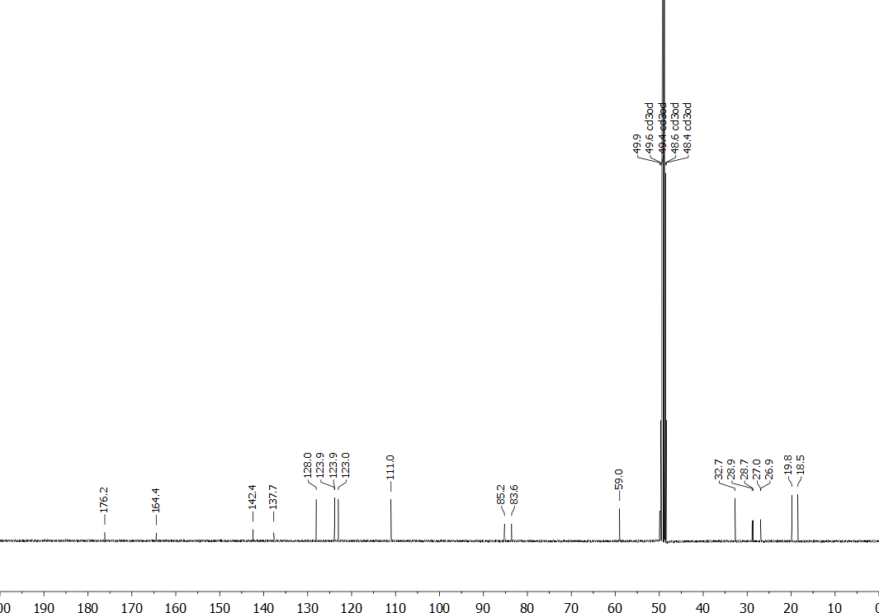

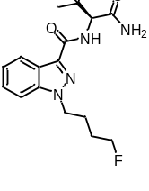Figure S23. ¹H (400 MHz, CD₃OD) and ¹³C (101 MHz, CDCl₃) NMR spectra for (S)-N-(1-amino-3,3-dimethyl-1-oxobutan-2-yl)-1-(4-fluorobutyl)-1H-indazole-3-carboxamide (ADB-4F-BUTINACA, 29).
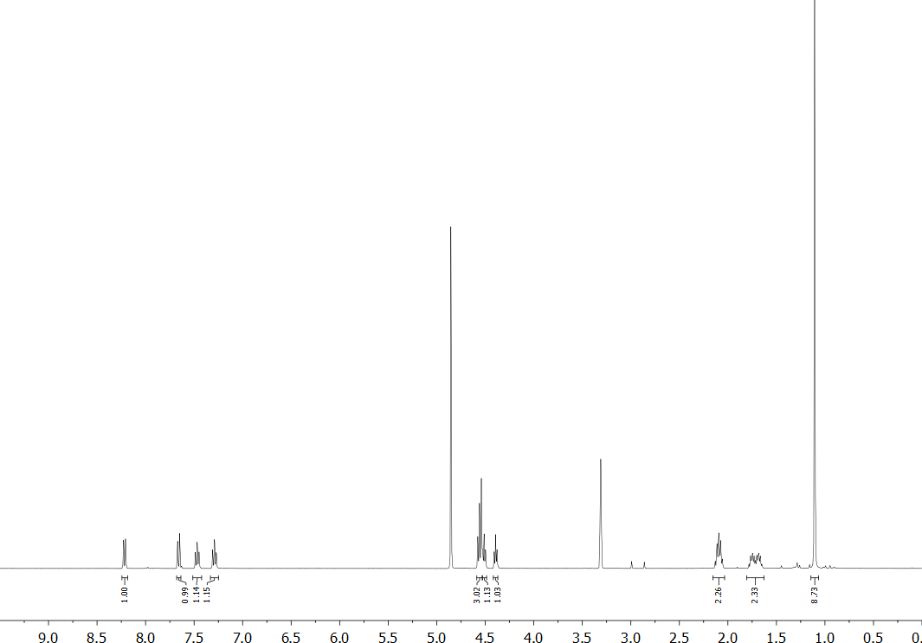
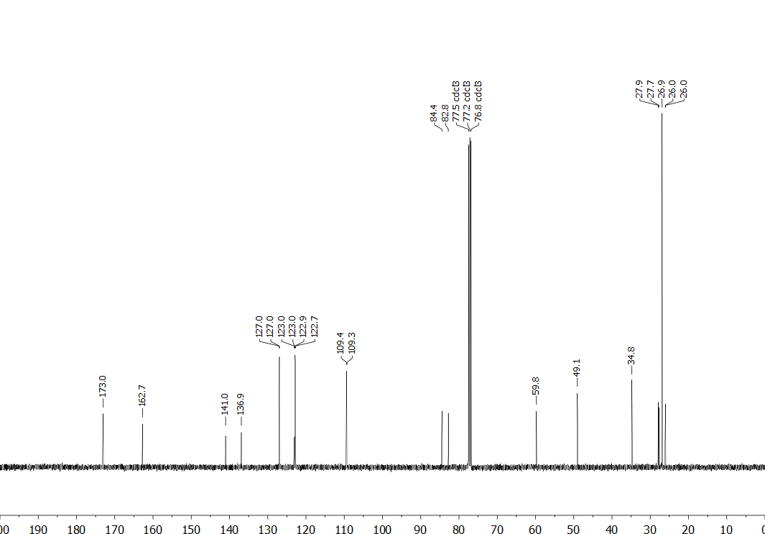

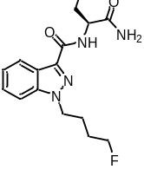Figure S24. ¹H (400 MHz, DMSO-d₆) and ¹³C (101 MHz, DMSO-d₆) NMR spectra for (S)-N-(1-amino-1-oxo-3-phenylpropan-2-yl)-1-(4-fluorobutyl)-1H-indazole-3-carboxamide (APP-4F-BUTINACA, 30).
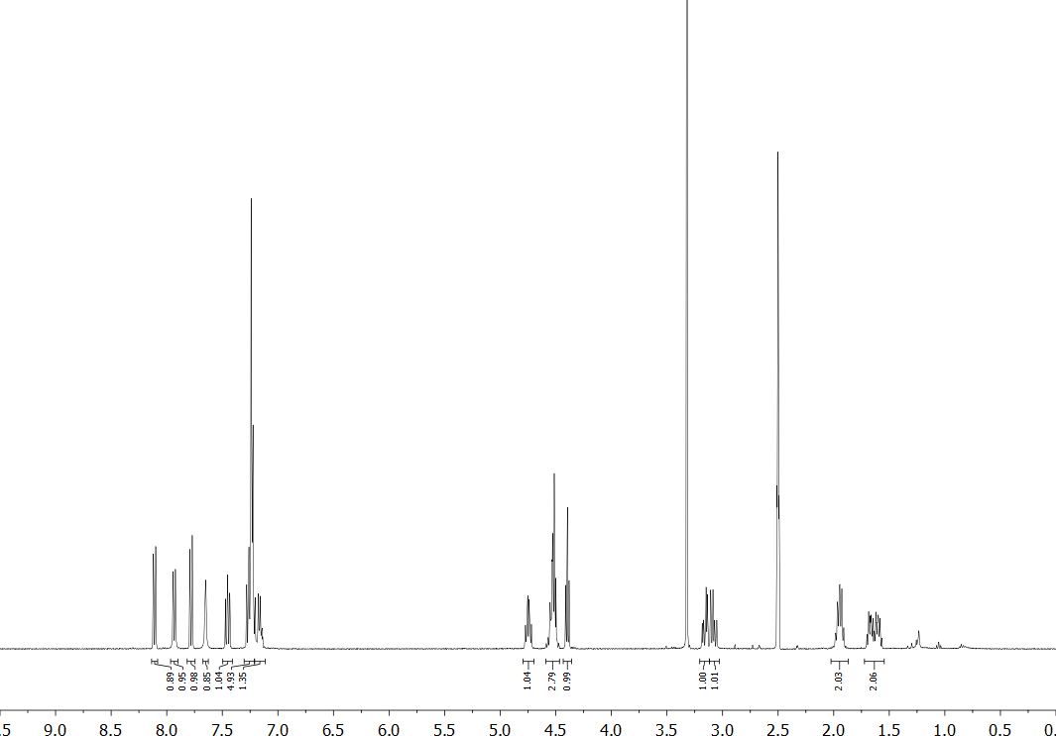
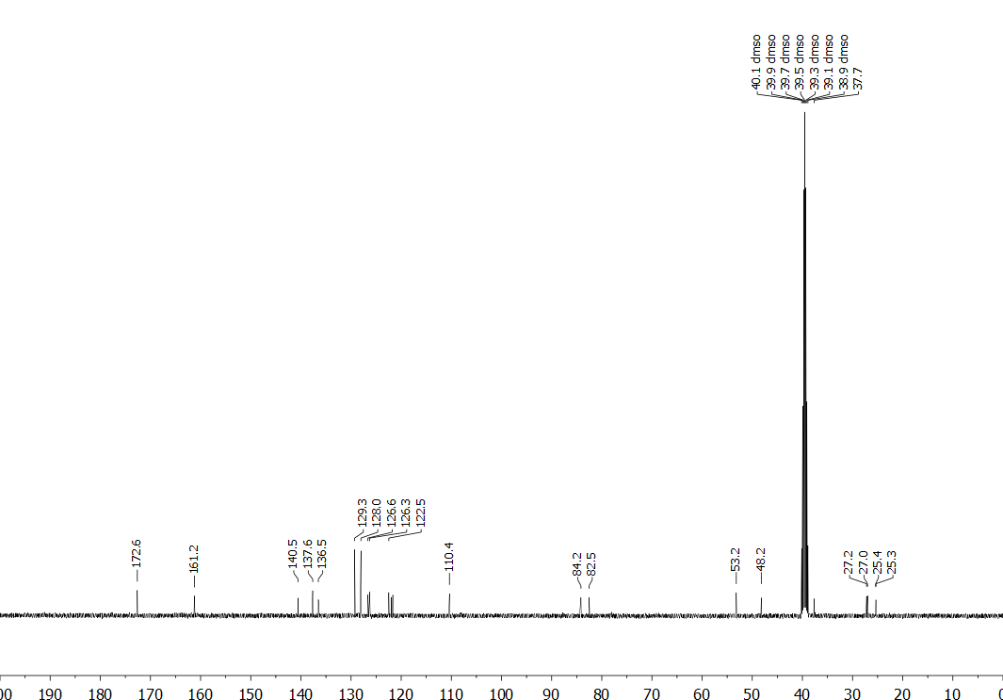

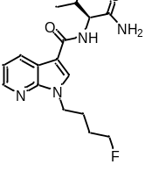Figure S25. ¹H (400 MHz, CD₃OD) and ¹³C (101 MHz, CD₃OD) NMR spectra for (S)-N-(1-amino-3-methyl-1-oxobutan-2-yl)-1-(4-fluorobutyl)-1H-pyrrolo[2,3-b]pyridine-3-carboxamide (AB-4F-BUT7AICA, 31).
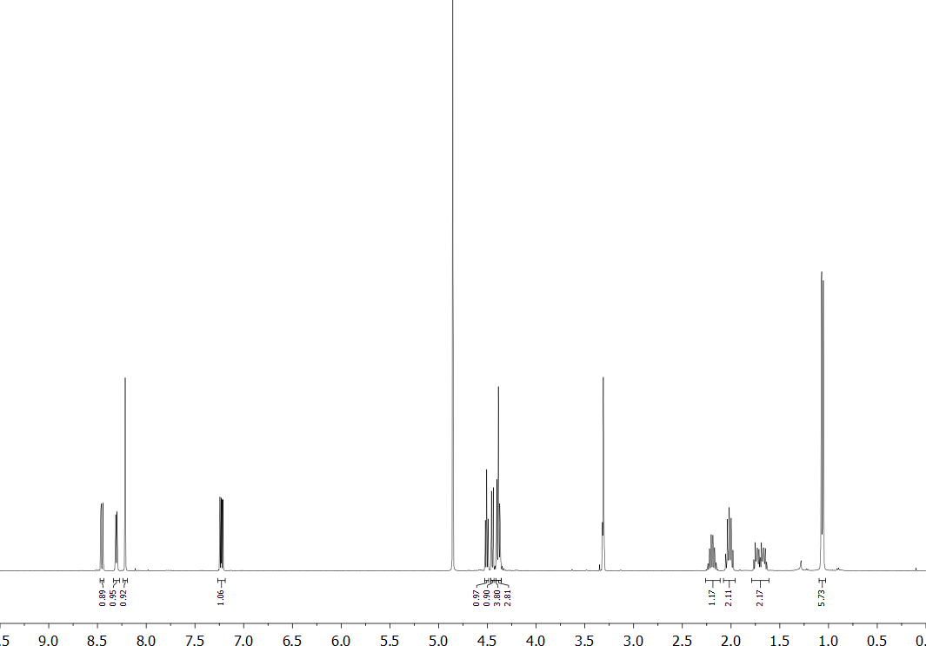
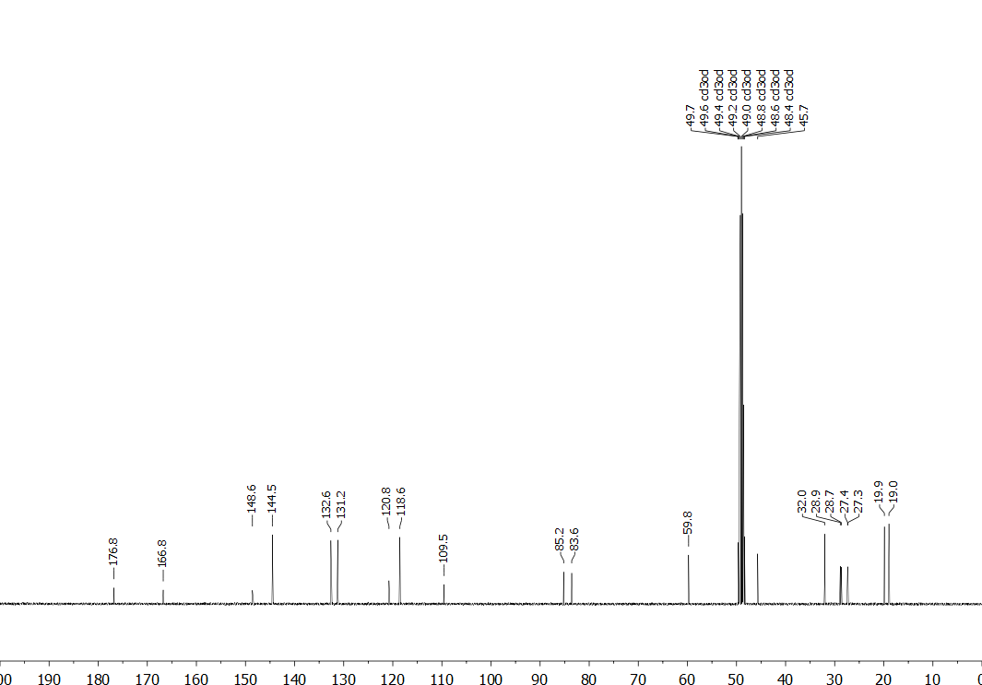

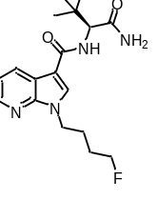Figure S26. ¹H (400 MHz, CDCl₃) and ¹³C (101 MHz, CD₃OD) NMR spectra for (S)-N-(1-amino-3,3-dimethyl-1-oxobutan-2-yl)-1-(4-fluorobutyl)-1H-pyrrolo[2,3-b]pyridine-3-carboxamide (ADB-4F-BUT7AICA, 32).
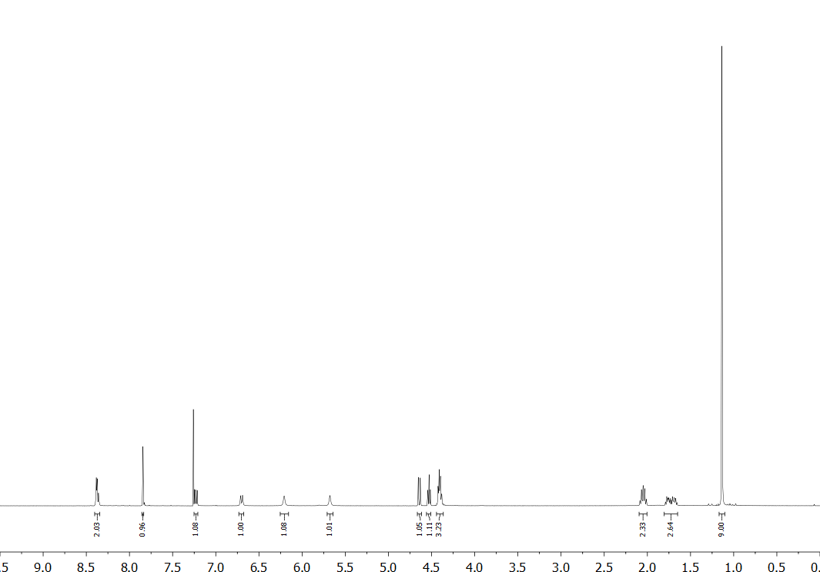
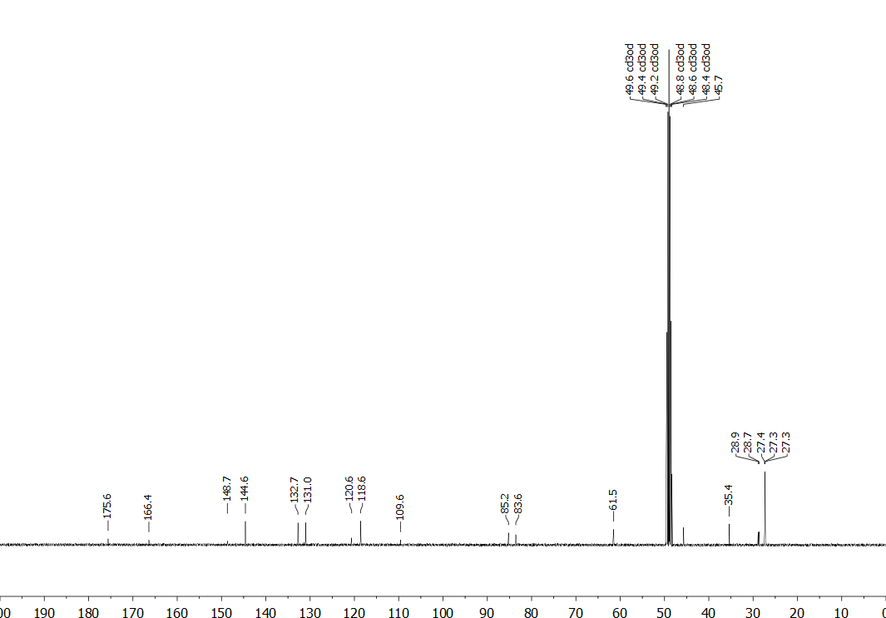

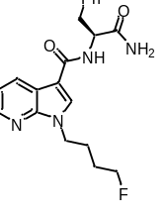Figure S27. ¹H (400 MHz, DMSO-d₆) and ¹³C (101 MHz, DMSO-d₆) NMR spectra for (S)-N-(1-amino-1-oxo-3-phenylpropan-2-yl)-1-(4-fluorobutyl)-1H-pyrrolo[2,3-b]pyridine-3-carboxamide (APP-4F-BUT7AICA, 33).
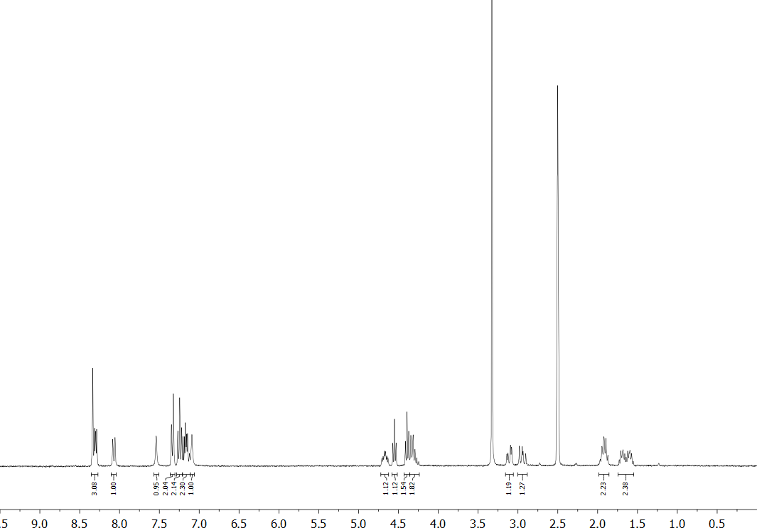
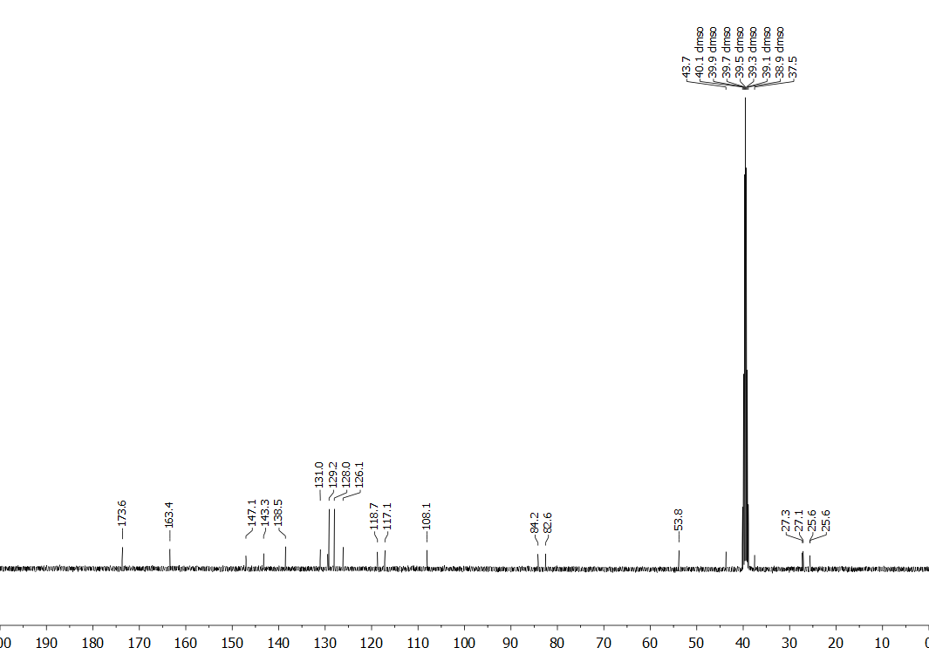

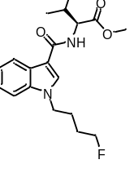Figure S28. ¹H (400 MHz, CDCl₃) and ¹³C (101 MHz, CD₃OD) NMR spectra for methyl (1-(4-fluorobutyl)-1H-indole-3-carbonyl)-L-valinate (MMB-4F-BUTICA, 34).
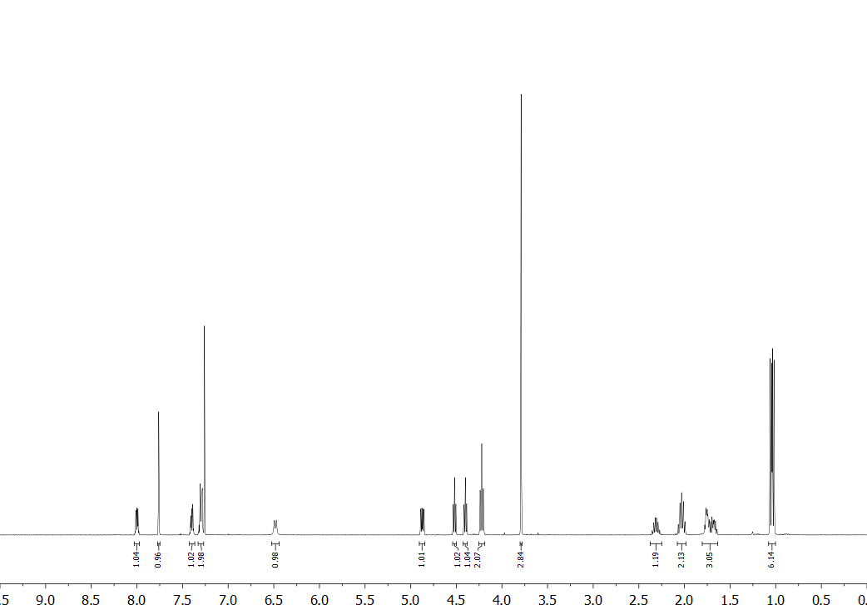
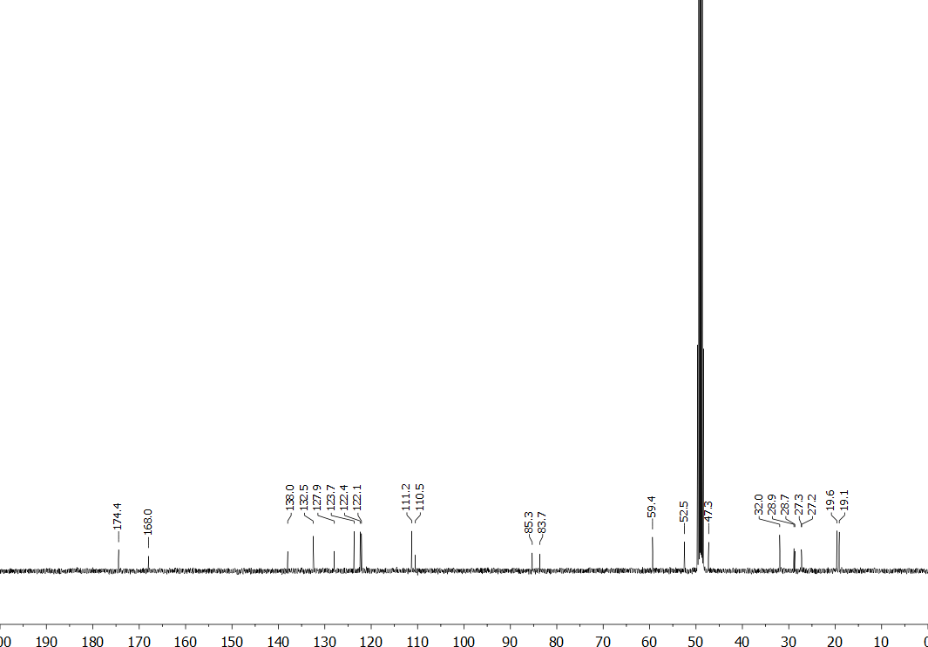

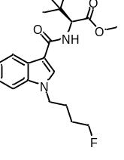Figure S29. ¹H (400 MHz, DMSO-d₆) and ¹³C (101 MHz, DMSO-d₆) NMR spectra for methyl (S)-2-(1-(4-fluorobutyl)-1H-indole-3-carboxamido)-3,3-dimethylbutanoate (MDMB-4F-BUTICA, 7).
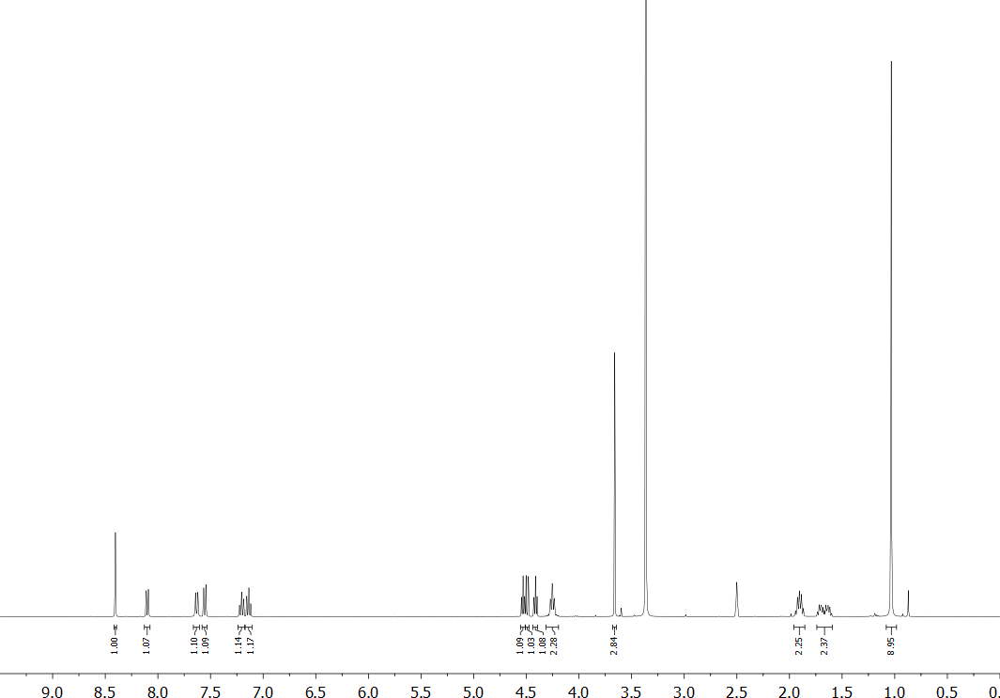
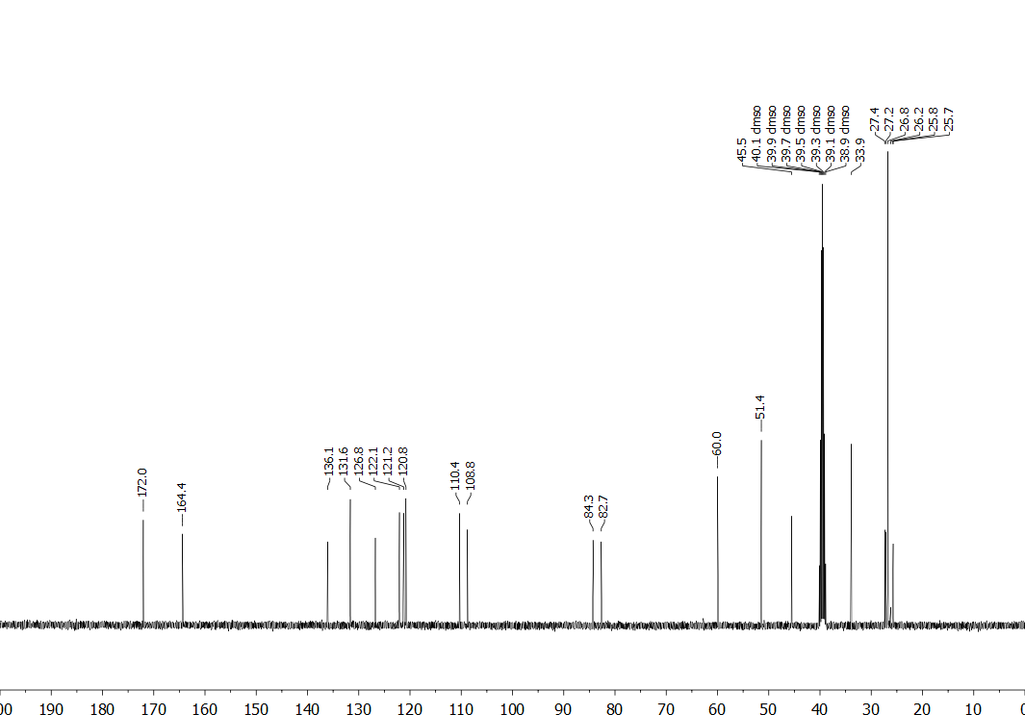

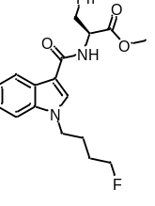Figure S30. ¹H (400 MHz, CDCl₃) and ¹³C (101 MHz, CD₃OD) NMR spectra for methyl (1-(4-fluorobutyl)-1H-indole-3-carbonyl)-L-phenylalaninate (MPP-4F-BUTICA, 35).
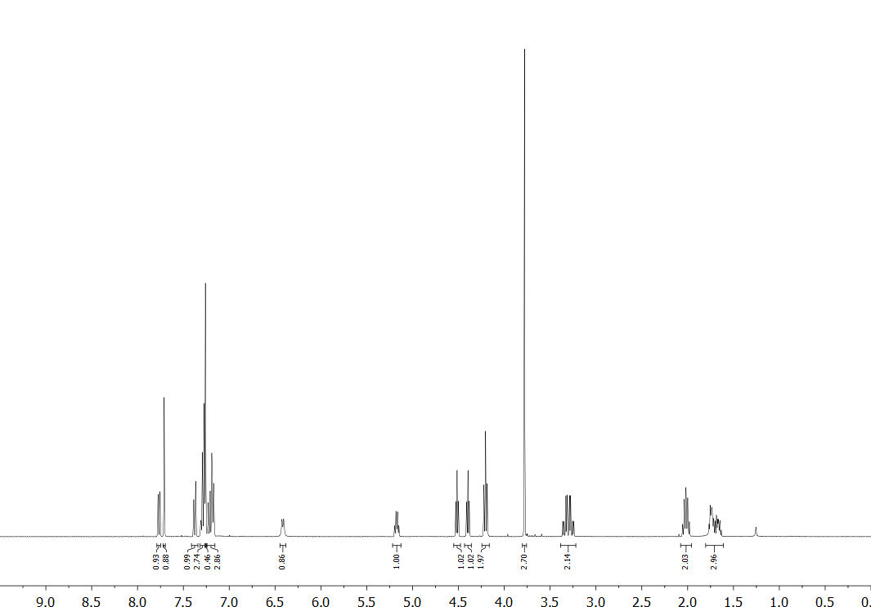
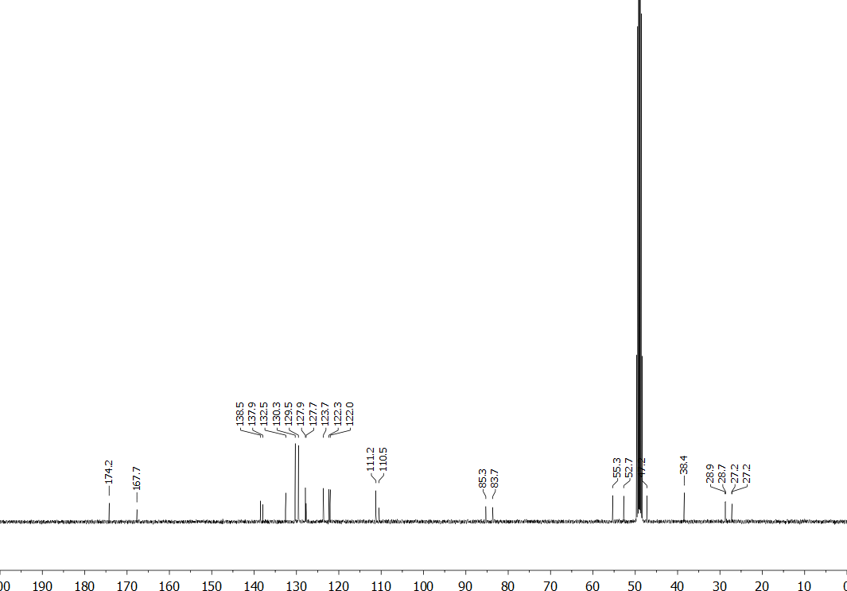

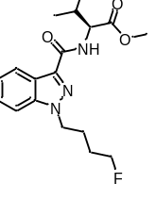Figure S31. ¹H (400 MHz, DMSO-d₆) and ¹³C (101 MHz, CD₃OD) NMR spectra for methyl (1-(4-fluorobutyl)-1H-indazole-3-carbonyl)-L-valinate (MMB-4F-BUTINACA, 36).
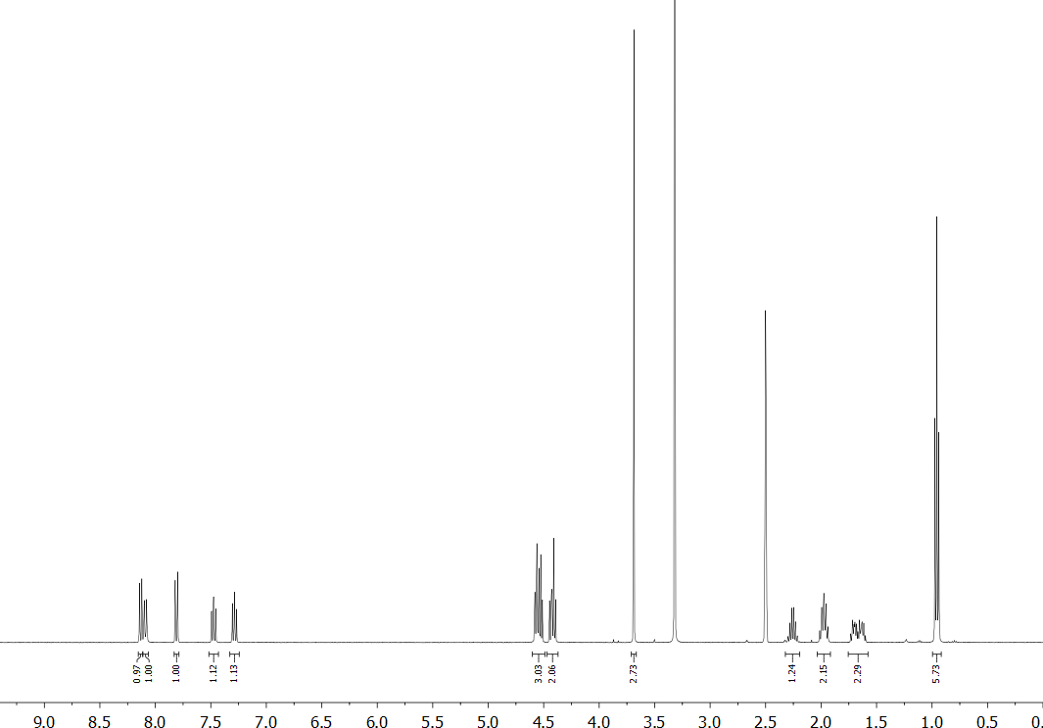
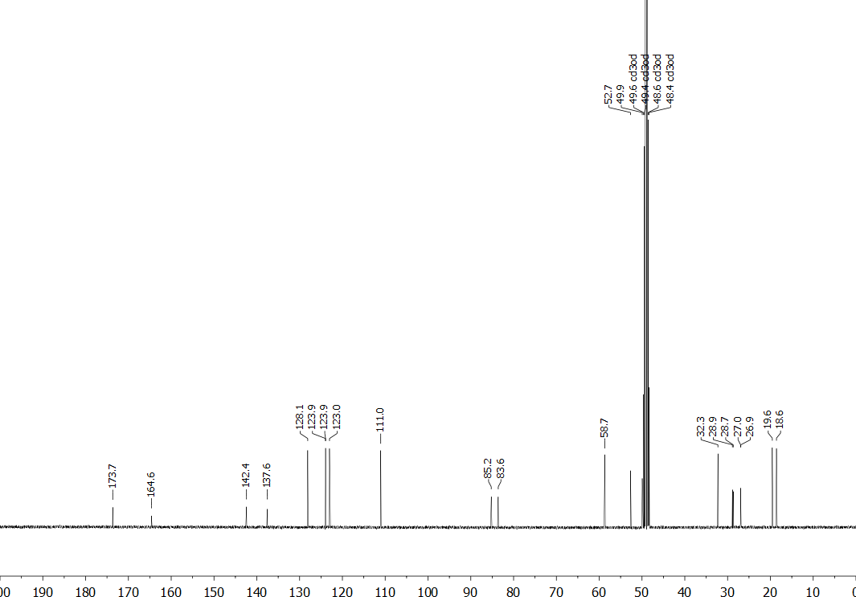

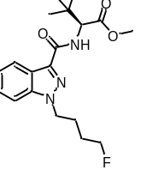Figure S32. ¹H (400 MHz, DMSO-d₆) and ¹³C (101 MHz, DMSO-d₆) NMR spectra for methyl (S)-2-(1-(4-fluorobutyl)-1H-indazole-3-carboxamido)-3,3-dimethylbutanoate (MDMB-4F-BUTINACA, 8).
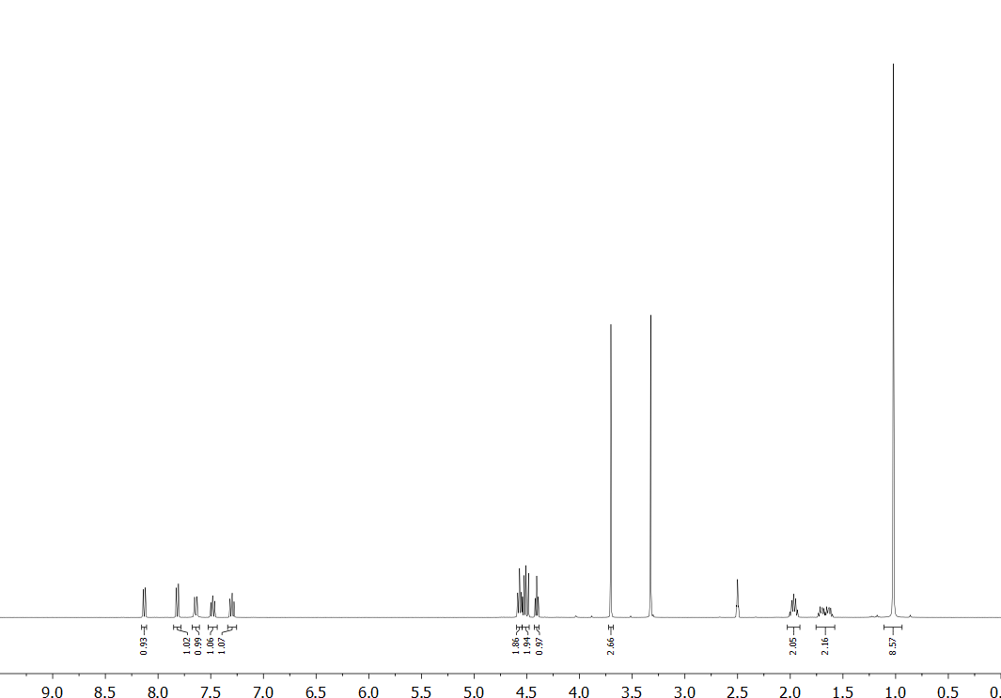
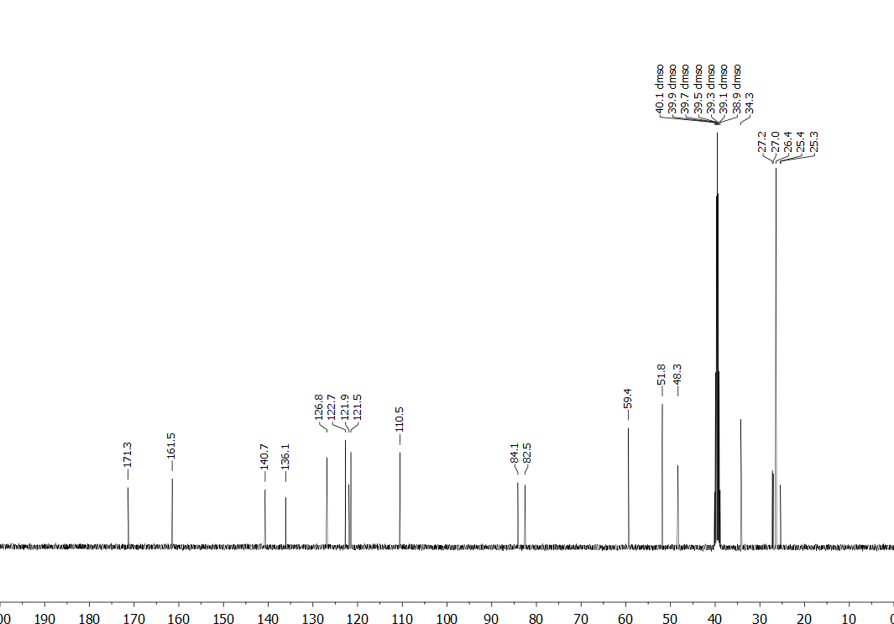

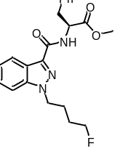Figure S33. ¹H (400 MHz, CDCl₃) and ¹³C (101 MHz, CD₃OD) NMR spectra for methyl (1-(4-fluorobutyl)-1H-indazole-3-carbonyl)-L-phenylalaninate (MPP-4F-BUTINACA, 37).
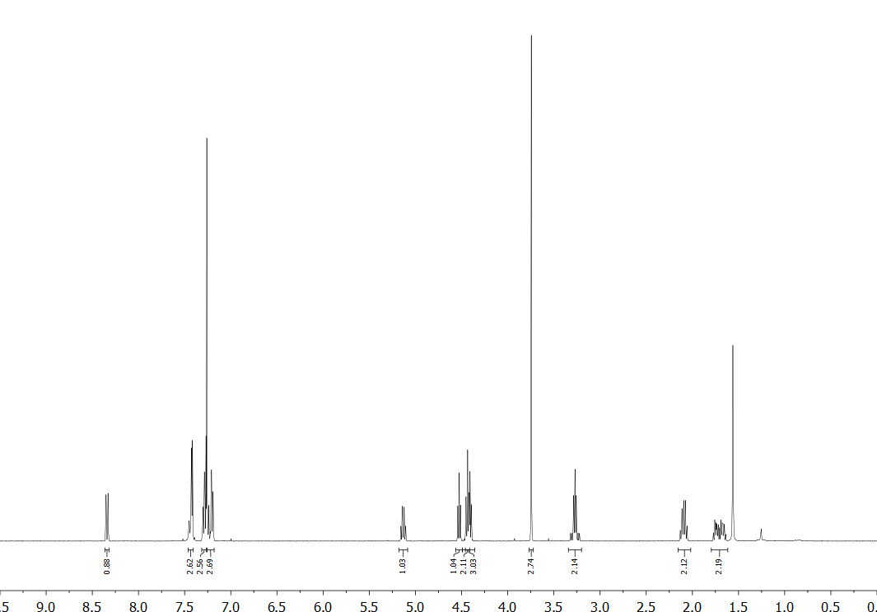
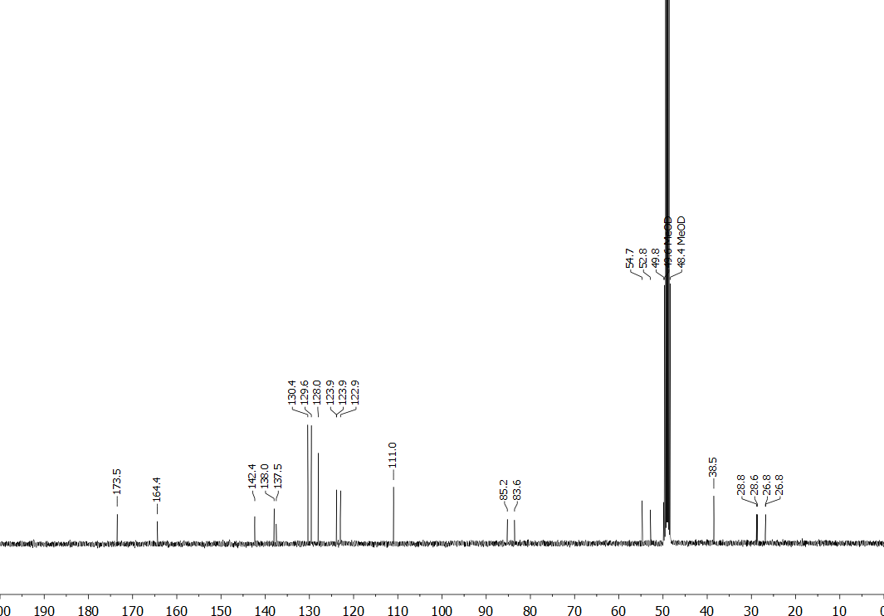

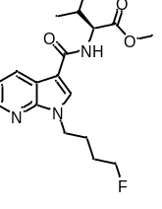Figure S34. ¹H (400 MHz, DMSO-d₆) and ¹³C (101 MHz, CD₃OD) NMR spectra for methyl (1-(4-fluorobutyl)-1H-pyrrolo[2,3-b]pyridine-3-carbonyl)-L-valinate (MMB-4F-BUT7AICA¸38).
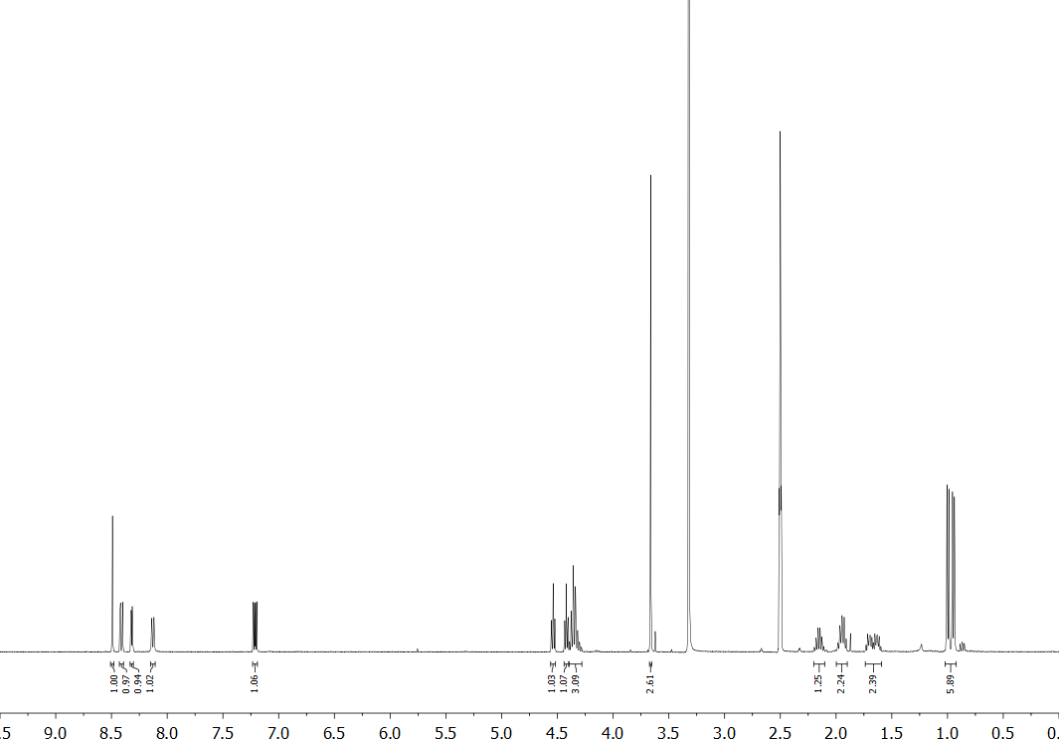
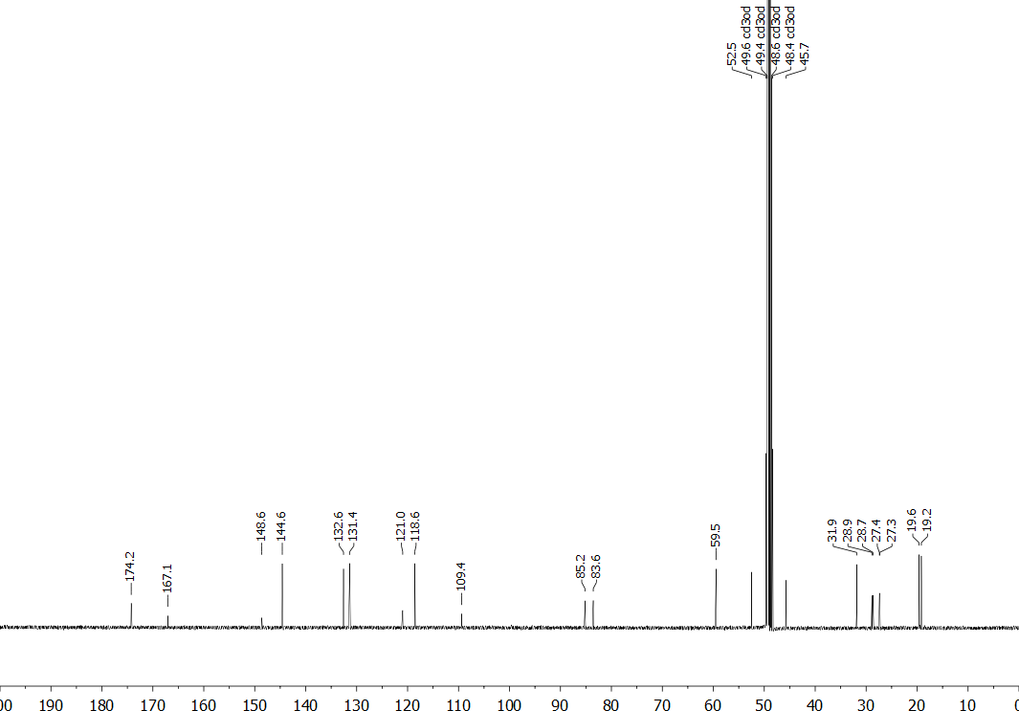

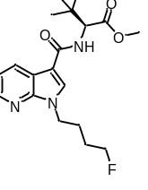Figure S35. ¹H (400 MHz, DMSO-d₆) and ¹³C (101 MHz, CD₃OD) NMR spectra for methyl (S)-2-(1-(4-fluorobutyl)-1H-pyrrolo[2,3-b]pyridine-3-carboxamido)-3,3-dimethylbutanoate (MDMB-4F-BUT7AICA, 39).
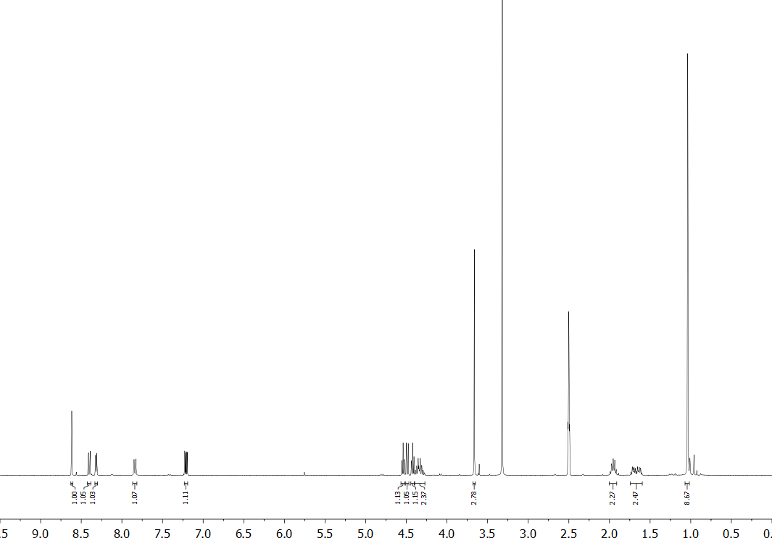
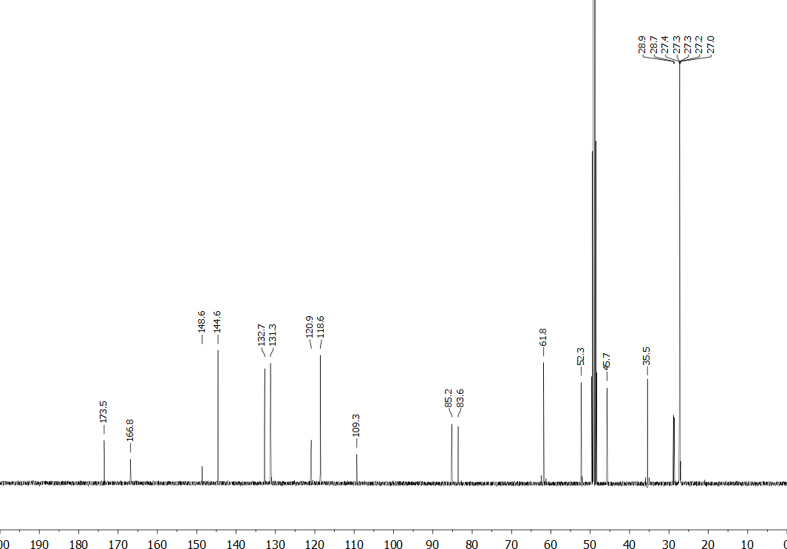

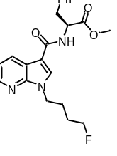Figure S36. ¹H (400 MHz, CDCl₃) and ¹³C (101 MHz, CD₃OD) NMR spectra for methyl (1-(4-fluorobutyl)-1H-pyrrolo[2,3-b]pyridine-3-carbonyl)-L-phenylalaninate (MPP-4F-BUT7AICA, 40).
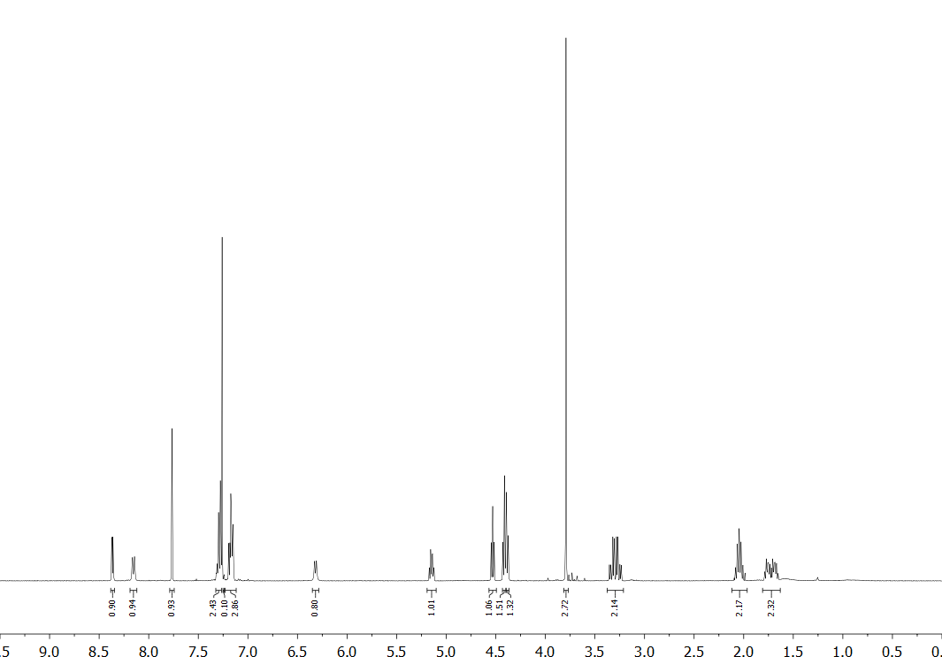
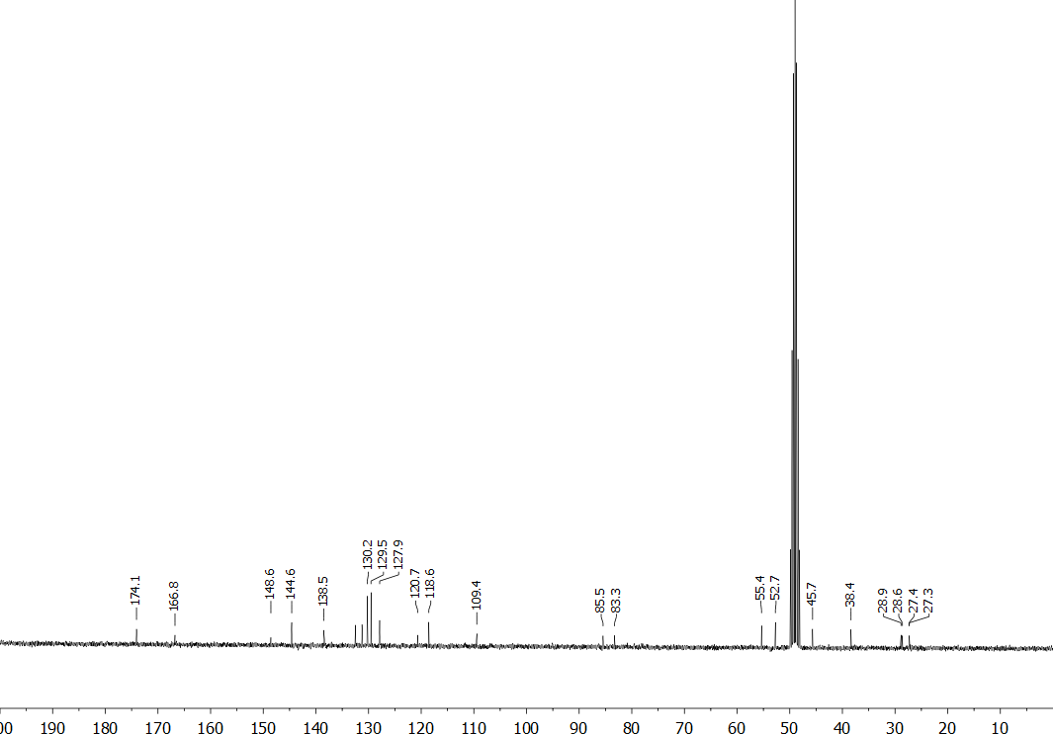

Figure S37. ¹H (400 MHz, CDCl₃) and ¹³C (101 MHz, CDCl₃) NMR spectra for methyl 1-(4-fluorobutyl)-1H-pyrrolo[2,3-b]pyridine-3-carboxylate (4F-BUT7AICA COOMe, 49).
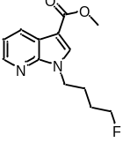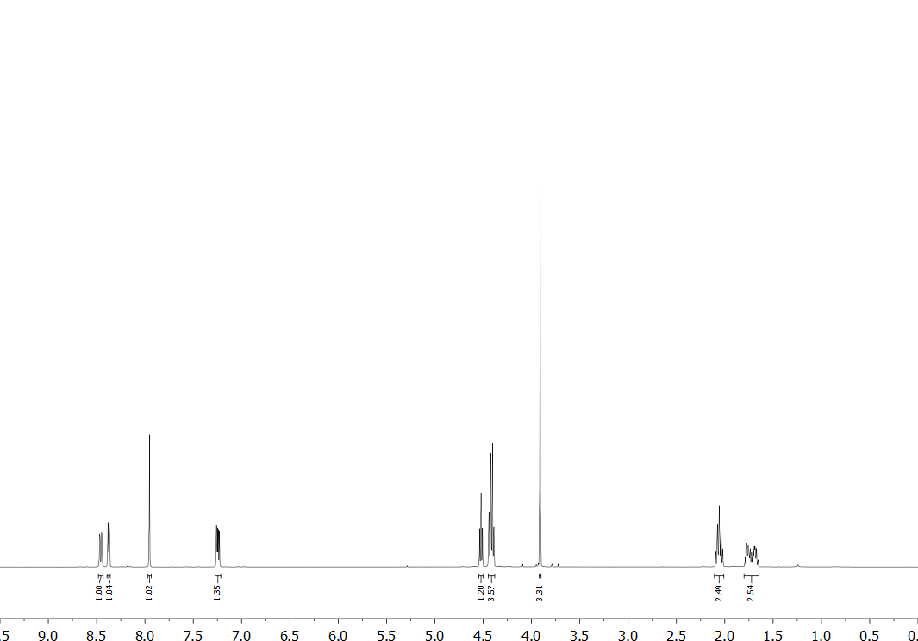
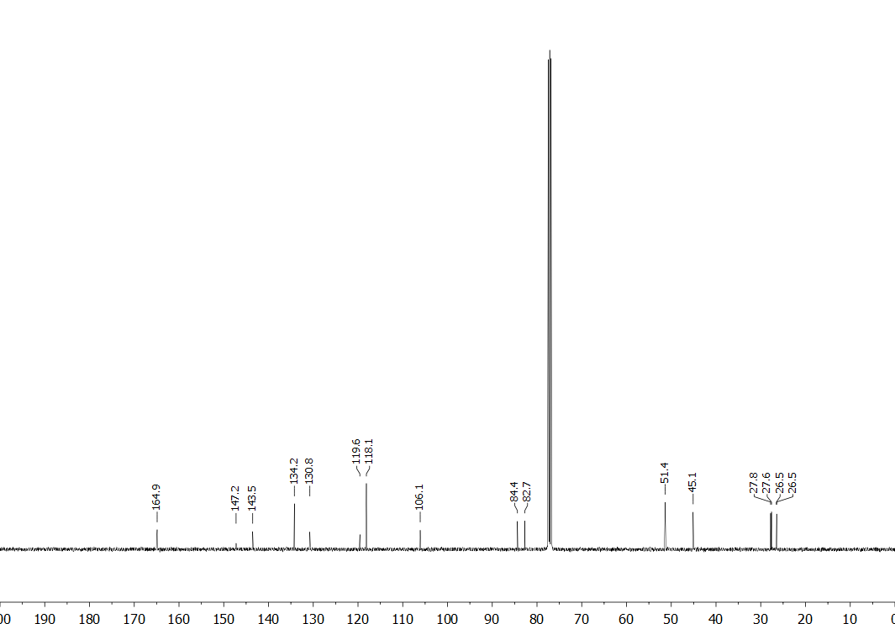

Figure S38. ¹H (400 MHz, DMSO-d₆) and ¹³C (75 MHz, DMSO-d₆) NMR spectra for 1-(4-fluorobutyl)-1H-pyrrolo[2,3-b]pyridine-3-carboxylic acid (4F-BUT7AICA COOH, 53).
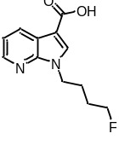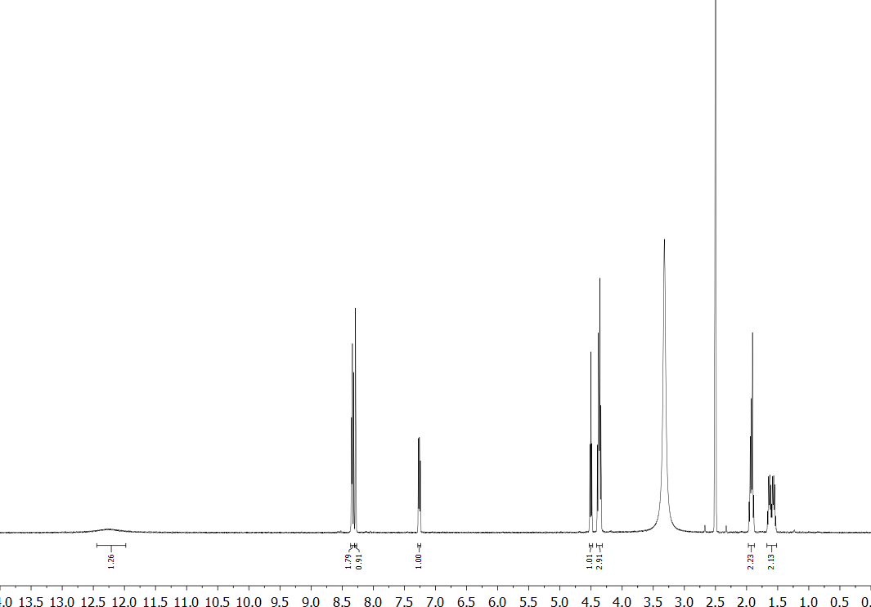
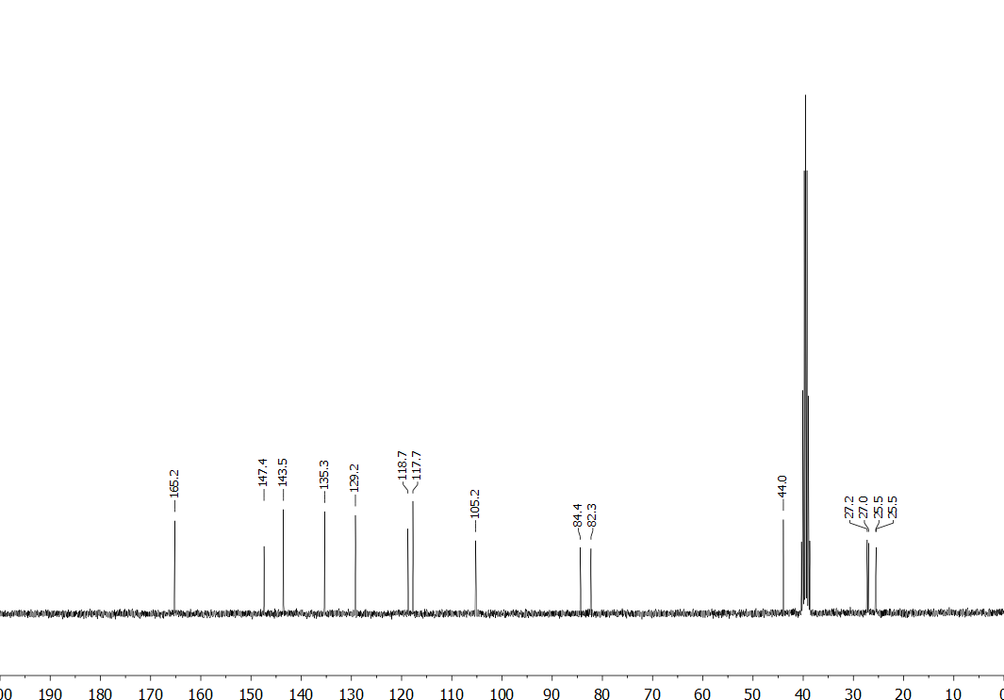

Figure S39. LC-UV chromatogram for (S)-N-(1-amino-3-methyl-1-oxobutan-2-yl)-1-(4-cyanobutyl)-1H-indole-3-carboxamide (AB-4CN-BUTICA, 5).
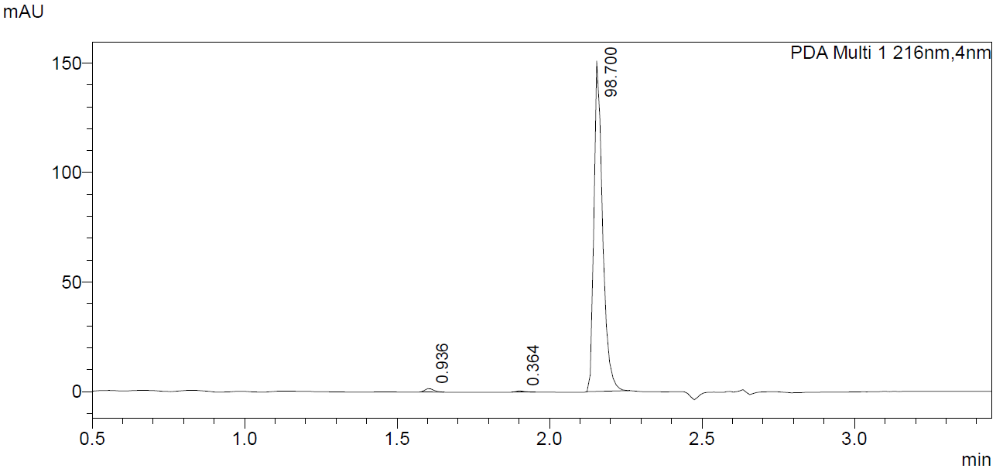

Figure S40. LC-UV chromatogram for (S)-N-(1-amino-3,3-dimethyl-1-oxobutan-2-yl)-1-(4-cyanobutyl)-1H-indole-3-carboxamide (ADB-4CN-BUTICA, 9).
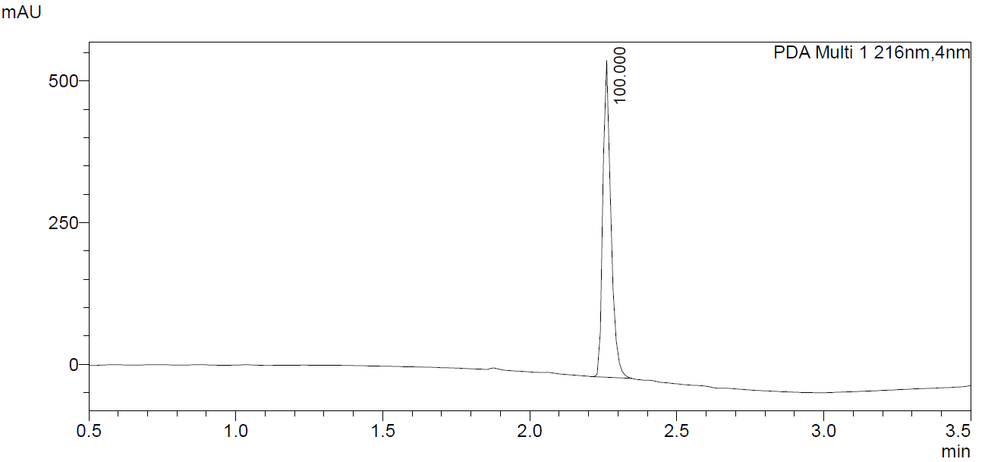

Figure S41. LC-UV chromatogram for (S)-N-(1-amino-1-oxo-3-phenylpropan-2-yl)-1-(4-cyanobutyl)-1H-indole-3-carboxamide (APP-4CN-BUTICA, 10).
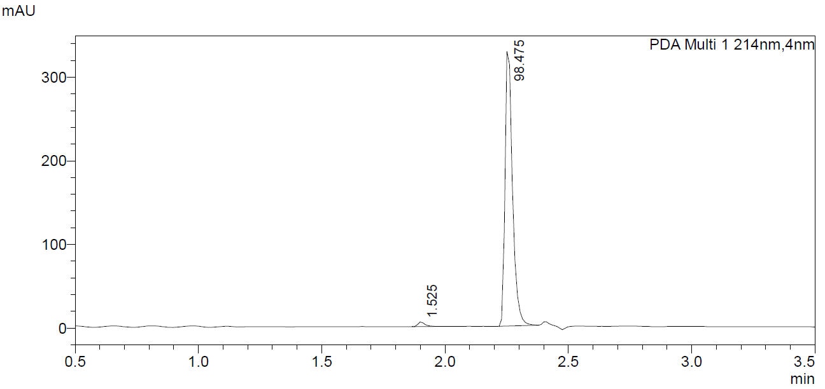

Figure S42. LC-UV chromatogram for (S)-N-(1-amino-3-methyl-1-oxobutan-2-yl)-1-(4-cyanobutyl)-1H-indazole-3-carboxamide (AB-4CN-BUTINACA, 11).
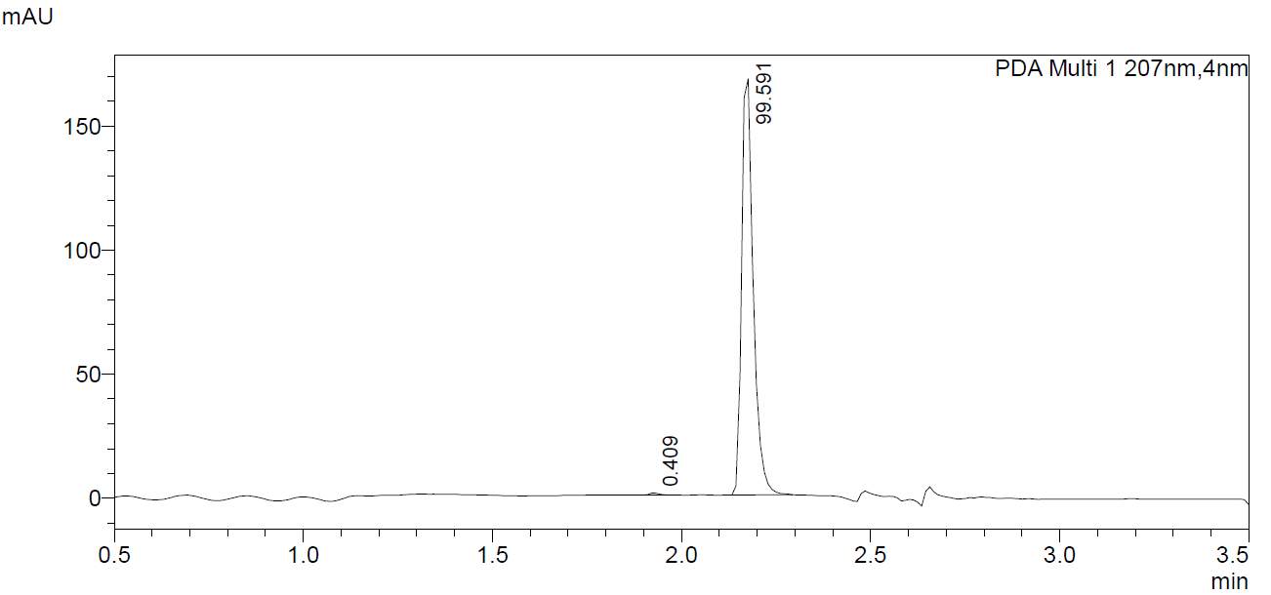

Figure S43. LC-UV chromatogram for (S)-N-(1-amino-3,3-dimethyl-1-oxobutan-2-yl)-1-(4-cyanobutyl)-1H-indazole-3-carboxamide (ADB-4CN-BUTINACA, 12).
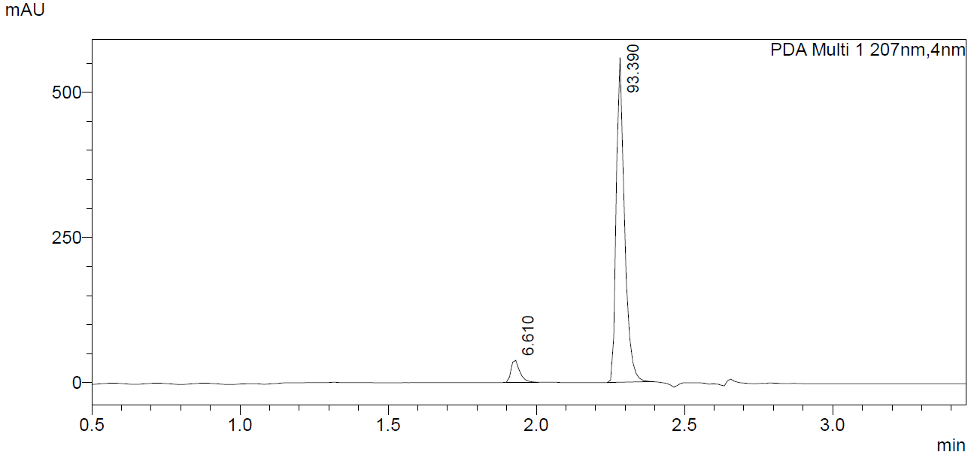

Figure S44. LC-UV chromatogram for (S)-N-(1-amino-1-oxo-3-phenylpropan-2-yl)-1-(4-cyanobutyl)-1H-indazole-3-carboxamide (APP-4CN-BUTINACA, 13).
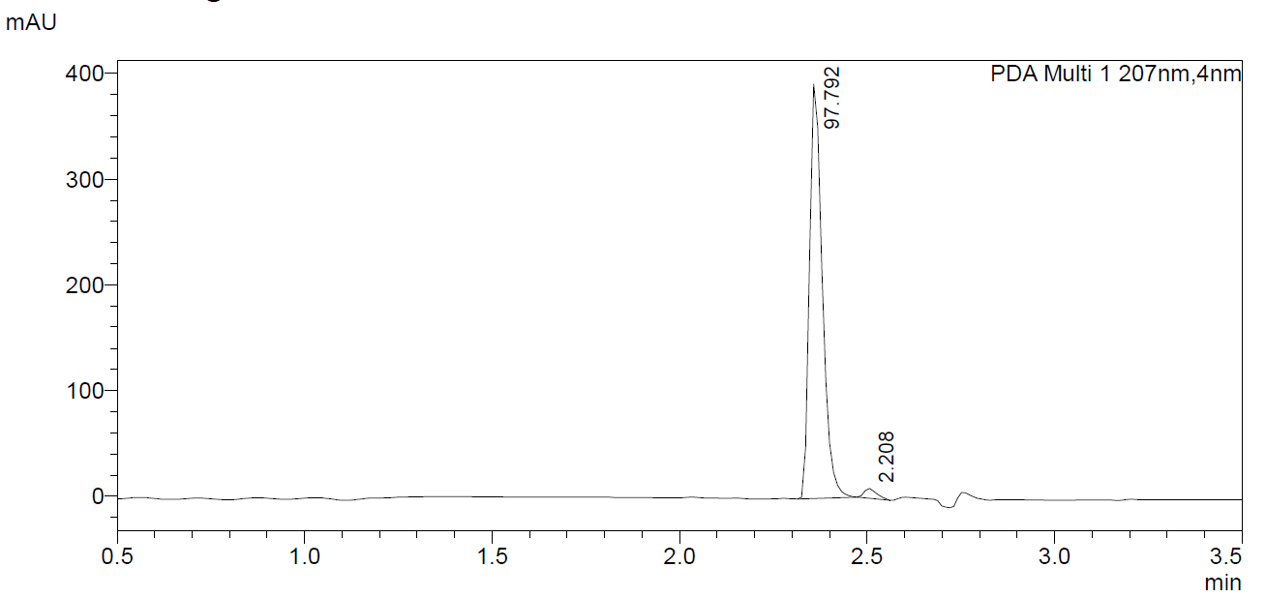

Figure S45. LC-UV chromatogram for (S)-N-(1-amino-3-methyl-1-oxobutan-2-yl)-1-(4-cyanobutyl)-1H-pyrrolo[2,3-b]pyridine-3-carboxamide (AB-4CN-BUT7AICA, 14).
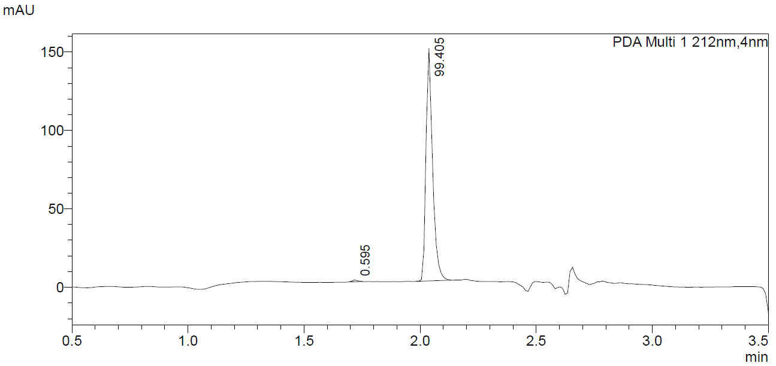

Figure S46. LC-UV chromatogram for (S)-N-(1-amino-3,3-dimethyl-1-oxobutan-2-yl)-1-(4-cyanobutyl)-1H-pyrrolo[2,3-b]pyridine-3-carboxamide (ADB-4CN-BUT7AICA, 15).
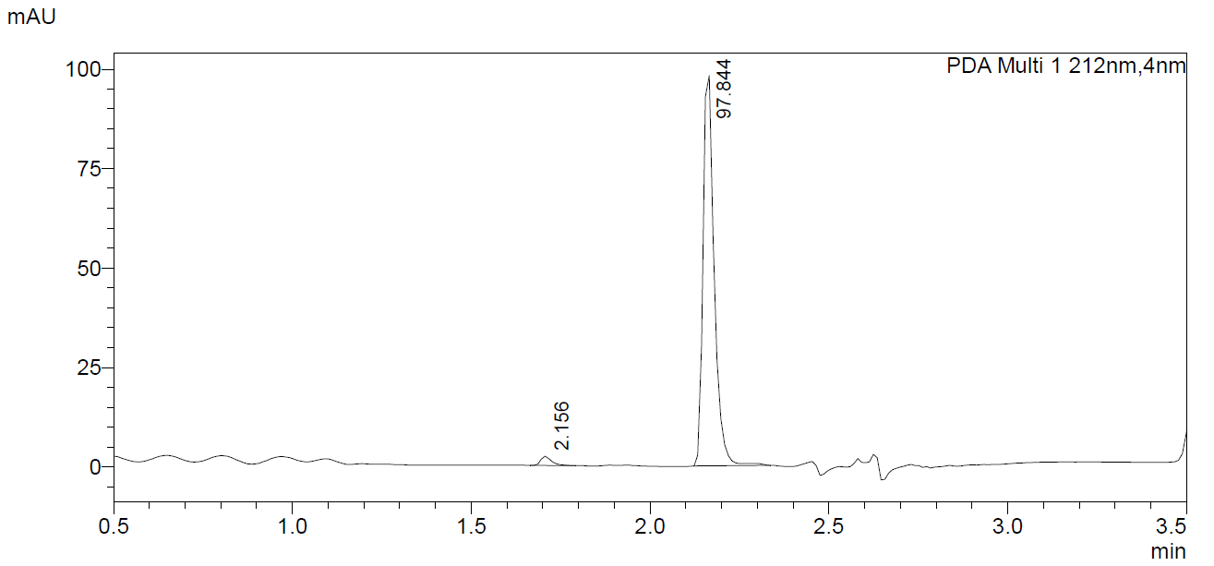

Figure S47. LC-UV chromatogram for (S)-N-(1-amino-1-oxo-3-phenylpropan-2-yl)-1-(4-cyanobutyl)-1H-pyrrolo[2,3-b]pyridine-3-carboxamide (APP-4CN-BUT7AICA, 16).
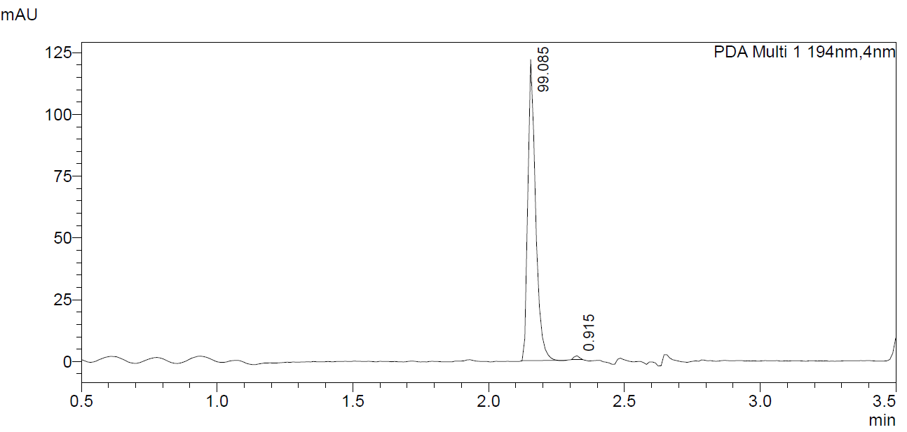

Figure S48. LC-UV chromatogram for methyl (1-(4-cyanobutyl)-1H-indole-3-carbonyl)-L-valinate (MMB-4CN-BUTICA, 17).
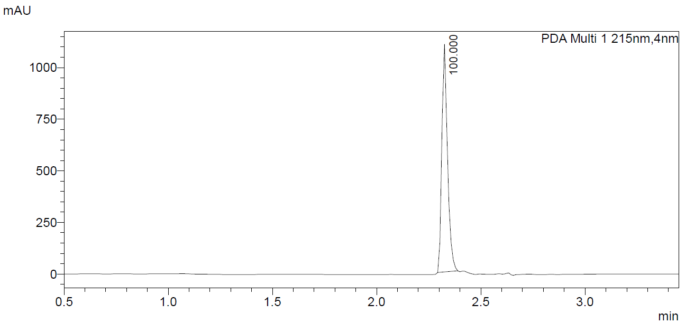

Figure S49. LC-UV chromatogram for methyl (S)-2-(1-(4-cyanobutyl)-1H-indole-3-carboxamido)-3,3-dimethylbutanoate (MDMB-4CN-BUTICA, 18).
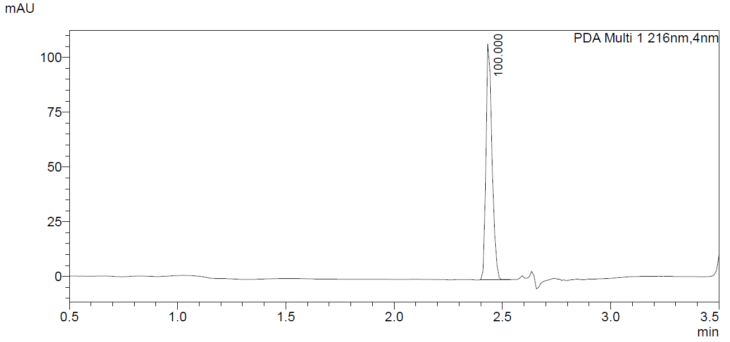

Figure S50. LC-UV chromatogram for methyl (1-(4-cyanobutyl)-1H-indole-3-carbonyl)-L-phenylalaninate (MPP-4CN-BUTICA, 19).
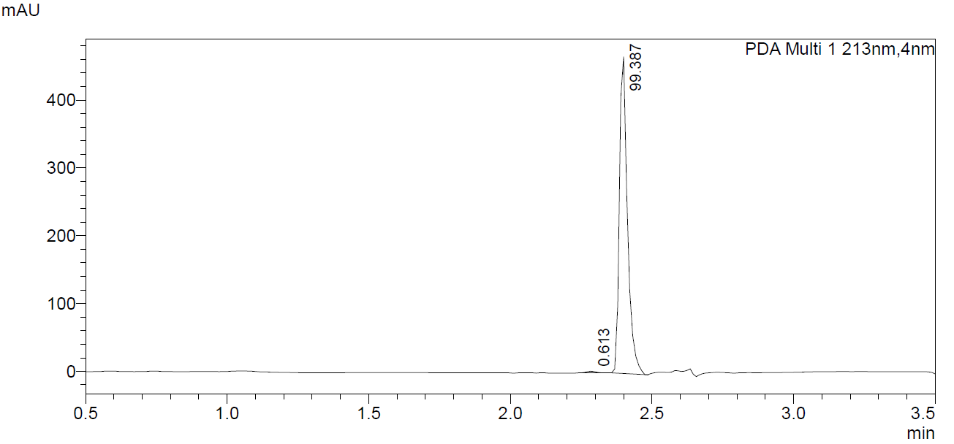

Figure S51. LC-UV chromatogram for methyl (1-(4-cyanobutyl)-1H-indazole-3-carbonyl)-L-valinate (MMB-4CN-BUTINACA, 6).
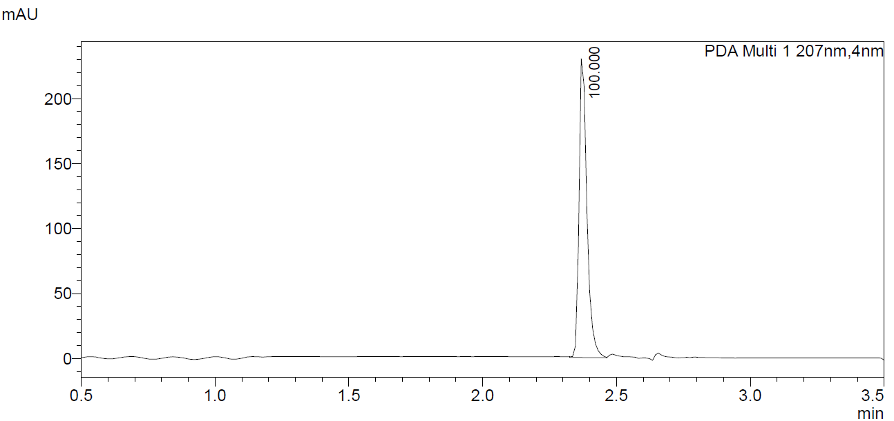

Figure S52. LC-UV chromatogram for methyl (S)-2-(1-(4-cyanobutyl)-1H-indazole-3-carboxamido)-3,3-dimethylbutanoate (MDMB-4CN-BUTINACA, 20).
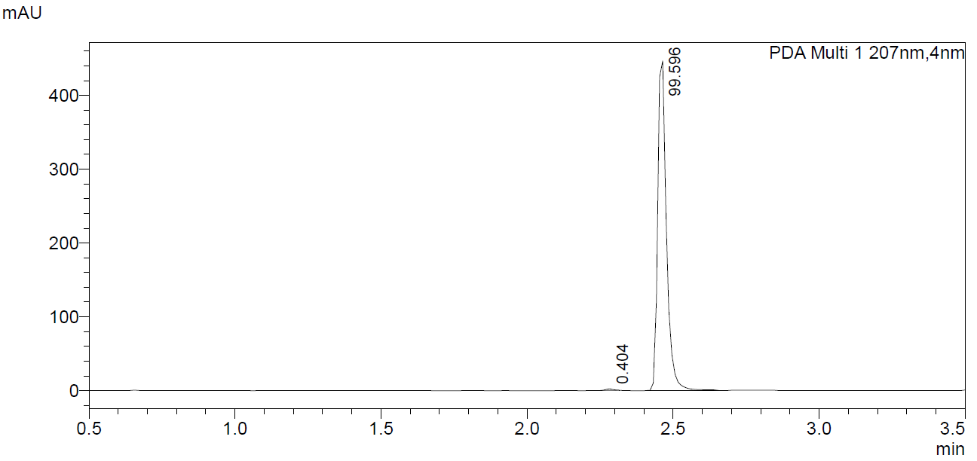

Figure S53. LC-UV chromatogram for methyl (1-(4-cyanobutyl)-1H-indazole-3-carbonyl)-L-phenylalaninate (MPP-4CN-BUTINACA, 21).
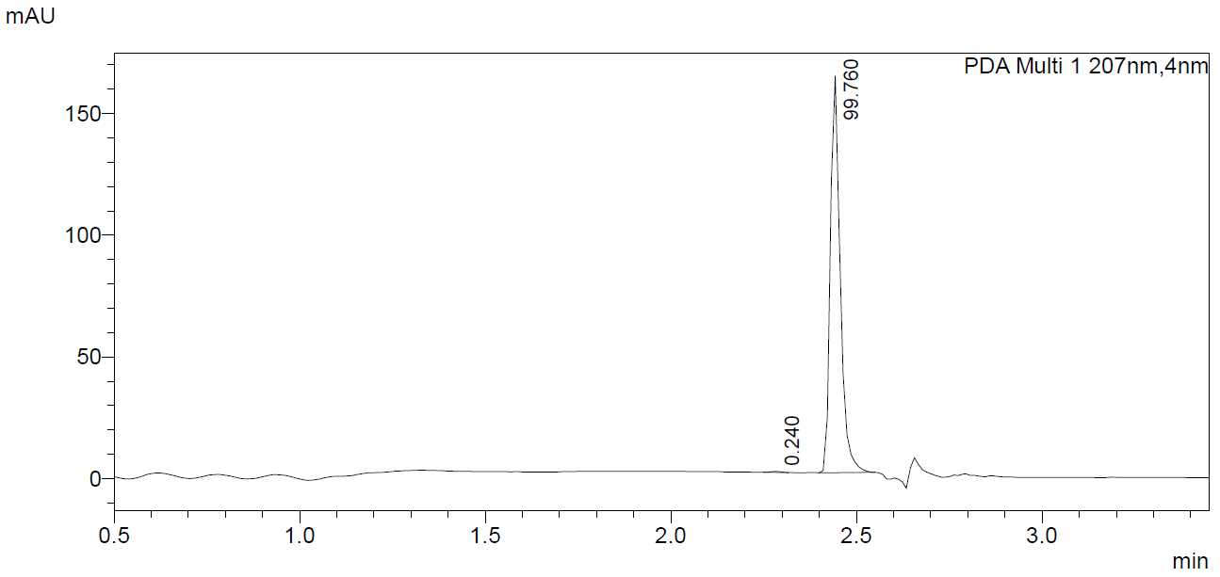

Figure S54. LC-UV chromatogram for methyl (1-(4-cyanobutyl)-1H-pyrrolo[2,3-b]pyridine-3-carbonyl)-L-valinate (MMB-4CN-BUT7AICA, 22).
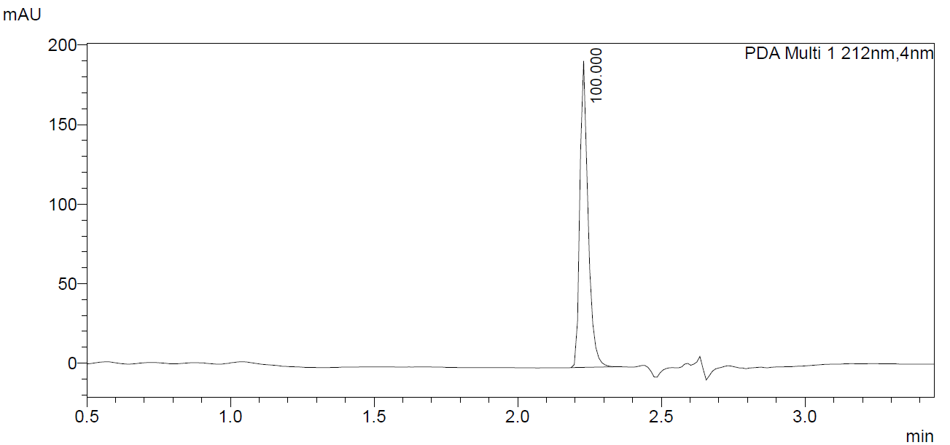

Figure S55. LC-UV chromatogram for methyl (S)-2-(1-(4-cyanobutyl)-1H-pyrrolo[2,3-b]pyridine-3-carboxamido)-3,3-dimethylbutanoate (MDMB-4CN-BUT7AICA, 23).
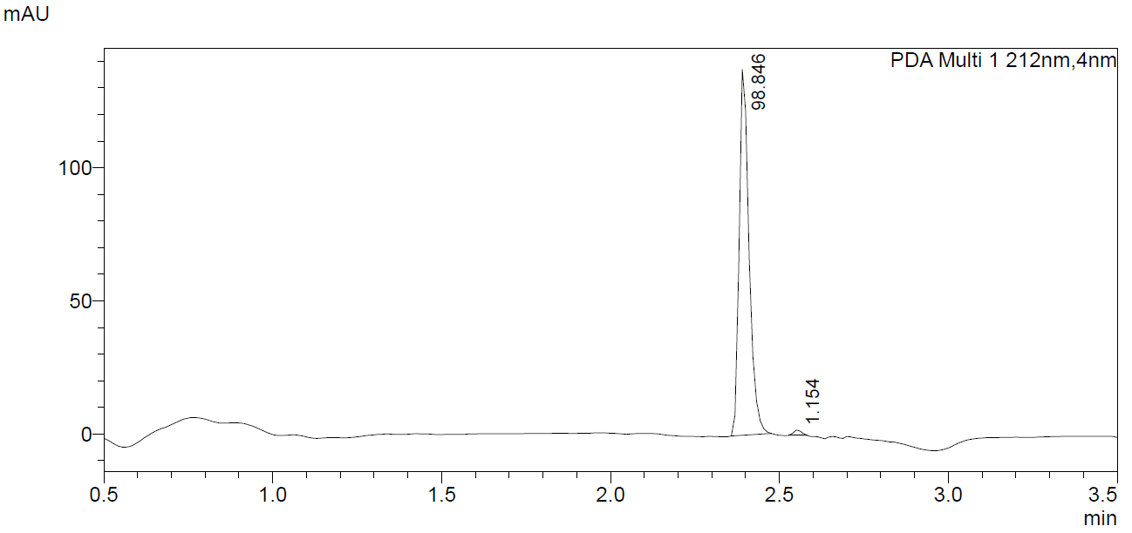

Figure S56. LC-UV chromatogram for methyl (1-(4-cyanobutyl)-1H-pyrrolo[2,3-b]pyridine-3-carbonyl)-L-phenylalaninate (MPP-4CN-BUT7AICA, 24).
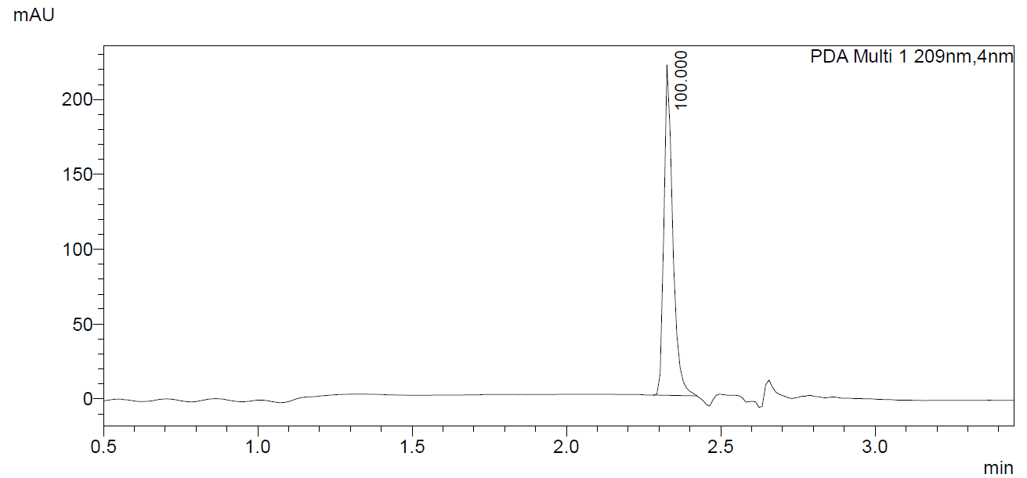

Figure S57. LC-UV chromatogram for (S)-N-(1-amino-3-methyl-1-oxobutan-2-yl)-1-(4-fluorobutyl)-1H-indole-3-carboxamide (AB-4F-BUTICA, 25).
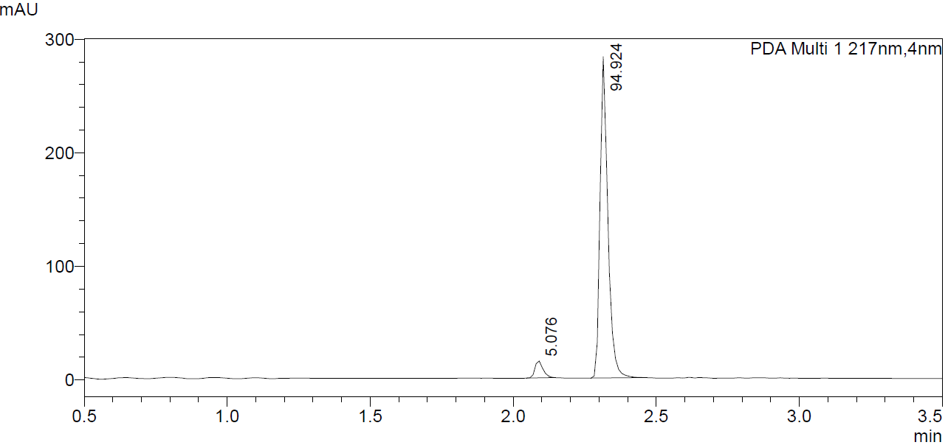

Figure S58. LC-UV chromatogram for (S)-N-(1-amino-3,3-dimethyl-1-oxobutan-2-yl)-1-(4-fluorobutyl)-1H-indole-3-carboxamide (ADB-4F-BUTICA, 26).
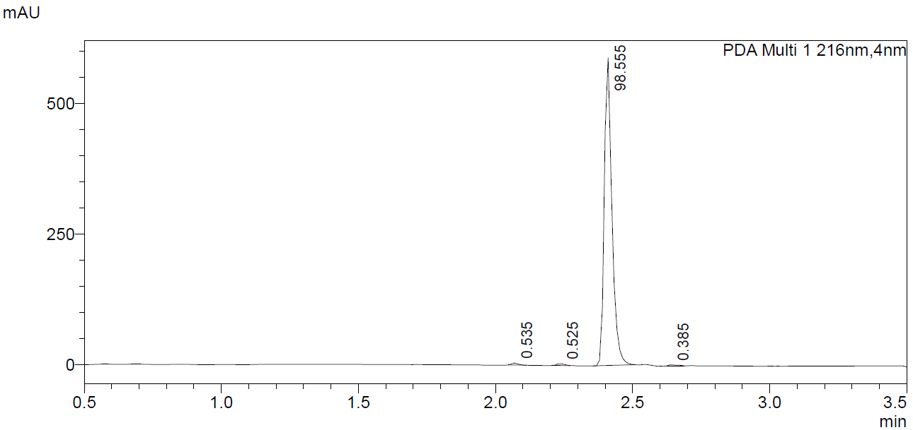

Figure S59. LC-UV chromatogram for (S)-N-(1-amino-1-oxo-3-phenylpropan-2-yl)-1-(4-fluorobutyl)-1H-indole-3-carboxamide (APP-4F-BUTICA, 27).
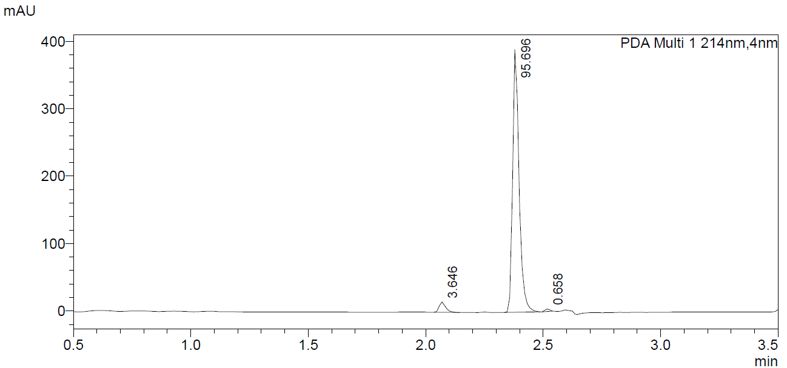

Figure S60. LC-UV chromatogram for (S)-N-(1-amino-3-methyl-1-oxobutan-2-yl)-1-(4-fluorobutyl)-1H-indazole-3-carboxamide (AB-4F-BUTINACA, 28).
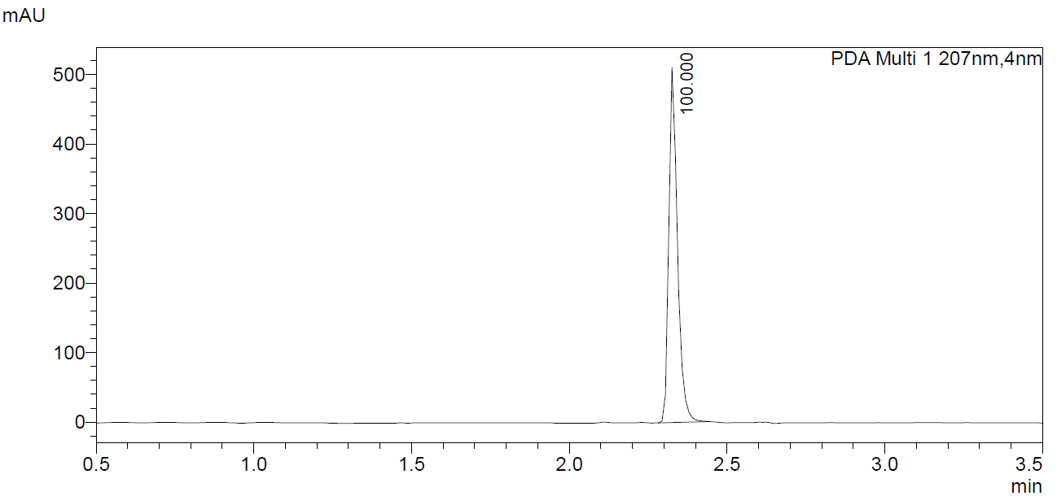

Figure S61. LC-UV chromatogram for (S)-N-(1-amino-3,3-dimethyl-1-oxobutan-2-yl)-1-(4-fluorobutyl)-1H-indazole-3-carboxamide (ADB-4F-BUTINACA, 29).
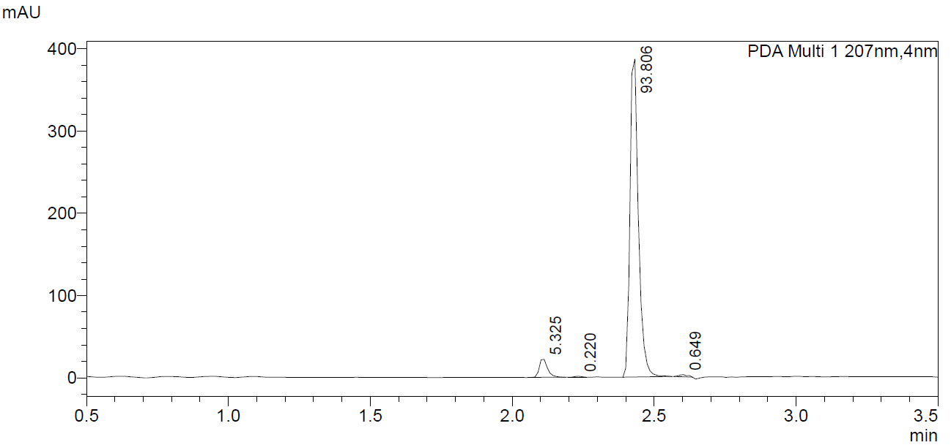

Figure S62. LC-UV chromatogram for (S)-N-(1-amino-1-oxo-3-phenylpropan-2-yl)-1-(4-fluorobutyl)-1H-indazole-3-carboxamide (APP-4F-BUTINACA, 30).
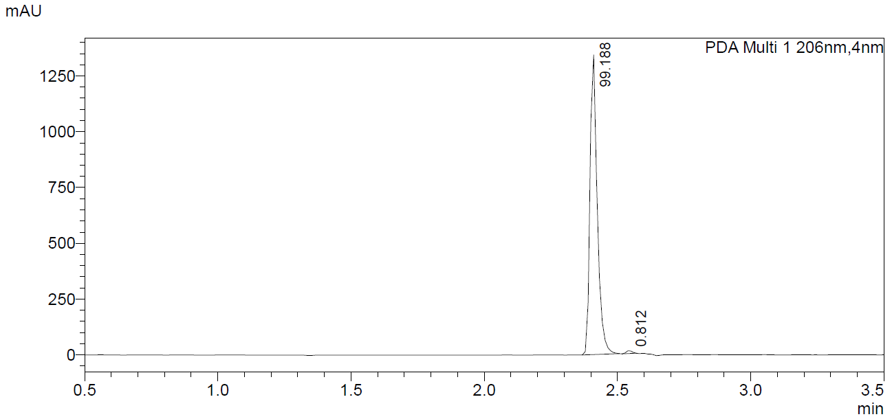

Figure S63. LC-UV chromatogram for (S)-N-(1-amino-3-methyl-1-oxobutan-2-yl)-1-(4-fluorobutyl)-1H-pyrrolo[2,3-b]pyridine-3-carboxamide (AB-4F-BUT7AICA, 31).
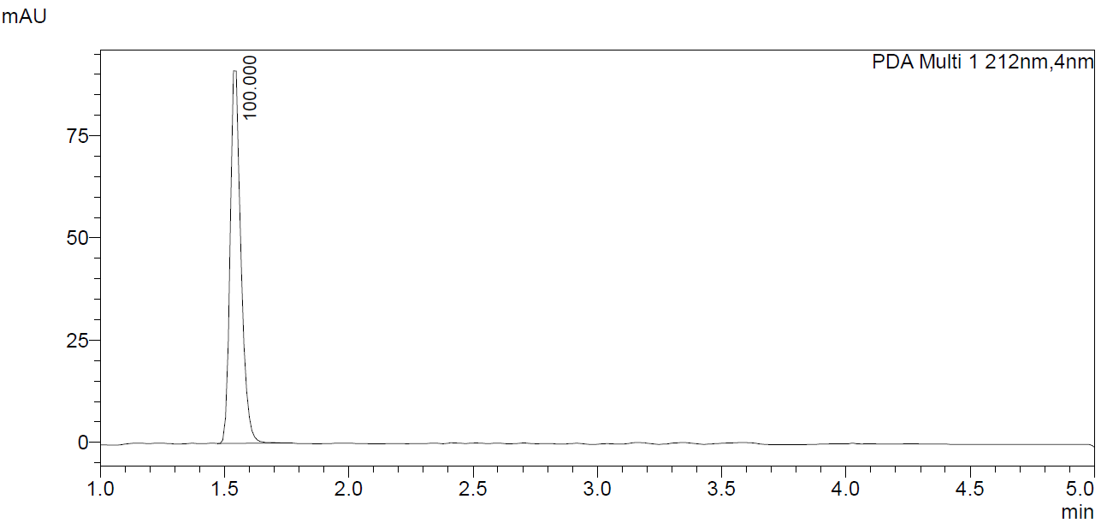

Figure S64. LC-UV chromatogram for (S)-N-(1-amino-3,3-dimethyl-1-oxobutan-2-yl)-1-(4-fluorobutyl)-1H-pyrrolo[2,3-b]pyridine-3-carboxamide (ADB-4F-BUT7AICA, 32).
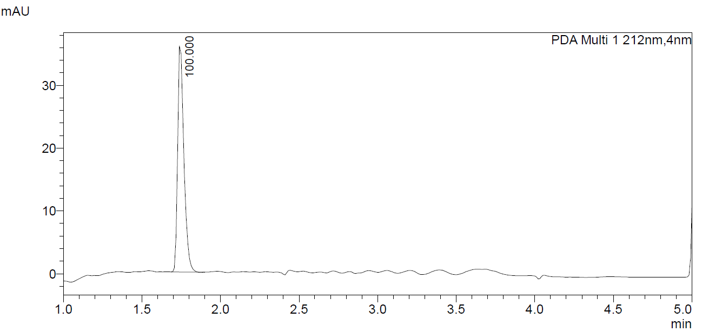

Figure S65. LC-UV chromatogram for (S)-N-(1-amino-1-oxo-3-phenylpropan-2-yl)-1-(4-fluorobutyl)-1H-pyrrolo[2,3-b]pyridine-3-carboxamide (APP-4F-BUT7AICA, 33).
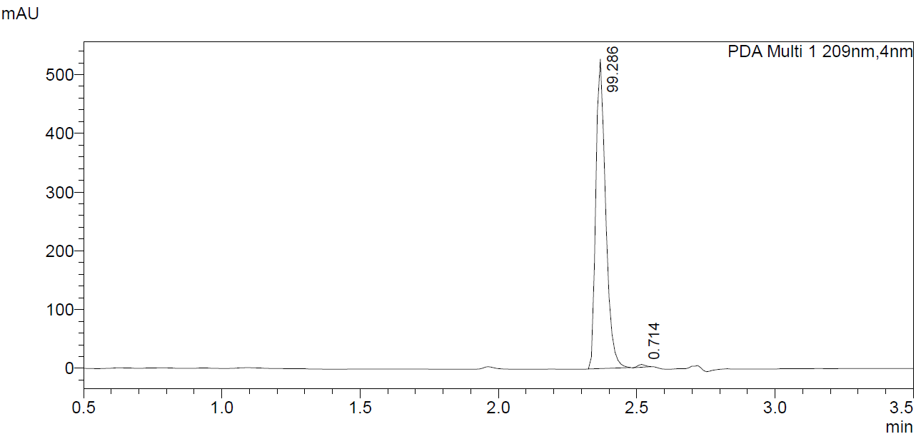

Figure S66. LC-UV chromatogram for methyl (1-(4-fluorobutyl)-1H-indole-3-carbonyl)-L-valinate (MMB-4F-BUTICA, 34).
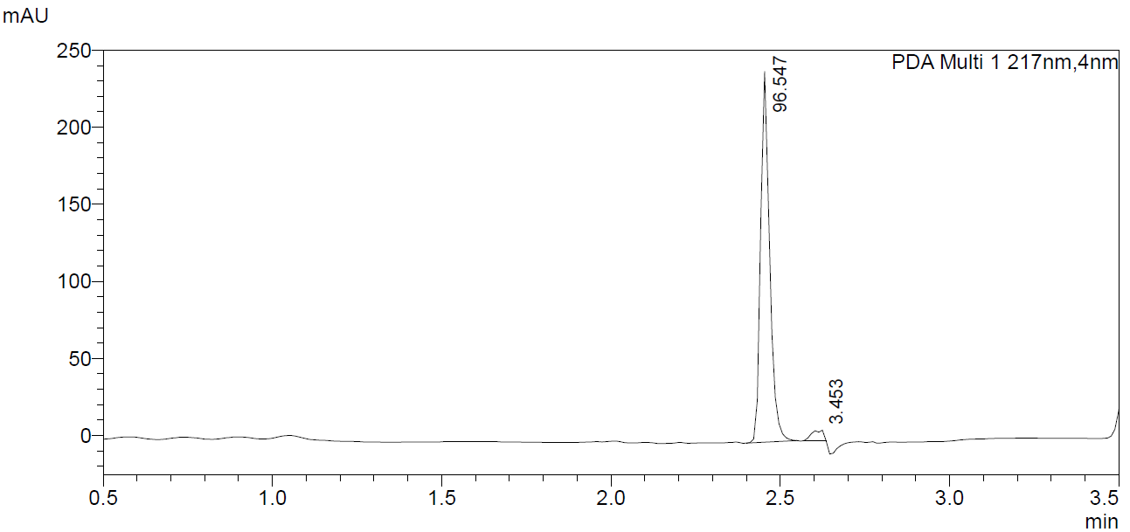

Figure S67. LC-UV chromatogram for methyl (S)-2-(1-(4-fluorobutyl)-1H-indole-3-carboxamido)-3,3-dimethylbutanoate (MDMB-4F-BUTICA, 7).
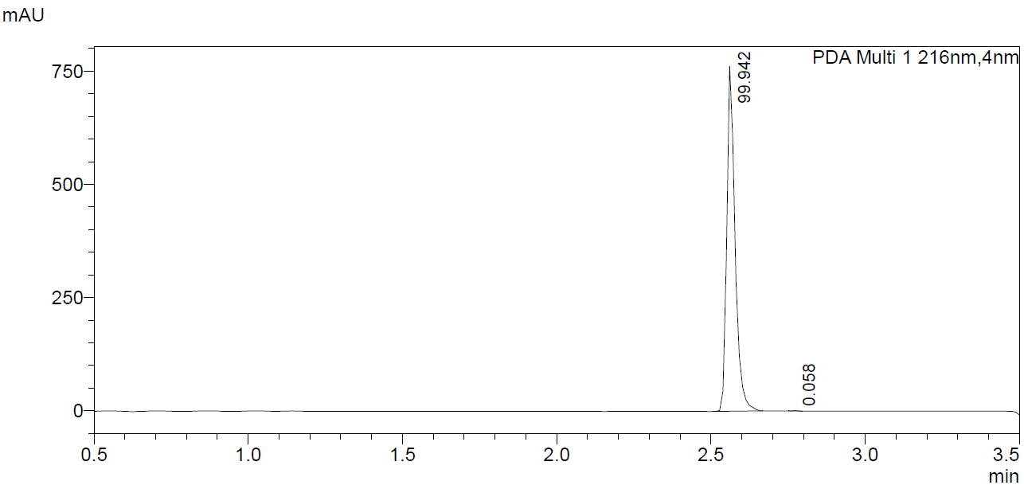

Figure S68. LC-UV chromatogram for methyl (1-(4-fluorobutyl)-1H-indole-3-carbonyl)-L-phenylalaninate (MPP-4F-BUTICA, 35).
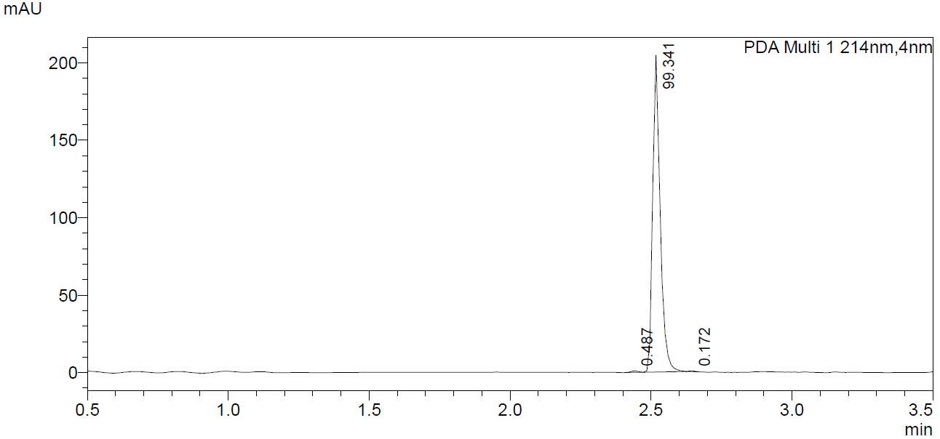

Figure S69. LC-UV chromatogram for methyl (1-(4-fluorobutyl)-1H-indazole-3-carbonyl)-L-valinate (MMB-4F-BUTINACA, 36).
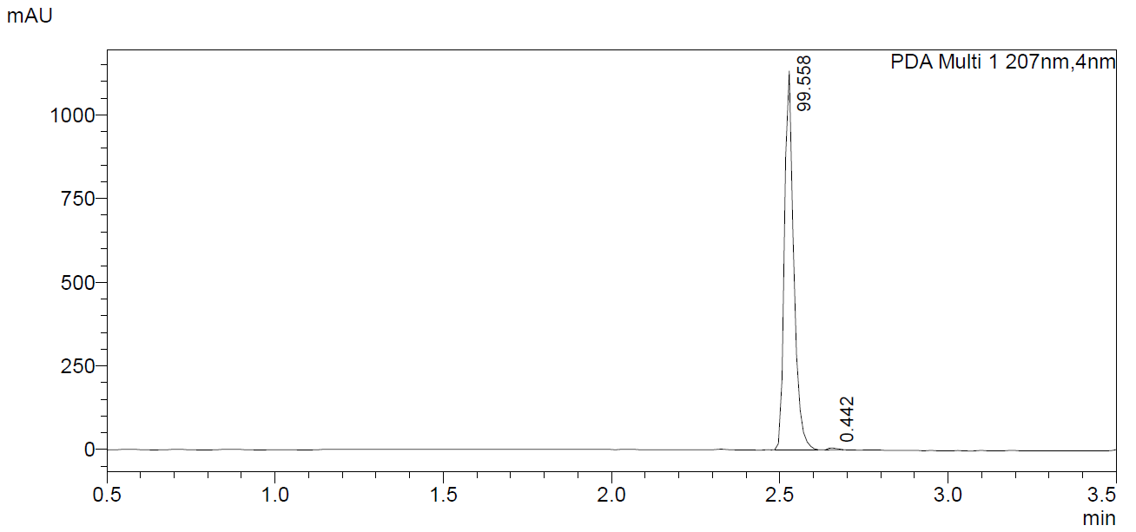

Figure S70. LC-UV chromatogram for methyl (S)-2-(1-(4-fluorobutyl)-1H-indazole-3-carboxamido)-3,3-dimethylbutanoate (MDMB-4F-BUTINACA, 8).
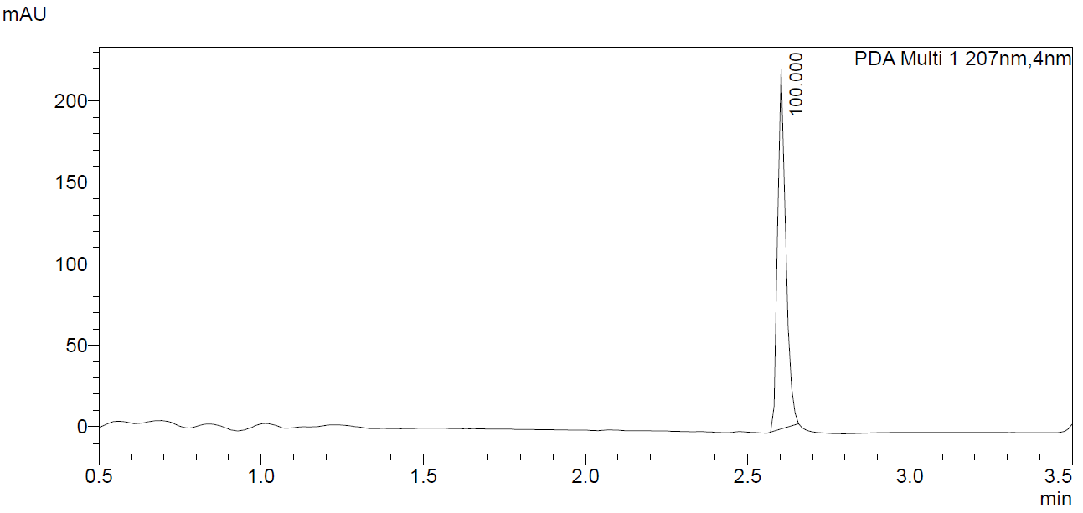

Figure S71. LC-UV chromatogram for methyl (1-(4-fluorobutyl)-1H-indazole-3-carbonyl)-L-phenylalaninate (MPP-4F-BUTINACA, 37).
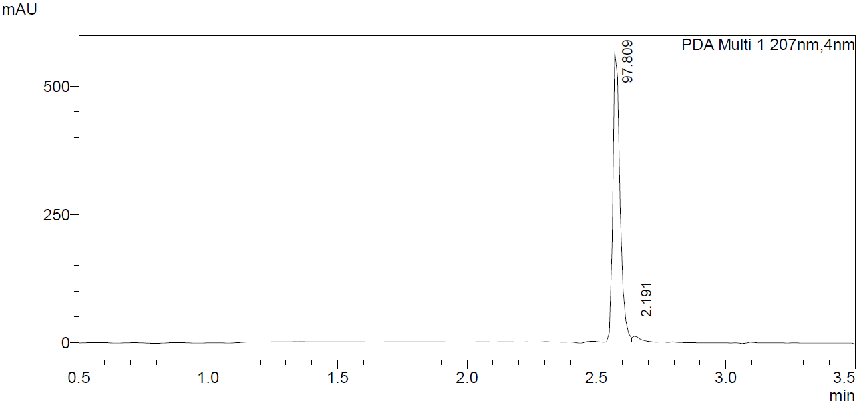

Figure S72. LC-UV chromatogram for methyl (1-(4-fluorobutyl)-1H-pyrrolo[2,3-b]pyridine-3-carbonyl)-L-valinate (MMB-4F-BUT7AICA, 38).
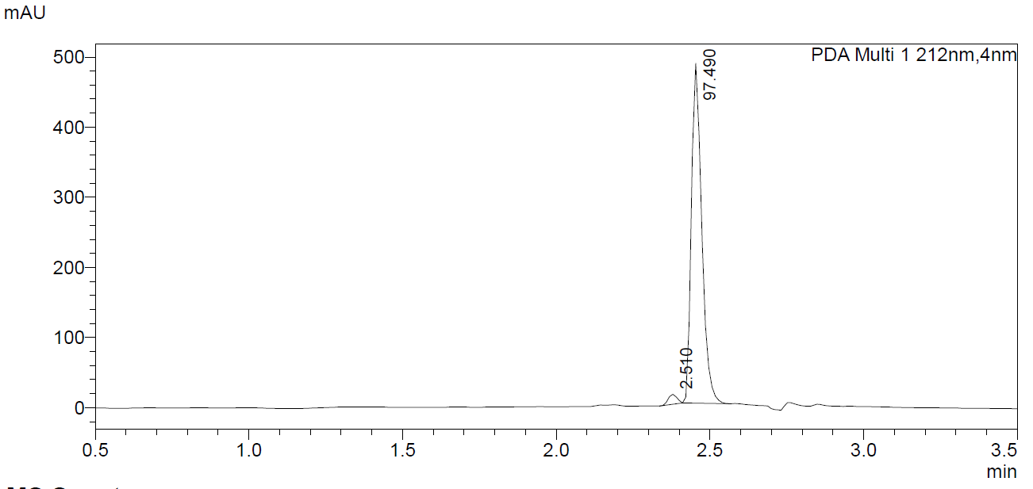

Figure S73. LC-UV chromatogram for methyl (S)-2-(1-(4-fluorobutyl)-1H-pyrrolo[2,3-b]pyridine-3-carboxamido)-3,3-dimethylbutanoate (MDMB-4F-BUT7AICA, 39).
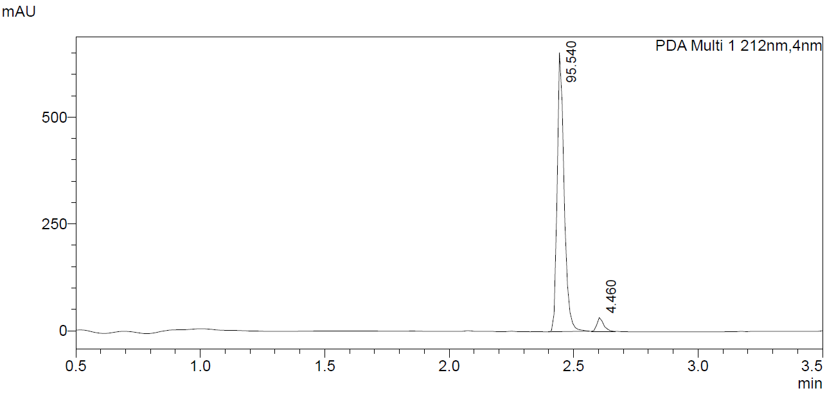

Figure S74. LC-UV chromatogram for methyl (1-(4-fluorobutyl)-1H-pyrrolo[2,3-b]pyridine-3-carbonyl)-L-phenylalaninate (MPP-4F-BUT7AICA, 40).
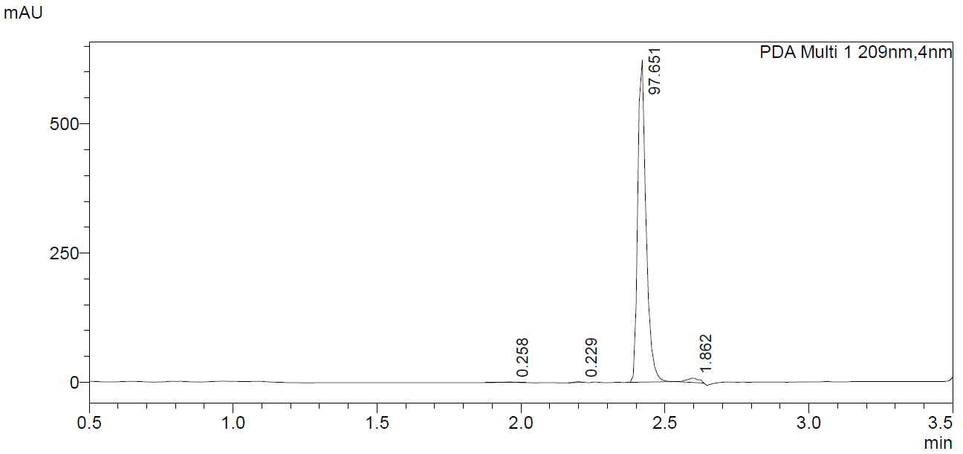

Figure S75. UV spectrum for (S)-N-(1-amino-3-methyl-1-oxobutan-2-yl)-1-(4-cyanobutyl)-1H-indole-3-carboxamide (AB-4CN-BUTICA, 5).
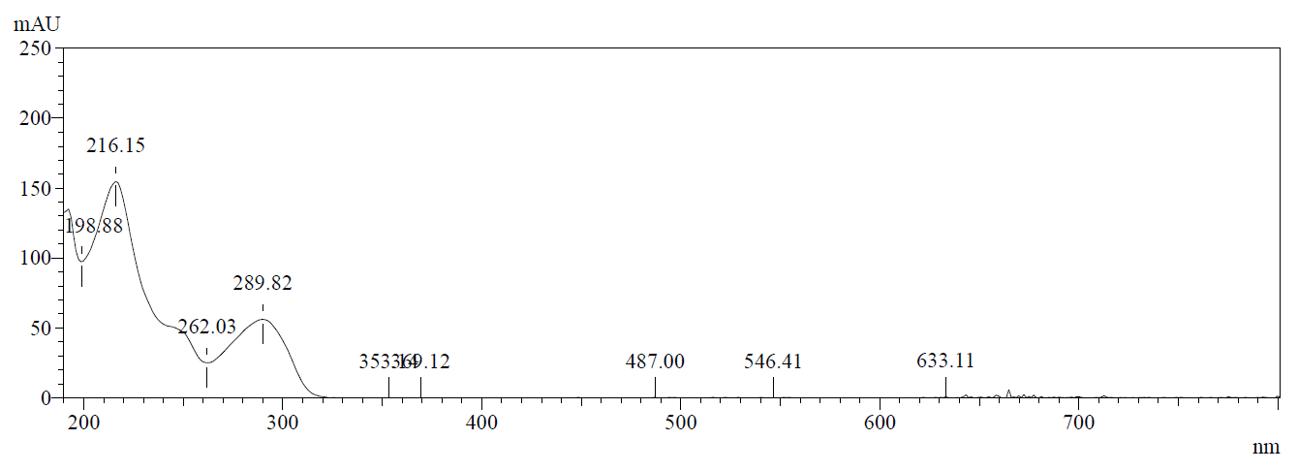

Figure S76. UV spectrum for (S)-N-(1-amino-3,3-dimethyl-1-oxobutan-2-yl)-1-(4-cyanobutyl)-1H-indole-3-carboxamide (ADB-4CN-BUTICA, 9).
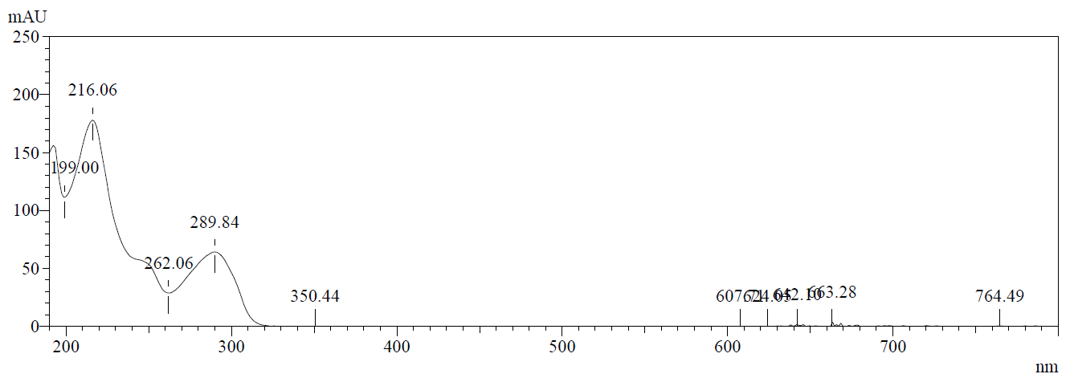

Figure S77. UV spectrum for (S)-N-(1-amino-1-oxo-3-phenylpropan-2-yl)-1-(4-cyanobutyl)-1H-indole-3-carboxamide (APP-4CN-BUTICA, 10).
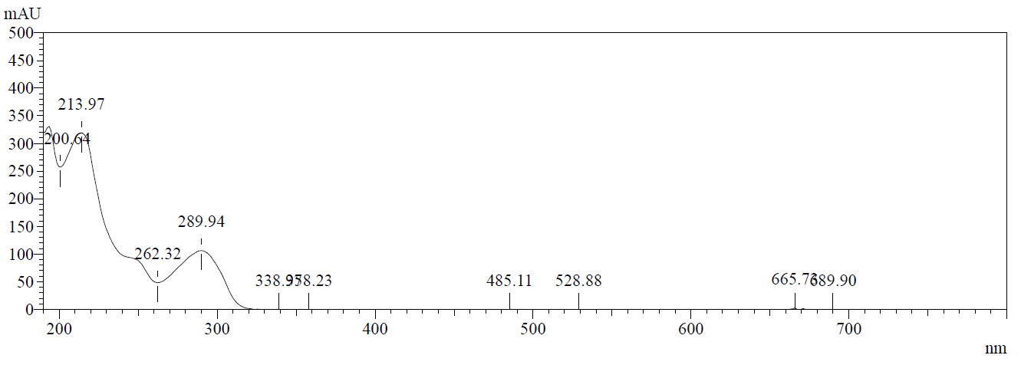

Figure S78. UV spectrum for (S)-N-(1-amino-3,3-dimethyl-1-oxobutan-2-yl)-1-(4-cyanobutyl)-1H-indazole-3-carboxamide (ADB-4CN-BUTINACA, 12).
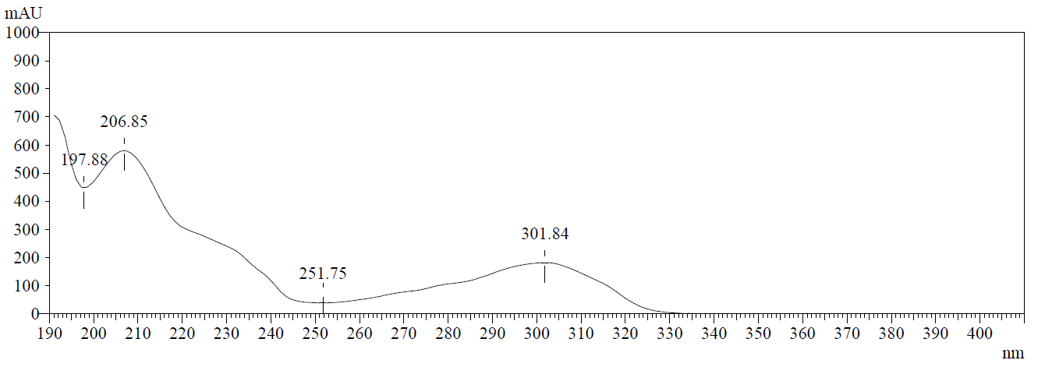

Figure S79. UV spectrum for (S)-N-(1-amino-1-oxo-3-phenylpropan-2-yl)-1-(4-cyanobutyl)-1H-indazole-3-carboxamide (APP-4CN-BUTINACA, 13).
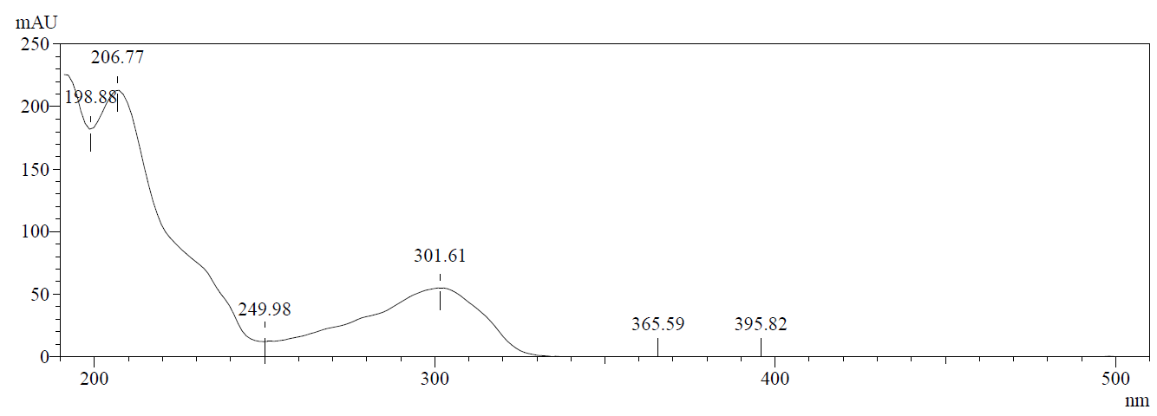

Figure S80. UV spectrum for (S)-N-(1-amino-3-methyl-1-oxobutan-2-yl)-1-(4-cyanobutyl)-1H-pyrrolo[2,3-b]pyridine-3-carboxamide (AB-4CN-BUT7AICA, 14).
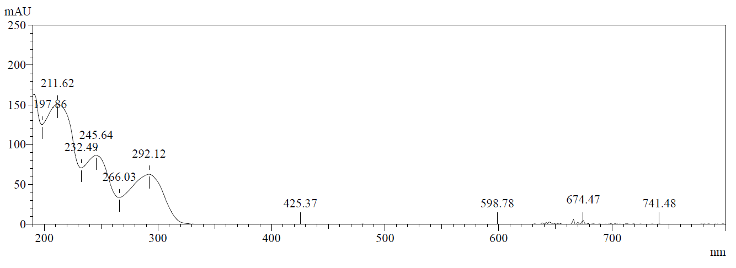

Figure S81. UV spectrum for (S)-N-(1-amino-3,3-dimethyl-1-oxobutan-2-yl)-1-(4-cyanobutyl)-1H-pyrrolo[2,3-b]pyridine-3-carboxamide (ADB-4CN-BUT7AICA, 15).
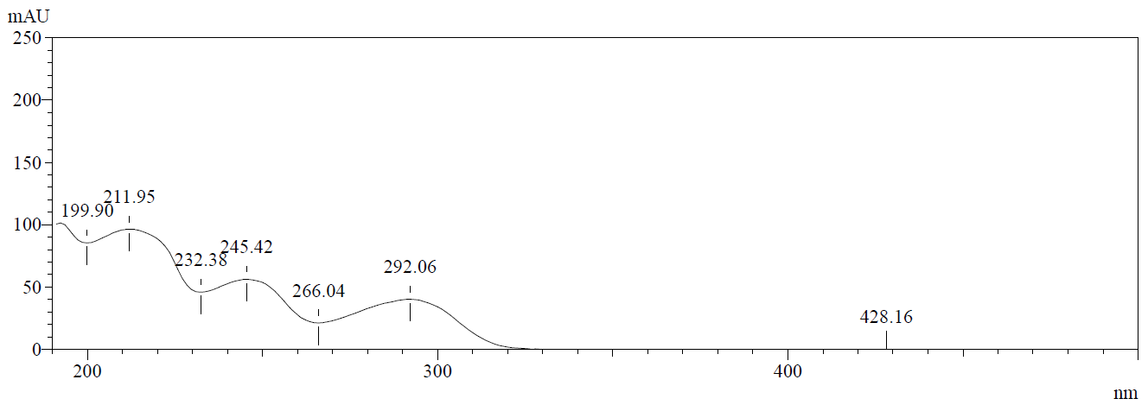

Figure S82. UV spectrum for (S)-N-(1-amino-1-oxo-3-phenylpropan-2-yl)-1-(4-cyanobutyl)-1H-pyrrolo[2,3-b]pyridine-3-carboxamide (APP-4CN-BUT7AICA, 16).
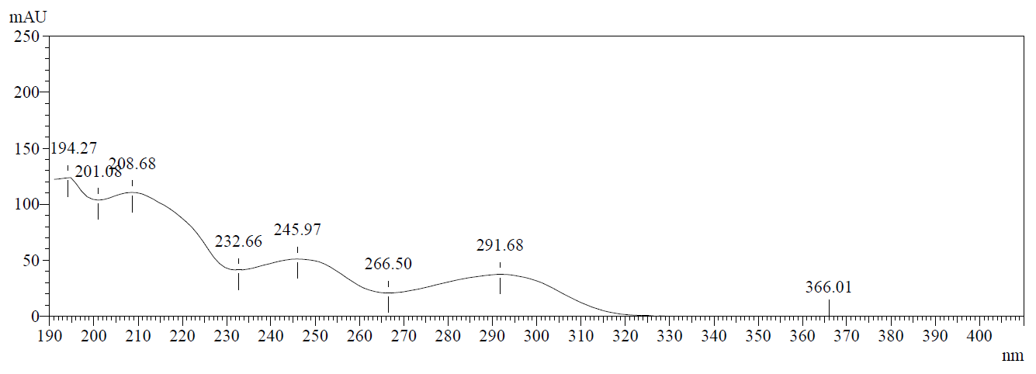

Figure S83. UV spectrum for methyl (S)-2-(1-(4-cyanobutyl)-1H-indole-3-carboxamido)-3,3-dimethylbutanoate (MDMB-4CN-BUTICA, 18).
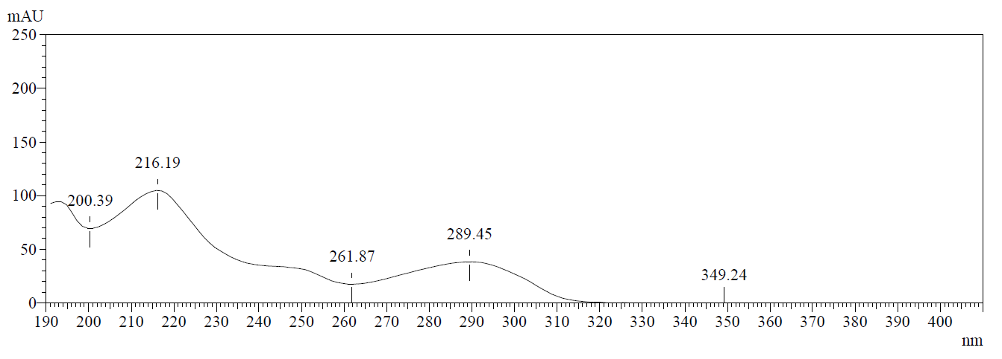

Figure S84. UV spectrum for methyl (1-(4-cyanobutyl)-1H-indole-3-carbonyl)-L-phenylalaninate (MPP-4CN-BUTICA, 19).
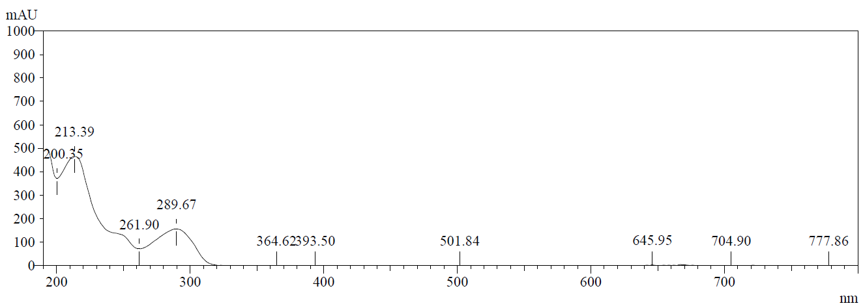

Figure S85. UV spectrum for methyl (S)-2-(1-(4-cyanobutyl)-1H-indazole-3-carboxamido)-3,3-dimethylbutanoate (MDMB-4CN-BUTINACA, 20).
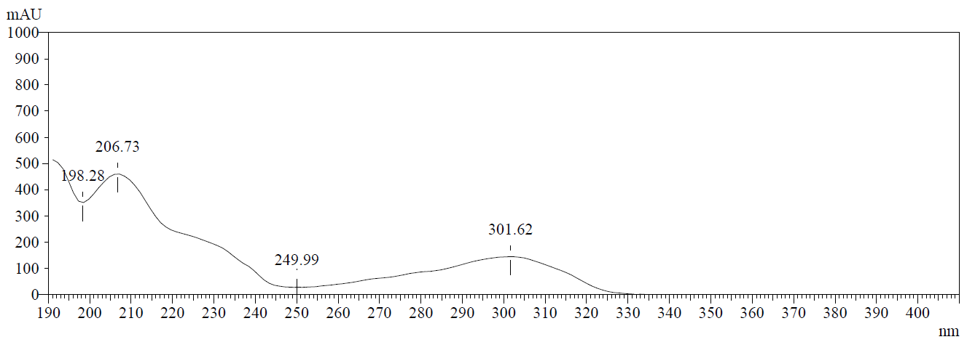

Figure S86. UV spectrum for methyl (1-(4-cyanobutyl)-1H-indazole-3-carbonyl)-L-phenylalaninate (MPP-4CN-BUTINACA, 21).
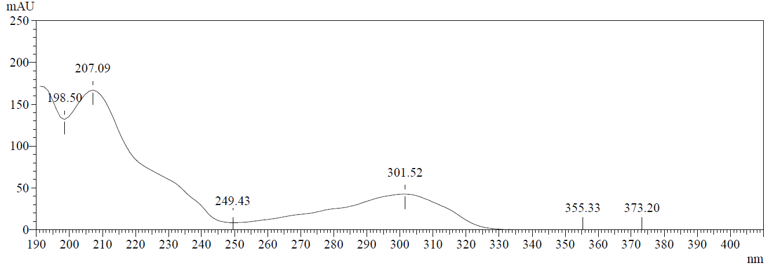

Figure S87. UV spectrum for methyl (S)-2-(1-(4-cyanobutyl)-1H-pyrrolo[2,3-b]pyridine-3-carboxamido)-3,3-dimethylbutanoate (MDMB-4CN-BUT7AICA, 23).
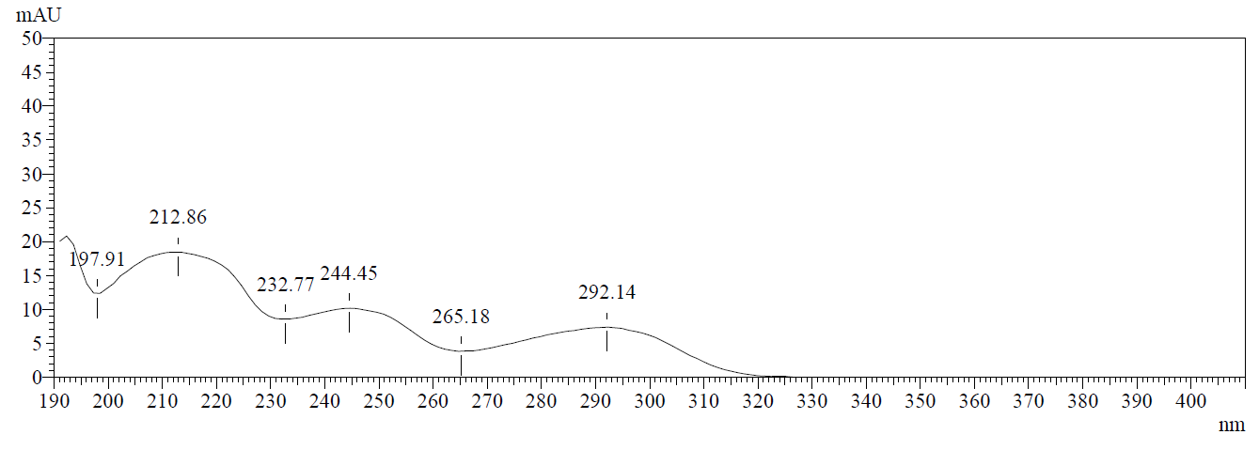

Figure S88. UV spectrum for methyl (1-(4-cyanobutyl)-1H-pyrrolo[2,3-b]pyridine-3-carbonyl)-L-phenylalaninate (MPP-4CN-BUT7AICA, 24).
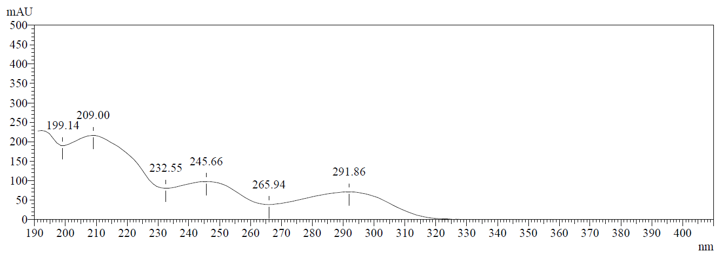

Figure S89. UV spectrum for (S)-N-(1-amino-3-methyl-1-oxobutan-2-yl)-1-(4-fluorobutyl)-1H-indole-3-carboxamide (AB-4F-BUTICA, 25).
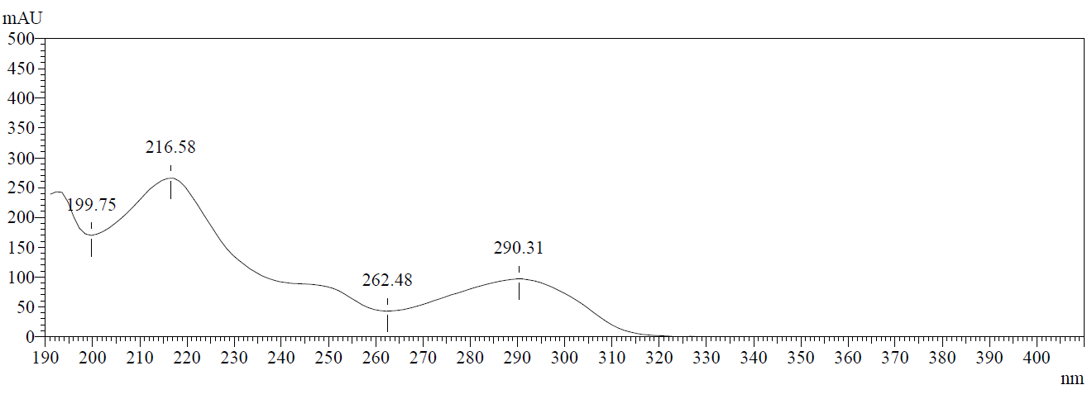

Figure S90. UV spectrum for (S)-N-(1-amino-3,3-dimethyl-1-oxobutan-2-yl)-1-(4-fluorobutyl)-1H-indole-3-carboxamide (ADB-4F-BUTICA, 26).
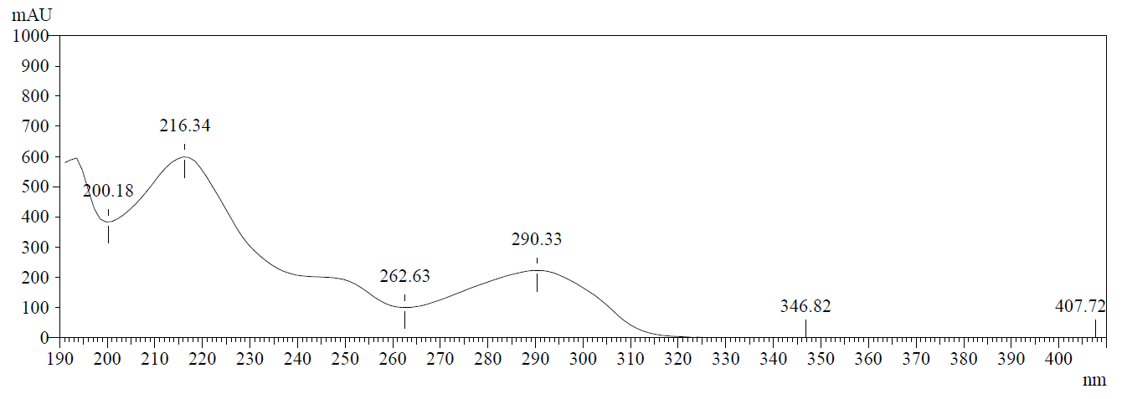

Figure S91. UV spectrum for (S)-N-(1-amino-1-oxo-3-phenylpropan-2-yl)-1-(4-fluorobutyl)-1H-indole-3-carboxamide (APP-4F-BUTICA, 27).
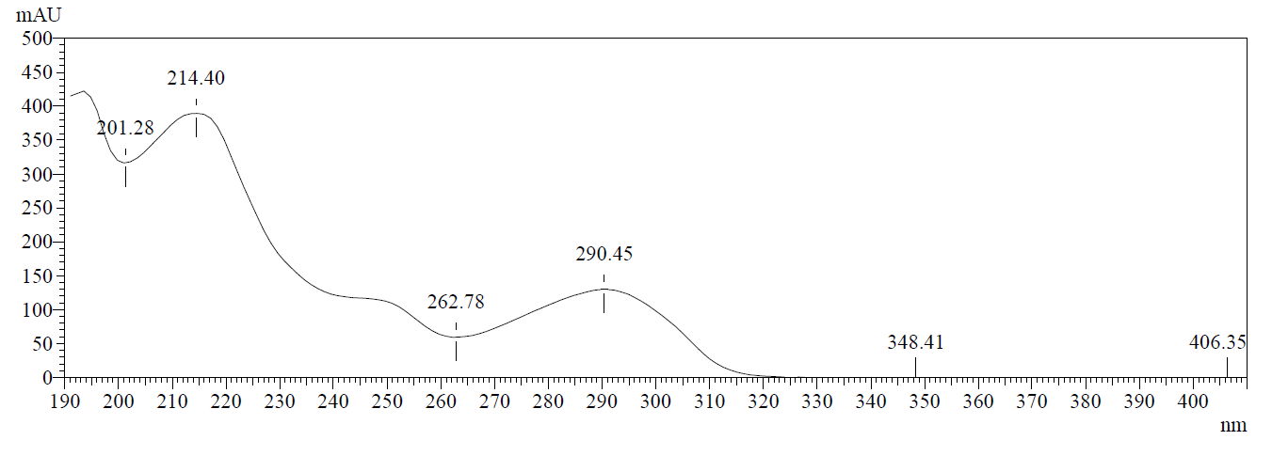

Figure S92. UV spectrum for (S)-N-(1-amino-3-methyl-1-oxobutan-2-yl)-1-(4-fluorobutyl)-1H-indazole-3-carboxamide (AB-4F-BUTINACA, 28).
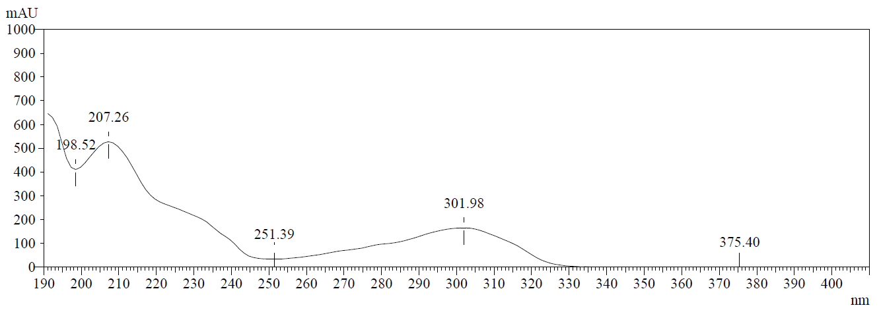

Figure S93. UV spectrum for (S)-N-(1-amino-3,3-dimethyl-1-oxobutan-2-yl)-1-(4-fluorobutyl)-1H-indazole-3-carboxamide (ADB-4F-BUTINACA, 29).
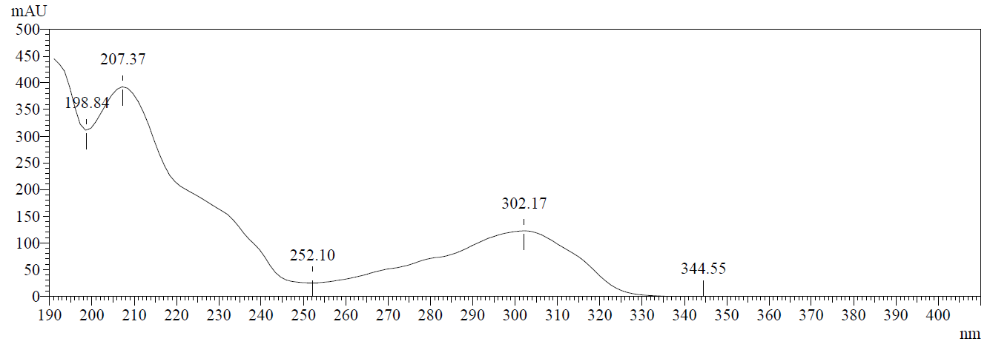

Figure S94. UV spectrum for (S)-N-(1-amino-1-oxo-3-phenylpropan-2-yl)-1-(4-fluorobutyl)-1H-indazole-3-carboxamide (APP-4F-BUTINACA, 30).
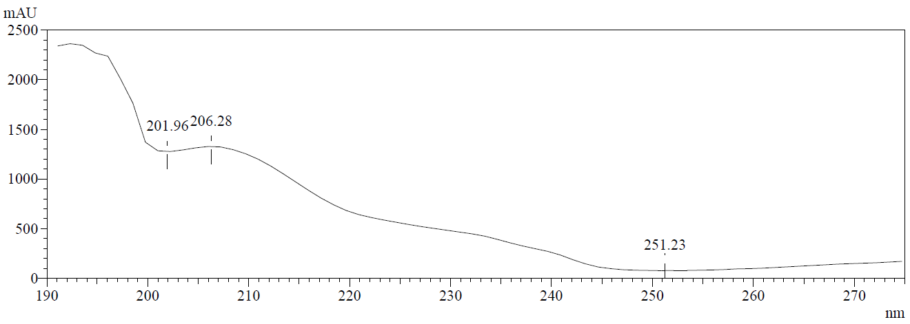

Figure S95. UV spectrum for (S)-N-(1-amino-3-methyl-1-oxobutan-2-yl)-1-(4-fluorobutyl)-1H-pyrrolo[2,3-b]pyridine-3-carboxamide (AB-4F-BUT7AICA, 31).
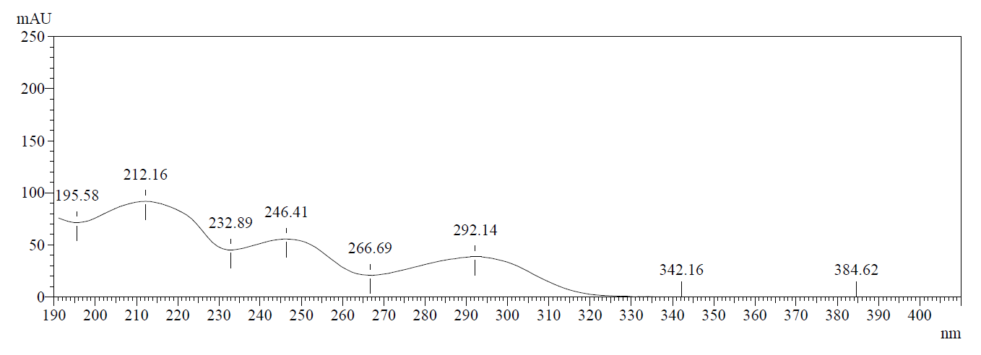

Figure S96. UV spectrum for (S)-N-(1-amino-3,3-dimethyl-1-oxobutan-2-yl)-1-(4-fluorobutyl)-1H-pyrrolo[2,3-b]pyridine-3-carboxamide (ADB-4F-BUT7AICA, 32).
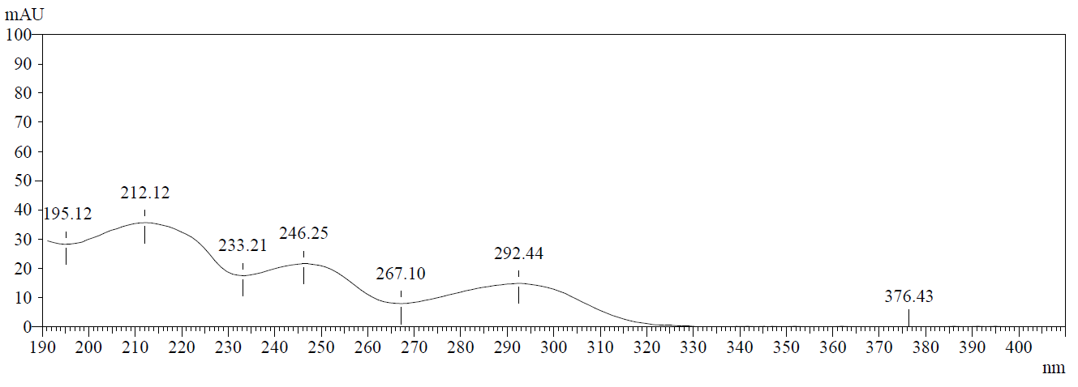

Figure S97. UV spectrum for (S)-N-(1-amino-1-oxo-3-phenylpropan-2-yl)-1-(4-fluorobutyl)-1H-pyrrolo[2,3-b]pyridine-3-carboxamide (APP-4F-BUT7AICA, 33).
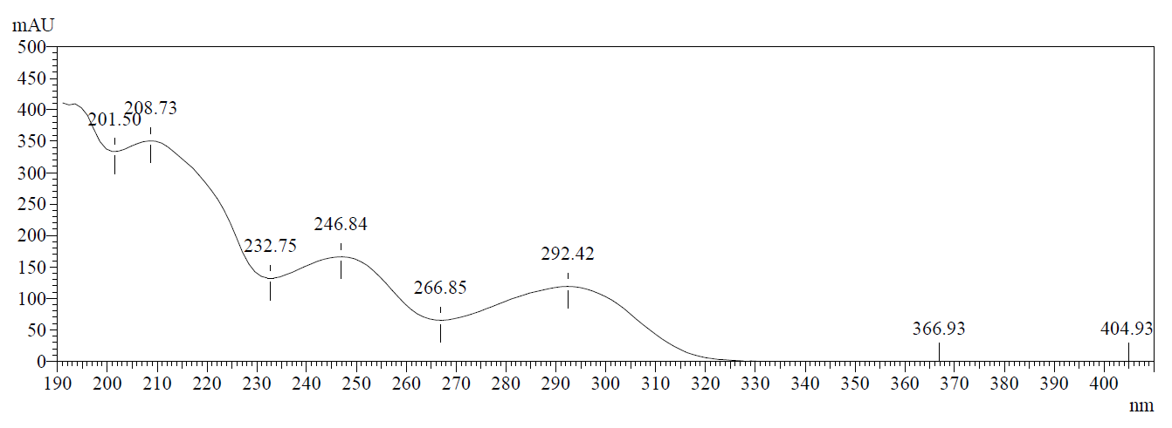

Figure S98. UV spectrum for methyl (1-(4-fluorobutyl)-1H-indole-3-carbonyl)-L-valinate (MMB-4F-BUTICA, 34).
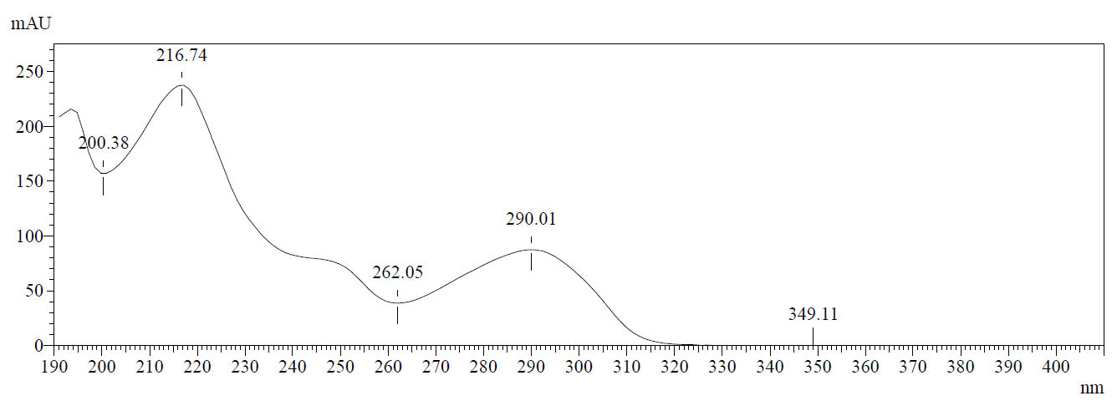

Figure S99. UV spectrum for methyl (1-(4-fluorobutyl)-1H-indole-3-carbonyl)-L-phenylalaninate (MPP-4F-BUTICA, 35).
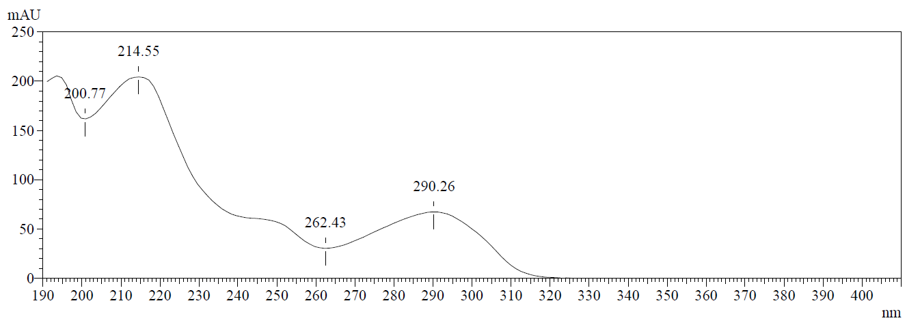

Figure S100. UV spectrum for methyl (1-(4-fluorobutyl)-1H-indazole-3-carbonyl)-L-valinate (MMB-4F-BUTINACA, 36).
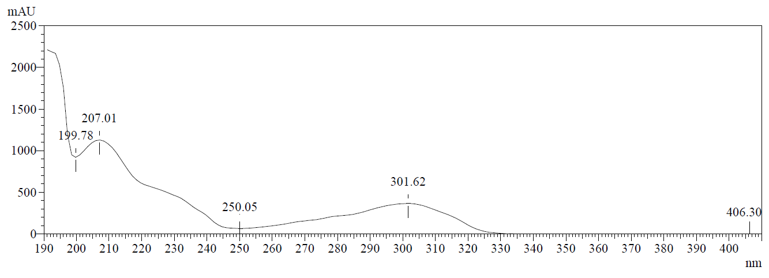

Figure S101. UV spectrum for methyl (1-(4-fluorobutyl)-1H-indazole-3-carbonyl)-L-phenylalaninate (MPP-4F-BUTINACA, 37).
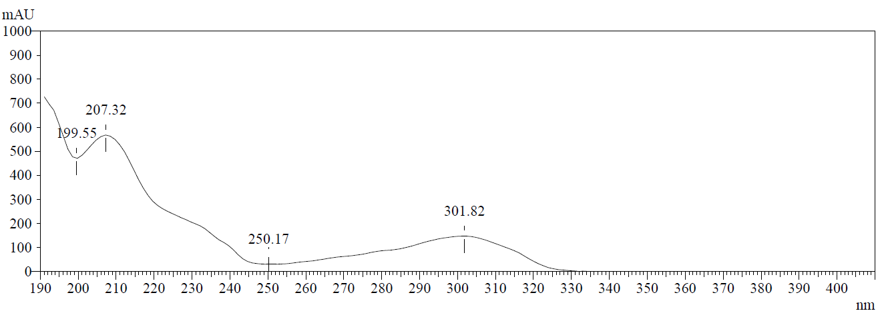

Figure S102. UV spectrum for methyl (1-(4-fluorobutyl)-1H-pyrrolo[2,3-b]pyridine-3-carbonyl)-L-valinate (MMB-4F-BUT7AICA, 38).
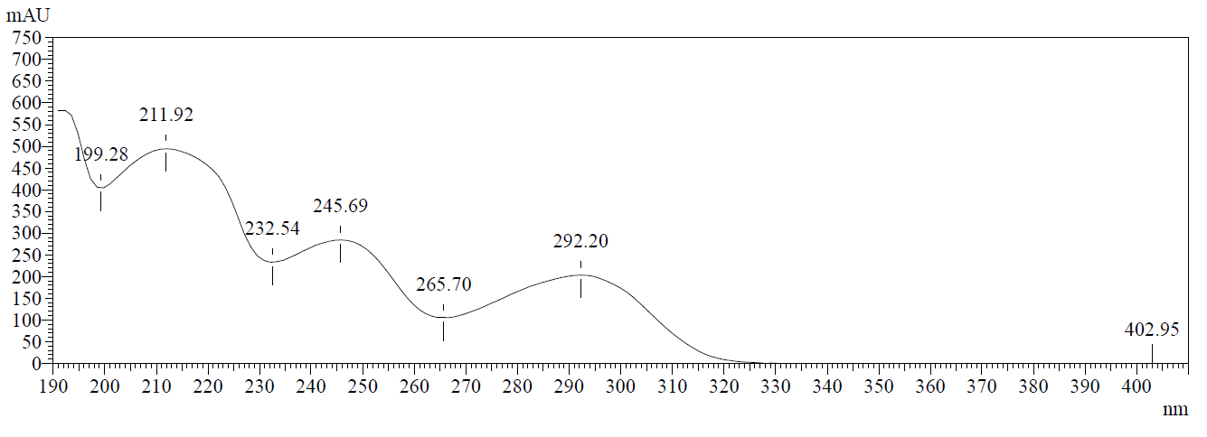

Figure S103. UV spectrum for methyl (S)-2-(1-(4-fluorobutyl)-1H-pyrrolo[2,3-b]pyridine-3-carboxamido)-3,3-dimethylbutanoate (MDMB-4F-BUT7AICA, 39).
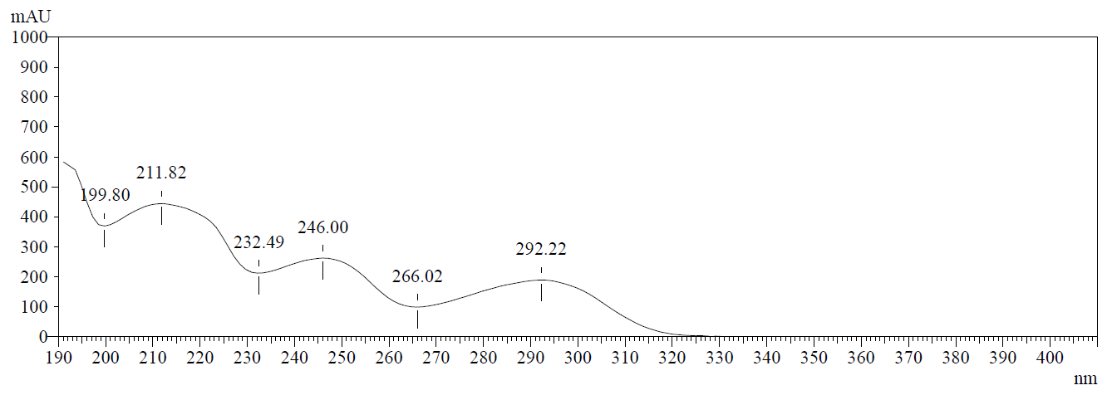

Figure S104. UV spectrum for methyl (1-(4-fluorobutyl)-1H-pyrrolo[2,3-b]pyridine-3-carbonyl)-L-phenylalaninate (MPP-4F-BUT7AICA, 40).
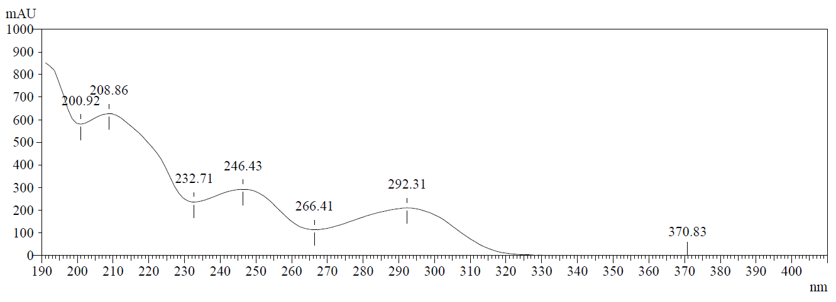

Table T Strain energy calculations of compounds 5-40

Compound | Core | Head | Tail | CB₁ Strain  (kcal/mol) | ∆_{strain} | CB₂ Strain  (kcal/mol) | ∆_{strain}
14 | 7aza | AB | 4CN | 1.608 | 0.108 | 2.513 | 1.273
31 | 7aza | AB | 4F | 1.500 | 0.108 | 1.240 | 1.273
15 | 7aza | ADB | 4CN | 6.131 | -1.282 | 4.039 | 1.422
32 | 7aza | ADB | 4F | 7.413 | -1.282 | 2.617 | 1.422
22 | 7aza | MMB | 4CN | 1.275 | -0.217 | 1.334 | 1.319
38 | 7aza | MMB | 4F | 1.492 | -0.217 | 0.015 | 1.319
16 | 7aza | APP | 4CN | 3.767 | -0.455 | 6.604 | 0.965
33 | 7aza | APP | 4F | 4.222 | -0.455 | 5.639 | 0.965
23 | 7aza | MDMB | 4CN | 1.360 | 0.136 | 2.678 | 1.201
39 | 7aza | MDMB | 4F | 1.224 | 0.136 | 1.477 | 1.201
24 | 7aza | MPP | 4CN | 12.845 | 5.784 | 12.152 | 3.319
40 | 7aza | MPP | 4F | 7.061 | 5.784 | 8.833 | 3.319
11 | Indazole | AB | 4CN | 1.943 | -1.382 | 0.334 | 0.165
28 | Indazole | AB | 4F | 3.325 | -1.382 | 0.169 | 0.165
12 | Indazole | ADB | 4CN | 8.485 | -0.208 | 6.454 | 3.427
29 | Indazole | ADB | 4F | 8.693 | -0.208 | 3.027 | 3.427
6 | Indazole | MMB | 4CN | 0.012 | -1.283 | 3.975 | 3.800
36 | Indazole | MMB | 4F | 1.295 | -1.283 | 0.175 | 3.800
13 | Indazole | APP | 4CN | 1.711 | 0.073 | 8.010 | 1.275
30 | Indazole | APP | 4F | 1.638 | 0.073 | 6.735 | 1.275
20 | Indazole | MDMB | 4CN | 0.571 | -0.252 | 1.777 | 0.858
8 | Indazole | MDMB | 4F | 0.823 | -0.252 | 0.919 | 0.858
21 | Indazole | MPP | 4CN | 1.145 | -0.641 | 15.514 | 7.820
37 | Indazole | MPP | 4F | 1.786 | -0.641 | 7.694 | 7.820
5 | Indole | AB | 4CN | 1.986 | 0.254 | 3.960 | 1.656
25 | Indole | AB | 4F | 1.732 | 0.254 | 2.304 | 1.656
9 | Indole | ADB | 4CN | 5.880 | 0.220 | 5.667 | 5.657
26 | Indole | ADB | 4F | 5.660 | 0.220 | 0.010 | 5.657
17 | Indole | MMB | 4CN | 0.571 | -0.358 | 1.627 | 1.595
34 | Indole | MMB | 4F | 0.929 | -0.358 | 0.032 | 1.595
10 | Indole | APP | 4CN | 3.531 | 0.207 | 13.244 | 2.927
27 | Indole | APP | 4F | 3.324 | 0.207 | 10.317 | 2.927
18 | Indole | MDMB | 4CN | 1.684 | 0.102 | 3.808 | 2.303
7 | Indole | MDMB | 4F | 1.582 | 0.102 | 1.505 | 2.303
19 | Indole | MPP | 4CN | 4.042 | 3.157 | 12.615 | 4.952
35 | Indole | MPP | 4F | 0.885 | 3.157 | 7.663 | 4.952

Calculated binding poses
Representational computationally predicted binding modes of 4CN (orange) and 4F (green) overlayed at the CB₁ (PDB:6N4B) and CB₂ (PDB:6PT0) receptors. The hydrophobic regions of the binding site (grey) were evaluated with SiteMap. Glide docking performed using the Schrodinger computational chemistry suite.

Figure S105. Computationally predicted binding modes of 11 (orange) and 28 (green) overlayed at the CB₁ (PDB:6N4B) receptor.

Figure S106. Computationally predicted binding modes of 13 (orange) and 30 (green) overlayed at the CB₁ (PDB:6N4B) receptor.

Figure S107. Computationally predicted binding modes of 9 (orange) and 26 (green) overlayed at the CB₁ (PDB:6N4B) receptor.

Figure S108. Computationally predicted binding modes of 15 (orange) and 32 (green) overlayed at the CB₁ (PDB:6N4B) receptor.

Figure S109. Computationally predicted binding modes of 23 (orange) and 39 (green) overlayed at the CB₁ (PDB:6N4B) receptor.

Figure S110. Computationally predicted binding modes of 18 (orange) and 7 (green) overlayed at the CB₁ (PDB:6N4B) receptor.

Figure S111. Computationally predicted binding modes of 11 (orange) and 28 (green) overlayed at the CB₂ (PDB:6PT0) receptor.

Figure S112. Computationally predicted binding modes of 13 (orange) and 30 (green) overlayed at the CB₂ (PDB:6PT0) receptor.

Figure S113. Computationally predicted binding modes of 9 (orange) and 26 (green) overlayed at the CB₂ (PDB:6PT0) receptor.

Figure S114. Computationally predicted binding modes of 15 (orange) and 32 (green) overlayed at the CB₂ (PDB:6PT0) receptor.

Figure S115. Computationally predicted binding modes of 23 (orange) and 39 (green) overlayed at the CB₂ (PDB:6PT0) receptor.

Figure S116. Computationally predicted binding modes of 18 (orange) and 7 (green) overlayed at the CB₂ (PDB:6PT0) receptor.

