Supplementary Table 1 Characteristics of studies included
Author | Study year¹ | Country | Design | Setting | Participant | Sampling | Risk of bias | Suspected cases (n) | Case fatality rate (%)
Breman et al. [1] | 1970 | Liberia | Cross-sectional | Community | General population | Non-probabilistic | L | 4 | 0,0
Breman et al. [1] | 1971 | Nigeria | Cross-sectional | Community | General population | Non-probabilistic | L | 2 | 0,0
Breman et al. [1] | 1979 | Democratic Republic of Congo | Cross-sectional | Community | General population | Non-probabilistic | L | 38 | 21,1
Arita et al. [2] | 1983 | Multinational | Cross-sectional | Community | General population | Non-probabilistic | L | 155 | 11,0
Durski et al. [3] | 1984 | Central African Republic | Cross-sectional | Community | General population | Non-probabilistic | M | 6 | 0,0
Jezek et al. [4] | 1985 | Democratic Republic of Congo | Cross-sectional | Community | General population | Non-probabilistic | L | 282 | 9,6
Jezek et al. [4] | 1986 | Democratic Republic of Congo | Cross-sectional | Community | General population | Non-probabilistic | L | 276 | 2,2
Durski et al. [3] | 1987 | Gabon | Cross-sectional | Community | General population | Non-probabilistic | M | 9 | 22,2
Mwamba et al. [5] | 1997 | Democratic Republic of Congo | Cross-sectional | Community | General population | Non-probabilistic | L | 92 | 3,3
Hutin et al. [6] | 1997 | Democratic Republic of Congo | Cross-sectional | Community | General population | Non-probabilistic | Low | 88 | 0.0
Aplogan et al. [7] | 1997 | Democratic Republic of Congo | Cross-sectional | Community | General population | Non-probabilistic | Low | 419 | 0.0
Durski et al. [3] | 2003 | Congo | Cross-sectional | Community | General population | Non-probabilistic | Moderate | 12 | 21.1
Boumandouki et al. [8] | 2003 | Congo | Case series | Hospital | General population | Non-probabilistic | Low | 8 | 11.0
Formenty et al. [9] | 2005 | Sudan | Cross-sectional | Community | General population | Non-probabilistic | Low | 19 | 0.0
Damon et al. [10] | 2005 | Sudan | Case report | Community | General population | Non-probabilistic | Low | 2 | 9.6
Durski et al. [3] | 2010 | Central African Republic | Cross-sectional | Community | General population | Non-probabilistic | Moderate | 2 | 2.2
Berthet et al. [11] | 2010 | Central African Republic | Case report | Community | General population | Non-probabilistic | Low | 2 | 22.2
Reynolds et al. [12] | 2010 | Congo | Case series | Community | General population | Non-probabilistic | Low | 11 | 3.3
Pittman et al. [13] | 2011 | Democratic Republic of Congo | Cross-sectional | Hospital | General population | Non-probabilistic | Moderate | 222 | 3.4
Durski et al. [3] | 2015 | Central African Republic | Cross-sectional | Community | General population | Non-probabilistic | Moderate | 12 | 1.2
Kalthan et al. [14] | 2015 | Central African Republic | Cross-sectional | Community | General population | Non-probabilistic | Low | 12 | 8.3
Kalthan et al. [15] | 2016 | Central African Republic | Cross-sectional | Community | General population | Non-probabilistic | Low | 26 | 12.5
Nakoune et al. [16] | 2016 | Central African Republic | Cross-sectional | Community | General population and HCWs | Non-probabilistic | Moderate | 15 | 0.0
Durski et al. [3] | 2017 | Central African Republic | Cross-sectional | Community | General population | Non-probabilistic | Moderate | 2 | 0.0
Durski et al. [3] | 2017 | Central African Republic | Cross-sectional | Community | General population | Non-probabilistic | Moderate | 6 | 0.0
Doshi et al. [17] | 2017 | Congo | Case series | Community | General population | Non-probabilistic | Moderate | 88 | 100.0
Durski et al. [3] | 2017 | Liberia | Cross-sectional | Community | General population | Non-probabilistic | Moderate | 2 | 9.1
Ogoina et al. [18] | 2017 | Nigeria | Cross-sectional | Hospital | General population | Non-probabilistic | Low | 38 | 1.4
Ita et al. [19] | 2017 | Nigeria | Cross-sectional | Hospital | General population | Non-probabilistic | Low | 15 | 25.0
Ibegu et al. [20] | 2017 | Nigeria | Cross-sectional | Hospital | General population | Non-probabilistic | Moderate | 30 | 25.0
Reynolds et al. [21] | 2017 | Sierra Leone | Cross-sectional | Community | General population | Non-probabilistic | Low | 2 | 3.8
Vaughan et al. [22] | 2018 | Nigeria | Case report | Hospital | General population | Non-probabilistic | Low | 2 | 13.3
Yinka-ogunleye et al. [23] | 2018 | Nigeria | Cross-sectional | Community | General population | Non-probabilistic | Low | 276 | 0.0
Ogoina et al. [18] | 2018 | Nigeria | Cross-sectional | Hospital | General population | Non-probabilistic | Low | 51 | 0.0
Echekwube et al. [24] | 2018 | Nigeria | Case series | Hospital | General population | Non-probabilistic | Low | 4 | 6.8
Ngbolua et al. [25] | 2019 | Democratic Republic of Congo | Cross-sectional | Hospital | General population | Non-probabilistic | High | 3 | 0.0
Ogoina et al. [26] | 2019 | Nigeria | Cross-sectional | Hospital | General population | Non-probabilistic | Low | 21 | 0.0
Hobson et al. [27] | 2021 | Nigeria | Case report | Hospital | General population | Non-probabilistic | Low | 3 | 0.0
Amao et al. [28] | 2021 | Nigeria | Cross-sectional | Community | General population | Non-probabilistic | Low | 25 | 0.0
Djuicy et al. [29] | 2022 | Cameroon | Cross-sectional | Community and hospital | General population | Non-probabilistic | Low | 137 | 0.0
Besombes et al. [30] | 2022 | Central African Republic | Cross-sectional | Community | General population | Non-probabilistic | Low | 11 | 0.0
Yadouleton et al. [31] | 2022 | Benin | Case series | Community | General population | Non-probabilistic | Low | 12 | 2.5
Kibungu et al. [32] | 2023 | Democratic Republic of Congo | Case series | Community | General population | Non-probabilistic | Low | 5 | 9.8
Nizigiyimana et al. [33] | 2024 | Burundi | Cross-sectional | Community | General population | Non-probabilistic | Low | 607 | 0.0
Brosius et al. [34] | 2024 | Democratic Republic of Congo | Cohort study | Hospital | General population | Non-probabilistic | Moderate | 511 | 0.0
Mukadi-Bamuleka et al. [35] | 2024 | Democratic Republic of Congo | Cross-sectional | Community | General population | Non-probabilistic | Low | 9 | 0.0
Vakaniaki et al. [36] | 2024 | Democratic Republic of Congo | Cross-sectional | Community | General population | Non-probabilistic | Low | 241 | 0.0
1: Last year that the study was conducted;

Study period
Event rate (%)

Case fatality rate (%)
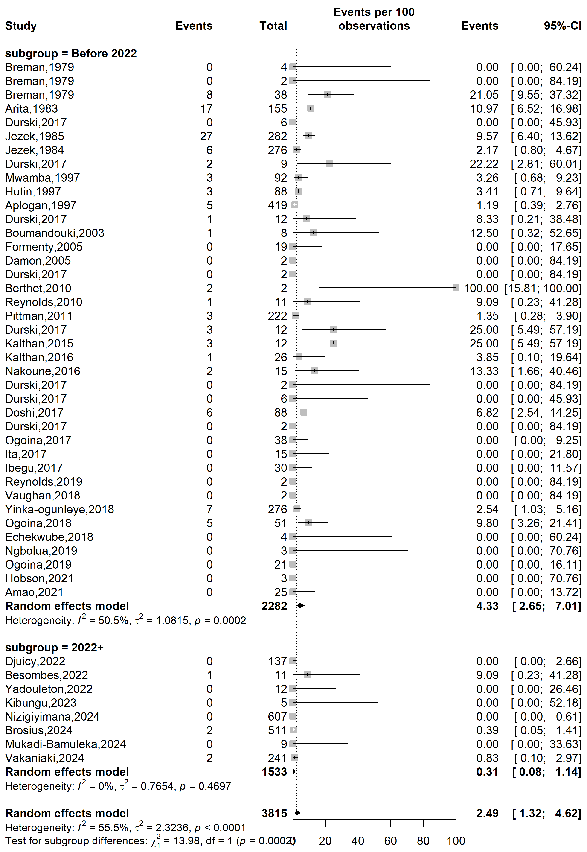
Supplementary Fig. 1 Case fatality rate among suspected mpox case in Africa by study periods

Country
Event rate (%)

Case fatality rate (%)
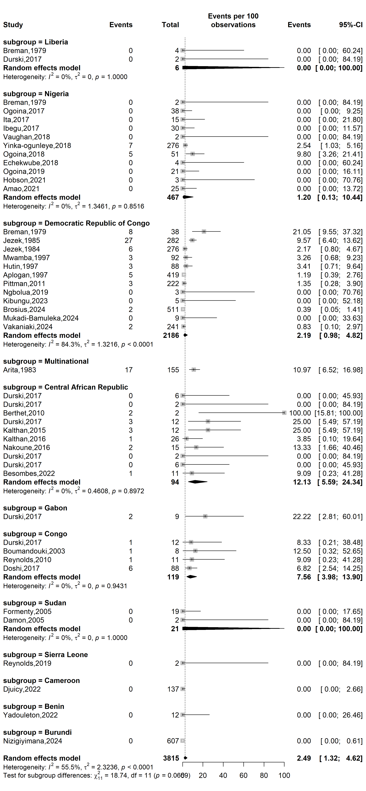
Supplementary Fig. 2 Case fatality rate among suspected mpox case across African countries

Study setting
Event rate (%)

Case fatality rate (%)
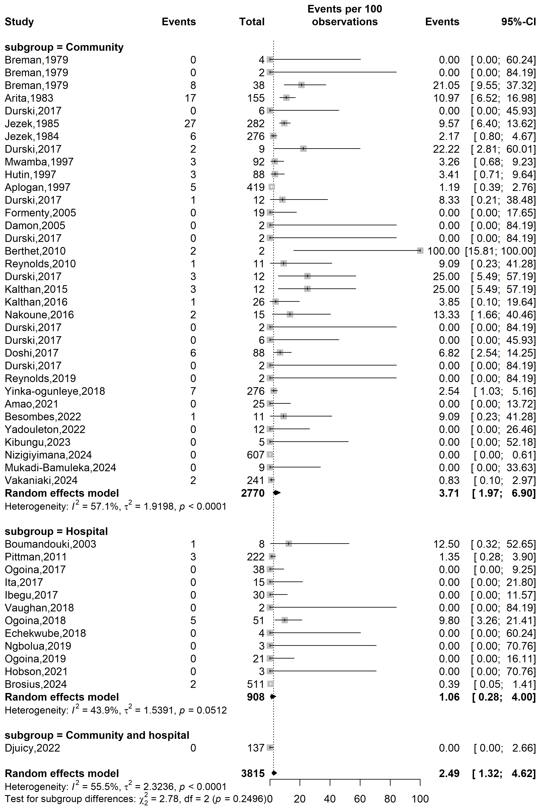
Supplementary Fig. 3 Case fatality rate among suspected mpox case in Africa by study setting

Study design
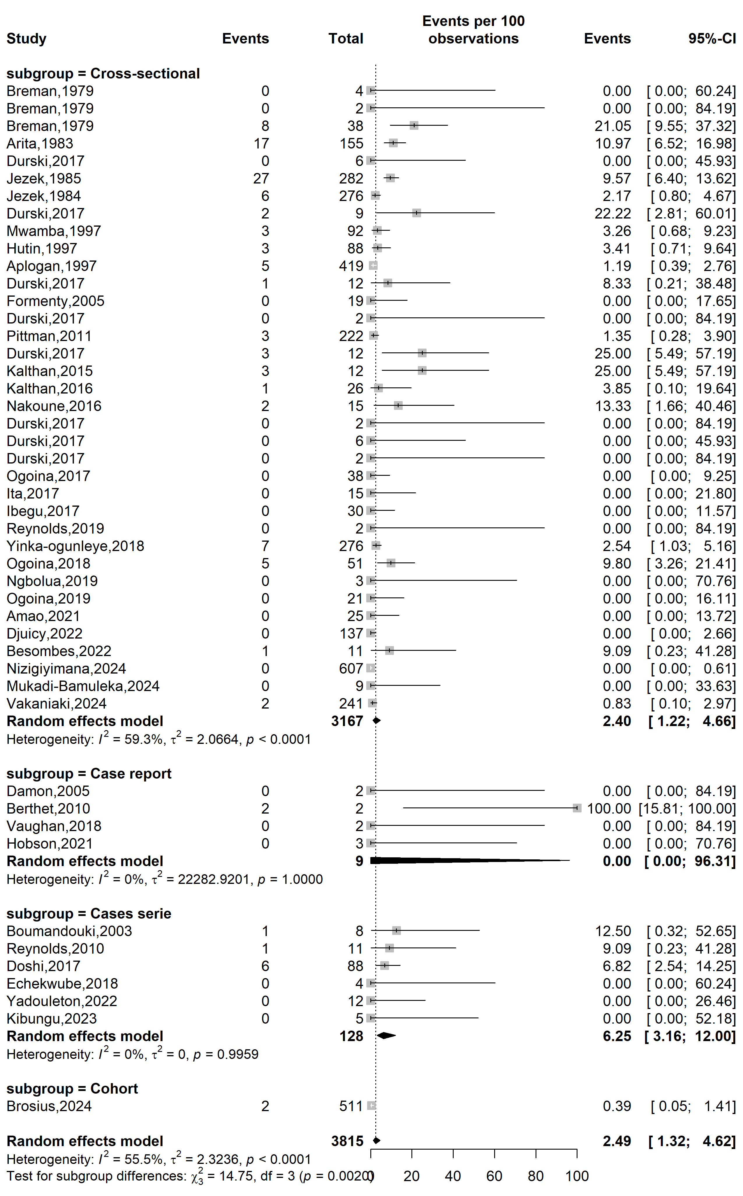
Case fatality rate (%)
Event rate (%)

Supplementary Fig. 4 Case fatality rate among suspected mpox case across African countries
Setting

WHO Afro region
Case fatality rate (%)
Event rate (%)

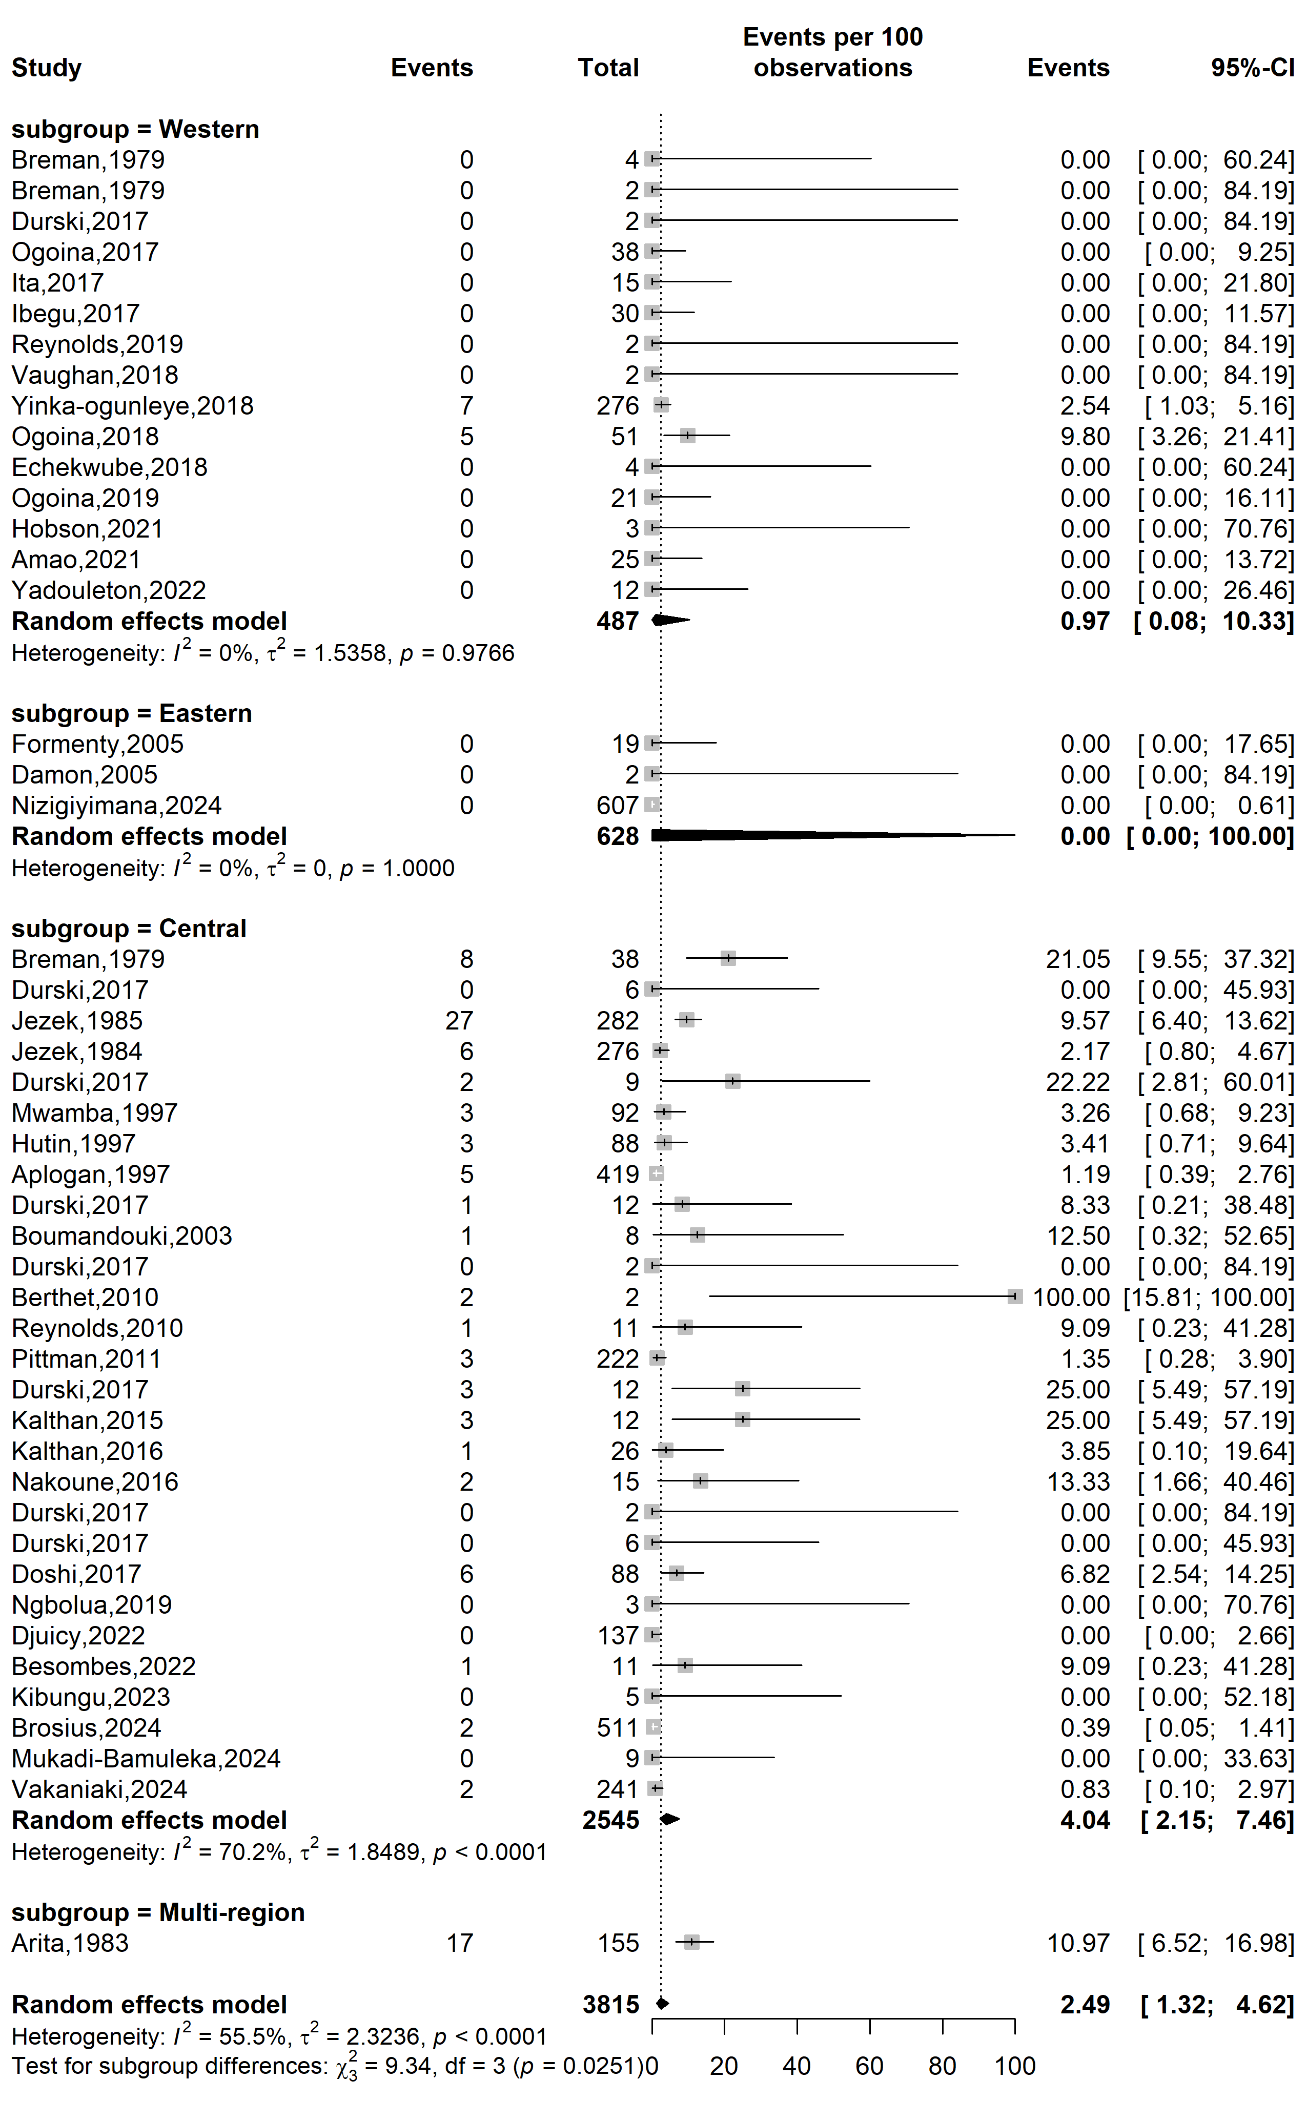
Supplementary Fig. 5 Case fatality rate among suspected mpox case WHO Afro regions
Publication bias analysis
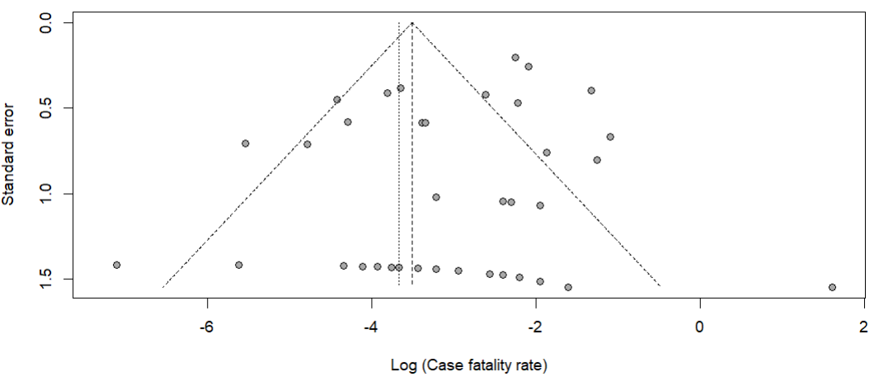
Egger’s test p-value = 0.472
Begg’s test p-value = 0.019

Supplementary Fig. 6 Funnel plot displaying the pseudo 95% confidence limits and tests assessing the publication bias of studies included

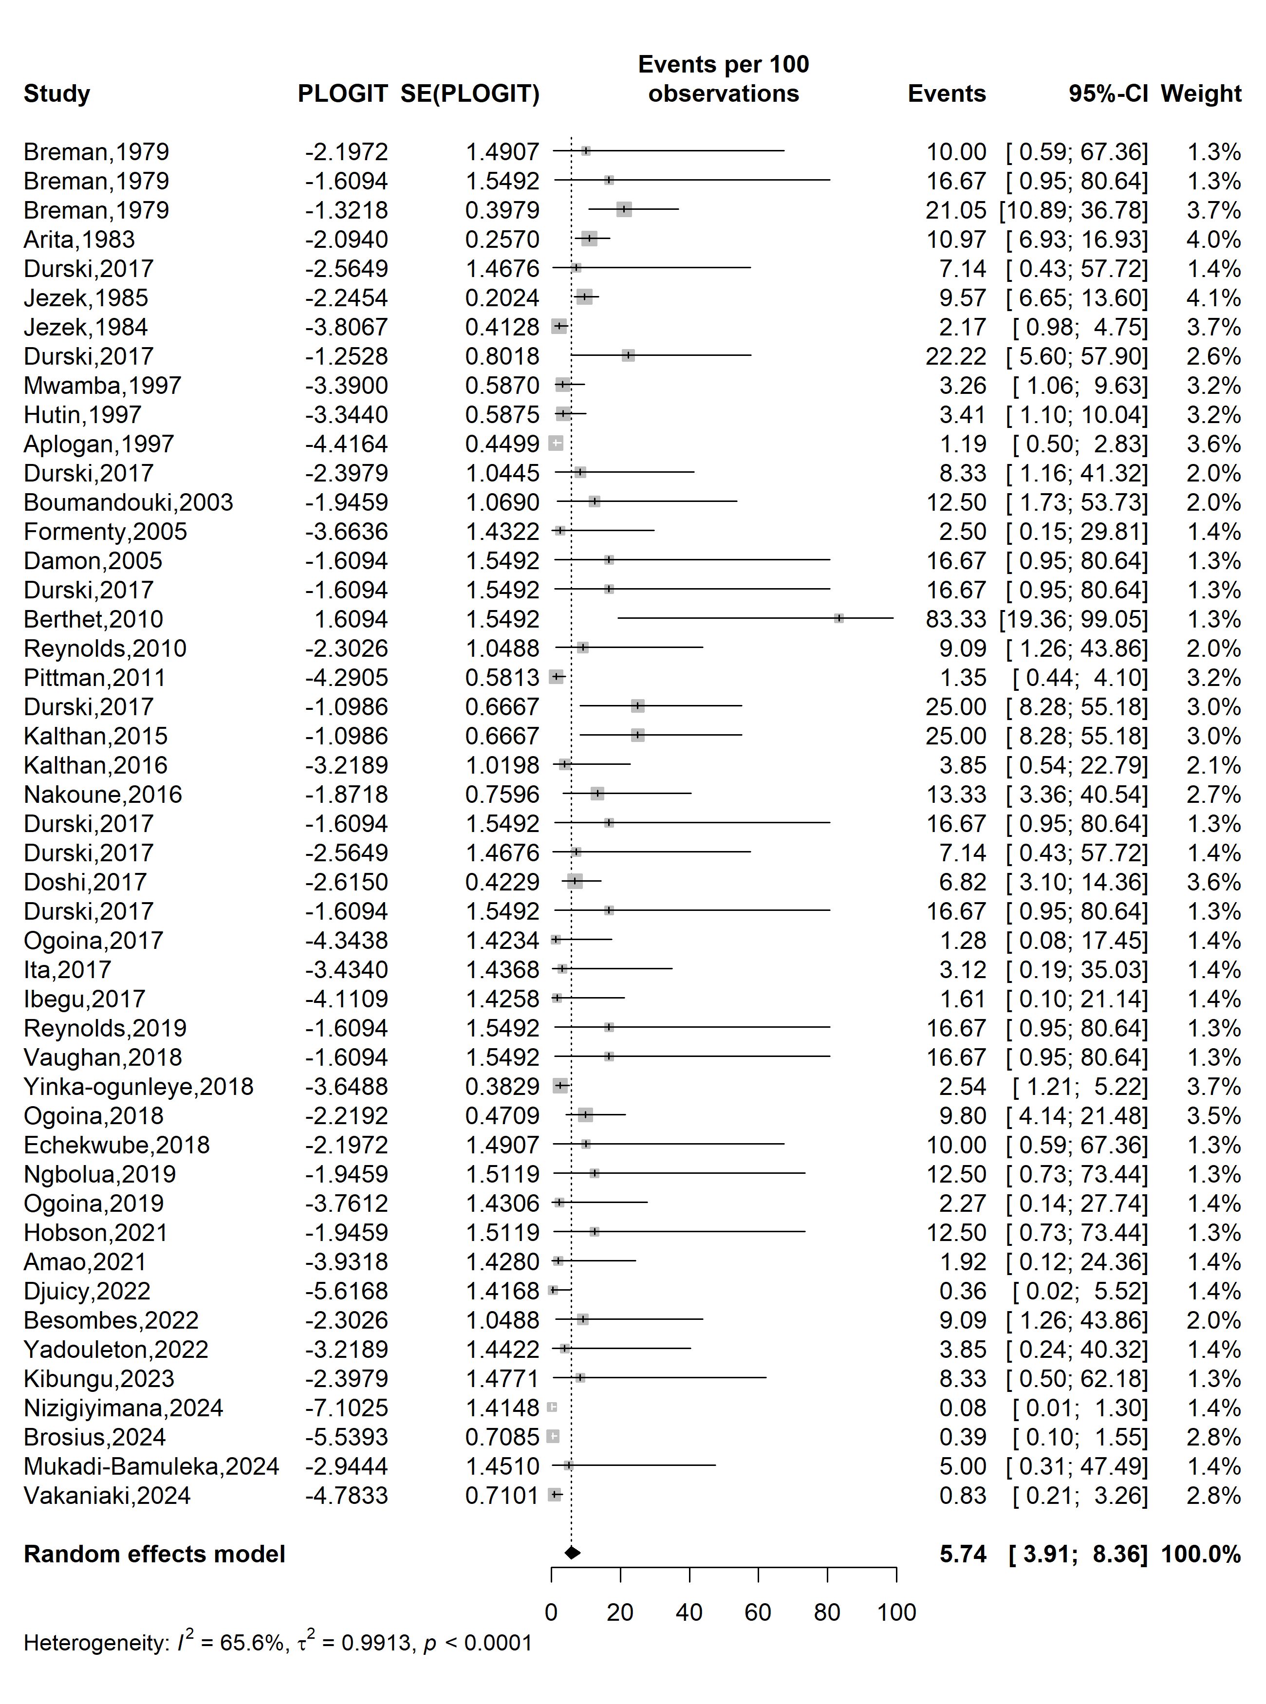
Event rate (%)

Case fatality rate (%)
Supplementary Fig. 7 Trim and fill analysis of included studies

Sensitivity analysis
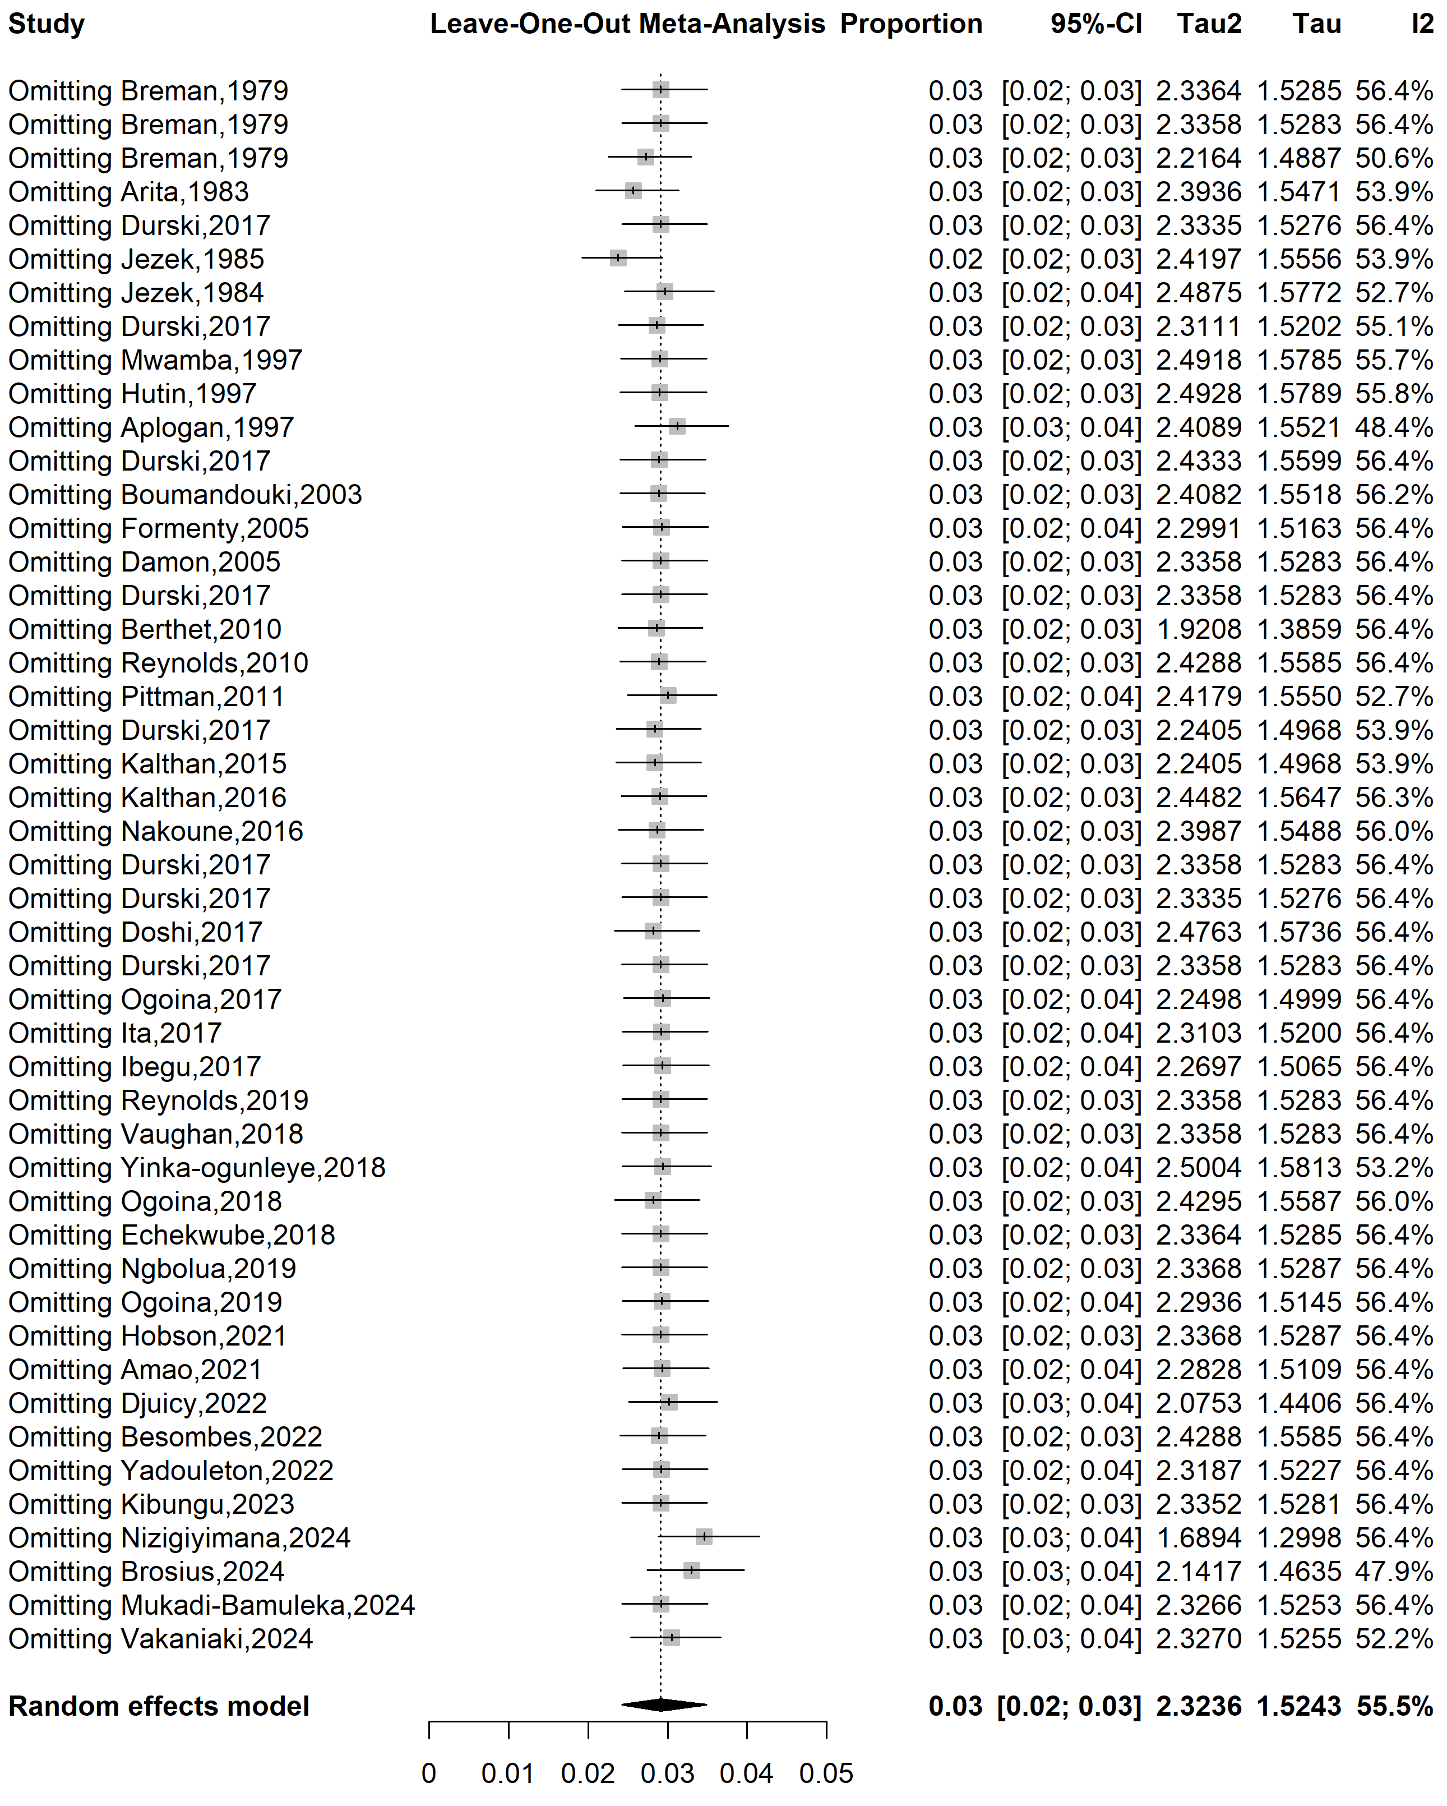
Supplementary Fig. 8 Sensitivity analysis of the case fatality rate among suspected mpox cases in Africa

References
1. Breman JG, Kalisa-Ruti, Steniowski MV, Zanotto E, Gromyko AI, Arita I. Human monkeypox, 1970-79. Bull World Health Organ. 1980;58(2):165–82.
2. Arita I, Jezek Z, Khodakevich L, Ruti K. Human monkeypox: a newly emerged orthopoxvirus zoonosis in the tropical rain forests of Africa. Am J Trop Med Hyg. 1985;34(4):781–9.
3. Durski KN. Emergence of Monkeypox — West and Central Africa, 1970–2017. MMWR Morb Mortal Wkly Rep [Internet]. 2018 [cited 2025 Jun 29];67. Available from: https://www.cdc.gov/mmwr/volumes/67/wr/mm6710a5.htm
4. Jezek Z, Marennikova SS, Mutumbo M, Nakano JH, Paluku KM, Szczeniowski M. Human Monkeypox: A Study of 2,510 Contacts of 214 Patients. J Infect Dis. 1986;154(4):551–5.
5. Mwanba PT, Tshioko KF, Moudi A, Mukinda V, Mwema GN, Messinger D, et al. Human monkeypox in Kasaï Oriental, Zaire (1996-1997). Eurosurveillance. 1997;2(5):33–5.
6. Hutin YJF, Williams RJ, Malfait P, Pebody R, Loparev VN, Ropp SL, et al. Outbreak of Human Monkeypox, Democratic Republic of Congo, 1996 to 1997. Emerg Infect Dis. 2001;7(3):434–8.
7. Aplogan A, Mangindula V, Muamba P, Mwema G, Okito L, Pebody R, et al. Human monkeypox -- Kasai Oriental, Democratic Republic of Congo, February 1996-October 1997. MMWR Morb Mortal Wkly Rep. 1997;46(49):1168–71.
8. Boumandouki P, Bileckot R, Ibara JR, Satounkazi C, Wassa Wassa D, Libama E, et al. [Simian smallpox (or monkey smallpox): study of 8 cases observed at Impfondo Hospital in Republic of Congo]. Bull Soc Pathol Exot 1990. 2007;100(1):17–21.
9. Formenty P, Muntasir MO, Damon I, Chowdhary V, Opoka ML, Monimart C, et al. Human Monkeypox Outbreak Caused by Novel Virus Belonging to Congo Basin Clade, Sudan, 2005. Emerg Infect Dis. 2010;16(10):1539–45.
10. Damon IK, Roth CE, Chowdhary V. Discovery of Monkeypox in Sudan. N Engl J Med. 2006;355(9):962–3.
11. Berthet N, Nakouné E, Whist E, Selekon B, Burguière AM, Manuguerra JC, et al. Maculopapular lesions in the Central African Republic. The Lancet. 2011;378(9799):1354.
12. Reynolds MG, Emerson GL, Pukuta E, Karhemere S, Muyembe JJ, Bikindou A, et al. Detection of human monkeypox in the Republic of the Congo following intensive community education. Am J Trop Med Hyg. 2013;88(5):982.
13. Pittman PR, Martin JW, Kingebeni PM, Tamfum JJM, Mwema G, Wan Q, et al. Clinical characterization and placental pathology of mpox infection in hospitalized patients in the Democratic Republic of the Congo. Bowman N, editor. PLoS Negl Trop Dis. 2023;17(4):e0010384.
14. Kalthan E, Dondo-Fongbia JP, Yambele S, Dieu-Creer LR, Zepio R, Pamatika CM. Epidémie de 12 cas de maladie à virus monkeypox dans le district de Bangassou en République Centrafricaine en décembre 2015. Bull Société Pathol Exot. 2016;109(5):358–63.
15. Kalthan E, Tenguere J, Ndjapou SG, Koyazengbe TA, Mbomba J, Marada RM, et al. Investigation of an outbreak of monkeypox in an area occupied by armed groups, Central African Republic. Médecine Mal Infect. 2018;48(4):263–8.
16. Nakoune E, Lampaert E, Ndjapou SG, Janssens C, Zuniga I, Van Herp M, et al. A Nosocomial Outbreak of Human Monkeypox in the Central African Republic. Open Forum Infect Dis. 2017;4(4):ofx168.
17. Doshi RH, Guagliardo SAJ, Dzabatou-Babeaux A, Likouayoulou C, Ndakala N, Moses C, et al. Strengthening of Surveillance during Monkeypox Outbreak, Republic of the Congo, 2017. Emerg Infect Dis. 2018;24(6):1158–60.
18. Ogoina D, Izibewule JH, Ogunleye A, Ederiane E, Anebonam U, Neni A, et al. The 2017 human monkeypox outbreak in Nigeria—Report of outbreak experience and response in the Niger Delta University Teaching Hospital, Bayelsa State, Nigeria. PLOS ONE. 2019;14(4):e0214229.
19. Ita OI, Amuzi C, Udo U, Uwa A. Descriptive epidemiology of monkeypox outbreak in Akwa Ibom State, Nigeria—5th October to 7th November 2017. East Afr Sch J Med Sci. 2019;2(5):224–7.
20. Ibegu M, Numbere TW, Balogun M, Nguku P. Descriptive epidemiology of Monkeypox outbreak in Bayelsa State South-South Nigeria, November 2017. Int J Infect Dis. 2020;101:255.
21. Reynolds MG, Wauquier N, Li Y, Satheshkumar PS, Kanneh LD, Monroe B, et al. Human Monkeypox in Sierra Leone after 44-Year Absence of Reported Cases. Emerg Infect Dis. 2019;25(5):1023–5.
22. Vaughan A, Aarons E, Astbury J, Balasegaram S, Beadsworth M, Beck CR, et al. Two cases of monkeypox imported to the United Kingdom, September 2018. Eurosurveillance. 2018;23(38):1800509.
23. Yinka-Ogunleye A, O A, M D, D O, A M, Y D, et al. Outbreak of human monkeypox in Nigeria in 2017-18: a clinical and epidemiological report. Lancet Infect Dis [Internet]. 2019 Aug [cited 2025 Jul 9];19(8). Available from: https://pubmed.ncbi.nlm.nih.gov/31285143/
24. Echekwube PO, Mbaave PT, Abidakun OA, Utoo BT, Swende TZ. Human monkeypox and human immunodeficiency virus co-infection: a case series in Makurdi, Benue State, Nigeria. J Biomed Res Clin Pract. 2020;3(2):375–81.
25. Ngbolua K te N, Guy Kumbali Ngambika, Blaise Mbembo-wa-Mbembo, Kohowe Pagerezo Séraphin, Kogana Kapalata Fabrice, Gédéon Ngiala Bongo, et al. First Report on Three Cases of Monkey pox in Nord Ubangi Province (Democratic Republic of the Congo). Br Int Exact Sci BIoEx J. 2020;2(1):120–5.
26. Ogoina D, Iroezindu M, James HI, Oladokun R, Yinka-Ogunleye A, Wakama P, et al. Clinical Course and Outcome of Human Monkeypox in Nigeria. Clin Infect Dis. 2020;71(8):e210–4.
27. Hobson G, Adamson J, Adler H, Firth R, Gould S, Houlihan C, et al. Family cluster of three cases of monkeypox imported from Nigeria to the United Kingdom, May 2021. Eurosurveillance. 2021;26(32):2100745.
28. Amao LK, Olatunji DI, Igbodo G, Okoli SC, Amaechi I, Goni MI, et al. Trend and enhanced surveillance of Monkeypox during COVID-19 pandemic in Nigeria. J Public Health Afr. 2022;13(1):2184.
29. Djuicy DD, Sadeuh-Mba SA, Bilounga CN, Yonga MG, Tchatchueng-Mbougua JB, Essima GD, et al. Concurrent Clade I and Clade II Monkeypox Virus Circulation, Cameroon, 1979–2022. Emerg Infect Dis. 2024;30(3):433–43.
30. Besombes C, Mbrenga F, Malaka C, Gonofio E, Schaeffer L, Konamna X, et al. Investigation of a mpox outbreak in Central African Republic, 2021-2022. One Health. 2023;16:100523.
31. Yadouleton A, Faye M, Tchibozo C, Oke M, Faye O, Lawale T, et al. Introduction of monkeypox virus in Benin, 2022. Mil Med Res. 2022 Nov 9;9(1):63.
32. Kibungu EM, Vakaniaki EH, Kinganda-Lusamaki E, Kalonji-Mukendi T, Pukuta E, Hoff NA, et al. Clade I–Associated Mpox Cases Associated with Sexual Contact, the Democratic Republic of the Congo. Emerg Infect Dis. 2024;30(1):172–6.
33. Nizigiyimana A, Ndikumwenayo F, Houben S, Manirakiza M, Lettow M van, Liesenborghs L, et al. Epidemiological analysis of confirmed mpox cases, Burundi, 3 July to 9 September 2024. Eurosurveillance. 2024;29(42):2400647.
34. Brosius I, Vakaniaki EH, Mukari G, Munganga P, Tshomba JC, Vos ED, et al. Epidemiological and clinical features of mpox during the clade Ib outbreak in South Kivu, Democratic Republic of the Congo: a prospective cohort study. The Lancet. 2025;405(10478):547–59.
35. Mukadi-Bamuleka D, Kinganda-Lusamaki E, Mulopo-Mukanya N, Amuri-Aziza A, O’Toole Á, Modadra-Madakpa B, et al. First imported Cases of MPXV Clade Ib in Goma, Democratic Republic of the Congo: Implications for Global Surveillance and Transmission Dynamics [Internet]. medRxiv; 2024 [cited 2025 Feb 24]. Available from: http://medrxiv.org/lookup/doi/10.1101/2024.09.12.24313188
36. Vakaniaki EH, Kacita C, Kinganda-Lusamaki E, O’Toole Á, Wawina-Bokalanga T, Mukadi-Bamuleka D, et al. Sustained human outbreak of a new MPXV clade I lineage in eastern Democratic Republic of the Congo. Nat Med. 2024;30(10):2791–5.

