Supplementary materials

Table S1 Timeline of COVID-19 pandemic alert levels in Taiwan
Timeline | Alert levels
Until 2020-01-20 | No restrictions (Pre-pandemic)
2020-01-21 to 2021-05-10 | Level-1 ª
2021-05-11 to 2021-05-18 | Level-2 ^{b}
2021-05-19 to 2021-07-26 | Level-3 ^{c}
2021-07-27 to 2021-12-13 | Level-2
ª Sporadic community infections caused by overseas immigration (basic control measures, such as social distancing).
^{b} Local cases of infection with unknown origins (moderate level of restrictions, such as banning outdoor gatherings of 500 or more people, or indoor gatherings of 100 or more people).
^{c} More than ten local cases of infection with unknown origins in a day (stringent restrictions, such as banning outdoor gatherings of ten or more people, or indoor gatherings of five or more people).

Table S2 Total number of bus trips on the sample bus routes in different months
Months | Route-59 | Route-131 | Route-132 | Route-133
Sep-2019 | 880 | 1740 | 1750 | 1000
Oct-2019 | 920 | 1814 | 1903 | 1060
Nov-2019 | 888 | 1752 | 1839 | 1020
Dec-2019 | 920 | 1814 | 1903 | 1060
Jan-2020 | 920 | 1814 | 1815 | 1060
Feb-2020 | 848 | 1678 | 1690 | 960
Mar-2020 | 920 | 1814 | 1903 | 1060
Apr-2020 | 880 | 1740 | 1830 | 1000
May-2020 | 912 | 1802 | 1894 | 1040
Jun-2020 | 888 | 1752 | 1755 | 1020
Jul-2020 | 928 | 1826 | 1820 | 1080
Aug-2020 | 912 | 1802 | 1810 | 1040
Sep-2020 | 904 | 1776 | 1765 | 1060
Oct-2020 | 896 | 1778 | 1876 | 1000
Nov-2020 | 888 | 1752 | 1839 | 1020
Dec-2020 | 928 | 1826 | 1912 | 1080
Jan-2021 | 904 | 1790 | 1805 | 1020
Feb-2021 | 800 | 1592 | 1620 | 880
Mar-2021 | 920 | 1814 | 1903 | 1060
Apr-2021 | 872 | 1728 | 1821 | 860
May-2021 | 912 | 1802 | 1894 | 1040
Jun-2021 | 888 | 1752 | 1755 | 1020
Jul-2021 | 920 | 1814 | 1815 | 1060
Aug-2021 | 920 | 1814 | 1815 | 1060
Sep-2021 | 888 | 1752 | 1755 | 1020
Mean ± SD | 898 ± 29 | 1774 ± 53 | 1819 ± 73 | 1023 ± 54

Table S3 Moisture correction factors
Sample | Moisture correction factor (mean ± SD)
Bus-1 | 0.96 ± 0.02
Bus-2 | 0.95 ± 0.02
Bus-3 | 0.95 ± 0.02
Bus-4 | 0.95 ± 0.02
Car-1 | 0.86 ± 0.002
Car-2 | 0.86 ± 0.002
Car-3 | 0.86 ± 0.002
Car-4 | 0.86 ± 0.001

Table S4 Emission factors of motorcycles belonging to various emission certification levels of Taiwan
Emission phase | Model year | CO  (g km⁻¹) | THC  (mg km⁻¹) | NO  (g km⁻¹) | CO₂  (g km⁻¹) | FC  (g km⁻¹) | Source
Phase-3 | 2003 or older | 5.81 | 1840 | 0.20 | 61 | 25 | [1] ª
 |  | 7.32 | 1831 | 0.19 | 62 | 26 | [2] ª
Phase-4 | 2004-2006 | 3.85 | 900 | 0.21 | 61 | 23 | [1] ª
 |  | 3.83 | 982 | 0.20 | 61 | 23 | [2] ª
Phase-5 | 2007-2016 | 2.45 | 840 | 0.23 | 60 | 22 | [1] ª
 |  | 2.42 | 836 | 0.23 | 61 | 22 | [2] ª
 |  | 2.84 | 585 | 0.30 | − | − | [3] ^{b}
 |  | 4.76 | 3397 | 0.09 | 58 | 22 | [4] ^{c}
Phase-7 | 2021 or newer | 0.30 | 9 | 0.01 | 41 | 13 | [5] ^{d}
ª Dynamometer test with the ECE test cycle.
^{b} Average of fuel injection and carburetor motorcycles; dynamometer test.
^{c} Average of emissions on three test routes, real-world emission test.
^{d} Average of emissions on two routes, real-world emission test.

Table S5 Fleet-average emission factor for Taiwan’s 2021 motorcycle fleet
Model year | Taiwan’s 2021 motorcycle fleet composition (%) [6] | CO  (g km⁻¹) | THC  (mg km⁻¹) | NO  (g km⁻¹) | CO₂  (g km⁻¹) | FC  (g km⁻¹)
2003 and older | 13.5 | 6.57 | 1835 | 0.20 | 62 | 25
2004-2006 | 9.1 | 3.84 | 941 | 0.21 | 61 | 23
2007-2020 | 71.9 | 2.57 | 754 | 0.25 | 60 | 22
2021 and newer | 5.5 | 0.30 | 9 | 0.01 | 41 | 13
Motorcycle fleet | 100 | 3.10 | 876 | 0.23 | 60 | 22

Table S6 Monthly total ridership and PKT on the sample bus routes in different months
Months | Route-59 |  | Route-131 |  | Route-132 |  | Route-133
 | Ridership | PKT | Ridership | PKT | Ridership | PKT | Ridership | PKT
Sep-19 | 42688 | 176772 | 95936 | 518837 | 89345 | 453639 | 23676 | 106159
Oct-19 | 33247 | 136924 | 100940 | 616149 | 93818 | 481388 | 27945 | 120419
Nov-19 | 32526 | 132087 | 96012 | 613579 | 86654 | 446790 | 25976 | 116224
Dec-19 | 34283 | 141373 | 102592 | 678836 | 90708 | 466704 | 26922 | 121424
Jan-20 | 29317 | 122290 | 75156 | 506589 | 67302 | 329940 | 17348 | 82791
Feb-20 | 14997 | 63932 | 53973 | 351217 | 46476 | 216593 | 9898 | 45155
Mar-20 | 13397 | 57363 | 78233 | 239884 | 72036 | 91728 | 23080 | 23600
Apr-20 | 11569 | 48952 | 65457 | 434404 | 58612 | 295744 | 19180 | 84658
May20 | 12242 | 51340 | 75808 | 504682 | 67840 | 344590 | 21538 | 93072
Jun-20 | 12842 | 55426 | 74820 | 495049 | 66793 | 333803 | 20074 | 86806
Jul-20 | 12768 | 55451 | 68646 | 443327 | 57876 | 273349 | 13702 | 62150
Aug-20 | 13391 | 58712 | 70240 | 456106 | 55792 | 264479 | 13614 | 62424
Sep-20 | 13006 | 56203 | 71836 | 422046 | 69826 | 396952 | 20513 | 92142
Oct-20 | 13230 | 59314 | 81115 | 478800 | 73065 | 424023 | 21590 | 96993
Nov-20 | 13371 | 59300 | 82709 | 476620 | 76412 | 437606 | 22662 | 102858
Dec-20 | 13312 | 58033 | 92523 | 542389 | 84027 | 463780 | 25098 | 110504
Jan-21 | 11494 | 51108 | 67279 | 395594 | 64137 | 354090 | 18331 | 82691
Feb-21 | 9344 | 40519 | 46933 | 282037 | 47154 | 254886 | 11438 | 53207
Mar-21 | 12765 | 57336 | 74225 | 429828 | 75562 | 418969 | 23647 | 103806
Apr-21 | 11998 | 52801 | 69288 | 394972 | 70329 | 376185 | 19295 | 92780
May21 | 6966 | 31259 | 41479 | 231008 | 40874 | 218868 | 10451 | 44569
Jun-21 | 2560 | 11789 | 10164 | 55971 | 10625 | 49487 | 1938 | 7544
Jul-21 | 3760 | 17354 | 15345 | 84419 | 16701 | 78960 | 3427 | 14145
Aug-21 | 6326 | 29524 | 25551 | 144943 | 28965 | 138663 | 5287 | 23478
Sep-21 | 8843 | 39895 | 43262 | 257374 | 41979 | 203258 | 5287 | 23478

Table S7 Independent sample t-test of monthly average bus occupancy rates between pre-pandemic and during-pandemic scenarios
Route | p-value | Remarks
59 | 0.000 | Mean bus occupancy rates between pre-pandemic and during-pandemic scenarios are significantly different at 0.01 level
131 | 0.002 | Mean bus occupancy rates between pre-pandemic and during-pandemic scenarios are significantly different at 0.01 level
132 | 0.003 | Mean bus occupancy rates between pre-pandemic and during-pandemic scenarios are significantly different at 0.01 level
133 | 0.007 | Mean bus occupancy rates between pre-pandemic and during-pandemic scenarios are significantly different at 0.01 level

Table S8 Average distance (km) traveled by a passenger on a bus ride
Months | Route-59 | Route-131 | Route-132 | Route-133
19-Sep | 4.14 | 5.41 | 5.08 | 4.48
19-Oct | 4.12 | 6.10 | 5.13 | 4.31
19-Nov | 4.06 | 6.39 | 5.16 | 4.47
19-Dec | 4.12 | 6.62 | 5.15 | 4.51
20-Jan | 4.17 | 6.74 | 4.90 | 4.77
20-Feb | 4.26 | 6.51 | 4.66 | 4.56
20-Mar | 4.28 | 3.07 | 1.27 | 1.02
20-Apr | 4.23 | 6.64 | 5.05 | 4.41
20-May | 4.19 | 6.66 | 5.08 | 4.32
20-Jun | 4.32 | 6.62 | 5.00 | 4.32
20-Jul | 4.34 | 6.46 | 4.72 | 4.54
20-Aug | 4.38 | 6.49 | 4.74 | 4.59
20-Sep | 4.32 | 5.88 | 5.68 | 4.49
20-Oct | 4.48 | 5.90 | 5.80 | 4.49
20-Nov | 4.43 | 5.76 | 5.73 | 4.54
20-Dec | 4.36 | 5.86 | 5.52 | 4.40
21-Jan | 4.45 | 5.88 | 5.52 | 4.51
21-Feb | 4.34 | 6.01 | 5.41 | 4.65
21-Mar | 4.49 | 5.79 | 5.54 | 4.39
21-Apr | 4.40 | 5.70 | 5.35 | 4.81
21-May | 4.49 | 5.57 | 5.35 | 4.26
21-Jun | 4.60 | 5.51 | 4.66 | 3.89
21-Jul | 4.62 | 5.50 | 4.73 | 4.13
21-Aug | 4.67 | 5.67 | 4.79 | 4.44
21-Sep | 4.51 | 5.95 | 4.84 | 4.44
Pre-pandemic mean ± SD | 4.11 ± 0.03 | 6.13 ± 0.52 | 5.13 ± 0.03 | 4.44 ± 0.09
During-pandemic mean ± SD | 4.40 ± 0.14 | 5.91 ± 0.77 | 4.97 ± 0.93 | 4.29 ± 0.77

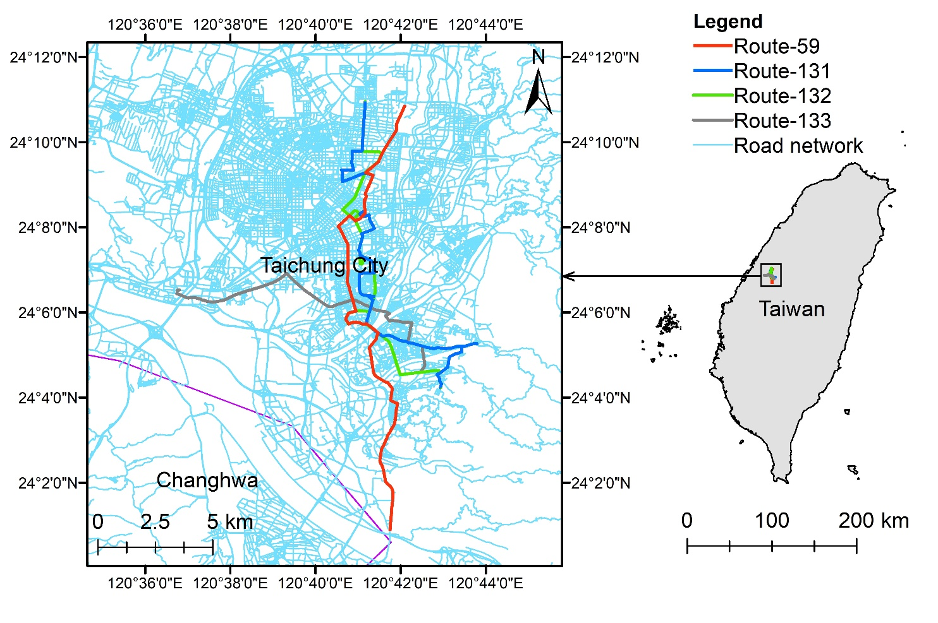
Fig. S1 Map of the study area showing the sample bus routes

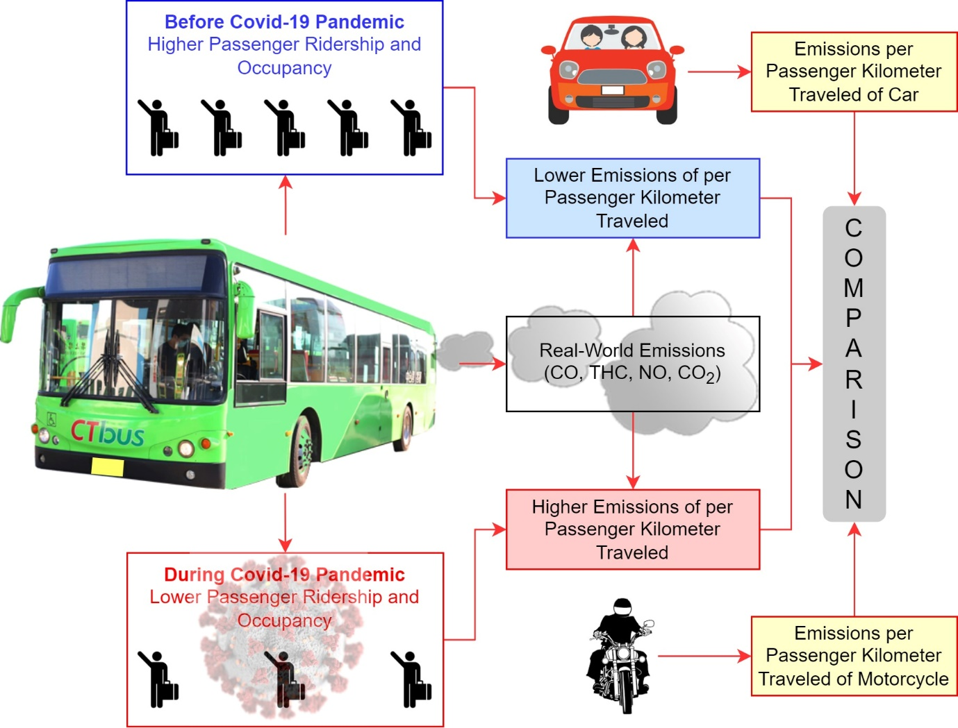
Fig. S2 Schematic of the study design
References
- Tsai JH, Yao YC, Huang PH, Chiang HL. Criteria pollutants and volatile organic compounds emitted from motorcycle exhaust under various regulation phases. Aerosol Air Qual Res. 2017;17:1214–23.
- Tsai JH, Yao YC, Huang PH, Chiang HL. Fuel economy and volatile organic compound exhaust emission for motorcycles with various running mileages. Aerosol Air Qual Res. 2018;18:3056–67.
- Yao YC, Tsai JH, Wang IT. Emissions of gaseous pollutant from motorcycle powered by ethanol-gasoline blend. Appl Energ. 2013;102:93–100.
- Tsai JH, Huang PH, Chiang HL. Characteristics of volatile organic compounds from motorcycle exhaust emission during real-world driving. Atmos Environ. 2014;99:215–26.
- Yang HH, Dhital NB, Cheruiyot NK, Wang LC, Wang SX. Effects of road grade on real-world tailpipe emissions of regulated gaseous pollutants and volatile organic compounds for a Euro 5 motorcycle. Atmos Pollut Res. 2021;12:101167.
- MOTC. Motor Vehicle Registrations. Taipei: Ministry of Transportation and Communications; 2021 [in Chinese]. https://stat.motc.gov.tw/mocdb/stmain.jsp?sys=220&ym=8101&ymt=11106&kind=21&type=1&funid=b330101&cycle=41&outmode=0&compmode=0&outkind=1&fldspc=0,3,7,1,10,1,16,1,21,2,31,2,&rdm=yfeYbthy. Accessed 20 Jan 2022.

