Supplemental Figures.

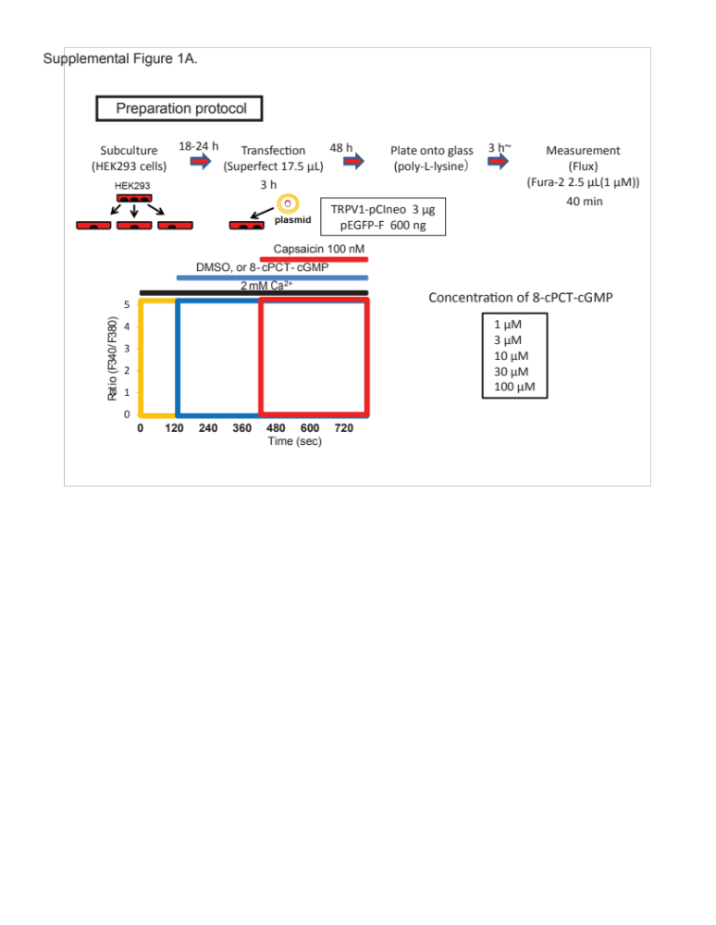

Supplemental Figure 1. Schematic of the capsaicin induced TRPV1 calcium influx assay. Indicating transfection times, measurement times, capsaicin and 8-bromoguanosine 3′,5′-cyclic monophosphate concentrations used. Transfected HEK293 cells were subjected to [Ca²⁺]i measurement 3 h after plating onto poly-L-lysine-coated glass coverslips. The Fura-2 (Dojindo) fluorescence was measured in HEPES-buffered saline containing the following: 107 mM NaCl, 6 mM KCl, 1.2 mM MgSO₄, 2 mM CaCl₂, 11.5 mM glucose, and 20 mM HEPES (pH adjusted to 7.4 with NaOH). Fluorescence images of the cells were recorded and analyzed with the video image analysis system AQUACOSMOS (Hamamatsu Photonics, Shizuoka, Japan) according to the manufacturer instructions. Fura-2 measurements were carried out at room temperature in HEPES-buffered saline. The 340:380-nm ratio images were obtained on a pixel-by-pixel basis.

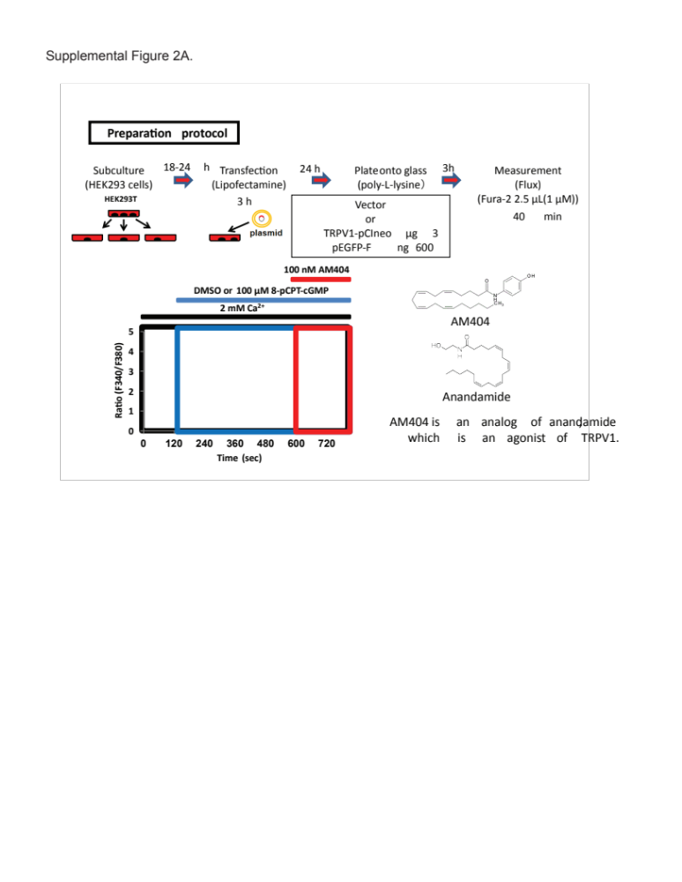

Supplemental Figure 2. Schematic of the AM404 induced TRPV1 calcium influx assay. Indicating transfection times, measurement times, AM404 (N-arachidonoylaminophenol) and 8-bromoguanosine 3′,5′-cyclic monophosphate concentrations used. Transfected HEK293 cells were subjected to [Ca²⁺]i measurement 3h after plating onto poly-L-lysine-coated glass coverslips. The Fura-2 (Dojindo) fluorescence was measured in HEPES-buffered saline containing the following: 107 mM NaCl, 6 mM KCl, 1.2 mM MgSO₄, 2 mM CaCl₂, 11.5 mM glucose, and 20 mM HEPES (pH adjusted to 7.4 with NaOH). Fluorescence images of the cells were recorded and analyzed with the video image analysis system AQUACOSMOS (Hamamatsu Photonics, Shizuoka, Japan) according to the manufacturer instructions. Fura-2 measurements were carried out at room temperature in HEPES-buffered saline. The 340:380-nm ratio images were obtained on a pixel-by-pixel basis.

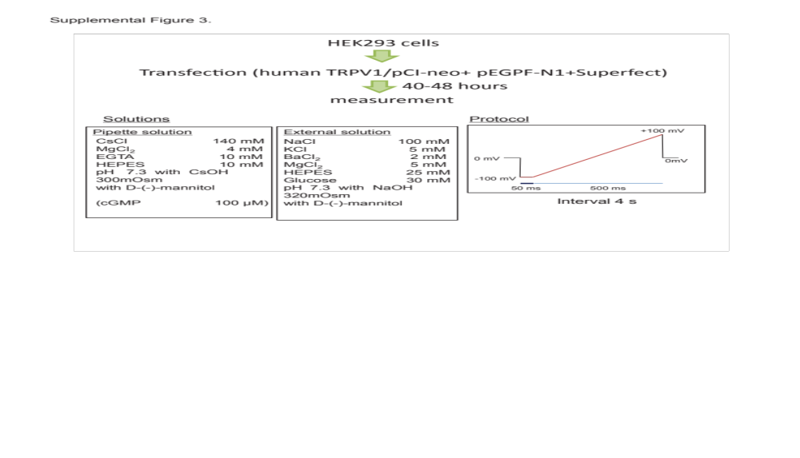

Supplemental Figure 3. Schematic of the electrophysiological measurements protocol. For electrophysiological measurements, coverslips with HEK293 cells were placed in dishes containing bath solutions. Currents from cells were recorded at room temperature using patch-clamp techniques of whole-cell mode with EPC-10 (Heka Elektronik, Lambrecht/Pfalz, Germany) patch clamp amplifier. The patch electrode prepared from borosilicate glass capillaries had a resistance of 2–4 megaohms. Current signals were filtered at 2.9 kHz with a 4-pole Bessel filter and digitized at 10 kHz. Patchmaster (Heka Elektronik) software was used for command pulse control, data acquisition, and data analysis. The series resistance was compensated (50–70%) to minimize voltage errors. Ramp pulses were applied every 5 seconds from -100 to +100 mV at a speed of 0.4 mV ms⁻¹ after a 50 ms step to -100 mV from a holding potential of 0 mV. The external solution contained 100 mM NaCl, 5 mM KCl, 2 mM BaCl₂, 5 mM MgCl₂, 25 mM HEPES, and 30 mM glucose (pH 7.3 adjusted with NaOH, and osmolarity adjusted to 320 mosM with D-mannitol). The pipette solution contained 140 mM CsCl, 4 mM MgCl2, 10 mM EGTA, 10 mM HEPES (pH 7.3 adjusted with CsOH and osmolarity adjusted to 300 mosM with D-mannitol).

