Supplementary Material

Supplementary Figures and Tables

Supplementary Figures
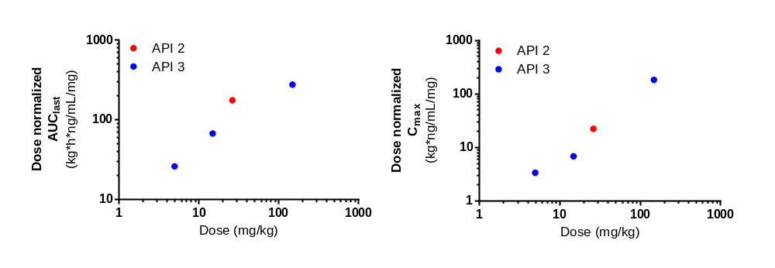
Supplementary Figure 1. Comparisons of plasma CBD PK parameters between synthesized CBD (API 2) and hemp-derived CBD (API 3). Data are presented as mean values of the dose normalized AUC_{last} and C_{max} data. The PK parameters of CBD between current (using synthesized CBD, API2) and published ((Xia et al. 2025) hemp-derived CBD using API3) data are shown for dose normalized area under the curve (AUC_{last}_D) and maximum plasma concentration (C_{max}_D).

Supplementary Tables

 |  |  | Measured CBD concentration
Name of formulations | Theoretical CBD Concentration (mg/mL) | Replicate # | Measured (mg/mL) | Average (mg/mL) | %Accuracy | % RSD
Synthesized CBD (API2) | 8.857 | 1 | 8.834 | 8.823 | 99.62 | 0.14
Synthesized CBD (API2) | 8.857 | 2 | 8.809 | 8.823 | 99.62 | 0.14
Synthesized CBD (API2) | 8.857 | 3 | 8.825 | 8.823 | 99.62 | 0.14
Synthesized CBD (API2) | 8.857 | 1 | 8.785 | 8.838 | 99.79 | 0.53
Synthesized CBD (API2) | 8.857 | 2 | 8.854 | 8.838 | 99.79 | 0.53
Synthesized CBD (API2) | 8.857 | 3 | 8.874 | 8.838 | 99.79 | 0.53
Supplementary Table 1. Measured concentrations of CBD oral formulation

Reference
Xia, W., R. Yanuar, V. Mandal, K. Renggli, J. Ho, B. Phillips, G. N. Nikolajsen, S. S. Jensen, H. Z. Bruun, and J. Hoeng. 2025. 'A 13-week oral toxicity and toxicokinetic study of cannabidiol in Sprague Dawley rats with a 4-week recovery period', Drug and Chemical Toxicology: 1-14.

Dosing day | Average body weight (kg) | Achieved delivered dose (mg/kg/day) | % Difference from target dose
1 | 0.383 | 26.469 | -0.4%
21 | 0.428 | 26.514 | -0.2%
Supplementary Table 2. Delivered CBD doses in animals (target 26.572 mg/kg) following oral dosing of API2

 | Day
Animal ID | 1 | 3 | 7 | 10 | 14 | 17 | 21 | 24
1001001 | 379.3 | 368 | 384.4 | 394.8 | 406.2 | 409.5 | 425.1 | 412.6
1001002 | 389.3 | 370.8 | 387 | 394.8 | 409.6 | 419.8 | 438.1 | 426.7
1001003 | 401.5 | 386.6 | 406.3 | 416.1 | 424.9 | 430 | 443.6 | 437.9
1001004 | 378.9 | 363.9 | 380.3 | 389.4 | 403.1 | 406.4 | 418.9 | 410.3
1001005 | 394.7 | 391.9 | 406.9 | 422.5 | 431.9 | 445.8 | 460.1 | 454
1001006 | 365.4 | 357.4 | 368.5 | 383 | 389.9 | 395.6 | 408.3 | 400.3
1001007 | 382.5 | 369.2 | 380.4 | 388.7 | 400.1 | 401.1 | 416.4 | 404.9
1001008 | 367.1 | 361.7 | 367.1 | 378.5 | 382.8 | 386.2 | 389.2 | 380.9
1001009 | 403.8 | 387.6 | 409.2 | 426.4 | 418.5 | 446.2 | 462.1 | 457.5
1001010 | 365.2 | 361.6 | 373.2 | 382.4 | 369.7 | 396.3 | 406.5 | 401.6
1001011 | 381 | 367 | 381.9 | 395.2 | 413.8 | 420.6 | 433.8 | 428.6
1001012 | 389.2 | 379.7 | 392.9 | 403.6 | 415.4 | 422.6 | 433.7 | 424.9
1001013 | 376.2 | 363.2 | 381.1 | 387.2 | 401.6 | 405.3 | 423 | 413.9
N | 13 | 13 | 13 | 13 | 13 | 13 | 13 | 13
mean | 382.6 | 371.4 | 386.1 | 397.1 | 405.2 | 414.3 | 427.6 | 419.5
SD | 12.7 | 11.3 | 14.1 | 15.6 | 17.1 | 18.7 | 20.8 | 21.8
SEM | 3.5 | 3.1 | 3.9 | 4.3 | 4.7 | 5.2 | 5.8 | 6.0
RSD (%) | 3.3 | 3.0 | 3.6 | 3.9 | 4.2 | 4.5 | 4.9 | 5.2
% of initial mean | 100 | 97 | 101 | 104 | 106 | 108 | 112 | 110
Supplementary Table 3. Body weight progression during and following repeated oral dosing of API2

 | AUC_{last}_D | AUC_{INF}_D | C_{max}_D | T_{max} | T_{1/2}
Analyte/ Day | h*kg*ng/mL/mg | h*kg*ng/mL/mg | kg*ng/mL/mg | h | h
CBD
Day 1 | 175 ± 56 | 209 ± 46 | 22 ± 12 | 5.5 ± 2.0 | 5.9 ± 2.6
Day 21 | 446 ± 80 | 567 ± 124 | 46 ± 19 | 4.0 ± 0.0 | 41.9 ± 9.7
Day 21: Day 1 | 2.9 *** | 3.1 *** | 2.5 *** | 0.8 | 8.3 ***
7-COOH-CBD
Day 1 | 581 ± 179 | NC | 53 ± 15 | 8.8 ± 2.8 | NC
Day 21 | 1006 ± 301 | NC | 106 ± 26 | 8.0 ± 0.0 | 9.6 ± 1.5
Day 21: Day 1 | 2.0 ** | 1009 ± 302 | 2.2 *** | 1.0 | -
7-COOH-CBD: CBD Day 1 | 3.4 | - | 2.8 | 1.7 | -
7-COOH-CBD: CBD Day 21 | 2.3 | 1.9 | 2.5 | 2.0 | 0.2
7-OH-CBD
Day 1 | 31 ± 9 | NC | 3.7 ± 1.0 | 8.0 ± 0.0 | NC
Day 21 | 43 ± 4 | 46 ± 4 | 4.1 ± 0.6 | 6.2 ± 2.1 | 26.5 ± 5.3
Day 21: Day 1 | 1.5 *** | - | 1.2 | 0.8 | -
7-OH-CBD: CBD Day 1 | 0.19 | - | 0.21 | 1.6 | -
7-OH-CBD: CBD Day 21 | 0.10 | 0.08 | 0.10 | 1.5 | 0.68
6-OH-CBD
Day 1 | 13 ± 5 | NC | 1.5 ± 0.4 | 8.0 ± 0.0 | NC
Day 21 | 33 ± 3 | 37 ± 3 | 3.7 ± 0.6 | 8.0 ± 0.0 | 57.0 ± 33.2
Day 21: Day 1 | 2.8 *** | - | 2.7 *** | 1.0 | -
6-OH-CBD: CBD Day 1 | 0.08 | - | 0.09 | 1.6 | -
6-OH-CBD: CBD Day 21 | 0.08 | 0.07 | 0.10 | 2.0 | 1.5
Supplementary Table 4. Pharmacokinetics parameters of CBD, 7-COOH-CBD, 7-OH-CBD and 6-OH CBD following oral dosing of API2. Data shown are mean and standard deviation of the PK parameters for dose-normalized area under the curve (AUC_{last}_D and AUC_{inf}_D), maximum plasma concentration (C_{max}_D), time to maximum plasma concentration (T_{max}) and half-life (T_{1/2}) for CBD, 6-COOH-CBD, 7-OH-CBD and 6-OH-CBD. The average ratios of the respective parameters obtained on day 21 versus day 1 as well as metabolites to CBD ratios are indicated. N =8-13 male rats. NC, not calculable. *, **, and *** refer to statistical significance at p<0.05, p<0.01, and p<0.001, respectively, at day 21 versus day 1.

Tissue to plasma ratio | Brain | Liver | Lung | Adipose | MLN
CBD | 0.3 ± 0.1 (7) | 1.5 ± 0.4 (13) | 0.7 ± 0.6 (10) | 1470.0 ± 1047.0 (13) | 201.3 ± 83.5 (13)
7-COOH-CBD | NC | NC | NC | 10.0 ± 7.4 (9) | NC
7-OH-CBD | NC | NC | NC | 20.9 ± 11.4 (8) | 73.4 ± 29.3 (13)
6-OH-CBD | NC | NC | NC | NC | NC
Supplementary Table 5. Tissue to plasma concentration ratios of CBD and its metabolites following oral dosing of API2. The tissue to plasma ratios for CBD and its metabolites are presented as mean and standard deviation with the number of independent subjects in parenthesis. The tissue to plasma concentration ratio is indicated NC when the concentration in the tissues were <LOQ. MLN, mesenteric lymph nodes; NC, not calculable.

