Supplementary Table 1. Primers used for quantitative reverse-transcription PCR analysis. THCAS (tetrahydrocannabinolic acid synthase); CBCAS (cannabichromenic acid synthase); CBDAS (cannabidiolic-acid synthase); GPP (geranyl pyrophosphate) synthase; OLS (olivetol synthase); OAC (olivetolic acid cyclase); PT (geranyl pyrophosphate-olivetolate geranyl transferase)
Gene | Primer Sequence (5´ to 3´)
Gene | Forward Primer | Reverse Primer
GPPS | GTGAACTCGTAGGCGGAAAA | ATACAAGGGAGGTCGTCGTG
OLS | AGTCCCTCAGTGAAGCGTGT | GCGCCTTTGTTATTCTCTGC
OAC | CACAGAAGCCCAAAAGGAAG | TCTTTCATGGCTGGGATGAT
PT | CTGAGCCTCCAGAATCTGATAATC | GCCTTGAACATCAGAGACCAAC
THCAS | CGAAAATCCATGGGAGAAGA | ACTTTGATGGGACAGCAACC
CBCAS | AGGAGGCTATGGAGCATTGA | TCTTCTCCCATGGATTTTCG
CBDAS | GAGGCTATGGACCATTGA | GGACAGCAACCAGTCTAA

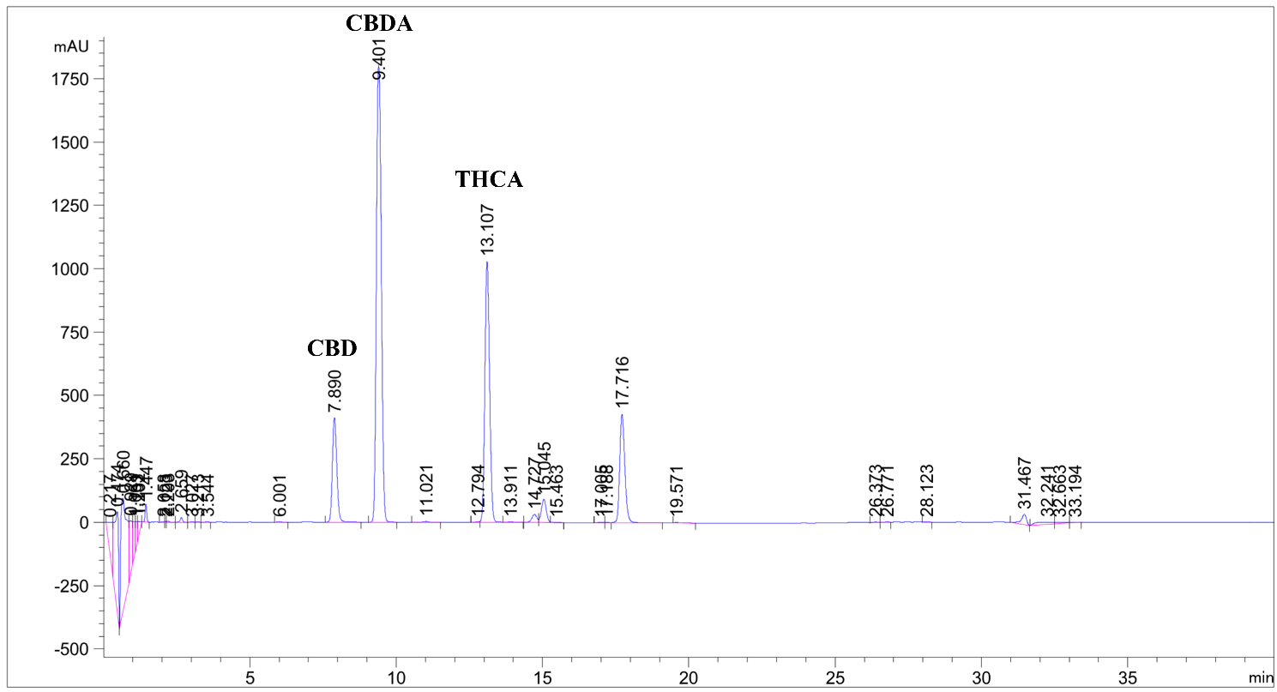
Supplementary Figure 1. Representative HPLC chromatogram showing separation and identification of cannabinoids in hemp (Cannabis sativa 'Queen Dream') flower extracts. The chromatogram displays three main cannabinoid peaks: cannabidiol (CBD) at retention time 7.890 min, cannabidiolic acid (CBDA) at 9.401 min, and tetrahydrocannabinolic acid (THCA) at 13.107 min.

