Supplementary Material

Table 1. Inclusion and exclusion criteria to access the Italian expanded access program for
cannabidiol
_______________________________________________________________________________
Inclusion criteria
- Aged 2 years and above;
- Dravet syndrome or Lennox-Gastaut syndrome diagnosis;
- Currently taking between 1 and 4 other ASMs, with a stable antiseizure treatment for the previous 4 weeks (including ketogenic diet and vagus nerve stimulation);
- Lack of seizure control due to failed treatment with 2 or more prior ASMs
- Written informed consent provided by the participant and/or parent(s)/caregiver(s).

Exclusion criteria
- Pregnancy, lactation, and risk of pregnancy
- Clinically significant unstable medical or psychiatric conditions that may place the patient’s safety at risk;
- Clinically significant liver disease or serum aminotransferase (ALT or AST) >3 times the upper limit of the normal range or total bilirubin > 2 times the upper limit of the normal range or international normalized ratio (INR) > 1.5.
- Known or suspected intolerance or hypersensitivity to cannabinoids or any of the excipients of the medicinal product such as sesame oil;
- Stable felbamate dosing < 1 year
- Current use (or use in the previous 2 months) of recreational or medicinal cannabis, or synthetic cannabinoid-based medications.
- Alcohol abuse < 2 years before cannabidiol initiation
________________________________________________________________________________
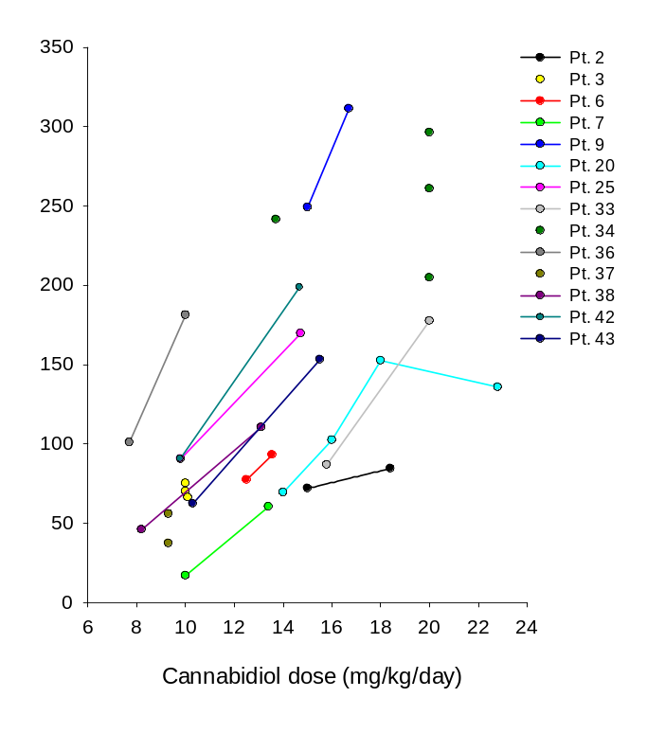
Figure 1. Intrasubject relationship between cannabidiol trough plasma concentrations and
matched daily doses on different occasions during the follow-up

 | Age groups
Variable | ≥ 18 years  (n=44) | < 18 years  (n=23) | p value
Age (years) | 35±11 | 10±4 | <0.001
Sex (f/m) | 22/22 | 7/16 | 0.202
Weight (kg) | 69±17 | 34±12 | <0.001
CBD dose (mg/kg/day) | 13.0±4.5 | 13.7±4.9 | 0.577
Syndrome (LGS/DS) | 35/9 | 7/16 | <0.001
Type of ASM cotherapy  Strong enzyme inducers  Not strong inducers/not strong inhibitors  Enzyme inhibitors | n= 13  n= 22  n= 33 | n= 3  n=12  n=19 | 0.139  0.870  0.938
Table 2a. Clinical characteristics associated with patients’ plasma samples grouped by age
Table 2b. Clinical characteristics associated with patients’ plasma samples grouped by sex
 | Sex
Variable | Females  (n=30) | Males  (n=37) | p value
Age | 33±15 | 21±12 | <0.001
Weight (kg) | 63±23 | 52±22 | 0.05
CBD dose (mg/kg/day) | 14.4±4.1 | 12.4±4.9 | 0.08
Syndrome (LGS/DS) | 22/8 | 20/17 | 0.171
Type of ASM cotherapy  Strong enzyme inducers  Not strong inducers/not strong inhibitors  Enzyme inhibitors | n= 11  n= 17  n= 19 | n= 5  n=17  n=33 | 0.055  0.531  <0.03
Data are expressed as mean±SD; f, females; m, males; CBD, cannabidiol; LGS, Lennox Gastaut Syndrome; DS, Dravet Syndrome; ASM, antiseizure medication

Table 3. Concomitant antiseizure medication associated with patients’ plasma samples
Strong enzyme inducers,  dose (mg/day) (n) | Not strong inducers/  not strong inhibitors,  dose (mg/day) (n) | Strong enzyme inhibitors,  dose (mg/day) (n)
Carbamazepine, 1100±200 (6)  Phenobarbital, 106±32 (8)  Phenytoin, 300 (2) | Brivaracetam, 93±60 (5)  Clobazam, 18±9 (36)  Clonazepam, 2 (6)  Ethosuximide 550±204 (4)  Felbamate 1515±810 (4)  Lacosamide, 361±157 (8)  Lamotrigine, 310±166 (12)  Levetiracetam, 1000 (3)  Nitrazepam, 3.7±3 (5)  Oxcarbazepine, 1200 (1)  Perampanel, 6 (4)  Rufinamide, 1607±727 (7)  Topiramate, 210±110 (12)  Vigabatrin, 1500 (1)  Zonisamide, 400±173 (5) | Stiripentol, 1125±476 (18)  Valproic acid, 952±385 (42)
Doses are expressed as mean±SD.

Table 4a. Clinical characteristics associated with patients’ plasma samples grouped by
cannabidiol efficacy

Variable | Responders  (n=36) | Nonresponders  (n=31) | p value
Sex (f/m) | 19/17 | 11/20 | 0.241
Age (years) | 30±13 | 21±14 | <0.01
CBD dose (mg/kg/day) | 13.2±4.9 | 13.3±4.4 | 0.988
CBD treatment duration (months)* | 3 (1.2-5) | 3 (3-6) | <0.02
Syndrome (LGS/DS) | 24/12 | 18/13 | 0.637
Type of ASM cotherapy  Strong enzyme inducers  Not strong inducers/not strong inhibitors  Enzyme inhibitors | n= 10  n= 17  n= 30 | n= 6  n=17  n=22 | 0.649  0.706  0.359

Table 4b. Clinical characteristics associated with patients’ plasma samples grouped by cannabidiol
tolerability
 | Adverse effects
Variable | Yes  (n=29) | No  (n=38) | p value
Sex (f/m) | 14/15 | 16/22 | 0.798
Age (years) | 31±16 | 22±13 | <0.02
CBD dose (mg/kg/day) | 11.6±3.9 | 14.4±4.8 | <0.01
CBD treatment duration (months)* | 3 (2-3) | 3.5 (3-6) | <0.008
Syndrome (LGS/DS) | 21/8 | 21/17 | 0.237
Type of ASM cotherapy  Strong enzyme inducers  Not strong inducers/not strong inhibitors  Enzyme inhibitors | n= 12  n= 12  n= 22 | n= 4  n=22  n=30 | <0.008  0.274  0.996
Data are expressed as mean±SD or median* (25-75 percentiles); f, females; m, males; CBD, cannabidiol; LGS, Lennox Gastaut Syndrome; DS, Dravet Syndrome; ASM, antiseizure medication

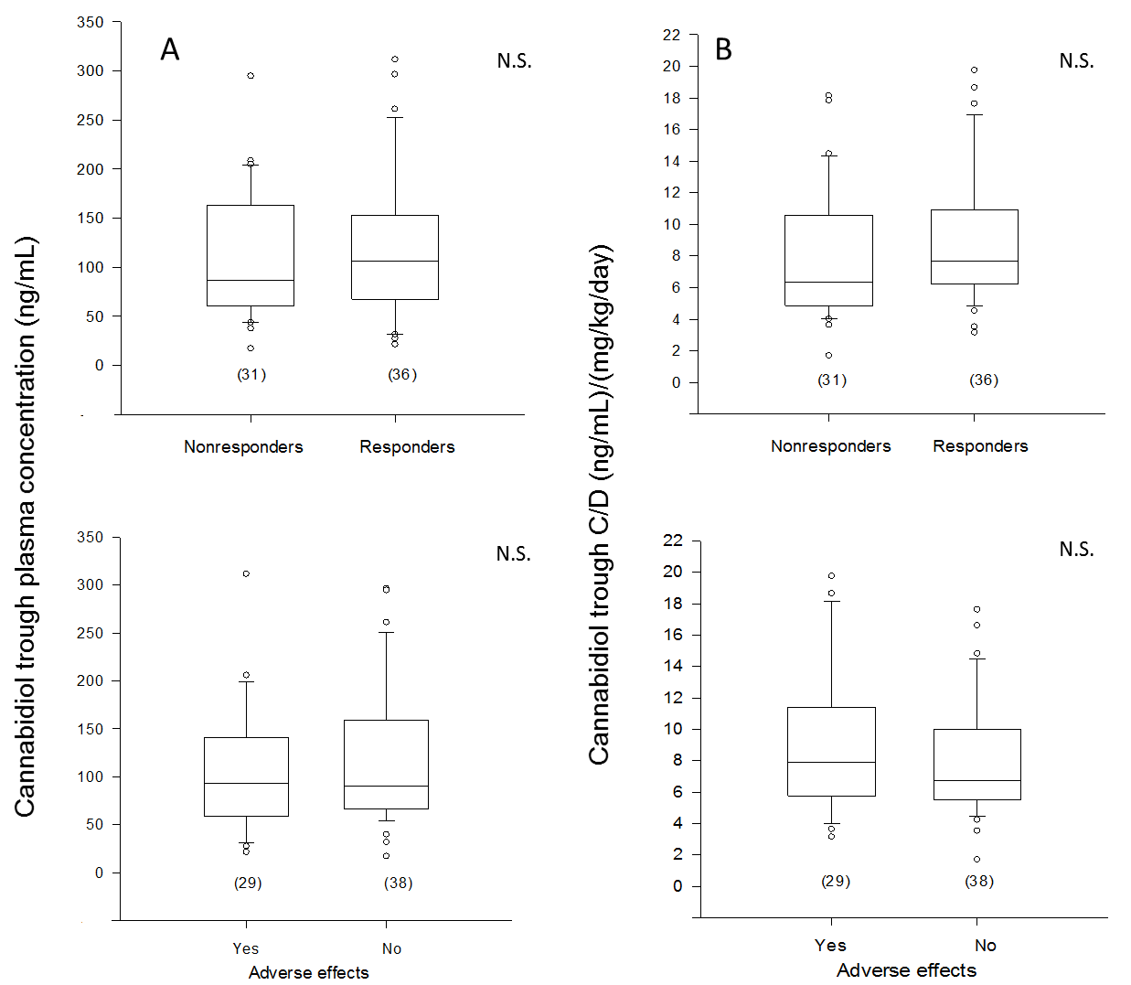

Figure 2S. Plasma concentration of cannabidiol (panel A) and matched plasma concentration to
weight-adjusted daily dose ratio (C/D) (panel B) from patients’ specimens (n)
grouped according to cannabidiol efficacy (top) and tolerability (bottom). Box plots
depict the range between the 25th and 75th percentiles of the data. The horizontal line
marks the median value; capped bars indicate 10th-90th percentiles. Black circles
represent outlying values. N.S., not significant (p>0.05), according to Mann-Whitney
rank sum test.

