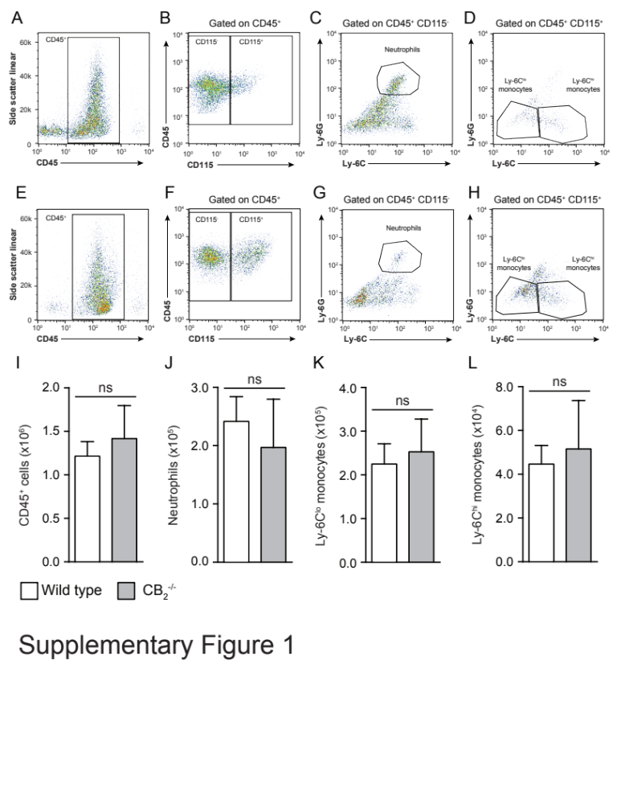
Supplementary Figure 1. Flow cytometry gating strategy for cell identification in the dorsal air pouch inflammation model. Dorsal air pouches from WT and CB₂^{-/-} mice (8-10 weeks old) were lavaged and representative dot plots of (A) total CD45⁺ cells, (B) CD45⁺CD115⁻ and CD45⁺CD115⁺ cells, (C) neutrophils (CD45⁺ CD115⁻ Ly-6G⁺ Ly-6C^{lo}) and (D) Ly-6C^{lo} and Ly-6C^{hi} monocytes (CD45⁺ CD115⁺) from one WT mouse were determined by flow cytometry. Representative dot plots displaying (E) total CD45⁺ cells, (F) CD45⁺ CD115⁻ and CD45⁺ CD115⁺ cells, (G) neutrophils (CD45⁺ CD115⁻ Ly-6G⁺ Ly-6C^{lo}) and (H) Ly-6C^{lo} and Ly-6C^{hi} monocytes (CD45⁺ CD115⁺) from one CB₂^{-/-} mouse. Total numbers of: (I) CD45⁺ cells, (J) Neutrophils, (K) Ly-6C^{lo} monocytes and (L) Ly-6C^{hi} monocytes present in the dorsal air pouches of WT (white bars) and CB₂^{-/-} (grey bars) animals under basal conditions. Data are mean + SEM, n=5-11 animals per group. Statistical analysis was conducted by a two-tailed students t-test, ns p>0.05.
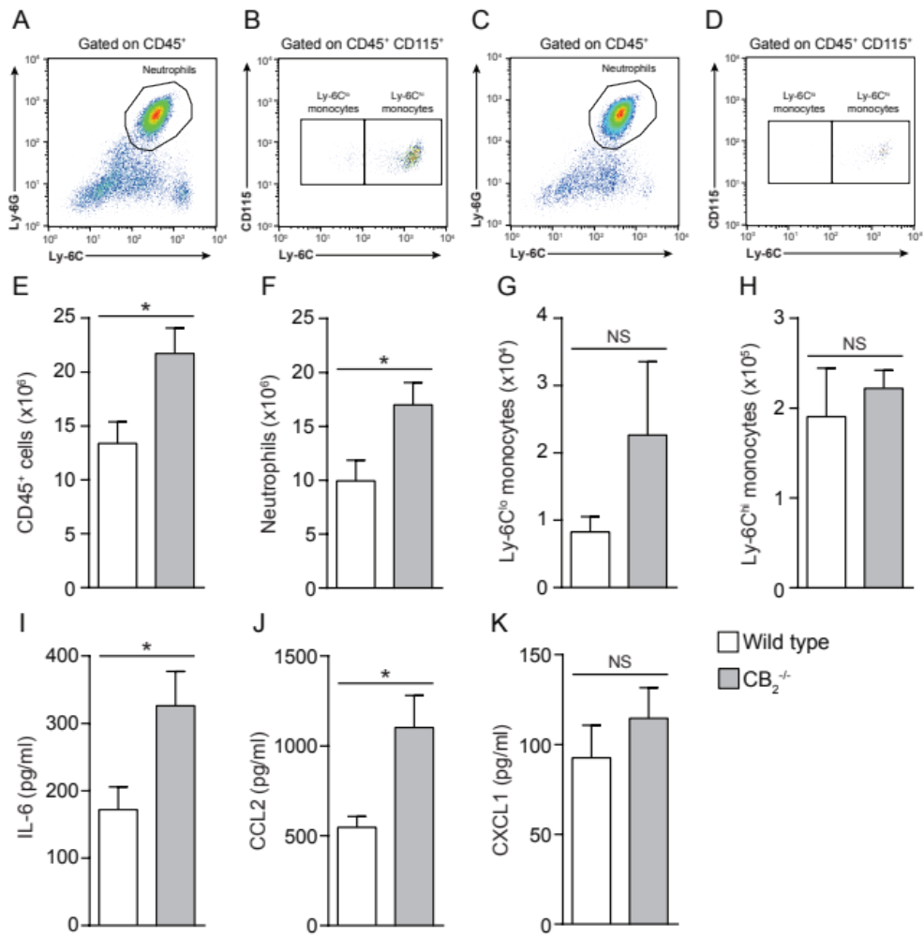

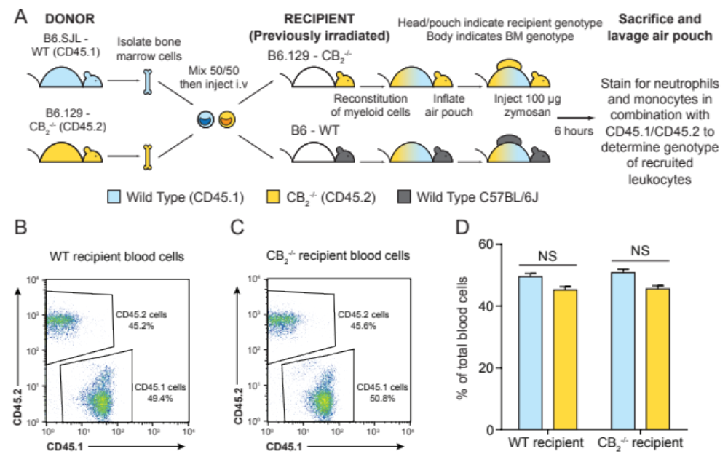
Figure S2. Male CB₂^{-/-} animals have an exaggerated acute inflammatory response 6 hours after pouch zymosan injection. The dorsal air pouches of male WT or CB₂^{-/-} mice were injected with 100 µg zymosan and 6 hours later the pouches lavaged and total cell counts and populations present determined by flow cytometry. Representative dot plots of (A) neutrophils and (B) Ly6C^{lo} and Ly6C^{hi} monocytes in the dorsal air pouch of male WT mice 6 hours after zymosan injection. Representative dot plots of (C) neutrophils and (D) Ly6C^{lo} and Ly6C^{hi} monocytes in the dorsal air pouch of male CB₂^{-/-} mice 6 hours after zymosan injection. Quantification of the number of (E) CD45⁺ cells, (F) neutrophils, (G) Ly6C^{lo} or (H) Ly6C^{hi} monocytes recruited to the dorsal air pouch 6 hours after zymosan injection in male WT (white bars) and CB₂^{-/-} (grey bars) animals. The levels of pro-inflammatory mediators present in the air pouch were determined by ELISA and male CB₂^{-/-} mice had significantly higher levels of (I) IL-6 and (J) CCL2 compared to WT animals. (K) There was no difference in the level of CXCL1 between the genotypes. Data are mean+ SEM, n = 6-8 independent animals per group. Statistical analysis was conducted using the unpaired student's t-test. ns P > 0.05, * P < 0.05, ** P < 0.01.

Supplementary Figure 3. Generation of mixed bone marrow chimeric animals. (A) Scheme detailing the strategy used to generate mixed bone marrow chimeric animals. Bone marrow cells were isolated from 8-10 week old female B6.SJL animals expressing the CD45.1 and 8-10 week old female B6.129 CB₂^{-/-} animals expressing the CD45.2 surface antigen, were mixed in equal amounts and were injected intravenously into female C57BL/6 WT and CB₂^{-/-} animals (8-10 weeks old) which had been previously irradiated with 5 Gy twice to deplete their endogenous bone marrow. The mice were allowed to reconstitute their bone marrow and 4 weeks later, blood was withdrawn from the tail vein and the proportion of CD45.1⁺/CD45.2⁺ cells was determined by flow cytometry as shown in representative dot plots from one WT (B) and one CB₂^{-/-} (C) recipient mouse and (D) the absolute numbers of CD45.1⁺ and CD45.2⁺ cells. Data are mean+SEM, n=9-11 animals per group. Statistical analysis was conducted by two-way ANOVA with Sidak's multiple comparisons correction, ns p>0.05.

