Supplementary Material

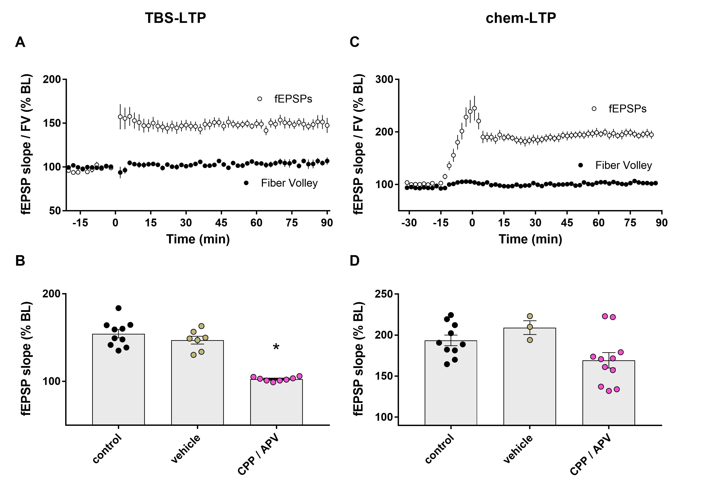
Supplementary Figure 1. A) Group time course of the fEPSP slope and fiber volley amplitude following TBS delivered at minute 0 (n=10). B) Effects of DMSO vehicle (n=7) or NMDA receptor antagonists (3 µM CPP or 50 µM APV, n=8) on the magnitude of TBS-LTP at 60 min post-induction. *, p<0.05 compared to control. Control data repeated from Figure 2. C) Group time course of the fEPSP slope and fiber volley amplitude following chem-LTP cocktail delivered from -15-0 min (n=12). D) Effects of vehicle (n=3) or NMDA receptor antagonists (n=11) on the magnitude of chem-LTP at 60 min post-induction. Control data repeated from Figure 2.

