Supporting Information
This supplement has been provided by the authors to give readers additional information about the work.

Table of Contents
Table S1 2
Figure S1 3

Table S1. Regression results for monthly per capita alcohol sales from May 2017 to February 2020.ª
Regression parameter | Alcohol,  percent (95% CI)
Pre-legalisation slope, per month | 0.0% (-0.1, 0.1)
Legalisation level change, immediate | -0.6% (-1.8, 1.6)
Legalisation slope change, per month | -0.0% (-0.1, 0.1)
Difference from February 2020 counterfactual | -0.7% (-3.1 to 1.7)

ª Interrupted time series regressions were run on the natural logarithm of alcohol retailer sales in CAD$ per resident age 15+, with the output expressed as monthly percentage changes. N = 34 monthly observations: 17 months pre- and 17 months post-legalisation. CI, confidence interval.

Figure S1. Seasonally adjusted monthly alcohol retailer sales in dollars per capita (left) and beer producer sales in litres per capita (right), plus the regression-fitted values.ª
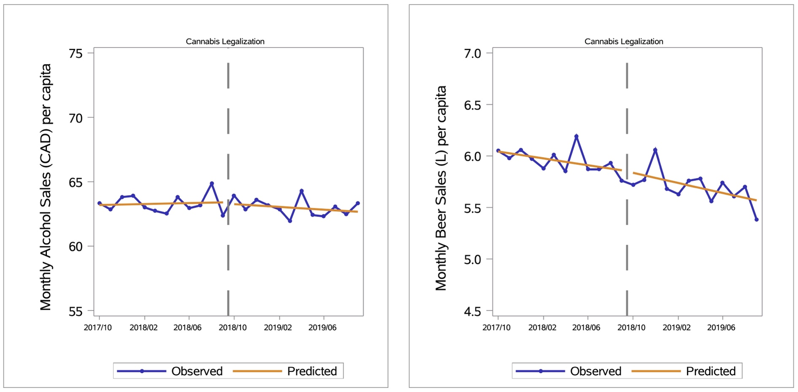
ª The vertical dashed line marks when cannabis became legal.

