SUPPLEMENT PART II (S10-S14, TABLES S1-S2)
Figure S10
A
CBD μM
CBD μM
% Viability
% Viability

B
*

C

Supplementary Figure S10. Pharmacological inhibition of ID1 does not impact control cell invasion and migration. (A) KNS42 (H3G34V HGG) and NHA (normal human astrocyte) cells were plated in a 96-well plate and treated with CBD 72 hours prior to measurement using the XTT cell proliferation assay. Each data point represents an average of 3 wells, mean+/-SEM
(B) KNS42 (H3G34V HGG) and NHA (normal human astrocyte) cells treated for 2 days with DMSO (control), 5μM, or 7.5μM CBD and invasion was measured by Matrigel-coated Boyden chamber. Each data point represents an individual image, mean+/-SEM. *P<0.05, unpaired parametric t-test. (C) Effect of CBD treatment on KNS42 and NHA cell migration as measured by scratch assay, quantified as percent wound closure.

A
JUMP4 Matrigel Invasion Assay
Figure S11
B
***
***
IC₅₀ = 8.2 µM

**
D
C

IC₅₀ = 6.7 µM

F
**
IC₅₀ = 7.2 µM
E
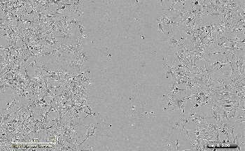
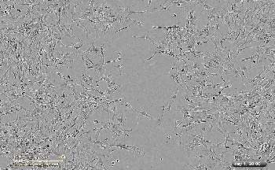
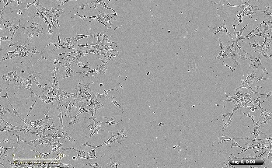
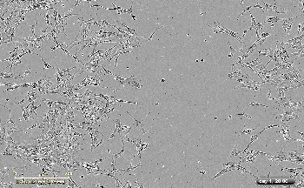
G
DMSO
0 hr
48 hr
10 µM CBD
Migration Assay- DIPG007

Supplementary Figure S11. Pharmacologic inhibition of ID1 decreases DMG cell invasion and migration. (A) JUMP4 (H3.1K27M DMG) cells were plated in a 96-well plate and treated with CBD 72 hours prior to measurement using the XTT cell proliferation assay. Each data point represents an average of 3 wells, mean+/-SEM. (B) JUMP4 cells were treated for 2 days with DMSO (control), 5μM, or 7.5μM CBD and invasion was measured by Matrigel-coated Boyden chamber. Each data point represents an individual image, mean+/-SEM; ***P<0.001, unpaired parametric t-test. (C) DIPGXIIIP cells were plated in a 96-well plate and treated with CBD 72 hours prior to measurement using the XTT cell proliferation assay. Each data point represents an average of 3 wells, mean+/-SEM. (D) Effect of CBD treatment on DIPGXIIIP cell migration as measured by scratch assay, quantified as percent wound closure, mean+/-SEM; **P<0.01, 2-way ANOVA. (E) PBT-29 cells were plated in a 96-well plate and treated with CBD 72 hours prior to measurement using the XTT cell proliferation assay. Each data point represents an average of 3 wells, mean+/-SEM. (F) Effect of ID1 inhibition on DIPG007 migration as measured by scratch assay, quantified as percent wound closure, mean+/-SEM; **P<0.01, 2-way ANOVA. (G) Images show representative scratch at 0 and 48 hours outlined in dotted red line. Experiment completed in triplicate; images taken with Incucyte; area measured by ImageJ.
Figure S12
C
F
E
D

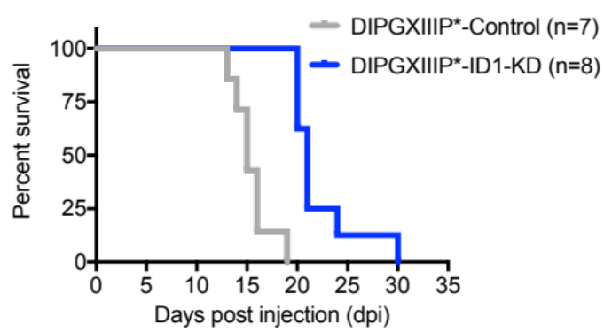
G
DIPGXIIIP* – Genetic ID1 Knockdown
**** P=0.0001

Supplementary Figure S12. Genetic and pharmacologic (CBD) targeting of ID1 slows tumor growth in H3.3-PPK-IUE and human xenograft models. (A-B) IHC analysis and quantification of tumor images for ID1 and Ki67 expression (representative of n=3 tumors); **P=0.0065 and ****P≤0.0001, Dunnett’s multiple comparisons test. N=3 animals/treatment group and 4 images/animal from H3.3-PPK-sh-contrl and H3.3-PPK-sh-ID1 tumor bearing mice. Data represent mean+/-SEM. Magnification=20x(C) Representative images of bioluminescent tumors from intracranial injection of scrambled-control or ID1-shRNA DIPG007 cells at DPI-97; *P<0.05, one-way ANOVA t-test (D) Bioluminescence of intracranially-injected scrambled or ID1-shRNA DIPG007 cells over days-post-injection. (E-F) Example images of IHC staining for Ki67 (E) and ID1 (F) in a sagittal tissue section (tumors generated from implantation of DIPG007 cells). Magnification is 20x. (G) Survival analysis of NSG mice bearing either human DIPGXIIIP* sh-Control or sh-ID1 xenograft tumor. Median survival for control condition was 15 and 21 days for sh-ID1. ****P<0.0001, Log-rank test.

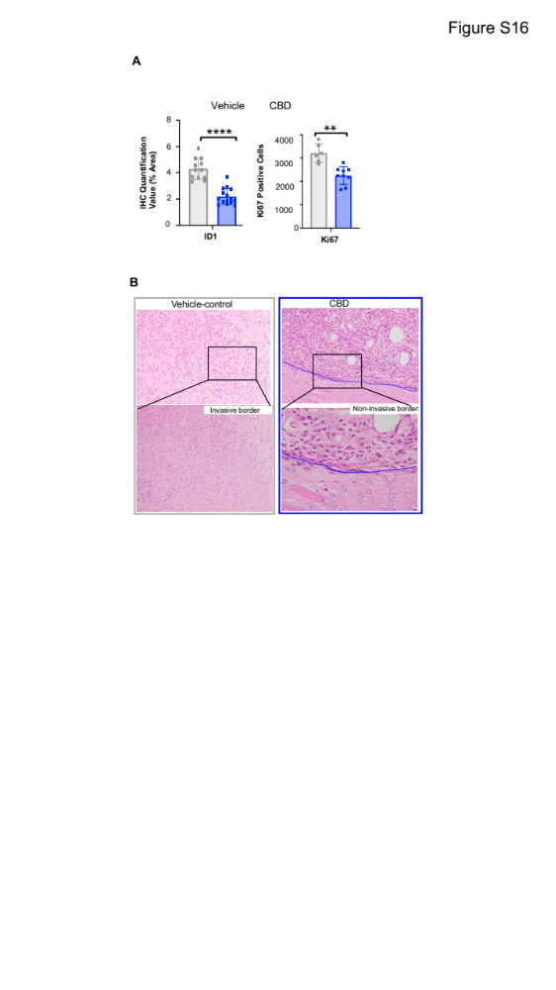
Figure S13
C
Supplementary Figure S13. Pharmacologic (CBD) targeting of ID1 slows tumor growth in IUE model. (A) Quantification of tumor images for ID1 and Ki67 expression (representative of n=3 tumors); **P=0.0065 and ****P≤0.0001, Dunnett’s multiple comparisons test. N=3 animals/treatment group and 4 images/animal. Data represent mean +/- SEM. (B) Images of IUE-generated PPK tumor borders treated with or without CBD (DMSO vs. 15mg/kg CBD) for assessment of tumor cell invasiveness. Magnification for top row images is 10x and magnification for bottom row is 40x. (C) Representative bioluminescence images of PPK3.1 mouse tumors (Control, CBD, Sh-ID1 and Sh-ID1+CBD) displaying lower average
luminescence with CBD, 1D1 KD and CBD+ID1 KD.

Figure S14
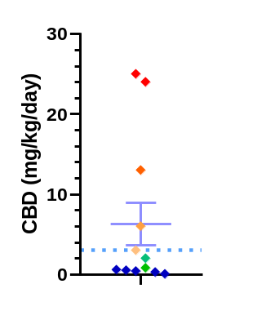
Estimated HED
brain [CBD] >IC50
CBD dosing in
(DMG patient reported)

Supplementary Figure S14. Patient-reported CBD dosing. Plot representing CBD dosing range (mg/kg/day) in human DMG patients.

Abbreviations for Main Figure 3A.
[For (A), from left to right (row headings), RSP: rostral secondary prosencephalon, Tel: telencephalic vesicle, PedHy: peduncular (caudal) hypothalamus, P3: prosomere 1, P2: prosomere 2, P1: prosomere 3, M: midbrain, PPH: prepontine hindbrain, PH: pontine hindbrain, PMH: pontomedullary hindbrain, MH: medullary hindbrain (medulla); from top to bottom (column headings), E11.5/15.5: embryonic day 11.5/15.5, P4: postnatal day 4].

Supplementary Table S1. Primer sequences for use in ChIP-qPCR and qPCR

Primer | Forward | Reverse | Species
ID1 Enhancer | CTGGCGTCTAACGGTCT | CTGCGGAGCTACAGTCT | Human
ID1 Promoter 1 | GAGGCTGGACCTAGGAG | GAGCCACAGCTTGTCTTT | Human
ID1 Promoter 2 | CTCTCATTCCACGTTCTTAAC | CTGGCGACTTTCATGATTC | Human
ID1 Gene Body | AGATCCAGATCCGACCAC | AGGTACCCGCAAGGATG | Human
PAX4 Promoter | TGGCTGAGGACTGGATCTTT | CTGGAGACAACAGCTGTCCA | Human
Primers for use in qPCR for gene expression analysis
Primer | Forward | Reverse | Species
ID1 | CGAGGCGGCATGCGTTC | GGAGACCCACAGAGCACGTAAT | Human
GAPDH | CGCTCTCTGCTCCTCCTGTT | CCATGGTGTCTGAGCGATGT | Human

Supplementary Table S2. Clinical details of pediatric HGG patients treated with CBD.
Patient ID | Age | Diagnosis | Molecular | Therapies given | Time to first progression | Overall survival from Diagnosis | CBD duration/dosing/toxicity noted
CHCO01 | 11yo | DMG, H3K27M (thalamus) | H3K27M mutant | Radiation | 24 months | 40 months (still alive) | CBD 2.5g mg (~0.07 mg/kg/day); PO daily; CBD therapy started adjuvantly after initial radiation
CHCO02 | 15yo | DMG, H3 WT (bi-thalamic) | H3 WT; BARD1 E19* mutation; increased tumor mutational burden | Radiation; TMZ/CCNU; olaparib; pembrolizumab | 14 months | 26 months | CBD 50 mg (0.8 mg/kg/day); PO BID (+THC); CBD therapy started at diagnosis
UMPED18 | 9yo | DMG, H3K27M (brainstem) | H3F3A K27M; PIK3CA E545K; TCF12 V650D | Radiation (+AZD-1775); panobinostat + everolimus | 8 months | 10 months | CBD 300 (13 mg/kg/day) + THC; no toxicity; PO daily; therapy started at radiation – taken until passing
UMPED22 | 5 yo | DMG, H3K27M (brainstem) | HIST1H3B K27M; ACVR1 G328E | Radiation; hyper-baric O2; Re-irradiation | 9 months | 12 months | CBD 45 mg (2 mg/kg/day) +THC; PO BID or TID; therapy started at radiation – taken until passing
UMPED37 | 13yo | DMG, H3 WT (bi-thalamic) | H3 WT; EGFR V292L; EGFR in-frame deletion; deletion CDKN2C | Chemotherapy (thioguanine, procarbazine, lomustine, and vincristine); Radiation; osimertinib; bevacizumab | 5 months | 17 months | CBD 150 mg (3 mg/kg/day) after radiation -> 50 mg (1 mg/kg/day), until passing due to nausea; PO daily; therapy started at radiation – taken until passing
UMPED56 | 8 yo | DMG, H3K27M (brainstem) | HIST1H3B K27M; ACVR1 R206H | Radiation; ONC201; bevacizumab | 13 months | 24 months | CBD (0.6 mg/kg/day) +THC; PO daily; therapy started at radiation – taken until passing
UMPED58 | 9 yo | DMG, H3K27M (brainstem) | H3F3A K27M; ATRX Q119*; PPM1D G463fs; PDGFRA amplification | Radiation; multi-agent intra-arterial; ONC201 | 18 months | 21 months | CBD (? Dose) + THC; PO or per rectum daily; therapy started at radiation – taken until passing
UMPED65 | 16 yo | DMG, H3K27M (brainstem) | H3F3A K27M; TP53; PIK3CA | Radiation; ONC201; panobinostat; re-irradiation; paxilisib | 16 months | 24 months | CBD (0.3 mg/kg/day); PO BID/TID, intermittent early in therapy, stopped 7 months prior to passing
UMPED67 | 7 yo | DMG, H3K27M (thalamus) | H3F3A K27M; TP53 C277F; NF1 H2434fs | Radiation; ONC201; re-irradiation; bevacizumab | 10 months | 15 months | CBD (0.7 mg/kg/day) + THC; PO daily; therapy started at radiation, stopped 4-5 months prior to passing
UMPED69 | 4 yo | DMG, H3K27M (brainstem) | HIST1H3B K27M | Radiation; convection-enhanced delivery (CED) trial; re-irradiation; ONC201; paxalisib | 13 months | 28 months | CBD 9 mg (0.5 mg/kg/day) + THC; PO TID; therapy started at radiation – taken until passing
UMPED83 | 11 yo | DMG, H3K27M (thalamus) | H3F3A K27M; TP53 S241C | Chemotherapy (temozolomide, irinotecan, bevacizumab); Radiation; ONC201 | 36 months | 60 months | CBD 1500 mg (25 mg/kg/day) + THC; PO TID; therapy started at radiation, stopped one year prior to passing
UMPED86 | 7 yo | DMG, H3K27M (brainstem) | HIST1H3B K27M; ACVR1 G328E; PI3KCB; PPM1D | Radiation; ONC201; Re-irradiation | 6 months | 8 months | CBD 3 mg (0.4 mg/kg/day); PO TID or QID; therapy started at radiation – taken until passing
UMPED97 | 16yo | Cortical anaplastic astrocytoma | H3 WT; Tp53 R342* (+germline); CDK4 gain; KRAS gain | Chemotherapy (procarbazine, CCNU, and vincristine); Radiation; irinotecan and bevacizumab | 5 months | 19 months | CBD 400 mg (6 mg/kg/day) after radiation, until passing due to nausea; PO twice daily (Epidiolex); therapy started at radiation – taken until passing
UMPED101 | 6yo | DMG, H3K27M (brainstem) | H3F3A K27M mutant | Radiation; ONC201; re-irradiation; bevacizumab | 10 months | 14 months | CBD 600 mg (24 mg/kg/day) PO TID; CBD therapy started after radiation – taken until passing

