Clinically Significant PTSD Symptoms: IES-R Score >= 33
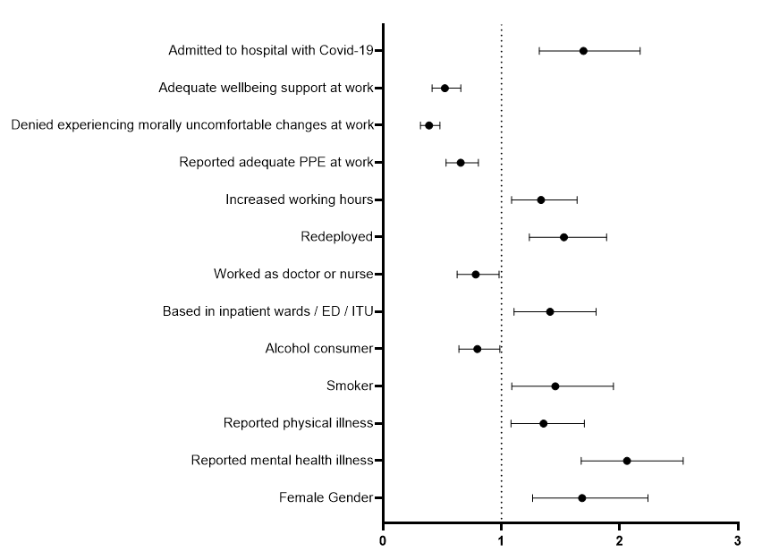
Odds Ratio (95% CI)

Admitted to hospital with Covid-19* | 1·7 (1·3 – 2·2); p<0·001
Wellbeing support available at work | 0·5 (0·4 – 0·7); p<0·001
Denied morally uncomfortable changes | 0·4 (0·3 – 0·5); p<0·001
Reported adequate PPE at work | 0·7 (0·5 – 0·8); p<0·001
Increased working hours | 1·3 (1·1 – 1·6); p=0·006
Redeployed | 1·5 (1·2 – 1·9); p<0·001
Worked as a doctor or nurse | 0·8 (0·6 – 0·9); p=0·034
Working in inpatient wards / ED / ITU | 1·4 (1·1 – 1·8); p=0·006
Alcohol consumer | 0·8 (0·6 – 0·9); p=0·038
Smoker | 1·5 (1·1 – 1·9); p=0·012
A history of physical illness | 1·4 (1·1 – 1·7); p=0·009
A history of mental health conditions | 2·1 (1·7 – 2·5); p<0·001
Female gender | 1·7 (1·3 – 2·2); p<0·001

Odds Ratio (95% CI)

Supplementary Figure 4: Factors associated with clinically significant symptoms of PTSD in adjusted analysis

