Table S1. Antibiotic concentrations in various terrestrial and aquatic matrices gathered from previous studies
Antibiotic [MSC (mg/L)] |  | Environment |  |  | Concentration |  | Location | Reference
PEN  [14.1 -  28.2] | Manure |  |  | Broiler | 12, 500 units/kg |  | USA | (1)
PEN  [14.1 -  28.2] | Manured Soil |  |  |  | 5.6 mg/kg |  | USA | (2)
PEN  [14.1 -  28.2] | WWTP |  |  | Influent | 0.153 mg/L
PEN  [14.1 -  28.2] |  |  |  | Effluent | 1.68${ \text{x} \text{10}}^{\text{-3}}$ mg/L |  | Germany | (3)
PEN  [14.1 -  28.2] | Industrial Waste |  |  | Pharmaceutical | 1$\text{x}{\text{10}}^{\text{-4}}$−1$\text{x}{\text{10}}^{\text{-3}}$mg/L |  | Korea | (4)
PEN  [14.1 -  28.2] | Aquatic Matrices |  |  | WWTP Effluent | 3.1$\text{x} {\text{10}}^{\text{-5}}$ mg/L (discharge point)  3.0$\text{x} {\text{10}}^{\text{-5}}$ mg/L (30 km from discharge) |  |  | (5)
LIN  [2] |  | Manure |  | Swine | 0.164 $-$ 0.547 mg/kg |  | China | (6)
 |  |  |  | Swine-liquid | 0.0251 mg/L  0.0385 mg/L |  | USA | (7)
 |  | Manured Soil |  | Swine | 0.0923 mg/kg |  | China | (6)
 |  |  |  | Swine | 9.0$\text{x} {\text{10}}^{\text{-3}}$ mg/kg |  | USA | (8)
 |  |  |  | Swine | 2.4$\text{x} {\text{10}}^{\text{-5}}-$9.7$\text{x} {\text{10}}^{\text{-4}}$ mg/kg |  | China | (9)
 |  | WWTP |  | Influent | 2.6$\text{x} {\text{10}}^{\text{-5}}$− 3.7$\text{x} {\text{10}}^{\text{-5}}$ mg/L |  |  | (10)
 |  |  |  | Swine WW Influent | 5.021 mg/L  4.216 mg/L |  | USA | (8)
 |  |  |  | Effluent
 |  |  |  | Swine Lagoon Effluent | 0.166 mg/L  1.42$\text{x}{ \text{10}}^{\text{-3}}$ mg/L |  | China | (6)
 |  | Biosolids |  |  | 2.6$\text{x} {\text{10}}^{\text{-3}}$ mg/kg |  | USA | (11)
 |  | Industrial Waste |  | Pharmaceutical | >10 mg/L |  | Korea | (4)
 |  | Aquatic Matrices |  | Wetland (from swine manure snow runoff) | 1.2$\text{x} {\text{10}}^{\text{-4}}$− 2.7$\text{x} {\text{10}}^{\text{-4}}$ mg/L |  | USA | (7)
 |  |  |  | Wastewater Discharge | 1.8$\text{x} {\text{10}}^{\text{-5}}$− 9.29$\text{x} {\text{10}}^{\text{-3}}$ mg/L |  | China | (9)
FLR  [1] |  | Manure |  | Poultry | 2.4$\text{x}{ \text{10}}^{\text{-3}}$ mg/L |  | China | (12)
 |  |  |  | Dairy | 4.2$\text{x} {\text{10}}^{\text{-4}}$ mg/L |  | China
 |  |  |  | Swine | 2.84$\text{x} {\text{10}}^{\text{-3}}$ mg/L |  | China
 |  | WWTP |  | Influent (animal farm) | 1.53$\text{x} {\text{10}}^{\text{-3}}$ mg/L |  | China | (12)
 |  |  |  | Effluent (animal farm) | 9.5 $\text{x} {\text{10}}^{\text{-4}}$ mg/L |  | China
 |  |  |  | Swine Lagoon Effluent | 2.53$\text{x} {\text{10}}^{\text{-5}}$ mg/L |  | China | (6)
 |  | Biosolids |  | Wastewater | 9.29$\text{x} {\text{10}}^{\text{-7}}$ mg/L |  | China | (13)
 |  | Industrial Waste |  |  | 0.001 − 0.01 mg/L |  | Korea | (4)
 |  | Aquatic Matrices |  | River | 2.4$\text{x} {\text{10}}^{\text{-3}}$ mg/L |  | China | (12)
 |  |  |  | Pond | 2.84$\text{x} {\text{10}}^{\text{-3}}$ mg/L |  | China
OXY  [0.1] |  |  | Manure | Cattle (beef) | 11.3 mg/kg |  | USA | (1)
 |  |  | Manure | Broiler | 10.9 mg/kg |  | USA
 |  |  | Manure | Swine | 1.700 mg/kg  0.235 mg/kg  0.661 mg/kg |  | China |  |  | (6)
 |  |  | Manure | Cattle (beef) | 0.05 - 18 mg/kg |  | USA |  |  | (14)
 |  |  | Manure | Cattle (calves) | 0.8 - 871.7 mg/kg |  | Italy |  |  | (15)
 |  |  | Manure | Poultry | 0.06-0.45 mg/kg |  | Turkey |  |  | (16)
 |  |  | Manure | Swine | 18.7 mg/kg |  | China |  |  | (17)
 |  |  | Manure | Cattle | 21.36 mg/kg
 |  |  | Manure | Poultry | 21.96 mg/kg
 |  |  | Manured Soil |  | 0.300 mg/kg |  | China |  |  | (18)
 |  |  | Manured Soil | Swine | 1.41 mg/kg  0.0523 mg/kg  8.59 $\text{x} {\text{10}}^{\text{-3}}$ mg/kg |  | China |  |  | (6)
 |  |  | Manured Soil | Swine | 0.254 mg/kg |  | USA |  |  | (8)
 |  |  | Manured Soil | Swine | 4.24 mg/kg |  | China |  |  | (17)
 |  |  | Manured Soil | Cattle | 4.02 mg/kg
 |  |  | Manured Soil | Poultry | 3.41 mg/kg
 |  |  | Manured Soil |  | 0.3976 mg/kg |  | China |  |  | (19)
 |  |  | WWTP | Swine WW Influent | 4.260 mg/L  2.367 mg/L |  | USA |  |  | (8)
 |  |  | WWTP | Cattle WW Influent | 7.34$\text{x} {\text{10}}^{\text{-3}}$ mg/kg (suspension 1)  1.56$\text{x} {\text{10}}^{\text{-5}}$ mg/L  (aqueous 2)  4.46$\text{x} {\text{10}}^{\text{-3}}$ mg/kg (suspension 2)  5.8$\text{x} {\text{10}}^{\text{-5}}$ mg/L  (aqueous 2)  0.166 mg/kg (suspension 2)  0.196 mg/kg (suspension 3) |  | China |  |  | (6)
 |  |  | WWTP | Swine Lagoon Effluent | 6.80$\text{x} {\text{10}}^{\text{-4}}$ mg/L  1.41$\text{x} {\text{10}}^{\text{-3}}$ mg/L |  | China |  |  | (6)
 |  |  | WWTP | Cattle WW Effluent | 0.0349 mg/kg (suspension 1)  0.0361 mg/L  (aqueous 2)  8.52$\text{x} {\text{10}}^{\text{-3}}$ mg/kg (suspension 2)
 |  |  | Biosolids |  | 1.714 mg/kg |  |  |  |  | (20)
 |  |  | Industrial Waste | Pharmaceutical | 19.5 mg/L |  | China |  |  | (4)
 |  |  | Industrial Waste | Pharmaceutical | < 1 $\text{x} {\text{10}}^{\text{-4}}$ mg/L |  | Taiwan
 |  |  | Aquatic Matrices | River | 3.4$\text{x} {\text{10}}^{\text{-4}}$ mg/L |  | USA |  |  | (1)
 |  |  | Aquatic Matrices | Surface Water | 7$\text{x} {\text{10}}^{\text{-5}}$− 1.34$\text{x} {\text{10}}^{\text{-3}}$ mg/L
CTE  [0.45] |  |  | Manure | Swine-Liquid | 3.5-5.2 mg/L |  | USA |  |  | (1)
 |  |  | Manure | Swine-Liquid | 0.1mg/L |  | Germany
 |  |  | Manure | Cattle (beef) | 5.3 mg/kg |  | USA
 |  |  | Manure | Poultry | 23 mg/kg |  | Canada
 |  |  | Manure | Cattle (fresh) | 14 mg/kg |  | USA
 |  |  | Manure | Cattle (aged) | 0.34 mg/kg |  | USA
 |  |  | Manure | Broiler | 12.5 mg/kg |  | USA
 |  |  | Manure | Cattle | 1.450 mg/kg |  | China |  |  | (6)
 |  |  | Manure | Swine | 77.6 mg/kg  2.36 mg/kg  35.5 mg/kg
 |  |  | Manured Soil | Swine | 0.02 - 0.03 mg/kg |  | Denmark |  |  | (21)
 |  |  | Manured Soil | Swine | 0.039 mg/kg |  | Germany
 |  |  | Manured Soil |  | 4.9$\text{x} {\text{10}}^{\text{-3} }$− 6.1917 mg/kg |  | China |  |  | (18)
 |  |  | Manured Soil | Swine | 8.95$\text{x}{\text{10}}^{\text{-3}}$ mg/kg  12.9 mg/kg  0.667 mg/kg  0.0333 mg/kg |  | China |  |  | (6)
 |  |  | Manured Soil | Swine | 4.0E6 mg/kg |  | USA |  |  | (8)
 |  |  | Manured Soil |  | 8.3E3 mg/kg |  | China |  |  | (19)
 |  |  | WWTP | Influent | 4.487E3mg/LNorth  4.66E4mg/LEast  2.977E3mg/LSouth  4.07E4mg/LWest |  | Rome |  |  | (22)
 |  |  | WWTP | Swine WW Influent | 3.482 mg/L  3.941 mg/L |  | USA |  |  | (8)
 |  |  | WWTP | Effluent | 8.97$\text{x} {\text{10}}^{\text{-4}}$ mg/L North  1.69$\text{x} {\text{10}}^{\text{-4}}$ mg/L East  8.63$\text{x} {\text{10}}^{\text{-4}}$ mg/L South  1.36 $\text{x} {\text{10}}^{\text{-4}}$ mg/L West |  | Rome |  |  | (22)
 |  |  | WWTP | Effluent | 4.59 $\text{x} {\text{10}}^{\text{-4}}$ mg/L |  | Pakistan |  |  | (23)
 |  |  | WWTP | Swine Lagoon Effluent | 2.93$\text{x} {\text{10}}^{\text{-3}}$ mg/L  4.76 $\text{x} {\text{10}}^{\text{-4}}$ mg/L |  | China |  |  | (6)
 |  |  | WWTP | Cattle WW Effluent | 1.71 mg/kg (suspension 1)
 |  |  | Biosolids |  | 0.52 mg/L |  |  |  |  | (20)
 |  |  | Industrial Waste | Pharmaceutical | < 1$\text{x} {\text{10}}^{\text{-4}}$ mg/L |  | Taiwan |  |  | (4)
 |  |  | Industrial Waste | Pharmaceutical | 1$\text{x} {\text{10}}^{\text{-4}}$− 1$\text{x} {\text{10}}^{\text{-3}}$ mg/L |  | Korea
 |  |  | Aquatic Matrices | Rivers | 2$\text{x} {\text{10}}^{\text{-5}}$ mg/L |  | Switzerland |  |  | (23)
 |  |  | Aquatic Matrices | Creek | 1.5 $\text{x} {\text{10}}^{\text{-4}}$ mg/L |  | USA |  |  | (1)
TET  [0.13 – 0.25] |  | Manure |  | Hog/cattle lagoon | 5$\text{x} {\text{10}}^{\text{-4}}$− 200 mg/kg | USA |  |  | (1)
 |  |  |  | Liquid | 20 mg/L | Germany
 |  |  |  | Swine-slurry | 5 – 24 mg/L | Germany
 |  |  |  | Swine-slurry | 0.04 - 0.70 mg/L | Denmark
 |  |  |  | Swine | 5 - 24 mg/kg | Germany |  |  | (24)
 |  |  |  | Swine | 7.38 mg/kg  0.0671 mg/kg  0.821 mg/kg | China |  |  | (6)
 |  |  |  | Cattle | 0.0167 mg/kg
 |  |  |  | Swine | 12.27 mg/kg | China |  |  | (17)
 |  |  |  | Cattle | 12.01 mg/kg
 |  |  |  | Poultry | 10.31 mg/kg
 |  | Manured Soil |  | Swine | 0.295 mg/kg | Germany |  |  | (21)
 |  |  |  | N/A | 2.2$\text{x} {\text{10}}^{\text{-3}}$− 0.0466 mg/kg | China |  |  | (18)
 |  |  |  | Swine | 1.01 mg/kg  0.0373 mg/kg  0.00309 mg/kg | China |  |  | (6)
 |  |  |  | Swine | 0.009 mg/kg | USA |  |  | (8)
 |  |  |  | Swine | 1.87 mg/kg | China |  |  | (17)
 |  |  |  | Cattle | 2.38 mg/kg
 |  |  |  | Poultry | 2.45 mg/kg
 |  |  |  |  | 0.0274 mg/kg | China |  |  | (19)
 |  | WWTP |  | Swine WW Influent | 0.166 mg/L  0.214 mg/L | USA |  |  | (8)
 |  |  |  | Cattle WW Influent | 3.76$\text{x} {\text{10}}^{\text{-3}}$ mg/kg (suspension 1)  5.41 $\text{x} {\text{10}}^{\text{-5}}$ mg/L (aqueous 2)  0.0713 mg/kg (suspension 2) | China |  |  | (6)
 |  |  |  | Influent | 2.2$\text{x} {\text{10}}^{\text{-4}}$ mg/L | Zambia |  |  | (25)
 |  |  |  | Effluent | 4.59$\text{x}{ \text{10}}^{\text{-3}}$ mg/L | Zambia |  |  | (25)
 |  |  |  | Effluent | 0.107 mg/L |  |  |  | (26)
 |  |  |  | Effluent | 4.12$\text{x} {\text{10}}^{\text{-4}}$ mg/L |  |  |  | (23)
 |  |  |  | Swine Lagoon Effluent | 1.19$\text{x} {\text{10}}^{\text{-3}}$ mg/L (aqueous 1)  3.6$\text{x}{ \text{10}}^{\text{-3}}$ mg/L (suspension 1)  5.15 $\text{x} {\text{10}}^{\text{-5}}$ mg/L (aqueous 2)  1.12$\text{x}{ \text{10}}^{\text{-3}}$ mg/L (suspension 2)  4.71 $\text{x} {\text{10}}^{\text{-5}}$ mg/L (aqueous 3)  5.67$\text{x}{ \text{10}}^{\text{-4}}$ mg/L (suspension 3) | China |  |  | (6)
 |  |  |  | Cattle WW Effluent | 0.0866 mg/L(suspension)
 |  | Biosolids |  | Urban domestic WWTP | 0.644 mg/L |  |  |  | (20)
 |  | Industrial Waste |  | Pharmaceutical | <1$\text{x} {\text{10}}^{\text{-4}}$ mg/L | Taiwan |  |  | (4)
 |  |  |  | Hospital | 1$\text{x}{ \text{10}}^{\text{-4}}$ mg/L | Vietnam |  |  | (27)
 |  | Aquatic Matrices |  | Rivers | 1.9$\text{x} {\text{10}}^{\text{-3}}$ mg/L | North America |  |  | (23)
 |  |  |  | Rivers | 4.8$\text{x} {\text{10}}^{\text{-4}}$ mg/L | Germany
 |  |  |  | Creek | 11 $\text{x} {\text{10}}^{\text{-4}}$ mg/L | USA |  |  | (1)
AZI  [1.3 - 4] |  | WWTP |  | Influent | 1.11$\text{x} {\text{10}}^{\text{-3}}$ mg/L | USA |  |  | (28)
 |  |  |  | Effluent | 1.23$\text{x} {\text{10}}^{\text{-3}}$ mg/L | USA |  |  | (28)
 |  |  |  | Effluent | 1.6$\text{x} {\text{10}}^{\text{-4}}$− 1.866$\text{x} {\text{10}}^{\text{-3}}$ mg/L |  |  |  | (10)
 |  | Biosolids |  |  | 0.83 mg/L | USA |  |  | (29)
 |  |  |  |  | 0.27 mg/L | USA |  |  | (30)
 |  |  |  |  | 0.014 mg/L |  |  |  | (31)
 |  |  |  | Sewage | 3.84 $\text{x} {\text{10}}^{\text{-4}}$ mg/L  3.16$\text{x} {\text{10}}^{\text{-4}}$ mg/vial | Asia |  |  | (32)
 |  |  |  | Sewage | 1.3$\text{x}{ \text{10}}^{\text{-3}}$− 0.158 mg/kg | Germany & Switzerland |  |  | (33)
 |  | Industrial Waste |  | Pharmaceutical | 2.768$\text{x} {\text{10}}^{\text{-3}}$ mg/L | Vietnam |  |  | (27)
 |  | Aquatic Matrices |  | Surface Water | 1$\text{x} {\text{10}}^{\text{-6}}$− 3$\text{x} {\text{10}}^{\text{-6}}$ mg/L | Germany |  |  | (34)
CHL  [0.45] |  | Manure |  | Swine | 11.01 mg/kg | China |  |  | (17)
 |  |  |  | Poultry | 17.85 mg/kg
 |  |  |  | Cattle | 12.9 mg/kg
 |  | Manured Soil |  | Swine | 4.32 mg/kg | China |  |  | (17)
 |  |  |  | Poultry | 4.83 mg/kg
 |  |  |  | Cattle | 4.65 mg/kg
 |  | WWTP |  | Effluent | 5.6$\text{x}{ \text{10}}^{\text{-4}}$ mg/L | Germany |  |  | (3)
 |  | Aquatic Matrices |  | Surface Water | 6$\text{x}{ \text{10}}^{\text{-5}}$ mg/L | Germany |  |  | (3)
TMP  [0.06] |  | Manure |  | Swine | 0.246 mg/kg  0.0378 mg/kg  0.0626 mg/kg | China |  |  | (6)
 |  | Manured Soil |  | Swine | 3.2$\text{x} {\text{10}}^{\text{-3}}$ mg/kg | China |  |  | (6)
 |  | WWTP |  | Cattle WW Influent | 4.75 $\text{x} {\text{10}}^{\text{-6}}$ mg/L | China |  |  | (6)
 |  |  |  | Influent | 8$\text{x}{ \text{10}}^{\text{-5}}$ mg/L | Sweden |  |  | (35)
 |  |  |  | Influent | 0.03267 mg/L | Zambia |  |  | (25)
 |  |  |  | Effluent | 1.77$\text{x} {\text{10}}^{\text{-3}}$ mg/L | Zambia |  |  | (25)
 |  |  |  | Effluent | 6.6$\text{x}{ \text{10}}^{\text{-4}}$ mg/L | Germany |  |  | (3)
 |  |  |  | Effluent | 4.2 $\text{x} {\text{10}}^{\text{-5}}$ mg/L  1.77$\text{x} {\text{10}}^{\text{-6}}$ mg/L  1.96 $\text{x} {\text{10}}^{\text{-6}}$ mg/L | USA |  |  | (36)
 |  |  |  | Swine Lagoon Effluent | 6 $\text{x} {\text{10}}^{\text{-4}}$ mg/L  3.46 $\text{x} {\text{10}}^{\text{-5}}$ mg/L | China |  |  | (6)
 |  | Biosolids |  | Sewage | 5.3$\text{x} {\text{10}}^{\text{-5}}$ mg/L | Asia |  |  | (32)
 |  |  |  | Sewage | 0.133 mg/L | Germany & Switzerland |  |  | (33)
 |  | Industrial Waste |  | Pharmaceutical | 0.107 mg/L | Vietnam |  |  | (26)
 |  |  |  | Pharmaceutical | 1$\text{x} {\text{10}}^{\text{-3}}$− 0.01 mg/L | India |  |  | (4)
 |  |  |  | Pharmaceutical | 8.445$\text{x} {\text{10}}^{\text{-4}}$ mg/L | Vietnam |  |  | (27)
 |  |  |  | Hospital | 7.1$\text{x}{ \text{10}}^{\text{-3}}$ mg/L | Vietnam |  |  | (27)
 |  | Aquatic Matrices |  | Surface Water | 2$\text{x} {\text{10}}^{\text{-4}}$ mg/L | Germany |  |  | (3)
 |  |  |  | Surface Water | 3$\text{x} {\text{10}}^{\text{-6}}$− 1.2 $\text{x} {\text{10}}^{\text{-5}}$ mg/L | Germany |  |  | (34)
SMX  [63] |  | Manure |  | Poultry | 8.62 mg/kg | China |  |  | (17)
 |  |  |  | Swine | 2.23$\text{x} {\text{10}}^{\text{-4}}$ mg/kg | China |  |  | (13)
 |  |  |  | Swine | 7.56 mg/kg | China |  |  | (17)
 |  |  |  | Cattle | 9.36 mg/kg | China |  |  | (17)
 |  | Manured Soil |  | Poultry | 2.21 mg/kg | China |  |  | (17)
 |  |  |  | Swine | 1.32 mg/kg
 |  |  |  | Cattle | 1.61 mg/kg
 |  |  |  |  | 6$\text{x} {\text{10}}^{\text{-4}}$ mg/kg | China |  |  | (19)
 |  | WWTP |  | Influent | 0.0183 mg/L | USA |  |  | (28)
 |  |  |  | Influent | 2$\text{x} {\text{10}}^{\text{-5}}$ mg/L | Sweden |  |  | (35)
 |  |  |  | Influent | 0.0333 mg/L | Zambia |  |  | (25)
 |  |  |  | Effluent | 3.25 mg/L | USA |  |  | (28)
 |  |  |  | Effluent | 7$\text{x} {\text{10}}^{\text{-5}}$ mg/L | Sweden |  |  | (35)
 |  |  |  | Effluent | 0.03004 mg/L | Zambia |  |  | (25)
 |  |  |  | Effluent | 2$\text{x} {\text{10}}^{\text{-3}}$ mg/L | Germany |  |  | (3)
 |  |  |  | Effluent | 5.92 $\text{x} {\text{10}}^{\text{-5}}$ mg/L  2.61$\text{x} {\text{10}}^{\text{-6}}$ mg/L | USA |  |  | (36)
 |  |  |  | Swine Lagoon Effluent | 8.48$\text{x} {\text{10}}^{\text{-5}}$ mg/L | China |  |  | (6)
 |  | Biosolids |  | Sewage | 1.72$\text{x} {\text{10}}^{\text{-3}}$ mg/L | Vietnam |  |  | (32)
 |  |  |  | Sewage | 8.02$\text{x} {\text{10}}^{\text{-4}}$ mg/L | Philippines
 |  |  |  | Sewage | 5.38 $\text{x} {\text{10}}^{\text{-4}}$ mg/L | India
 |  |  |  | Sewage | 2.82$\text{x} {\text{10}}^{\text{-4}}$ mg/L | Indonesia
 |  |  |  | Sewage | 7.6$\text{x} {\text{10}}^{\text{-5}}$ mg/L | Malaysia
 |  | Industrial Waste |  | Pharmaceutical | 0.252 mg/L | Vietnam |  |  | (26)
 |  |  |  | Pharmaceutical | < 1 $\text{x} {\text{10}}^{\text{-4}}$ mg/L | Taiwan |  |  | (4)
 |  |  |  | Pharmaceutical | 0.010-0.100 mg/L | Korea
 |  |  |  | Pharmaceutical | 1.089$\text{x}{ \text{10}}^{\text{-3}}$ mg/L | Vietnam |  |  | (27)
 |  |  |  | Hospital | 0.0203 mg/L
 |  | Aquatic Matrices |  | Source Water | 3.33$\text{x} {\text{10}}^{\text{-6}}$ mg/L |  |  |  | (37)
 |  |  |  | Sediment Tank Effluent | 3.68 $\text{x} {\text{10}}^{\text{-6}}$ mg/L
 |  |  |  | Surface Water | 4.8 $\text{x} {\text{10}}^{\text{-4}}$ mg/L | Germany |  |  | (3)
 |  |  |  | Ground Water | 4.7$\text{x} {\text{10}}^{\text{-4}}$ mg/L
 |  |  |  | Surface Water | 4$\text{x} {\text{10}}^{\text{-6}}$− 5.2$\text{x} {\text{10}}^{\text{-5}}$ mg/L | Germany |  |  | (34)
PEN = penicillin, LIN = lincomycin, FLR = florfenicol, CTE = chlortetracycline, OXY = oxytetracycline, TET = tetracycline, AZI = azithromycin, CHL = chloramphenicol, TMP = trimethoprim, SXT = trimethoprim/sulfamethoxazole,
SMX = sulfamethoxazole.
Concentrations in bold are equal or above MSC found in this study.

REFERENCES
1. Kumar K, C. Gupta S, Chander Y, Singh AK. 2005. Antibiotic use in agriculture and its impact on the terrestrial environment. Advances in Agronomy 87:1-54.
2. Thiele-Bruhn S. 2003. Pharmaceutical antibiotic compounds in soils – a review. Journal of Plant Nutrition and Soil Science 166:145-167.
3. Hirsch R, Ternes T, Haberer K, Kratz K-L. 1999. Occurrence of antibiotics in the aquatic environment. Sci Total Environ 225:109-118.
4. Cardoso O, Porcher JM, Sanchez W. 2014. Factory-discharged pharmaceuticals could be a relevant source of aquatic environment contamination: review of evidence and need for knowledge. Chemosphere 115:20-30.
5. Li D, Yang M, Hu J, Zhang Y, Chang H, Jin F. 2008. Determination of penicillin G and its degradation products in a penicillin production wastewater treatment plant and the receiving river. Water Res 42:307-17.
6. Zhou LJ, Ying GG, Liu S, Zhang RQ, Lai HJ, Chen ZF, Pan CG. 2013. Excretion masses and environmental occurrence of antibiotics in typical swine and dairy cattle farms in China. Sci Total Environ 444:183-95.
7. Kuchta SL, Cessna AJ. 2009. Fate of lincomycin in snowmelt runoff from manure-amended pasture. Chemosphere 76:439-46.
8. Zilles J, Shimada T, Jindal A, Robert M, Raskin L. 2005. Presence of macrolide-lincosamide-streptogramin b and tetracycline antimicrobials in swine waste treatment processes and amended soil. Water Environment Research, 77:57-62.
9. Li L, Sun J, Liu B, Zhao D, Ma J, Deng H, Li X, Hu F, Liao X, Liu Y. 2013. Quantification of lincomycin resistance genes associated with lincomycin residues in waters and soils adjacent to representative swine farms in China. Front Microbiol 4:364.
10. Ghosh G, Hanamoto S, Yamashita N, Huang X, Tanaka H. 2016. Antibiotics removal in biological sewage treatment plants. Pollution doi:10.7508/pj.2016.02.003:131-139.
11. Ding Y, Zhang W, Gu C, Xagoraraki I, Li H. 2011. Determination of pharmaceuticals in biosolids using accelerated solvent extraction and liquid chromatography/tandem mass spectrometry. J Chromatogr A 1218:10-6.
12. Wei R, Ge F, Chen M, Wang R. 2012. Occurrence of ciprofloxacin, enrofloxacin, and florfenicol in animal wastewater and water resources. J Environ Qual 41:1481-6.
13. Hanna N, Sun P, Sun Q, Li X, Yang X, Ji X, Zou H, Ottoson J, Nilsson LE, Berglund B, Dyar OJ, Tamhankar AJ, Stalsby Lundborg C. 2018. Presence of antibiotic residues in various environmental compartments of Shandong province in eastern China: Its potential for resistance development and ecological and human risk. Environ Int 114:131-142.
14. Arikan O, Mulbry W, Ingram D, Millner P. 2009. Minimally managed composting of beef manure at the pilot scale: effect of manure pile construction on pile temperature profiles and on the fate of oxytetracycline and chlortetracycline. Bioresour Technol 100:4447-53.
15. De Liguoro M, Cibin V, Capolongo F, Halling-Sørensen B, Montesissa C. 2003. Use of oxytetracycline and tylosin in intensive calf farming: evaluation of transfer to manure and soil. Chemosphere 52:203-212.
16. Karcı A, Balcıoğlu IA. 2009. Investigation of the tetracycline, sulfonamide, and fluoroquinolone antimicrobial compounds in animal manure and agricultural soils in Turkey. Sci Total Environ 407:4652-4664.
17. Ji X, Shen Q, Liu F, Ma J, Xu G, Wang Y, Wu M. 2012. Antibiotic resistance gene abundances associated with antibiotics and heavy metals in animal manures and agricultural soils adjacent to feedlots in Shanghai; China. J Hazard Mater 235-236:178-85.
18. Hou J, Wan W, Mao D, Wang C, Mu Q, Qin S, Luo Y. 2015. Occurrence and distribution of sulfonamides, tetracyclines, quinolones, macrolides, and nitrofurans in livestock manure and amended soils of Northern China. Environ Sci Pollut Res Int 22:4545-54.
19. Zhang H, Zhou Y, Huang Y, Wu L, Liu X, Luo Y. 2016. Residues and risks of veterinary antibiotics in protected vegetable soils following application of different manures. Chemosphere 152:229-37.
20. Yang L, Liu W, Zhu D, Hou J, Ma T, Wu L, Zhu Y, Christie P. 2018. Application of biosolids drives the diversity of antibiotic resistance genes in soil and lettuce at harvest. Soil Biology and Biochemistry 122:131-140.
21. Heuer H, Schmitt H, Smalla K. 2011. Antibiotic resistance gene spread due to manure application on agricultural fields. Curr Opin Microbiol 14:236-43.
22. Spataro F, Ademollo N, Pescatore T, Rauseo J, Patrolecco L. 2019. Antibiotic residues and endocrine disrupting compounds in municipal wastewater treatment plants in Rome, Italy. Microchemical Journal 148:634-642.
23. Ibraheem JA, Abdul-Ahad MY. 2012. Detection of tetracycline, doxycycline, chlortetracycline, and oxytetracycline antibiotics in Nineveha drug wastewater. NUCEJ 15:215 - 221.
24. Hamscher G, Sczesny S, Höper H, Nau H. 2002. Determination of persistent tetracycline residues in soil fertilized with liquid manure by high-performance liquid chromatography with electrospray ionization tandem mass spectrometry. Anal Chem 74:1509-1518.
25. Elijah N, Anthony G, James N, Johanna M, Tuula T. 2020. Occurrence of antibiotics and antiretroviral drugs in source-separated urine, groundwater, surface water and wastewater in the peri-urban area of Chunga in Lusaka, Zambia. Water SA 46:278–284.
26. Thai PK, Ky LX, Binh VN, Nhung PH, Nhan PT, Hieu NQ, Dang NTT, Tam NKB, Anh NTK. 2018. Occurrence of antibiotic residues and antibiotic-resistant bacteria in effluents of pharmaceutical manufacturers and other sources around Hanoi, Vietnam. Sci Total Environ 645:393-400.
27. Binh VN, Dang N, Anh NTK, Ky LX, Thai PK. 2018. Antibiotics in the aquatic environment of Vietnam: Sources, concentrations, risk and control strategy. Chemosphere 197:438-450.
28. Bhandari A, Close LI, Kim W, Hunter RP, Koch DE, Surampalli RY. 2008. Occurrence of ciprofloxacin, sulfamethoxazole, and azithromycin in municipal wastewater treatment plants. 12:275-281.
29. Sidhu H, O'Connor G, Kruse J. 2019. Plant toxicity and accumulation of biosolids-borne ciprofloxacin and azithromycin. Sci Total Environ 648:1219-1226.
30. Sidhu H, O'Connor G, McAvoy D. 2019. Risk assessment of biosolids-borne ciprofloxacin and azithromycin. Sci Total Environ 651:3151-3160.
31. Jones-Lepp TL, Stevens R. 2007. Pharmaceuticals and personal care products in biosolids/sewage sludge: the interface between analytical chemistry and regulation. Anal Bioanal Chem 387:1173-83.
32. Shimizu A, Takada H, Koike T, Takeshita A, Saha M, Rinawati, Nakada N, Murata A, Suzuki T, Suzuki S, Chiem NH, Tuyen BC, Viet PH, Siringan MA, Kwan C, Zakaria MP, Reungsang A. 2013. Ubiquitous occurrence of sulfonamides in tropical Asian waters. Sci Total Environ 452-453:108-15.
33. Gobel A, Thomsen A, McArdell CS, Alder AC, Giger W, Theiss N, Loffler D, Ternes TA. 2005. Extraction and determination of sulfonamides, macrolides, and trimethoprim in sewage sludge. J Chromatogr A 1085:179-89.
34. Christian T, Schneidera RJ, Färberb HA, Skutlarekb D, Meyerc MT, Goldbacha HE. 2003. Determination of antibiotic residues in manure, soil, and surface waters. Acta hydrochim hydrobiol 31:36–44.
35. Bendz D, Paxeus NA, Ginn TR, Loge FJ. 2005. Occurrence and fate of pharmaceutically active compounds in the environment, a case study: Hoje River in Sweden. J Hazard Mater 122:195-204.
36. Kinney CA, Furlong ET, Werner SL, Cahill JD. 2006 Presence and distribution of wastewater-derived pharmaceuticals in soil irrigated with reclaimed water. Environ Toxicol Chem 25:317-26.
37. Jia S, Shi P, Hu Q, Li B, Zhang T, Zhang XX. 2015. Bacterial community shift drives antibiotic resistance promotion during drinking water chlorination. Environ Sci Technol 49:12271-9.

Table S2. Antibiotic concentration range in single tests (one antibiotic tested at a time) or mixture tests (two antibiotics tested at a time)
Type of test | Drug classes | Drugs | Lowest Concentration (µg/L) | Highest Concentration (mg/L)
 | Beta-lactams | PEN | 50.0 | 409.8
 | Beta-lactams | FOT | 0.001 | 0.1
 | Tetracyclines | CTE | 6.25 | 51.2
 | Tetracyclines | OXY | 6.25 | 51.2
 | Tetracyclines | TET | 1.95 | 16
 | Phenicols | FFC | 1.95 | 16
 | Phenicols | CHL | 3.9 | 32
Single tests | Macrolides | LIN | 3.05 | 25
 | Macrolides | AZI | 3.9 | 32
 | Sulfonamides | TMP | 0.06 | 1
 | Sulfonamides | SMX | 0.59 | 304
 | Sulfonamides | TMP/SMX (SXT) | 0.06/2.31 | 1/19
 | Sulfonamides | SMZ | 0.78 | 400
Mixture tests |  | PEN/CTE | 50.0/0.78 | 409.8/6.4
Mixture tests |  | PEN/OXY | 50.0/0.195 | 409.8/1.6
Mixture tests |  | PEN/LIN | 50.0/3.05 | 409.8/25
Mixture tests |  | FFC/LIN | 2/3.05 | 16/25
Mixture tests |  | OXY/CTE | 0.195/0.78 | 1.6/6.4
Mixture tests |  | PEN/FFC | 50.0/2.0 | 409.8/16

PEN = penicillin, FOT = cefotaxime, CTE = chlortetracycline, OXY = oxytetracycline, TET = tetracycline, FFC = florfenicol, CHL = chloramphenicol, LIN = lincomycin, AZI = azithromycin, TMP = trimethoprim, SMX = sulfamethoxazole, SMZ = sulfisoxazole.

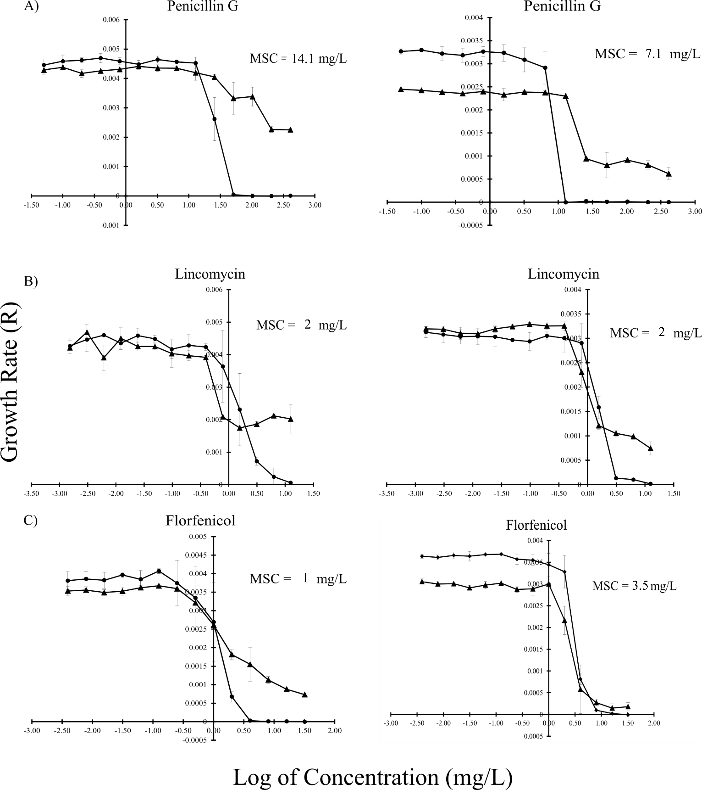
FIG. S1 The growth rate (R) as a function of log of antibiotic concentrations in MHB (left) or M9+ (right) between E. coli host CV601 () and plasmid-bearing E. coli CV601(pT270A) () in the presence of A) Penicillin G, B) Lincomycin, and C) Florfenicol. Experiments were performed in triplicate. Standard deviations are indicated.
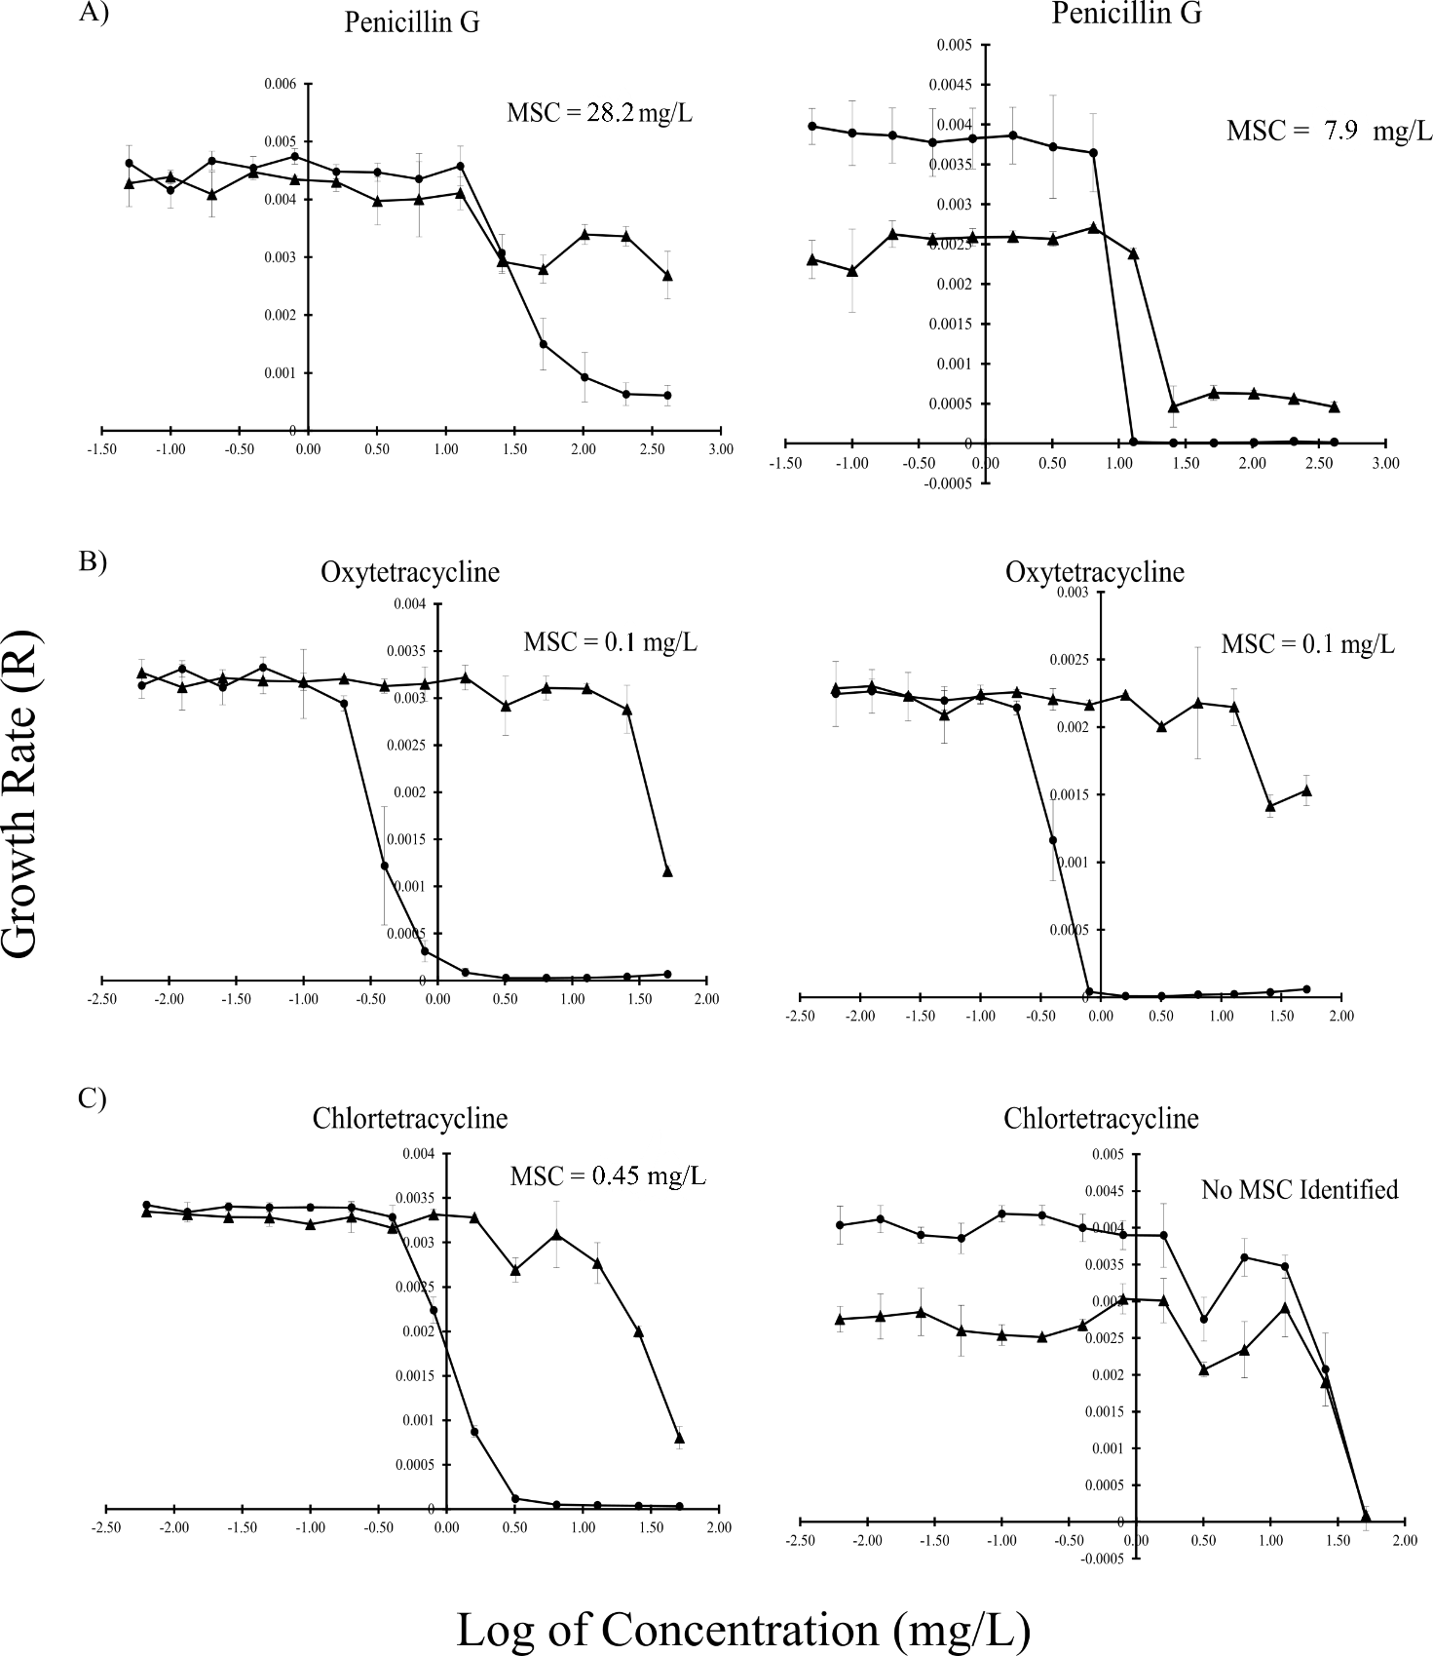

FIG. S2 The growth rate (R) as a function of log of antibiotic concentrations in MHB (left) or M9+ (right) between E. coli host CV601 () and plasmid-bearing E. coli CV601(pT413A) () in the presence of A) Penicillin G, B) Oxytetracycline, C) Chlortetracycline. Experiments were performed in triplicate. Standard deviations are indicated.
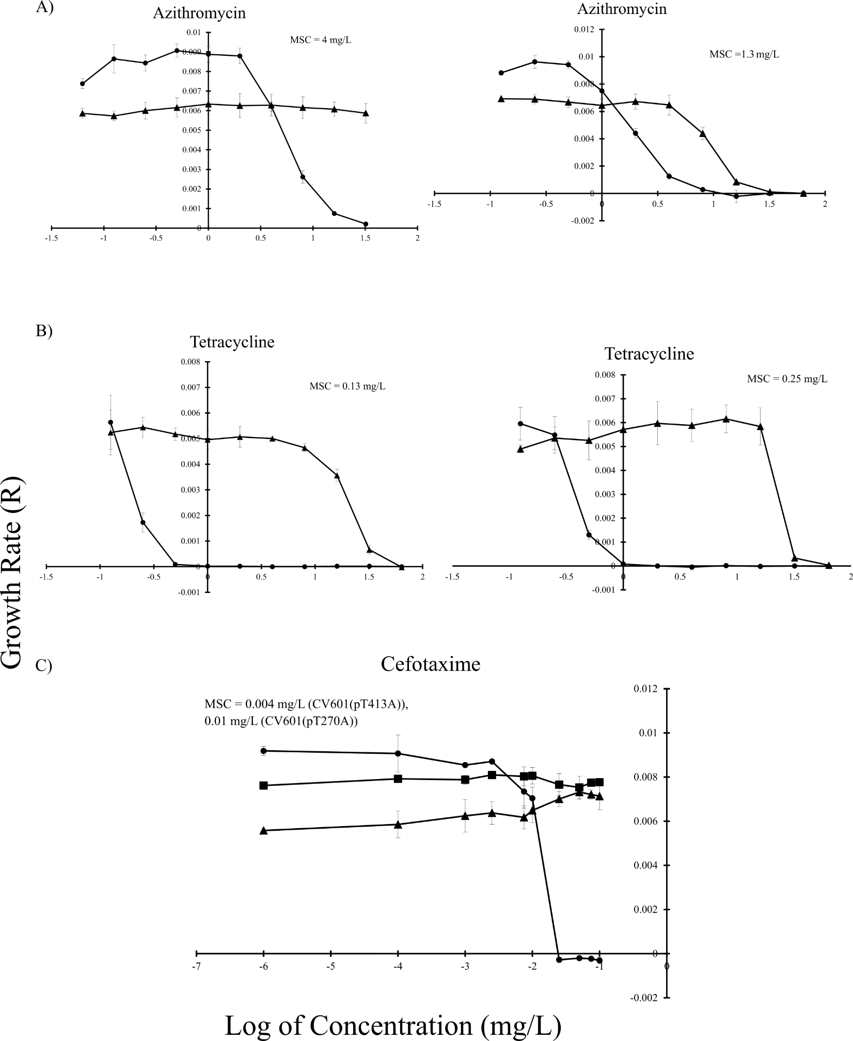
FIG. S3 The growth rate (R) as a function of log of antibiotic concentrations in LB between E. coli host CV601() and plasmid-bearing E. coli () in the presence of A) Azithromycin using CV601(pT413A) (left) and CV601(pTA1a+pTA1b) (right), B) Tetracycline CV601(pT413A) (left) and CV601(pT295A) (right). Experiments were performed in quadruplicate. C) The growth rate (R) as a function of log of cefotaxime concentrations in LB among E. coli host CV601 () and plasmid-bearing E. coli strains: CV601(pT270A) (), CV601(pT413A) (). Experiment was performed in duplicate (E. coli host) and triplicate (plasmid-bearing E. coli) on the same 96-well plate. Standard deviations are indicated.

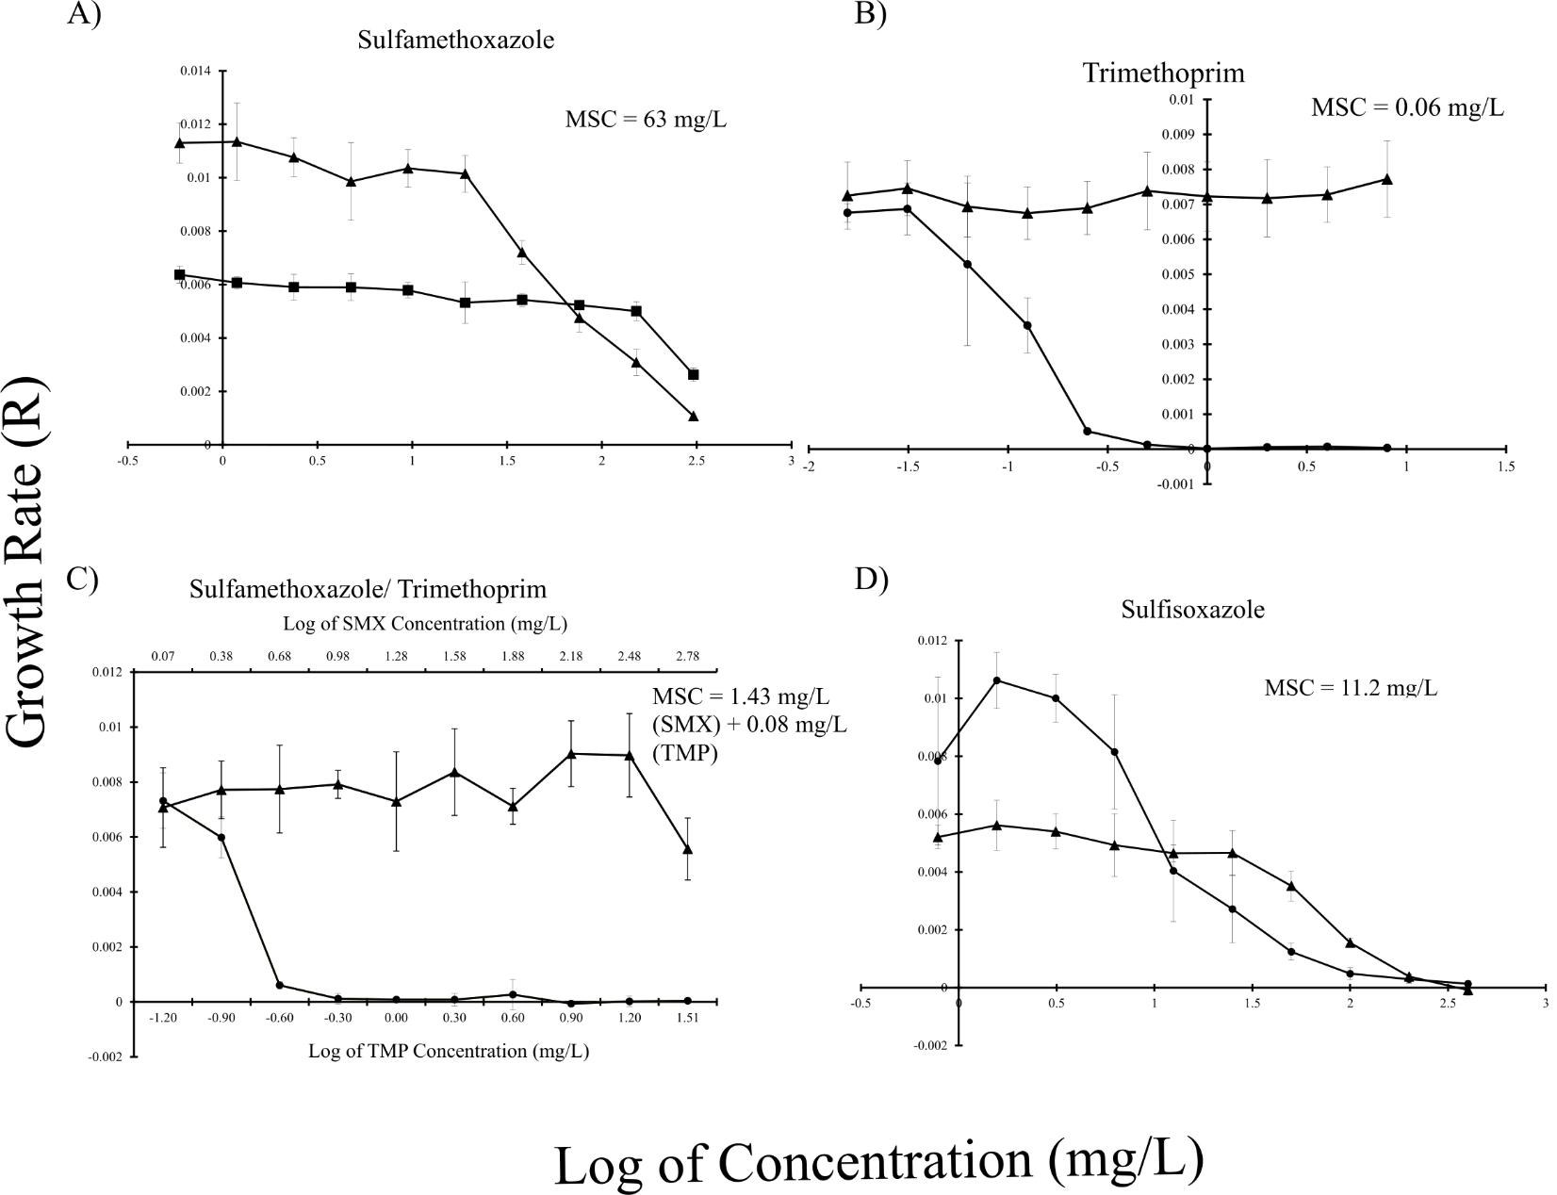
FIG. S4 The growth rate (R) as a function of log of antibiotic concentrations in LB between two E. coli strains: E. coli host CV601 () and plasmid-bearing E. coli CV601(pT295A) () in the presence of A) Sulfamethoxazole, B) Trimethoprim, C) Sulfamethoxazole + Trimethoprim, D) Sulfisoxazole. Standard deviations are indicated. Experiments were performed in quadruplicate.

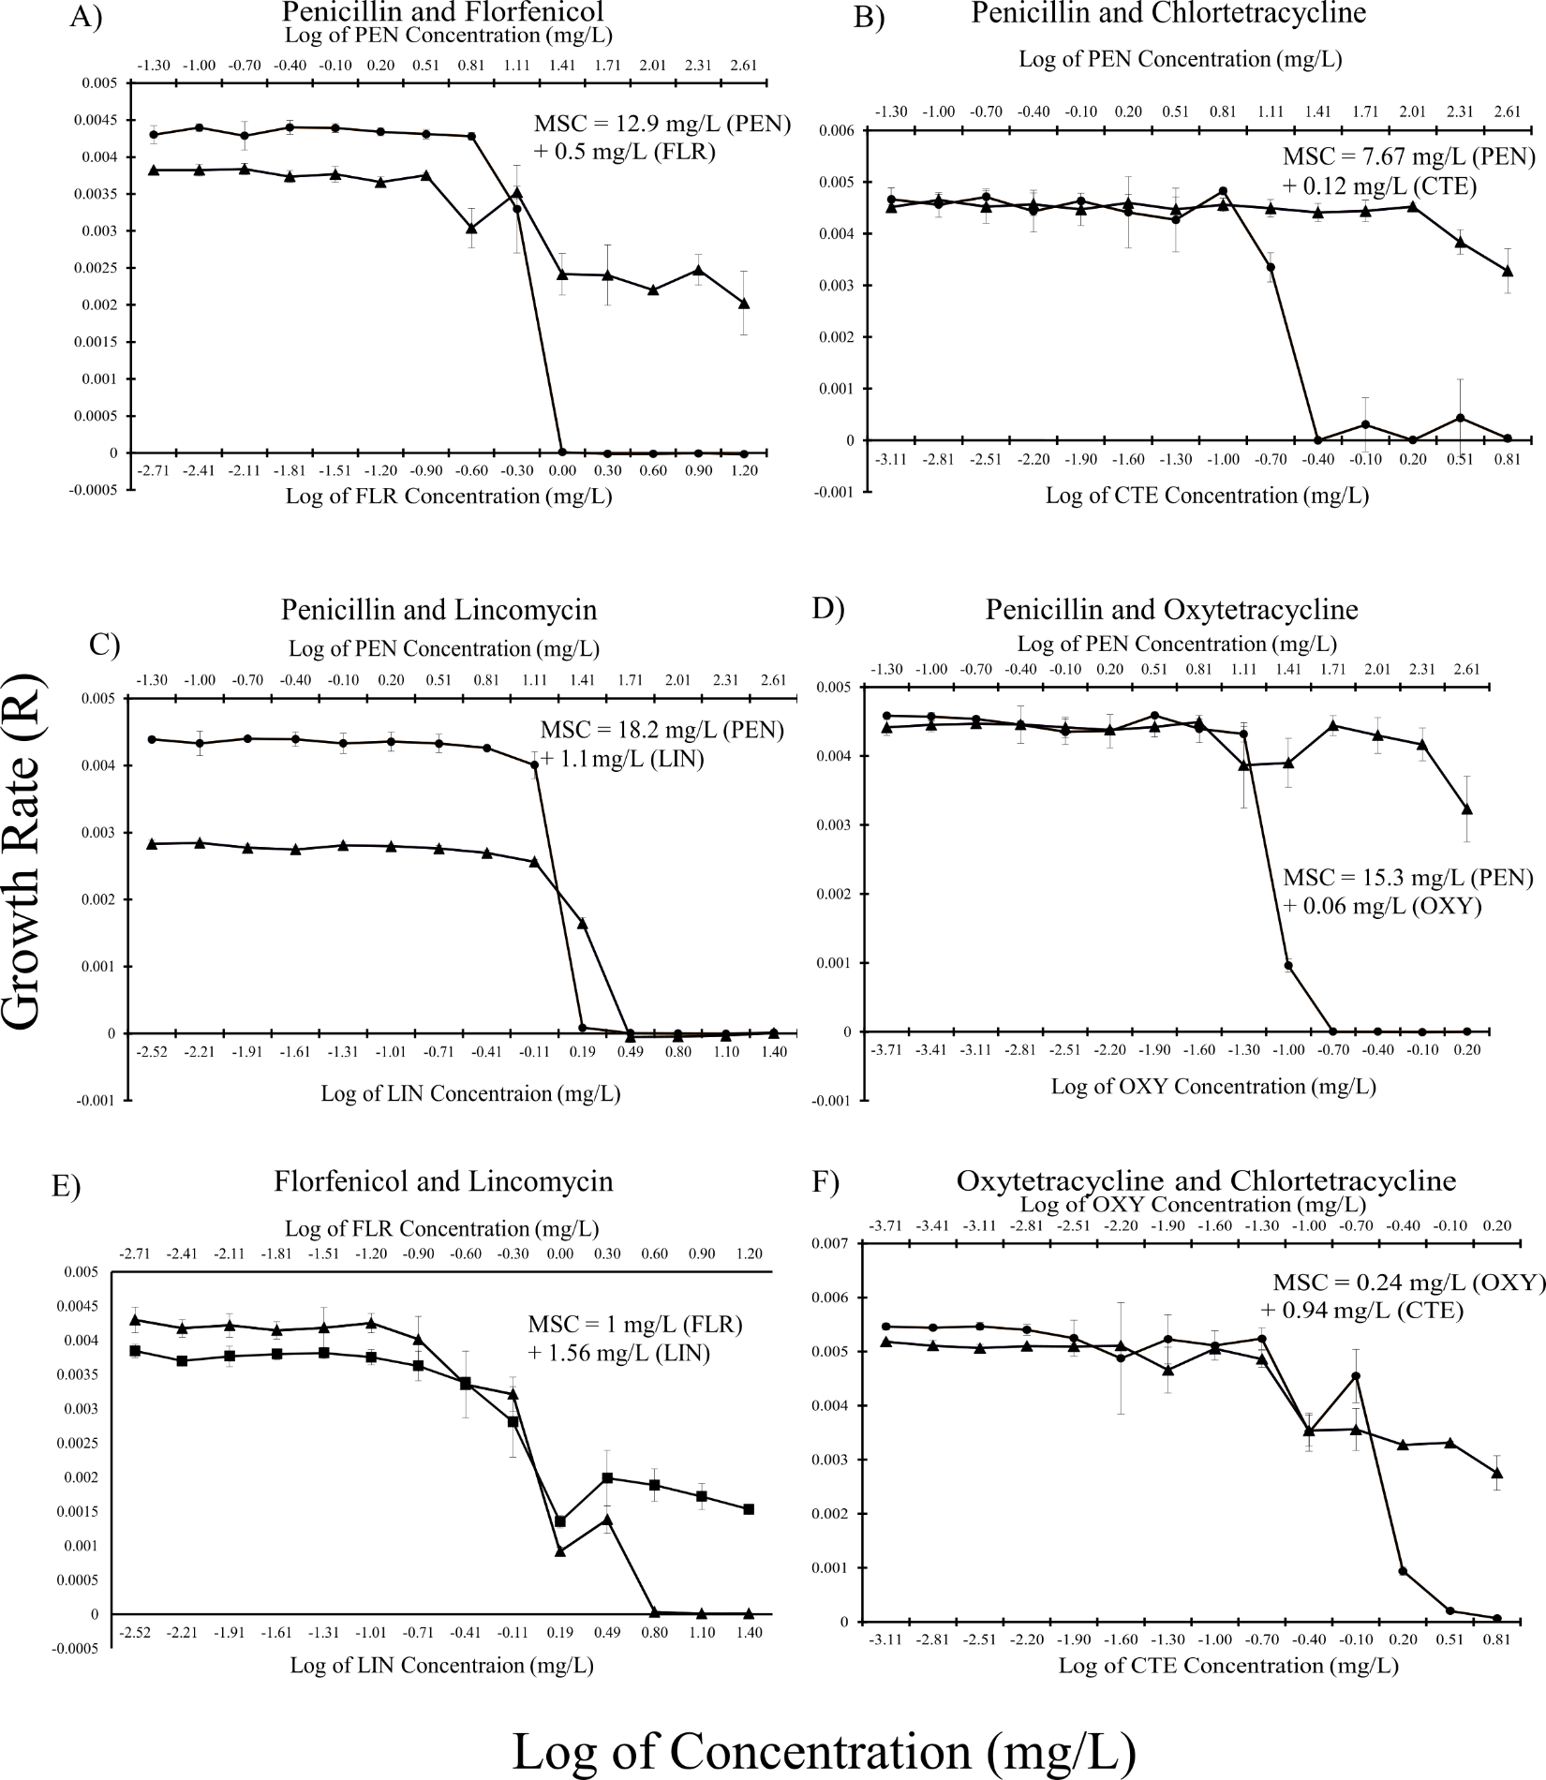
FIG. S5 The growth rate (R) as a function of log of combined antibiotic concentrations in MHB between E. coli host CV601 () and plasmid-bearing E. coli (): CV601 (pT270A) (left), CV601 (pT413A) (right) in the mixture of two antibiotics. A) Penicillin G + Florfenicol, B) Penicillin G + Chlortetracycline, and C) Penicillin G + Lincomycin, D) Penicillin G + Oxytetracycline, E) Florfenicol + Lincomycin, and F) Oxytetracycline + Chlortetracycline. Two X-axes represent the concentration range of two antibiotics used in the test. Standard deviations are indicated. Experiments were performed in triplicate.

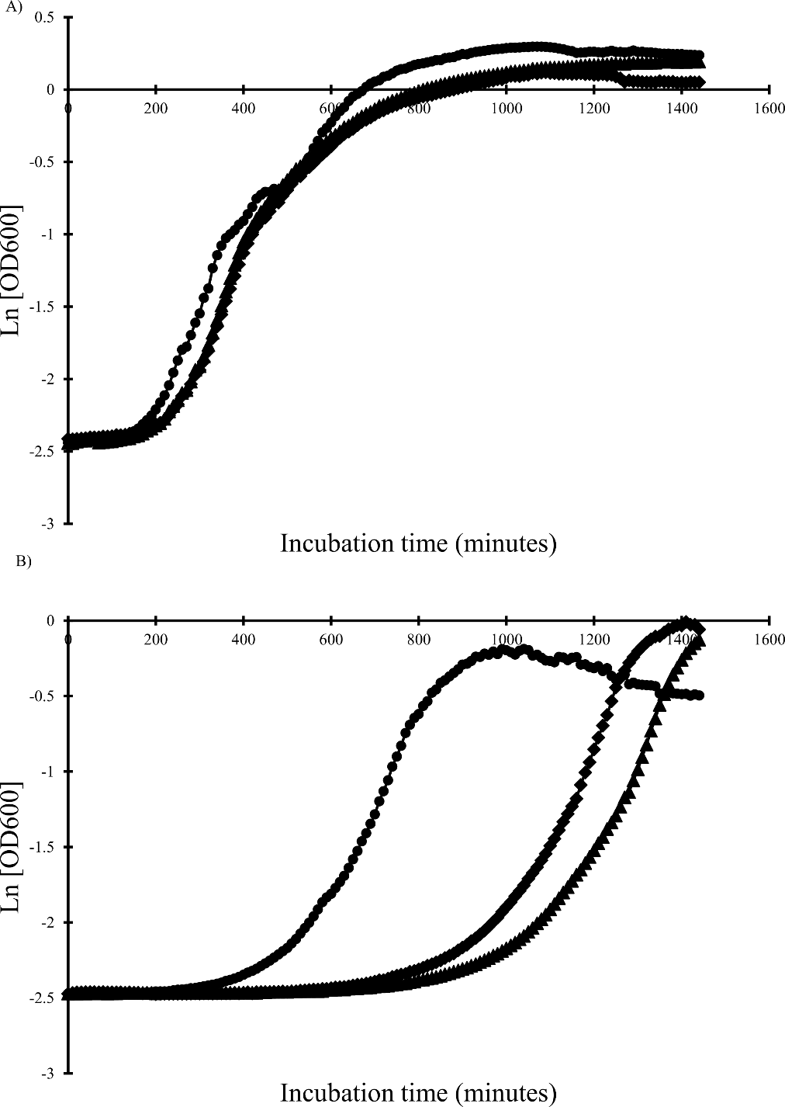
FIG. S6 Average growth curves as a function of incubation time when culturing an E. coli host CV601 () and two plasmid-bearing strains: CV601(pT270A) (), CV601(pT413A) () in two antibiotic-free media at 37°C: A) MHB, B) M9+. Values were the mean of three triplicates.

