Western blot images supplementary materials

This section will provide images of the three replicate samples used for Western blot experiments. The three replicate experiments are from three independent mouse hippocampal samples in the same group. For Western blot, the top and bottom of each blot label the position of the Marker (specific molecular weights of each protein can be found in the legend or figures of the manuscript), and the group corresponding to each lane is labeled at the bottom of the image. All samples and controls used for a comparative analysis were run on the same blot.

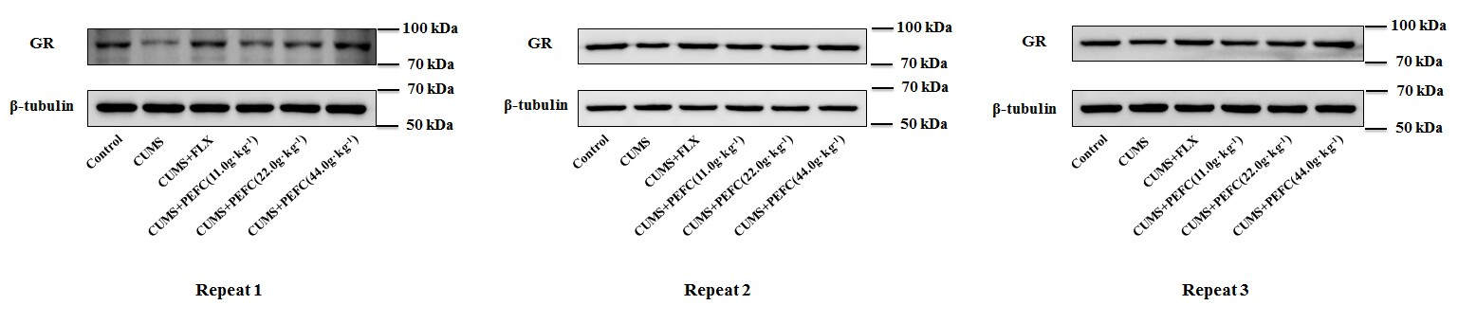
Figure S1. Western blot images of GR (90 kDa) in mouse hippocampus, corresponding to Figure 5(B) in the main text of the manuscript.. The three replicate experiments are from three independent mouse hippocampal samples in the same group and all samples and controls used for a comparative analysis were run on the same blot.

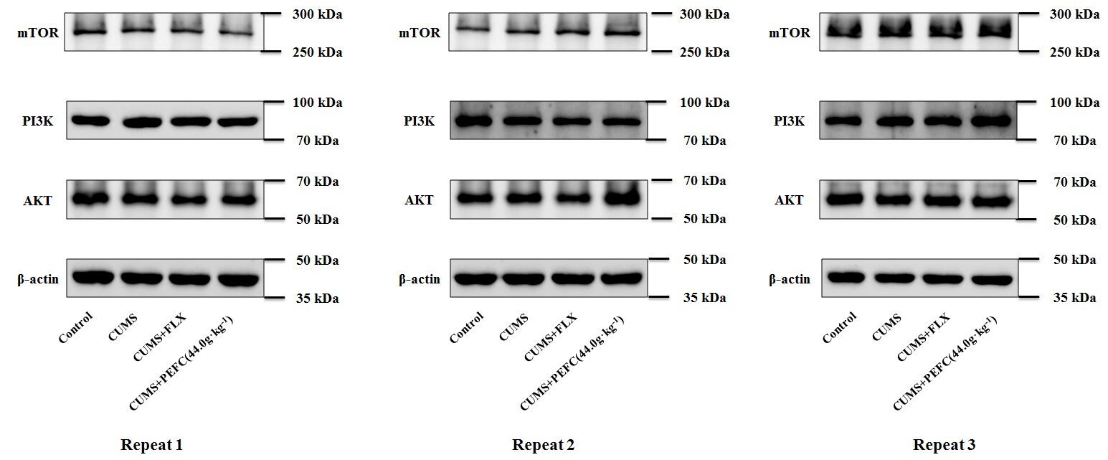
Figure S2. Western blot images of mTOR (289 kDa), PI3K (85 kDa) and AKT (60 kDa) in mouse hippocampus, corresponding to Figure 10(A) in the main text of the manuscript. The three replicate experiments are from three independent mouse hippocampal samples in the same group and all samples and controls used for a comparative analysis were run on the same blot.
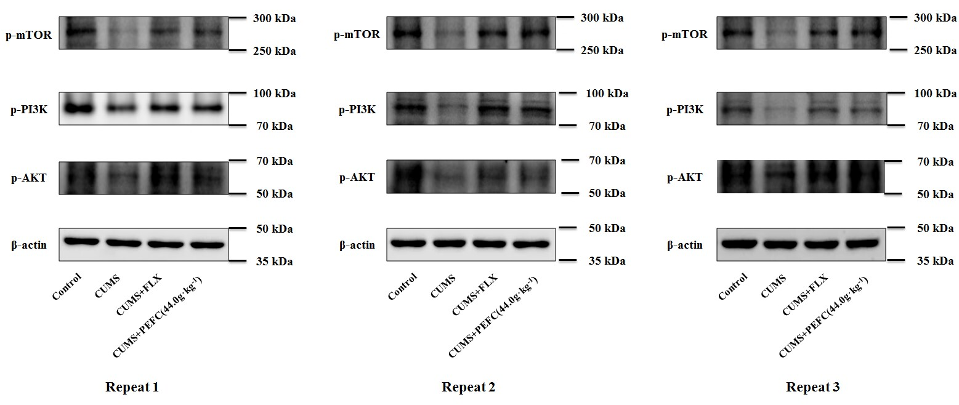
Figure S2. Western blot images of p-mTOR (289 kDa), p-PI3K (85 kDa) and p-AKT (60 kDa) in mouse hippocampus, corresponding to Figure 10(A) in the main text of the manuscript. The three replicate experiments are from three independent mouse hippocampal samples in the same group and all samples and controls used for a comparative analysis were run on the same blot.

