Supplementary Document
Table S1: Unstandardized beta coefficients for multilevel path analysis results for comorbid overweight/obesity and depression by gender
Outcome | Predictor | Female  β (95% CI) | Male  β (95% CI)
Social cohesion | Income Inequality | -0.25 (-0.43 -0.08) | -0.25 (-0.41 -0.10)
Comorbid overweight/obesity and depression | Income Inequality | -0.04 (-0.11 0.03) | 0.05 (-0.08 0.17)
 | Social Cohesion | -0.34 (-0.36 -0.32) | -0.29 (-0.31 -0.27)
 | Age | -0.06 (-0.09 -0.02) | 0.02 (-0.03 0.08)
 | Ethnicity
 | White | 0 | 0
 | Others | 0.43 (0.21 0.64) | 0.41 (0.28 0.54)
 | Weekly spending money
 | 0 | 0 | 0
 | 1 to 5 | -0.02 (-0.22 0.18) | -0.12 (-0.30 0.06)
 | 6 to 10 | -0.10 (-0.28 0.08) | -0.37 (-0.56 -0.17)
 | 11 to 20 | -0.16 (-0.34 0.02) | -0.10 (-0.28 0.08)
 | 21 to 40 | -0.25 (-0.45 -0.05) | -0.09 (-0.24 0.05)
 | 41 to 100 | -0.22 (-0.36 -0.07) | -0.23 (-0.40 -0.06)
 | >100 | -0.10 (-0.25 0.04) | -0.19 (-0.35 -0.03)
 | Don't Know | -0.36 (-0.52 -0.19) | -0.31 (-0.45 -0.16)
 | Alcohol consumption
 | None | 0 | 0
 | <Once per month | 0.42 (0.32 0.52) | 0.23 (0.11 0.35)
 | Monthly | 0.64 (0.47 0.81) | 0.48 (0.31 0.65)
 | Weekly | 0.65 (0.42 0.89) | 0.56 (0.33 0.79)
 | Not stated | -0.14 (-0.96 0.68) | 0.40 (-0.30 1.11)
 | Physical activity
 | <60 minutes a day | 0 | 0
 | >60 minutes a day | 0.10 (0.02 0.19) | -0.12 (-0.24 0.00)
 | Not stated | -0.13 (-0.50 0.25) | -0.09 (-0.58 0.40)
 | Provinces
 | Ontario | 0 | 0
 | Alberta | 0.05 (-0.23 0.33) | -0.11 (-0.52 0.30)
 | British Columbia | -0.14 (-0.32 0.04) | -0.11 (-0.37 0.15)
 | Quebec | -0.45 (-0.57 -0.33) | -0.60 (-0.84 -0.36)
 | Median after tax income | -0.05 (-0.07 -0.03) | 0.00 (-0.08 0.08)
 | Population size | -0.02 (-0.04 0.00) | -0.02 (-0.03 0.00)

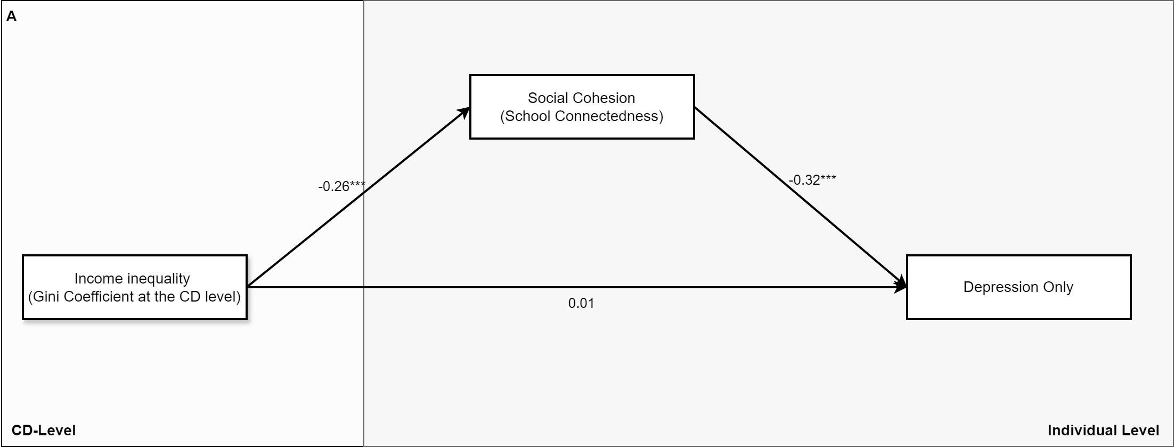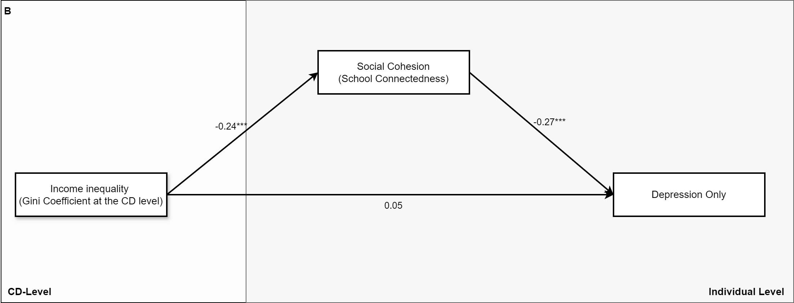
*= p < 0.05, ** = p < 0.01 *** = p < 0.001
Figure S1: Path diagrams (A-Females and B-Males) displaying the unstandardized beta coefficients of the multilevel path analysis between CD-Level income inequality and depression as mediated by social cohesion: COMPASS 2018-2019
Table S2: Multi-level path analysis results of depression by gender
 | Variable | Female  OR (95% CI) | Male  OR (95% CI)
Direct Effect | Income Inequality | 1.01 (0.90 1.14) | 1.05 (0.96 1.14)
Indirect Effect | Income Inequality - social cohesion | 1.08 (1.03 1.14) | 1.07 (1.02 1.11)
Covariates | Individual level
 | Age | 0.99 (0.97 1.02) | 1.11 (1.06 1.16)
 | Ethnicity
 | White | 1.00 | 1.00
 | Others | 1.25 (1.10 1.43) | 1.33 (1.22 1.46)
 | Weekly spending money
 | 0 | 1.00 | 1.00
 | 1 to 5 | 1.11 (0.92 1.35) | 1.08 (0.89 1.30)
 | 6 to 10 | 0.92 (0.78 1.10) | 1.01 (0.85 1.20)
 | 11 to 20 | 0.95 (0.81 1.11) | 0.98 (0.85 1.14)
 | 21 to 40 | 0.88 (0.75 1.03) | 0.88 (0.77 0.99)
 | 41 to 100 | 0.86 (0.73 1.00) | 0.91 (0.78 1.07)
 | >100 | 0.82 (0.71 0.94) | 0.82 (0.74 0.91)
 | Don't Know | 0.81 (0.71 0.92) | 0.85 (0.74 0.98)
 | Alcohol consumption
 | None | 1.00 | 1.00
 | <Once per month | 1.47 (1.33 1.62) | 1.25 (1.13 1.37)
 | Monthly | 1.93 (1.64 2.27) | 1.38 (1.23 1.55)
 | Weekly | 2.02 (1.59 2.57) | 1.47 (1.20 1.79)
 | Not stated | 1.44 (0.80 2.61) | 0.84 (0.37 1.89)
 | Physical activity
 | <60 minutes a day | 1.00 | 1.00
 | >60 minutes a day | 1.05 (0.98 1.12) | 0.88 (0.82 0.94)
 | Not stated | 0.96 (0.70 1.30) | 0.71 (0.46 1.11)
 | CD level
 | Provinces
 | Ontario | 1.00 | 1.00
 | Alberta | 0.84 (0.67 1.06) | 0.62 (0.48 0.81)
 | British Columbia | 0.97 (0.74 1.26) | 1.17 (0.93 1.47)
 | Quebec | 0.76 (0.66 0.88) | 0.84 (0.59 1.20)
 | Median after tax income | 0.99 (0.97 1.01) | 1.06 (1.01 1.12)
 | Population size | 1.00 (0.98 1.01) | 0.99 (0.98 1.00)

Table S3: Unstandardized beta coefficients multilevel path analysis results for depression by gender
Outcome | Predictor | Female  β (95% CI) | Male  β (95% CI)
Social cohesion | Income Inequality | -0.26 (-0.41 -0.11) | -0.24 (-0.39 -0.08)
Depression | Income Inequality | 0.01 (-0.100 0.13) | 0.05 (-0.04 0.13)
 | Social Cohesion | -0.32 (-0.33 -0.31) | -0.27 (-0.28 -0.25)
 | Age | -0.01 (-0.03 0.02) | 0.10 (0.06 0.15)
 | Ethnicity
 | White | 0 | 0
 | Others | 0.23 (0.09 0.36) | 0.29 (0.20 0.38)
 | Weekly spending money
 | 0 | 0 | 0
 | 1 to 5 | 0.11 (-0.09 0.30) | 0.07 (-0.12 0.26)
 | 6 to 10 | -0.08 (-0.25 0.09) | 0.01 (-0.17 0.18)
 | 11 to 20 | -0.06 (-0.21 0.10) | -0.02 (-0.17 0.13)
 | 21 to 40 | -0.13 (-0.29 0.03) | -0.13 (-0.26 -0.01)
 | 41 to 100 | -0.16 (-0.31 0.00) | -0.09 (-0.25 0.07)
 | >100 | -0.20 (-0.35 -0.06) | -0.20 (-0.30 -0.09)
 | Don't Know | -0.21 (-0.34 -0.08) | -0.16 (-0.30 -0.02)
 | Alcohol consumption
 | None | 0 | 0
 | <Once per month | 0.38 (0.29 0.48) | 0.22 (0.12 0.32)
 | Monthly | 0.66 (0.50 0.82) | 0.32 (0.21 0.44)
 | Weekly | 0.70 (0.46 0.94) | 0.39 (0.19 0.59)
 | Not stated | 0.37 (-0.23 0.96) | -0.17 (-0.98 0.63)
 | Physical activity
 | <60 minutes a day | 0 | 0
 | >60 minutes a day | 0.05 (-0.02 0.12) | -0.13 (-0.20 -0.06)
 | Not stated | -0.05 (-0.36 0.27) | -0.34 (-0.77 0.10)
 | Provinces
 | Ontario | 0 | 0
 | Alberta | -0.17 (-0.39 0.06) | -0.47 (-0.74 -0.21)
 | British Columbia | -0.04 (-0.30 0.23) | 0.16 (-0.08 0.39)
 | Quebec | -0.27 (-0.41 -0.13) | -0.17 (-0.52 0.18)
 | Median after tax income | -0.01 (-0.03 0.01) | 0.06 (0.01 0.12)
 | Population size | 0.00 (-0.02 0.01) | -0.01 (-0.02 0.00)

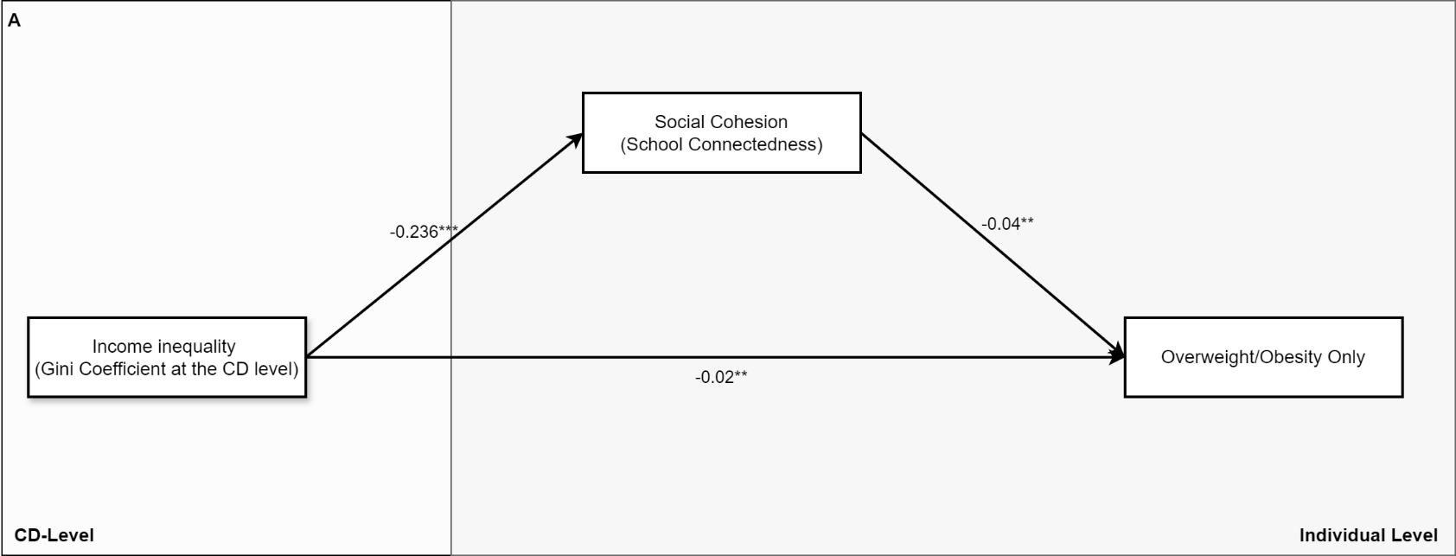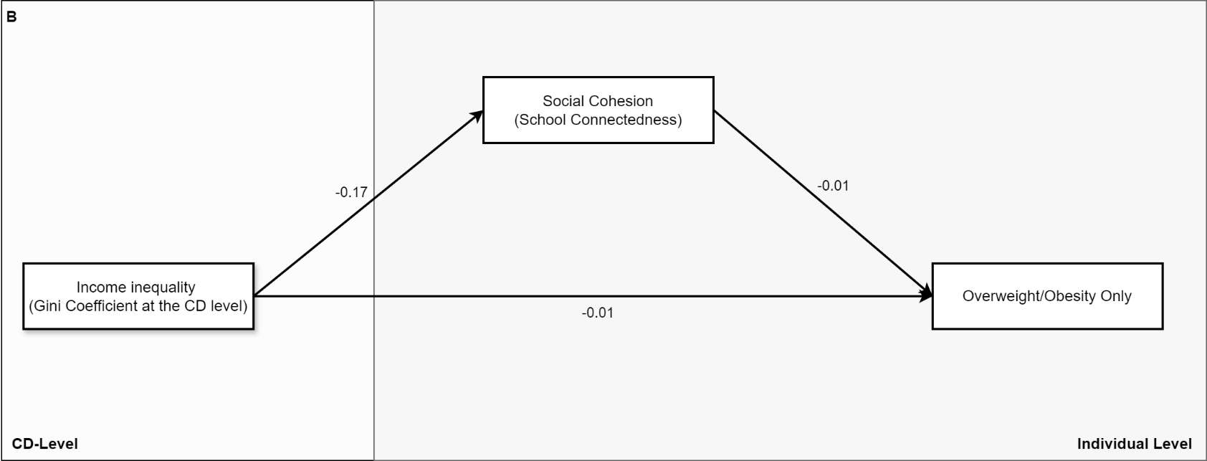
*= p < 0.05, ** = p < 0.01 *** = p < 0.001
Figure S2: Path diagrams (A-Females and B-Males) displaying the unstandardized beta coefficients of the multilevel path analysis between CD-Level income inequality and overweight/obesity as mediated by social cohesion: COMPASS 2018-2019
Table S4: Multi-level path analysis results of overweight/obesity by gender
 | Variable | Female  OR (95% CI) | Male  OR (95% CI)
Direct effect | Income inequality | 0.98 (0.97 0.99) | 1.01 (0.48 2.13)
Indirect effect | Income inequality - social cohesion | 1.01 (1.00 1.02) | 1.00 (0.99 1.02)
Covariates | Individual level
 | Age | 0.92 (0.89 0.95) | 0.92 (0.61 1.40)
 | Ethnicity
 | White | 1.00 | 1.00
 | Others | 1.26 (1.12 1.43) | 1.18 (0.98 1.42)
 | Weekly spending money
 | 0 | 1.00 | 1.00
 | 1 to 5 | 0.72 (0.59 0.89) | 0.97 (0.82 1.14)
 | 6 to 10 | 0.92 (0.80 1.06) | 0.87 (0.75 1.01)
 | 11 to 20 | 0.81 (0.69 0.96) | 0.95 (0.83 1.10)
 | 21 to 40 | 0.85 (0.75 0.97) | 1.12 (0.99 1.28)
 | 41 to 100 | 0.88 (0.78 1.00) | 1.09 (0.98 1.20)
 | >100 | 0.93 (0.81 1.08) | 1.15 (0.94 1.40)
 | Don't know | 0.74 (0.65 0.84) | 1.08 (0.96 1.21)
 | Alcohol consumption
 | None | 1.00 | 1.00
 | <Once per month | 1.15 (1.05 1.26) | 1.01 (0.88 1.15)
 | Monthly | 1.06 (0.95 1.18) | 1.08 (0.90 1.28)
 | Weekly | 1.00 (0.77 1.30) | 1.19 (1.07 1.32)
 | Not stated | 1.25 (0.68 2.30) | 0.81 (0.55 1.18)
 | Physical activity
 | <60 minutes a day | 1.00 | 1.00
 | >60 minutes a day | 1.00 (0.94 1.07) | 1.00 (0.86 1.15)
 | Not stated | 0.84 (0.55 1.27) | 0.74 (0.57 0.96)
 | CD Level
 | Provinces
 | Ontario
 | Alberta | 1.11 (1.09 1.13) | 1.10 (0.89 1.36)
 | British Columbia | 0.77 (0.76 0.78) | 0.93 (0.85 1.03)
 | Quebec | 0.89 (0.89 0.90) | 0.67 (0.44 1.02)
 | Median after tax income | 1.00 (0.99 1.00) | 0.94 (0.31 2.83)
 | Population size | 0.98 (0.97 0.98) | 0.98 (0.90 1.07)

Table S5: Unstandardized beta coefficients for multilevel path analysis results for overweight/obesity by gender
Outcome | Predictor | Female  β (95% CI) | Male  β (95% CI)
Social cohesion | Income inequality | -0.24 (-0.37 -0.11) | -0.17 (-0.39 0.05)
Overweight/Obesity | Income inequality | -0.02 (-0.03 -0.01) | 0.01 (-0.74 0.76)
 | Social cohesion | -0.04 (-0.06 -0.02) | -0.01 (-0.09 0.08)
 | Age | -0.08 (-0.11 -0.05) | -0.08 (-0.49 0.33)
 | Ethnicity
 | White | 0 | 0
 | Others | 0.24 (0.11 0.36) | 0.17 (-0.02 0.35)
 | Weekly spending money
 | 0 | 0 | 0
 | 1 to 5 | -0.33 (-0.53 -0.12) | -0.03 (-0.19 0.13)
 | 6 to 10 | -0.08 (-0.22 0.06) | -0.14 (-0.28 0.01)
 | 11 to 20 | -0.21 (-0.38 -0.04) | -0.05 (-0.19 0.09)
 | 21 to 40 | -0.16 (-0.29 -0.03) | 0.12 (-0.01 0.25)
 | 41 to 100 | -0.12 (-0.24 0.00) | 0.08 (-0.02 0.18)
 | >100 | -0.07 (-0.22 0.07) | 0.14 (-0.07 0.34)
 | Don't know | -0.30 (-0.43 -0.17) | 0.07 (-0.05 0.19)
 | Alcohol consumption
 | None | 0 | 0
 | <Once per month | 0.14 (0.05 0.23) | 0.01 (-0.13 0.14)
 | Monthly | 0.06 (-0.06 0.17) | 0.08 (-0.10 0.25)
 | Weekly | 0.00 (-0.27 0.26) | 0.17 (0.07 0.28)
 | Not stated | 0.23 (-0.38 0.83) | -0.22 (-0.6 0.17)
 | Physical activity
 | <60 minutes a day | 0 | 0
 | >60 minutes a day | 0.00 (-0.07 0.07) | -0.01 (-0.15 0.14)
 | Not stated | -0.18 (-0.6 0.24) | -0.30 (-0.57 -0.04)
 | Provinces
 | Ontario | 0 | 0
 | Alberta | 0.10 (0.09 0.12) | 0.10 (-0.11 0.30)
 | British Columbia | -0.27 (-0.28 -0.25) | -0.07 (-0.17 0.03)
 | Quebec | -0.11 (-0.12 -0.10) | -0.40 (-0.81 0.02)
 | Median after tax income | 0.00 (-0.01 0.00) | -0.06 (-1.16 1.04)
 | Population size | -0.03 (-0.03 -0.02) | -0.02 (-0.10 0.07)

