Supplementary Material

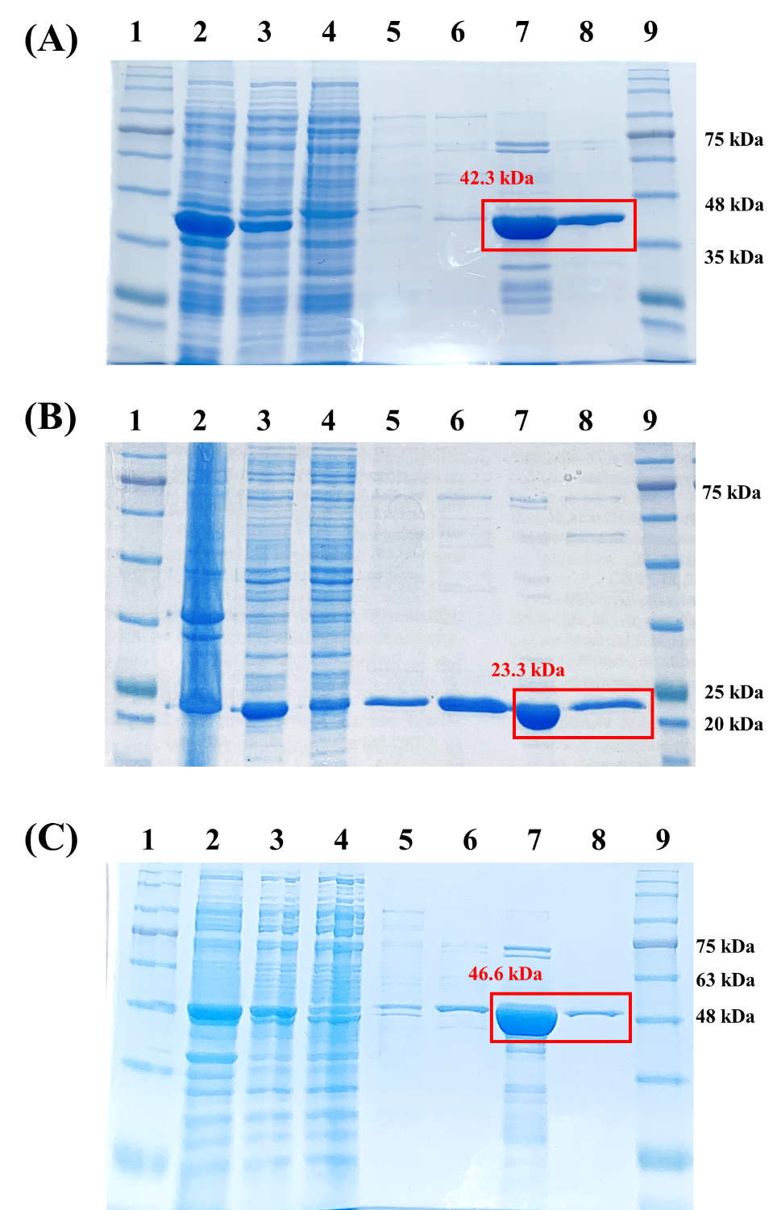
Supplementary Figure 1. SDS-PAGE analysis of purified LysGR1 (42.3 kDa) (A), its EAD (23.3 kDa) (B), and EGFP-fused LysGR1_CBD (46.6 kDa) (C). Lane 1 & 9; protein marker (GenDepot, P8503-050), lane 2; cell extract, lane 3; supernatant, lane 4; Ni-NTA flow-through, lane 5; washing (10 mM imidazole), lane 6; washing (20 mM imidazole), lane 7 & 8; elution (200 mM imidazole). Red boxes indicate the target proteins we used.

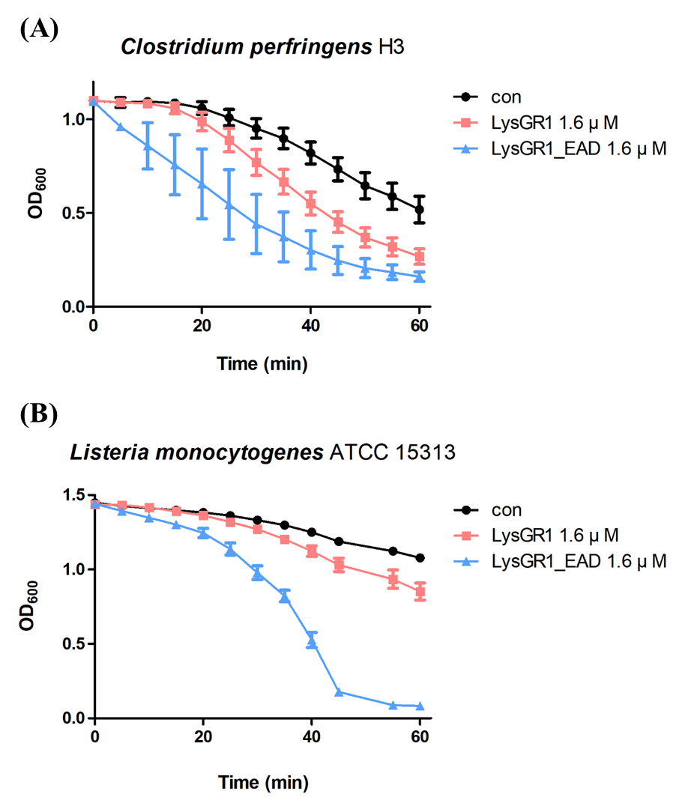
Supplementary Figure 2. Lytic activity of LysGR1 and LysGR1_EAD against Clostridium perfringens H3 cells (A) and Listeria monocytogenes ATCC 15313 cells (B).

Supplementary Table 1 Plasmids and primers used in this study

