Title
The Impact of External Drainage of the Main Pancreatic Duct and Common Bile Duct on Postoperative Pancreatic Fistula Following Pancreaticoduodenectomy: Protocol for A Multi-center Prospective Randomized Controlled Trial

Authors
Wen-Quan Wang^{1, 2, 3†}, Yao-Lin Xu^{1, 2, 3†}, Lin-Hui Tang^{1, 2, 3†}, Jun-Yi He^{1, 2, 3}, Yu Li^{1, 2, 3}, Fei Liang⁴, Yue-Ming Zhang^{1, 2, 3}, Wei Gan^{1, 2, 3}, Hua-Xiang Xu^{1, 2, 3}, Lei Zhang^{1, 2, 3}, Wen-Chuan Wu^{1, 2, 3}, Chen-Ye Shi^{1, 2, 3}, Yun Jin⁵, Chong-Yi Jiang⁶, Zheng Wang⁷, Min He⁸, Xu-An Wang^{1, 2, 3}, Yu-Dong Qiu⁹, Liang Liu^{1, 2, 3*}

¹Department of Pancreatic Surgery, Zhongshan Hospital, Fudan University, Shanghai, China.
²Cancer Center, Zhongshan Hospital, Fudan University, Shanghai, China.
³Department of General Surgery, Zhongshan Hospital, Fudan University, Shanghai, China.
⁴Department of Biostatistics, Zhongshan Hospital, Fudan University, Shanghai, China.
⁵Department of Hepatobiliary Surgery, The First People's Hospital of Yunnan Province, Kunming City, Yunnan Province, China.
⁶Department of Hepato-Biliary-Pancreatic Surgery, Huadong Hospital Affliated to Fudan University, Shanghai, China.
⁷Department of Hepatobiliary Surgery, The First Affiliated Hospital of Xi’an Jiaotong University, Xi’an City, Shaanxi Province, China.
⁸Department of Biliary-Pancreatic Surgery, Shanghai Jiao Tong University School of Medicine Affiliated Renji Hospital, Shanghai, China.
⁹Department of General Surgery, Nanjing University Medical School Affiliated Nanjing Drum Tower Hospital, Nanjing City, Jiangsu Province, China.
†These authors contributed equally to this work.

Corresponding author.
Liang Liu, MD, PhD, Professor
Department of Pancreatic Surgery, Zhongshan Hospital, Fudan University, 180 Feng Lin Road, Shanghai, China
Email: liu.liang@zs-hospital.sh.cn

Supplementary Materials - Index

Supplementary Methods
Surgical intervention | Page 3-4
Data collection and management | Page 4
Dissemination policy and confidentiality | Page 4
Supplementary Figures and Tables
Supplementary Figure 1. Placement of external drainage tubes. | Page 5
Supplementary Table 1. SPIRIT-Checklist | Page 6-10
Supplementary Table 2. Definition and grading system of postpancreatectomy complications. | Page 11-12

Supplementary Methods
Surgical intervention
Distinct drainage approaches are employed between cohorts: the study group receives external drainage of both MPD and CBD, while the control group experiences internal drainage. In both groups, reconstruction is performed using the Child technique, sequentially comprising pancreaticojejunostomy, hepaticojejunostomy, and Billroth II gastrojejunostomy. In the external drainage group, the pancreaticojejunostomy is performed following standardised procedures: after assessing pancreatic texture (soft/hard) and MPD diameter, approximately 2 cm of pancreatic stump is preserved. Hemostasis of the transected surface is achieved before anchoring the pancreatic remnant to the jejunal seromuscular layer using interrupted 3-0 polypropylene U-shaped sutures. An enterotomy is created in the jejunum, on the antimesenteric aspect proximal to the MPD site. A dissecting clamp is advanced approximately 5 cm in distance through this enterotomy. Using the clamp tip against the contralateral jejunal wall as a guide, a second enterotomy is created with electrocautery. An appropriately sized external drainage tube is passed retrograde through the second enterotomy, advanced along the jejunal lumen, and exteriorised at the pancreatic transection surface. A 4-0 Prolene suture is used to perform interrupted sutures between the posterior wall of the pancreatic duct and the jejunal mucosa, followed by interrupted sutures between the anterior wall of the pancreatic duct and the jejunal mucosa. A 3-0 Prolene suture is again used to perform interrupted sutures through the anterior pancreatic wall and the anterior jejunal wall, reinforcing the anastomosis. A purse-string suture is used to secure the outward end of the external drainage tube at the second enterotomy. Referring to the drainage device instructions, the drainage tube is brought out through the abdominal wall and connected to a drainage bag. For the hepaticojejunostomy, the CBD is measured, and an enterotomy is created 10 cm distal to the pancreatic anastomosis. Interrupted 4-0 absorbable sutures are used for duct-to-jejunal mucosa approximation. The external drainage tube for CBD is placed, secured, and exteriorised in a similar way to external drainage of MPD (Figure S1). In the internal drainage group, the pancreaticojejunostomy is also initiated by assessing pancreatic texture and MPD diameter. Both the end-to-end invagination and the duct-to-mucosa anastomotic approach are permitted when performing pancreaticojejunostomy. A trans-anastomotic stent is placed to span the MPD and jejunal lumen without external diversion. A jejunal enterotomy is created approximately 10 cm distal to the pancreatic anastomosis. Hepaticojejunostomy omits drainage tube placement, utilising direct mucosa-to-mucosa approximation with 4-0 absorbable sutures. (Figure 2) Specifically, for patients in the external drainage group and with past history of PTCD, the hepaticojejunostomy were performed same as those in the internal drainage group. This double external pancreatic-biliary drainage device has been authorised by the State Intellectual Property Office of China (patent number: ZL202222162808.2).

Data collection and management
The data collection encompasses baseline characteristics, surgical details, pathological diagnosis, postoperative complications, hospitalisation duration and associated costs, adjuvant therapy, assessment of tumour recurrence or metastasis, and long-term survival. The data management process at 6 centers follows the same procedure. The specific date of visits, patient conditions, their past and present medications, and treatment details are essential for each visit record. Additionally, medical information obtained from phone calls and other sources also needs to be documented in the original medical records. To ensure professional documentation, the information contained in the original medical record should be promptly transcribed into the appropriate section of the CRF. If any modification to the original medical records, CRF, and other documents is made, it must be dated and signed by researchers or their designated personnel. And if necessary, a concise description of the modification should be provided near the modification.

Dissemination policy and confidentiality
The research findings obtained from this study may be presented at international conferences and published in peer-reviewed medical journals, ensuring strict adherence to patient confidentiality as required by law. The personal information of patients will not be disclosed unless mandated by relevant legislation. When deemed necessary, the government management department and the hospital ethics committee, along with their authorised personnel in charge, may access patient data in accordance with corresponding regulations.

Supplementary Figures and Tables

Supplementary Figure 1. Placement of external drainage tubes.

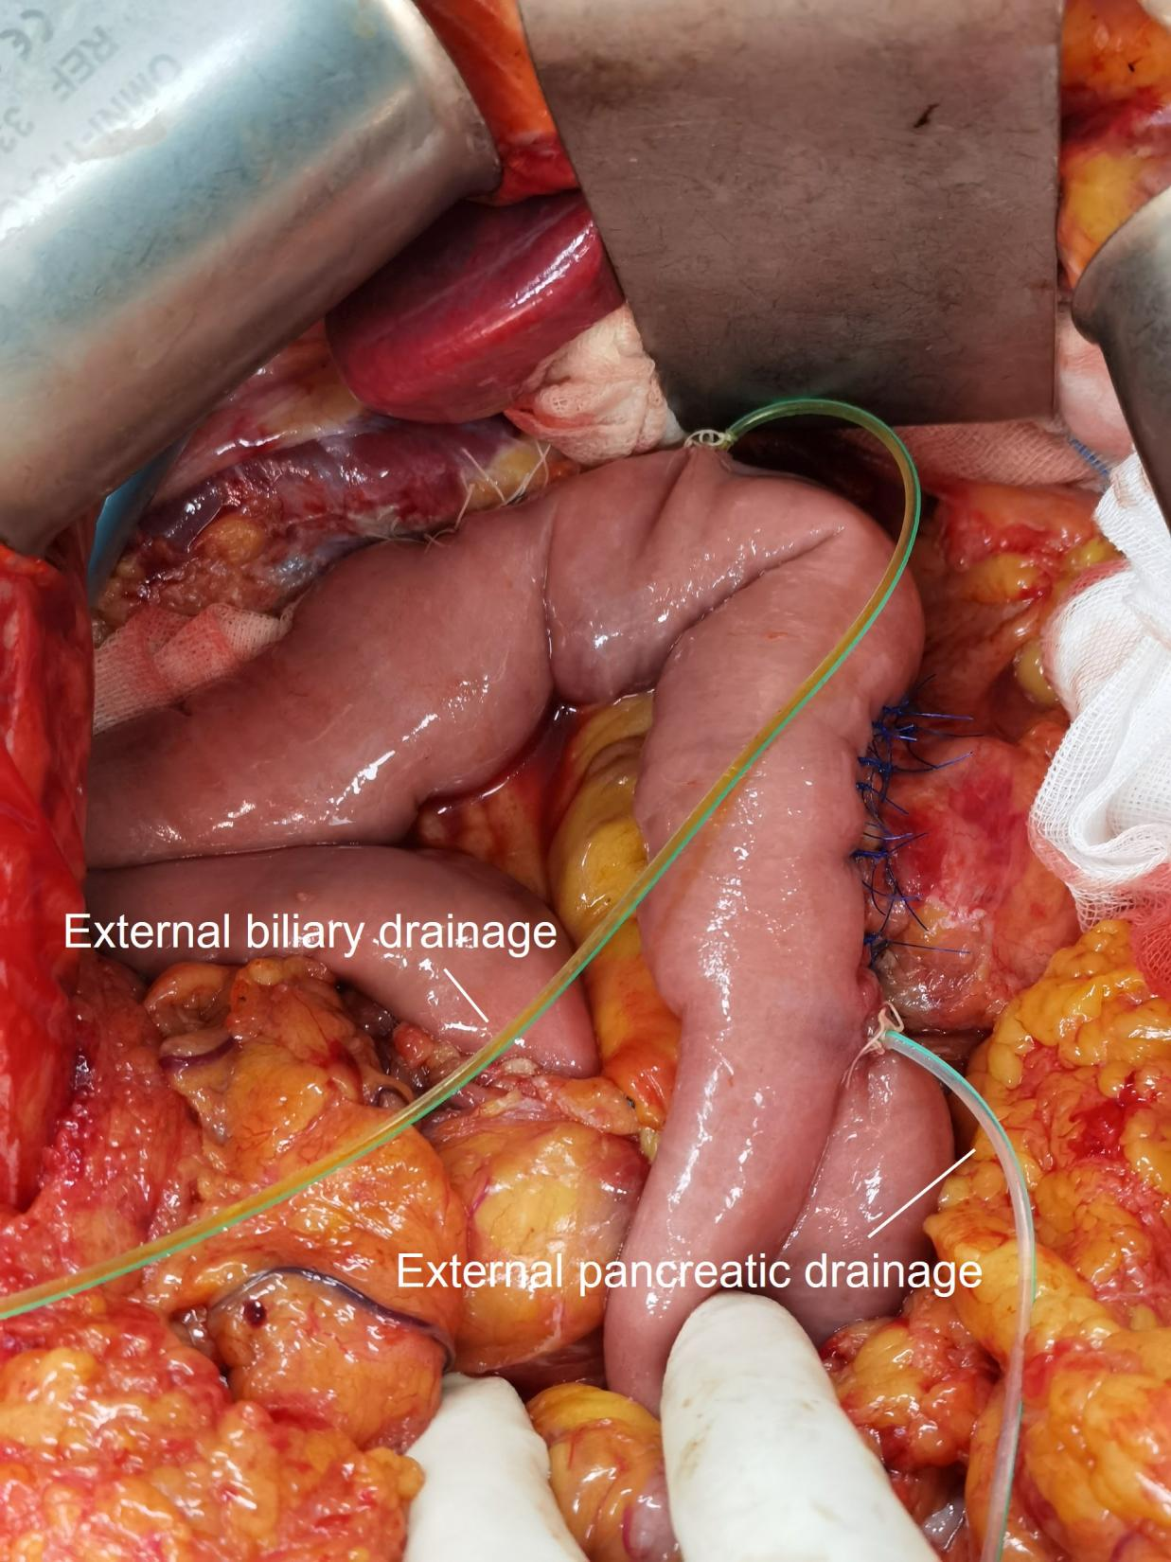

Supplementary Table 1. SPIRIT-Checklist


SPIRIT 2013 Checklist: Recommended items to address in a clinical trial protocol and related documents*
Section/item | ItemNo | Description | Addressed on page number
Administrative information
Title | 1 | Descriptive title identifying the study design, population, interventions, and, if applicable, trial acronym | 1
Trial registration | 2a | Trial identifier and registry name. If not yet registered, name of intended registry | 5
Trial registration | 2b | All items from the World Health Organization Trial Registration Data Set | Registered in ClinicalTrials.gov
Protocol version | 3 | Date and version identifier | 8
Funding | 4 | Sources and types of financial, material, and other support | 2
Roles and responsibilities | 5a | Names, affiliations, and roles of protocol contributors | 1-2
Roles and responsibilities | 5b | Name and contact information for the trial sponsor | 2
 | 5c | Role of study sponsor and funders, if any, in study design; collection, management, analysis, and interpretation of data; writing of the report; and the decision to submit the report for publication, including whether they will have ultimate authority over any of these activities | 3
 | 5d | Composition, roles, and responsibilities of the coordinating centre, steering committee, endpoint adjudication committee, data management team, and other individuals or groups overseeing the trial, if applicable (see Item 21a for data monitoring committee) | Not applicable
Introduction
Background and rationale | 6a | Description of research question and justification for undertaking the trial, including summary of relevant studies (published and unpublished) examining benefits and harms for each intervention | 5-7
 | 6b | Explanation for choice of comparators | 6-7
Objectives | 7 | Specific objectives or hypotheses | 6-7
Trial design | 8 | Description of trial design including type of trial (eg, parallel group, crossover, factorial, single group), allocation ratio, and framework (eg, superiority, equivalence, noninferiority, exploratory) | 6-7
Methods: Participants, interventions, and outcomes
Study setting | 9 | Description of study settings (eg, community clinic, academic hospital) and list of countries where data will be collected. Reference to where list of study sites can be obtained | 8
Eligibility criteria | 10 | Inclusion and exclusion criteria for participants. If applicable, eligibility criteria for study centres and individuals who will perform the interventions (eg, surgeons, psychotherapists) | 8-9
Interventions | 11a | Interventions for each group with sufficient detail to allow replication, including how and when they will be administered | 10-12
Interventions | 11b | Criteria for discontinuing or modifying allocated interventions for a given trial participant (eg, drug dose change in response to harms, participant request, or improving/worsening disease) | Not applicable
Interventions | 11c | Strategies to improve adherence to intervention protocols, and any procedures for monitoring adherence (eg, drug tablet return, laboratory tests) | Not applicable
Interventions | 11d | Relevant concomitant care and interventions that are permitted or prohibited during the trial | Not applicable
Outcomes | 12 | Primary, secondary, and other outcomes, including the specific measurement variable (eg, systolic blood pressure), analysis metric (eg, change from baseline, final value, time to event), method of aggregation (eg, median, proportion), and time point for each outcome. Explanation of the clinical relevance of chosen efficacy and harm outcomes is strongly recommended | 12-13
Participant timeline | 13 | Time schedule of enrolment, interventions (including any run-ins and washouts), assessments, and visits for participants. A schematic diagram is highly recommended (see Figure) | 13-14
Sample size | 14 | Estimated number of participants needed to achieve study objectives and how it was determined, including clinical and statistical assumptions supporting any sample size calculations | 14-15
Recruitment | 15 | Strategies for achieving adequate participant enrolment to reach target sample size | 15
Methods: Assignment of interventions (for controlled trials)
Allocation:
Sequence generation | 16a | Method of generating the allocation sequence (eg, computer-generated random numbers), and list of any factors for stratification. To reduce predictability of a random sequence, details of any planned restriction (eg, blocking) should be provided in a separate document that is unavailable to those who enrol participants or assign interventions | 15-16
Allocation concealment mechanism | 16b | Mechanism of implementing the allocation sequence (eg, central telephone; sequentially numbered, opaque, sealed envelopes), describing any steps to conceal the sequence until interventions are assigned | 15-16
Implementation | 16c | Who will generate the allocation sequence, who will enrol participants, and who will assign participants to interventions | 15-16
Blinding (masking) | 17a | Who will be blinded after assignment to interventions (eg, trial participants, care providers, outcome assessors, data analysts), and how | 15-16
 | 17b | If blinded, circumstances under which unblinding is permissible, and procedure for revealing a participant’s allocated intervention during the trial | Not applicable
Methods: Data collection, management, and analysis
Data collection methods | 18a | Plans for assessment and collection of outcome, baseline, and other trial data, including any related processes to promote data quality (eg, duplicate measurements, training of assessors) and a description of study instruments (eg, questionnaires, laboratory tests) along with their reliability and validity, if known. Reference to where data collection forms can be found, if not in the protocol | 16-17
 | 18b | Plans to promote participant retention and complete follow-up, including list of any outcome data to be collected for participants who discontinue or deviate from intervention protocols | Not applicable
Data management | 19 | Plans for data entry, coding, security, and storage, including any related processes to promote data quality (eg, double data entry; range checks for data values). Reference to where details of data management procedures can be found, if not in the protocol | 16-17
Statistical methods | 20a | Statistical methods for analysing primary and secondary outcomes. Reference to where other details of the statistical analysis plan can be found, if not in the protocol | 17-19
 | 20b | Methods for any additional analyses (eg, subgroup and adjusted analyses) | 17-19
 | 20c | Definition of analysis population relating to protocol non-adherence (eg, as randomised analysis), and any statistical methods to handle missing data (eg, multiple imputation) | 17-19
Methods: Monitoring
Data monitoring | 21a | Composition of data monitoring committee (DMC); summary of its role and reporting structure; statement of whether it is independent from the sponsor and competing interests; and reference to where further details about its charter can be found, if not in the protocol. Alternatively, an explanation of why a DMC is not needed | Not applicable
 | 21b | Description of any interim analyses and stopping guidelines, including who will have access to these interim results and make the final decision to terminate the trial | Not applicable
Harms | 22 | Plans for collecting, assessing, reporting, and managing solicited and spontaneously reported adverse events and other unintended effects of trial interventions or trial conduct | Not applicable
Auditing | 23 | Frequency and procedures for auditing trial conduct, if any, and whether the process will be independent from investigators and the sponsor | Not applicable
Ethics and dissemination
Research ethics approval | 24 | Plans for seeking research ethics committee/institutional review board (REC/IRB) approval | 19-20
Protocol amendments | 25 | Plans for communicating important protocol modifications (eg, changes to eligibility criteria, outcomes, analyses) to relevant parties (eg, investigators, REC/IRBs, trial participants, trial registries, journals, regulators) | 19-20
Consent or assent | 26a | Who will obtain informed consent or assent from potential trial participants or authorised surrogates, and how (see Item 32) | Not applicable
 | 26b | Additional consent provisions for collection and use of participant data and biological specimens in ancillary studies, if applicable | Not applicable
Confidentiality | 27 | How personal information about potential and enrolled participants will be collected, shared, and maintained in order to protect confidentiality before, during, and after the trial | 20
Declaration of interests | 28 | Financial and other competing interests for principal investigators for the overall trial and each study site | 4
Access to data | 29 | Statement of who will have access to the final trial dataset, and disclosure of contractual agreements that limit such access for investigators | 4
Ancillary and post-trial care | 30 | Provisions, if any, for ancillary and post-trial care, and for compensation to those who suffer harm from trial participation | Not applicable
Dissemination policy | 31a | Plans for investigators and sponsor to communicate trial results to participants, healthcare professionals, the public, and other relevant groups (eg, via publication, reporting in results databases, or other data sharing arrangements), including any publication restrictions | 20
 | 31b | Authorship eligibility guidelines and any intended use of professional writers | 20
 | 31c | Plans, if any, for granting public access to the full protocol, participant-level dataset, and statistical code | Not applicable
Appendices
Informed consent materials | 32 | Model consent form and other related documentation given to participants and authorised surrogates | Not applicable
Biological specimens | 33 | Plans for collection, laboratory evaluation, and storage of biological specimens for genetic or molecular analysis in the current trial and for future use in ancillary studies, if applicable | Not applicable
*It is strongly recommended that this checklist be read in conjunction with the SPIRIT 2013 Explanation & Elaboration for important clarification on the items. Amendments to the protocol should be tracked and dated. The SPIRIT checklist is copyrighted by the SPIRIT Group under the Creative Commons “Attribution-NonCommercial-NoDerivs 3.0 Unported” license.

Supplementary Table 2. Definition and grading system of postpancreatectomy complications.
Complications | Definition and grading system
Postoperative pancreatic fistula (POPF) | POPF is diagnosed when drain fluid amylase exceeds 3× the institutional upper limit of normal (ULN) serum amylase.  Biochemical Leak: Drain fluid amylase > 3 × ULN, without clinical impact;  Grade B: meet biochemical criteria, plus ≥ 1 of:  Persisting drainage > 3 weeks;  Requiring additional interventions including percutaneous or endoscopic drainage, angiographic procedures for bleeding, antibiotic therapy for infection, etc.  Grade C: requiring reoperation, presence of organ failure, or with a result of death.
Bile leakage (BL) | At least 3 times greater bilirubin concentration in drain or intra-abdominal fluid compared to serum:  Grade A: BL managed conservatively and without therapeutic intervention;  Grade B: BL requiring nonoperative interventions, or persistent Grade A bile leakage (> 7 days);  Grade C: BL requiring relaparotomy.
Chyle leak (CL) | Drain effluent demonstrate milky turbidity with triglyceride concentration ≥ 1 100 mg/L (1.2 mmol/L), on or after postoperative day 3:  Grade A: asymptomatic CL lasting within 7 days, with none intervention or oral dietary restrictions;  Grade B:  requiring ≥ 1 of:  Nasoenteral nutrition with dietary restriction and/or total parenteral nutrition (TPN);  Prolonged drainage (> 7 days) or percutaneous drainage;  Drug treatment (somatostatin analogs, antibiotics, etc.)  Grade C: requiring invasive interventions beyond percutaneous drainage, ICU admission, or with a result of death. B-grade cases requiring readmission for invasive interventions are reclassified as Grade C.
Postpancreatectomy hemorrhage (PPH) | Hemorrhagic manifestations requiring classification per:  Onset time:  Early onset: ≤ 24 hours postoperatively  Late onset: > 24 hours postoperatively  Location: intraluminal or extraluminal  Severity:  Mild: Hemoglobin concentration drop ≤ 30 g/L, transfusion ≤ 3 units packed red blood cells (PRBC)  Severe: Hemoglobin concentration > 30 g/L, transfusion > 3 units PRBC  Grade A: early-onset mild bleeding, without significant clinical impact.  Grade B:  Clinically significant bleeding requiring interventions.  Early-onset severe bleeding  Late-onset mild bleeding  Grade C: late-onset severe bleeding, with a presence of hypovolemic shock.
Delayed gastric emptying (DGE) | Excluding mechanical construction of digestive tract:  Grade A: nasogastric drainage persisting 4-7 days, or reinsertion after postoperative 3 days; unable to tolerate solid food within postoperative 7 days  Grade B: nasogastric drainage persisting 8-14 days, or reinsertion after postoperative 7 days; unable to tolerate solid food within postoperative 14 days  Grade C: nasogastric drainage persisting > 14 days, or after postoperative 14 days; unable to tolerate solid food within postoperative 21 days
Intra-abdominal infection | Intra-abdominal infection is defined the presence of symptoms including chills, high-grade fever (>39 ℃), abdominal distention and paralytic ileus emerging on or after postoperative day 3, persisting >24 hours, accompanied by:  Laboratory confirmation: markedly elevated white blood cell counts, procalcitonin, and hypersensitive C-reactive protein  Radiological evidence: computed tomography demonstrating intraperitoneal fluid collections  Microbiological confirmation: pathogen identification via culture of intraoperative specimens, percutaneous aspirates, or drainage fluid
Post pancreatectomy acute pancreatitis (PPAP) | PPAP is defined as an acute inflammatory condition of the pancreatic remnant following partial pancreatic resection, characterized by sustained postoperative serum hyperamylasemia, clinical relevance, and radiological confirmation.  Postoperative hyperamylasemia (POH): biochemical elevation of serum amylase, without clinical and radiological evidence of pancreatitis  Grade B:  Sustained serum amylase activity (> 48 hours)  Presence of radiological features including diffuse or localized inflammatory enlargement of pancreatic remnant, inflammatory changes of peripancreatic fat, intra and/or peripancreatic fluid collections, and parenchymal and/or peripancreatic necrosis  Grade C: life-threatening complications that lead with persistent organ failure (> 48 hours), ICU admission, reoperation, or death

