Associations of comorbid substance use disorders with clinical outcomes in schizophrenia using electronic health record data: Supplementary Materials

Supplementary Table 1: Poisson distribution model comparing the impact of comorbid substance use disorders (SUD) on number of unique antipsychotics prescribed to patients with schizophrenia (n=13,634), a significance threshold of p<.05 was used.
Variables |  |  |  |  |  |  | Reference category
 | n | Mean (SD) | IRR | Confidence Interval | p |  | n | Mean (SD)
SUD category |  |  |  |  |  |  | Without SUD
Alcohol only | 540 | 1.3 (1.1) | 0.93 | 0.86 to 1.01 | 0.073 |  | 10624 | 1.4 (1.1)
Cannabis only | 363 | 1.6 (1.3) | 1.13 | 1.04 to 1.23 | 0.003
Cocaine only | 135 | 1.1 (1.1) | 0.91 | 0.77 to 1.07 | 0.25
Opioid only | 113 | 1.5 (1.1) | 1.04 | 0.89 to 1.21 | 0.62
Nicotine only | 59 | 1.7 (1.2) | 1.20 | 0.98 to 1.46 | 0.076
Stimulant only | 42 | 1.5 (1.0) | 0.95 | 0.74 to 1.22 | 0.68
Others only | 667 | 1.4 (1.2) | 1.01 | 0.95 to 1.08 | 0.67
Polysubstance | 1091 | 1.5 (1.3) | 1.08 | 1.03 to 1.14 | 0.003
Gender |  |  |  |  |  |  | Female
Male | 8571 | 1.3 (1.1) | 0.91 | 0.89 to 0.94 | < 0.001 |  | 5063 | 1.5 (1.2)
Age |  |  |  |  |  |  | Age < 40
Age 40 and above | 7252 | 1.3 (1.1) | 0.89 | 0.86 to 0.92 | < 0.001 |  | 6382 | 1.5 (1.2)
Race |  |  |  |  |  |  | Black
White | 5280 | 1.5 (1.3) | 1.14 | 1.1 to 1.18 | < 0.001 |  | 4259 | 1.4 (1.1)
Others | 1002 | 1.4 (1.2) | 1.04 | 0.98 to 1.1 | 0.18
Unknown | 3093 | 1.2 (1.0) | 0.90 | 0.86 to 0.94 | < 0.001
Marital status |  |  |  |  |  |  | Divorced/  Separated
Single | 8694 | 1.4 (1.2) | 0.99 | 0.94 to 1.05 | 0.75 |  | 1152 | 1.4 (1.2)
Married/Engaged/In a relationship | 1066 | 1.5 (1.3) | 1.05 | 0.98 to 1.13 | 0.16
Widowed | 237 | 1.4 (1.1) | 1.03 | 0.92 to 1.16 | 0.61
Unknown | 2485 | 1.2 (1.0) | 0.92 | 0.86 to 0.98 | 0.008
Employment status |  |  |  |  |  |  | Disabled
Employed | 579 | 1.6 (1.4) | 0.95 | 0.87 to 1.03 | 0.18 |  | 1100 | 1.6 (1.2)
Unemployed/  Student/Retired | 2377 | 1.6 (1.2) | 0.93 | 0.87 to 0.98 | 0.008
Unknown | 9578 | 1.3 (1.1) | 0.82 | 0.78 to 0.86 | < 0.001
Year of Schizophrenia diagnosis |  |  |  |  |  |  | 2004 and before
2005 - 2009 | 3375 | 1.4 (1.1) | 1.32 | 1.21 to 1.43 | < 0.001 |  | 586 | 1.0 (1.0)
2010 – 2014 | 6941 | 1.4 (1.2) | 1.34 | 1.23 to 1.46 | < 0.001
2015 - 2020 | 2732 | 1.5 (1.2) | 1.45 | 1.33 to 1.58 | < 0.001
Note: IRR: Incidence rate ratio

Supplementary Table 2: CoxPH model comparing the impact of comorbid substance use disorders (SUD) on the duration of time to first antipsychotic discontinuation for patients with schizophrenia (n=9,504), a significance threshold of p<.05 was used.
Variables |  |  |  |  |  |  | Reference category
 | n | Mean (SD) | Hazard Ratio | Confidence Interval | p |  | n | Mean (SD)
SUD category |  |  |  |  |  |  | without SUD
Alcohol only | 346 | 342.1 (535.8) | 1.12 | 0.99 to 1.27 | 0.077 |  | 7490 | 357.8 (579.6)
Cannabis only | 267 | 306.9 (486.7) | 1.06 | 0.92 to 1.23 | 0.41
Opioid only | 82 | 333.1 (543.4) | 1.21 | 0.95 to 1.56 | 0.13
Cocaine only | 66 | 180.1 (356.4) | 1.87 | 1.42 to 2.45 | < 0.001
Nicotine only | 48 | 488.0 (612.4) | 0.93 | 0.67 to 1.28 | 0.64
Stimulant only | 31 | 167.0 (333.8) | 1.64 | 1.07 to 2.52 | 0.024
Others only | 437 | 233.9 (440.5) | 1.39 | 1.24 to 1.56 | < 0.001
Polysubstance | 737 | 219.4 (385.3) | 1.46 | 1.33 to 1.59 | < 0.001
Gender |  |  |  |  |  |  | Female
Male | 5829 | 367.4 (590.3) | 0.85 | 0.81 to 0.90 | < 0.001 |  | 5063 | 248.6 (502.4)
Age |  |  |  |  |  |  | Age < 40
Age 40 and above | 5023 | 432.5 (640.8) | 0.74 | 0.71 to 0.78 | < 0.001 |  | 6382 | 192.4 (428.3)
Race |  |  |  |  |  |  | Black
White | 4055 | 430.4 (632.7) | 0.86 | 0.82 to 0.91 | < 0.001 |  | 4259 | 210.5 (466.6)
Others | 701 | 218.6 (483.9) | 1.12 | 1.01 to 1.24 | 0.031
Unknown | 1891 | 320.3 (528.0) | 0.92 | 0.86 to 0.99 | 0.025
Marital status |  |  |  |  |  |  | Divorced/  Separated
Singleª | - | - | - | - | -
Married/ Engaged/In a relationship | 780 | 405.4 (611.5) | 1.00 | 0.92 to 1.09 | 0.95 |  | 1152 | 347.8 (568.1)
Widowed | 180 | 352.2 (498.2) | 1.15 | 0.97 to 1.36 | 0.12
Unknownª | - | - | - | - | -
Employment status |  |  |  |  |  |  | Disabled
Employed | 446 | 322.8 (602.2) | 0.90 | 0.79 to 1.03 | 0.12 |  | 1100 | 244.4 (457.5)
Unemployed/  Student/  Retired | 1823 | 198.3 (405.6) | 1.17 | 1.07 to 1.29 | < 0.001
Unknown | 6367 | 412.5 (620.3) | 0.75 | 0.69 to 0.82 | < 0.001
ªDropped due to violation of proportional hazard assumption

Supplementary Table 3: Logistic regression for baseline CGI-S scores comparing patients with schizophrenia and a specific SUD versus the absence of a specific SUD (n=12676) CGI-S scores were dichotomized into two groups: low = 1-4 and high = 5-7, a significance threshold of p<.05 was used.
Variables |  |  |  |  |  |  | Reference category
 | n | Mean (SD) | Odds Ratio | Confidence Interval | p |  | n | Mean (SD)
Specific SUD |  |  |  |  |  |  | Absence of the specific SUD
Alcohol | 1092 | 4.5 (1.4) | 0.91 | 0.79 to 1.04 | 0.17 |  | 11584 | 4.6 (1.2)
Cannabis | 920 | 4.8 (1.1) | 1.30 | 1.11 to 1.51 | 0.001 |  | 11756 | 4.6 (1.2)
Cocaine | 421 | 4.7 (1.2) | 1.05 | 0.85 to 1.30 | 0.66 |  | 12255 | 4.6 (1.2)
Opioid | 271 | 4.4 (1.3) | 0.63 | 0.49 to 0.82 | < 0.001 |  | 12405 | 4.6 (1.2)
Nicotine | 241 | 4.5 (1.3) | 0.91 | 0.69 to 1.20 | 0.50 |  | 12435 | 4.6 (1.2)
Stimulant | 156 | 4.7 (1.1) | 1.35 | 0.95 to 1.90 | 0.091 |  | 12520 | 4.6 (1.2)
Others | 1099 | 4.9 (1.1) | 1.53 | 1.33 to 1.76 | < 0.001 |  | 11577 | 4.6 (1.2)
Gender |  |  |  |  |  |  | Female
Male | 7939 | 4.6 (1.2) | 0.98 | 0.9 to 1.05 | 0.54 |  | 4737 | 4.6 (1.2)
Age |  |  |  |  |  |  | Age < 40
Age 40 and above | 6725 | 4.5 (1.3) | 0.83 | 0.77 to 0.90 | < 0.001 |  | 5951 | 4.7 (1.2)
Race |  |  |  |  |  |  | Black
White | 4890 | 4.6 (1.2) | 1.10 | 1.01 to 1.20 | 0.034 |  | 3848 | 4.6 (1.2)
Others | 988 | 5.1 (1.1) | 1.90 | 1.63 to 2.22 | < 0.001
Unknown | 2950 | 4.4 (1.3) | 0.92 | 0.83 to 1.02 | 0.11
Marital status |  |  |  |  |  |  | Divorced/  Separated
Single | 8123 | 4.7 (1.2) | 1.41 | 1.23 to 1.61 | < 0.001 |  | 1068 | 4.4 (1.3)
Married/  Engaged/In a relationship | 981 | 4.4 (1.2) | 0.92 | 0.77 to 1.10 | 0.39
Widowed | 208 | 4.4 (1.2) | 1.30 | 0.96 to 1.77 | 0.086
Unknown | 2296 | 4.4 (1.3) | 1.10 | 0.94 to 1.28 | 0.23
Employment status |  |  |  |  |  |  | Disabled
Employed | 534 | 4.8 (1.2) | 0.90 | 0.72 to 1.13 | 0.37 |  | 1000 | 4.8 (1.1)
Unemployed/  Student/  Retired | 2207 | 4.9 (1.1) | 1.26 | 1.07 to 1.48 | 0.005
Unknown | 8935 | 4.5 (1.3) | 0.67 | 0.59 to 0.77 | < 0.001
Year of Schizophrenia diagnosis |  |  |  |  |  |  | 2004 and before
2005 - 2009 | 3290 | 4.8 (1.2) | 0.99 | 0.74 to 1.32 | 0.94 |  | 216 | 4.8 (0.9)
2010 – 2014 | 6560 | 4.5 (1.3) | 0.65 | 0.49 to 0.87 | 0.003
2015 - 2020 | 2610 | 4.5 (1.2) | 0.57 | 0.42 to 0.76 | < 0.001
Supplementary Table 4: Poisson distribution model for number of inpatient days comparing patients with schizophrenia and a specific SUD versus the absence of a specific SUD (n=13,634) a significance threshold of p<.05 was used.
Variables |  |  |  |  |  |  | Reference category
 | n | Mean (SD) | IRR | Confidence Interval | p |  | n | Mean (SD)
Specific SUD |  |  |  |  |  |  | Absence of the specific SUD
Alcohol | 1204 | 5.9 (13.1) | 0.85 | 0.83 to 0.87 | < 0.001 |  | 12430 | 7.8 (20.0)
Cannabis | 988 | 8.0 (16.7) | 1.04 | 1.01 to 1.06 | 0.003 |  | 12646 | 7.6 (19.7)
Cocaine | 506 | 5.4 (10.9) | 0.77 | 0.74 to 0.8 | < 0.001 |  | 13128 | 7.7 (19.8)
Opioid | 280 | 5.4 (12.8) | 0.76 | 0.72 to 0.8 | < 0.001 |  | 13354 | 7.6 (19.7)
Nicotine | 252 | 4.7 (11.5) | 0.71 | 0.67 to 0.75 | < 0.001 |  | 13382 | 7.6 (19.7)
Stimulant | 158 | 7.6 (13.4) | 1.07 | 1.01 to 1.14 | 0.017 |  | 13476 | 7.6 (19.6)
Others | 1129 | 10.3 (18.6) | 1.37 | 1.35 to 1.4 | < 0.001 |  | 12505 | 7.3 (19.6)
Gender |  |  |  |  |  |  | Female
Male | 8571 | 7.6 (19.8) | 0.93 | 0.92 to 0.94 | < 0.001 |  | 5063 | 7.5 (19.1)
Age |  |  |  |  |  |  | Age < 40
Age 40 and above | 7525 | 7.2 (20.1) | 1.16 | 1.14 to 1.17 | < 0.001 |  | 6382 | 8.0 (18.9)
Race |  |  |  |  |  |  | Black
White | 5280 | 7.2 (19.3) | 1.0 | 0.98 to 1.01 | 0.742 |  | 4259 | 7.8 (18.9)
Others | 1002 | 16.4 (29.7) | 1.9 | 1.86 to 1.93 | < 0.001
Unknown | 3093 | 5.1 (15.4) | 0.84 | 0.82 to 0.85 | < 0.001
Marital status |  |  |  |  |  |  | Divorced/  Separated
Single | 8694 | 9.8 (22.5) | 2.44 | 2.36 to 2.52 | < 0.001 |  | 1152 | 3.6 (9.4)
Married/Engaged/In a relationship | 1066 | 3.3 (9.6) | 0.9 | 0.86 to 0.94 | < 0.001
Widowed | 237 | 4.6 (10.4) | 1.25 | 1.17 to 1.34 | < 0.001
Unknown | 2485 | 3.9 (13.9) | 1.27 | 1.22 to 1.32 | < 0.001
Employment status |  |  |  |  |  |  | Disabled
Employed | 579 | 6.5 (12.5) | 0.65 | 0.63 to 0.68 | < 0.001 |  | 1100 | 9.6 (21.5)
Unemployed/  Student/Retired | 2377 | 13.8 (26.7) | 1.32 | 1.29 to 1.35 | < 0.001
Unknown | 9578 | 5.9 (17.0) | 0.66 | 0.65 to 0.68 | < 0.001
Year of Schizophrenia diagnosis |  |  |  |  |  |  | 2004 and before
2005 - 2009 | 3375 | 8.3 (21.5) | 1.57 | 1.51 to 1.64 | < 0.001 |  | 586 | 4.1 (8.3)
2010 – 2014 | 6941 | 7.3 (19.8) | 1.47 | 1.41 to 1.53 | < 0.001
2015 - 2020 | 2732 | 8.3 (17.8) | 1.54 | 1.47 to 1.6 | < 0.001
Note: IRR: Incidence rate ratio

Supplementary Table 5: Poisson distribution model for number of unique antipsychotics prescribed comparing patients with schizophrenia and a specific SUD versus the absence of a specific SUD (n=13634), a significance threshold of p<.05 was used.
Variables |  |  |  |  |  |  | Reference category
 | n | Mean (SD) | IRR | Confidence Interval | p |  | n | Mean (SD)
Specific SUD |  |  |  |  |  |  | Absence of the specific SUD
Alcohol | 1204 | 1.4 (1.2) | 0.97 | 0.92 to 1.03 | 0.30 |  | 12430 | 1.4 (1.1)
Cannabis | 988 | 1.5 (1.3) | 1.09 | 1.02 to 1.15 | 0.005 |  | 12646 | 1.4 (1.1)
Cocaine | 506 | 1.3 (1.2) | 0.93 | 0.85 to 1.01 | 0.075 |  | 13128 | 1.4 (1.2)
Opioid | 280 | 1.5 (1.3) | 1.00 | 0.91 to 1.11 | 0.96 |  | 13354 | 1.4 (1.2)
Nicotine | 252 | 1.7 (1.2) | 1.16 | 1.05 to 1.29 | 0.003 |  | 13382 | 1.4 (1.2)
Stimulant | 158 | 1.7 (1.6) | 1.04 | 0.92 to 1.18 | 0.50 |  | 13476 | 1.4 (1.2)
Others | 1129 | 1.5 (1.3) | 1.07 | 1.02 to 1.13 | 0.009 |  | 12505 | 1.4 (1.1)
Gender |  |  |  |  |  |  | Female
Male | 8571 | 1.4 (1.1) | 0.91 | 0.88 to 0.94 | < 0.001 |  | 5063 | 1.5 (1.2)
Age |  |  |  |  |  |  | Age < 40
Age 40 and above | 7252 | 1.3 (1.1) | 0.89 | 0.87 to 0.92 | < 0.001 |  | 6382 | 1.6 (1.2)
Race |  |  |  |  |  |  | Black
White | 5280 | 1.5 (1.3) | 1.14 | 1.10 to 1.18 | < 0.001 |  | 4259 | 1.4 (1.1)
Others | 1002 | 1.4 (1.2) | 1.04 | 0.98 to 1.10 | 0.22
Unknown | 3093 | 1.2 (1.0) | 0.90 | 0.86 to 0.94 | < 0.001
Marital status |  |  |  |  |  |  | Divorced/  Separated
Single | 8694 | 1.4 (1.2) | 0.99 | 0.94 to 1.05 | 0.78 |  | 1152 | 1.4 (1.2)
Married/Engaged/In a relationship | 1066 | 1.5 (1.3) | 1.05 | 0.98 to 1.13 | 0.14
Widowed | 237 | 1.4 (1.1) | 1.03 | 0.92 to 1.16 | 0.62
Unknown | 2485 | 1.2 (1.0) | 0.92 | 0.86 to 0.98 | 0.009
Employment status |  |  |  |  |  |  | Disabled
Employed | 579 | 1.6 (1.4) | 0.94 | 0.87 to 1.02 | 0.16 |  | 1100 | 1.6 (1.2)
Unemployed/  Student/Retired | 2377 | 1.6 (1.2) | 0.92 | 0.87 to 0.98 | 0.006
Unknown | 9578 | 1.3 (1.1) | 0.82 | 0.78 to 0.86 | < 0.001
Year of Schizophrenia diagnosis |  |  |  |  |  |  | 2004 and before
2005 - 2009 | 3375 | 1.35 (1.07) | 1.30 | 1.19 to 1.42 | < 0.001 |  | 586 | 1.0 (1.0)
2010 – 2014 | 6941 | 1.40 (1.17) | 1.32 | 1.22 to 1.44 | < 0.001
2015 - 2020 | 2732 | 1.52 (1.22) | 1.43 | 1.31 to 1.56 | < 0.001
Note: IRR: Incidence rate ratio

Supplementary Table 6: CoxPH model for the duration of time to first antipsychotic discontinuation comparing patients with schizophrenia and a specific SUD versus the absence of a specific SUD (n=9,504), a significance threshold of p<.05 was used.
Variables |  |  |  |  |  |  | Reference category
 | n (days) | Mean (SD) | Hazard Ratio | Confidence Interval | p |  | n (days) | Mean (SD)
Specific SUD |  |  |  |  |  |  | Absence of the specific SUD
Alcohol | 800 | 295.4 (482.7) | 1.06 | 0.96 to 1.16 | 0.24 |  | 12430 | 254.6 (519.0)
Cannabis | 707 | 242.3 (414.5) | 1.09 | 0.99 to 1.21 | 0.072 |  | 12646 | 255.4 (520.2)
Cocaine | 281 | 181.6 (360.0) | 1.35 | 1.17 to 1.57 | < 0.001 |  | 13128 | 255.1 (517.0)
Opioid | 190 | 251.5 (433.7) | 1.16 | 0.98 to 1.38 | 0.078 |  | 13354 | 251.1 (513.4)
Nicotineª | - | - | - | - | - |  | - | -
Stimulant | 117 | 174.2 (335.6) | 1.15 | 0.92 to 1.44 | 0.23 |  | 13476 | 250.8 (512.9)
Others | 768 | 192.2 (368.4) | 1.42 | 1.30 to 1.56 | < 0.001 |  | 12505 | 260.1 (523.8)
Gender |  |  |  |  |  |  | Female
Male | 5829 | 367.4 (590.3) | 0.85 | 0.81 to 0.90 | < 0.001 |  | 5063 | 248.6 (502.4)
Age |  |  |  |  |  |  | Age < 40
Age 40 and above | 5023 | 432.5 (640.8) | 0.74 | 0.71 to 0.78 | < 0.001 |  | 6382 | 192.4 (428.3)
Race |  |  |  |  |  |  | Black
White | 4055 | 430.4 (632.7) | 0.87 | 0.82 to 0.92 | < 0.001 |  | 4259 | 210.5 (466.6)
Others | 701 | 218.6 (483.9) | 1.13 | 1.02 to 1.25 | 0.025
Unknown | 1891 | 320.3 (528.0) | 0.92 | 0.86 to 0.99 | 0.030
Marital status |  |  |  |  |  |  | Divorced/Separated
Singleª | - | - | - | - | - |  | 1152 | 347.8 (568.1)
Married/ Engaged/In a relationship | 780 | 405.4 (611.5) | 0.99 | 0.91 to 1.08 | 0.89
Widowed | 180 | 352.2 (498.2) | 1.15 | 0.97 to 1.36 | 0.12
Unknownª | - | - | - | - | -
Employment status |  |  |  |  |  |  | Disabled
Employed | 446 | 322.8 (602.2) | 0.89 | 0.78 to 1.02 | 0.086 |  | 1100 | 244.4 (457.5)
Unemployed/  Student/ Retired | 1823 | 198.3 (405.6) | 1.17 | 1.06 to 1.28 | 0.001
Unknown | 6367 | 412.5 (620.3) | 0.75 | 0.69 to 0.82 | < 0.001
ªDropped due to violation of proportional hazard assumption

Supplementary Table 7: ICD9/10 codes used to identify each psychiatric disorder
Disorder | ICD-9/10 Code
Schizophrenia | F20, F20.8, F20.0, F20.1, F20.2, F20.3, F20.5, F20.9, 295.94, 295.00, 295.15, 295.53, 295.6, 295.30, 295.31, 295.54, 295.64, 295.95, 295.02, 295.25, 295.34, 295.10, 295.4, 295.42, 295.81, 295.9, 295.12, 295.91, 295.92, 295.01, 295.11, 295.14, 295.20, 295.33, 295.35, 295.8, 295.22, 295.32, 295.40, 295.52, 295.55, 295.63, 295.03, 295.23, 295.44, 295.51, 295.65, 295.5, 295.62, 295.90, 295.1, 295.83, 295.0, 295.04, 295.13, 295.24, 295.61, 295.84, 295.82, 295.21, 295.93, 295.05, 295.2, 295.3, 295.41, 295.43, 295.45, 295.50, 295.85, F20.89, F20.81
Alcohol use disorder | F10.10, F10.11, F10.120, F10.121, F10.129, F10.14, F10.15, F10.150, F10.151, F10.159, F10.18, F10.180, F10.181, F10.182, F10.188, F10.19, F10.2, F10.20, F10.21, F10.22, F10.220, F10.221, F10.229, F10.23, F10.230, F10.231, F10.232, F10.239, F10.24, F10.25, F10.250, F10.251, F10.259, F10.26, F10.27, F10.28, F10.280, F10.281, F10.282, F10.288, F10.29, F10.92, F10.920, F10.921, F10.929, F10.94, F10.95, F10.950, F10.951, F10.959, F10.96, F10.97, F10.98, F10.980, F10.981, F10.982, F10.988, F10.99  291, 291, 291.1, 291.2, 291.3, 291.4, 291.5, 291.8, 291.81, 291.82, 291.89, 291.9, 303, 303, 303, 303.01, 303.02, 303.03, 303.9, 303.9.0, 303.91, 303.92, 303.93, 305, 305, 305.01, 305.02, 305.03
Cannabis use disorder | F12, F12.10, F12.11, F12.12, F12.120, F12.121, F12.122, F12.129, F12.15, F12.150, F12.151, F12.159, F12.18, F12.180, F12.188, F12.19, F12.20, F12.21, F12.22, F12.220, F12.221, F12.222, F12.229, F12.25, F12.250, F12.251, F12.259, F12.28, F12.280, F12.288, F12.29, F12.90, F12.92, F12.920, F12.921, F12.922, F12.929, F12.95, F12.950, F12.951, F12.959, F12.98, F12.980, F12.988, F12.99  304.3, 304.3, 304.31, 304.32, 304.33, 305.2, 305.2, 305.21, 305.22, 305.23
Cocaine use disorder | F14.10, F14.11, F14.12, F14.120, F14.121, F14.122, F14.129, F14.14, F14.15, F14.150, F14.151, F14.159, F14.18, F14.180, F14.181, F14.182, F14.188, F14.19, F14.2, F14.20, F14.21, F14.22, F14.220, F14.221, F14.222, F14.229, F14.23, F14.24, F14.25, F14.250, F14.251, F14.259, F14.28, F14.280, F14.281, F14.282, F14.288, F14.29, F14.90, F14.92, F14.920, F14.921, F14.922, F14.929, F14.94, F14.95, F14.950  304.2, 304.2, 304.21, 304.22, 304.23, 305.6, 305.6, 305.61, 305.62, 305.63
Opioid use disorder | F11.10, F11.11, F11.12, F11.120, F11.121, F11.122, F11.129, F11.14, F11.150, F11.151, F11.159, F11.18, F11.181, F11.182, F11.188, F11.19, F11.2, F11.20, F11.21, F11.220, F11.221, F11.222, F11.229, F11.23, F11.24, F11.25, F11.250, F11.251, F11.259, F11.28, F11.281, F11.282, F11.288, F11.29, F11.9, F11.90, F11.92, F11.920, F11.921, F11.922, F11.929, F11.93  304, 304, 304.01, 304.02, 304.03, 304.7, 304.7, 304.71, 304.72, 304.73, 305.5, 305.5, 305.51, 305.52, 305.53,
Nicotine use disorder | F17, F17.2, F17.20, F17.200, F17.201, F17.203, F17.208, F17.209, F17.21, F17.210, F17.211, F17.213, F17.218, F17.219, F17.22, F17.220, F17.221, F17.223, F17.228, F17.229, F17.29, F17.290, F17.291, F17.293, F17.298, F17.299  305.1
Stimulant use disorder | F15.10, F15.11, F15.12, F15.120, F15.121, F15.122, F15.129, F15.14, F15.15, F15.150, F15.151, F15.159, F15.18, F15.180, F15.181, F15.182, F15.188, F15.19, F15.2, F15.20, F15.21, F15.22, F15.220, F15.221, F15.222, F15.229, F15.23, F15.24, F15.25, F15.250, F15.251, F15.259, F15.28, F15.280, F15.281, F15.282, F15.288, F15.29, F15.9, F15.90, F15.92, F15.920, F15.921, F15.922, F15.929, F15.93, F15.94, F15.95, F15.950, F15.951, F15.959, F15.98, F15.980, F15.981, F15.982, F15.988, F15.99  304.4, 304.4, 304.41, 304.42, 304.43, 305.7, 305.7, 305.71, 305.72, 305.73
Sedatives/hypnotics use disorder | F13.10, F13.11, F13.12, F13.120, F13.121, F13.129, F13.14, F13.15, F13.150, F13.151, F13.159, F13.18, F13.180, F13.181, F13.182, F13.188, F13.19, F13.2, F13.20, F13.21, F13.22, F13.220, F13.221, F13.229, F13.23, F13.230, F13.231, F13.232, F13.239, F13.24, F13.25, F13.250, F13.251, F13.259, F13.26, F13.27, F13.28, F13.280, F13.281, F13.282, F13.288, F13.29, F13.9, F13.90, F13.92, F13.920, F13.921  304.1, 304.1, 304.11, 304.12, 304.13, 305.4, 305.4, 305.41, 305.42, 305.43
Inhalant use disorder | F18, F18.1, F18.10, F18.11, F18.12, F18.120, F18.121, F18.129, F18.14, F18.15, F18.150, F18.151, F18.159, F18.17, F18.18, F18.180, F18.188, F18.19, F18.2, F18.20, F18.21, F18.22, F18.220, F18.221, F18.229, F18.24, F18.25, F18.250, F18.251, F18.259, F18.27, F18.28, F18.280, F18.288, F18.29, F18.9, F18.90, F18.92, F18.920, F18.921, F18.929, F18.94, F18.95, F18.950, F18.951, F18.959, F18.97, F18.98, F18.980, F18.988, F18.99
Hallucinogen used disorder | F16.10, F16.11, F16.12, F16.120, F16.121, F16.122, F16.129, F16.14, F16.15, F16.150, F16.151, F16.159, F16.18, F16.180, F16.183, F16.188, F16.19, F16.2, F16.20, F16.21, F16.22, F16.220, F16.221, F16.229, F16.24, F16.25, F16.250, F16.251, F16.259, F16.28, F16.280, F16.283, F16.288, F16.29, F16.9, F16.90, F16.920, F16.921, F16.929, F16.94, F16.95, F16.950, F16.951, F16.959, F16.98, F16.980, F16.983, F16.988, F16.99  304.5, 304.5, 304.51, 304.52, 304.53, 305.3, 305.3, 305.31, 305.32, 305.33
Others use disorders | F19.10, F19.11, F19.12, F19.120, F19.121, F19.122, F19.129, F19.14, F19.15, F19.150, F19.151, F19.159, F19.16, F19.17, F19.18, F19.180, F19.181, F19.182, F19.188  292, 292, 292.1, 292.11, 292.12, 292.2, 292.8, 292.81, 292.82, 292.83, 292.84, 292.85, 292.89, 292.9, 304.6, 304.6, 304.61, 304.62, 304.63, 304.8, 304.8, 304.81, 304.82, 304.83, 304.9, 304.9, 304.91, 304.92, 304.93, 305.8, 305.8, 305.81, 305.82, 305.83, 305.9, 305.9, 305.91, 305.92, 305.93

Supplementary Figure 1: Schematic of patient inclusion and exclusion criteria from the data available in the NeuroBlu database.

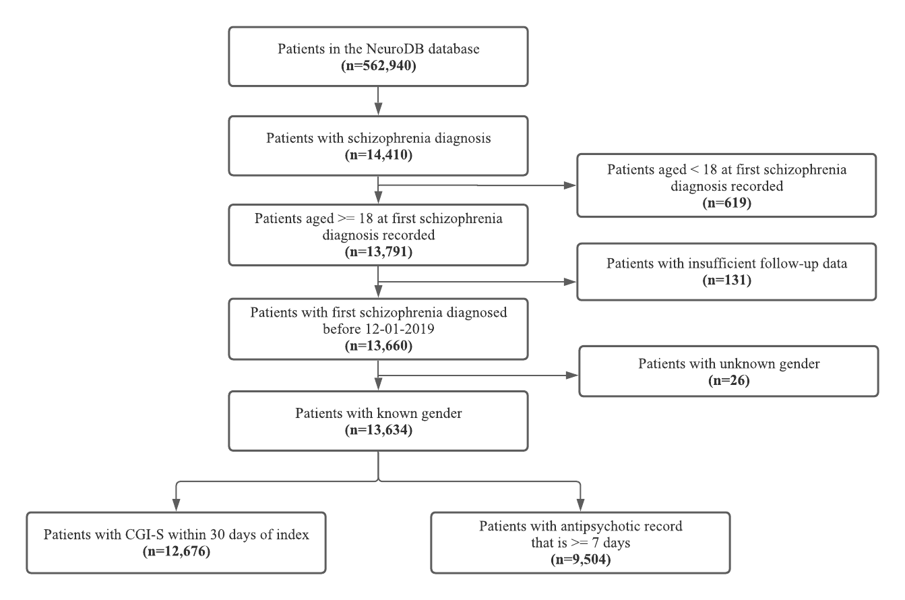

Supplementary Figure 2: Number of patients with schizophrenia with record of 1 or more substance use disorder diagnoses. This data was extracted from the electronic health records in the NeuroBlu database of n=3,010 patients before or at the time of schizophrenia diagnosis.
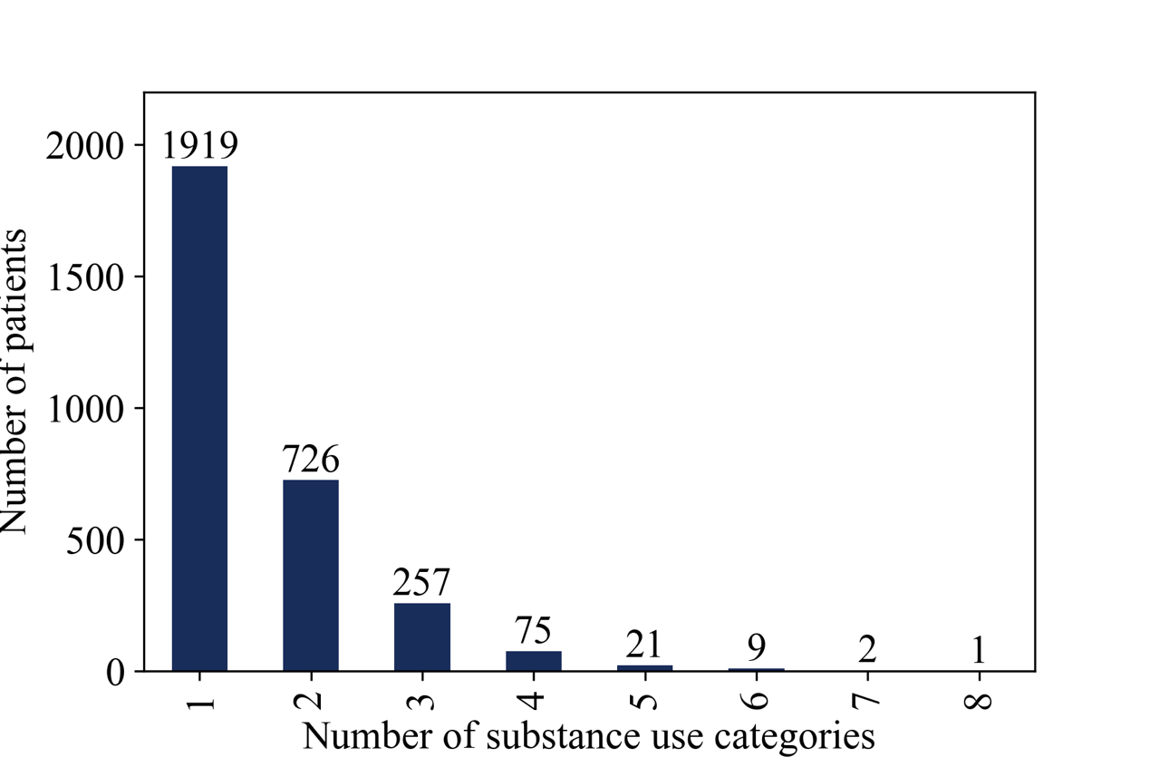

Supplementary Figure 3: Age was modelled in a generalized additive model to model age non-linearly in association to the odds of having a more severe baseline CGI-S (CGI-S of 5-7)

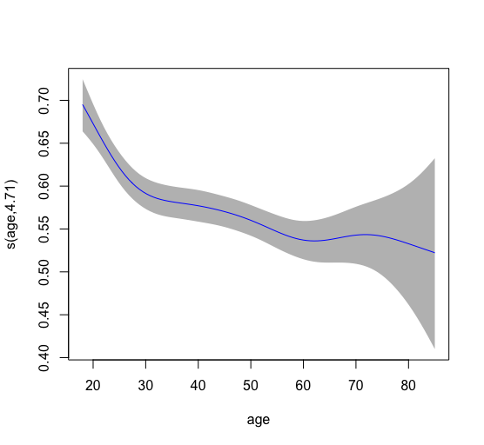

When modelled linearly, patients aged 40 and above were less likely to have a severe baseline CGI-S (OR=0.79, 95%CI [0.73, 0.86], p< .001). When modelled non-linearly, the overall findings remained consistent. Additionally, more nuances are revealed with a steep increase in the probability of having a severe baseline CGI-S from age 30 to 20.
Supplementary Figure 4: Age was modelled in a generalized additive model to model age non-linearly in association to the number of inpatient days
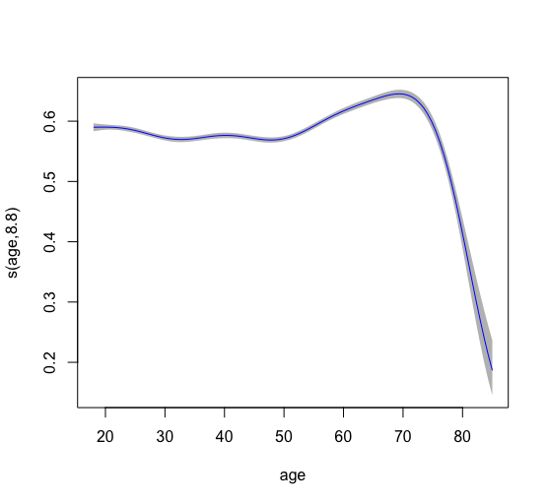
When modelled linearly, age was not found to be associated with number of inpatient days (IRR=1.01, 95%CI [1.00, 1.03], p=0.074). When modelled non-linearly, it appears that patients aged 40 to 70 were associated with greater number of inpatient days, and patients aged above 70 were associated with lesser number of inpatient days; though, it could be affected by the sample size as observed by the increase in confidence band.

