Supplementary Appendix: Smoothed age-dependent probabilities of adverse events and hospitalization for 9H and 4R latent tuberculosis preventive therapy

S1. Rationale
In the base model, age-specific probabilities of adverse events and of hospitalization for isoniazid (9H) and rifampin (4R) were specified as step functions across discrete age strata. This produces implausible discontinuities at the boundaries of those strata, under which two patients differing by a single year of age can be assigned meaningfully different risks. To address this, we re-modeled each age-dependent probability as a smooth continuous function of age, anchored on the same underlying clinic-observed data points used to parameterize the step-function version.

S2. Data sources and provenance
Anchor values were obtained from the TSTin3D online interpreter (https://www.tstin3d.com), which implements the population-based estimates of Smith et al. (reference 12 of the main manuscript). The model was initially constructed in 2022 using Version 3.0; between the original build and the present analysis, the interpreter was updated to Version 4.0, which revised the adverse-event probabilities (notably introducing age-dependent rifampin risk that was absent in v3.0) and removed the hospitalization module entirely. We adopted a mixed-provenance approach: adverse-event anchors were taken from v4.0 to avoid the bias toward rifampin that v3.0's age-independent rifampin risk would have introduced in older patients, and hospitalization anchors were taken from v3.0 (as accessed in 2022) because v4.0 does not provide equivalents. We have contacted the tool maintainers to clarify the rationale for these changes.
Anchor values used for the quadratic fits:
Adverse events (v4.0): 9H — 0.030, 0.047, 0.068, 0.063 at ages 18, 35, 51, 66; 4R — 0.017, 0.021, 0.024, 0.041 at the same ages.
Hospitalization (v3.0, 2022): INH — 0.001, 0.002, 0.006, 0.024 at ages 35, 40, 50, 65; RIF — 0.00070, 0.00050, 0.00060, 0.00140 at the same ages.

S3. Functional form and fitting
For each outcome we fit a quadratic P(age) = a + b·age + c·age² by ordinary nonlinear least squares (scipy.optimize.curve_fit). A quadratic is the lowest-order polynomial that can accommodate the non-monotonic behavior visible in the 9H and RIF anchors while remaining robust to four data points per curve.
Fitted coefficients:
• P(adverse event | 9H): a = -8.1482e-3, b = 2.3892e-3, c = -1.9465e-5
• P(adverse event | 4R): a = 2.5193e-2, b = -6.5400e-4, c = 1.3333e-5
• P(hospitalization | INH): a = 3.8917e-2, b = -2.0621e-3, c = 2.8182e-5
• P(hospitalization | RIF): a = 4.5167e-3, b = -1.8182e-4, c = 2.0606e-6

S4. Handling of ages outside the anchor range
The adverse-event anchors span ages 18 to 66; the hospitalization anchors span ages 35 to 65. To avoid extrapolation artifacts, each fitted function is clamped at its value at the nearest in-range endpoint: the age-66 fit value is used for ages above 66 (adverse events), and the age-35 and age-65 fit values are used for ages 18–34 and 66–85 respectively (hospitalization). This is conservative in that it does not project the 9H curve's apparent late-life decline — driven by a single age-66 anchor — into ages without data.

S5. Fit diagnostics
eFigure 1. Quadratic fits for age-specific probability of adverse events on 9H and 4R regimens, with TSTin3D v4.0 anchor points. Shaded region (age > 66) indicates clamped extrapolation.
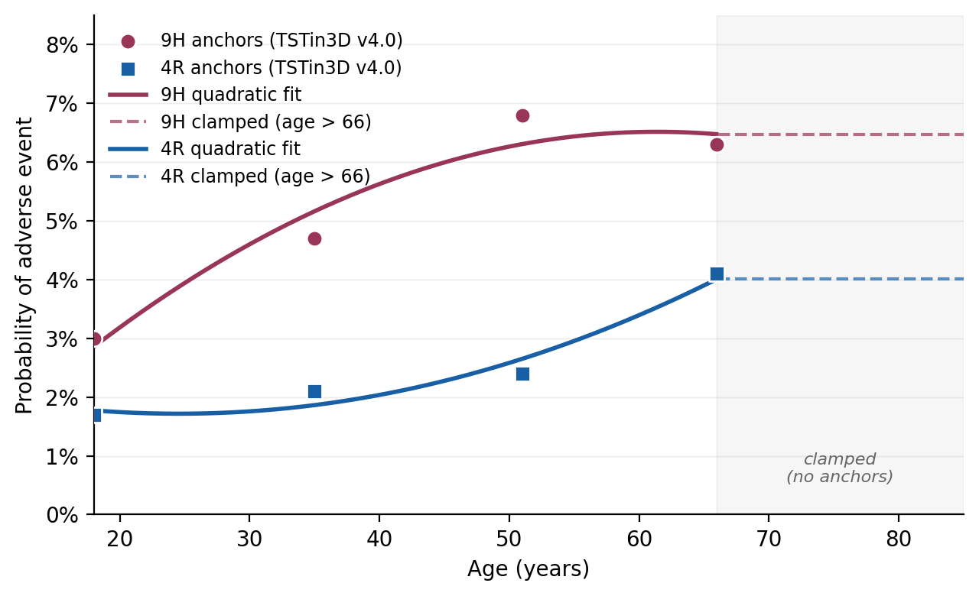
eFigure 2. Quadratic fits for age-specific probability of hospitalization on INH and RIF, with TSTin3D v3.0 (2022) anchor points. Shaded regions (age < 35 and age > 65) indicate clamped extrapolation.
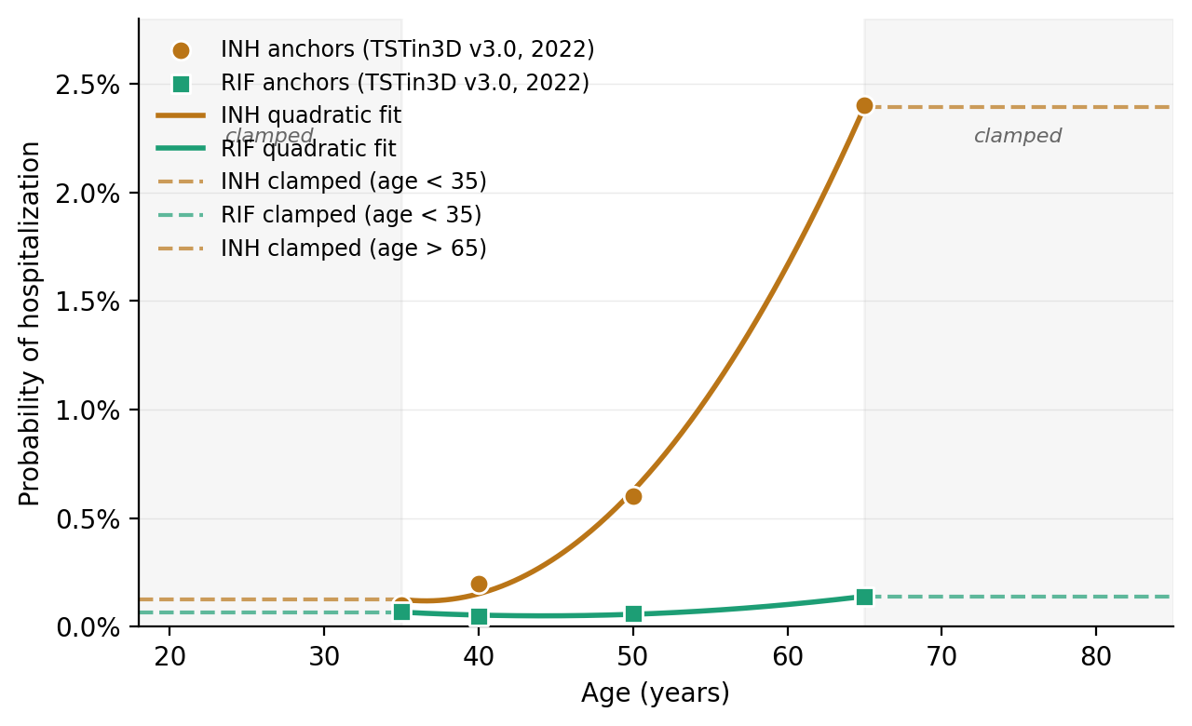

S6. Lookup tables
eTable 1. Age-specific probability of any adverse event while on 9H or 4R latent tuberculosis preventive therapy, smoothed quadratic fit with clamping outside the anchor range (ages 18–66).
Age (years) | P(adverse event | 9H) | P(adverse event | 4R)
18 | 0.0286 | 0.0177
19 | 0.0302 | 0.0176
20 | 0.0318 | 0.0174
21 | 0.0334 | 0.0173
22 | 0.0350 | 0.0173
23 | 0.0365 | 0.0172
24 | 0.0380 | 0.0172
25 | 0.0394 | 0.0172
26 | 0.0408 | 0.0172
27 | 0.0422 | 0.0173
28 | 0.0435 | 0.0173
29 | 0.0448 | 0.0174
30 | 0.0460 | 0.0176
31 | 0.0472 | 0.0177
32 | 0.0484 | 0.0179
33 | 0.0495 | 0.0181
34 | 0.0506 | 0.0184
35 | 0.0516 | 0.0186
36 | 0.0526 | 0.0189
37 | 0.0536 | 0.0192
38 | 0.0545 | 0.0196
39 | 0.0554 | 0.0200
40 | 0.0563 | 0.0204
41 | 0.0571 | 0.0208
42 | 0.0579 | 0.0212
43 | 0.0586 | 0.0217
44 | 0.0593 | 0.0222
45 | 0.0599 | 0.0228
46 | 0.0606 | 0.0233
47 | 0.0611 | 0.0239
48 | 0.0617 | 0.0245
49 | 0.0622 | 0.0252
50 | 0.0626 | 0.0258
51 | 0.0631 | 0.0265
52 | 0.0635 | 0.0272
53 | 0.0638 | 0.0280
54 | 0.0641 | 0.0288
55 | 0.0644 | 0.0296
56 | 0.0646 | 0.0304
57 | 0.0648 | 0.0312
58 | 0.0649 | 0.0321
59 | 0.0651 | 0.0330
60 | 0.0651 | 0.0340
61 | 0.0652 | 0.0349
62 | 0.0652 | 0.0359
63 | 0.0651 | 0.0369
64 | 0.0650 | 0.0379
65 | 0.0649 | 0.0390
66 | 0.0647 | 0.0401
67 | 0.0647 | 0.0401
68 | 0.0647 | 0.0401
69 | 0.0647 | 0.0401
70 | 0.0647 | 0.0401
71 | 0.0647 | 0.0401
72 | 0.0647 | 0.0401
73 | 0.0647 | 0.0401
74 | 0.0647 | 0.0401
75 | 0.0647 | 0.0401
76 | 0.0647 | 0.0401
77 | 0.0647 | 0.0401
78 | 0.0647 | 0.0401
79 | 0.0647 | 0.0401
80 | 0.0647 | 0.0401
81 | 0.0647 | 0.0401
82 | 0.0647 | 0.0401
83 | 0.0647 | 0.0401
84 | 0.0647 | 0.0401
85 | 0.0647 | 0.0401

eTable 2. Age-specific probability of hospitalization attributable to drug-induced adverse events while on INH or RIF, smoothed quadratic fit with clamping outside the anchor range (ages 35–65).
Age (years) | P(hospitalization | INH) | P(hospitalization | RIF)
18 | 0.00127 | 0.00068
19 | 0.00127 | 0.00068
20 | 0.00127 | 0.00068
21 | 0.00127 | 0.00068
22 | 0.00127 | 0.00068
23 | 0.00127 | 0.00068
24 | 0.00127 | 0.00068
25 | 0.00127 | 0.00068
26 | 0.00127 | 0.00068
27 | 0.00127 | 0.00068
28 | 0.00127 | 0.00068
29 | 0.00127 | 0.00068
30 | 0.00127 | 0.00068
31 | 0.00127 | 0.00068
32 | 0.00127 | 0.00068
33 | 0.00127 | 0.00068
34 | 0.00127 | 0.00068
35 | 0.00127 | 0.00068
36 | 0.00120 | 0.00064
37 | 0.00120 | 0.00061
38 | 0.00125 | 0.00058
39 | 0.00136 | 0.00056
40 | 0.00152 | 0.00054
41 | 0.00174 | 0.00053
42 | 0.00202 | 0.00052
43 | 0.00235 | 0.00051
44 | 0.00274 | 0.00051
45 | 0.00319 | 0.00051
46 | 0.00369 | 0.00051
47 | 0.00425 | 0.00052
48 | 0.00487 | 0.00054
49 | 0.00554 | 0.00056
50 | 0.00627 | 0.00058
51 | 0.00705 | 0.00060
52 | 0.00789 | 0.00063
53 | 0.00879 | 0.00067
54 | 0.00974 | 0.00071
55 | 0.01075 | 0.00075
56 | 0.01182 | 0.00080
57 | 0.01294 | 0.00085
58 | 0.01412 | 0.00090
59 | 0.01535 | 0.00096
60 | 0.01664 | 0.00103
61 | 0.01799 | 0.00109
62 | 0.01940 | 0.00116
63 | 0.02086 | 0.00124
64 | 0.02237 | 0.00132
65 | 0.02395 | 0.00140
66 | 0.02395 | 0.00140
67 | 0.02395 | 0.00140
68 | 0.02395 | 0.00140
69 | 0.02395 | 0.00140
70 | 0.02395 | 0.00140
71 | 0.02395 | 0.00140
72 | 0.02395 | 0.00140
73 | 0.02395 | 0.00140
74 | 0.02395 | 0.00140
75 | 0.02395 | 0.00140
76 | 0.02395 | 0.00140
77 | 0.02395 | 0.00140
78 | 0.02395 | 0.00140
79 | 0.02395 | 0.00140
80 | 0.02395 | 0.00140
81 | 0.02395 | 0.00140
82 | 0.02395 | 0.00140
83 | 0.02395 | 0.00140
84 | 0.02395 | 0.00140
85 | 0.02395 | 0.00140

S7. Implementation notes and limitations
The lookup tables are read directly by the microsimulation: at each simulated patient's current age, the corresponding probability is applied as a per-event Bernoulli draw. Two limitations should be noted. First, the adverse-event and hospitalization anchors derive from different versions of the TSTin3D interpreter (v4.0 and v3.0), as described in S2; a sensitivity analysis using v3.0 adverse-event values could bracket the impact of this choice. Second, the interpreter was designed for adults under 80, and our anchors end below that age, so values for ages 80–85 are conservative floor estimates from clamping. Because older remote immigrants are the subgroup in which our model already finds no-treatment to be optimal, this conservatism would, if anything, further strengthen that conclusion if corrected.

S8. Time-since-immigration progression function
Menzies et al report progression to active tuberculosis as a function of time since infection, giving annual rates of 38 (33–46), 3.4 (2.6–4.0), 0.76 (0.60–0.92), and 0.38 (0.32–0.45) per 1000 person-years at 1, 5, 10, and 25 years, and a cumulative risk of progression of 3.8%, 6.6%, 7.2%, and 7.9% at those same times (their Figure 1A and 1B). We reconstructed a continuous progression hazard as a function of time since immigration (equated with time since infection, assuming infection occurred immediately prior to immigration) by monotone piecewise-cubic (PCHIP) interpolation of the published cumulative-risk trajectory, taking the instantaneous rate as its derivative. This reproduces the Menzies cumulative-risk curve exactly at the four published points (eFigure 3B) and yields interval-average rates of 38.7, 3.2, 0.8, and 0.30 per 1000 over years 1, 5, 10, and 25, closely matching the published rate estimates.
Because Menzies reports interval rates whereas the model applies a continuous instantaneous hazard, the per-year values in eTable 3 differ from the interval rates in the main-text table but integrate to the same cumulative risk. Beyond 25 years the curve is extended using the published lifetime cumulative risk (8.8% at infection, Figure 1C). The prior version of this model placed the 38, 3.4, and 0.38 per 1000 estimates at years 2.5, 15, and 27.5 (the midpoints of exposure intervals) rather than at Menzies' years 1, 5, and 25; the present function corrects that alignment.
eFigure 3. (A) Reconstructed TB progression rate by time since immigration (base case with low–high bounds), the continuous input used in the model. (B) Cumulative risk of progression from the reconstructed hazard (line) versus Menzies et al published estimates (points) at years 1, 5, 10, and 25.
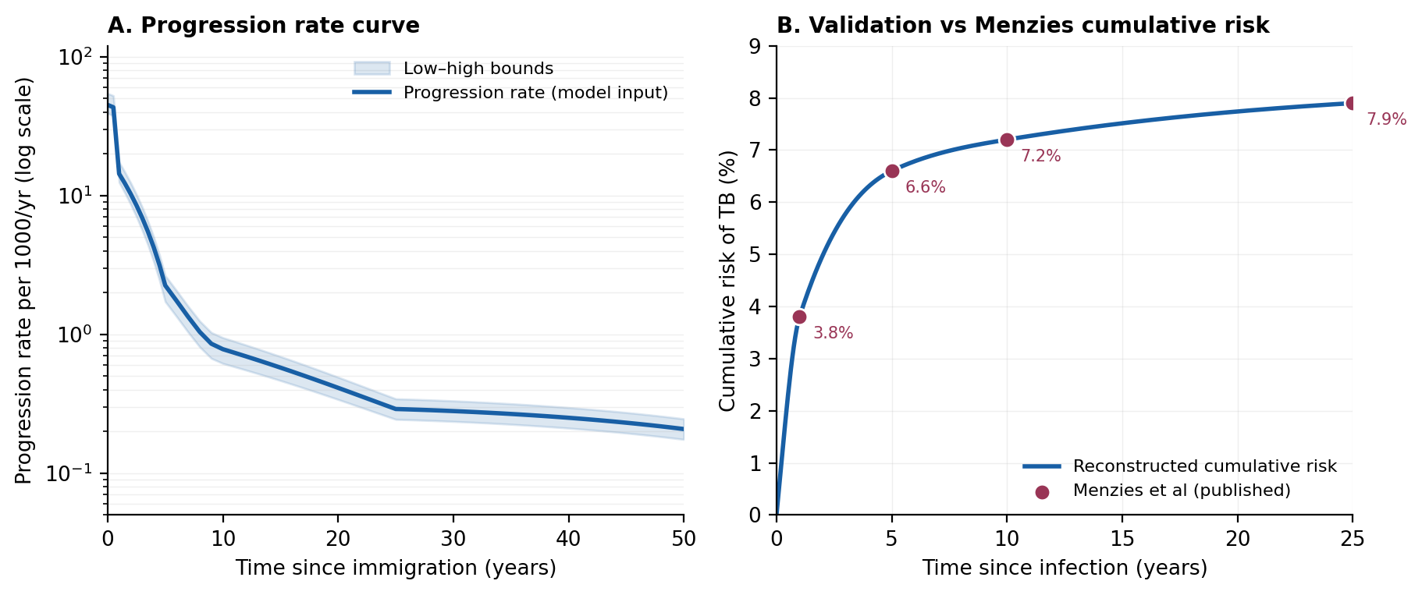
eTable 3. Reconstructed annual TB progression rate per 1000 per year by time since immigration (base case, low, high). Continuous model input reproducing the Menzies et al cumulative-risk trajectory; values are instantaneous hazards.
Time since immigration, y | Base case | Low | High
0 | 45 | 39.1 | 54.5
0.5 | 43.3 | 37.6 | 52.4
1 | 14.4 | 12.5 | 17.4
1.5 | 12.2 | 10.5 | 14.8
2 | 10.3 | 8.66 | 12.4
2.5 | 8.52 | 7.06 | 10.2
3 | 6.92 | 5.64 | 8.26
3.5 | 5.5 | 4.41 | 6.54
4 | 4.24 | 3.35 | 5.03
4.5 | 3.16 | 2.46 | 3.73
5 | 2.25 | 1.72 | 2.65
6 | 1.74 | 1.34 | 2.06
7 | 1.34 | 1.03 | 1.59
8 | 1.04 | 0.811 | 1.25
9 | 0.857 | 0.672 | 1.03
10 | 0.782 | 0.618 | 0.947
11 | 0.738 | 0.585 | 0.892
12 | 0.695 | 0.553 | 0.839
13 | 0.654 | 0.523 | 0.788
14 | 0.614 | 0.493 | 0.739
15 | 0.576 | 0.465 | 0.693
16 | 0.54 | 0.438 | 0.648
17 | 0.506 | 0.411 | 0.606
18 | 0.473 | 0.386 | 0.566
19 | 0.442 | 0.362 | 0.528
20 | 0.412 | 0.34 | 0.492
21 | 0.384 | 0.318 | 0.458
22 | 0.358 | 0.298 | 0.426
23 | 0.334 | 0.279 | 0.397
24 | 0.311 | 0.261 | 0.369
25 | 0.29 | 0.244 | 0.344
26 | 0.288 | 0.243 | 0.342
27 | 0.287 | 0.241 | 0.339
28 | 0.285 | 0.24 | 0.337
29 | 0.283 | 0.238 | 0.335
30 | 0.28 | 0.236 | 0.332
31 | 0.278 | 0.234 | 0.329
32 | 0.276 | 0.232 | 0.326
33 | 0.273 | 0.23 | 0.323
34 | 0.27 | 0.228 | 0.32
35 | 0.267 | 0.225 | 0.317
36 | 0.264 | 0.223 | 0.313
37 | 0.261 | 0.22 | 0.309
38 | 0.258 | 0.217 | 0.305
39 | 0.254 | 0.214 | 0.301
40 | 0.251 | 0.211 | 0.297
41 | 0.247 | 0.208 | 0.293
42 | 0.243 | 0.205 | 0.288
43 | 0.239 | 0.202 | 0.284
44 | 0.235 | 0.198 | 0.279
45 | 0.231 | 0.195 | 0.274
46 | 0.227 | 0.191 | 0.269
47 | 0.222 | 0.187 | 0.263
48 | 0.218 | 0.183 | 0.258
49 | 0.213 | 0.179 | 0.252
50 | 0.208 | 0.175 | 0.246

