Supplementary Material

Supplementary Data
NMR (¹H and ¹³C)
6-Formylnaphthalen-2-yl (5Z,8Z,11Z,14Z)-icosa-5,8,11,14-tetraenoate (AA-HNA)
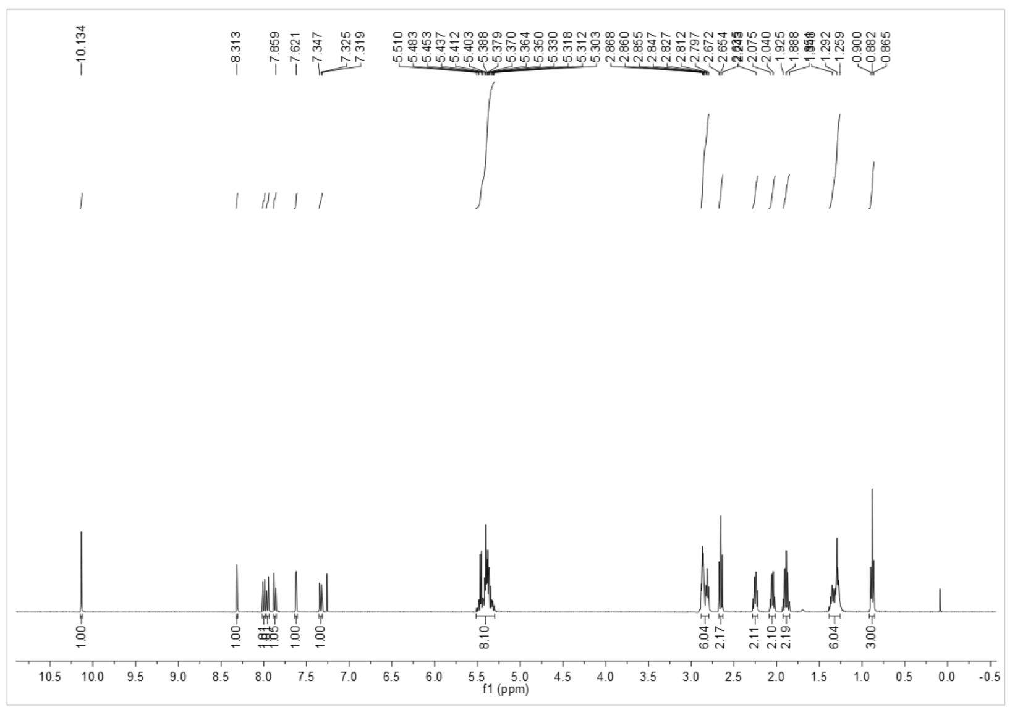
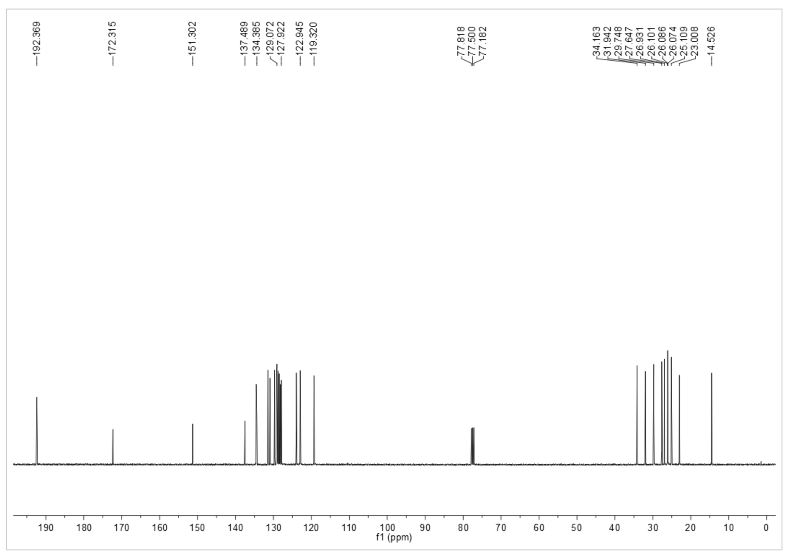
HRMS
6-Formylnaphthalen-2-yl (5Z,8Z,11Z,14Z)-icosa-5,8,11,14-tetraenoate (AA-HNA)
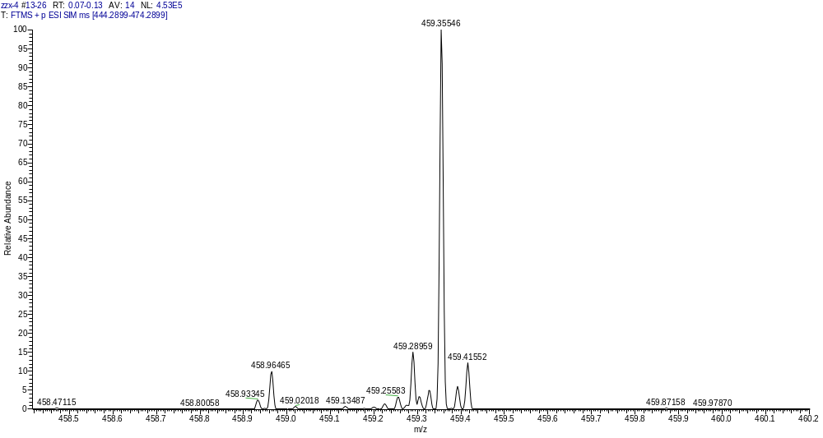

Supplementary Figures and Tables

Supplementary Figures

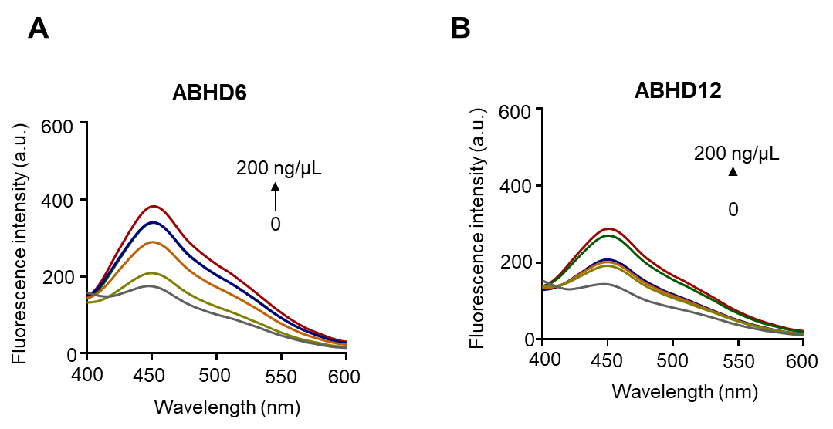
Supplementary Figure 1. The concentration-dependent fluorescence spectra response of fluorescence intensity at the emission of 455 nm with the increasing of protein concentration of ABHD6 (A) and ABHD12 (B).

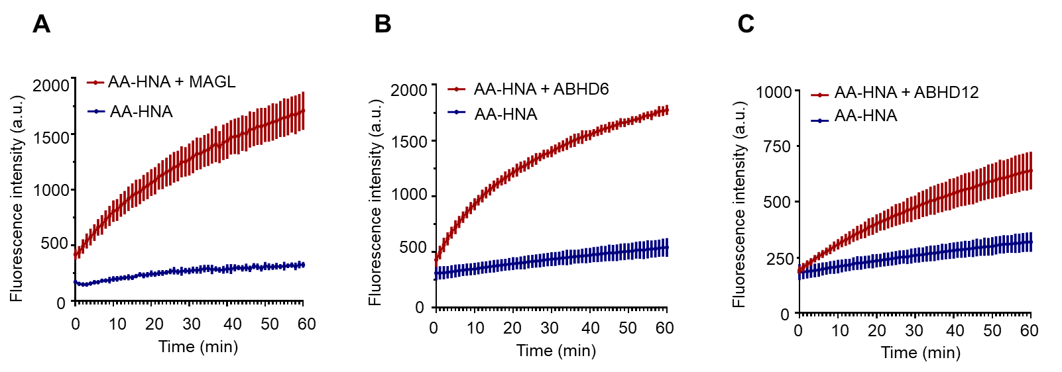
Supplementary Figure 2. (A) The time-dependent increase of fluorescence intensity in the presence of MAGL and fluorogenic substrate AA-HNA. (B) The time-dependent increase of fluorescence intensity in the presence of ABHD6 and fluorogenic substrate AA-HNA. (C) The time-dependent increase of fluorescence intensity in the presence of ABHD12 and fluorogenic substrate AA-HNA. Note that the excitation and emission was 330 nm and 455 nm, respectively.

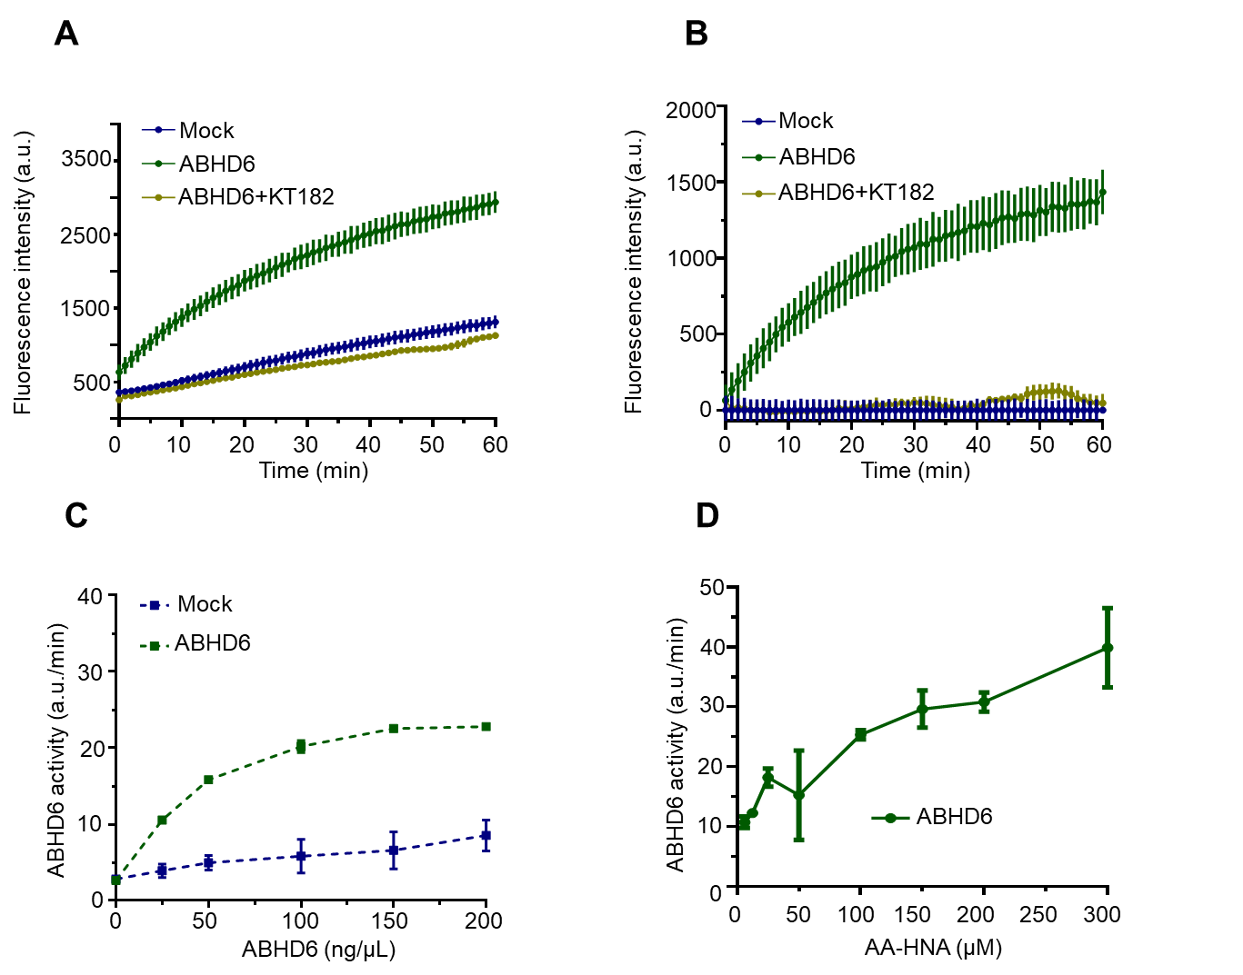
Supplementary Figure 3. Setup and optimization of AA-HNA-based activity assay for ABHD6. (A) Time course of AA-HNA hydrolysis by ABHD6, resulting in an increase of fluorescence over time. Preincubation with ABHD6 inhibitor KT182 (10 µM) resulted in reduction of the fluorescent signal. Membrane proteins from Mock-transfected cells served as a negative control. (B) Time course of 2-AG hydrolysis by ABHD6, corrected for background fluorescence of the Mock-transfected negative control. (C) Optimization of protein concentration for the ABHD6 activity assay. ABHD6 activity was monitored in time with various concentrations of ABHD6. (D) Optimization of AA-HNA concentration for the ABHD6 activity assay.

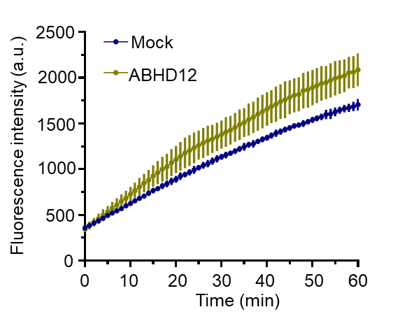
Supplementary Figure 4. Time course of AA-HNA hydrolysis by ABHD12 and Mock-membrane, resulting in an increase of fluorescence over time.

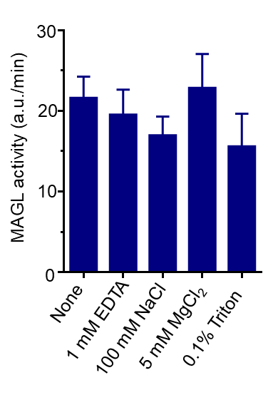
Supplementary Figure 5. Optimization of AA-HNA-based activity assay for MAGL.

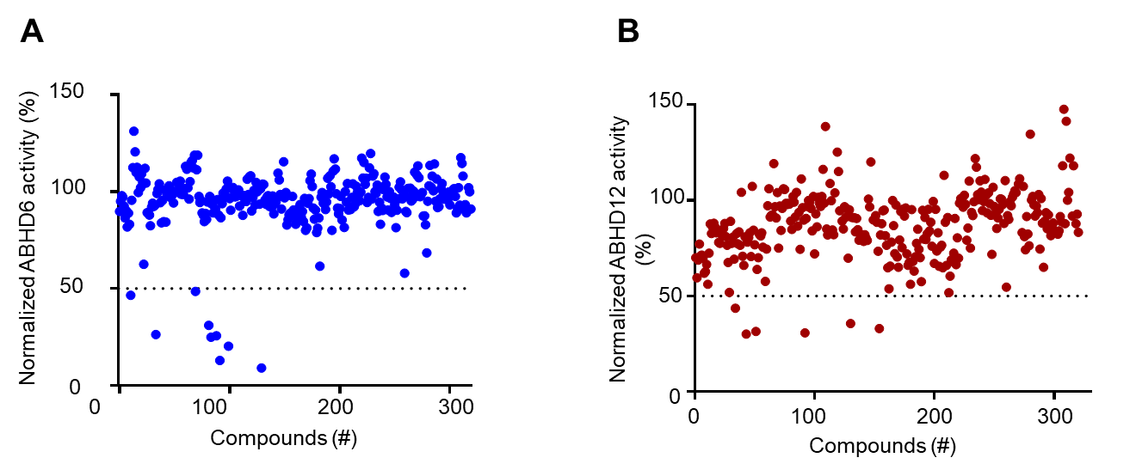
Supplementary Figure 6. Screening results of the ~320 focused library against the activity of ABHD6 (A) and ABHD12 (B).

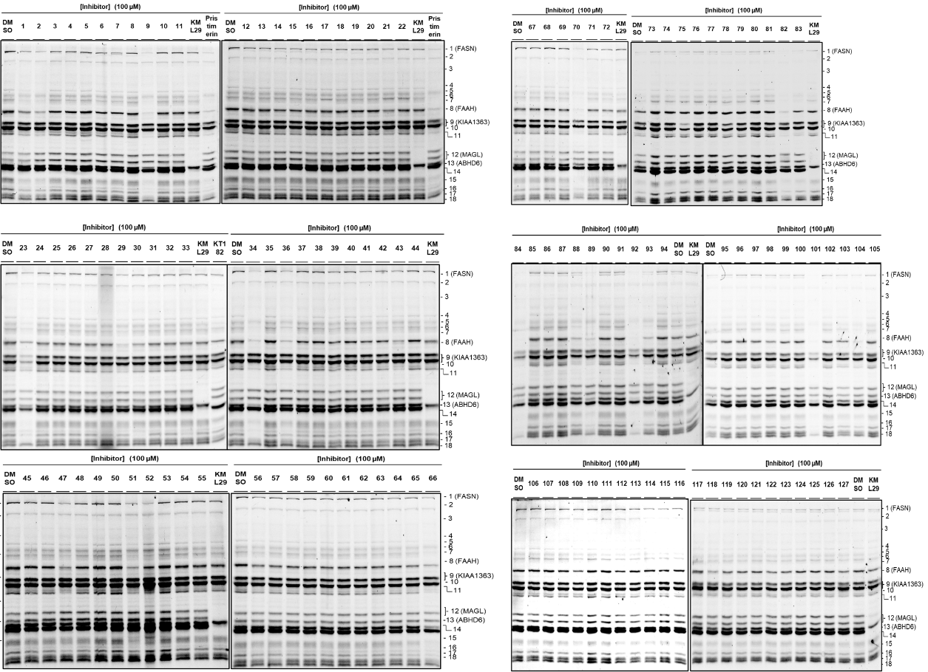
Supplementary Figure 7. Representative gels of ABPP assay for determination of the selectivity of compounds 1-127.

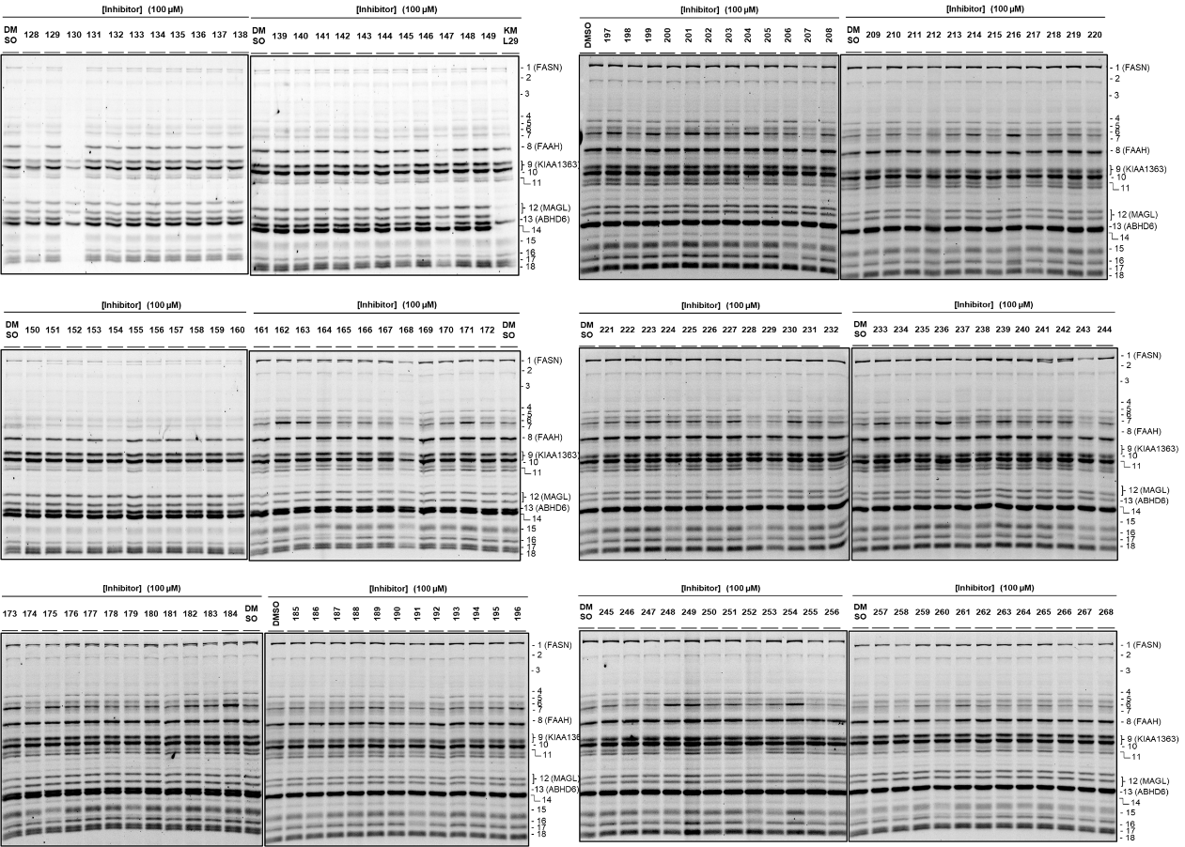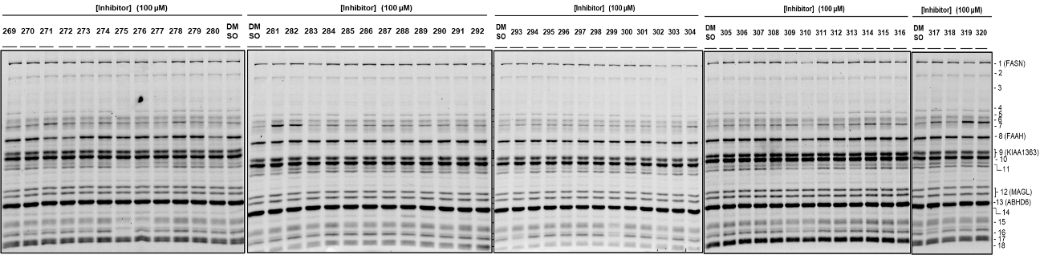
Supplementary Figure 8. Representative gels of ABPP assay for determination of the selectivity of compounds 128-320.

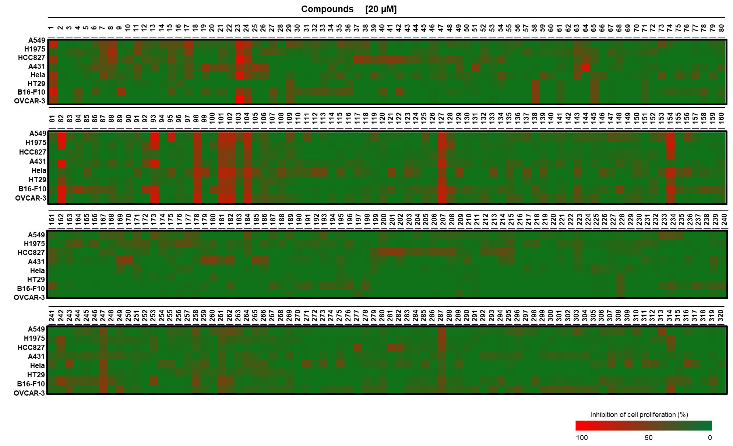
Supplementary Figure 9. Heatmap overview of the antiproliferative screening of the natural organic compound library against a panel of cancer cell lines, including lung cancer (A549, H1975, HCC827), epidermal carcinoma (A431), cervical carcinoma (Hela), colon cancer (HT-29), melanoma (B16-F10) and ovarian (OVCAR-3).

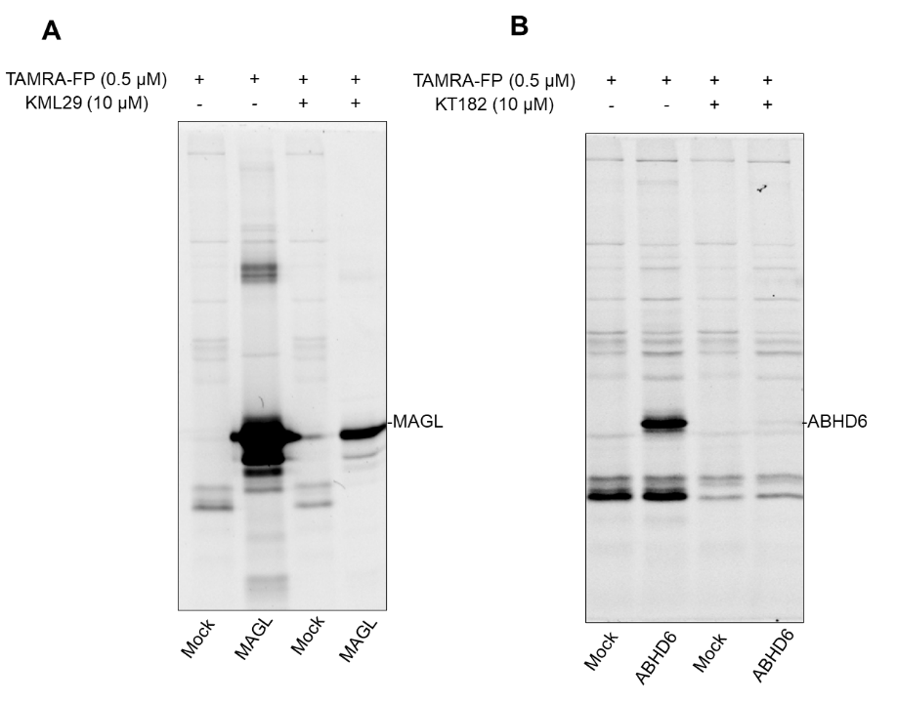
Supplementary Figure 10. ABPP assay demonstrates HEK293T cells overexpressing human MAGL and ABHD6. TAMRA-FP (0.5 µM) was used as an activity-based probe to label recombinant MAGL or ABHD6, and the labelling can be blocked by pre-treated with inhibitors KT109 or KT182.

Supplementary Tables
Supplementary Table 1. Inhibitory values for 320 natural organic compounds at 100 µM against MAGL determined by AA-HNA substrate assay.
Entry | MAGL Inhibition (%) | Entry | MAGL Inhibition (%) | Entry | MAGL Inhibition (%) | Entry | MAGL Inhibition (%)
1 | 31.7 | 81 | 77.6 | 161 | 88.3 | 241 | 86.8
2 | 38.9 | 82 | 20.1 | 162 | 90.9 | 242 | 93.9
3 | 85.6 | 83 | 15.3 | 163 | 92.6 | 243 | 92.2
4 | 85.4 | 84 | 34.3 | 164 | 82.4 | 244 | 60.8
5 | 90.1 | 85 | 82 | 165 | 89.7 | 245 | 86.3
6 | 31.1 | 86 | 77.7 | 166 | 77.1 | 246 | 76.3
7 | 75.9 | 87 | 77.7 | 167 | 66.8 | 247 | 74.9
8 | 83.5 | 88 | 31 | 168 | 88.1 | 248 | 74
9 | 13.3 | 89 | 29.4 | 169 | 89.7 | 249 | 65.3
10 | 84.2 | 90 | 89.2 | 170 | 93.4 | 250 | 86
11 | 105.7 | 91 | 83.9 | 171 | 126.9 | 251 | 65
12 | 86 | 92 | 39.4 | 172 | 72.5 | 252 | 87.2
13 | 89.9 | 93 | 18.9 | 173 | 96.6 | 253 | 81.8
14 | 64.3 | 94 | 79.3 | 174 | 92.4 | 254 | 87.4
15 | 80.3 | 95 | 88.9 | 175 | 99.4 | 255 | 88.2
16 | 124.4 | 96 | 79.3 | 176 | 128.9 | 256 | 92.7
17 | 82.8 | 97 | 70.9 | 177 | 88.7 | 257 | 58.5
18 | 97.8 | 98 | 78.6 | 178 | 102.7 | 258 | 81.9
19 | 90.1 | 99 | 89.3 | 179 | 92.4 | 259 | 87.9
20 | 95.2 | 100 | 39.6 | 180 | 102 | 260 | 89.5
21 | 59.3 | 101 | 84 | 181 | 86.3 | 261 | 86.6
22 | 93.2 | 102 | 87.2 | 182 | 97.3 | 262 | 88
23 | 11.2 | 103 | 17.8 | 183 | 92.3 | 263 | 90.1
24 | 99.1 | 104 | 74.9 | 184 | 101 | 264 | 85.7
25 | 99 | 105 | 88.5 | 185 | 96.9 | 265 | 91.1
26 | 92.5 | 106 | 87.7 | 186 | 93.2 | 266 | 83.8
27 | 97.6 | 107 | 84 | 187 | 97 | 267 | 81.7
28 | 63.2 | 108 | 93.4 | 188 | 81.1 | 268 | 89
29 | 76.2 | 109 | 82 | 189 | 90.2 | 269 | 73.2
30 | 95.9 | 110 | 68.8 | 190 | 93.9 | 270 | 88.4
31 | 102.7 | 111 | 106.7 | 191 | 114.9 | 271 | 98
32 | 104 | 112 | 51.6 | 192 | 106.9 | 272 | 86.1
33 | 99.5 | 113 | 79.3 | 193 | 102.6 | 273 | 101.7
34 | 35.2 | 114 | 93.9 | 194 | 97.2 | 274 | 104.4
35 | 97.3 | 115 | 100.3 | 195 | 96 | 275 | 103.2
36 | 47.9 | 116 | 101.4 | 196 | 75 | 276 | 99.1
37 | 90.9 | 117 | 104.3 | 197 | 95.7 | 277 | 98.3
38 | 91.4 | 118 | 100.7 | 198 | 91.3 | 278 | 89.3
39 | 111.3 | 119 | 95.3 | 199 | 101.6 | 279 | 91.3
40 | 97 | 120 | 86.5 | 200 | 99.8 | 280 | 79.8
41 | 84 | 121 | 102.8 | 201 | 91.6 | 281 | 108.8
42 | 70.6 | 122 | 94 | 202 | 86.6 | 282 | 105.3
43 | 32.2 | 123 | 62.3 | 203 | 76.8 | 283 | 98.8
44 | 90.5 | 124 | 91.6 | 204 | 92.6 | 284 | 104.4
45 | 81.1 | 125 | 92.1 | 205 | 82 | 285 | 103.5
46 | 90.6 | 126 | 97.1 | 206 | 91.9 | 286 | 101.4
47 | 43.2 | 127 | 62.2 | 207 | 84.9 | 287 | 86.5
48 | 72.2 | 128 | 32.2 | 208 | 93.2 | 288 | 83.6
49 | 85.4 | 129 | 109.9 | 209 | 94.2 | 289 | 94.2
50 | 62.5 | 130 | 28.2 | 210 | 94.7 | 290 | 67.8
51 | 49.4 | 131 | 103.5 | 211 | 85.1 | 291 | 100.6
52 | 41.2 | 132 | 105.5 | 212 | 96 | 292 | 106.1
53 | 93.1 | 133 | 97.9 | 213 | 91.8 | 293 | 89.7
54 | 143.4 | 134 | 105.6 | 214 | 137.4 | 294 | 107.3
55 | 104.4 | 135 | 105.6 | 215 | 107.4 | 295 | 122.2
56 | 87.4 | 136 | 106.9 | 216 | 99.3 | 296 | 98.3
57 | 86.8 | 137 | 106.1 | 217 | 97.7 | 297 | 106.2
58 | 83.4 | 138 | 88.3 | 218 | 101.8 | 298 | 96.8
59 | 129.6 | 139 | 108.6 | 219 | 137.6 | 299 | 106.9
60 | 59.6 | 140 | 114.6 | 220 | 99.2 | 300 | 94.7
61 | 101.1 | 141 | 109.1 | 221 | 93.5 | 301 | 104.2
62 | 94.5 | 142 | 96.7 | 222 | 91.6 | 302 | 100.7
63 | 99.9 | 143 | 76.4 | 223 | 96.6 | 303 | 75.3
64 | 101.7 | 144 | 74.8 | 224 | 89.1 | 304 | 78.1
65 | 87.5 | 145 | 103 | 225 | 96.1 | 305 | 105.8
66 | 41.3 | 146 | 82.3 | 226 | 78.1 | 306 | 102.4
67 | 75.9 | 147 | 43.5 | 227 | 86.5 | 307 | 95.2
68 | 99.7 | 148 | 56.1 | 228 | 95.7 | 308 | 79.7
69 | 94.8 | 149 | 79.7 | 229 | 91.3 | 309 | 81.4
70 | 42 | 150 | 54.8 | 230 | 84.1 | 310 | 96.2
71 | 99.2 | 151 | 84.6 | 231 | 92.1 | 311 | 100.8
72 | 75.9 | 152 | 98.7 | 232 | 88.5 | 312 | 78.5
73 | 89.7 | 153 | 85.2 | 233 | 92.3 | 313 | 98.8
74 | 101.1 | 154 | 41.1 | 234 | 94 | 314 | 91.6
75 | 66.3 | 155 | 62.4 | 235 | 89.8 | 315 | 81.7
76 | 84.4 | 156 | 80.1 | 236 | 90.7 | 316 | 99.2
77 | 70.2 | 157 | 90.1 | 237 | 85.1 | 317 | 93.2
78 | 63.1 | 158 | 74.9 | 238 | 85.4 | 318 | 96.5
79 | 71.2 | 159 | 98 | 239 | 82.5 | 319 | 85
80 | 62 | 160 | 102.3 | 240 | 86 | 320 | 112.9

Supplementary Table 2. Inhibitory values for 320 natural organic compounds at 100 µM against ABHD6 determined by AA-HNA substrate assay.
Entry | ABHD6 Inhibition (%) | Entry | ABHD6 Inhibition (%) | Entry | ABHD6 Inhibition (%) | Entry | ABHD6 Inhibition (%)
1 | 89.8 | 81 | 94.7 | 161 | 83.2 | 241 | 101
2 | 95 | 82 | 31 | 162 | 84.3 | 242 | 107.6
3 | 97.9 | 83 | 97.6 | 163 | 86.8 | 243 | 103.8
4 | 97.2 | 84 | 24.9 | 164 | 91.7 | 244 | 97.3
5 | 92.5 | 85 | 93.6 | 165 | 93.4 | 245 | 90.5
6 | 86.4 | 86 | 89.1 | 166 | 87 | 246 | 100
7 | 90.2 | 87 | 95.6 | 167 | 89.8 | 247 | 96.5
8 | 81.8 | 88 | 91.1 | 168 | 84.7 | 248 | 89.3
9 | 88.9 | 89 | 25.7 | 169 | 96.6 | 249 | 96.2
10 | 83.2 | 90 | 95.9 | 170 | 80 | 250 | 97.2
11 | 46.5 | 91 | 87.9 | 171 | 81.3 | 251 | 93.2
12 | 95.6 | 92 | 12.9 | 172 | 94.1 | 252 | 81.4
13 | 112.4 | 93 | 86.5 | 173 | 96.4 | 253 | 90.4
14 | 131.2 | 94 | 93.8 | 174 | 105.7 | 254 | 96.3
15 | 120.6 | 95 | 99.2 | 175 | 109.1 | 255 | 102.3
16 | 109.9 | 96 | 97.1 | 176 | 102.7 | 256 | 105
17 | 112.5 | 97 | 98.2 | 177 | 91.5 | 257 | 101.1
18 | 99.5 | 98 | 101.4 | 178 | 85.8 | 258 | 96.3
19 | 107.5 | 99 | 105.4 | 179 | 90.6 | 259 | 98.4
20 | 102.1 | 100 | 20.3 | 180 | 78.9 | 260 | 57.9
21 | 109.2 | 101 | 96.4 | 181 | 81.2 | 261 | 89.8
22 | 104.7 | 102 | 90.4 | 182 | 86.4 | 262 | 89.2
23 | 62.5 | 103 | 101.5 | 183 | 61.6 | 263 | 101.7
24 | 112 | 104 | 102.2 | 184 | 97.2 | 264 | 97.3
25 | 104.4 | 105 | 98 | 185 | 99.6 | 265 | 101.8
26 | 89.2 | 106 | 97.3 | 186 | 94 | 266 | 95.2
27 | 88.9 | 107 | 99.2 | 187 | 95.1 | 267 | 95.9
28 | 87.9 | 108 | 97.8 | 188 | 90.8 | 268 | 100.3
29 | 82.4 | 109 | 100.9 | 189 | 94.7 | 269 | 110.1
30 | 92 | 110 | 92.5 | 190 | 106.9 | 270 | 97.6
31 | 94.1 | 111 | 98 | 191 | 98.8 | 271 | 108.6
32 | 92.4 | 112 | 98.1 | 192 | 108.2 | 272 | 113.3
33 | 92.9 | 113 | 87.8 | 193 | 102.6 | 273 | 107.2
34 | 26.3 | 114 | 98 | 194 | 80 | 274 | 97.4
35 | 99 | 115 | 95 | 195 | 110.6 | 275 | 98.7
36 | 101.2 | 116 | 94.9 | 196 | 116.9 | 276 | 99.5
37 | 104.1 | 117 | 106.4 | 197 | 111.7 | 277 | 87.4
38 | 94.3 | 118 | 98.6 | 198 | 98.9 | 278 | 87.5
39 | 83.9 | 119 | 107.7 | 199 | 91.6 | 279 | 82.9
40 | 95.4 | 120 | 108.2 | 200 | 88.6 | 280 | 68.4
41 | 84.6 | 121 | 90 | 201 | 91.3 | 281 | 95.1
42 | 100.9 | 122 | 97 | 202 | 97.5 | 282 | 103.1
43 | 84.3 | 123 | 100.7 | 203 | 85.4 | 283 | 113.5
44 | 98.5 | 124 | 93.2 | 204 | 85.3 | 284 | 102.3
45 | 98.8 | 125 | 104.8 | 205 | 81.5 | 285 | 108.1
46 | 103 | 126 | 99.9 | 206 | 100 | 286 | 100.4
47 | 97 | 127 | 103 | 207 | 94.5 | 287 | 114.3
48 | 100.8 | 128 | 93.6 | 208 | 104.2 | 288 | 95
49 | 98.3 | 129 | 101.4 | 209 | 90.6 | 289 | 106.5
50 | 94.2 | 130 | 9.1 | 210 | 91.1 | 290 | 91.8
51 | 99.4 | 131 | 103.9 | 211 | 90.8 | 291 | 92.3
52 | 100.1 | 132 | 103.7 | 212 | 97 | 292 | 96.3
53 | 104.8 | 133 | 95.7 | 213 | 104.1 | 293 | 101.7
54 | 100.5 | 134 | 93.5 | 214 | 92.2 | 294 | 104.2
55 | 103.8 | 135 | 97.4 | 215 | 93.5 | 295 | 99.4
56 | 105.4 | 136 | 97.9 | 216 | 102.8 | 296 | 96.2
57 | 98.7 | 137 | 92.4 | 217 | 99.6 | 297 | 96.3
58 | 100.5 | 138 | 95.1 | 218 | 98.3 | 298 | 96
59 | 98.5 | 139 | 91.9 | 219 | 95.3 | 299 | 95.7
60 | 101.5 | 140 | 97.8 | 220 | 99.8 | 300 | 99.8
61 | 113 | 141 | 88.5 | 221 | 117.3 | 301 | 93.2
62 | 111.5 | 142 | 93.7 | 222 | 107 | 302 | 98.7
63 | 101.9 | 143 | 94.8 | 223 | 115.1 | 303 | 98.2
64 | 96.2 | 144 | 97 | 224 | 103.8 | 304 | 101
65 | 105.2 | 145 | 109.5 | 225 | 106.9 | 305 | 101.5
66 | 115.2 | 146 | 106.1 | 226 | 94.4 | 306 | 97.5
67 | 116 | 147 | 98.5 | 227 | 97 | 307 | 89
68 | 112.3 | 148 | 91.1 | 228 | 112.3 | 308 | 91.4
69 | 118.8 | 149 | 97.7 | 229 | 119.7 | 309 | 102.1
70 | 48.6 | 150 | 115.4 | 230 | 96.2 | 310 | 93
71 | 111.3 | 151 | 96.8 | 231 | 108.1 | 311 | 117.6
72 | 118.8 | 152 | 99.5 | 232 | 109.3 | 312 | 114.6
73 | 97.5 | 153 | 82.8 | 233 | 100.1 | 313 | 108.1
74 | 94.4 | 154 | 85.5 | 234 | 99 | 314 | 90.8
75 | 95.4 | 155 | 88.1 | 235 | 103.4 | 315 | 93.3
76 | 89.1 | 156 | 88.9 | 236 | 89.8 | 316 | 89
77 | 87.8 | 157 | 87.5 | 237 | 94.6 | 317 | 91.4
78 | 84.6 | 158 | 97.5 | 238 | 83.2 | 318 | 102.1
79 | 88.8 | 159 | 90.6 | 239 | 91.5 | 319 | 99.9
80 | 85.7 | 160 | 88.1 | 240 | 90.3 | 320 | 91

Supplementary Table 3. Inhibitory values for 320 natural organic compounds at 100 µM against ABHD12 determined by competitive activity-based protein profiling (ABPP) with probe FP-TAMRA (250 nM).
Entry | ABHD12 Inhibition (%) | Entry | ABHD12 Inhibition (%) | Entry | ABHD12 Inhibition (%) | Entry | ABHD12 Inhibition (%)
1 | 70.1 | 81 | 84.8 | 161 | 64.8 | 241 | 99.4
2 | 59.6 | 82 | 102 | 162 | 53.8 | 242 | 110.9
3 | 68.8 | 83 | 99.1 | 163 | 65.7 | 243 | 102.7
4 | 77.2 | 84 | 91.3 | 164 | 78.2 | 244 | 93.4
5 | 71 | 85 | 104.2 | 165 | 99.9 | 245 | 103.9
6 | 71.4 | 86 | 86.5 | 166 | 86.8 | 246 | 98.3
7 | 69.8 | 87 | 93.7 | 167 | 72.2 | 247 | 92.2
8 | 61.9 | 88 | 74.4 | 168 | 97.6 | 248 | 71.8
9 | 62.8 | 89 | 111.2 | 169 | 70.4 | 249 | 106.8
10 | 66.6 | 90 | 96.2 | 170 | 65.1 | 250 | 96.8
11 | 56.2 | 91 | 89.7 | 171 | 79.3 | 251 | 93.1
12 | 72.4 | 92 | 30.8 | 172 | 94.2 | 252 | 85.3
13 | 87.7 | 93 | 90.5 | 173 | 75.3 | 253 | 90.8
14 | 82.7 | 94 | 96.8 | 174 | 95.4 | 254 | 95.3
15 | 85.9 | 95 | 99.9 | 175 | 91.8 | 255 | 100.8
16 | 88 | 96 | 99.2 | 176 | 96.1 | 256 | 100.6
17 | 86.1 | 97 | 95.8 | 177 | 72.1 | 257 | 97.8
18 | 83 | 98 | 84 | 178 | 66 | 258 | 87.9
19 | 83.7 | 99 | 102 | 179 | 67.5 | 259 | 110.3
20 | 78.1 | 100 | 72.1 | 180 | 56.2 | 260 | 54.7
21 | 77.6 | 101 | 92.9 | 181 | 95.2 | 261 | 92
22 | 84 | 102 | 86.2 | 182 | 68.1 | 262 | 90.1
23 | 81.6 | 103 | 101.5 | 183 | 63.1 | 263 | 99.3
24 | 85.3 | 104 | 98.5 | 184 | 70.6 | 264 | 97.2
25 | 87.9 | 105 | 96.8 | 185 | 77.5 | 265 | 101.7
26 | 81.1 | 106 | 102 | 186 | 84.9 | 266 | 103.3
27 | 76.6 | 107 | 116.2 | 187 | 74.4 | 267 | 105
28 | 67.6 | 108 | 98.5 | 188 | 70.1 | 268 | 104.1
29 | 51.9 | 109 | 138.5 | 189 | 57.5 | 269 | 181.4
30 | 89.1 | 110 | 85 | 190 | 94.8 | 270 | 108.5
31 | 77.5 | 111 | 81.9 | 191 | 79.8 | 271 | 111.3
32 | 80.8 | 112 | 164.2 | 192 | 91 | 272 | 252.1
33 | 69.3 | 113 | 108.8 | 193 | 79.5 | 273 | 83.2
34 | 43.7 | 114 | 99.8 | 194 | 82.5 | 274 | 107.3
35 | 82.7 | 115 | 84.5 | 195 | 95.3 | 275 | 81.1
36 | 77.3 | 116 | 82 | 196 | 84.1 | 276 | 74.2
37 | 83.6 | 117 | 103.9 | 197 | 88.5 | 277 | 91.5
38 | 76.6 | 118 | 159 | 198 | 76.1 | 278 | 82.4
39 | 104.2 | 119 | 125.2 | 199 | 99.4 | 279 | 76.3
40 | 70.8 | 120 | 115 | 200 | 67.1 | 280 | 134.5
41 | 66 | 121 | 94.6 | 201 | 95.3 | 281 | 100.2
42 | 80.9 | 122 | 94.8 | 202 | 73.5 | 282 | 102.1
43 | 30.2 | 123 | 89.2 | 203 | 83.1 | 283 | 97.7
44 | 78.2 | 124 | 85 | 204 | 65.5 | 284 | 91.8
45 | 80.6 | 125 | 96.7 | 205 | 75.5 | 285 | 97
46 | 83.1 | 126 | 91.2 | 206 | 76.6 | 286 | 93.5
47 | 70.7 | 127 | 95.6 | 207 | 64.8 | 287 | 103
48 | 107.3 | 128 | 69.8 | 208 | 113.1 | 288 | 74.6
49 | 84.4 | 129 | 95 | 209 | 88.5 | 289 | 100.9
50 | 76.8 | 130 | 35.7 | 210 | 66.1 | 290 | 88.1
51 | 31.6 | 131 | 91 | 211 | 91.1 | 291 | 65
52 | 63.9 | 132 | 91 | 212 | 51.8 | 292 | 89.2
53 | 70 | 133 | 90.9 | 213 | 60.4 | 293 | 93.5
54 | 82.2 | 134 | 83.6 | 214 | 68.9 | 294 | 85.2
55 | 81.4 | 135 | 90.6 | 215 | 68 | 295 | 92.4
56 | 83.1 | 136 | 84.7 | 216 | 72.4 | 296 | 87
57 | 75.6 | 137 | 79.2 | 217 | 90.5 | 297 | 81.5
58 | 75.6 | 138 | 82.4 | 218 | 66.4 | 298 | 86.9
59 | 57.7 | 139 | 82.3 | 219 | 80.4 | 299 | 88.2
60 | 74.6 | 140 | 81.3 | 220 | 69.8 | 300 | 84
61 | 97.2 | 141 | 78.6 | 221 | 98.5 | 301 | 83.5
62 | 106 | 142 | 82.1 | 222 | 100.9 | 302 | 83.2
63 | 91.3 | 143 | 80.3 | 223 | 100.6 | 303 | 82.3
64 | 92.2 | 144 | 79.1 | 224 | 96.4 | 304 | 84.1
65 | 92.4 | 145 | 100.7 | 225 | 102.7 | 305 | 91.6
66 | 119.2 | 146 | 96.5 | 226 | 97.9 | 306 | 88.8
67 | 96.7 | 147 | 120 | 227 | 79.2 | 307 | 118.1
68 | 90.8 | 148 | 169.7 | 228 | 85.5 | 308 | 147.5
69 | 104.1 | 149 | 89.8 | 229 | 110 | 309 | 87.8
70 | 75.1 | 150 | 198.3 | 230 | 75.1 | 310 | 141.3
71 | 97 | 151 | 92 | 231 | 93.7 | 311 | 100
72 | 84.3 | 152 | 88.5 | 232 | 92.1 | 312 | 104.2
73 | 95.8 | 153 | 73.4 | 233 | 99.3 | 313 | 122
74 | 106.1 | 154 | 33 | 234 | 121.8 | 314 | 171.8
75 | 105.7 | 155 | 81.9 | 235 | 117.3 | 315 | 91.8
76 | 98.4 | 156 | 87.8 | 236 | 102.9 | 316 | 118.1
77 | 97.8 | 157 | 94.6 | 237 | 100.4 | 317 | 167.5
78 | 98.4 | 158 | 94.9 | 238 | 110.2 | 318 | 87.8
79 | 98.1 | 159 | 81.6 | 239 | 104.3 | 319 | 92.8
80 | 89.2 | 160 | 76.5 | 240 | 94.7 | 320 | 83.3

Supplementary Table 4. Chemical structures of commercially available natural organic compounds 1-72.
Entry | Structure | Entry | Structure
1  Cyclocytidine HCl | 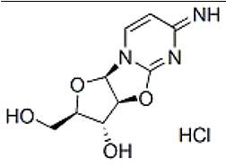 | 37  Hesperetin | 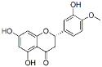
2  (-)-Epigallocatechin Gallate | 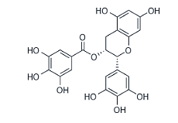 | 38  Hesperidin | 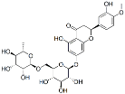
3  D-Usnic Acid | 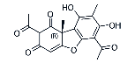 | 39  Honokiol | 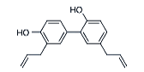
4  3-Indolebutyric acid | 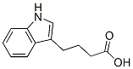 | 40  Hyodeoxycholic | 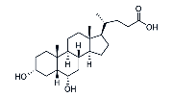
5  4-Methylumbelliferone | 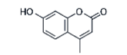 | 41  Icariin | 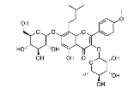
6  Silymarin | 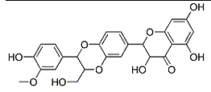 | 42  Ndole-3-carbinol | 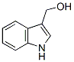
7  Amygdalin | 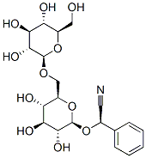 | 43  Kaempferol | 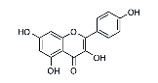
8  Andrographolide | 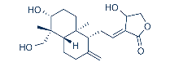 | 44  Kinetin | 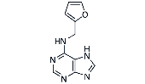
9  Apigenin | 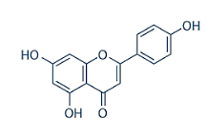 | 45  L-(+)-Rhamnose Monohydrate | 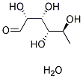
10  Arbutin | 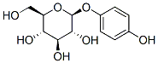 | 46  Limonin | 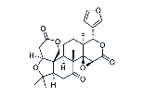
11  Artesunate | 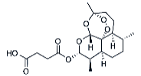 | 47  Terminalia chebula | 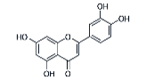
12  Asiatic acid | 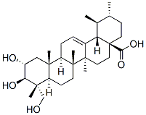 | 48  Magnolol | 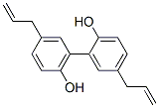
13  Azomycin | 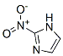 | 49  (+)-Matrine | 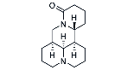
14  Baicalein | 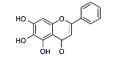 | 50  Methyl-Hesperidin | 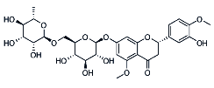
15  Baicalin | 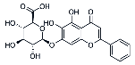 | 51  Morin hydrate | 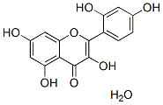
16  Bergenin | 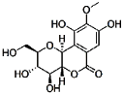 | 52  Myricetin | 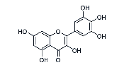
17  Berberine chloride | 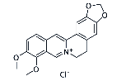 | 53  Myricitrin | 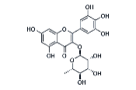
18  Bilobalide | 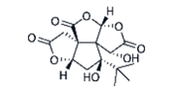 | 54  Nalidixic acid | 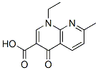
19  Caffeic Acid | 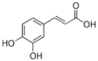 | 55  Naringin | 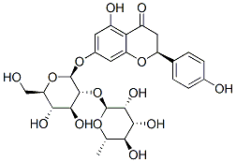
20  Chlorogenic acid | 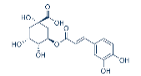 | 56  Neohesperidin dihydrochalcone | 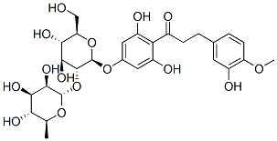
21  Cinchonidine | 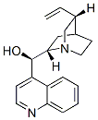 | 57  Neohesperidin | 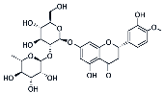
22  Chrysin | 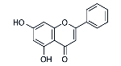 | 58  Nobiletin | 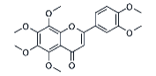
23  Cryptotanshinone | 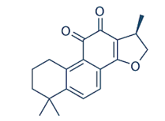 | 59  Oleanolic Acid | 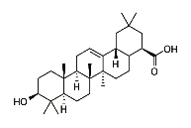
24  Cyclosporine A | 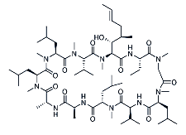 | 60  Oridonin | 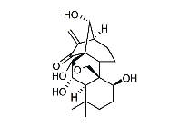
25  Cytisine | 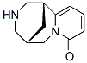 | 61  Orotic acid | 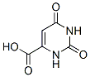
26  Dihydroartemisinin | 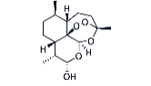 | 62  Osthole | 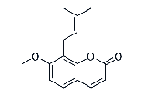
27  DL-Carnitine HCl | 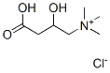 | 63  Oxymatrine | 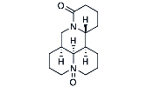
28  Emodin | 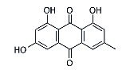 | 64  Paeonol | 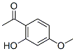
29  Fisetin | 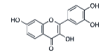 | 65  (-)-Parthenolide | 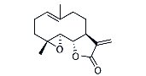
30  Enoxolone | 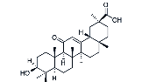 | 66  Dihydronaringenin | 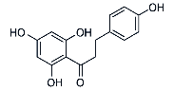
31  Formononetin | 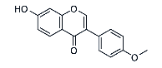 | 67  Phlorizin | 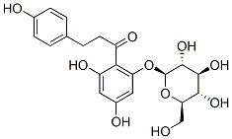
32  Ferulic Acid | 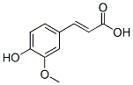 | 68  Piperine | 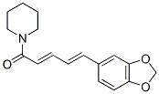
33  Glycyrrhizin | 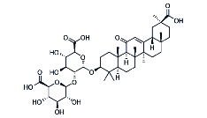 | 69  Puerarin | 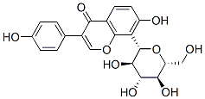
34  Gossypol Acetate | 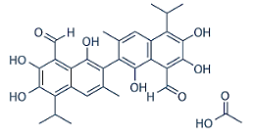 | 70  Quercetin | 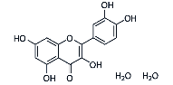
35  Gramine | 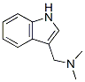 | 71  Rutaecarpine | 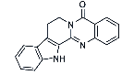
36  Gynostemma Extract | 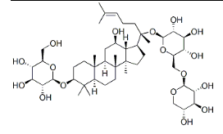 | 72  Rutin | 