Supplementary Material

Mitigating CYP450-Mediated Insecticide Resistance in Malaria Vectors with Cannabis-Derived Synergists: The Potential of Cannabidiol
Maria Chalkiadaki ª, Linda Grigoraki ^{b}, Dimitra Tsakireli ^{b,c}, Georgia Vasalaki ª, Petros S. Tzimas ª, Mengling Chen ^{b}, Latifa Remadi ^{b}, Rino Ragno ^{d}, Ifigeneia Akrani ª, Emmanouel Mikros ^{a,e}, Rafaela Panteleri ^{b}, Spyros Vlogiannitis ^{c}, Vassilios Myrianthopoulos ª, Ioannis K. Kostakis ª, Alexios-Leandros Skaltsounis ª, John Vontas ^{b,c*}, Maria Halabalaki ^{a*}
ª Department of Pharmacy, National and Kapodistrian University of Athens, Panepistimiopolis Zografou, Athens, 15771, Greece;
^{b} Institute of Molecular Biology and Biotechnology, Foundation for Research and Technology-Hellas, 73100 Heraklion, Greece;
^{c} Department of Crop Science, Agricultural University of Athens, GR-11855 Athens, Greece;
^{d} Rome Center for Molecular Design, Department of Drug Chemistry and Technology, Sapienza University of Rome, Piazzale Aldo Moro 5, 00185 Rome, Italy;
^{e} Pharma-Informatics Unit, Athena Research and Innovation Center in Information Communication and Knowledge Technologies, Marousi, Greece

Table S1. Inhibitory activity of screened plant extracts and fractions against Bemisia tabaci CYP6CM1. Data include botanical family, species, plant part, and extraction method/fraction type. Activity is reported as mean percentage inhibition ± standard deviation (SD) at 8.33 µg/mL (n = 3).
Species | Family | Plant part | Extract/ fraction type | Inhibition  (% mean ± SD)
Alkanna graeca | Boraginaceae | whole plant | MeOH (UAE) | 2.35 ± 1.14
Artemisia arborescens | Asteraceae | aerial parts | EtOAc (UAE) | nd
Artemisia arborescens | Asteraceae | aerial parts | THF (UAE) | nd
Cannabis sativa | Cannabaceae | inflorescences | SFE CO₂₋LLE acidic fraction | 12.58 ± 3.00
Cannabis sativa | Cannabaceae | inflorescences | SFE CO₂₋LLE acidic fraction decarboxylated | 32.32 ± 0.59
Cannabis sativa | Cannabaceae | inflorescences | SFE CO₂₋LLE neutral fraction | nd
Centaurea attica | Asteraceae | whole plant | EtOAc (UAE) | nd
Centaurea attica | Asteraceae | whole plant | MeOH (UAE) | nd
Centaurea peucedanifolia | Asteraceae | flowering aerial parts | EtOAc (UAE) | 17.10 ± 5.10
Daphne laureotica | Thymelaeaceae | branches and leaves | EtOAc (UAE) | 12.39 ± 2.10
Daphne laureotica | Thymelaeaceae | branches and leaves | MeOH (UAE) | 3.40 ± 0.76
Daphne oleoides | Thymelaeaceae | branches and leaves | EtOAc (UAE) | nd
Daphne oleoides | Thymelaeaceae | branches and leaves | MeOH (UAE) | nd
Daphne sericea | Thymelaeaceae | branches and leaves | EtOAc (UAE) | 20.87 ± 0.99
Daphne sericea | Thymelaeaceae | branches and leaves | MeOH (UAE) | 6.47 ± 1.20
Dianthus haematocalyx ssp. pindicola | Caryophyllaceae | whole plant | EtOAc (UAE) | 0.37 ± 0.30
Dianthus haematocalyx ssp. pindicola | Caryophyllaceae | whole plant | MeOH (UAE) | nd
Epilobium hirsutum | Onagraceae | aerial parts | EtOAc (UAE) | nd
Epilobium hirsutum | Onagraceae | aerial parts | MeOH (UAE) | nd
Gentiana lutea | Gentianaceae | roots | MeOH (UAE) | nd
Morus alba | Moraceae | wood | MeOH (UAE) | 29.94 ± 9.72
Onobrychis alba ssp. laconica | Fabaceae | perennial aerial parts and roots | EtOAc (UAE) | 21.33 ± 0.23
Onobrychis alba ssp. laconica | Fabaceae | perennial aerial parts and roots | MeOH (UAE) | 7.45 ± 1.76
Onobrychis alba ssp. laconica | Fabaceae | whole plant | EtOAc (UAE) | 28.36 ± 0.06
Onobrychis alba ssp. laconica | Fabaceae | whole plant | MeOH (UAE) | 10.72 ± 0.23
Pistacia lentiscus | Anacardiaceae | resin | acidic triterpenic fraction after LLE | nd
Pistacia lentiscus | Anacardiaceae | leaves | MeOH fraction after XAD7 | nd
Rubia peregrina | Rubiaceae | aerial parts | EtOAc (UAE) | nd
Rubia peregrina | Rubiaceae | aerial parts | MeOH (UAE) | nd
Salvia candidissima | Lamiaceae | whole plant | EtOAc (UAE) | 16.11 ± 0.53
Salvia candidissima | Lamiaceae | whole plant | MeOH (UAE) | 6.67 ± 1.00
Sesamum indicum | Pedaliaceae | seed | oil LLE- ACN fraction | nd
Thapsia garganica | Apiaceae | aerial parts | EtOAc (UAE) | nd
Thapsia garganica | Apiaceae | aerial parts | MeOH (UAE) | nd
Olea europea | Oleaceae | fruits | Total polyphenolic fraction from EVOO after LLE | 25.68 ± 0.01
Verbascum arcturus | Scrophulariaceae | annual aerial parts | EtOAc (UAE) | nd
Verbascum arcturus | Scrophulariaceae | annual aerial parts | MeOH (UAE) | nd
UAE: ultrasound-assisted extraction, MeOH: methanolic, EtOAc: ethyl acetate, THF: tetrahydrofuranic, SFE: supercritical fluid extraction, LLE: liquid-liquid extraction EtOH: ethanolic, ACN: acetonitrile, EVOO: extra virgin olive oil, nd: not determined.

Table S2. Root-mean-square deviations (RMSDs) of the CYP3A4 experimental binding sites with those of the CYP9K1 models from Alpha Fold (AF) and MODELLER (modbase).
PDB Entry code | AF | modbase
7KVK | 3.1 | 5.1
9COY | 3.0 | 4.8
6UNL | 3.0 | 4.4
6UNJ | 3.3 | 5.7
6UNI | 2.9 | 5.2
6UNM | 4.2 | 8.9
6BDH | 3.5 | 8.8
7KVM | 3.0 | 4.5
6BD7 | 3.5 | 5.0
7KVI | 3.1 | 4.5

Table S3. 39 representative compounds from in-silico screening using SwissADME, ADMET Predictor (Simulation Plus Inc.), and ADMETlab platforms.
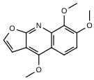 | 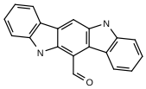 | 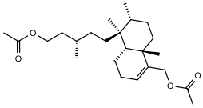
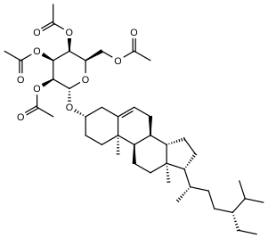 | 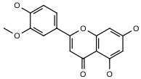 | 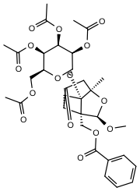
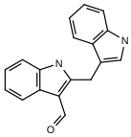 | 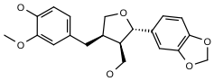 | 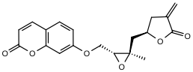
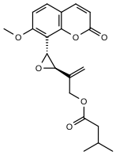 | 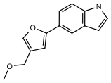 | 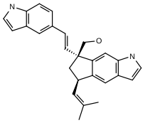
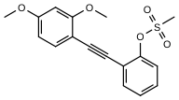 | 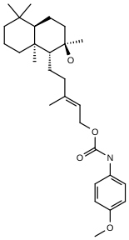 | 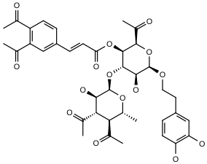
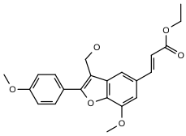 | 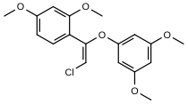 | 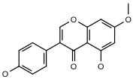
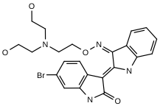 | 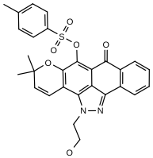 | 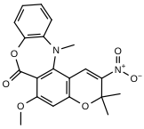
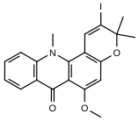 | 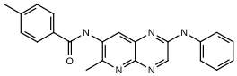 | 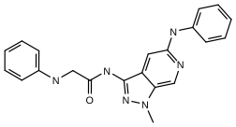
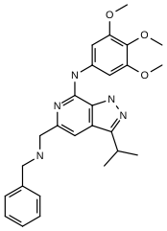 | 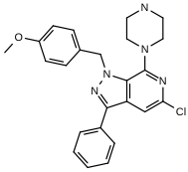 | 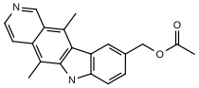
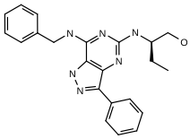 | 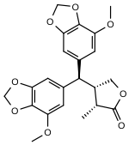 | 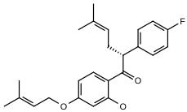
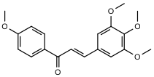 | 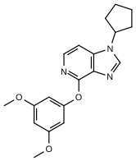 | 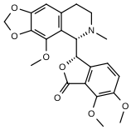
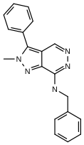 | 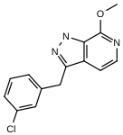 | 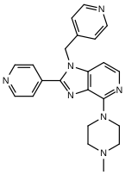
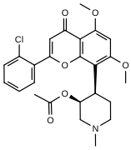 | 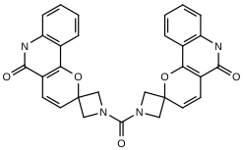 | 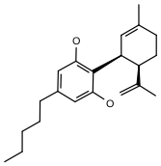

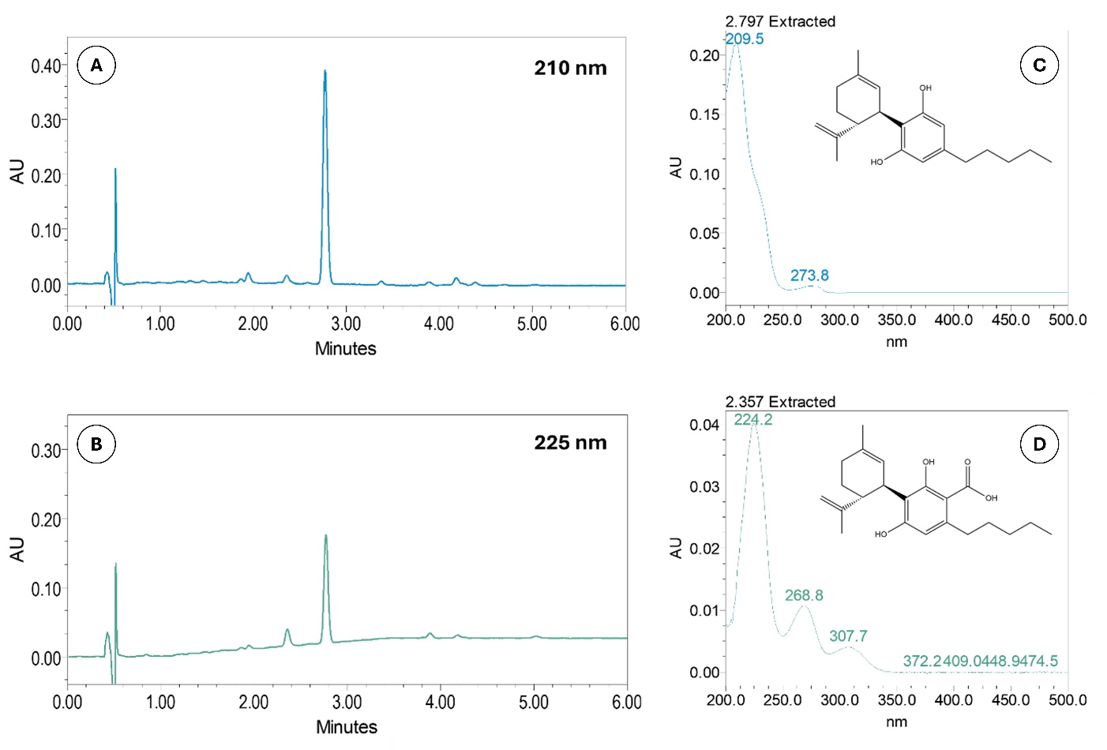
Figure S1. UPLC-PDA chromatograms of the decarboxylated acidic hemp fraction at 0.10 mg/mL, recorded at (A) 210 nm and (B) 225 nm. UV/Vis absorbance spectra of (C) CBD and (D) CBDA.

Table S4. UHPLC-HRMS/MS data of the decarboxylated acidic hemp fraction (SFEAFD) annotated cannabinoids in comparison to reference standards.
Compound | CBDV | CBE | CBDA | CBD | CBN | THC | CBC | CBCT
Rt (min) | 6.51 | 7.50 | 8.30 | 9.48 | 13.17 | 16.09 | 20.72 | 24.02
Adduct | [M+H]⁺ | [M+H]⁺ | [M+H]⁺ | [M+H]⁺ | [M+H]⁺ | [M+H]⁺ | [M+H]⁺ | [M+H]⁺
Experimental m/z | 287.2005 | 331.2262 | 359.2212 | 315.2314 | 311.2000 | 315.2312 | 315.2316 | 315.2317
Elemental composition (EC) | C₁₉H₂₆O₂ | C₂₁H₃₀O₃ | C₂₂H₃₀O₄ | C₂₁H₃₀O₂ | C₂₁H₂₆O₂ | C₂₁H₃₀O₂ | C₂₁H₃₀O₂ | C₂₁H₃₀O₂
RDB_{eq}. values | 6.5 | 6.5 | 7.5 | 6.5 | 8.5 | 6.5 | 6.5 | 6.5
Δm (ppm) | -0.20 | -1.64 | -1.29 | -1.31 | -1.85 | -2.08 | -0.71 | -0.63
HRMS/MS fragments | 165.0909 (100) 287.2004 (97) 231.1378 (34) 135.1167 (31) 93.0698 (30) 81.0698 (22) 95.0491 (19) 91.0542 (17) 207.1379 (16) | 205.1222 (100) 109.1011 (68) 135.0440 (37) 331.2267 (17) | 341.2110 (100) 219.1016 (36) 261.1483 (14) | 315.2317 (100) 193.1223 (82) 135.1167 (35) 93.0698 (34) 259.1692 (33) 123.0439 (22) 81.0698 (22) 95.0490 (19) 235.1691 (16) (107.0855 (16) 233.1535 (15) | 223.1128 (100) 311.2020 (92) 293.1913 (41) 241.1235 (30) 195.1178 (20) 178.0785 (16) | 315.2317 (100) 193.1223 (87) 259.1691 (363) 93.0698 (35) 135.1168 (34)  81.0698 (25) 123.0440 (19) 95.0491 (18) 91.0542 (18) | 193.1223 (100) 81.0698 (45) 259.1693 (32) 315.2319 (26) 69.0699 (21) 233.1537 (18) 93.0699 (17) 135.1168 (16) 109.1011 (16) 123.0441 (15) | 315.2318 (100) 193.1223 (39) 259.1692 (19) 135.1167 (18)
Rt: retention time expressed in minutes; RDBeq: ring and double bond equivalent; Δm: mass accuracy expressed in ppm.

To further assess the possibility of direct CBD binding to CYP6CM1, the biophysical method of differential scanning fluorimetry (DSF) was employed (Niesen et al., 2007). The effect of ligand binding on the enzyme thermal stability was monitored in terms of the change in melting temperature (T_{m}) and results revealed that CBD induced a -1.1°C shift to the enzyme’s T_{m} compared to the apoenzyme, suggesting a weak yet measurable binding interaction between CYP6CM1 and CBD (Supplementary Figure S2).
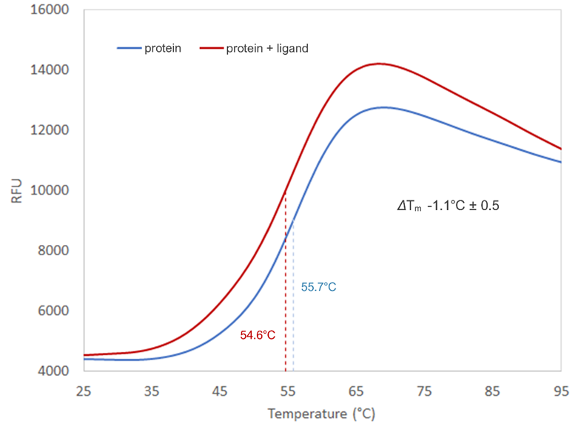
Figure S2. DSF curve showing the unfolding status of the target protein (CYP6CM1) in the absence (blue) and presence (red) of a ligand (CBD). The difference in the melting temperature is indicated as ΔT_{m}.

Table S5. List of screened CBD analogues, their respective percentage inhibition of Anopheles gambiae CYP9K1 activity, and standard deviation (SD) at 20 μΜ (n=3).
Compound | IUPAC names | Inhibition  (% mean ± SD)
CBD | 2-[(1R,6R)-3-methyl-6-prop-1-en-2-ylcyclohex-2-en-1-yl]-5-pentylbenzene-1,3-diol | 52.79 ± 1.66
Analogue 1 | ethyl 2-(((1'R,2'R)-6-hydroxy-5'-methyl-4-pentyl-2'-(prop-1-en-2-yl)-1',2',3',4'-tetrahydro-[1,1'-biphenyl]-2-yl)oxy)acetate | 27.50 ± 4.26
Analogue 2 | N-(4-aminobutyl)-2-(((1'R,2'R)-6-hydroxy-5'-methyl-4-pentyl-2'-(prop-1-en-2-yl)-1',2',3',4'-tetrahydro-[1,1'-biphenyl]-2-yl)oxy)acetamide | 14.62 ± 0.91
Analogue 3 | 2-(((1'R,2'R)-6-hydroxy-5'-methyl-4-pentyl-2'-(prop-1-en-2-yl)-1',2',3',4'-tetrahydro-[1,1'-biphenyl]-2-yl)oxy)-1-(piperazin-1-yl)ethanone | 87.93 ± 2.16
Analogue 4 | N-(8-aminooctyl)-2-(((1'R,2'R)-6-hydroxy-5'-methyl-4-pentyl-2'-(prop-1-en-2-yl)-1',2',3',4'-tetrahydro-[1,1'-biphenyl]-2-yl)oxy)acetamide | 7.01 ± 5.73

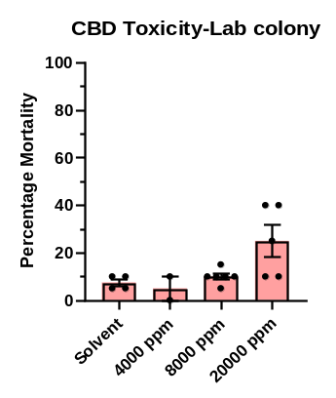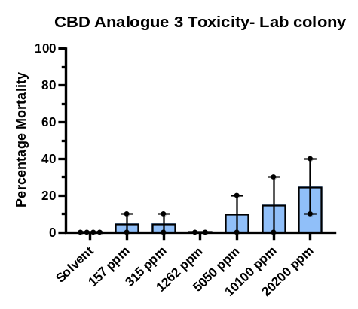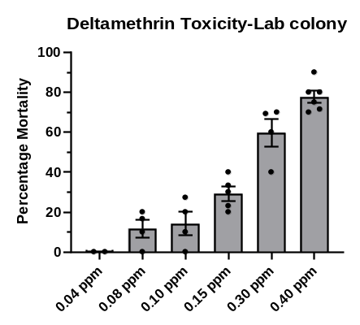
Figure S3. Percentage mortality of insecticide-susceptible Anopheles gambiae adults exposed to increasing concentrations of CBD, CBD analogue 3, and deltamethrin. Error bars represent standard deviation.

Table S6. Human P450 3A4 Oxidation sites of CBD and analogue 3 as predicted by online platform BioTransforemer 3.0.
Compound | Structure | CYP3A4 BioTransformer 3.0 Oxidation Site
CBD | 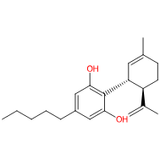 | 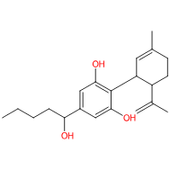
Analogue_3 | 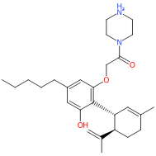 | 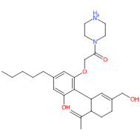

Table S7. Acute contact toxicity (LD₅₀, μg/bee) of test substances in Apis mellifera at 24 (A), 48 (B), 72 (C), and 96 h (D) post-treatment (95% CI; relative toxicity index).
- 24 hours post treatment
Test substance | LD₅₀ μg/bee | 95% Confidence Interval (μg/bee) | Relative toxicity index
SFEAFD | >10 | - | >16.38
CBD | >20 | - | >8.19
Analogue 3 | >20 | - | >8.19
Tau-Fluvalinate | 163.89 | 99.99 to 258.88 | -
Deltamethrin | 2.39 | 1.35 to 4.09 | 68.57
Lambda-cyhalothrin | 15.20 | 8.66 to 27.64 | 10.78
Beta-cyfluthrin | 0.50 | 0.331 to 0.745 | 327.78
(B) 48 hours post treatment
Test substance | LD₅₀ μg/bee | 95% Confidence Interval (μg/bee) | Relative toxicity index
SFEAFD | >10 | - | >6.05
CBD | 16.45 | 12.760 to 26.004 | 3.83
Analogue 3 | 11.17 | 7.554 to 18.766 | 5.64
Tau-Fluvalinate | 63.05 | 38.01 to 100.41 | -
Deltamethrin | 0.68 | 0.12 to 5.19 | 92.72
Lambda-cyhalothrin | 8.43 | 5.00 to 14.66 | 7.48
Beta-cyfluthrin | 0.20 | 0.135 to 0.289 | 315.25
(C) 72 hours post treatment
Test substance | LD₅₀ μg/bee | 95% Confidence Interval (μg/bee) | Relative toxicity index
SFEAFD | >10 | - | >1.4
CBD | 10.20 | 8.291 to 12.673 | 1.41
Analogue 3 | 5.77 | 2.983 to 7.803 | 2.49
Tau-Fluvalinate | 14.39 | 7.53 to 25.30 | -
Deltamethrin | 0.18 | 0.11 to 0.28 | 79.95
Lambda-cyhalothrin | 3.56 | 2.05 to 6.38 | 40.42
Beta-cyfluthrin | 0.139 | 0.087 to 0.209 | 103.55
(D) 96 hours post treatment
Test substance | LD₅₀ μg/bee | 95% Confidence Interval (μg/bee) | Relative toxicity index
SFEAFD | >10 | - | -
CBD | 7.474 | 5.583 to 9.264 | > 1.33
Analogue 3 | 3.297 | 1.162 to 4.718 | > 3.03
Tau-Fluvalinate | 3.69 | 1.91 to 6.49 | > 2.71
Deltamethrin | 0.044 | 0.022 to 0.070 | > 227.27
Lambda-cyhalothrin | 1.42 | 0.85 to 2.46 | > 7.04
Beta-cyfluthrin | 0.074 | 0.041 to 0.117 | > 135.13

Supplementary References
Niesen, F.H., Berglund, H., Vedadi, M., 2007. The use of differential scanning fluorimetry to detect ligand interactions that promote protein stability. Nat. Protoc. 2, 2212–2221. https://doi.org/10.1038/nprot.2007.321

