Supplementary Material

Regional variation in ADHD diagnosis and treatment in Denmark

Heidi Sonne, MScPharm,¹ hesonne@health.sdu.dk, ORCID: 0009-0005-3907-292X
Anton Pottegård, DMSc,¹ apottegaard@health.sdu.dk, ORCID: 0000-0001-9314-5679
Anna Sofie Kjærgaard Hansen, PhD,^{2,3} anna.hansen@rn.dk, ORCID: 0000-0003-0966-8042
Mickael Bech, PhD,⁴ mibech@sam.sdu.dk, ORCID: 0000-0003-3084-2068
Helene Kildegaard, PhD,^{1,5} hckildegaard@health.sdu.dk, ORCID: 0000-0003-1930-5851

Corresponding author:
Helene Kildegaard
hckildegaard@health.sdu.dk
Department of Public Health
Clinical Pharmacology, Pharmacy, and Environmental Medicine
University of Southern Denmark
Campusvej 55, 5230 Odense M, Denmark
Supplementary Table 1. Prevalence of ADHD medication use and ADHD diagnoses among children and adolescents aged 4-17 years in Denmark, 2024. Estimates are shown per 1,000 inhabitants at national, regional, and municipal levels.

Geographic entity | Prevalence proportion of drugs per 1,000 | Prevalence proportion of diagnosis per 1,000
National | 32 | 39
The Capital Region of Denmark | 30 | 38
Albertslund | 29 | 40
Allerød | 38 | 41
Ballerup | 35 | 48
Bornholm | 57 | 61
Brøndby | 25 | 40
Dragør | 36 | 40
Egedal | 44 | 53
Fredensborg | 31 | 34
Frederiksberg | 19 | 23
Frederikssund | 48 | 58
Furesø | 35 | 46
Gentofte | 28 | 31
Gladsaxe | 29 | 35
Glostrup | 28 | 46
Gribskov | 45 | 61
Halsnæs | 47 | 60
Helsingør | 38 | 47
Herlev | 37 | 48
Hillerød | 38 | 46
Hvidovre | 35 | 43
Høje-Taastrup | 22 | 33
Hørsholm | 38 | 42
Ishøj | 24 | 37
København | 23 | 30
Lyngby-Taarbæk | 33 | 39
Rudersdal | 30 | 36
Rødovre | 27 | 34
Tårnby | 30 | 37
Vallensbæk | 24 | 33
Region Zealand | 25 | 33
Faxe | 28 | 38
Greve | 21 | 28
Guldborgsund | 17 | 21
Holbæk | 36 | 46
Kalundborg | 32 | 43
Køge | 19 | 26
Lejre | 25 | 35
Lolland | 12 | 20
Næstved | 19 | 30
Odsherred | 39 | 44
Ringsted | 20 | 29
Roskilde | 23 | 26
Slagelse | 32 | 49
Solrød | 24 | 29
Sorø | 30 | 43
Stevns | 23 | 33
Vordingborg | 24 | 31
The Region of Southern Denmark | 23 | 34
Assens | 14 | 24
Billund | 34 | 49
Esbjerg | 30 | 42
Fanø | N < 10 | N < 10
Fredericia | 27 | 42
Faaborg-Midtfyn | 16 | 24
Haderslev | 36 | 48
Kerteminde | 10 | 22
Kolding | 28 | 36
Langeland | N < 10 | 18
Middelfart | 17 | 26
Nordfyns | 13 | 22
Nyborg | 14 | 20
Odense | 11 | 15
Svendborg | 11 | 20
Sønderborg | 38 | 51
Tønder | 31 | 46
Varde | 29 | 40
Vejen | 30 | 44
Vejle | 24 | 34
Ærø | N < 10 | N < 10
Aabenraa | 37 | 59
The Central Denmark Region | 39 | 43
Favrskov | 49 | 60
Hedensted | 44 | 54
Herning | 39 | 47
Holstebro | 42 | 53
Horsens | 36 | 32
Ikast-Brande | 52 | 66
Lemvig | 35 | 45
Norddjurs | 55 | 65
Odder | 42 | 51
Randers | 42 | 47
Ringkøbing-Skjern | 33 | 36
Samsø | 45 | 57
Silkeborg | 38 | 44
Skanderborg | 36 | 35
Skive | 40 | 48
Struer | 58 | 74
Syddjurs | 43 | 45
Viborg | 33 | 37
Aarhus | 36 | 35
The North Denmark Region | 45 | 50
Brønderslev | 55 | 61
Frederikshavn | 38 | 43
Hjørring | 46 | 55
Jammerbugt | 55 | 67
Læsø | N < 10 | N < 10
Mariagerfjord | 45 | 50
Morsø | 30 | 38
Rebild | 48 | 54
Thisted | 38 | 45
Vesthimmerlands | 47 | 50
Aalborg | 44 | 47

Supplementary Table 2. Regional and municipal indicators in Denmark, 2024. Indicators include municipal socioeconomic index (values >1 indicate higher-than-average needs), average regional waiting times in public child and adolescent psychiatry (days), and regional capacity of private practicing child and adolescent psychiatrists with a provider number (full-time equivalents per 100,000 inhabitants aged 4-17 years).

Geographic entity | Socioeconomic index | Average wait time (days) | Capacity of private psychiatrists (FTE) per 100,000
The Capital Region of Denmark |  | 29 | 2.6
Albertslund | 1.56
Allerød | 0.51
Ballerup | 1.27
Bornholm | 1.06
Brøndby | 1.66
Dragør | 0.62
Egedal | 0.61
Fredensborg | 0.92
Frederiksberg | 0.76
Frederikssund | 0.89
Furesø | 0.74
Gentofte | 0.64
Gladsaxe | 1.08
Glostrup | 1.18
Gribskov | 0.87
Halsnæs | 1.02
Helsingør | 1.02
Herlev | 1.25
Hillerød | 0.77
Hvidovre | 1.19
Høje-Taastrup | 1.22
Hørsholm | 0.64
Ishøj | 1.62
København | 1.04
Lyngby-Taarbæk | 0.73
Rudersdal | 0.62
Rødovre | 1.22
Tårnby | 1.06
Vallensbæk | 0.82
Region Zealand |  | 36 | 2.4
Faxe | 1.02
Greve | 0.90
Guldborgsund | 1.32
Holbæk | 1.07
Kalundborg | 1.26
Køge | 1.02
Lejre | 0.72
Lolland | 1.63
Næstved | 1.09
Odsherred | 1.25
Ringsted | 1.05
Roskilde | 0.78
Slagelse | 1.30
Solrød | 0.65
Sorø | 1.02
Stevns | 0.95
Vordingborg | 1.19
The Region of Southern Denmark |  | 29 | 2.2
Assens | 1.04
Billund | 1.04
Esbjerg | 1.08
Fanø | 0.69
Fredericia | 1.23
Faaborg-Midtfyn | 0.99
Haderslev | 1.16
Kerteminde | 0.99
Kolding | 0.98
Langeland | 1.28
Middelfart | 0.87
Nordfyns | 1.04
Nyborg | 1.13
Odense | 1.11
Svendborg | 1.01
Sønderborg | 1.12
Tønder | 1.17
Varde | 0.97
Vejen | 0.99
Vejle | 0.94
Ærø | 0.99
Aabenraa | 1.10
The Central Denmark Region |  | 31 | 1.9
Favrskov | 0.68
Hedensted | 0.80
Herning | 0.90
Holstebro | 0.89
Horsens | 0.97
Ikast-Brande | 0.95
Lemvig | 0.91
Norddjurs | 1.15
Odder | 0.83
Randers | 1.13
Ringkøbing-Skjern | 0.92
Samsø | 1.03
Silkeborg | 0.81
Skanderborg | 0.62
Skive | 1.05
Struer | 1.04
Syddjurs | 0.83
Viborg | 0.95
Aarhus | 0.95
The North Denmark Region |  | 53 | 3.5
Brønderslev | 0.98
Frederikshavn | 1.11
Hjørring | 1.01
Jammerbugt | 0.96
Læsø | 1.16
Mariagerfjord | 1.00
Morsø | 1.11
Rebild | 0.73
Thisted | 1.03
Vesthimmerlands | 1.11
Aalborg | 0.97
Supplementary Table 3. Spearman’s rank correlation coefficients between prevalence of ADHD medication use or ADHD diagnoses and regional/municipal indicators in Denmark, 2024. Results are shown for children and adolescents aged 4-17 years overall and stratified by sex.

Sex | Variable X | Variable Y | N | Rho | P-value
Both | Socioeconomic index | Drugs | 94 | -0,20 | 0,049
Both | Socioeconomic index | Diagnosis | 95 | -0,042 | 0,68
Both | Capacity per 100,000 | Drugs | 5 | 0,40 | 0,50
Both | Capacity per 100,000 | Diagnosis | 5 | 0,30 | 0,62
Both | Wait times | Drugs | 5 | 0,62 | 0,27
Both | Wait times | Diagnosis | 5 | 0,36 | 0,55
Girls | Socioeconomic index | Drugs | 93 | -0,29 | 0,005
Girls | Socioeconomic index | Diagnosis | 93 | -0,055 | 0,60
Girls | Capacity per 100,000 | Drugs | 5 | 0,40 | 0,50
Girls | Capacity per 100,000 | Diagnosis | 5 | 0,40 | 0,50
Girls | Wait times | Drugs | 5 | 0,62 | 0,27
Girls | Wait times | Diagnosis | 5 | 0,62 | 0,27
Boys | Socioeconomic index | Drugs | 94 | -0,15 | 0,15
Boys | Socioeconomic index | Diagnosis | 95 | -0,027 | 0,80
Boys | Capacity per 100,000 | Drugs | 5 | 0,30 | 0,62
Boys | Capacity per 100,000 | Diagnosis | 5 | 0,30 | 0,62
Boys | Wait times | Drugs | 5 | 0,36 | 0,55
Boys | Wait times | Diagnosis | 5 | 0,36 | 0,55

Supplementary Table 4. Results from linear regression analyses of the association between prevalence of ADHD medication use or ADHD diagnoses and regional/municipal indicators in Denmark, 2024. Analyses are presented for children and adolescents aged 4-17 years overall and stratified by sex. Municipal-level analyses are population-weighted, whereas regional-level analyses are unweighted.

Sex | Variable X | Variable Y | Estimate (95% CI) | P-value
Both | Socioeconomic index | Drugs | -0,013 (-0,024; -0,0015) | 0,027
Both | Socioeconomic index | Diagnosis | -0,0041 (-0,017; 0,0084) | 0,52
Both | Capacity per 100,000 | Drugs | 0,0082 (-0,016; 0,032) | 0,36
Both | Capacity per 100,000 | Diagnosis | 0,0072 (-0,010; 0,024) | 0,27
Both | Wait times | Drugs | 0,00061 (-0,00067; 0,0019) | 0,23
Both | Wait times | Diagnosis | 0,00050 (0,00039; 0,0014) | 0,17
Girls | Socioeconomic index | Drugs | -0,012 (-0,020; 0,0036) | 0,0055
Girls | Socioeconomic index | Diagnosis | -0,0049 (-0,014; 0,0040) | 0,28
Girls | Capacity per 100,000 | Drugs | 0,0029 (-0,0056; 0,011) | 0,36
Girls | Capacity per 100,000 | Diagnosis | 0,0028 (-0,0028; 0,0084) | 0,21
Girls | Wait times | Drugs | 0,00042 (-0,00053; 0,0014) | 0,26
Girls | Wait times | Diagnosis | 0,00036 (-0,00031; 0,0010) | 0,19
Boys | Socioeconomic index | Drugs | -0,013 (-0,028; 0,0013) | 0,073
Boys | Socioeconomic index | Diagnosis | -0,0030 (-0,020; 0,013) | 0,72
Boys | Capacity per 100,000 | Drugs | 0,0053 (-0,010; 0,021) | 0,36
Boys | Capacity per 100,000 | Diagnosis | 0,0044 (-0,0071; 0,016) | 0,31
Boys | Wait times | Drugs | 0,00078 (-0,00082; 0,0024) | 0,22
Boys | Wait times | Diagnosis | 0,00064 (-0,00050; 0,0018) | 0,17
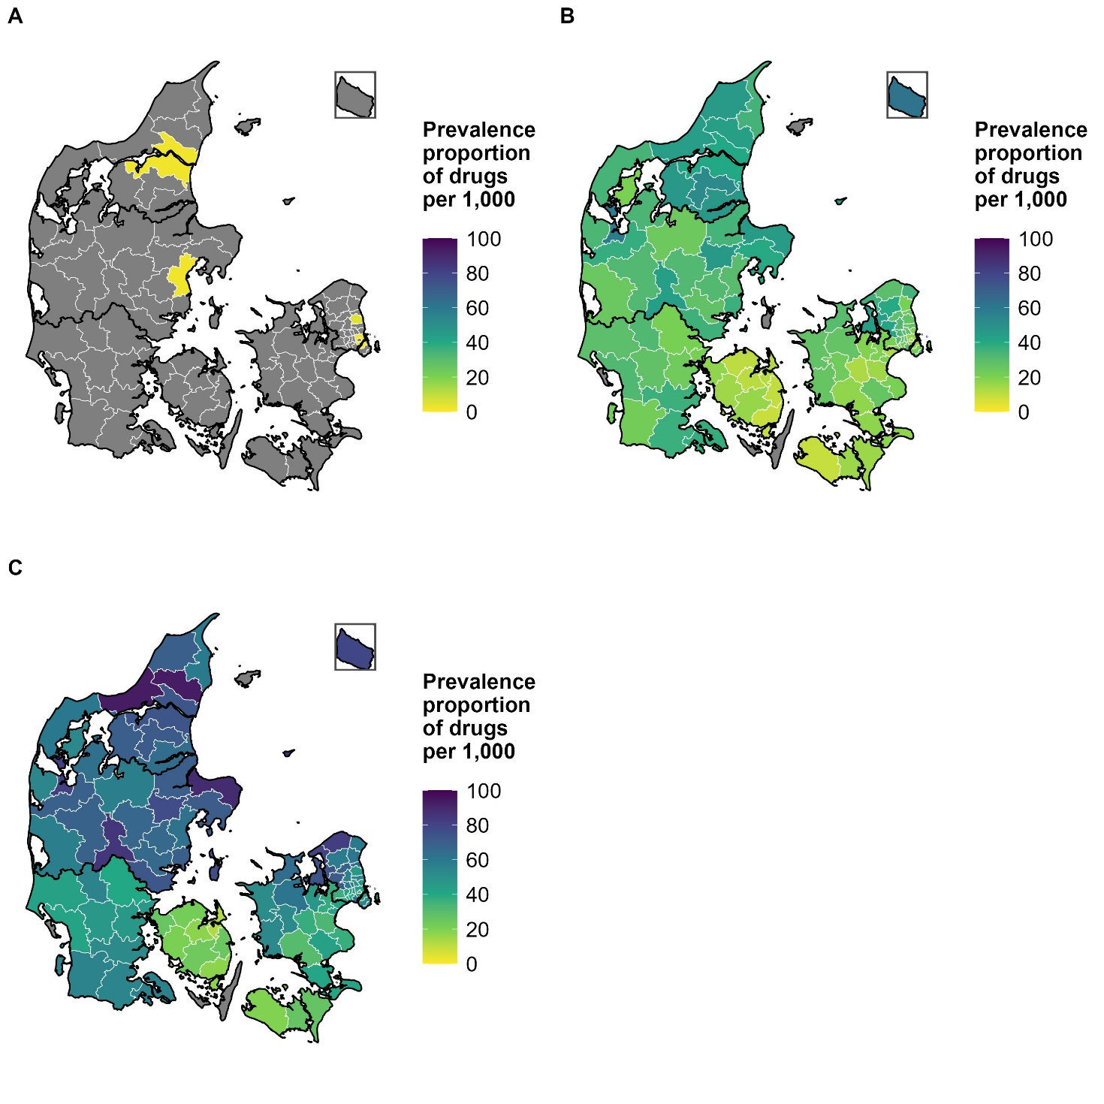
Supplementary Figure 1. Municipal prevalence of ADHD medication use per 1,000 inhabitants among children and adolescents aged 4-17 years in Denmark, 2024, stratified by age group.
- Children aged 4-6 years.
- Children aged 7-12 years.
- Adolescents aged 13-17 years.
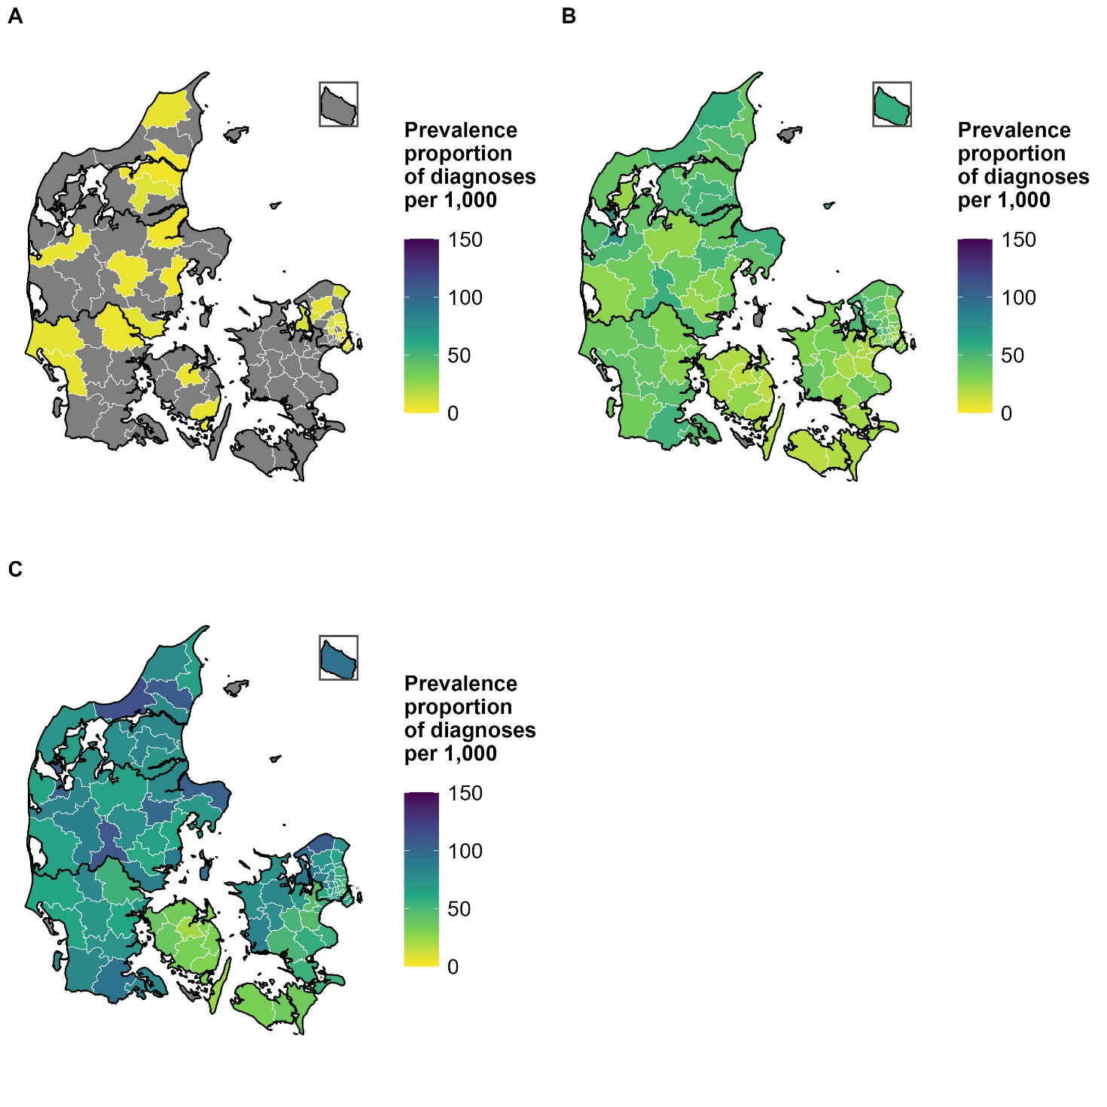
Supplementary Figure 2. Municipal prevalence of ADHD diagnoses per 1,000 inhabitants among children and adolescents aged 4-17 years in Denmark, 2024, stratified by age group.
- Children aged 4-6 years.
- Children aged 7-12 years.
- Adolescents aged 13-17 years.
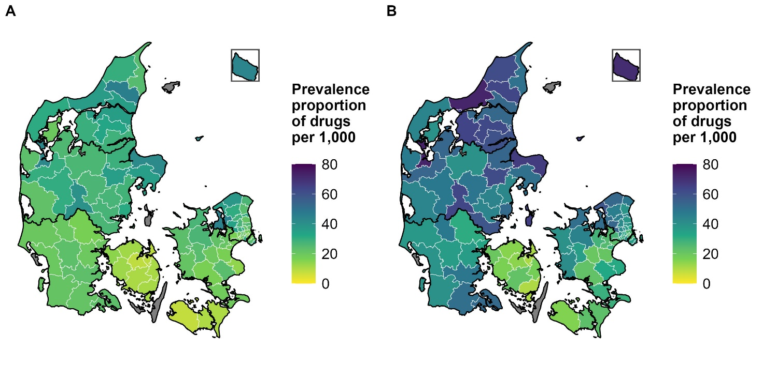
Supplementary Figure 3. Municipal prevalence of ADHD medication use per 1,000 inhabitants among children and adolescents aged 4-17 years in Denmark, 2024, stratified by sex.
- Girls.
- Boys.
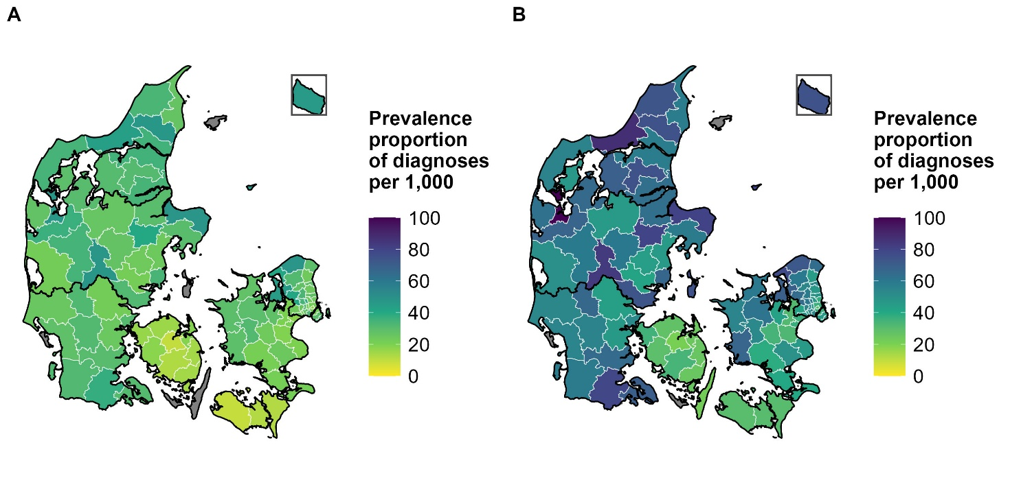
Supplementary Figure 4. Municipal prevalence of ADHD diagnoses per 1,000 inhabitants among children and adolescents aged 4-17 years in Denmark, 2024, stratified by sex.
- Girls.
- Boys.

