Supplemental Figure 1. Population-level longitudinal trends in cigarette, e-cigarette, other tobacco products, alcohol, and cannabis use by year

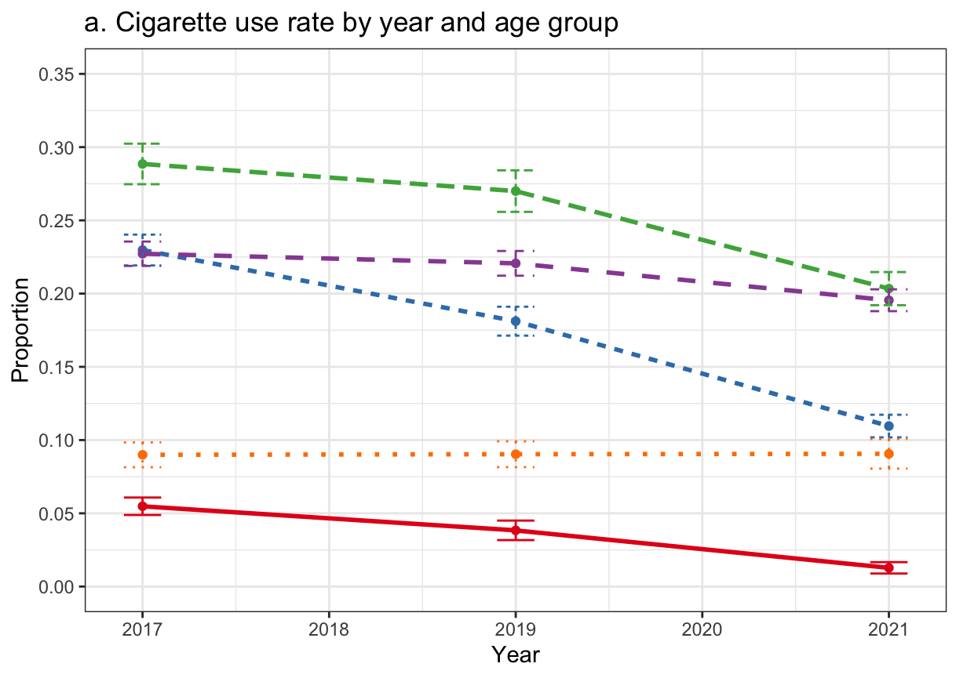 | 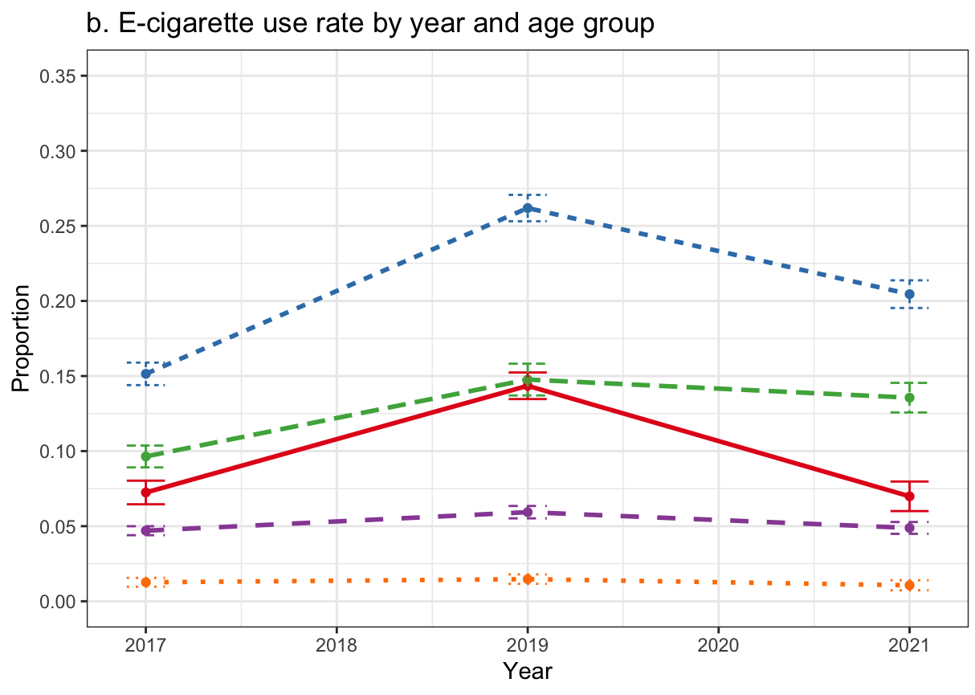
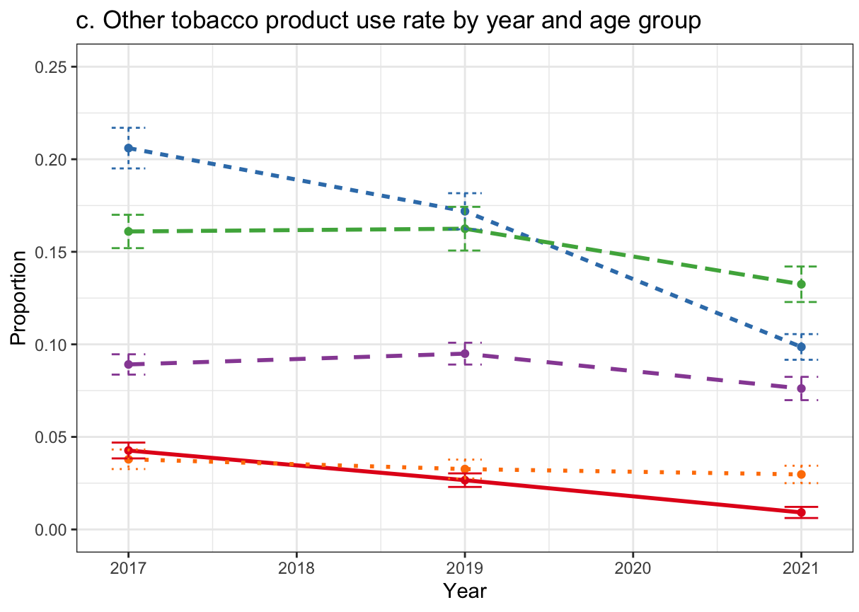 | 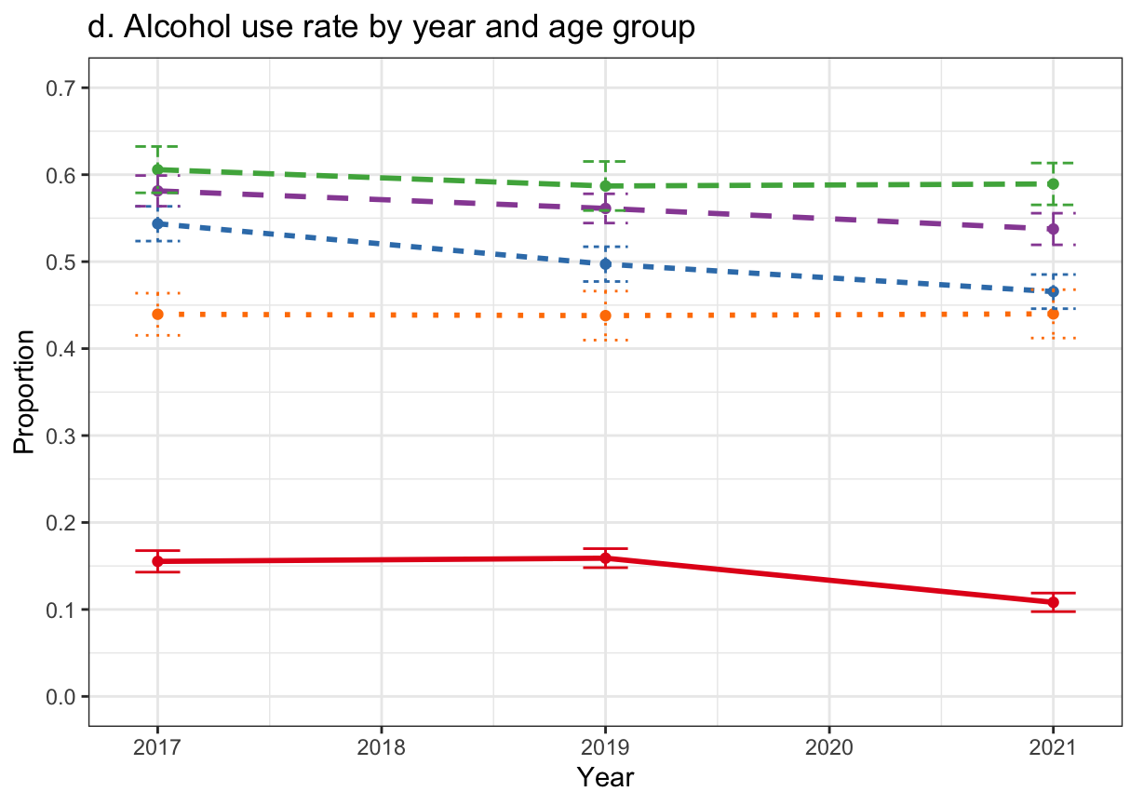
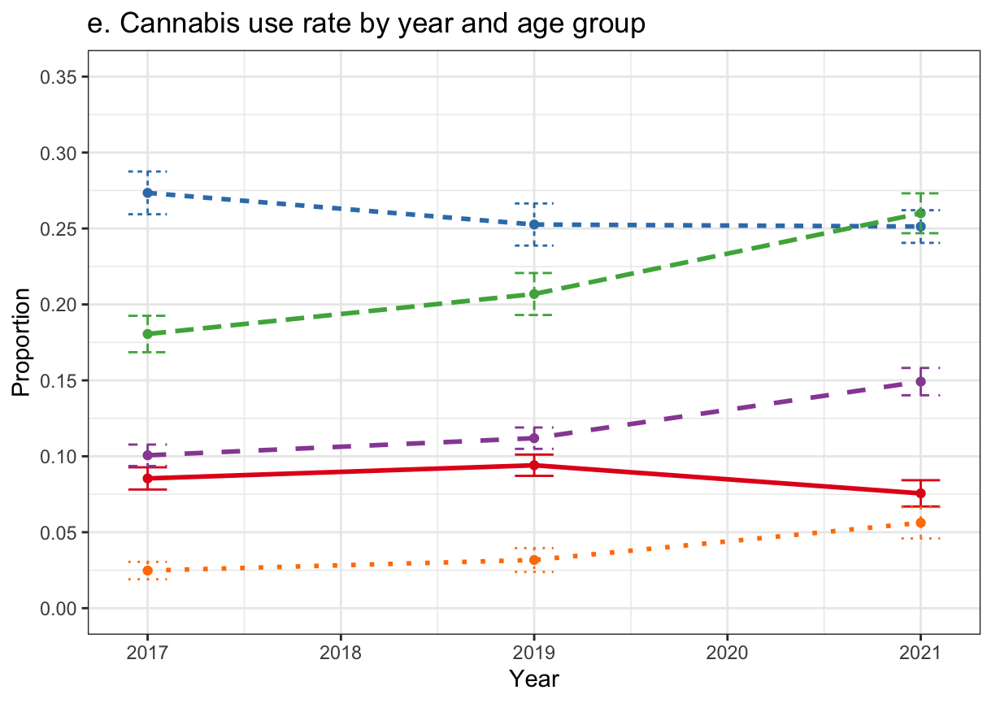
Age Group
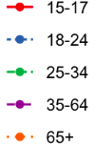
Note: Error bars represent 95% confidence intervals.
Supplemental Table 1. Product use and co-use rates by age group among all individuals age ≥ 15 in PATH Waves 4-7.
 | Wave 4 (December 2016 - January 2018) |  |  |  |  | Wave 5 (December 2018 - November 2019)
 | 15-17 | 18-24 | 25-34 | 35-64 | 65+ | 15-17 | 18-24 | 25-34 | 35-64 | 65+
ALC | .16 [.14-.17] | .54  [.52-.56] | .61  [.58-.63] | .58 [.56-.60] | .44 [.42-.46] | .16 [.15-.17] | .50  [.48-.52] | .59  [.56-.62] | .56 [.54-.58] | .44 [.41-.47]
CAN | .09 [.08-.09] | .27  [.26-.29] | .18  [.17-.19] | .10 [.09-.11] | .02 [.02-.03] | .09 [.09-.10] | .25  [.24-.27] | .21  [.19-.22] | .11 [.10-.12] | .03 [.02-.04]
CIG | .05 [.05-.06] | .23  [.22-.24] | .29  [.27-.30] | .23 [.22-.24] | .09 [.08-.10] | .04 [.03-.05] | .18  [.17-.19] | .27  [.26-.28] | .22 [.21-.23] | .09 [.08-.10]
ECIG | .07 [.06-.08] | .15  [.14-.16] | .10  [.09-.10] | .05 [.04-.05] | .01 [.01-.02] | .14 [.13-.15] | .26  [.25-.27] | .15  [.14-.16] | .06 [.06-.06] | .01 [.01-.02]
OTP | .04 [.04-.05] | .21  [.20-.22] | .16  [.15-.17] | .09 [.08-.09] | .04 [.03-.04] | .03 [.02-.03] | .17  [.16-.18] | .16  [.15-.17] | .09 [.09-.10] | .03 [.03-.04]
CIGAR | .00 [.00-.01] | .05  [.05-.06] | .05  [.05-.06] | .03 [.03-.03] | .01 [.01-.02] | .00 [.00-.01] | .05  [.04-.05] | .06  [.05-.06] | .04 [.03-.04] | .01 [.01-.02]
FLTRCIGAR | .00 [.00-.01] | .03  [.03-.03] | .02  [.02-.03] | .02 [.02-.02] | .01 [.00-.01] | .00 [.00-.00] | .02  [.02-.03] | .03  [.02-.03] | .02 [.01-.02] | .01 [.00-.01]
SMKLS | .02 [.01-.02] | .04  [.04-.05] | .04  [.04-.05] | .03 [.03-.03] | .01 [.01-.02] | .01 [.01-.01] | .03  [.03-.04] | .04  [.03-.05] | .03 [.03-.03] | .01 [.01-.01]
HOOKAH | .01 [.01-.01] | .07  [.06-.07] | .03  [.03-.04] | .01 [.01-.01] | .00 [.00-.00] | .00 [.00-.01] | .05  [.05-.06] | .04  [.04-.05] | .01 [.01-.01] | .00 [.00-.00]
SNUS | .01 [.00-.01] | .02  [.02-.02] | .02  [.01-.02] | .01 [.01-.01] | .00 [.00-.00] | .00 [.00-.01] | .02  [.01-.02] | .01  [.01-.02] | .01 [.01-.01] | .00 [.00-.00]
CIGARILLO | .02 [.01-.02] | .11  [.10-.11] | .07  [.07-.08] | .03 [.03-.03] | .01 [.00-.01] | .01 [.01-.01] | .08  [.07-.08] | .07  [.06-.07] | .03 [.03-.04] | .01 [.00-.01]
PIPE | .00 [.00-.01] | .01  [.01-.02] | .01  [.01-.01] | .01 [.00-.01] | .01 [.00-.01] | .00 [.00-.00] | .01  [.01-.01] | .01  [.01-.02] | .01 [.00-.01] | .00 [.00-.00]
ALC + CIG | .02 [.02-.03] | .15  [.14-.16] | .18  [.17-.19] | .13 [.13-.14] | .04 [.03-.04] | .01 [.01-.02] | .11  [.10-.11] | .15  [.14-.16] | .12 [.11-.13] | .04 [.04-.05]
ALC + ECIG | .04 [.03-.04] | .10  [.09-.11] | .06  [.05-.07] | .03 [.03-.03] | .00 [.00-.01] | .05 [.05-.06] | .17  [.16-.18] | .10  [.09-.11] | .03 [.03-.04] | .01 [.01-.01]
ALC + OTP | .02 [.01-.02] | .14  [.13-.15] | .11  [.10-.12] | .06 [.06-.06] | .02 [.02-.03] | .01 [.01-.01] | .10  [.10-.11] | .10  [.10-.11] | .06 [.06-.07] | .02 [.01-.02]
CAN + CIG | .02 [.02-.02] | .13  [.12-.13] | .10  [.10-.11] | .06 [.05-.06] | .01 [.01-.01] | .01 [.01-.02] | .09  [.08-.09] | .10  [.09-.11] | .06 [.05-.06] | .01 [.01-.01]
CAN + ECIG | .02 [.02-.03] | .09  [.08-.09] | .04  [.03-.05] | .01 [.01-.02] | .00 [.00-.00] | .04 [.04-.05] | .13  [.12-.14] | .07  [.06-.07] | .02 [.02-.02] | .00 [.00-.00]
CAN + OTP | .02 [.01-.02] | .12  [.11-.12] | .06  [.05-.07] | .02 [.02-.03] | .00 [.00-.01] | .01 [.01-.01] | .08  [.08-.09] | .06  [.05-.07] | .02 [.02-.03] | .00 [.00-.00]
ALC + CAN | .04 [.04-.05] | .21  [.20-.22] | .14  [.13-.15] | .08 [.07-.08] | .02 [.01-.02] | .04 [.04-.05] | .19  [.18-.20] | .16  [.14-.17] | .08 [.08-.09] | .02 [.02-.03]
 | Wave 6 (March 2021 - November 2021) |  |  |  |  | Wave 7 (January 2022 - April 2023)
 | 15-17 | 18-24 | 25-34 | 35-64 | 65+ | 15-17 | 18-24 | 25-34 | 35-64 | 65+
ALC | .11 [.10-.12] | .47  [.45-.49] | .59  [.57-.61] | .54 [.52-.56] | .44 [.41-.47] |  | .45  [.44-.47] | .56  [.54-.59] | .54  [.52-.56] | .43  [.40-.46]
CAN | .08 [.07-.08] | .25  [.24-.26] | .26  [.25-.27] | .15 [.14-.16] | .06 [.05-.07] |  | .28  [.26-.29] | .28  [.26-.30] | .16  [.15-.17] | .07  [.06-.08]
CIG | .01 [.01-.02] | .11  [.10-.12] | .20  [.19-.21] | .20 [.19-.20] | .09 [.08-.10] |  | .10  [.09-.11] | .19  [.18-.20] | .19  [.19-.20] | .09  [.08-.10]
ECIG | .07 [.06-.08] | .20  [.20-.21] | .14  [.13-.15] | .05 [.04-.05] | .01 [.01-.01] |  | .23 [.22-.24] | .18 [.17-.19] | .06  [.06-.07] | .01  [.01-.02]
OTP | .01 [.01-.01] | .10  [.09-.11] | .13  [.12-.14] | .08 [.07-.08] | .03 [.03-.03] |  | .09  [.08-.10] | .13  [.12-.14] | .08  [.07-.09] | .03  [.03-.04]
CIGAR | .00 [.00-.00] | .03  [.02-.03] | .04  [.04-.05] | .03 [.02-.03] | .01 [.01-.01] |  | .03  [.02-.03] | .04  [.04-.05] | .03  [.02-.03] | .02  [.01-.02]
FLTRCIGAR | .00 [.00-.00] | .01  [.01-.01] | .02  [.01-.02] | .01 [.01-.01] | .00 [.00-.01] |  | .01  [.01-.01] | .02  [.01-.02] | .01  [.01-.01] | .01  [.00-.01]
SMKLS | .00 [.00-.00] | .02  [.02-.02] | .03  [.02-.03] | .02 [.02-.03] | .01 [.01-.02] |  | .01  [.01-.01] | .02  [.01-.03] | .03  [.02-.03] | .01  [.01-.01]
HOOKAH | .00 [.00-.00] | .03  [.02-.03] | .03  [.03-.04] | .01 [.01-.01] | .00 [.00-.00] |  | .02  [.02-.03] | .03  [.03-.04] | .01  [.00-.01] | .00  [.00-.00]
SNUS | .00 [.00-.00] | .01  [.01-.01] | .01  [.01-.02] | .01 [.01-.01] | .00 [.00-.00] |  | .01  [.01-.01] | .01  [.01-.01] | .01  [.01-.01] | .00  [.00-.00]
CIGARILLO | .00 [.00-.01] | .04  [.03-.04] | .06  [.05-.06] | .02 [.02-.03] | .00 [.00-.01] |  | .04  [.03-.04] | .05  [.05-.06] | .03  [.03-.03] | .01  [.00-.01]
PIPE | .00 [.00-.00] | .01  [.00-.01] | .01  [.01-.01] | .01 [.00-.01] | .00 [.00-.00] |  | .01  [.00-.01] | .01  [.01-.01] | .01  [.00-.01] | .00  [.00-.00]
ALC + CIG | .01 [.00-.01] | .07  [.06-.07] | .12  [.11-.13] | .10 [.10-.11] | .04 [.03-.04] |  | .06  [.05-.06] | .10  [.09-.11] | .10  [.10-.11] | .04  [.04-.05]
ALC + ECIG | .03 [.02-.03] | .14  [.13-.15] | .09  [.08-.10] | .03 [.02-.03] | .00 [.00-.01] |  | .15  [.14-.15] | .11  [.10-.12] | .03  [.03-.04] | .00  [.00-.01]
ALC + OTP | .00 [.00-.00] | .06  [.06-.07] | .09  [.08-.10] | .05 [.04-.05] | .01 [.01-.02] |  | .05  [.05-.06] | .08  [.07-.09] | .05  [.04-.05] | .02  [.02-.03]
CAN + CIG | .01 [.00-.01] | .06  [.05-.06] | .10  [.09-.11] | .06 [.06-.07] | .01 [.01-.02] |  | .05  [.05-.06] | .09  [.09-.10] | .06  [.06-.07] | .02  [.01-.02]
CAN + ECIG | .03 [.03-.04] | .11  [.10-.11] | .07  [.06-.08] | .02 [.02-.02] | .00 [.00-.00] |  | .13  [.12-.14] | .09  [.08-.10] | .02  [.02-.03] | .00  [.00-.01]
CAN + OTP | .00 [.00-.01] | .05  [.04-.05] | .07  [.06-.07] | .02 [.02-.03] | .00 [.00-.01] |  | .04  [.04-.05] | .06  [.06-.07] | .03  [.02-.03] | .00  [.00-.01]
ALC + CAN | .03 [.02-.03] | .18  [.17-.19] | .19  [.18-.20] | .10 [.09-.11] | .04 [.03-.05] |  | .19  [.18-.20] | .20  [.18-.21] | .11  [.10-.12] | .04  [.04-.05]

Supplemental Table 2. Cigarette and alcohol co-use by age group and wave, 2017-2021
 |  |  |  |  | 95% CI
Parameter | Estimate | SE | p | OR | Low | High
Intercept | -2.79 | 0.11 | <.001 | 0.06 | 0.05 | 0.08
Sex (ref: Female) | 0.31 | 0.04 | <.001 | 1.36 | 1.26 | 1.48
Race (ref: White)
Black | -0.14 | 0.05 | .004 | 0.87 | 0.79 | 0.95
Other | -0.29 | 0.07 | <.001 | 0.75 | 0.65 | 0.86
Hispanic/Latino (ref: No) | -0.49 | 0.05 | <.001 | 0.61 | 0.55 | 0.68
Household Income (ref: < $10,000)
$10,000-$24,999 | -0.09 | 0.05 | .054 | 0.91 | 0.83 | 1.00
$25,000-$49,999 | -0.25 | 0.05 | <.001 | 0.78 | 0.71 | 0.86
$50,000-$99,999 | -0.43 | 0.05 | <.001 | 0.65 | 0.59 | 0.72
$100,000 or more | -0.87 | 0.06 | <.001 | 0.42 | 0.37 | 0.47
Education (ref: Less than high school)
GED | 0.40 | 0.07 | <.001 | 1.49 | 1.29 | 1.72
High school graduate | -0.02 | 0.06 | .777 | 0.98 | 0.87 | 1.11
Some college or associates degree | -0.04 | 0.06 | .528 | 0.96 | 0.85 | 1.09
Bachelor’s or advanced degree | -0.78 | 0.07 | <.001 | 0.46 | 0.40 | 0.53
Unemployed (ref: Employed/working) | -0.18 | 0.04 | <.001 | 0.83 | 0.77 | 0.90
Age (ref: 65+)
15-17 | -0.40 | 0.13 | .003 | 0.67 | 0.52 | 0.87
18-24 | 1.44 | 0.09 | <.001 | 4.22 | 3.50 | 5.09
25-34 | 1.81 | 0.10 | <.001 | 6.12 | 5.05 | 7.42
35-64 | 1.52 | 0.09 | <.001 | 4.56 | 3.79 | 5.48
Wave (ref: Wave 4)
Wave 5 | 0.16 | 0.10 | .105 | 1.18 | 0.97 | 1.43
Wave 6 | 0.10 | 0.09 | .277 | 1.10 | 0.92 | 1.32
Wave * Age
Wave 5 * 15-17 | -0.70 | 0.16 | <.001 | 0.50 | 0.36 | 0.68
Wave 6 * 15-17 | -1.52 | 0.29 | <.001 | 0.22 | 0.12 | 0.39
Wave 5 * 18-24 | -0.52 | 0.10 | <.001 | 0.59 | 0.48 | 0.73
Wave 6 * 18-24 | -0.83 | 0.10 | <.001 | 0.44 | 0.36 | 0.53
Wave 5 * 25-34 | -0.34 | 0.10 | .001 | 0.71 | 0.58 | 0.87
Wave 6 * 25-34 | -0.52 | 0.10 | <.001 | 0.59 | 0.49 | 0.72
Wave 5 * 35-64 | -0.27 | 0.10 | <.001 | 0.76 | 0.62 | 0.93
Wave 6 * 35-64 | -0.34 | 0.09 | <.001 | 0.71 | 0.59 | 0.85
Follow-up Main Effects of Wave for Specific Age Bands
15-17
Wave 5 | -0.53 | 0.15 | .001 | 0.59 | 0.43 | 0.79
Wave 6 | -1.42 | 0.28 | <.001 | 0.24 | 0.14 | 0.42
18-24
Wave 5 | -0.36 | 0.04 | <.001 | 0.70 | 0.64 | 0.76
Wave 6 | -0.73 | 0.05 | <.001 | 0.48 | 0.44 | 0.53
25-34
Wave 5 | -0.18 | 0.04 | <.001 | 0.84 | 0.77 | 0.90
Wave 6 | -0.42 | 0.05 | <.001 | 0.66 | 0.59 | 0.73
35-64
Wave 5 | -0.11 | 0.02 | <.001 | 0.89 | 0.85 | 0.94
Wave 6 | -0.25 | 0.03 | <.001 | 0.78 | 0.74 | 0.83
Note. SE: Standard error. CI: Confidence interval. Ref: Reference group.

Supplemental Table 3. E-cigarette and alcohol co-use by age group and wave, 2017-2021
 |  |  |  |  | 95% CI
Parameter | Estimate | SE | p | OR | Low | High
Intercept | -5.30 | 0.22 | .001 | 0.01 | 0.00 | 0.01
Sex (ref: Female) | 0.20 | 0.04 | .001 | 1.22 | 1.13 | 1.31
Race (ref: White)
Black | -0.52 | 0.08 | .001 | 0.59 | 0.51 | 0.69
Other | -0.19 | 0.06 | .004 | 0.83 | 0.73 | 0.94
Hispanic/Latino (ref: No) | -0.39 | 0.06 | .001 | 0.67 | 0.59 | 0.77
Household Income (ref: < $10,000)
$10,000-$24,999 | -0.02 | 0.07 | .785 | 0.98 | 0.84 | 1.14
$25,000-$49,999 | -0.09 | 0.06 | .161 | 0.91 | 0.81 | 1.04
$50,000-$99,999 | -0.18 | 0.07 | .010 | 0.84 | 0.73 | 0.96
$100,000 or more | -0.18 | 0.07 | .017 | 0.83 | 0.72 | 0.97
Education (ref: Less than high school)
GED | 0.38 | 0.09 | .001 | 1.47 | 1.22 | 1.76
High school graduate | 0.16 | 0.07 | .038 | 1.17 | 1.01 | 1.35
Some college or associates degree | 0.48 | 0.06 | .001 | 1.61 | 1.42 | 1.83
Bachelor’s or advanced degree | -0.27 | 0.08 | .001 | 0.77 | 0.66 | 0.89
Unemployed (ref: Employed/working) | -0.26 | 0.04 | .001 | 0.77 | 0.72 | 0.83
Age (ref: 65+)
15-17 | 2.33 | 0.23 | .001 | 10.25 | 6.43 | 16.35
18-24 | 3.07 | 0.22 | .001 | 21.44 | 13.89 | 33.07
25-34 | 2.64 | 0.22 | .001 | 13.96 | 9.07 | 21.48
35-64 | 1.87 | 0.20 | .001 | 6.51 | 4.35 | 9.72
Wave (ref: Wave 4)
Wave 5 | 0.48 | 0.24 | .051 | 1.61 | 1.00 | 2.61
Wave 6 | -0.02 | 0.38 | .964 | 0.98 | 0.46 | 2.10
Wave * Age
Wave 5 * 15-17 | -0.05 | 0.26 | .845 | 0.95 | 0.57 | 1.59
Wave 6 * 15-17 | -0.15 | 0.40 | .706 | 0.86 | 0.39 | 1.89
Wave 5 * 18-24 | 0.19 | 0.24 | .448 | 1.20 | 0.74 | 1.95
Wave 6 * 18-24 | 0.48 | 0.39 | .223 | 1.62 | 0.74 | 3.53
Wave 5 * 25-34 | 0.04 | 0.24 | .854 | 1.05 | 0.64 | 1.70
Wave 6 * 25-34 | 0.46 | 0.39 | .232 | 1.59 | 0.74 | 3.43
Wave 5 * 35-64 | -0.29 | 0.25 | .245 | 0.75 | 0.46 | 1.22
Wave 6 * 35-64 | -0.07 | 0.39 | .851 | 0.93 | 0.43 | 2.02
15-17
Wave 5 | 0.43 | 0.10 | <.001 | 1.53 | 1.26 | 1.87
Wave 6 | -0.17 | 0.16 | .293 | 0.85 | 0.62 | 1.16
18-24
Wave 5 | 0.66 | 0.05 | <.001 | 1.94 | 1.76 | 2.14
Wave 6 | 0.46 | 0.05 | <.001 | 1.59 | 1.43 | 1.77
25-34
Wave 5 | 0.52 | 0.06 | <.001 | 1.69 | 1.50 | 1.89
Wave 6 | 0.45 | 0.07 | <.001 | 1.56 | 1.36 | 1.80
35-64
Wave 5 | 0.19 | 0.06 | .003 | 1.21 | 1.07 | 1.36
Wave 6 | -0.09 | 0.07 | .193 | 0.91 | 0.80 | 1.05
Note. SE: Standard error. CI: Confidence interval. Ref: Reference group.

Supplemental Table 4. OTP and alcohol co-use by age group and wave, 2017-2021
 |  |  |  |  | 95% CI
Parameter | Estimate | SE | p | OR | Low | High
Intercept | -4.19 | 0.15 | .001 | 0.02 | 0.01 | 0.02
Sex (ref: Female) | 1.20 | 0.04 | .001 | 3.31 | 3.06 | 3.58
Race (ref: White)
Black | 0.39 | 0.05 | .001 | 1.48 | 1.33 | 1.65
Other | -0.22 | 0.09 | .016 | 0.81 | 0.68 | 0.96
Hispanic/Latino (ref: No) | -0.28 | 0.07 | .001 | 0.75 | 0.65 | 0.87
Household Income (ref: < $10,000)
$10,000-$24,999 | -0.17 | 0.07 | .014 | 0.85 | 0.74 | 0.97
$25,000-$49,999 | -0.29 | 0.07 | .001 | 0.75 | 0.66 | 0.86
$50,000-$99,999 | -0.24 | 0.06 | .001 | 0.78 | 0.69 | 0.89
$100,000 or more | -0.24 | 0.07 | .001 | 0.78 | 0.68 | 0.91
Education (ref: Less than high school)
GED | 0.18 | 0.09 | .038 | 1.20 | 1.01 | 1.42
High school graduate | 0.13 | 0.09 | .170 | 1.13 | 0.95 | 1.36
Some college or associates degree | 0.27 | 0.08 | .002 | 1.31 | 1.11 | 1.55
Bachelor’s or advanced degree | -0.13 | 0.08 | .134 | 0.88 | 0.75 | 1.04
Unemployed (ref: Employed/working) | -0.27 | 0.05 | .001 | 0.76 | 0.69 | 0.84
Age (ref: 65+)
15-17 | -0.16 | 0.18 | .393 | 0.85 | 0.59 | 1.23
18-24 | 1.79 | 0.13 | .001 | 5.98 | 4.65 | 7.68
25-34 | 1.53 | 0.12 | .001 | 4.63 | 3.62 | 5.92
35-64 | 0.94 | 0.12 | .001 | 2.56 | 2.00 | 3.28
Wave (ref: Wave 4)
Wave 5 | -0.19 | 0.09 | .046 | 0.82 | 0.68 | 1.00
Wave 6 | -0.40 | 0.12 | .001 | 0.67 | 0.53 | 0.85
Wave * Age
Wave 5 * 15-17 | -0.45 | 0.20 | .027 | 0.63 | 0.43 | 0.95
Wave 6 * 15-17 | -1.13 | 0.32 | .001 | 0.32 | 0.17 | 0.62
Wave 5 * 18-24 | -0.12 | 0.11 | .256 | 0.89 | 0.72 | 1.09
Wave 6 * 18-24 | -0.44 | 0.13 | .001 | 0.65 | 0.50 | 0.84
Wave 5 * 25-34 | 0.17 | 0.12 | .144 | 1.19 | 0.94 | 1.50
Wave 6 * 25-34 | 0.22 | 0.14 | .115 | 1.25 | 0.95 | 1.66
Wave 5 * 35-64 | 0.24 | 0.10 | .027 | 1.27 | 1.03 | 1.56
Wave 6 * 35-64 | 0.15 | 0.12 | .214 | 1.17 | 0.91 | 1.49
15-17
Wave 5 | -0.65 | 0.18 | <.001 | 0.52 | 0.37 | 0.74
Wave 6 | -1.53 | 0.31 | <.001 | 0.22 | 0.12 | 0.40
18-24
Wave 5 | -0.31 | 0.05 | <.001 | 0.73 | 0.66 | 0.81
Wave 6 | -0.84 | 0.06 | <.001 | 0.43 | 0.39 | 0.48
25-34
Wave 5 | -0.02 | 0.06 | .744 | 0.98 | 0.87 | 1.10
Wave 6 | -0.18 | 0.07 | .014 | 0.84 | 0.73 | 0.96
35-64
Wave 5 | 0.04 | 0.05 | .392 | 1.04 | 0.94 | 1.16
Wave 6 | -0.25 | 0.06 | <.001 | 0.78 | 0.70 | 0.88
Note. OTP: Other tobacco products. SE: Standard error. CI: Confidence interval. Ref: Reference group.
Supplemental Table 5. Cigarette and cannabis co-use by age group and wave, 2017-2021
 |  |  |  |  | 95% CI
Parameter | Estimate | SE | p | OR | Low | High
Intercept | -4.28 | 0.17 | .001 | 0.01 | 0.01 | 0.02
Sex (ref: Female) | 0.43 | 0.04 | .001 | 1.54 | 1.41 | 1.67
Race (ref: White)
Black | -0.14 | 0.06 | .029 | 0.87 | 0.77 | 0.99
Other | -0.14 | 0.07 | .045 | 0.87 | 0.77 | 1.00
Hispanic/Latino (ref: No) | -0.72 | 0.06 | .001 | 0.48 | 0.43 | 0.55
Household Income (ref: < $10,000)
$10,000-$24,999 | -0.15 | 0.05 | .002 | 0.86 | 0.78 | 0.94
$25,000-$49,999 | -0.54 | 0.05 | .001 | 0.59 | 0.53 | 0.65
$50,000-$99,999 | -0.94 | 0.06 | .001 | 0.39 | 0.34 | 0.44
$100,000 or more | -1.32 | 0.09 | .001 | 0.27 | 0.23 | 0.32
Education (ref: Less than high school)
GED | 0.38 | 0.07 | .001 | 1.46 | 1.27 | 1.67
High school graduate | -0.26 | 0.07 | .001 | 0.77 | 0.68 | 0.88
Some college or associates degree | -0.22 | 0.06 | .001 | 0.80 | 0.72 | 0.89
Bachelor’s or advanced degree | -1.06 | 0.09 | .001 | 0.35 | 0.29 | 0.41
Unemployed (ref: Employed/working) | 0.08 | 0.04 | .036 | 1.08 | 1.01 | 1.17
Age (ref: 65+)
15-17 | 1.03 | 0.15 | .001 | 2.79 | 2.05 | 3.79
18-24 | 2.99 | 0.16 | .001 | 19.81 | 14.51 | 27.06
25-34 | 2.97 | 0.16 | .001 | 19.57 | 14.25 | 26.89
35-64 | 2.36 | 0.16 | .001 | 10.55 | 7.72 | 14.43
Wave (ref: Wave 4)
Wave 5 | 0.33 | 0.17 | .059 | 1.39 | 0.99 | 1.95
Wave 6 | 0.71 | 0.18 | .001 | 2.03 | 1.41 | 2.92
Wave * Age
Wave 5 * 15-17 | -0.78 | 0.19 | .001 | 0.46 | 0.31 | 0.67
Wave 6 * 15-17 | -1.65 | 0.28 | .001 | 0.19 | 0.11 | 0.33
Wave 5 * 18-24 | -0.71 | 0.17 | .001 | 0.49 | 0.35 | 0.69
Wave 6 * 18-24 | -1.37 | 0.19 | .001 | 0.25 | 0.17 | 0.37
Wave 5 * 25-34 | -0.32 | 0.17 | .060 | 0.72 | 0.52 | 1.01
Wave 6 * 25-34 | -0.64 | 0.19 | .001 | 0.53 | 0.36 | 0.77
Wave 5 * 35-64 | -0.25 | 0.18 | .156 | 0.78 | 0.55 | 1.10
Wave 6 * 35-64 | -0.50 | 0.18 | .008 | 0.60 | 0.42 | 0.87
15-17
Wave 5 | -0.45 | 0.11 | <.001 | 0.64 | 0.51 | 0.80
Wave 6 | -0.94 | 0.24 | <.001 | 0.39 | 0.24 | 0.63
18-24
Wave 5 | -0.39 | 0.05 | <.001 | 0.68 | 0.61 | 0.76
Wave 6 | -0.66 | 0.06 | <.001 | 0.52 | 0.45 | 0.59
25-34
Wave 5 | 0.00 | 0.04 | .947 | 1.00 | 0.92 | 1.10
Wave 6 | 0.07 | 0.06 | .309 | 1.07 | 0.94 | 1.21
35-64
Wave 5 | 0.08 | 0.04 | .058 | 1.08 | 1.00 | 1.17
Wave 6 | 0.20 | 0.04 | <.001 | 1.23 | 1.13 | 1.34
Note. SE: Standard error. CI: Confidence interval. Ref: Reference group.

Supplemental Table 6. E-cigarette and cannabis co-use by age group and wave, 2017-2021
 |  |  |  |  | 95% CI
Parameter | Estimate | SE | p | OR | Low | High
Intercept | -5.75 | 0.36 | .001 | 0.00 | 0.00 | 0.01
Sex (ref: Female) | 0.27 | 0.05 | .001 | 1.31 | 1.20 | 1.43
Race (ref: White)
Black | -0.40 | 0.06 | .001 | 0.67 | 0.59 | 0.76
Other | -0.08 | 0.07 | .222 | 0.92 | 0.80 | 1.05
Hispanic/Latino (ref: No) | -0.45 | 0.07 | .001 | 0.64 | 0.55 | 0.74
Household Income (ref: < $10,000)
$10,000-$24,999 | -0.07 | 0.06 | .267 | 0.93 | 0.83 | 1.05
$25,000-$49,999 | -0.35 | 0.06 | .001 | 0.71 | 0.63 | 0.79
$50,000-$99,999 | -0.52 | 0.06 | .001 | 0.60 | 0.53 | 0.67
$100,000 or more | -0.67 | 0.07 | .001 | 0.51 | 0.44 | 0.59
Education (ref: Less than high school)
GED | 0.25 | 0.11 | .033 | 1.28 | 1.02 | 1.61
High school graduate | -0.14 | 0.09 | .122 | 0.87 | 0.73 | 1.04
Some college or associates degree | 0.04 | 0.09 | .687 | 1.04 | 0.87 | 1.23
Bachelor’s or advanced degree | -0.65 | 0.11 | .001 | 0.52 | 0.42 | 0.65
Unemployed (ref: Employed/working) | -0.04 | 0.05 | .361 | 0.96 | 0.87 | 1.05
Age (ref: 65+)
15-17 | 2.48 | 0.36 | .001 | 11.91 | 5.76 | 24.63
18-24 | 3.77 | 0.37 | .001 | 43.17 | 20.71 | 90.00
25-34 | 3.11 | 0.36 | .001 | 22.36 | 10.97 | 45.58
35-64 | 2.14 | 0.34 | .001 | 8.50 | 4.28 | 16.90
Wave (ref: Wave 4)
Wave 5 | 0.51 | 0.34 | .130 | 1.67 | 0.86 | 3.27
Wave 6 | 0.09 | 0.51 | .863 | 1.09 | 0.39 | 3.02
Wave * Age
Wave 5 * 15-17 | 0.14 | 0.33 | .672 | 1.15 | 0.60 | 2.22
Wave 6 * 15-17 | 0.35 | 0.52 | .500 | 1.42 | 0.51 | 3.97
Wave 5 * 18-24 | 0.01 | 0.34 | .966 | 1.01 | 0.52 | 1.99
Wave 6 * 18-24 | 0.28 | 0.51 | .590 | 1.32 | 0.48 | 3.66
Wave 5 * 25-34 | 0.04 | 0.33 | .902 | 1.04 | 0.54 | 2.02
Wave 6 * 25-34 | 0.60 | 0.51 | .241 | 1.82 | 0.66 | 4.97
Wave 5 * 35-64 | -0.17 | 0.33 | .607 | 0.84 | 0.43 | 1.63
Wave 6 * 35-64 | 0.18 | 0.50 | .723 | 1.20 | 0.44 | 3.26
15-17
Wave 5 | 0.65 | 0.12 | <.001 | 1.92 | 1.52 | 2.45
Wave 6 | 0.44 | 0.14 | <.001 | 1.55 | 1.16 | 2.07
18-24
Wave 5 | 0.53 | 0.05 | <.001 | 1.70 | 1.53 | 1.88
Wave 6 | 0.37 | 0.05 | <.001 | 1.44 | 1.29 | 1.61
25-34
Wave 5 | 0.56 | 0.08 | <.001 | 1.74 | 1.49 | 2.03
Wave 6 | 0.69 | 0.08 | <.001 | 1.98 | 1.69 | 2.33
35-64
Wave 5 | 0.34 | 0.08 | <.001 | 1.41 | 1.20 | 1.65
Wave 6 | 0.27 | 0.10 | .007 | 1.31 | 1.08 | 1.58
Note. SE: Standard error. CI: Confidence interval. Ref: Reference group.

Supplemental Table 7. OTP and cannabis co-use by age group and wave, 2017-2021
 |  |  |  |  | 95% CI
Parameter | Estimate | SE | p | OR | Low | High
Intercept | -5.33 | 0.22 | .001 | 0.00 | 0.00 | 0.01
Sex (ref: Female) | 0.74 | 0.05 | .001 | 2.09 | 1.89 | 2.31
Race (ref: White)
Black | 0.76 | 0.06 | .001 | 2.14 | 1.92 | 2.40
Other | 0.07 | 0.08 | .387 | 1.08 | 0.91 | 1.27
Hispanic/Latino (ref: No) | -0.28 | 0.08 | .001 | 0.76 | 0.65 | 0.89
Household Income (ref: < $10,000)
$10,000-$24,999 | -0.14 | 0.06 | .026 | 0.87 | 0.77 | 0.98
$25,000-$49,999 | -0.55 | 0.06 | .001 | 0.57 | 0.51 | 0.65
$50,000-$99,999 | -0.77 | 0.07 | .001 | 0.46 | 0.40 | 0.53
$100,000 or more | -0.92 | 0.09 | .001 | 0.40 | 0.34 | 0.48
Education (ref: Less than high school)
GED | 0.22 | 0.10 | .034 | 1.25 | 1.02 | 1.53
High school graduate | -0.18 | 0.09 | .036 | 0.83 | 0.70 | 0.99
Some college or associates degree | -0.02 | 0.09 | .846 | 0.98 | 0.83 | 1.17
Bachelor’s or advanced degree | -0.63 | 0.11 | .001 | 0.53 | 0.43 | 0.67
Unemployed (ref: Employed/working) | 0.00 | 0.05 | .945 | 1.00 | 0.90 | 1.10
Age (ref: 65+)
15-17 | 1.22 | 0.25 | .001 | 3.38 | 2.07 | 5.52
18-24 | 3.29 | 0.22 | .001 | 26.74 | 17.10 | 41.79
25-34 | 2.72 | 0.22 | .001 | 15.23 | 9.77 | 23.73
35-64 | 1.87 | 0.22 | .001 | 6.48 | 4.16 | 10.09
Wave (ref: Wave 4)
Wave 5 | -0.44 | 0.24 | .071 | 0.64 | 0.40 | 1.04
Wave 6 | -0.08 | 0.26 | .759 | 0.92 | 0.55 | 1.55
Wave * Age
Wave 5 * 15-17 | -0.09 | 0.27 | .736 | 0.91 | 0.53 | 1.58
Wave 6 * 15-17 | -1.01 | 0.35 | .005 | 0.36 | 0.18 | 0.73
Wave 5 * 18-24 | 0.09 | 0.24 | .706 | 1.10 | 0.67 | 1.79
Wave 6 * 18-24 | -0.73 | 0.28 | .010 | 0.48 | 0.28 | 0.84
Wave 5 * 25-34 | 0.48 | 0.25 | .063 | 1.62 | 0.97 | 2.68
Wave 6 * 25-34 | 0.29 | 0.28 | .308 | 1.34 | 0.76 | 2.35
Wave 5 * 35-64 | 0.52 | 0.24 | .039 | 1.67 | 1.03 | 2.73
Wave 6 * 35-64 | 0.13 | 0.25 | .610 | 1.14 | 0.69 | 1.88
15-17
Wave 5 | -0.53 | 0.18 | .004 | 0.59 | 0.41 | 0.84
Wave 6 | -1.09 | 0.25 | <.001 | 0.34 | 0.20 | 0.55
18-24
Wave 5 | -0.35 | 0.05 | <.001 | 0.71 | 0.64 | 0.78
Wave 6 | -0.81 | 0.07 | <.001 | 0.45 | 0.39 | 0.52
25-34
Wave 5 | 0.04 | 0.07 | .535 | 1.04 | 0.91 | 1.19
Wave 6 | 0.21 | 0.08 | .009 | 1.24 | 1.06 | 1.45
35-64
Wave 5 | 0.08 | 0.07 | .278 | 1.08 | 0.94 | 1.24
Wave 6 | 0.05 | 0.08 | .544 | 1.05 | 0.89 | 1.23
Note. OTP: Other tobacco products. SE: Standard error. CI: Confidence interval. Ref: Reference group.

