Supplemental Materials

Figure S1
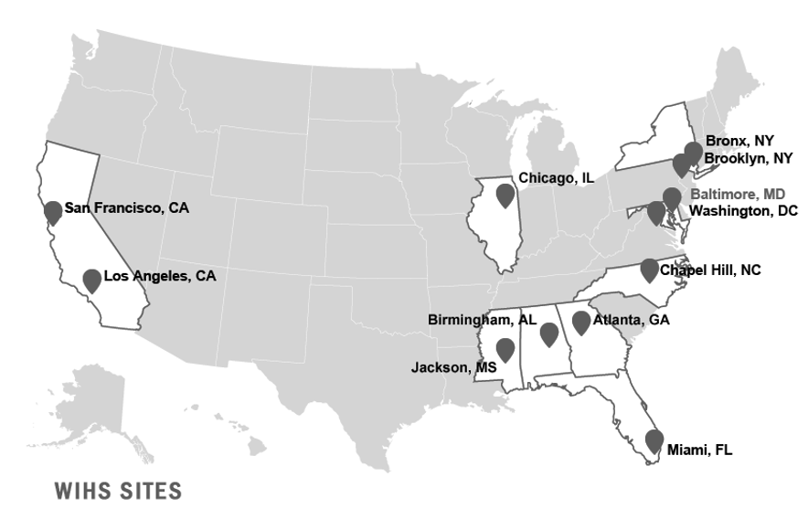

Study Population
The WIHS enrolled women from Bronx, New York; Brooklyn, New York; Chicago, Illinois; Los Angeles, California; San Francisco, California; and Washington, District of Columbia between 1994-2012. Four additional sites were added in 2013-2015 in the context of the growing HIV epidemic in the Southern US: Atlanta, Georgia; Chapel Hill, North Carolina; Miami, Florida; and Birmingham, Alabama-Jackson, Mississippi. To ensure comparability with women living with HIV, WIHS recruited women with high-risk activities in the HIV-negative group, including history of injection drug use, history of sexually transmitted infections (STI), or history of risky sexual behavior.

