Supplemental Data for

Exploration of (R)-[¹¹C]YH168 as a PET tracer for imaging monoacylglycerol lipase in the brain: from mice to non-human primates
Yingfang He^{1, 4#}, MingQiang Zheng^{2#}, Jiwei Gu², Lisa Reichert¹, Johannes Trimborn¹, Hui Zhang², Claudia Keller¹, Mallory Crosby², Ludovic Collin³, Dominik Heer³, Anto Pavlovic³, Andreas Topp³, Matthias Wittwer³, Uwe Grether³, Luca Gobbi³, Roger Schibli¹, Henry Huang^{2*}, Linjing Mu^{1*}
¹ Center for Radiopharmaceutical Sciences, Institute of Pharmaceutical Sciences, Department of Chemistry and Applied Biosciences, ETH Zurich, CH-8093 Zurich, Switzerland
² Yale PET Center, Department of Radiology and Biomedical Imaging, Yale University, New Haven, Connecticut
³ Pharma Research and Early Development, Roche Innovation Center Basel, F. Hoffmann-La Roche Ltd, CH-4070 Basel, Switzerland
⁴ Institute of Radiation Medicine, Fudan University, Xietu Road 2094, Shanghai 200032, China

#Yingfang He and MingQiang Zheng contributed equally to this work

*Corresponding author

Henry Huang
E-mail address: henry.huang@yale.edu

Linjing Mu (https://orcid.org/0000-0001-5354-1546)
E-mail address: linjing.mu@pharma.ethz.ch

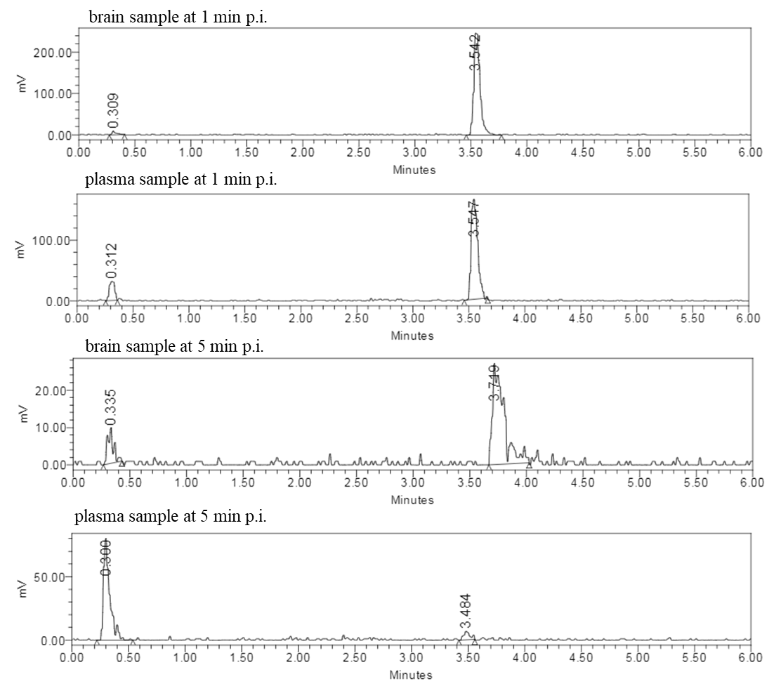
Figure 1. The representative UPLC chromatograms of (R)-[¹¹C]YH132 from ex vivo radiometabolite studies in mice.

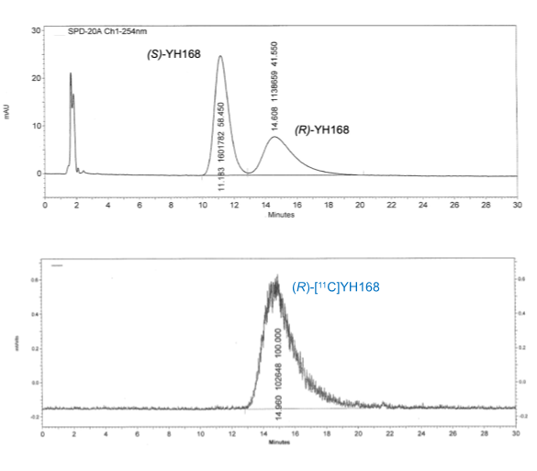
Figure 2. The representative HPLC chromatograms of (R)-[¹¹C]YH168 using a chiral column.
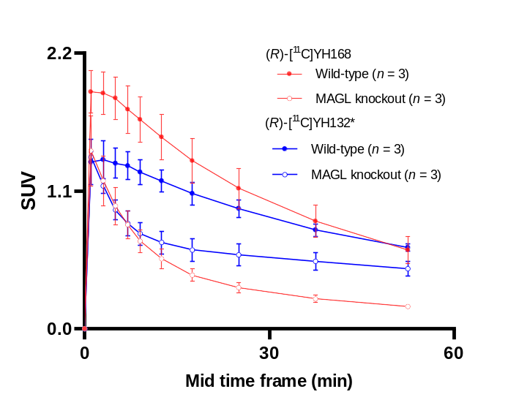
Figure 3. TACs of (R)-[¹¹C]YH132 and (R)-[¹¹C]YH168 in MAGL knockout and wild-type mouse brains.*The data was previously published by He et al. [1].

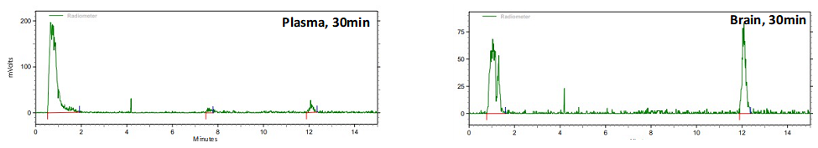
Figure 4. Ex vivo radiometabolite studies of (R)-[¹¹C]YH168 at 30 min post-injection.

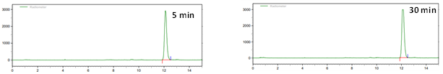
Figure 5. In vitro stability of (R)-[¹¹C]YH168 in freshly prepared C57/Bl6 mouse brain homogenates after 5 and 30 min incubation at 37 °C.

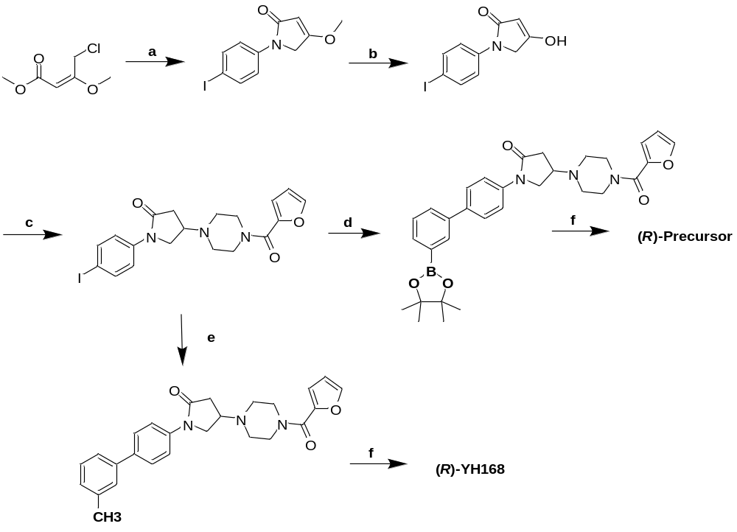
Scheme 1. Synthetic procedure of (R)-YH168 and corresponding precursor. Reagents and conditions: a) triethylamine, tetrabutylammonium iodide, CH₃CN/toluene, 50 °C, 4-iodoaniline, overnight; b) conc. hydrochloric acid, CH₃CN, 50 °C, 4-5 h; c) sodium cyanoborohydride, acetic acid, anhydrous THF, r.t, furan-2-yl(piperazin-1-yl)methanone, overnight; d) 1,3-phenyldiboronic acid, potassium acetate, [1,1′-bis(diphenylphosphino)ferrocene]dichloropalladium(II), anhydrous DMF, 80 °C, 4 h; e) cesium carbonate, tris(dibenzylideneacetone) dipalladium(0), Sphos, anhydrous dioxane, m-tolylboronic acid, overnight; f) chiral supercritical fluid chromatography separation.

Table 1. Characterizations of (R)-YH132, (R)-YH168, (R)-[¹¹C]YH132 and (R)-[¹¹C]YH168.
Compound |  | (R)-YH132 | (R)-YH168 | Radiotracer | (R)-[¹¹C]YH132 | (R)-[¹¹C]YH168
IC₅₀ (nM, mean ± SD) | Mouse MAGL | 4.1 ±1.7 | 3.8 ± 2.1 | Free fraction in mouse plasma (%, mean ± SD) | 23 ± 1 | 14.7 ± 0.2
IC₅₀ (nM, mean ± SD) | Cynomolgus monkey  MAGL | 6.2 ± 2.3 | 2.7 ± 1.3 | Free fraction in mouse plasma (%, mean ± SD) | 23 ± 1 | 14.7 ± 0.2
IC₅₀ (nM, mean ± SD) | Human  MAGL | 5.4 ± 1.6 | 4.0 ± 1.3 | Free fraction in mouse plasma (%, mean ± SD) | 23 ± 1 | 14.7 ± 0.2
Liver microsome Cl_{int} (mouse, μL/min/mg protein) |  | 189 | 388 | Percentage of intact structure 5 min post-injection (mouse brain sample, %) | 85 | 92
cLog P from ChemDraw 22.0.0 |  | 4.1 | 4.7 |  | 85 | 92
PAMPA_P_{EFF} (cm/s*10⁻⁶) |  | 4.0 | 15.8 | Percentage of intact structure 5 min post-injection (mouse plasma sample, %) | 8 | 34

Reference
- He Y, Delparente A, Jie CVML, Keller C, Humm R, Heer D, et al. Preclinical Evaluation of the Reversible Monoacylglycerol Lipase PET Tracer (R)-[¹¹C] YH132 : Application in Drug Development and Neurodegenerative Diseases. ChemBioChem. 2024;202300819. Available from: https://doi.org/10.1002/cbic.202300819

