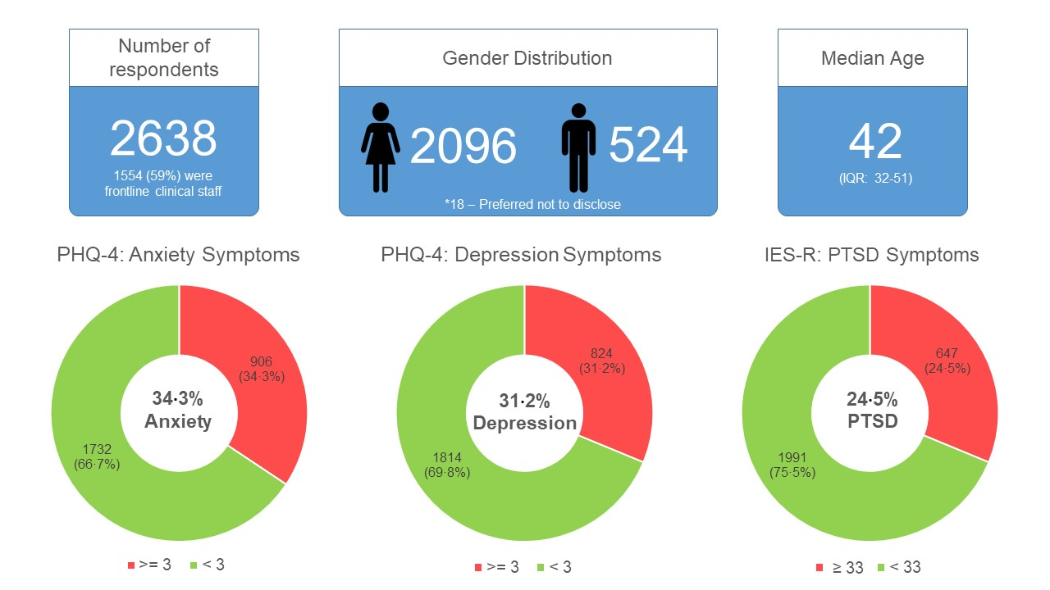
Supplementary Fig. 1: A summary of the key demographic data of survey participants, PHQ-4 and IES-R scores

