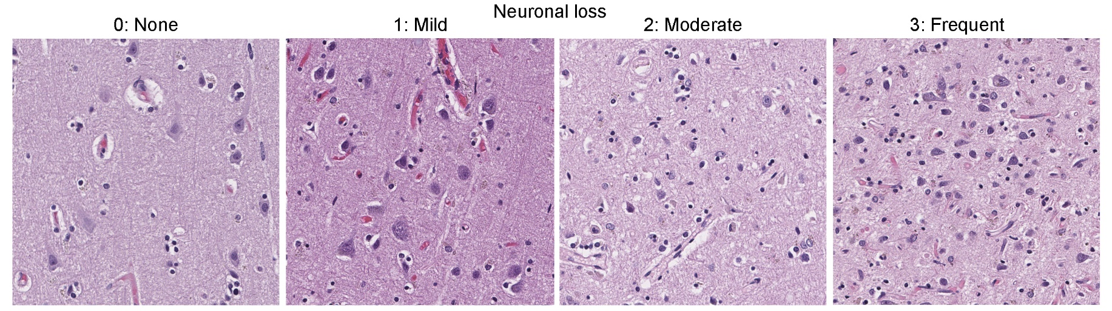
Supplementary Figure 1: The neuronal loss is assessed using a four-point scale (0 = none, 1 = mild, 2 = moderate, 3 = frequent) on H&E-stained sections. The representative images for each score are shown.

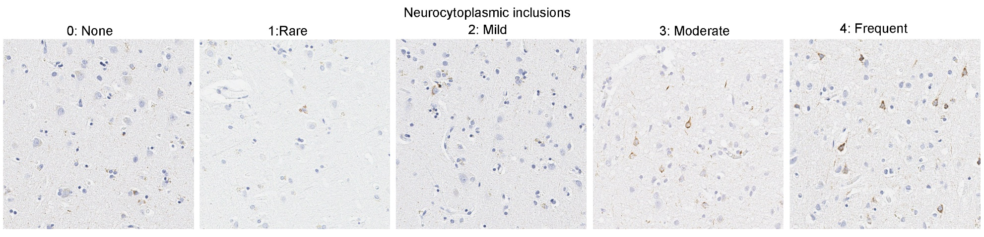

Supplementary Figure 2: The severity of TDP-43 pathology is graded semi-quantitatively on a four-point scale (0 = none, 1 = rare, 2 = mild, 3 = moderate, 4 = frequent). The representative images for each score are shown.

