Supplementary Results

Figure S1. Cell death with increasing concentration of CAN, synthetic CBG, 3704 or CAN fractions.
Figure S2. Intracellular expression of Arg-1 in alternatively activated macrophages and BMMDSCs.
Figure S3. iNOS expression in directly treated BM-MDSCs.
Figure S4. Intracellular expression of GrzB in CD8+ T-cells co-cultured with MO-MDSCs or PMN-MDSCs.
Figure S5. In-vivo experimental design and gating strategy of myeloid cells and CD8+ T-cell subpopulations from B16F10 tumors and spleens.
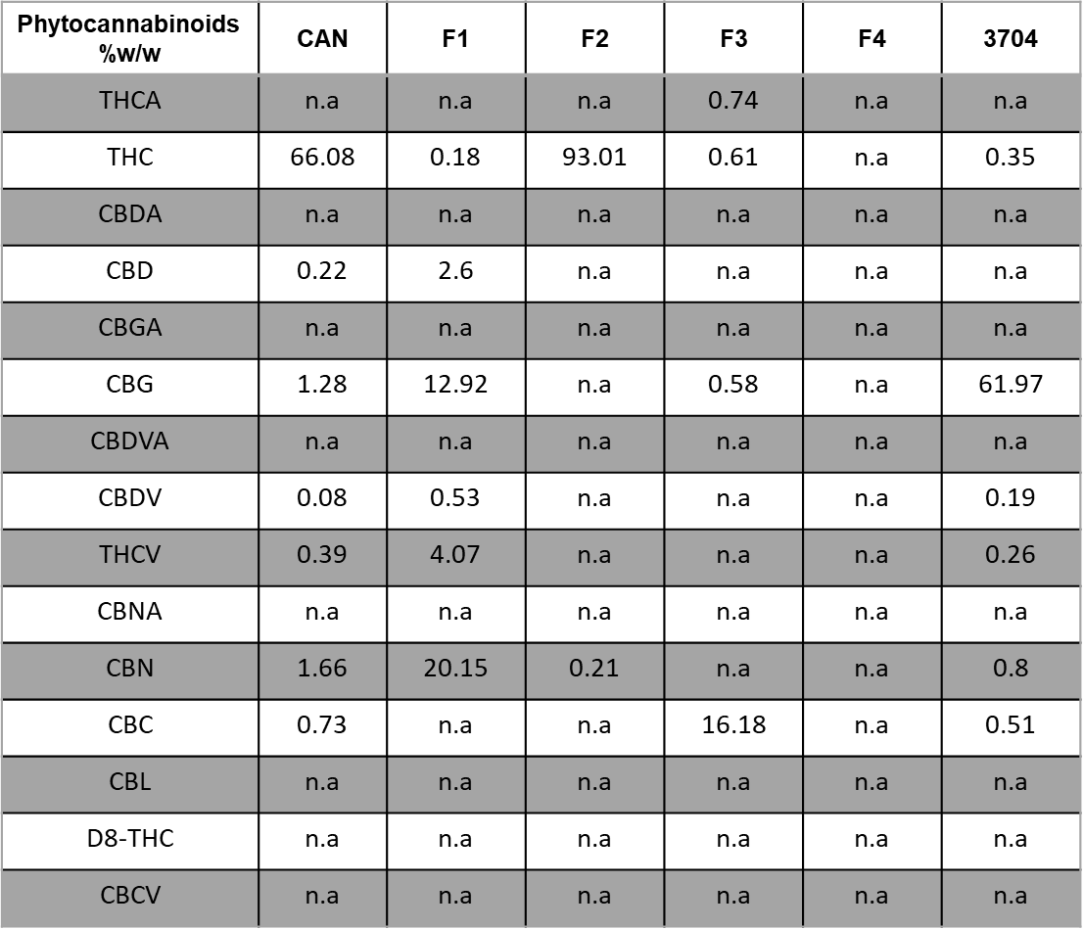
Supplementary Table 1: Phytocannabinoid profile of CAN, CAN fractions and 3704 (percent weight per weight) as measured by semi-preparative HPLC/UV *n.a = not available; limit of detection: 0.02% or 1 µg/ml.

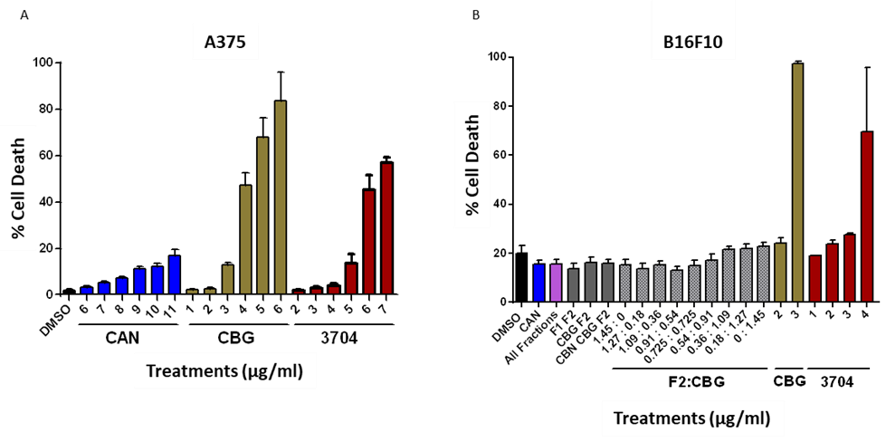
Supplementary Fig. 1. Cell death with increasing concentration of CAN, synthetic CBG, 3704 or CAN fractions. (A-B) Cell death percentage of (A) A375 and (B) B16F10 cells after 24 hours with the indicated treatments. Cells were stained with Fixable viability Dye and cell death percentage was measured using flow cytometry.
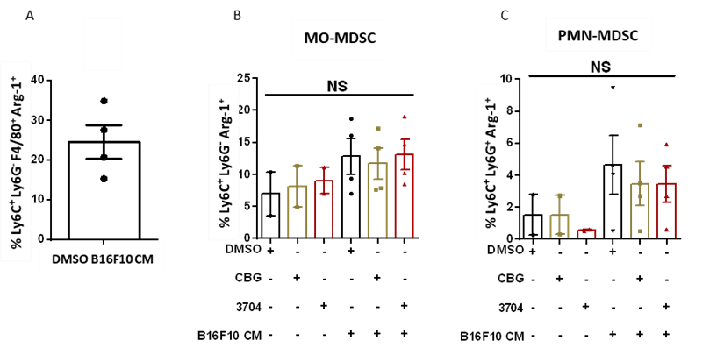

Supplementary Figure 2. Intracellular expression of Arg-1 in alternatively activated macrophages and BM-MDSCs. (A) Percent of Arg-1 expression by alternatively activated macrophages. The cells were stained for the extracellular markers Ly6C, Ly6G and F4/80 and the intracellular marker Arg-1 48 hours posttreatment. (B-C) Percent of Arg-1 expression (n=2-4) by MO-MDSCs (B) or PMN-MDSCs (C). The cells were stained with the extracellular markers Ly6C, Ly6G and the intracellular marker Arg-1 and staining was measured using flow cytometry. Results are shown as mean ±SEM and statistically analyzed with one-way ANOVA (NS – non-significant).
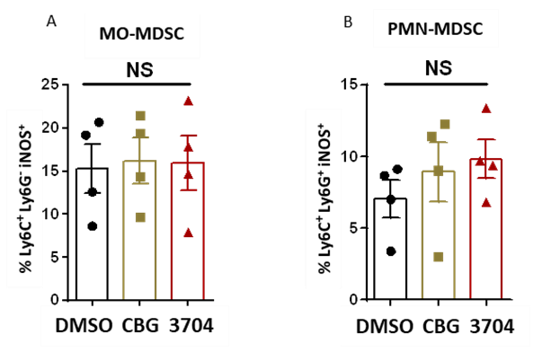
Supplementary Figure 3. iNOS expression is unchanged in directly treated BM-MDSCs. (A-B) Percent of iNOS expression (n=4) by MO-MDSC (A) and PMN-MDSC (B). BM-MDSCs were generated as described and on day 4 medium from untreated B16F10 was added to cells together with either DMSO, 2 µg/ml CBG or 6 µg/ml 3704 for 24 hours. Cells were stained with FVD for the exclusion of dead cells, and with the extracellular markers Ly6C, Ly6G and the intracellular marker iNOS. Staining was measured using flow cytometry. Results are shown as ±SEM and statistically analyzed with one-way ANOVA (NS – nonsignificant).
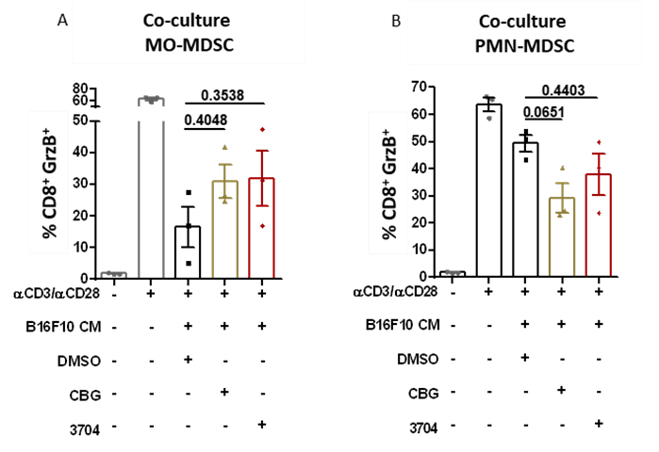

Supplementary Figure 4. Intracellular expression of GrzB in CD8+ T-cells co-cultured with MO-
MDSCs or PMN-MDSCs. (A-B) Percent of GrzB expression in CD8+ T-cells co-cultured with (A) MOMDSCs or (B) PMN-MDSCs. The cells were stained with the extracellular markers CD8 and the intracellular marker GrzB and staining was measured using flow cytometry. Results are shown as mean ±SEM and statistically analyzed with one-way ANOVA (significance values are shown). Diagram of the mice model experiment. Female WT C57BL/6 mice (n=5/group) were injected with 1×10⁶ B16F10 cells. After 3 days, the mice were treated intraperitoneal with either vehicle, synthetic CBG (2.5 mg/kg), or the high-CBG extract 3704 (3.75 mg/kg), as indicated over the course of 14 days.

A
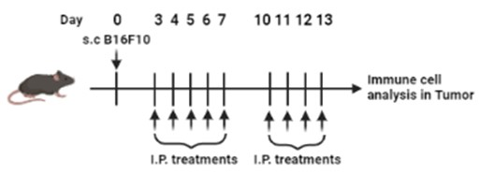

B
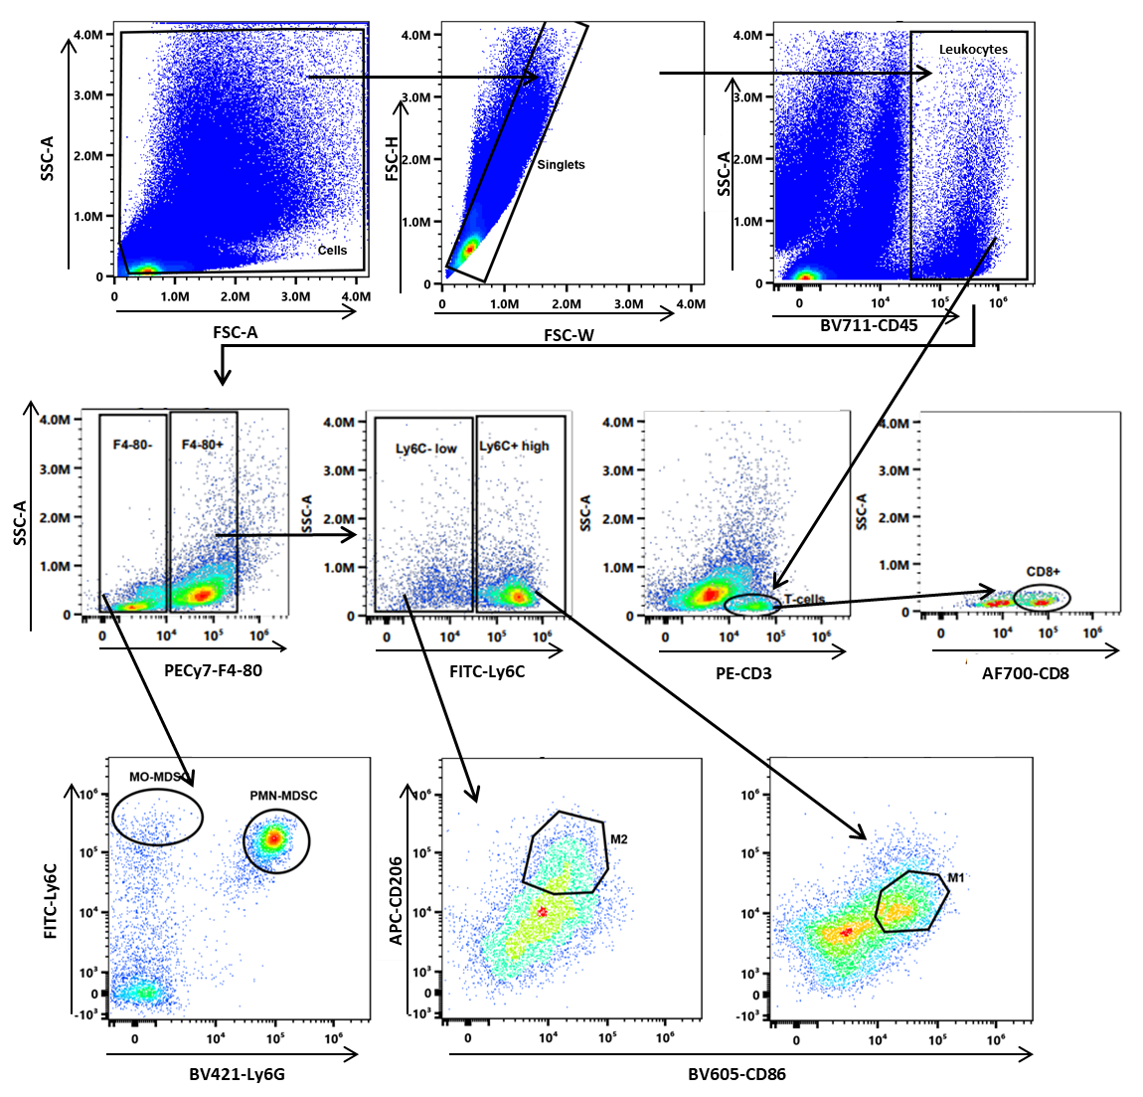

C
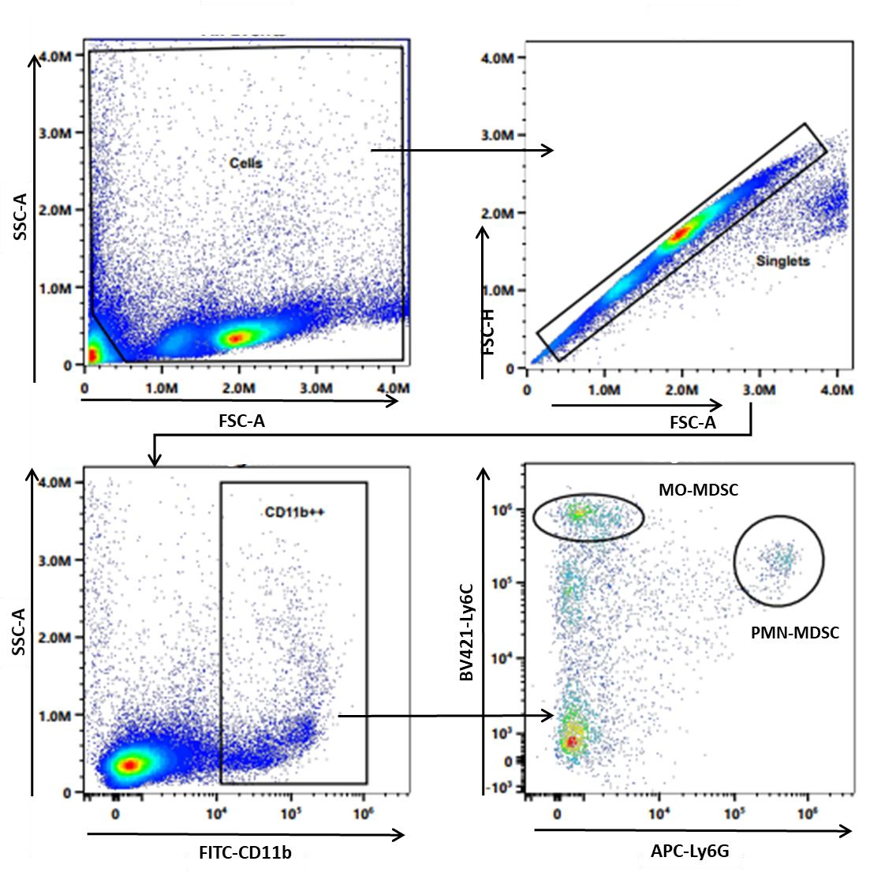

Supplementary Figure 5. In-vivo experimental design and gating strategy of myeloid cells and CD8+ T-cell subpopulations from B16F10 tumors and spleens. (A) Diagram of the mice model experiment. Female WT C57BL/6 mice (n=5/group) were injected with 1×10⁶ B16F10 cells. After 3 days, the mice were treated intraperitoneal with either vehicle, synthetic CBG (2.5 mg/kg), or the high-CBG extract 3704 (3.75 mg/kg), as indicated over the course of 14 days. (B) FACS gating strategy of MO-MDSC and PMN-MDSC, M1 and TAM macrophages, and CD3+ CD8+ T-cells. (C) FACS gating strategy of MO-MDSC and PMN-MDSC in spleens. Analysis was conducted using the SpectroFlo® analysis software.

Supplementary Material and Methods:

Phytocannabinoid extraction and analysis. This study focused on two cannabis extracts, the high-THC extract CAN and the high-CBG extract 3704. Air-dried medical Cannabis female inflorescences of these chemovars were ground to a fine powder using an electric grinder. Both samples were heat-decarboxylated in an oven at 130°C for 1 h. Exactly 5 g from each chemovar were accurately weighed and extracted with 50 mL HPLC-grade ethanol. Samples were sonicated in an ultrasonic bath for 30 min and agitated in an orbital shaker at 25°C for 15 min. Samples were then filtered under pressure through Whatman filter paper number 4 and the ethanol was evaporated under reduced pressure at 38°C using a rotary evaporator.
Phytocannabinoids were analyzed by reversed-phase ultra-high-performance liquid chromatography with an ultraviolet detector (UHPLC/UV) system (Thermo Scientific, Bremen, Germany). The phytocannabinoid analytical standards (>98%) cannabigerol (CBG; C-141), Δ9THC (T-005), CBD (C-045), cannabichromene (CBC; C-143), cannabinol (CBN; C-046), cannabigerolic acid (CBGA; C-142), (-)-Δ9-trans-tetrahydrocannabinolic acid (Δ9-THCA; T-093), cannabidiolic acid (CBDA; C-144), cannabinolic acid (CBNA; C-153), cannabichromenic acid
(CBCA; C-150), (-)-Δ8-trans-tetrahydrocannabinol (Δ8-THC; T-032), (-)-Δ9-transtetrahydrocannabivarin (Δ9-THCV; T-094), cannabidivarin (CBDV; C-140), cannabidivarinic acid (CBDVA; C-152), and cannabicyclol (CBL; C-154) were purchased from Sigma-Aldrich; cannabichromevarin (CBCV; 21974) and cannabicitran (21295) were purchased from Cayman Chemical Company.
The chromatographic separation was achieved using a HALO C18 Fused-Core column (2.7 μm, 150 × 2.1 mm i.d.), with a HALO guard column (2.1 x 5 mm, 2.7 μm), and a ternary A/B/C multistep gradient (solvent A: 0.1% acetic acid in water, solvent B: 0.1% acetic acid in acetonitrile, and solvent C: methanol, all solvents were of LC/MS grade). The multistep gradient program was established as follows: initial conditions were 50% B raised to 67% B until 3 min, held at 67% B for 5 min, and then raised to 90% B until 12 min, held at 90% B until 15 min, decreased to 50% B over the next min, and held at 50% B until 20 min for re-equilibration of the system prior to the next injection. Solvent C was initially 5% and then lowered to 3% until 3 min, held at 3% until 8 min, raised to 5% until 12 min and then kept constant at 5% throughout the run. A flow rate of 0.25 mL/min was used, the column temperature was 30°C and the injection volume was 1 μL. Data acquisition was performed in full UV-Vis scan mode. Standard mixes in DMSO were prepared ranging from 1 to 1000 µg/mL for Δ9-THCA, Δ9-THC, CBDA and CBD, and 0.25 to 250 µg/mL for all the other components.
Fractionation of the whole extract. Fractionation of CAN extract into four fractions was performed using 1260 Infinity II LC System semi-preparative HPLC/UV (Agilent Technologies, CA, USA). The chromatographic separation was achieved using a Zorbax Eclipse XBD-C18 column (5 μm, 150 mm × 30 mm i.d.) and a two-solvent A/B multistep gradient (solvent A: 0.05 % formic acid in water and solvent B: 0.05% formic acid in acetonitrile, all HPLC grade). The multistep gradient program was established as follows: initial conditions were 65% B for 3 min, raised to 76% B until 12 min, then raised to 95% and held at 95% B for 6 min, and then decreased to 65% B over the next 3 min. A flow rate of 40 mL/min and an injection volume of 0.75 mL were used. Data acquisition was performed at 220 nm. The crude Cannabis extract was prepared in a concentration of 68 mg/mL in ethanol. Fractions were collected and then lyophilized to dryness and analyzed by UHPLC/UV and ESI-LC/MS. Fraction F2 contained 93% THC.
Flow Cytometry. To differentiate the subpopulation of myeloid cells, BMDCs and myeloid cells from tumors were stained for the extracellular makers Ly6C-BV421 (BioLegend, Clone HK1.4; Cat# 128032, RRID:AB_2562178) or Ly6C-FITC (BioLegend, Clone HK1.4, Cat# 128006,
RRID:AB_1186135) , Ly6G-APC (BioLegend, Clone 1A8; Cat# 127614, RRID:AB_2227348),
Ly6G-BV421 (BioLegend, clone 1A8, Cat# 127627, RRID:AB_10897944), PECy7-F4/80
(BioLegend, Clone BM8 Cat# 123113, RRID:AB_893490), BV605-CD86 (BioLegend, Clone GL1, Cat# 105037, RRID:AB_11204429), APC-CD206 (Biolegend, Clone CO68C2, Cat# 141708,
RRID:AB_10900231) and BV711-CD45 (BioLegend, Clone 30F11, Cat# 103147, RRID:AB_2564383). Cells from tumors were also stained with PE-CD3+ (BioLegend, Clone 17A2, Cat# 100206, RRID:AB_312663), AF700-CD3+ (Biolegend, Clone 17A2, Cat# 100216, RRID:AB_493697) and CD8-PECY7 (BioLegend, Clone 53-6.7, Cat# 100722,
RRID:AB_312761) to identify the CD8+T-cell population. To characterize the cells in the subpopulations, cells were fixed and permeabilized with the Intracellular Fixation and
Permeabilization Buffer Set (eBioscience Cat# 88-8824-00) and stained with FITC-iNOS (Thermo
Fisher, Clone CXNFT, Cat# 53592082, RRID:AB_2574423) or FITC- Arginase-1 (Thermo Fisher, Clone A1exF5, Cat# 53369782, RRID:AB_2734831) or GranzymeB-FITC (BioLegend, Clone QA16A02, Cat# 372206, RRID:AB_2687030) or IFN-γ-FITC (BioLegend, Clone XMG1.2, Cat# 505806, RRID:AB_315400) and TNF-α (Biolegend, Clone MP6-XT22, Cat# 506329, RRID:AB_11123912). These cells were also stained with Fixable viability Dye (FVD)-eflour 780 (Thermo, Cat# 65086514) to exclude dead cells.

