Supplementary Data and Figures
Titration protocol
The 1:1 THC:CBD oil administration was started with 1 mg of THC/time (1 drop), 1 time per day (1 mg/day), applying sublingually. The dosage of THC and CBD was increased to 1 mg/day on the first day, then 2 mg/day every day if there was no adverse event and the clinically successful level (MAS < 2 in all muscle groups) did not reach. The titration protocol has complied with a guideline for adjusting the dose of Sativex®, which is used to reduce spasticity in patients with multiple sclerosis (MAS) and contains a comparable ratio and dosage of THC:CBD with the oil using in this study (available at www.medicines.org.uk/emc/product/602/smpc ). The maximum dosage of the 1:1 THC:CBD oil would be 2 mg of THC and CBD/time, 6 times per day (12 mg/day) (minimum of one-week titration). Supplementary Figure 1 summarizes the titration protocol of using THC:CBD oil.
Supplementary Figure 1. The titration protocol of the investigated drug

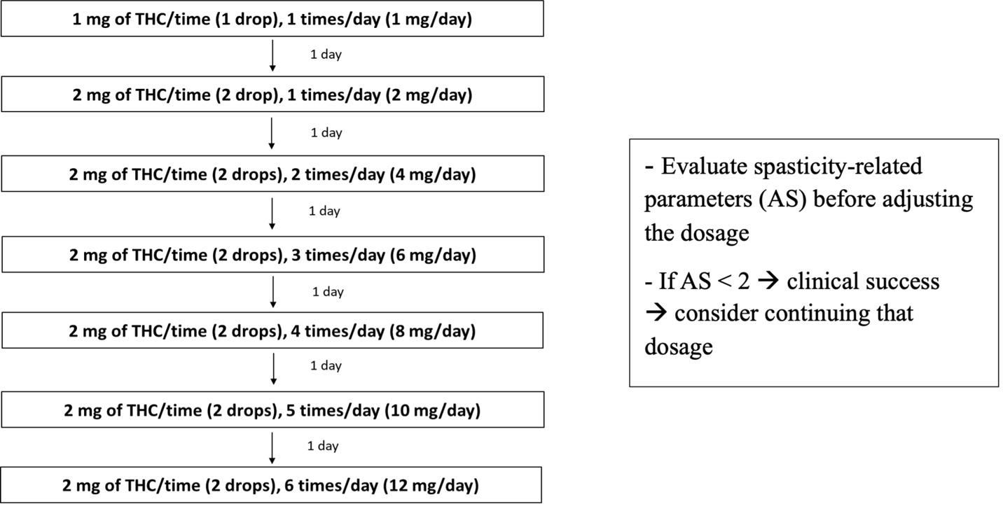
Safety control
Participants would be monitored for EKG, Complete blood count (CBC) kidney function (BUN, Cr), electrolyte and liver function test (AST, ALT, ALP, albumin, total protein) at the pre-treatment assessment, every week during the titration period and at the post-treatment assessment of each period. During the wash-out period, the degree of spasticity was evaluated using a patient rating numerical scale and withdrawal symptoms via telephone interview.
For each administration time, adverse events were monitored every 15 minutes for 4 times, every 30 minutes for 2 times, and every hour for 2 times in the day that the dosage has been changed. For the day that the dosage did not change, the adverse events were monitored every day for one hour after treatment. Participants who had serious adverse events, including disorientation, agitation, hallucination, severe anxiety, and psychosis [Department of Medical Services, Ministry of Public Health, Thailand Guidance on Cannabis for Medical Use, 2019], would be withdrawn from the study. After withdrawal, psychiatric consultation would be made to consider treatment and participants would be admitted at least one week or until normal. Participants who had non-serious adverse events, such as drowsiness, dizziness, loss of muscle coordination, bradycardia, and abnormal pressure, would receive one lower step of the current dosage for one week and then restart the titration protocol.
Participants would be withdrawn from the study if they had a serious adverse event, having abnormal kidney function test (BUN rising > 10 mg/dl, Cr rising > 0.5 mg/dl), and abnormal liver function test (AST or ALT rising > 3 times from upper normal limit). Supplementary Figure 2 demonstrates the observation protocol for using cannabinoids in this study.

Supplementary Figure 2. The observation protocol for using cannabinoids (V/S, vital sign)
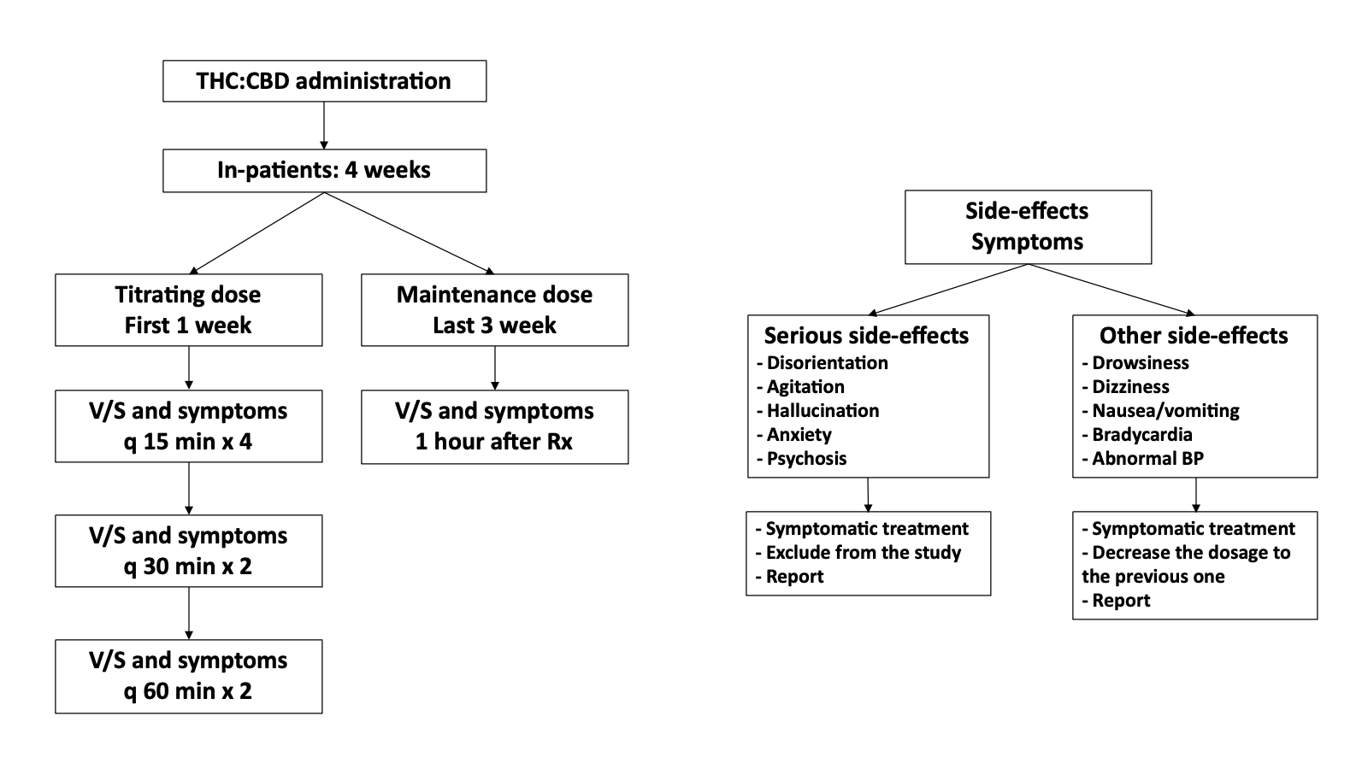
Exclusion criteria
- Having abnormal laboratory results that are potentially more harmful to using cannabinoids at the pre-treatment-1 assessment including:
- AST or ALT > 3 times of upper limit of the normal value
- Hemoglobin < 7 g/dL
- Absolute Neutrophil Count (ANC) < 1,500 /mm³
- Platelet < 50,000 /mm³
- Creatinine clearance less than or equal to 20 mL/min
- Having physical comorbidities or underlying diseases that are potentially more harmful for using cannabinoids including:
- Heart disease resulting in a chronic heart failure stage C or more
- Neurological diseases, including cerebrovascular diseases, other than SCI
- Chronic hepatic failure Child-Pugh Class C
- Chronic kidney disease that ongoing renal replacement therapy
- Myocardial infarction or coronary artery disease
- Having mental comorbidities or underlying diseases that are potentially more harmful for using cannabinoids including:
    - Diagnosed with severe depression or anxiety, personality disorder, psychosis, or schizophrenia
    - History of suicidal ideas
    - History of chronic alcoholism
    - Family history of first-degree relative with schizophrenia
- During the pregnancy or the lactation period
- Currently using a hepatotoxic medication, e.g., Carbamazepine, Phenytoin, Fluoxetine, Clobazam, Valproic acid.
- Currently using cannabinoids indicated by positive urine cannabinoid screening
- History of allergy to cannabis or cannabinoids
- History of allergy to sesame or its compounds (ingredient of the 1:1 THC:CBD oil)
- Shift worker
- Unable to stop drinking coffee ≥ 24 hr.
- Urinary incontinence that need to manage at night

H-reflex Protocol
Subjects were tested lying prone with their legs extended and feet overhanging the end of the table. The active recording electrode was attached over the soleus muscle in the midline of the calf, half the distance between the flare of the medial malleolus and the popliteal crease. The reference recording electrode was attached over the Achilles tendon. The stimulating cathode was placed overlying the tibia nerve in the popliteal space. The optimum stimulus location was determined as giving the maximum H-reflex amplitude with a minimum of stimulus intensity. The current intensity was adjusted until a maximum H-reflex amplitude was obtained with the stimulus frequency of 0.5 Hz.

Muscle groups for the sum Ashworth Scale (AS) assessment
Shoulder adductors and abductors, shoulder flexors and extensors, elbow flexors and extensors, wrist flexors and extensors, finger flexors and extensors, thumb flexors and extensors, hip adductors and abductors, hip flexors and extensors, knee flexors, and extensors, ankle plantar flexors and dorsiflexors, and toe flexors and extensors

