Supplementary Material
Cadmium Exposure is Associated with Increased Transcript Abundance of Multiple Heavy Metal Associated Transporter Genes in Roots of Hemp (Cannabis sativa L.) Amanda O. Marabesi^{1*}, Savithri U. Nambeesan¹, Marc W. van Iersel¹, Jason T. Lessl², and Timothy W. Coolong^{1*}
¹Department of Horticulture, University of Georgia, Athens GA 30602, USA.
²Agricultural and Environmental Services Lab, University of Georgia, Athens, GA 30602, USA.
*Correspondence:
Corresponding Authors
aom@uga.edu
tcoolong@uga.edu

Supplementary Figures and Tables

Supplementary Tables
Supplemental Table 1. Mineral nutrient concentrations (mg·L⁻¹) used in this study.
 | N | P | K | Ca | Mg | B | Cu | Mo | Fe | Mn | Zn
Well Water | ND^{i} | 0.1 | 2.9 | 10.5 | 1.9 | 1.7 | <0.05 | <0.01 | 0.3 | 0.2 | <0.05
Nutrient Solution^{ii} | 150 | 50 | 200 | 125 | 65 | 3 | 0.3 | 0.1 | 4 | 1 | 0.3
Total Concentration | 150 | 50.1 | 202.9 | 135.5 | 66.9 | 4.7 | 0.3 | 0.1 | 4.3 | 1.2 | 0.3
^{i}ND = not detected.
^{ii}Nutrient solution comprised from the following compounds: KNO₃, K₂HPO₄, MgSO₄, H₃BO₃, Cu-EDTA, Fe-EDTA, Mn- EDTA, Na₂MoO₄, Zn-EDTA, Ca(NO₃)₂•NH₄NO₃•10H₂O, (NH₄)₂MoO₄, Ca-EDTA, and Na₂B₄O₇·10H₂O.

Supplemental Table 2. Primer sequences and accession numbers of metal transporter, cannabinoid biosynthetic, and reference genes.
Gene name | NCBI reference | Fw sequence | Rv sequence
Cs probable cadmium/zinc-transporting ATPase HMA1 | XM_030630179.1 | GACGGAAGCTCAGAAAGCG | ACCTGTAGAACCGCAACAC
Cs putative inactive cadmium/zinc-transporting ATPase HMA3 | XM_030654349.1 | AGGGAAGTGCTGTAAACCT | CCGAGTTCCCGCTCTTCT
Cs putative inactive cadmium/zinc-transporting ATPase HMA3 Complement | XM_030655263.1 | GGTCATGGCCTGTGGATTATTAC | GTGAGGTTCCAAATGGAGGT
Cs copper-transporting ATPase HMA4 | XM_030648942.1 | CTTCAAGGTCAGGCTGTGA | CGGGAAACTCCTCAGCTGT
Cs probable copper-transporting ATPase HMA5 | XM_030645235.1 | CAATAGCTGCAGGAGCACTC | GAG CAG CAA ACA ACA CTG AC
Cs copper-transporting ATPase PAA1 | XM_030654671.1 | GTGGAAGAAGCCCAAAGTAGG | AAGGTAGCAGTAGAGAGAGCC
Cs copper-transporting ATPase PAA2 | XM_030633739.1 | TGGTCGTGAAGGAGAAGGC | TCCCCGGATAAGAGCAAAGT
Cs inactive tetrahydrocannabinolic acid synthase | XM_030625046.1 | CCTTCAAATGTCTCCCATATCCAGG | TGTAGGACAAACCCTCAGC
Cs cannabidiolic acid synthase-like | XM_030624886.1 | GTCACTCCTTCACATGTCTCTC | GGGACTTGAGATATGTAGGACATG
Cs Elongation factor 1 alpha/HBS1-like protein (reference gene) | XM_030654944.1 | TTGCACGGATCAGTTTGCG | AATGCCGACCGCTACAGTT
Cs ubiquitin-protein ligase/ubiquitin domain-containing protein DSK2b) (reference gene) | XM_030630092.1 | TACGAGGAGCAGCTGTAGAT | ATAGAGTGAGGGTGGGAGAAGA

Supplementary Figures
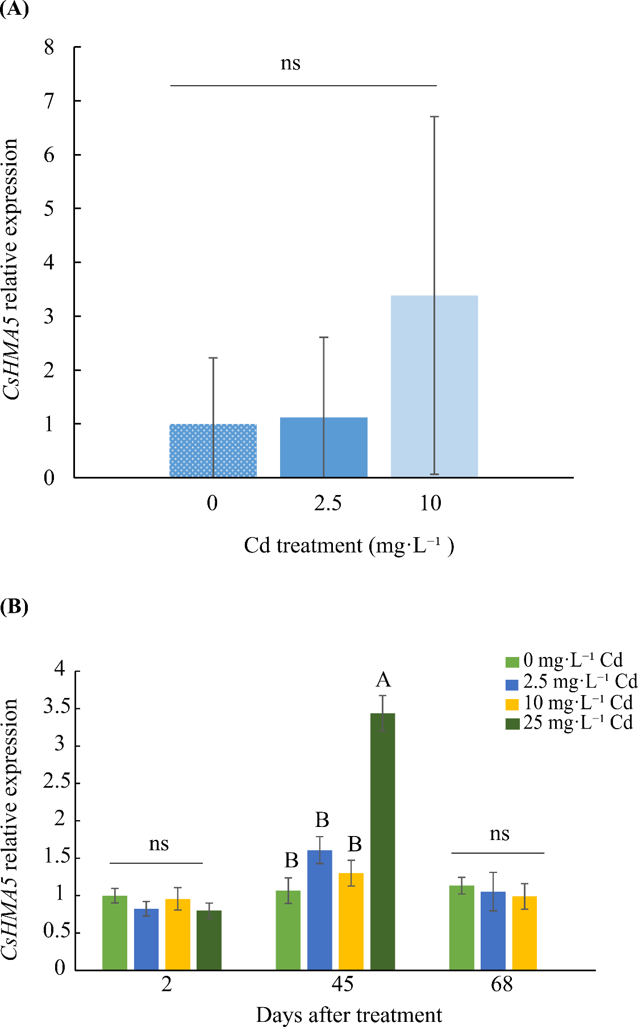

Supplemental Figure 1. Relative expression ± SE of ATPase CsHMA5 in flower tissue of plants exposed to 0, 2.5, and 10 mg·L⁻¹ Cd at 68 d after Cd treatment (DAT) (A). Relative expression ± SE of ATPase CsHMA5 in leaf tissue at 2, 45, and 68 DAT (B). Plants were exposed to 0, 2.5, 10, and 25 mg·L⁻¹ Cd.Bars associated with the same letter(s) are not significantly different at P ≤ 0.05 according to Tukey’s HSD all pairwise comparison test.
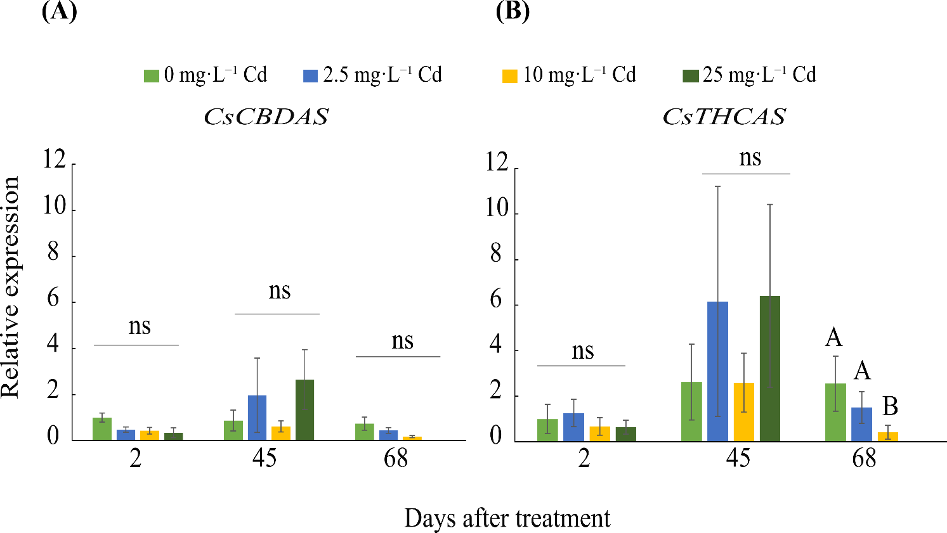
Supplemental Figure 2. Relative expression ± SE of CsCBDAS (A) and CsTHCAS (B) in leaf tissue at 2, 45, and 68 days after Cd treatment (DAT). Plants were exposed to 0, 2.5, 10, and 25 mg·L⁻¹ Cd. Bars associated with the same letter(s) are not significantly different at P ≤ 0.05 according to Tukey’s HSD all pairwise comparison test.

