Online Supplemental Material for Associations between cannabis use, polygenic liability for schizophrenia, and cannabis-related experiences in a sample of cannabis users

Emma C Johnson, PhD¹, Sarah MC Colbert, BA¹, Paul W Jeffries, MS¹, Rebecca Tillman, MS¹, Tim Bigdeli, PhD^{2,3}, Nicole R Karcher, PhD¹, Grace Chan, PhD^{4,5}, Samuel Kuperman, MD⁵, Jacquelyn L Meyers, PhD^{2,3}, John I Nurnberger, MD, PhD^{6,7}, Martin H Plawecki, MD, PhD⁷, Louisa Degenhardt, PhD⁸, Nicholas G Martin, PhD⁹, Chella Kamarajan, PhD^{2,3}, Marc Schuckit, MD¹⁰, Robin M. Murray, DsC, FRS¹¹, Danielle M Dick, PhD¹², Howard J Edenberg, PhD^{6,13}, Deepak Cyril D’Souza, MD^{14,15}, Marta Di Forti, MD, PhD^{16,17}, Bernice Porjesz, PhD^{2,3}, Elliot C Nelson, MD¹, Arpana Agrawal, PhD¹

Affiliations:
¹Department of Psychiatry, Washington University School of Medicine; ²Department of Psychiatry and Behavioral Sciences, SUNY Downstate Health Sciences University; ³Henri Begleiter Neurodynamics Lab, SUNY Downstate Health Sciences University; ⁴Department of Psychiatry, University of Connecticut; ⁵Department of Psychiatry, University of Iowa Carver College of Medicine; ⁶Department of Medical and Molecular Genetics, Indiana University School of Medicine; ⁷Department of Psychiatry, Indiana University School of Medicine; ⁸National Drug and Alcohol Research Centre, UNSW Sydney; ⁹QIMR Berghofer Medical Research Institute; ¹⁰Department of Psychiatry, University of California San Diego Medical School; ¹¹Department of Psychosis Studies, Institute of Psychiatry, Psychology and Neuroscience, King's College London; ¹²Department of Psychiatry, Rutgers Robert Wood Johnson Medical School; ¹³Department of Biochemistry and Molecular Biology, Indiana University School of Medicine; ¹⁴Department of Psychiatry, Yale University; ¹⁵Psychiatry Service, VA Connecticut Healthcare System; ¹⁶Department of Social Genetics and Developmental Psychiatry, Institute of Psychiatry, Psychology and Neuroscience, King's College London; ¹⁷South London and Maudsley NHS Mental Health Foundation Trust

Corresponding author:
Emma C Johnson
emma.c.johnson@wustl.edu
Washington University School of Medicine
Dept. of Psychiatry
660 S. Euclid, CB 8134
Saint Louis, MO 63110, USA

Supplemental Methods

Target sample description
The Collaborative Study on the Genetics of Alcoholism (COGA) was designed to investigate the genetic underpinnings of alcohol use disorders and related mental health conditions^{1–4}. This sample includes probands meeting criteria for DSM-III-R alcohol dependence, their family members, and community comparison families. Probands with alcohol dependence were ascertained from inpatient or outpatient treatment facilities across 7 sites in the United States. Community‐based control families were recruited from the same cities from a variety of sources (e.g., dental clinics). Data for the current analyses were gathered using the validated and reliable Semi-Structured Assessment for the Genetics of Alcoholism (SSAGA) interview^{5,6}.

Replication sample description
The Comorbidity and Trauma Study (CATS) sample²⁵ of individuals with opioid use disorder who were recruited from opioid substitution therapy clinics in the greater Sydney area and genetically unrelated individuals with little or no lifetime opioid misuse recruited from neighborhoods in geographic proximity to these clinics. Their mean age was 35.93 (SD 8.75) years. The CATS sample was assessed in-person using the SSAGA-OZ²⁵ (a modification of the SSAGA for studies conducted in Australia).

CATS genotype data
Briefly, DNA specimens from the CATS sample were genotyped at the Center for Inherited Disease Research (CIDR) using the Illumina Human660W-Quad BeadChip. Genotype and sample QC was as described previously⁷. After initial QC, data were imputed to the 1,000 Genomes Phase 3 European ancestries reference panel using the Michigan Imputation Server.

Additional details regarding PRS
Polygenic prediction can be biased when the discovery GWAS and target sample are not of the same genetic ancestry background. Thus, to maximize prediction in the African genetic ancestries subset of COGA, we used a variation of PRS-CS, PRS-CSx⁸ (https://github.com/getian107/PRScsx). This method for enhancing prediction in diverse samples aims to capitalize on the information provided from the larger, more well-powered GWAS and the ancestrally matched GWAS.

The “score” method in Plink⁹ was used to create final risk scores based on SNP weights in both PRS-CS and PRS-CSx methods.

Additional details regarding cannabis phenotypes
In COGA, maximum duration of daily cannabis use was defined as the self-reported longest period of time an individual used cannabis/marijuana almost every day [maximum reported at any data collection wave, in days].

Details regarding multiple testing corrections
To account for multiple testing, we consider that we performed 24 primary tests (testing associations between reporting any cannabis-related experience or one of the five specific cannabis-related experiences and four primary predictors: the schizophrenia PRS, age at first cannabis use, duration of daily use, and CUD diagnosis) and 37 secondary tests (associations between cannabis-related experiences and schizophrenia PRS when controlling for age at first cannabis use, when controlling for AUD, when controlling for a PRS for CUD, and the 15 interactions tested, as well as testing the association between CUD severity and the schizophrenia PRS, CUD severity and number of experiences endorsed, the schizophrenia PRS and number of experiences endorsed, and the schizophrenia PRS and lifetime use of illicit substances).

Supplemental Results
There were no significant differences between the European and African ancestry samples in terms of proportion of CUD diagnoses or age at first cannabis use, but significantly more individuals of European ancestry reported using illicit drugs other than cannabis (84%) compared to individuals of African ancestry (58%). A larger proportion of individuals of African ancestry (20%) reported cannabis-related paranoia than those of European ancestry (16%). The opposite was true for cannabis-related decreased social contact (33% in the European ancestry sample, 25% in the African ancestry sample), but there were no other significant differences across genetic ancestries.

Acknowledgements
The Collaborative Study on the Genetics of Alcoholism (COGA), Principal Investigators B. Porjesz, V. Hesselbrock, T. Foroud; Scientific Director, A. Agrawal; Translational Director, D. Dick, includes eleven different centers: University of Connecticut (V. Hesselbrock); Indiana University (H.J. Edenberg, T. Foroud, Y. Liu, M. Plawecki); University of Iowa Carver College of Medicine (S. Kuperman, J. Kramer); SUNY Downstate Health Sciences University (B. Porjesz, J. Meyers, C. Kamarajan, A. Pandey); Washington University in St. Louis (L. Bierut, J. Rice, K. Bucholz, A. Agrawal); University of California at San Diego (M. Schuckit); Rutgers University (J. Tischfield, R. Hart, J. Salvatore); The Children’s Hospital of Philadelphia, University of Pennsylvania (L. Almasy); Virginia Commonwealth University (D. Dick); Icahn School of Medicine at Mount Sinai (A. Goate, P. Slesinger); and Howard University (D. Scott). Other COGA collaborators include: L. Bauer (University of Connecticut); J. Nurnberger Jr., L. Wetherill, X., Xuei, D. Lai, S. O’Connor, (Indiana University); G. Chan (University of Iowa; University of Connecticut); D.B. Chorlian, J. Zhang, P. Barr, S. Kinreich, G. Pandey (SUNY Downstate); N. Mullins (Icahn School of Medicine at Mount Sinai); A. Anokhin, S. Hartz, E. Johnson, V. McCutcheon, S. Saccone (Washington University); J. Moore, Z. Pang, S. Kuo (Rutgers University); A. Merikangas (The Children’s Hospital of Philadelphia and University of Pennsylvania); F. Aliev (Virginia Commonwealth University); H. Chin and A. Parsian are the NIAAA Staff Collaborators. We continue to be inspired by our memories of Henri Begleiter and Theodore Reich, founding PI and Co-PI of COGA, and also owe a debt of gratitude to other past organizers of COGA, including Ting- Kai Li, P. Michael Conneally, Raymond Crowe, and Wendy Reich, for their critical contributions. This national collaborative study is supported by NIH Grant U10AA008401 from the National Institute on Alcohol Abuse and Alcoholism (NIAAA) and the National Institute on Drug Abuse (NIDA).

References
1. Nurnberger Jr, J. I. et al. A Family Study of Alcohol Dependence: Coaggregation of Multiple Disorders in Relatives of Alcohol-DependentProbands. Arch. Gen. Psychiatry 61, 1246–1256 (2004).
2. Reich, T. et al. Genome-wide search for genes affecting the risk for alcohol dependence. Am. J. Med. Genet. 81, 207–15 (1998).
3. Edenberg, H. J. The collaborative study on the genetics of alcoholism: an update. Alcohol Res. Heal. J. Natl. Inst. Alcohol Abus. Alcohol. 26, 214–218 (2002).
4. Bucholz, K. K. et al. Comparison of Parent, Peer, Psychiatric, and Cannabis Use Influences Across Stages of Offspring Alcohol Involvement: Evidence from the COGA Prospective Study. Alcohol. Clin. Exp. Res. 41, 359–368 (2017).
5. Bucholz, K. K. et al. A new, semi-structured psychiatric interview for use in genetic linkage studies: a report on the reliability of the SSAGA. J. Stud. Alcohol 55, 149–158 (1994).
6. Hesselbrock, M., Easton, C., Bucholz, K. K., Schuckit, M. & Hesselbrock, V. A validity study of the SSAGA - A comparison with the SCAN. Addiction 94, 1361–1370 (1999).
7. Nelson, E. C. et al. Evidence of CNIH3 involvement in opioid dependence. Mol. Psychiatry 21, 608 (2015).
8. Ruan, Y. et al. Improving Polygenic Prediction in Ancestrally Diverse Populations. medRxiv 2020.12.27.20248738 (2021). doi:10.1101/2020.12.27.20248738
9. Chang, C. C. et al. Second-generation PLINK: rising to the challenge of larger and richer datasets. Gigascience 4, 7 (2015).

Supplemental Tables and Figures

Supp. Table 1. Descriptive statistics for the CATS replication sample.
Total analytic N = 1,446.
Mean age at interview | 35.9 (8.8)
Females | 575 (39.8%)
OUD diagnosis | 1,175 (81.3%)
Mean age at first cannabis use | 14.5 (3.1)
CUD diagnosis | 1,202 (83.1%)
Lifetime use of other illicit drugs | 1,414 (97.8%)
Lifetime report of any cannabis-related experiences | 1,250 (86.4%)
Hallucinations* | 346 (23.9%)
Paranoia | 993 (68.7%)
Depression/anhedonia | 894 (61.9%)
Cognitive difficulties | 1012 (70.0%)
Decreased social contact | not assessed
*One person in the analyzed sample was missing this phenotype.

Supp Table 2. Associations between schizophrenia PRS and cannabis-induced experiences in the COGA sample, both ancestry-specific and meta-analyzed across both genetic ancestry sub-samples, controlling for age at first cannabis use (along with original covariates, including cannabis use disorder diagnosis and lifetime use of other illicit drugs). AAs = African genetic ancestry individuals; EAs = European genetic ancestry individuals. # The meta-analysis test for heterogeneity (Q(df = 1)) was significant (p < 0.05) for these two models. * indicates a result passed our statistical significance threshold of $α$= 8.2e-4.

Outcome | Beta (SE) of PRS in AAs | Beta (SE) of PRS in EAs | Beta (SE) of PRS (meta-analyzed) | Meta-analysis p-value
Any cannabis-related experience | 0.109 (0.066) | 0.146 (0.053) | 0.132 (0.041) | 0.001
Hallucinations | 0.029 (0.087) | 0.042 (0.071) | 0.037 (0.055) | 0.504
Paranoia | 0.039 (0.076) | 0.241 (0.062) | 0.160 (0.048)# | 8.49e-4
Depression/anhedonia | 0.030 (0.070) | 0.244 (0.056) | 0.161 (0.044)# | 2.43e-4*
Cognitive difficulties | 0.134 (0.069) | 0.263 (0.055) | 0.213 (0.043) | 7.43e-7*
Decreased social contact | 0.074 (0.066) | 0.214 (0.054) | 0.158 (0.042) | 1.59e-4*

Supp Table 3. Associations between schizophrenia PRS and cannabis-related experiences in the COGA sample, both ancestry-specific and meta-analyzed, when controlling for alcohol use disorder (AUD) diagnosis. Besides AUD, regression models controlled for sex, age, array type, DSM 5 cannabis use disorder (CUD) diagnosis, lifetime use of other illicit drugs (including hallucinogens), and 10 genetic ancestry principal components as fixed effects, and accounted for family ID as a random effect. AAs = African genetic ancestry individuals; EAs = European genetic ancestry individuals. #The meta-analysis test for heterogeneity (Q(df = 1)) was significant (p < 0.05) for these two models. * indicates a result passed our statistical significance threshold of $α$= 8.2e-4.

Outcome | Total N affected | Beta (SE) of PRS in AAs | Beta (SE) of PRS in EAs | Beta (SE) of PRS (meta-analyzed) | Meta-analysis p-value
Any cannabis-related experience | 2,210 | 0.105 (0.067) | 0.144 (0.053) | 0.129 (0.042) | 0.002
Hallucinations | 564 | 0.025 (0.087) | 0.036 (0.071) | 0.032 (0.055) | 0.566
Paranoia | 846 | 0.036 (0.076) | 0.235 (0.062) | 0.156 (0.048) # | 0.001
Depression/anhedonia | 1,078 | 0.022 (0.070) | 0.243 (0.056) | 0.157 (0.044) # | 3.37e-4*
Cognitive difficulties | 1,265 | 0.129 (0.069) | 0.259 (0.055) | 0.209 (0.043) | 1.25e-6*
Decreased social contact | 1,473 | 0.066 (0.066) | 0.212 (0.054) | 0.154 (0.042) | 2.41e-4*

Supp Table 4. Associations between schizophrenia PRS and cannabis-related experiences in the European ancestry subset of the COGA sample when controlling for a cannabis use disorder (CUD) polygenic risk score (PRS). Besides the CUD PRS, regression models controlled for sex, age, array type, DSM 5 CUD diagnosis, lifetime use of other illicit drugs (including hallucinogens), and 10 genetic ancestry principal components as fixed effects, and accounted for family ID as a random effect. EAs = European genetic ancestry individuals. * indicates a result passed our statistical significance threshold of $α$= 8.2e-4.

Outcome | N affected | Beta (SE) of PRS in EAs | P-value
Any cannabis-related experience | 1,458 | 0.145 (0.054) | 0.007
Hallucinations | 360 | 0.054 (0.071) | 0.447
Paranoia | 506 | 0.252 (0.062) | 4.95e-5*
Depression/anhedonia | 708 | 0.259 (0.057) | 5.11e-6*
Cognitive difficulties | 837 | 0.269 (0.056) | 1.25e-6*
Decreased social contact | 1,042 | 0.214 (0.055) | 8.39e-5*

Supp Table 5. Interaction effects between schizophrenia PRS and duration of daily cannabis use/age at first cannabis use/CUD diagnosis, predicting cannabis-induced experiences in the COGA sample, meta-analyzed across both genetic ancestry sub-samples. These models controlled for the original covariates, including cannabis use disorder diagnosis and lifetime use of other illicit drugs, as well as moderator x covariate and PRS x covariate cross-terms.
Outcome | Moderator | Beta (SE) of interaction term | P-value of interaction term
Any cannabis-related experience | Duration of daily cannabis use | 0.008 (0.039) | 0.834
Any cannabis-related experience | Age at first use | -0.007 (0.044) | 0.882
Any cannabis-related experience | CUD diagnosis | 0.425 (0.143) | 0.003
Paranoia | Duration of daily cannabis use | -0.009 (0.045) | 0.850
Paranoia | Age at first use | -0.054 (0.056) | 0.332
Paranoia | CUD diagnosis | 0.517 (0.318) | 0.103
Depression/anhedonia | Duration of daily cannabis use | -0.012 (0.041) | 0.778
Depression/anhedonia | Age at first use | -0.032 (0.053) | 0.545
Depression/anhedonia | CUD diagnosis | 0.334 (0.374) | 0.372
Cognitive difficulties | Duration of daily cannabis use | 0.037 (0.040) | 0.359
Cognitive difficulties | Age at first use | -0.118 (0.051) | 0.021
Cognitive difficulties | CUD diagnosis | 0.147 (0.253) | 0.562
Decreased social contact | Duration of daily cannabis use | -0.006 (0.039) | 0.874
Decreased social contact | Age at first use | 0.014 (0.048) | 0.777
Decreased social contact | CUD diagnosis | 0.355 (0.216) | 0.100

Supp Table 6. Associations between schizophrenia PRS and cannabis-related experiences in the CATS replication sample. These models controlled for CUD diagnosis, opioid use disorder diagnosis, lifetime use of other illicit drugs, age, sex, and the first 9 genetic principal components.
Outcome | CATS N affected | Beta (SE) of PRS in CATS | p-value in CATS | Beta (SE) of PRS in COGA | p-value in COGA | Z-score of the difference
Any cannabis-related experience | 1250 | 0.385 (0.264) | 0.144 | 0.149 (0.053) | 0.005 | 0.876
Hallucinations | 346 | 0.095 (0.199) | 0.633 | 0.043 (0.070) | 0.539 | 0.247
Paranoia | 993 | 0.281 (0.185) | 0.127 | 0.244 (0.062) | 7.38e-5 | 0.190
Depression/anhedonia | 894 | 0.223 (0.189) | 0.236 | 0.248 (0.056) | 1.02e-5 | 0.127
Cognitive difficulties | 1012 | 0.153 (0.193) | 0.428 | 0.266 (0.055) | 1.35e-6 | 0.563

Supplemental Fig 1. Phenotypic tetrachoric correlations amongst cannabis-related experiences in the COGA sample (panel a) and the CATS replication sample (panel b).
a.
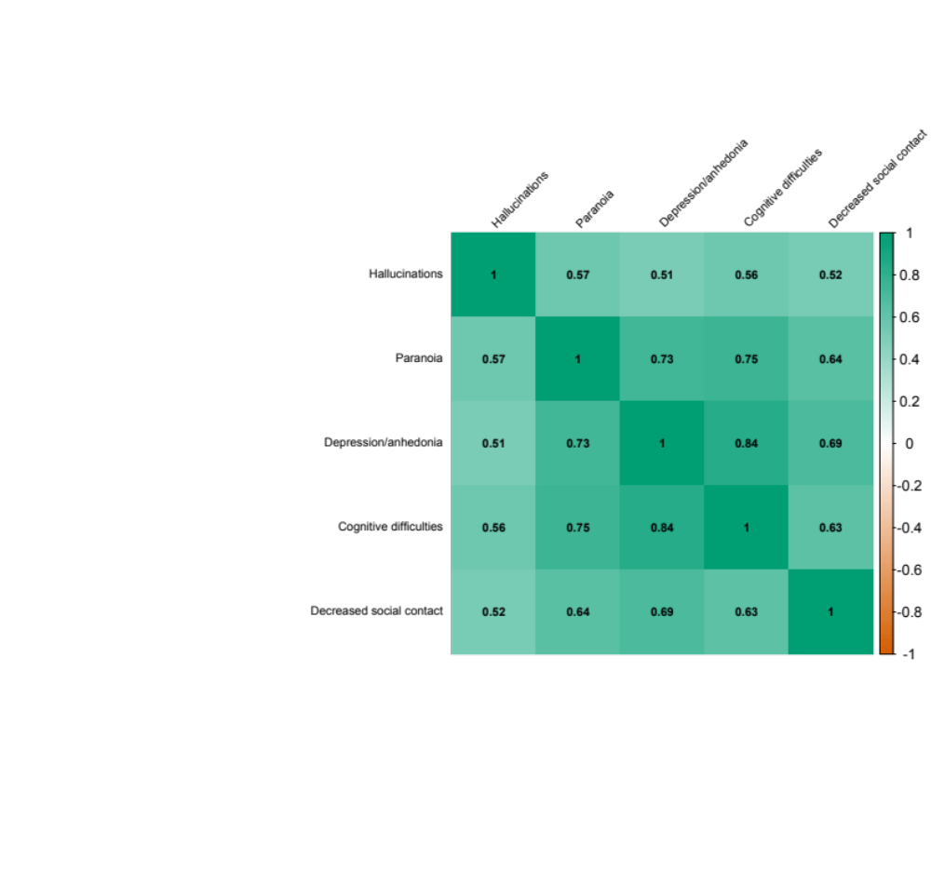

b.
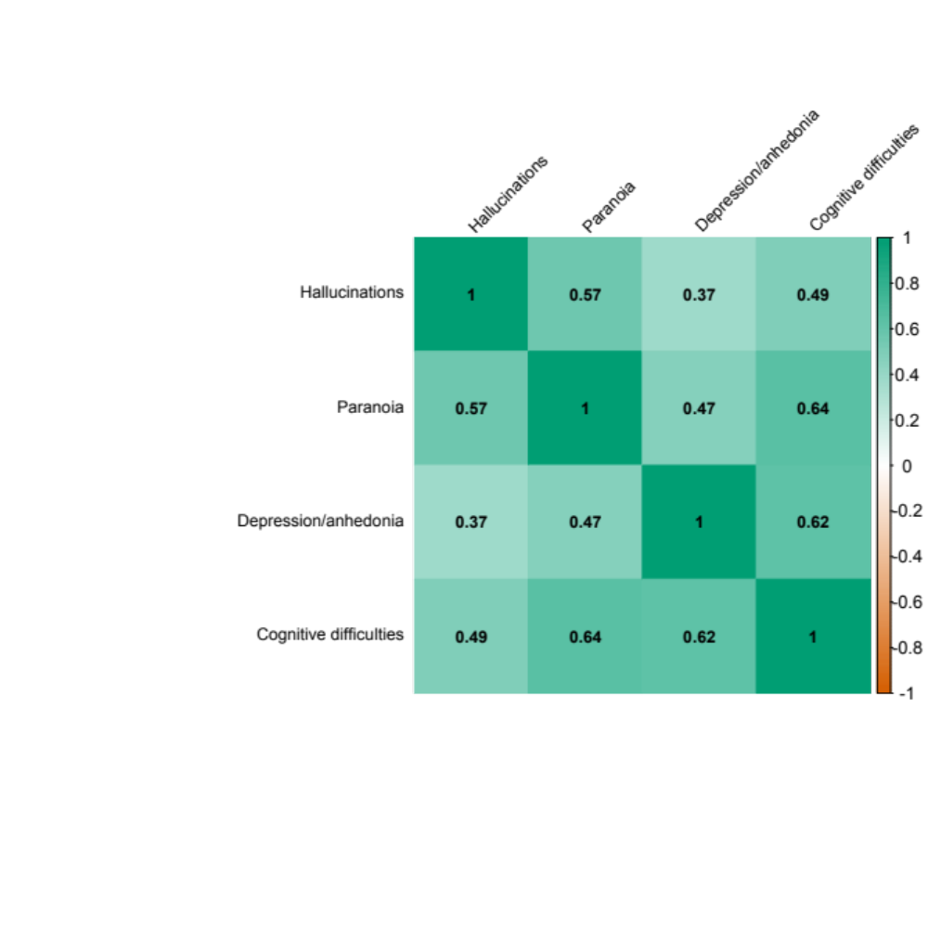

Supp. Fig 2. Odds ratios and 95% confidence intervals of reporting cannabis-related cognitive difficulties for different quartiles of polygenic risk for schizophrenia. The lowest quartile of polygenic risk served as the reference category. Individuals in the top 25% of risk had an odds ratio = 2.02, while individuals in the third quartile of risk had an odds ratio = 1.59, and individuals in the second quartile of risk had an odds ratio = 1.43. This analysis was only performed in individuals in the European ancestry sample of COGA.

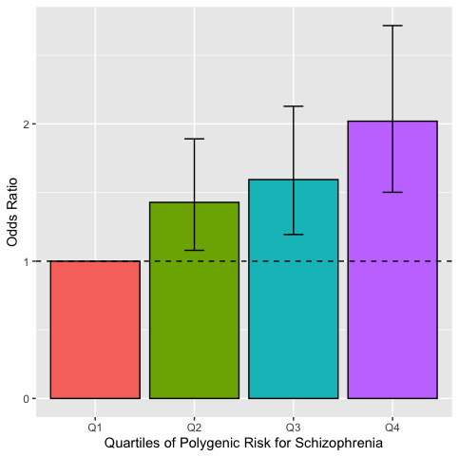

Supp. Fig 3. Density plots showing distribution of schizophrenia PRS in affected and unaffected African genetic ancestry individuals for cannabis-induced psychotic-like experiences.
