Supplemental Information
Age-linked suppression of lipoxin A4 associates with cognitive deficits in mice and humans

Fabricio A. Pamplona^{1,2,3}*, Gabriela Vitória¹, Felipe K. Sudo¹, Felipe C. Ribeiro⁴, Alinny R. Isaac⁴, Carolina A. Moraes², Mariana G. Chauvet⁴, Pitia Flores Ledur¹, Karina Karmirian^{1,5}, Isis M. Ornelas^{1,6}, Luciana M. Leo², Bruna Paulsen^{7,8}, Gabriel Coutinho¹, Claudia Drummond^{1,9}, Naima Assunção¹, Bart Vanderborght¹, Claudio A. Canetti¹⁰, Hugo C. Castro-Faria-Neto², Paulo Mattos¹, Sergio T. Ferreira^{1,4,10}, Stevens K. Rehen^{1,5}, Fernando A. Bozza^{1,2}, Mychael V. Lourenco⁴*, Fernanda Tovar-Moll¹*

¹D’Or Institute for Research and Education (IDOR), Rio de Janeiro, Brazil
²Laboratory of Immunopharmacology, Oswaldo Cruz Institute, Oswaldo Cruz Foundation (FIOCRUZ), Rio de Janeiro, Brazil ³Biosciences Program, Federal University for Latin American Integration, Foz do Iguaçu, Brazil
⁴Institute of Medical Biochemistry Leopoldo de Meis; ⁵Department of Genetics, Institute of Biology; ⁹Department of Speech and Hearing Pathology; ¹⁰Institute of Biophysics Carlos Chagas Filho, Federal University of Rio de Janeiro, Rio de Janeiro, RJ 21941-902, Brazil
⁶Department of Physiological Sciences, Federal University of Espírito Santo, ES 29040-090, Brazil
⁷Department of Stem Cell and Regenerative Biology, Harvard University, Cambridge, MA, USA.
⁸Stanley Center for Psychiatric Research, Broad Institute of MIT and Harvard, Cambridge, MA, USA.

*Correspondence to: fabriciopamplona@gmail.com (F.A. Pamplona), fernanda.tovarmoll@idor.org (F. Tovar-Moll) or mychael@bioqmed.ufrj.br (M.V. Lourenco).

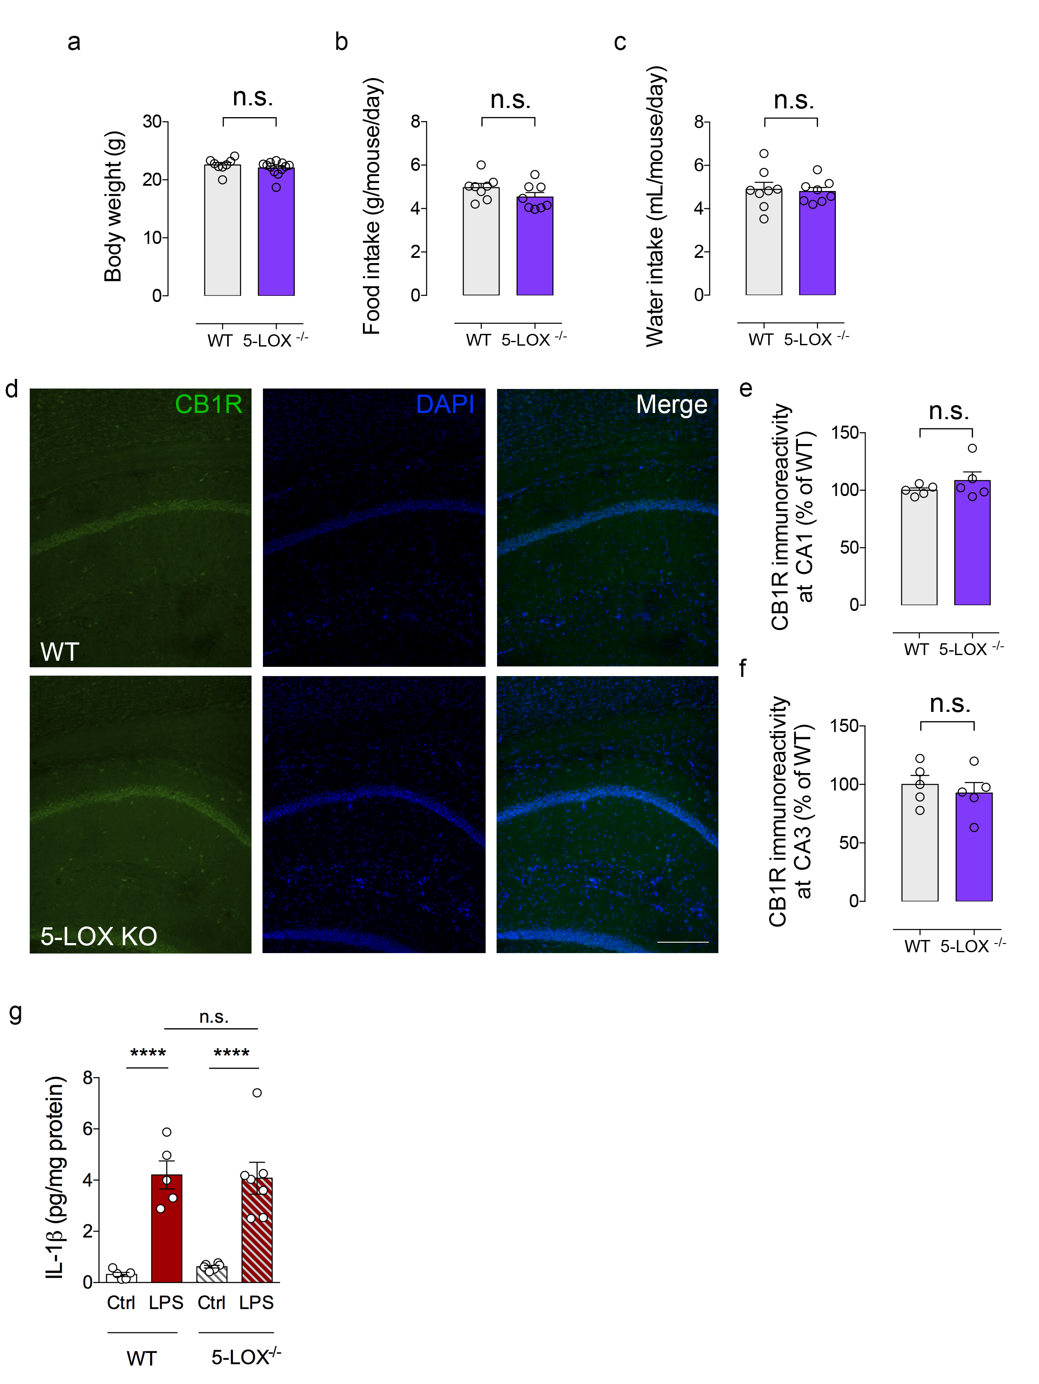

Supplemental Figure 1. 5-LOX^{-/-} mice do not present alterations in body weight, food/water intake, hippocampal endocannabinoid receptor 1 (CB1R) expression or neuroinflammation-associated IL-1β expression. (a-c) Body weight (a), 24-hour food intake (b) and 24-hour water intake (c) in adult male 5-LOX^{-/-} or WT mice. (d) Representative images of immunofluorescence experiments (CB1R immunoreactivity: green; DAPI immunoreactivity: blue) in the hippocampal formation of 5-LOX^{-/-} or WT mice. Scale bar: 50 μm. (e,f) Quantification of CB1R immunoreactivity at CA1 (e) and CA3 (f) hippocampal subregions obtained from experiments in d (n = 5 mice per group). Unpaired two-tailed Student’s t-test; n.s., non-significant. (g) Brain levels of IL-1β in WT or 5-LOX^{-/-} mice injected with saline or LPS (0.3 mg/kg; i.p.). Two-tailed unpaired two-way ANOVA followed by Holm- Šidák post hoc test; n.s., non-significant; **** p < 0.0001). Graphs show means ± standard error of the mean (SEM). Graphs show mean ± standard error of the mean (SEM).

Supplemental Figure 2. LXA4 does not correlate with total tau in the CSF. Line represents a partial rank correlation (r and p-values as indicated in graph) and the confidence interval is represented as gray shade. Healthy controls: white symbols; aMCI: grey symbols; AD: black symbols; DLB: golden symbols).

