Supplementary Material

Supplementary Figures and Tables

Supplementary Figures



Supplementary Figure 1. Tissue enrichment analysis result of shared genes between decaffeinated coffee consumption and neuroticism
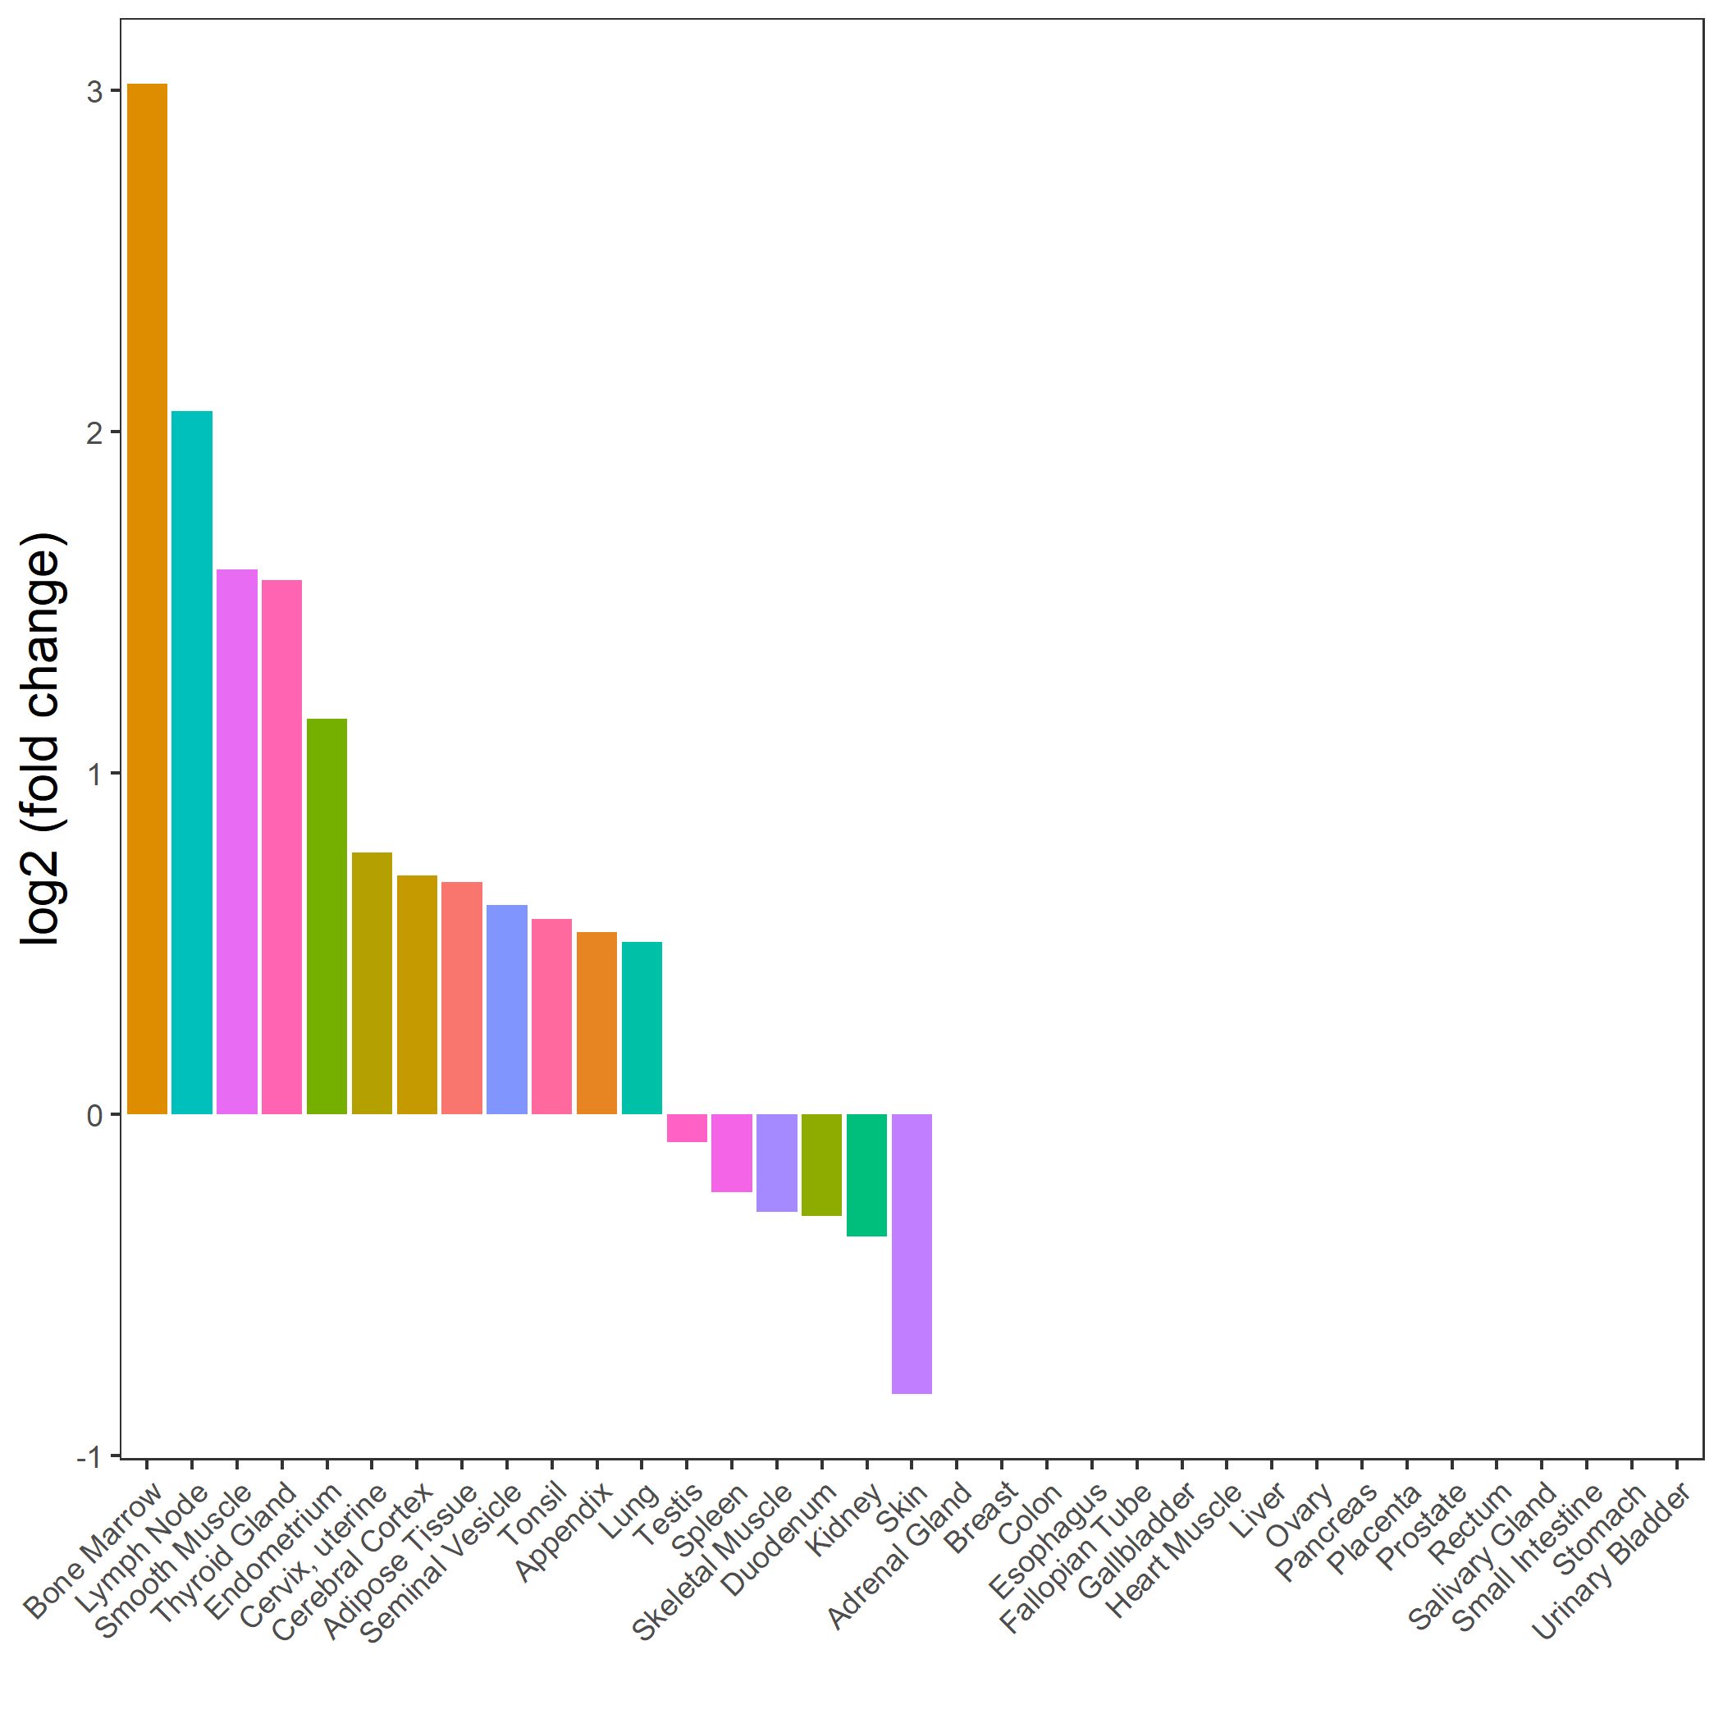

Supplementary Figure 2. Tissue enrichment analysis result of shared genes between decaffeinated coffee consumption and MDD
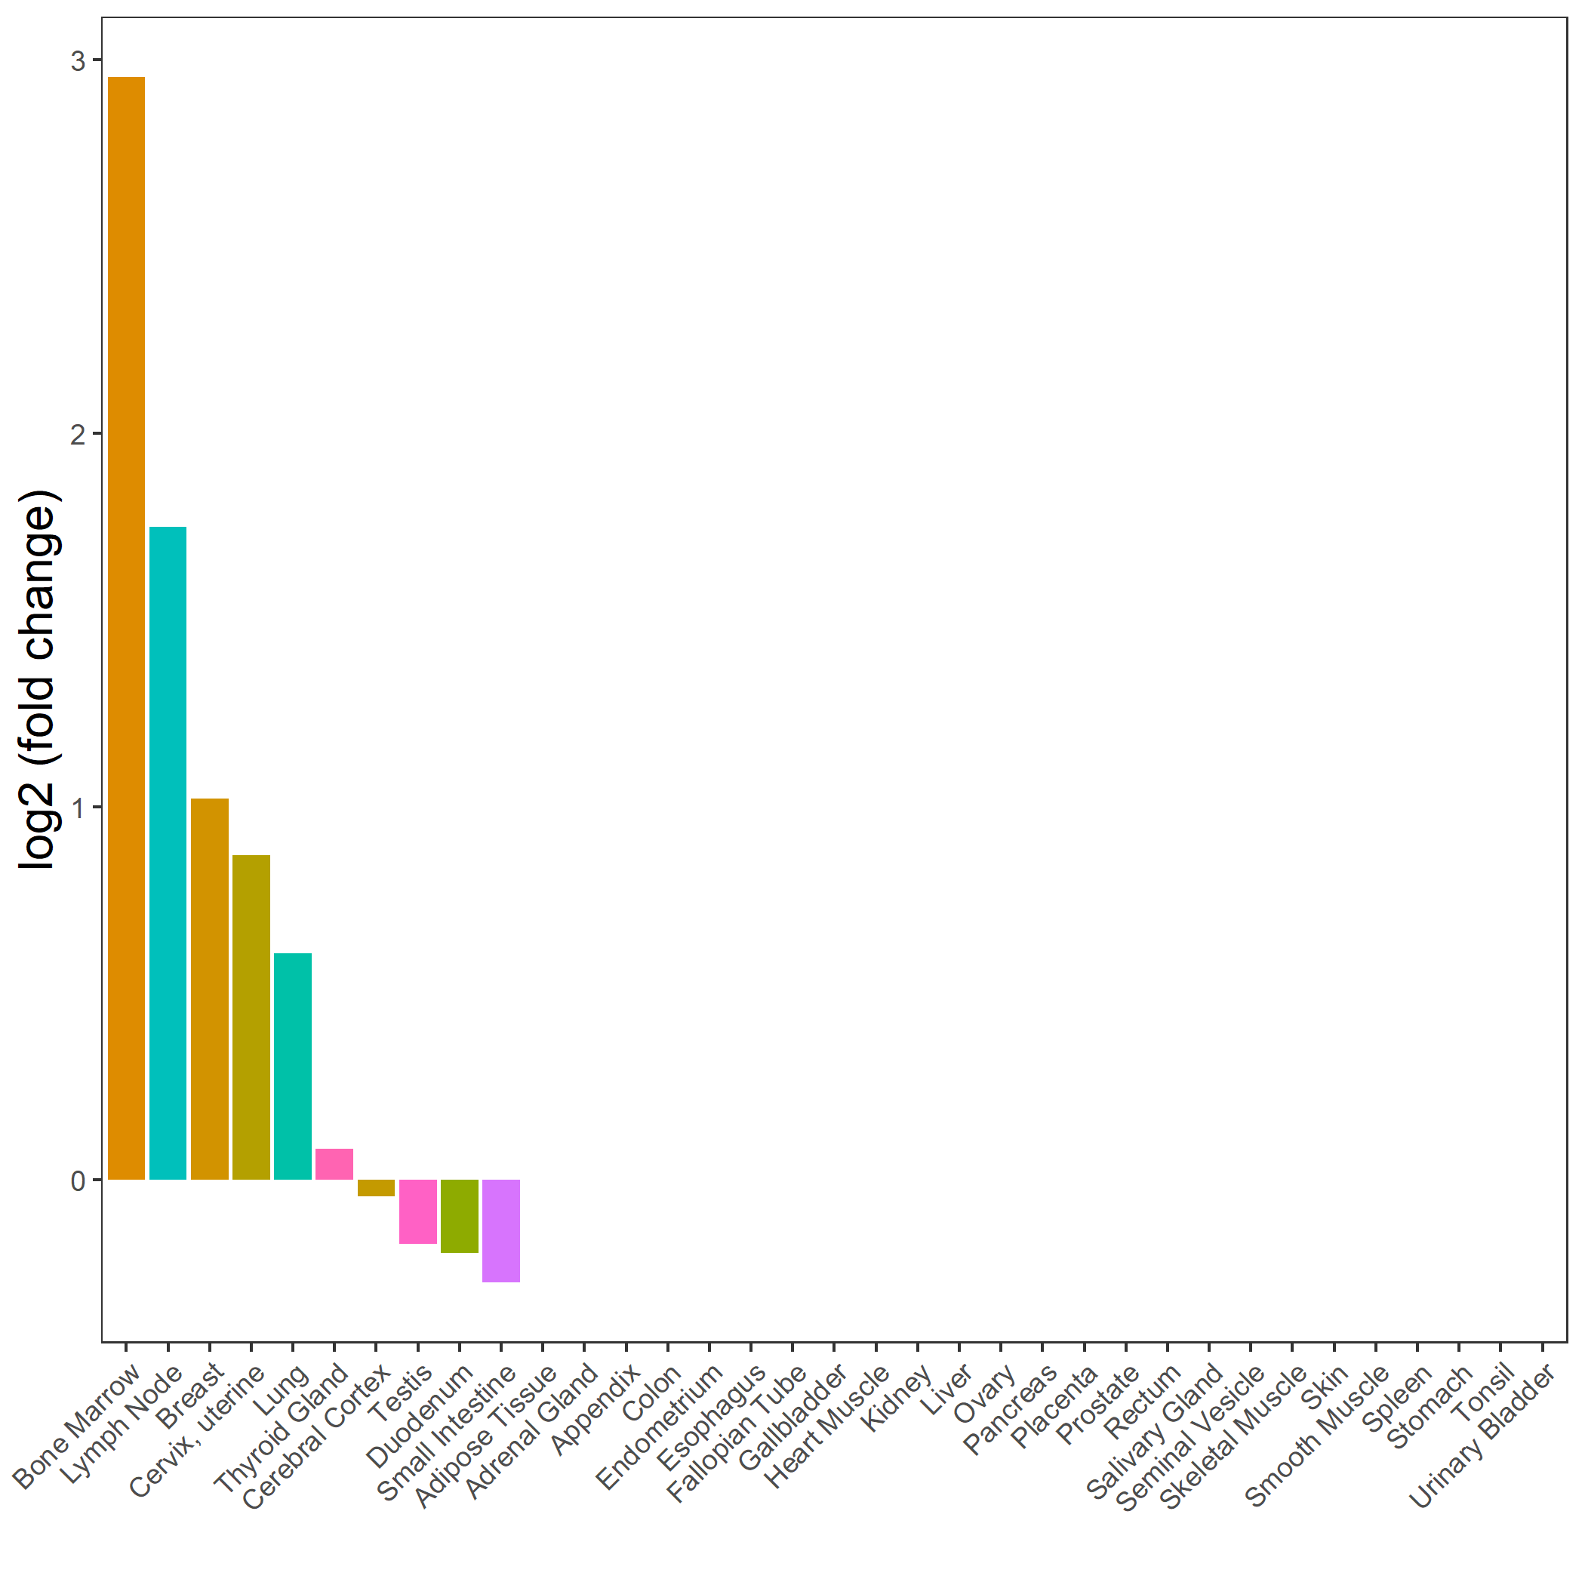

Supplementary Figure 3. Tissue enrichment analysis result of shared genes between decaffeinated coffee consumption and LCU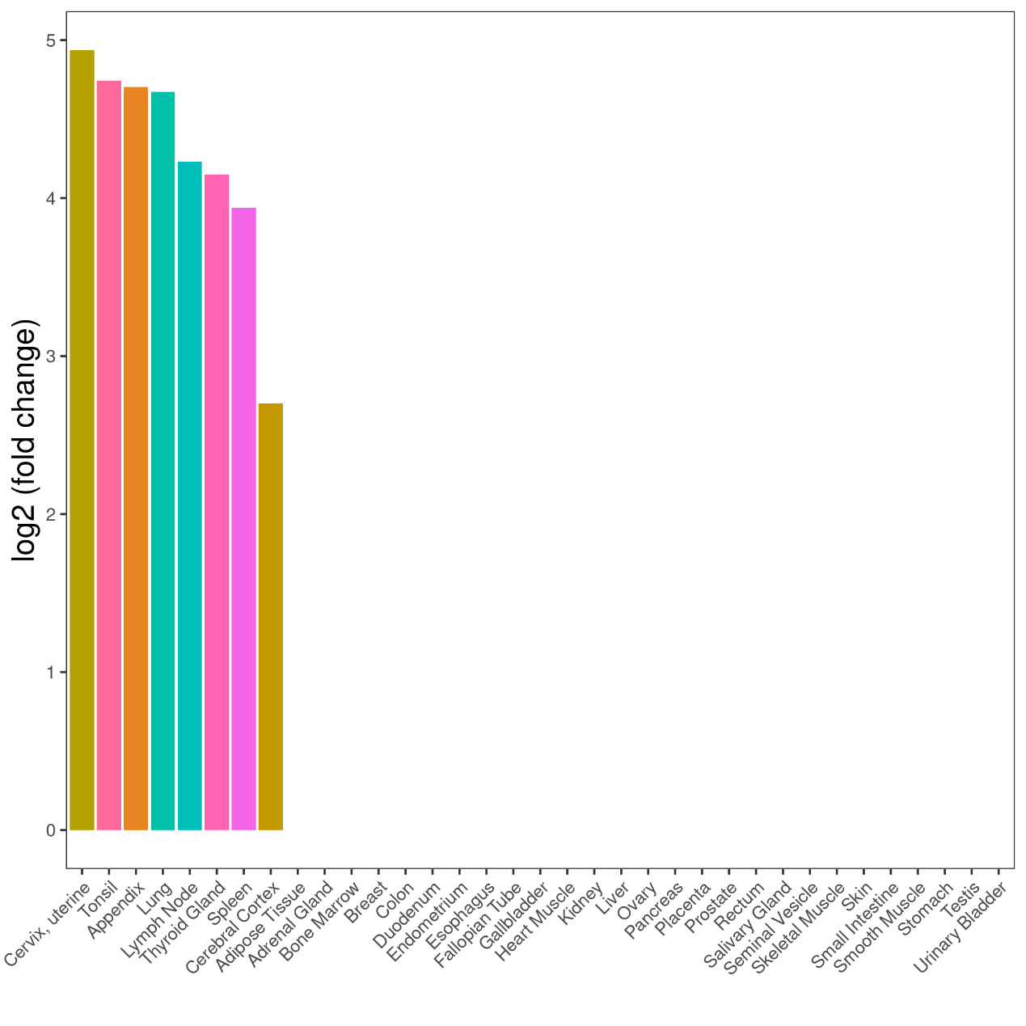

Supplementary Figure 4. Tissue enrichment analysis result of shared genes between decaffeinated coffee consumption and insomnia
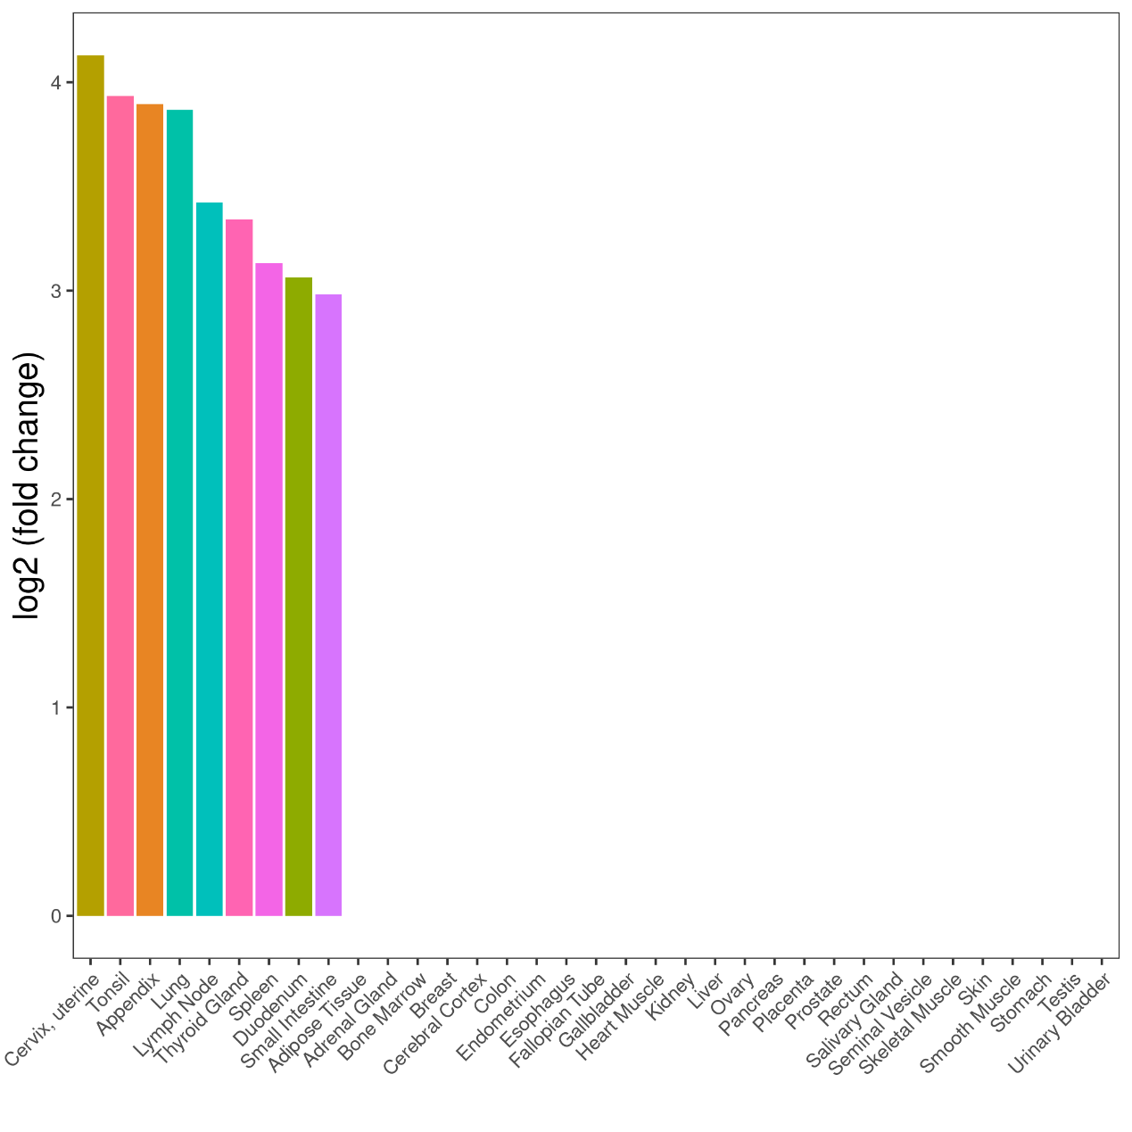

Supplementary Figure 5. Tissue enrichment analysis result of shared genes between decaffeinated coffee consumption and AUDIT_T/AUDIT_C/AUDIT_P
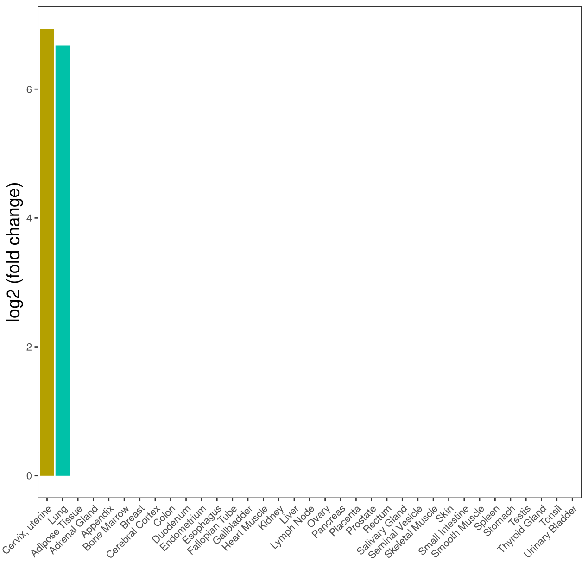

Supplementary Figure 6. Scatter plot of MR analysis of decaffeinated coffee consumption upon LCU
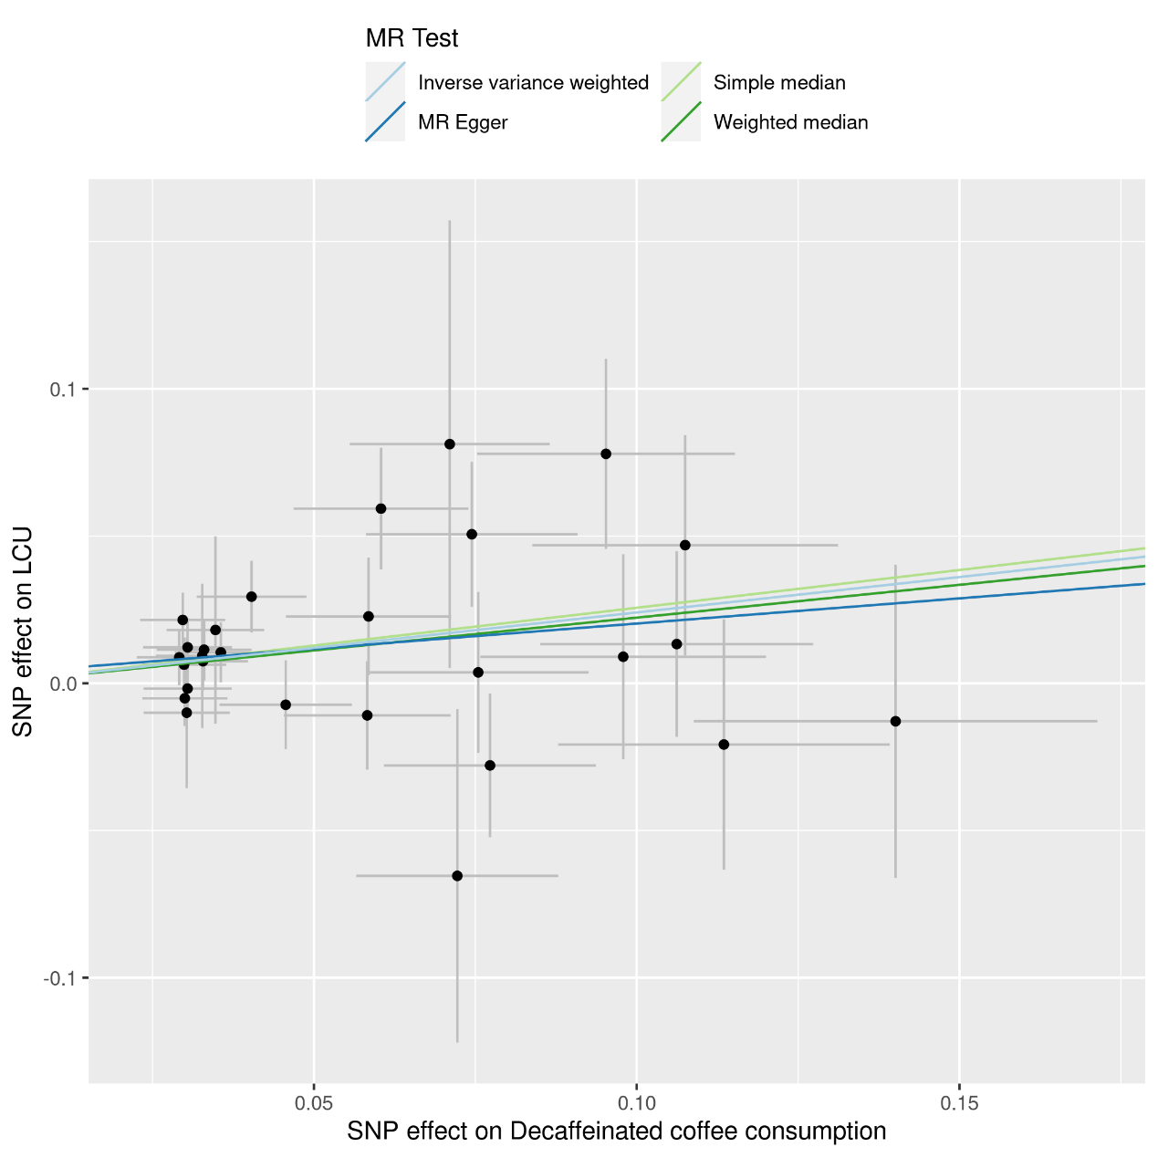

Supplementary Figure 7. Scatter plot of MR analysis of decaffeinated coffee consumption upon MDD
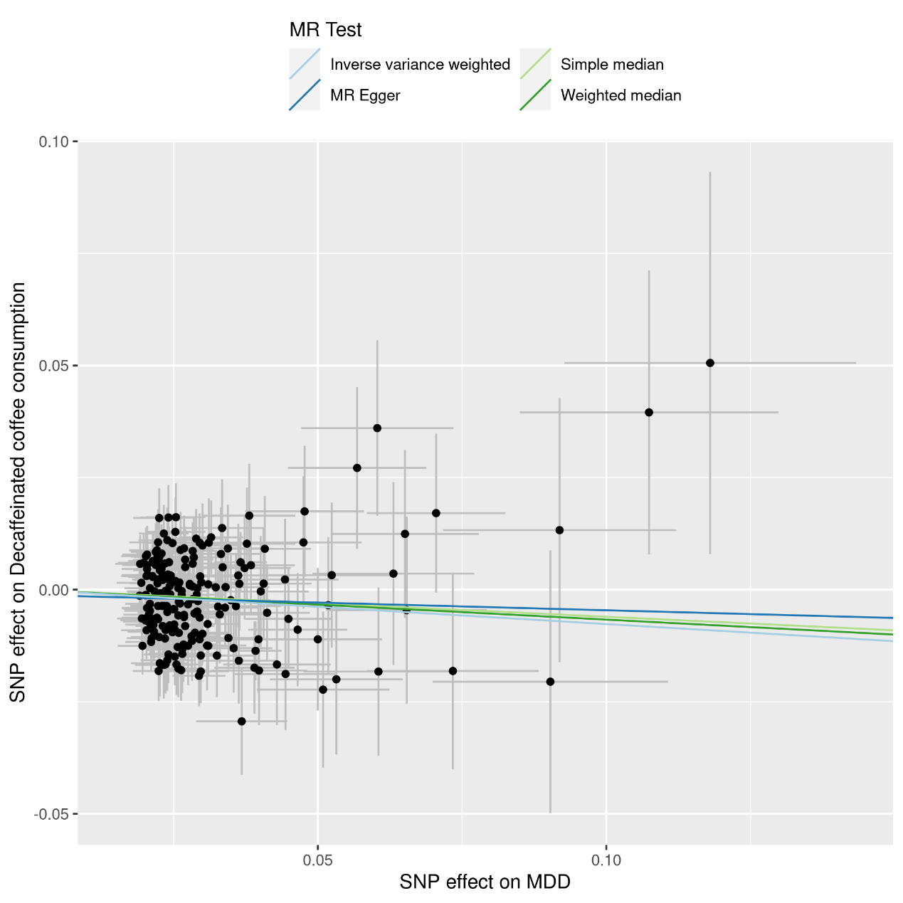

Supplementary Figure 8. Scatter plot of MR analysis of AUDIT_T upon decaffeinated coffee consumption
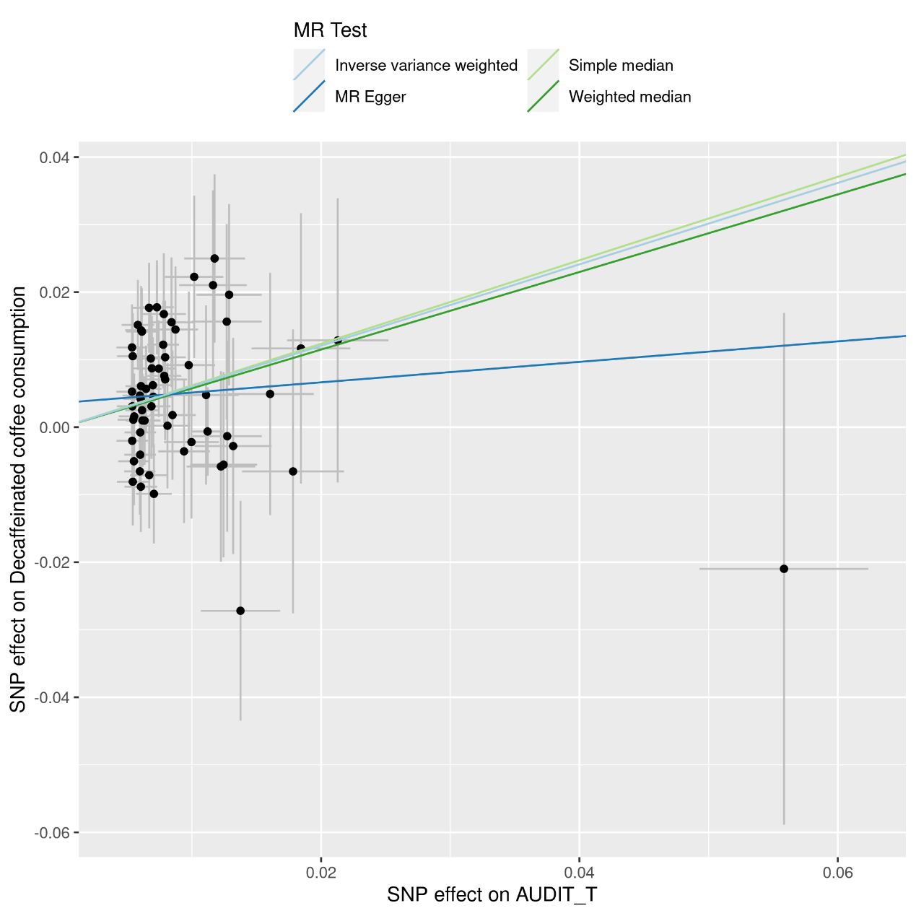

Supplementary Figure 9. Scatter plot of MR analysis of AUDIT_C upon decaffeinated coffee consumption
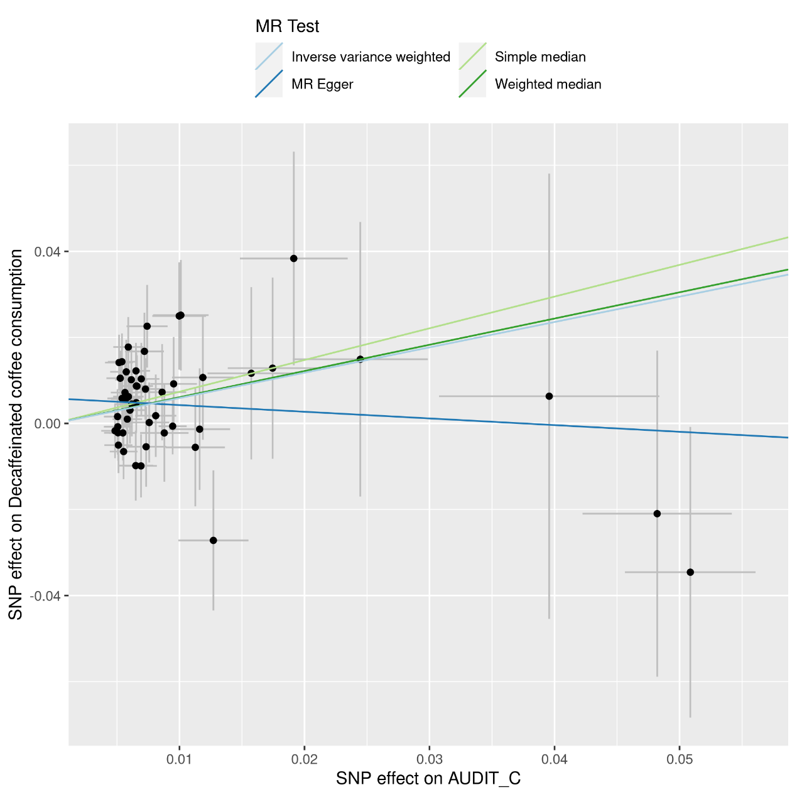

Supplementary Figure 10. Scatter plot of MR analysis of Insomnia upon decaffeinated coffee consumption
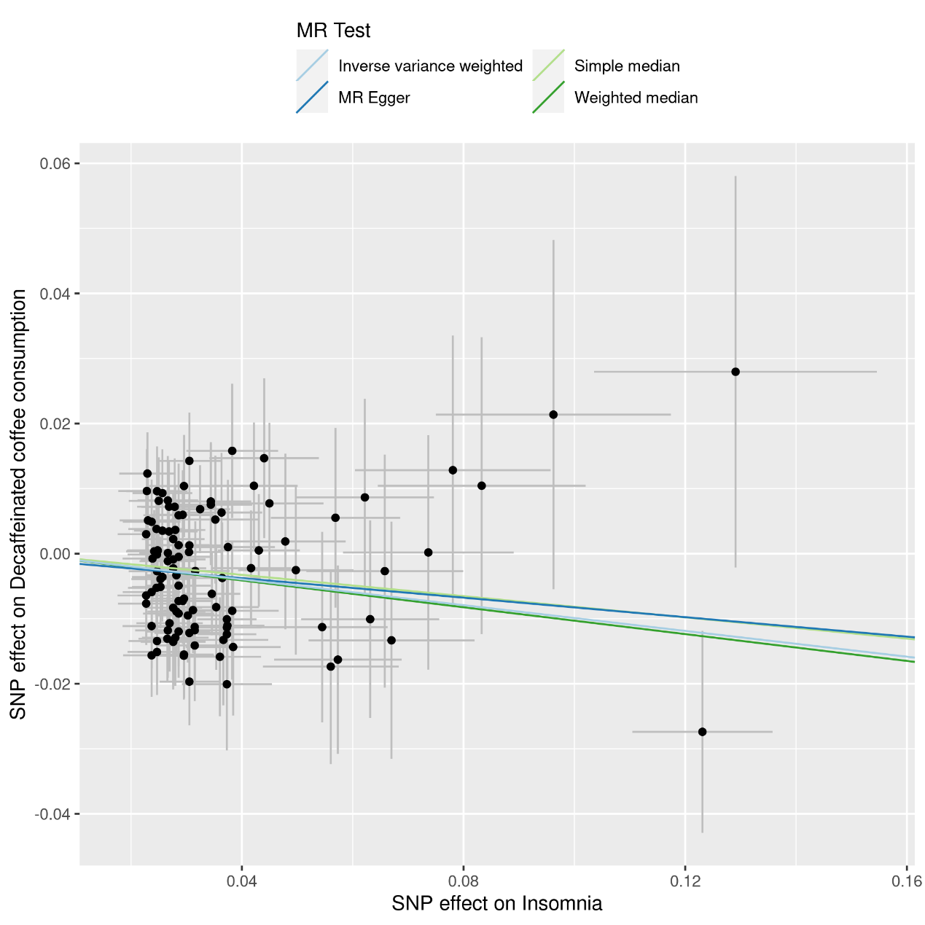

Supplementary Figure 11. Scatter plot of MR analysis of MDD upon decaffeinated coffee consumption

Supplementary Figure 12. Funnel plot of MR analysis of decaffeinated coffee consumption upon LCU

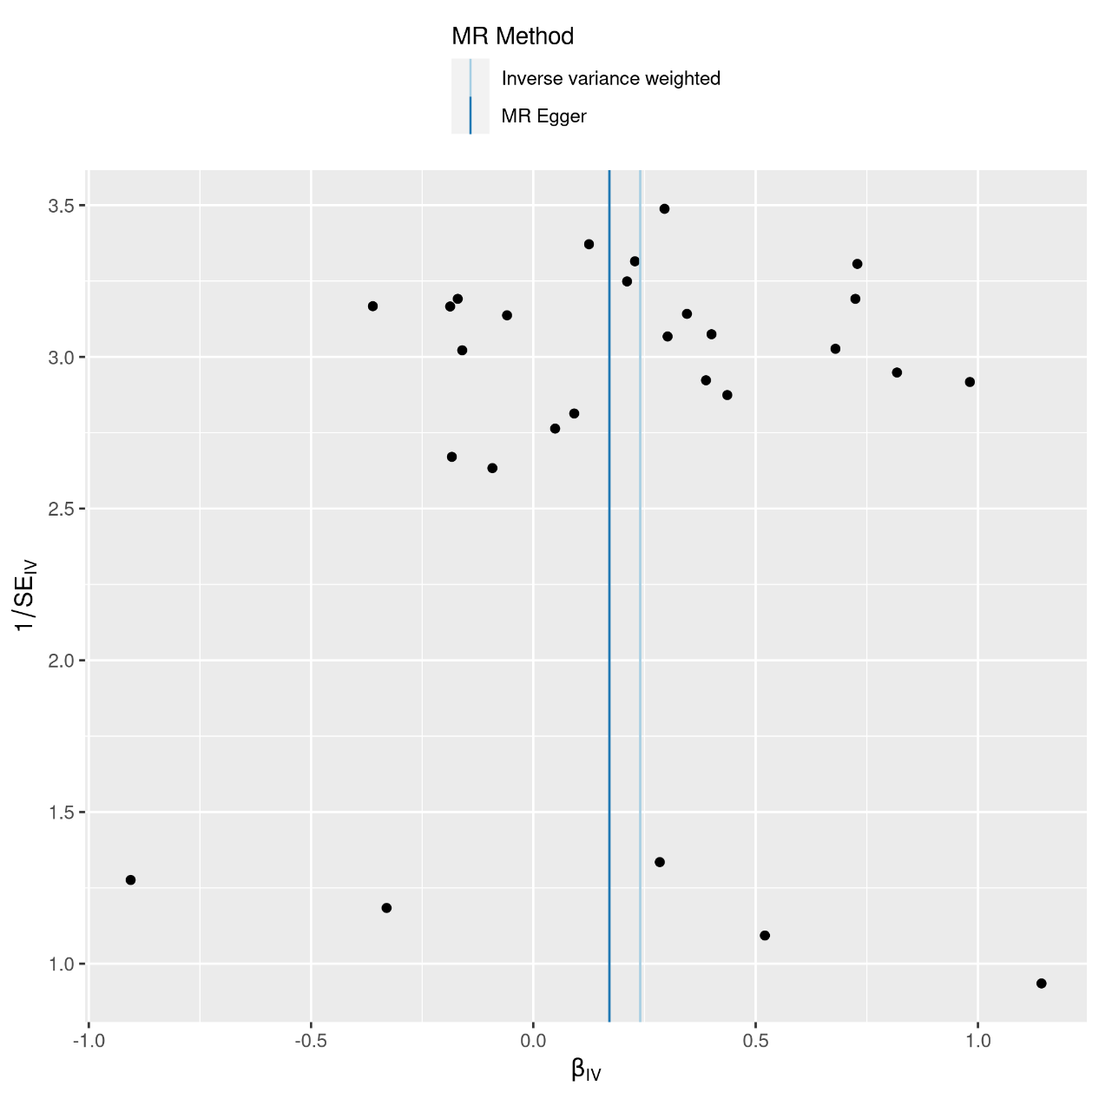

Supplementary Figure 13. Funnel plot of MR analysis of decaffeinated coffee consumption upon MDD

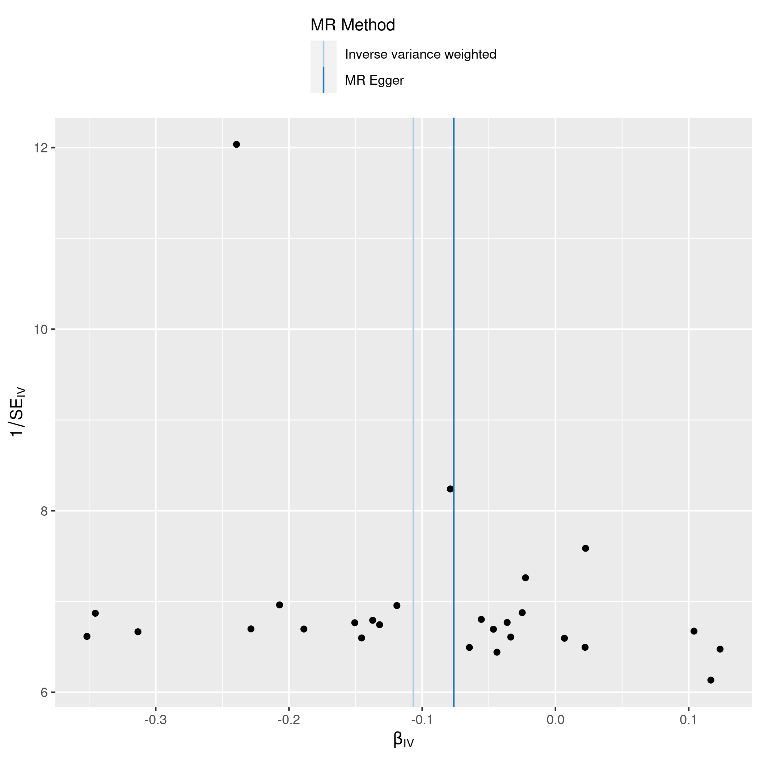

Supplementary Figure 14. Funnel plot of MR analysis of AUDIT_T upon decaffeinated coffee consumption
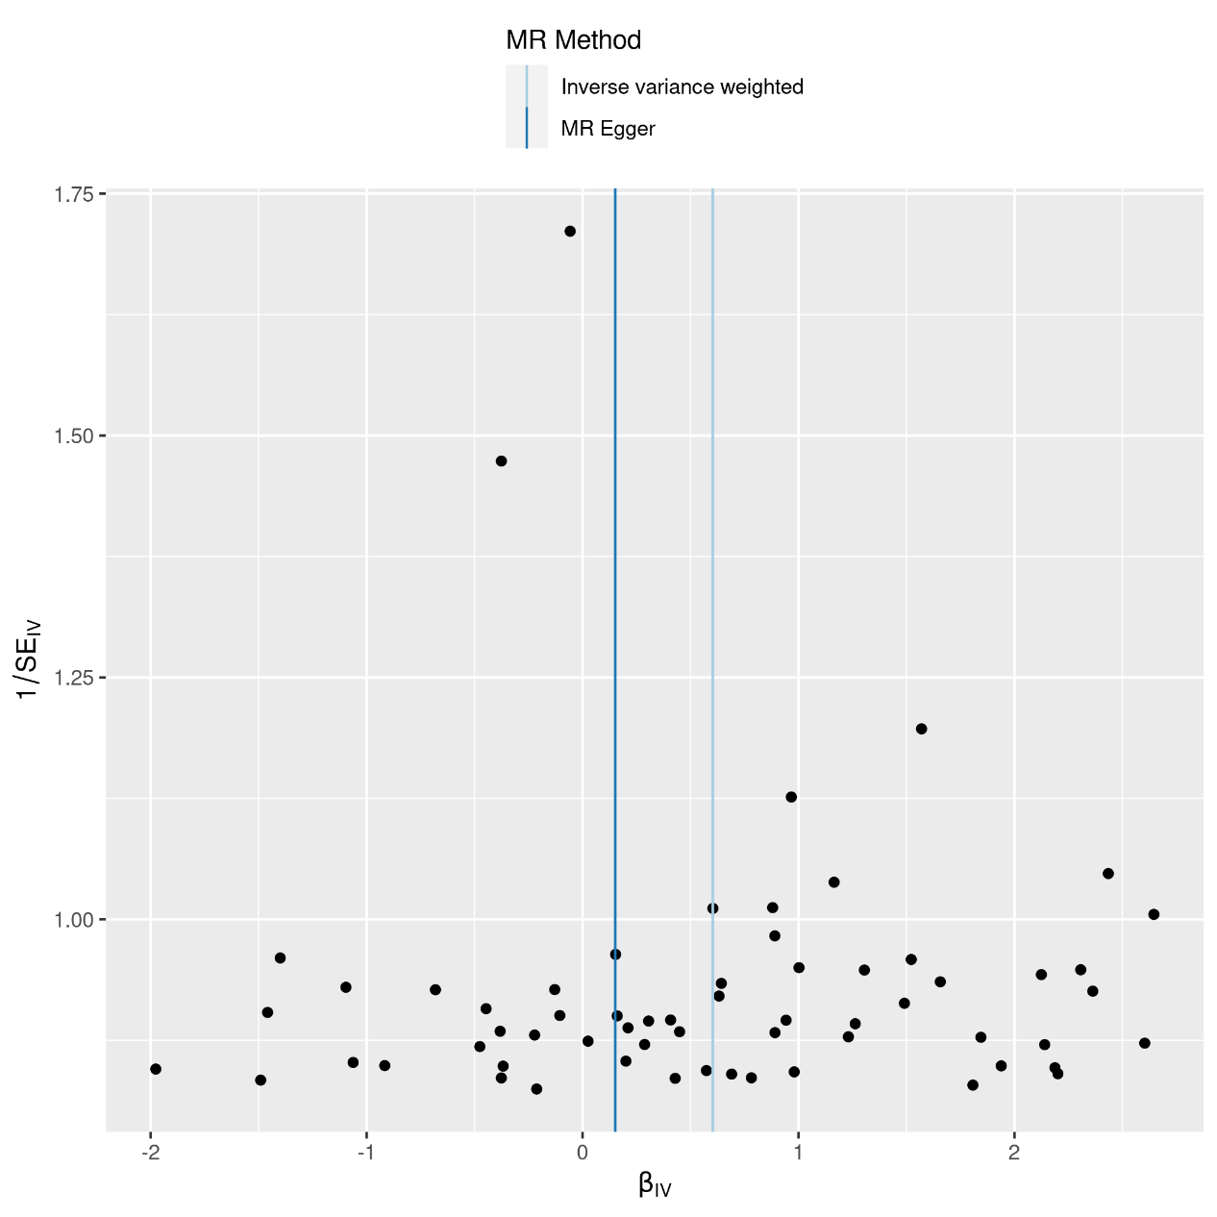

Supplementary Figure 15. Funnel plot of MR analysis of AUDIT_C upon decaffeinated coffee consumption

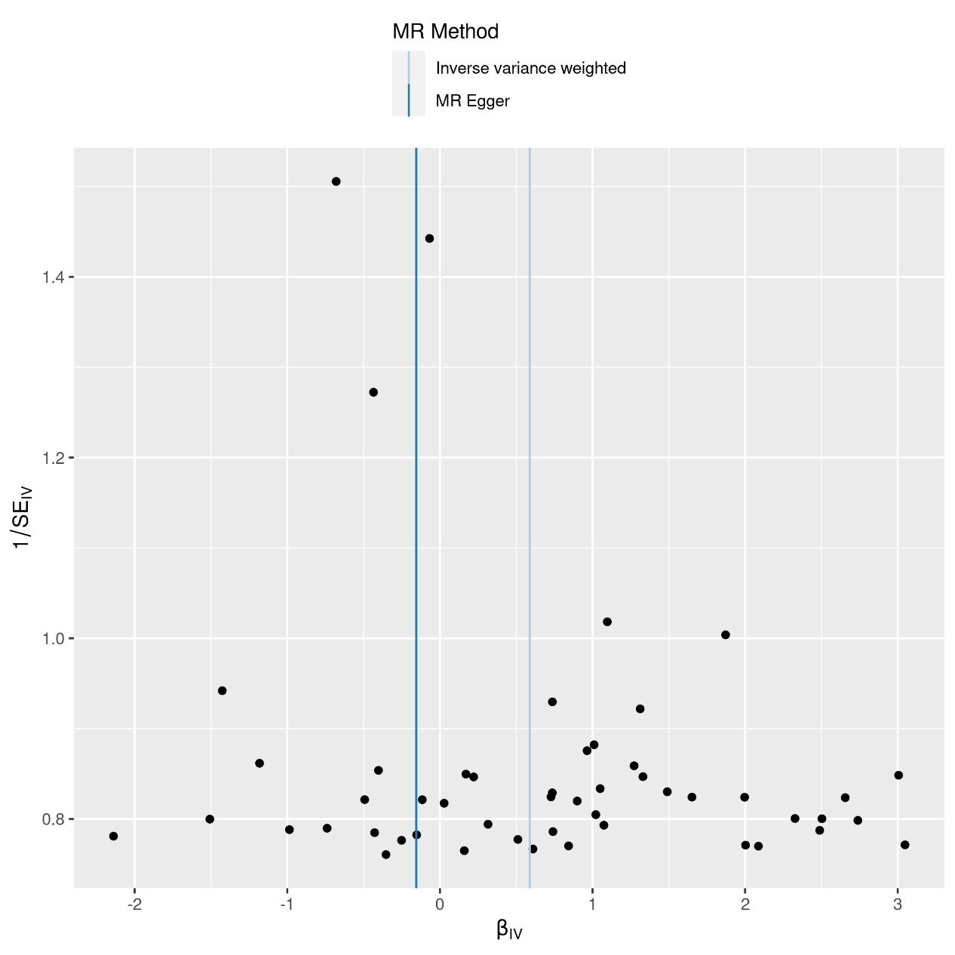

Supplementary Figure 16. Funnel plot of MR analysis of Insomnia upon decaffeinated coffee consumption

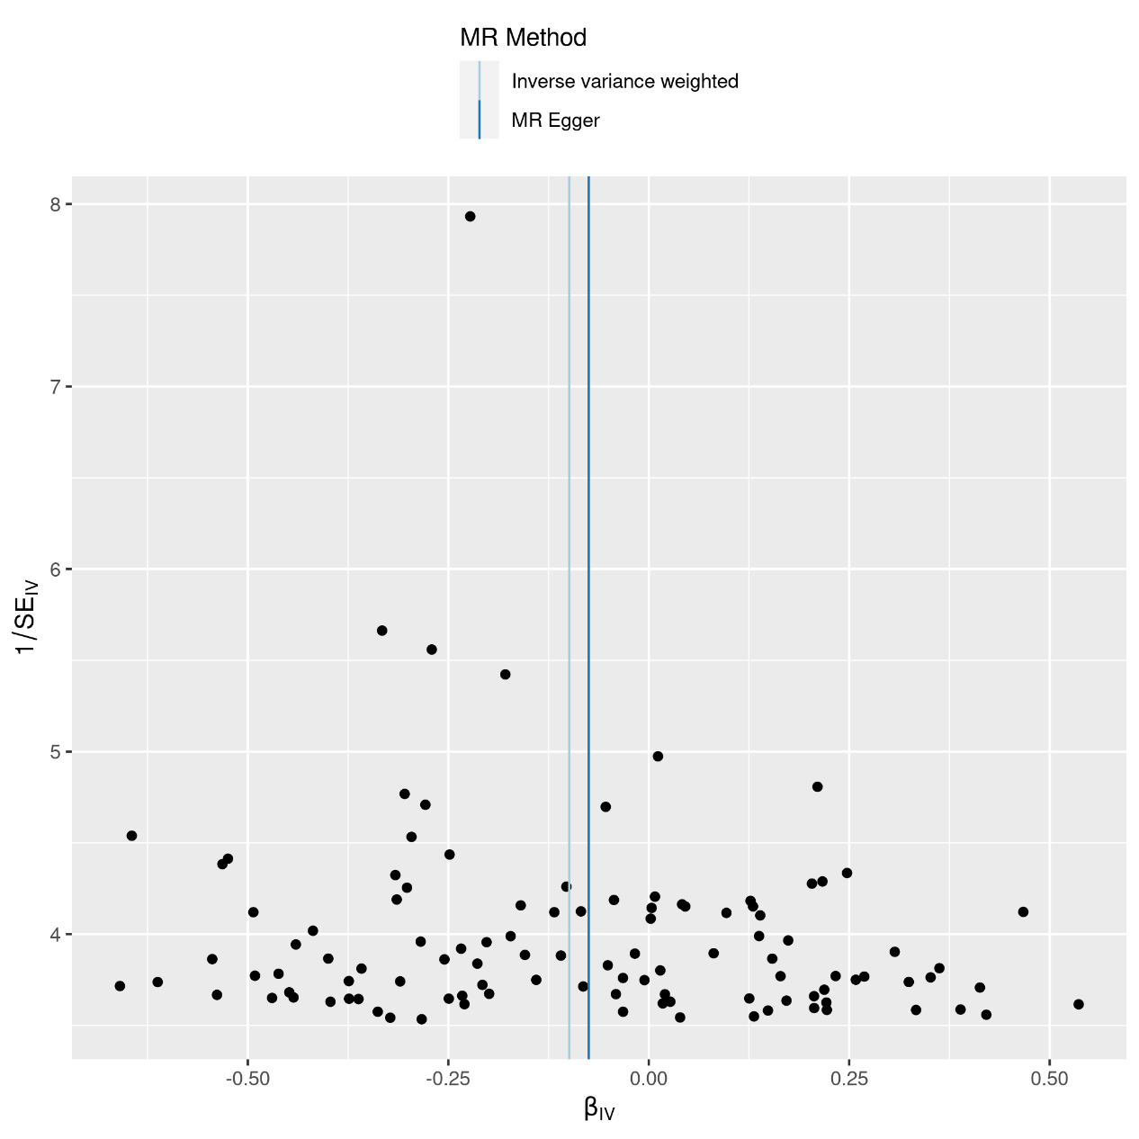

Supplementary Figure 17. Funnel plot of MR analysis of MDD upon decaffeinated coffee consumption

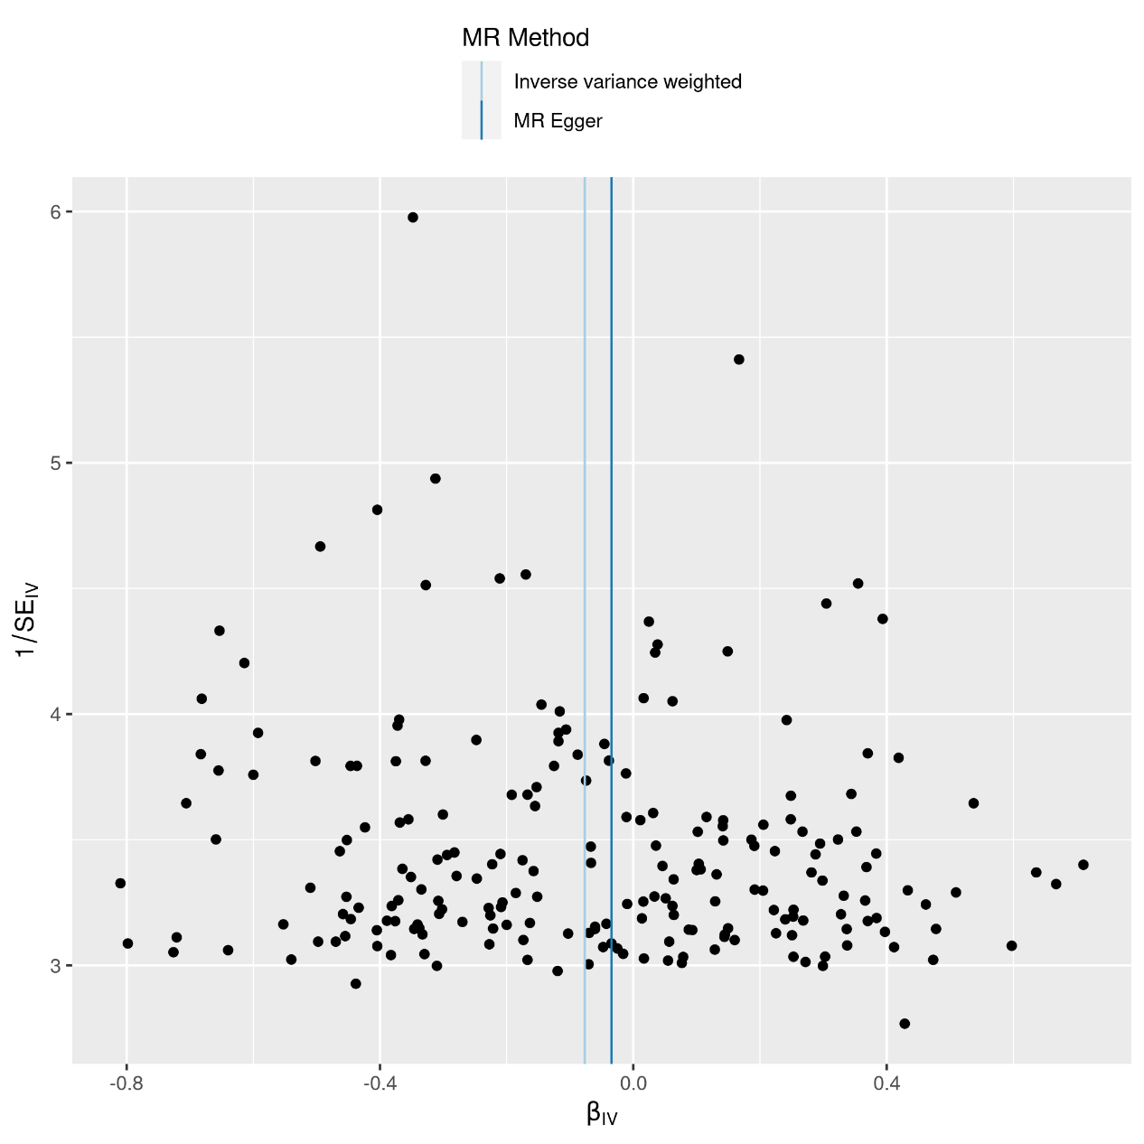

Supplementary Figure 18. Leave-one-out plot of MR analysis of decaffeinated coffee consumption upon LCU
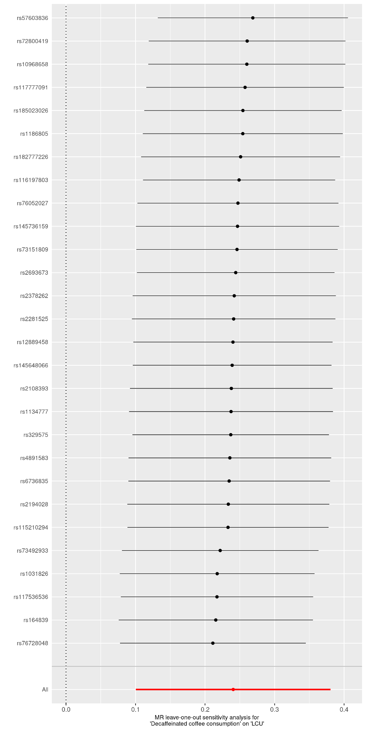

Supplementary Figure 19. Leave-one-out plot of MR analysis of decaffeinated coffee consumption upon MDD

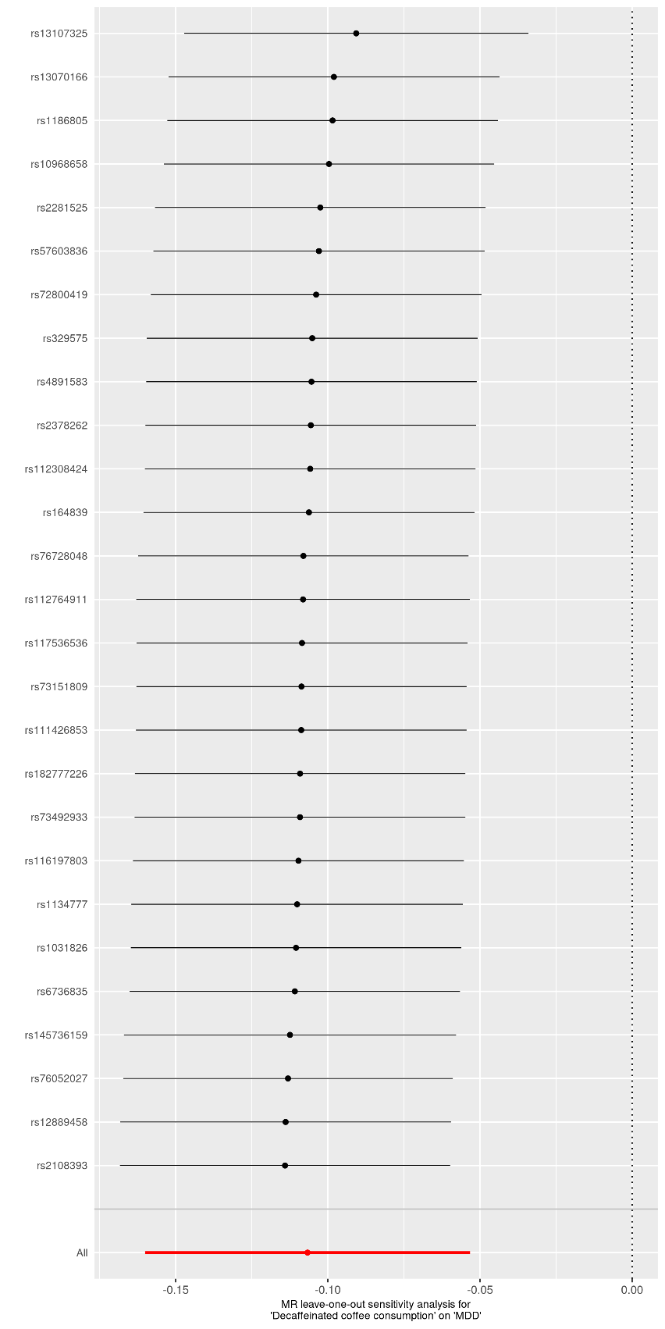

Supplementary Figure 20. Leave-one-out plot of MR analysis of AUDIT_T upon decaffeinated coffee consumption
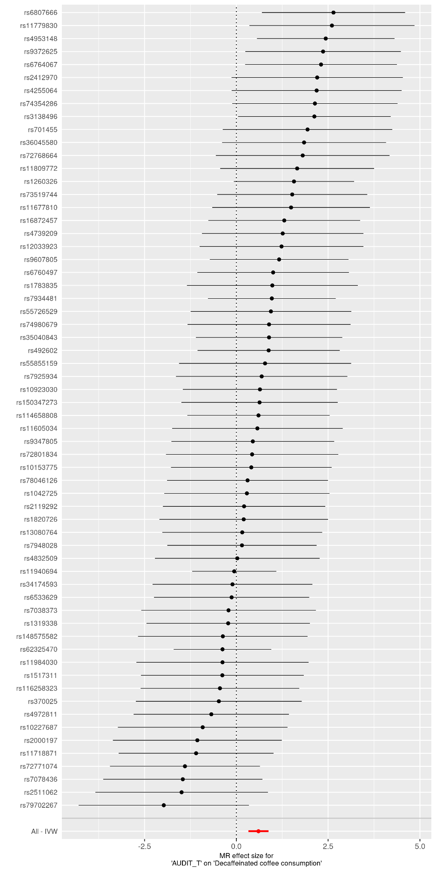

Supplementary Figure 21. Leave-one-out plot of MR analysis of AUDIT_C upon decaffeinated coffee consumption
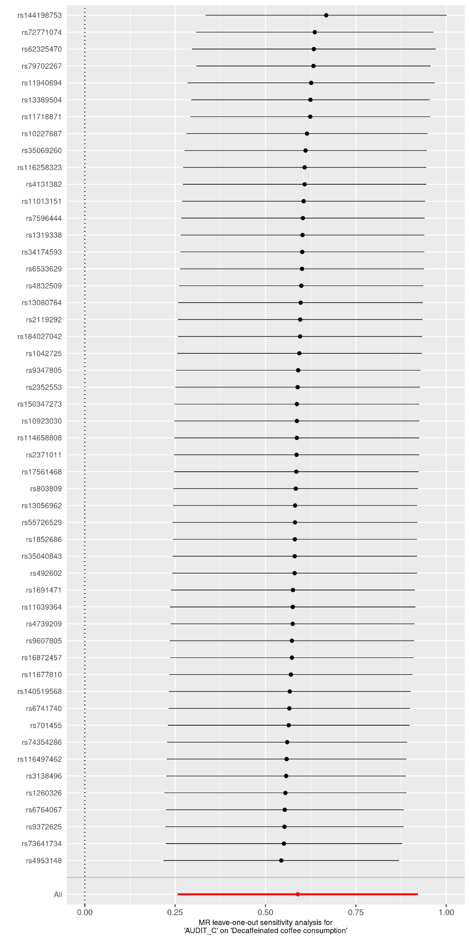

Supplementary Figure 22. Leave-one-out plot of MR analysis of Insomnia upon decaffeinated coffee consumption
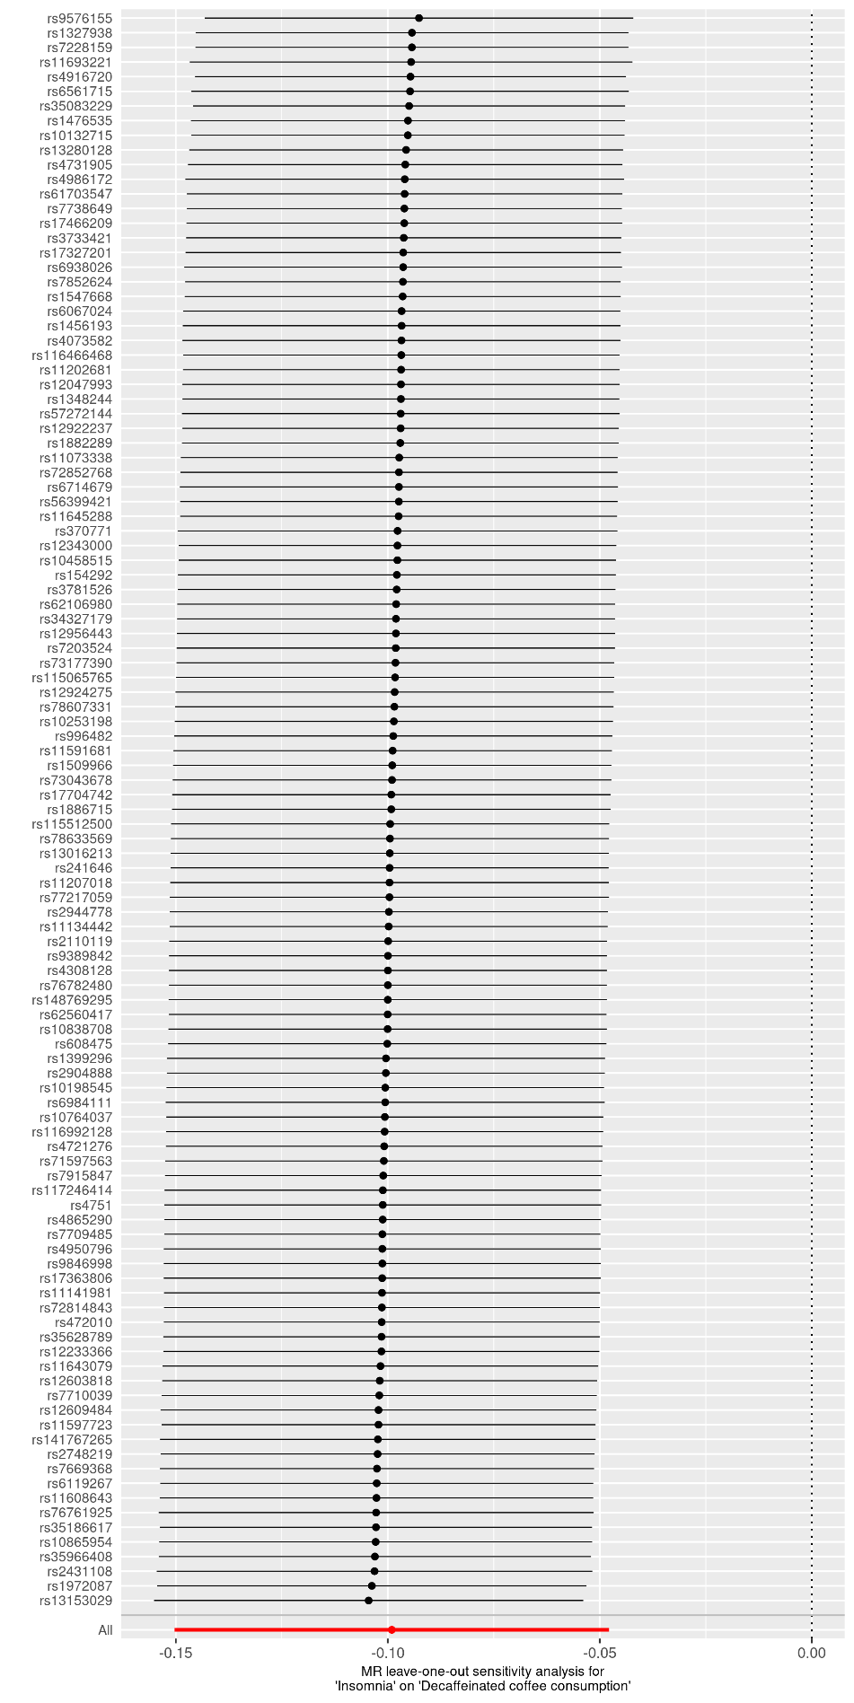

Supplementary Figure 23. Leave-one-out plot of MR analysis of MDD upon decaffeinated coffee consumption
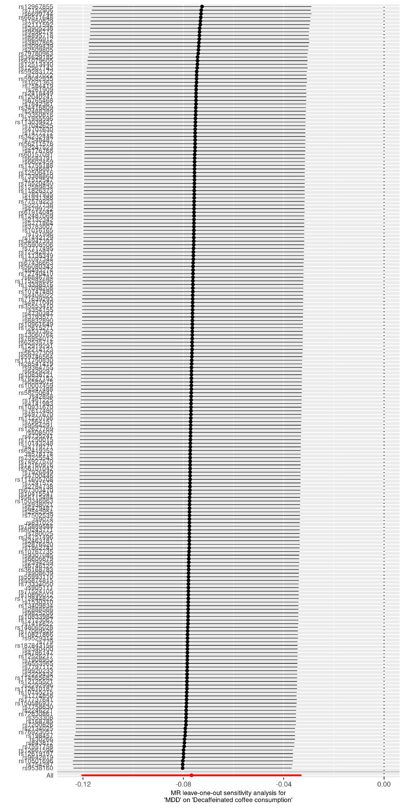
Supplementary Figure 24. Forest plot of MR analysis of decaffeinated coffee consumption upon LCU
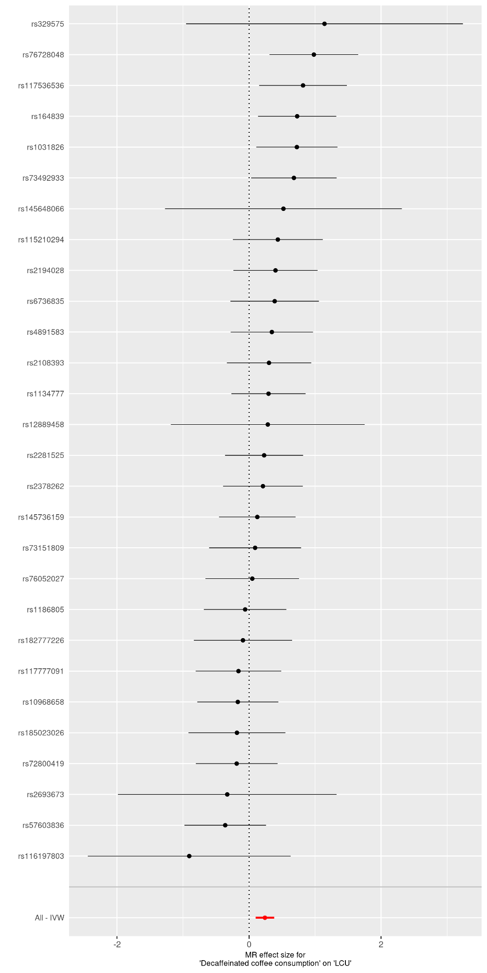

Supplementary Figure 25. Forest plot of MR analysis of decaffeinated coffee consumption upon MDD
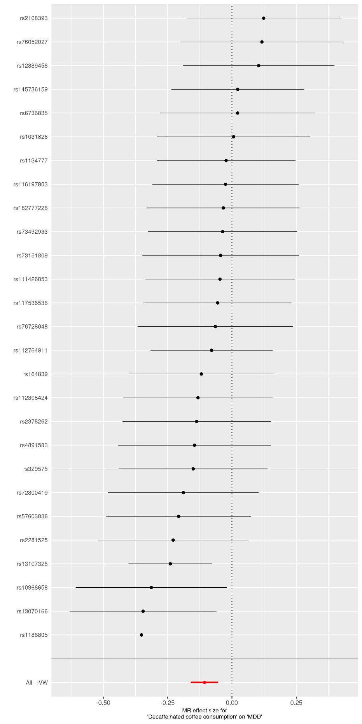

Supplementary Figure 26. Forest plot of MR analysis of AUDIT_T upon decaffeinated coffee consumption

Supplementary Figure 27. Forest plot of MR analysis of AUDIT_C upon decaffeinated coffee consumption
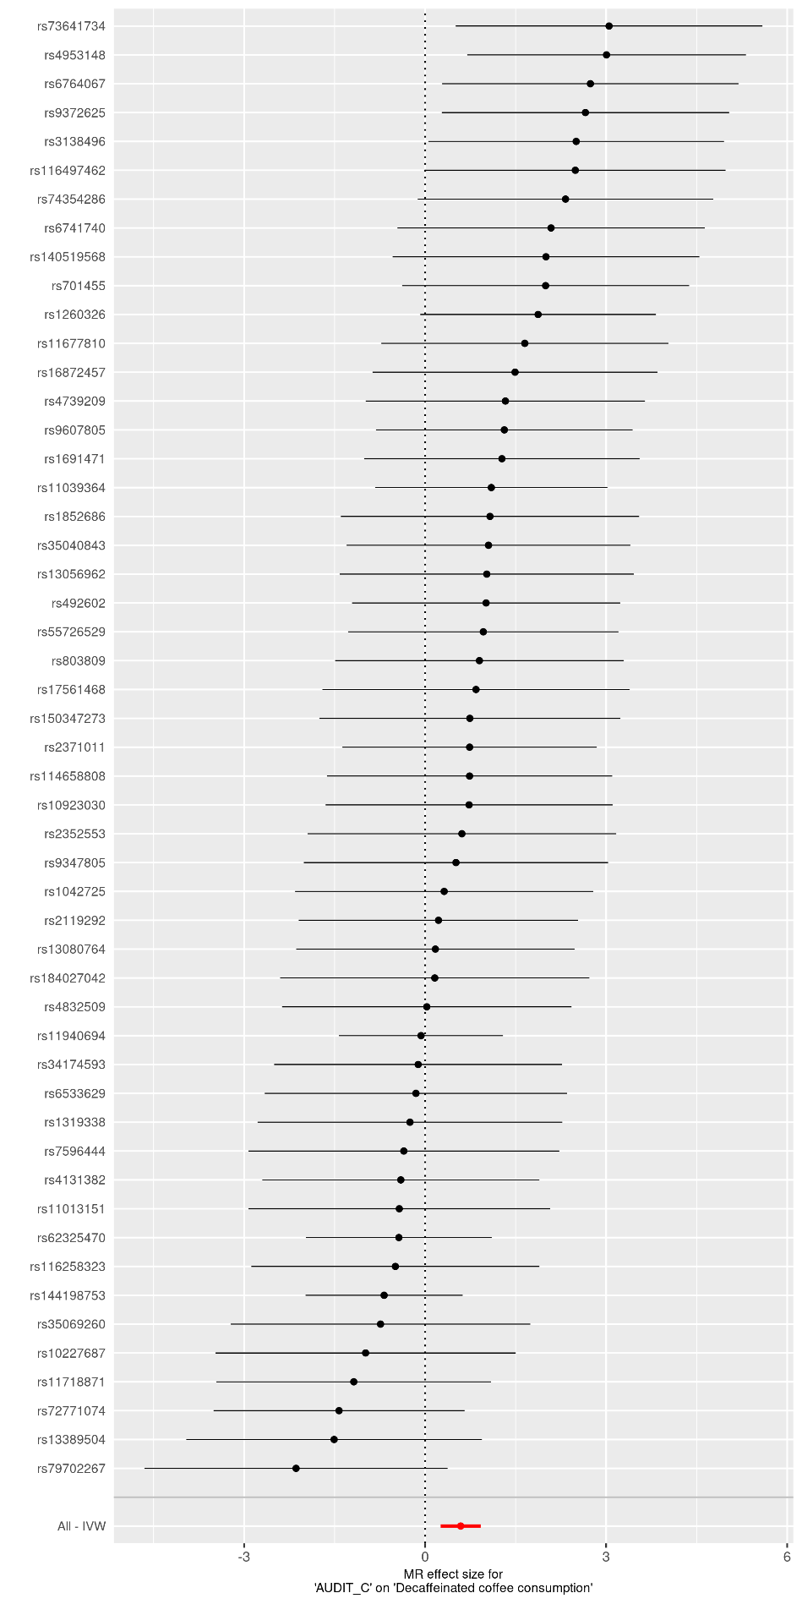

Supplementary Figure 28. Forest plot of MR analysis of Insomnia upon decaffeinated coffee consumption
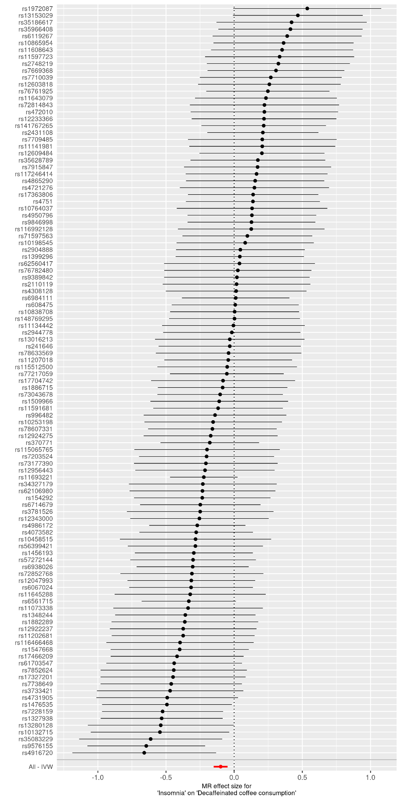

Supplementary Figure 29. Forest plot of MR analysis of MDD upon decaffeinated coffee consumption
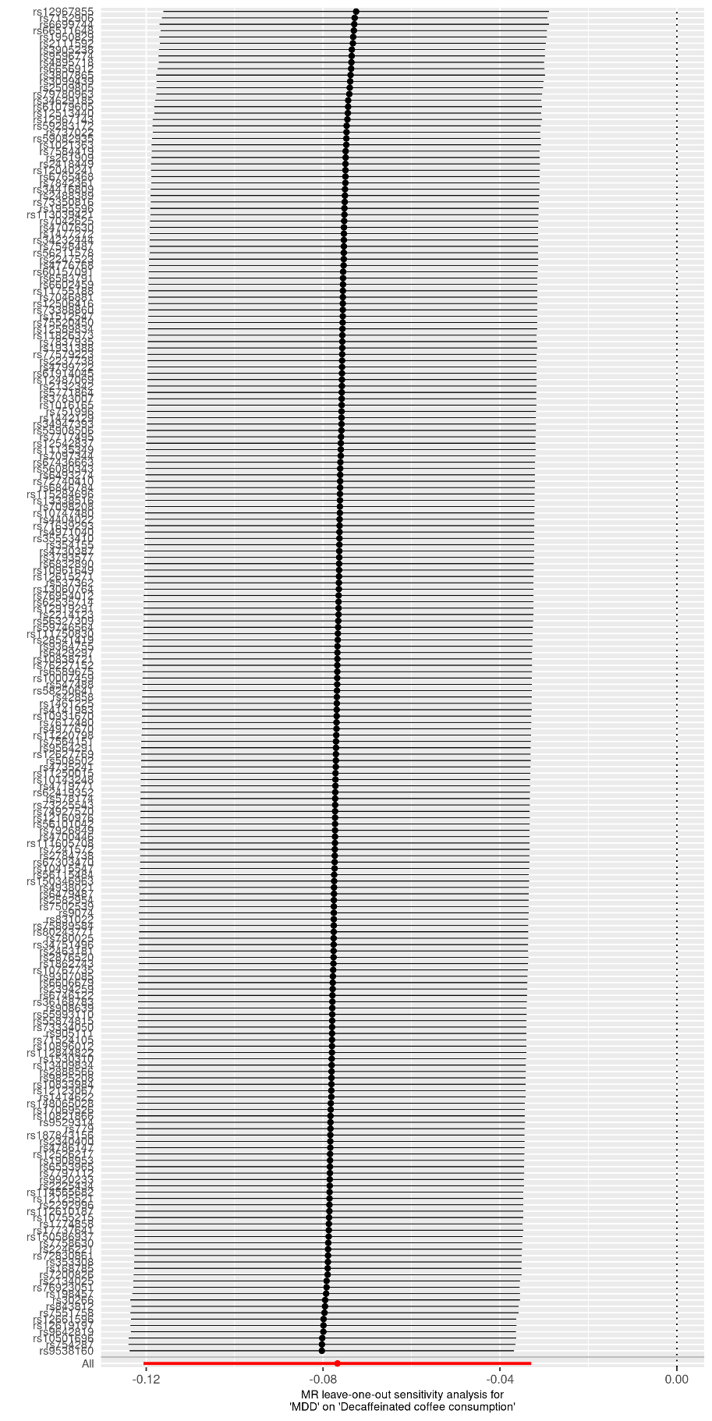

Supplementary Tables

Supplementary Table 1. Information on data sources
Supplementary Table 2. Summary of the 75 genomic loci associated with decaffeinated coffee consumption and neuropsychiatric traits in cross-trait meta-analysis
Supplementary Table 3. The bidirectional MR analysis of decaffeinated coffee consumption and neuropsychiatric traits
Supplementary Table 4. Biological process of the shared gene set between decaffeinated coffee consumption and neuropsychiatric traits in Gene Ontology (GO) terms (FDR<0.05)
Supplementary Table 5. Pathway analysis of the shared gene set between decaffeinated coffee consumption and neuropsychiatric traits in Reactome pathways (FDR<0.05)
Supplementary Table 6. List of credible set SNPs in each locus from fine mapping
Supplementary Table 7. Co-location analysis of both decaffeinated coffee consumption and neuropsychiatric traits
Supplementary Table 8. TWAS results of decaffeinated coffee consumption (FDR<0.05)
Supplementary Table 9. TWAS results of Insomnia (FDR<0.05)
Supplementary Table 10. TWAS results of Neuroticism (FDR<0.05)
Supplementary Table 11. TWAS results of LCU (FDR<0.05)
Supplementary Table 12. TWAS results of MDD (FDR<0.05)
Supplementary Table 13. TWAS results of AUDIT_T (FDR<0.05)
Supplementary Table 14. TWAS results of AUDIT_C (FDR<0.05)
Supplementary Table 15. TWAS results of AUDIT_P (FDR<0.05)
Supplementary Table 16. Specific characteristics of genetic instructions of MR analysis of decaffeinated coffee consumption upon AD
Supplementary Table 17. Specific characteristics of genetic instructions of MR analysis of decaffeinated coffee consumption upon ALS
Supplementary Table 18. Specific characteristics of genetic instructions of MR analysis of decaffeinated coffee consumption upon ADHD
Supplementary Table 19. Specific characteristics of genetic instructions of MR analysis of decaffeinated coffee consumption upon BIP
Supplementary Table 20. Specific characteristics of genetic instructions of MR analysis of decaffeinated coffee consumption upon AN
Supplementary Table 21. Specific characteristics of genetic instructions of MR analysis of decaffeinated coffee consumption upon AUDIT_T
Supplementary Table 22. Specific characteristics of genetic instructions of MR analysis of decaffeinated coffee consumption upon AUDIT_C
Supplementary Table 23. Specific characteristics of genetic instructions of MR analysis of decaffeinated coffee consumption upon AUDIT_P
Supplementary Table 24. Specific characteristics of genetic instructions of MR analysis of decaffeinated coffee consumption upon insomnia
Supplementary Table 25. Specific characteristics of genetic instructions of MR analysis of decaffeinated coffee consumption upon LCU
Supplementary Table 26. Specific characteristics of genetic instructions of MR analysis of decaffeinated coffee consumption upon MDD
Supplementary Table 27. Specific characteristics of genetic instructions of MR analysis of decaffeinated coffee consumption upon Neuroticism
Supplementary Table 28. Specific characteristics of genetic instructions of MR analysis of decaffeinated coffee consumption upon SCZ
Supplementary Table 29. Specific characteristics of genetic instructions of MR analysis of AD upon decaffeinated coffee consumption
Supplementary Table 30. Specific characteristics of genetic instructions of MR analysis of ALS upon decaffeinated coffee consumption
Supplementary Table 31. Specific characteristics of genetic instructions of MR analysis of ADHD upon decaffeinated coffee consumption
Supplementary Table 32. Specific characteristics of genetic instructions of MR analysis of BIP upon decaffeinated coffee consumption
Supplementary Table 33. Specific characteristics of genetic instructions of MR analysis of AN upon decaffeinated coffee consumption
Supplementary Table 34. Specific characteristics of genetic instructions of MR analysis of AUDIT_T upon decaffeinated coffee consumption
Supplementary Table 35. Specific characteristics of genetic instructions of MR analysis of AUDIT_C upon decaffeinated coffee consumption
Supplementary Table 36. Specific characteristics of genetic instructions of MR analysis of AUDIT_P upon decaffeinated coffee consumption
Supplementary Table 37. Specific characteristics of genetic instructions of MR analysis of insomnia upon decaffeinated coffee consumption
Supplementary Table 38. Specific characteristics of genetic instructions of MR analysis of LCU upon decaffeinated coffee consumption
Supplementary Table 39. Specific characteristics of genetic instructions of MR analysis of MDD upon decaffeinated coffee consumption
Supplementary Table 40. Specific characteristics of genetic instructions of MR analysis of Neuroticism upon decaffeinated coffee consumption
Supplementary Table 41. Specific characteristics of genetic instructions of MR analysis of SCZ upon decaffeinated coffee consumption

