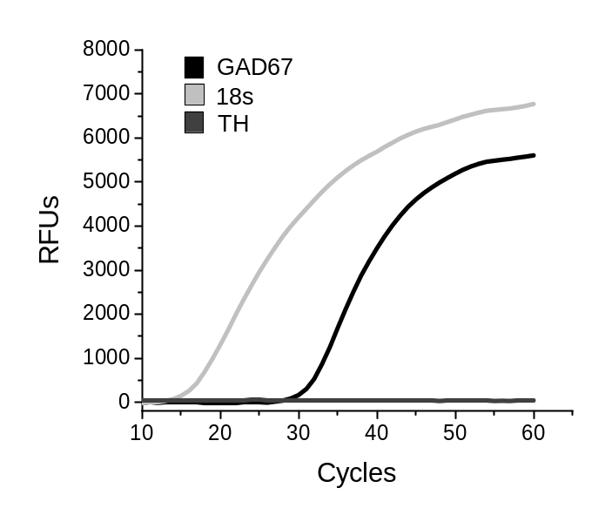
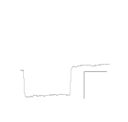
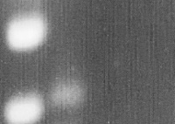
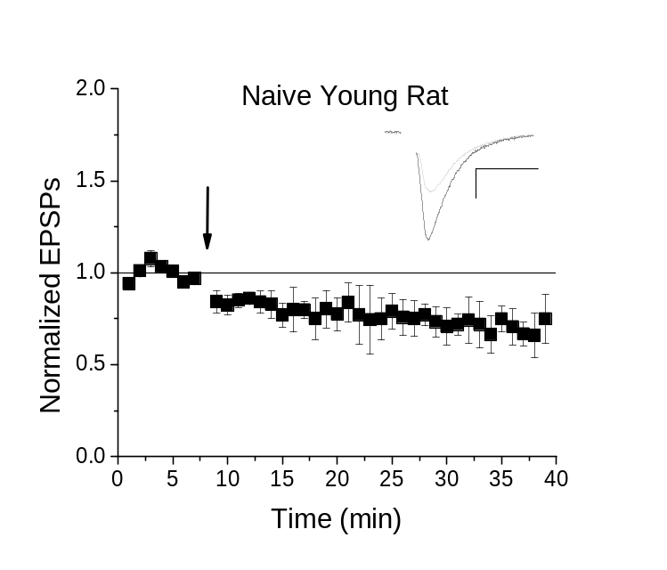
Supplemental Data
GAD67
ACSF+GAD67
TH
150bp
100bp
A
B

Supplemental Figure 1. High-frequency stimulus (HFS)-induced LTD in young rodents. A, In VTA GABA neurons of naïve young rats (P23-45) HFS stimulus induced significant LTD (24.6 ± 8.6% reduction) at 15-20 min and (30 ± 9.3%) 35-40 min post stimulus compared to baseline (n=4, p = 0.000009 and p = 0.000008). Plot is of whole-cell normalized excitatory post-synaptic currents (EPSC) amplitude means with bars indicating standard error of the mean (SEM). Arrow indicates time of HFS. Example traces representing 12-14 averaged traces before (black) and 15-20 min after (grey) conditioning or drug application. Note that all stimulation artifacts were removed from example traces. Scale bars represent 50 pA, 5 ms. B, Quantitative PCR fluorescent curve of a representative recorded rat GABAergic cell expressing GAD67, but lacking TH. 18S is the housekeeping control measure of baseline expression. Relative fluorescence units (RFU) were generated by Evagreen or probe and graphed relative to the number of PCR cycles performed. Inset top: Gel electrophoresis from a PCR reaction demonstrating single cell expression of GAD67 within a rat GABA neuron. Note the lack of TH amplicon and also the absence of GAD67 in the background control for GAD67 (ACSF+GAD67). Amplicon sizes for PCR products are TH: 108bp; GAD67: 101bp. Inset bottom: Representative hyperpolarization trace induced by -200 pA. GABA neurons do not exhibit significant I_{h} currents as noted here.
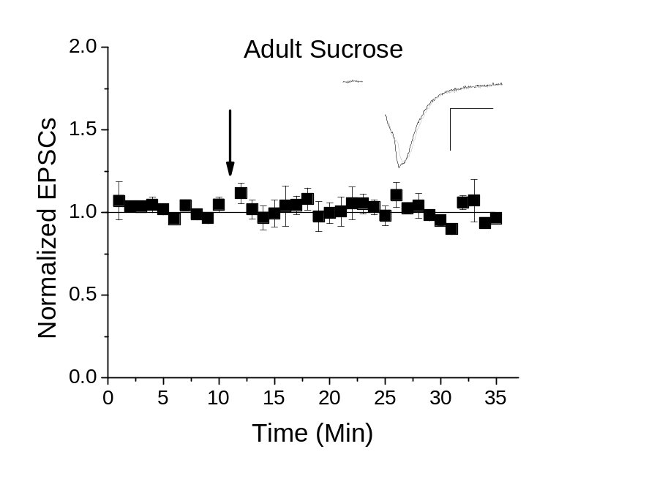
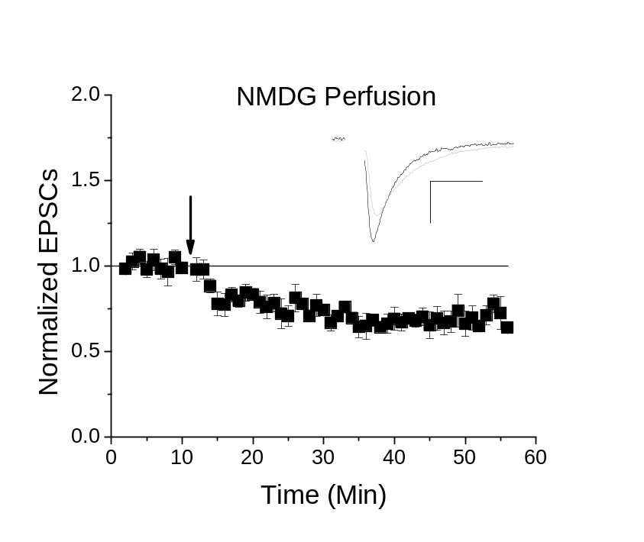
A
B

Supplemental Figure 2. NMDG cutting solution does not influence plasticity induction in adults. A. Young mice cut and perfused with NMDG cutting solution continue to exhibit the same LTD induction following HFS as seen in sucrose cutting solution (30.3 ± 6.8% LTD; n=6, p < 0.001 compared to baseline, p > 0.5 compared to Figure 1A). B. Adult mice cut in sucrose solution do not exhibit LTD following HFS, as also seen in adult NMDG cut slices (n=5, p > 0.5 compared to baseline, p > 0.5 compared to 3.

Within Experiment and Between Group Statistical Analysis Summary
Group(s) | Test | P Value | Location
Naïve Young Mice BL to Post-HFS | ANOVA | p < 0.001 | Figure 1A
Young Mice Chronic THC BL to Post-WIN55,212-2 | ANOVA | p > 0.1 | Figure 1B
Young Mice Chronic Vehicle BL to Post-WIN55,212-2 | ANOVA | p < 0.001 | Figure 1C
Young Mice 7 Days THC Withdrawal BL to Post-WIN55,212-2 | ANOVA | p < 0.001 | Figure 1D
Young Mice Chronic THC Post-WIN55,212-2 to Young Mice 7 Days THC Withdrawal Post-WIN55,212-2 | Unpaired two-way T-test | p < 0.001 | Figure 1D
Young Mice 7 Days THC Withdrawal BL to Post-HFS | ANOVA | p < 0.001 | Figure 1E
7 Days Withdrawal from Chronic Vehicle Young Mice BL to Post-HFS | ANOVA | p < 0.001 | Figure 1F
Naïve Adult Mice BL to Post-HFS | ANOVA | p > 0.1 | Figure 2A
Naïve Adult Mice BL to Post WIN55,212-2 | ANOVA | p < 0.001 | Figure 2B
Naïve Adult Mice Post-HFS to Naïve Adult Mice Post-WIN55,212-2 | Unpaired two-way T-test | p < 0.001 | Figure 2B
Naïve Adult Mice BL to Naïve Adult Mice Post-DHPG | ANOVA | p < 0.001 | Figure 2C
Naïve Adult Mice Post-HFS to Naïve Adult Mice Post-DHPG | Unpaired two-way T-test | p <0.001 | Figure 2C
Naïve Adult Mice Post-DHPG to Naïve Young Mice Post-DHPG (Previously reported) | Unpaired two-way T-test | p > 0.1 | Figure 2C & Friend 2017
Naïve Adult Mice Post-WIN55,212-2 to Naïve Young Mice Post-WIN55,212-2 (Previously reported) | Unpaired two-way T-test | p > 0.1 | Figure 2B & Friend 2017
Naïve Adult Mice BL to Naïve Adult Mice Post-2xHFS | ANOVA | p < 0.001 | Figure 2D
Naïve Adult Mice Post-HFS to Naïve Adult Mice Post-2xHFS | Unpaired two-way T-test | p < 0.001 | Figure 2D
Naïve Adult Mice BL to Naïve Adult Mice Post-2xHFS with AM251 | ANOVA | p > 0.1 | Figure 2E
Naïve Adult Mice HFS to Naïve Adult Mice Post-2xHFS with AM251 | Unpaired two-way T-test | p > 0.1 | Figure 2E/A
Adult Chronic THC BL to Post-2xHFS | ANOVA | p > 0.1 | Figure 2F
Adult Chronic THC Post-2x-HFS to Naïve Adult Post 2xHFS | Unpaired two-way T-test | p < 0.001 | Figure 2F
Naïve Adult Coefficient of Variance BL to Post-2xHFS | Wilcoxon Rank Sum | p < 0.05 | Figure 2H
Naïve Adult Coefficient of Variance BL to Post-WIN55,212-2 | Wilcoxon Rank Sum | p < 0.05 | Figure 2H
Naïve Adult Coefficient of Variance BL to Post-DHPG | Wilcoxon Rank Sum | p < 0.05 | Figure 2H
Naïve Adult Paired Pulse Ratio BL to Post-2xHFS | Wilcoxon Rank Sum | p < 0.05 | Figure 2I
Naïve Adult Paired Pulse Ratio BL to Post-WIN55,212-2 | Wilcoxon Rank Sum | p < 0.05 | Figure 2I
Naïve Adult Paired Pulse Ratio BL to Post-DHPG | Wilcoxon Rank Sum | p < 0.1 | Figure 2I
AMPA/NMDA Ratio Naïve Adult to Naïve Young | Unpaired two-way T-test | p < 0.05 | Figure 3A
AMPA/NMDA Ratio Naïve Young to Chronic THC Young | Unpaired two-way T-test | p > 0.1 | Figure 3A
-70/40 Ratio Naïve Adult to Naïve Young | Unpaired two-way T-test | p > 0.1 | Figure 3B
-70/40 Ratio Naïve Young to Chronic THC Young | Unpaired two-way T-test | p > 0.1 | Figure 3B
IV Plots Naïve Young to Naïve Adult | ANCOVA | p > 0.1 | Figure 3C
Input/Output Curves of Evoked AMPA Currents by Stimulation Intensity Naïve Young Mice to Naïve Adult Mice | ANCOVA | p > 0.1 | Figure 3D
Input/Output Curves of Evoked NMDA Currents by Stimulation Intensity Naïve Young Mice to Naïve Adult Mice | ANCOVA | p < 0.05 | Figure 3E
GluA1 Subunit mRNA Relative Expression Naïve Young Mice to Chronic THC Young Mice | ANOVA & Tukey Post-Hoc | p < 0.05 | Figure 4A
GluA1 Subunit mRNA Relative Expression Naïve Adult Mice to Naïve Young Mice | ANOVA & Tukey Post-Hoc | p < 0.001 | Figure 4A
GluA1 Subunit mRNA Relative Expression Naïve Adult Mice to Chronic Vehicle Young Mice | ANOVA & Tukey Post-Hoc | p < 0.05 | Figure 4A
GluA1 Subunit mRNA Relative Expression Naïve Adult Mice to THC Withdrawal Young Mice | ANOVA & Tukey Post-Hoc | p < 0.05 | Figure 4A
CB1 Receptor mRNA Relative Expression Naïve Young Mice to Chronic THC Young Mice | ANOVA & Tukey Post-Hoc | p < 0.05 | Figure 4B
CB1 Receptor mRNA Relative Expression Naïve Young Mice to THC Withdrawal Young Mice | ANOVA & Tukey Post-Hoc | p > 0.1 | Figure 4B
DAGLα mRNA Relative Expression Naïve Young Mice to Chronic THC Young Mice | ANOVA & Tukey Post-Hoc | p < 0.05 | Figure 4B
FAAH mRNA Relative Expression Naïve Adult Mice to Naïve Young Mice | ANOVA & Tukey Post-Hoc | P < 0.1 | Figure 4B
MAGL mRNA Relative Expression Chronic THC Young Mice to THC Withdrawal Young Mice | ANOVA & Tukey Post-Hoc | p < 0.05 | Figure 4B
HDAC3 mRNA Relative Expression Chronic THC Young Mice to THC Withdrawal Young Mice | ANOVA & Tukey Post-Hoc | p < 0.05 | Figure 4C
HDAC3 mRNA Relative Expression Naïve Adult Mice to THC Withdrawal Young Mice | ANOVA & Tukey Post-Hoc | p < 0.05 | Figure 4C

Supplemental Table 1. Statistical analysis and significance of experimental data.

