SUPPLEMENTARY METHODS
- THC treatment
Δ⁹-Tetrahydrocannabinol (THC) was purchased from THCPharm (Frankfurt, Germany) as resin, dissolved in pure ethanol (Merck) and stored at -30ºC in 0.5 mL aliquots in siliconized vials (siliconized with Sigmacote; Merck) with a nitrogen-saturated atmosphere, protected from the light. Vehicle (VEH) aliquots were treated in the same way, but no THC was added. Each day the final solution was prepared by adding to each aliquot, kolliphor (PEG-35 castor oil; Merk) and saline (0.9% NaCl solution; Vitulia, Spain), 1:1:18 proportion, to a final volume of 10 mL.
The dose of THC employed is considered mild and non-aversive but able to produce neurochemical changes in synaptic plasticity in brain regions involved in reward learning (Mato et al., 2004, 2005). Moreover, a dose of 3 mg/kg i.p. has been shown to produce peak plasma levels near those which a human user would experience after inhalation of 34 mg of marijuana (Grotehermen, 2003; Ranganathan and D’Souza, 2006; Harte-Hargrove and Dow-Edwards, 2012; Silva et al., 2016), a concentration that is not rare in clinical controlled settings (Huestis et al., 1992). In addition, the 3 mg/kg dose of THC employed here is not likely to be aversive in adolescent rats. This is concluded on the base of the experiments performed by Quinn and coworkers showing, in a place-conditioning paradigm, that while adult rats avoided a THC (5mg/kg i.p.) paired environment after either four or eight pairings, adolescent rats showed no significant place aversion (Quinn et al., 2008). The equivalency of this dose in human patterns of consumption would be similar to smoking one or two marihuana cigarettes (assuming a THC concentration of around 8%). Regarding the ethanol exposure, in both the THC and VEH solutions, the concentration in the total volume is 5%, thus animals received a dose of approximately 0.0789 gr/kg that does not induce significant behavioral effects (Frye and Breese, 1981).
- Apparatus
All the behavioral procedures (except for cocaine self-administration) were performed in Med-Associates operant boxes (29.53 L x 24.84 W x 18.67 H cm) placed inside a sound-attenuating chamber equipped with a fan, a tone generator, and a clicker. Rewards were food pellets (Noyes pellets; Test diets). The food magazine placed on one of the walls was connected to a pellet dispenser located outside the box. All conditioning boxes were equipped with two retractable levers with cue lights above them on the right and left side of the food magazine.
Cocaine self-administration was performed in Coulbourn Instruments operant boxes (30 L x 25, 4 W x 30 H cm). These boxes were equipped with two levers in one of the walls, with a LED light cue over each of them and a stainless-steel grid floor connected to a shock generator (Coulbourn) for the study of compulsivity. Every box was placed inside a sound-attenuating chamber and equipped with a pump (Harvard apparatus) outside of the chamber that delivered a programmed volume of the cocaine solution to the animal.
- Reward-related psychological alterations.
During food restriction, the weight gain associated to the normal development of these animals without dietary restrictions was taken as the reference for the calculation of the food regime and the weight range in which they had to be maintained. Animals received their daily food after the experimental sessions.
  - Experiment 1.
    - Pavlovian conditioned approach (PCA).
The PCA protocol, session set-up and PCA index calculation were implemented according to previous literature (Fitzpatrick and Morrow, 2016).
At approximately postnatal day (PND) 90, animals were food-restricted, and their weight kept between 90-95% of the original in the free-feeding state. Two days later, after reaching the desired body weight, animals underwent a single magazine training session. During this session the feeder dispensed 25 food pellets, under a variable interval of 90 s program.
During PCA sessions the interaction with the conditioned stimulus (CS)⁺ lever (CS⁺ LPs), presses in the inactive lever in between each CS⁺ (ILPs) or during the CS⁺ (CS⁺ ILPs), Head Entries (HE) in between each CS⁺ presentation and during the CS⁺ (CS⁺ HE) were recorded.
The main PCA index was calculated each day as the mean of three other indexes:
- Response bias, i.e., ratio of the total number of LP and HE for a session during the CS+ presentations: (CS⁺LPs - CS⁺HEs) / (CS⁺ LPs + CS⁺HEs)
- Latency score, i.e., average latency to perform a LP or HE during the 8 s of CS+ presentation: (Mean HEs latency - Mean LP latency)/8
- Probability difference, i.e., the probability of performing a HE during the CS⁺ presentations minus the probability of performing a LP during the CS⁺ presentation: P(LP) - P(HE)
Every index score ranged from 1 (absolute sign-tracking) to -1 (absolute goal-tracking). Animals with a PCA score higher than 0.5 were classified as sign-trackers, whereas animals with a PCA lower than -0.5 were categorized as goal-trackers. Scores from 0.5 to -0.5 are considered an intermediate phenotype with no clear preference bias.
    - Habit formation studies:
Ten days after the final PCA session animals began the habit training protocol. The rats performed a brief, in principle non-habit-forming, training, and an extended training scheme (supposed to induce habit-like responding). The brief training consisted of 5 consecutive daily sessions: one fixed ratio -FR- 1 session, two variable-interval (VI) 30 s sessions and two VI 60 s sessions. Every session was implemented with a single lever protracted inside the operant box and limited to 30 pellets. After the training sessions, we subjected the animals to two counterbalanced, sensory-specific satiety-based, devaluation tests. In these tests, the rats were allowed to eat pellets or chow food freely for one hour before undergoing an extinction test. This test was a brief extinction session of 5 minutes with two levers present, the one presented during training and a new one. This allowed us to discriminate reinforcer seeking from locomotor activity. Both levers had no programmed consequences. On the day after the first test, the animals were retrained under a regular VI60 session and, on the next day, another devaluation session was carried out with the other type of food (pellets or regular chow). For extended training, animals performed another 10 sessions (VI60) and then animals underwent the same counterbalanced devaluation tests as described before. Male VEH n=10; Male THC n=10; Female VEH n=10; Female THC n=10
Due to the higher rate of LP in the THC-female group compared to all other groups we calculated a non-biased Habit Formation Index, in addition to the raw number of LP, applying the following formula: LP_{Devalued} /(LP_{Devalued}+LP_{NonDevalued})
After the short and long training devaluation testing sessions, animals were retrained on a VI60s session and performed an omission test to assess their performance during contingency degradation. During this session, the omission of the response was rewarded but every LP reset the clock that delivered the reward every 30 s.
  - Experiment 2.
    - Pavlovian to Instrumental Transfer (PIT):
Before starting each behavioral protocol (at around PND 90), animals followed the same food restriction regime as the one described above. The PIT protocol was designed considering the factors that modulate the expression of the PIT phenomenon (Holmes et al., 2010) and based on preliminary tests conducted in our laboratory. The PIT protocol consisted of four consecutive phases:
(1) Pavlovian training: 10 sessions of 4 cycles composed of a) 2 minutes under a variable interval of 30 s (VI30) schedule of reinforcement where they were exposed to a reward-associated conditioned stimulus (clicker or homeobox light, counterbalanced) or CS⁺; b) 1-minute trials without conditioned stimulus (No Stimuli Interval or NSI), where no stimuli or programmed contingencies were administered; and c) a 2-minute trial where the animals were exposed to a non-rewarded stimulus or CS⁻ (tone or clicker, counterbalanced). This is summarized as follows:
[NSI → CS^{+/-} → NSI → CS^{-/+}] * 4times
During the Pavlovian training sessions of the PIT protocol, the number of head entries (HE) into the magazine under each stimulus condition was recorded, and a CS⁺ HE ratio was calculated as (CS⁺ HEs) / (CS⁺HEs + CS⁻ HEs)
(2) Instrumental training: 1 session under FR1, three sessions under variable-ratio -VR- 5 and three sessions under VR10. Sessions began with the insertion of the active lever, associated with the reinforcer schedule, and the inactive lever, which had no programmed consequences. All sessions were limited to 30 pellets. During the instrumental training sessions, lever presses performed on the active lever (ALP), active lever presses during time out (TOALP), inactive lever presses (ILP) and HE were recorded. To study the discrimination between the rewarded and the unrewarded lever, an ALP ratio was calculated as (ALPs) / (ALPs + ILPs)
(3) Extinction: Two daily sessions of 20 minutes with levers protracted but no programmed consequences. On extinction sessions, HE and lever presses performed on the former active or inactive levers were recorded. The total LP (ALP+ILP) was calculated.
(4) PIT test: One single session that began with a third extinction period of 20 minutes then 4 cycles composed CS or NSI presentations (counterbalanced) lasting two minutes, as indicated below:
[NSI → CS^{+/-} → NSI → CS^{-/+}] * 4times
In the PIT test, HE and lever presses on former active or inactive levers under the different stimulus conditions were registered. The Pavlovian to instrumental transfer phenomenon was calculated using the percentage of ALP on CS+: [(CS⁺ALPs) / (CS⁺ALPs+ CS─ALPs)] *100
We also studied the simple Pavlovian approach in contrast to the instrumental transfer, for this purpose, we calculated the percentage of HEs on CS+: [(CS⁺HE) / (CS⁺+ CS─HE)] *100.
The main PIT index considered was the percentage of ALP in CS⁺ time (%CS⁺ALPs). A %CS⁺ALPs between 50 and 75% was considered intermediate PIT, over 75% high PIT. Subjects were not considered to express PIT when the %CS⁺ALPs was less than 50%.
    - Two-choice serial reaction time task (2-CSRTT):
Ten days after the end of the PIT animals were again food-restricted and the two-choice serial reaction time task (2-CSRTT) protocol (modified from the one published by Bari and Robins (2008)) began.
Twelve phases with increasing demands were implemented. In each phase, the duration of a light stimulus over a lever that signaled the availability of a pellet was progressively shortened (phase 1: 30 s – phase 12: 0.5 s). Also, the response time that the rats had to press the lever in order to obtain the reward was progressively shortened (phase 1: 30 s – phase 12: 5 s). The Inter-trial-interval (ITI) time also increased across sessions (phase 1: 2 s – phase 12: 5 s). Rats progressed to the next phase if they managed to perform at least 80% of correct lever presses (CLP), i.e., press the lever closer to the light stimulus. Further lever presses after a CLP during the response time were registered as perseverative responses (PerR), while responses in any of the levers during ITI were counted as premature responses (PreR). PreR and lever presses in the non-signaled lever, namely incorrect lever presses (ILP), or failure to respond in a trial (Omission Response-OR) were punished with a time out (TO) of 5 s. During this TO, responses were considered as time-out responses (TOR) and caused the TO period to be initiated. Each session had 100 trials. Animals quickly learned to avoid responses before cues were present in order to obtain a new pellet. Once phase 12 was reached, 6 more consecutive sessions with the same requirements (but 75% of correct responses required) were implemented to serve as a baseline (BL).
Additionally to the raw PreR, we calculated the percentage of PreR in each BL session and test session as follows: [PreR/(PreR+CLP+ILP+OR)]*100. The percentage of increase was calculated as: [(PreRTest-PreRBaseline)/PreRTest]*100. The baseline sessions computed were the two immediately preceding baseline sessions to each long-ITI test.
  - Experiment 3: Transcriptomic studies.
At PND 90, animals were deeply anaesthetized with isoflurane and sacrificed by decapitation. Brains were extracted and, with the help of a brain matrix, 1 mm thick coronal slices were obtained between 2.28 mm and 1.08 mm, approximately, anterior from bregma. With the help of two dissecting lancet-shaped needles, the nucleus accumbens (NAcc) shell division was dissected according to the Paxinos and Watson atlas (Paxinos and Watson, 2007). All the surfaces and tools used for dissection were sterilized and treated with RNAseZap® (Ambion), and all the steps were carried out with caution to maintain RNA integrity. The tissue samples were snap-frozen with dry ice and stored at -70ºC. Samples were homogenized, and RNA extracted according to the protocol, tools and reagents provided by RNeasy Mini Kit (Qiagen). Libraries were prepared according to the instructions of the NEBNext Ultra Directional RNA Library Prep kit for Illumina kit (New England Biolabs), as detailed in “Chapter 1: Protocol for use with NEBNext Poly(A) mRNA Magnetic Isolation Module”. The input yield of total RNA to start the protocol was 1 µg quantified by an Agilent 2100 Bioanalyzer using an RNA 6000 nano LabChip kit. We performed the library amplification included in the cited protocol using a PCR of 14 cycles. The obtained libraries were validated and quantified by an Agilent 2100 Bioanalyzer using a DNA7500 LabChip kit and an equimolecular pool of libraries were titrated by quantitative PCR using the “Kapa-SYBR FAST qPCR kit forLightCycler480” (Kapa BioSystems) and a reference standard for quantification. The pool of libraries was denatured prior to being seeded on a flow-cell at a density of 2.2 pM, where clusters were formed and sequenced using a “NextSeq™ 500 High Output Kit”, in a 1x75 single read sequencing run on a NextSeq500 sequencer.
We used the Chipster analysis suite (Kallio et al., 2011) to perform data processing and analysis. Briefly, data quality analysis of the obtained raw data (singleEnd, stranded) was performed on FASTQC and PRINSEQ; no low-quality bases, or very few, were detected at the end of the reads. Reads were aligned to reference genome Rattus_norvergicus. Rnor_6.0.87 using TOPHAPT and the alignment of the counts per read was performed using HTSeq. Differential gene expression analysis was performed using CUFFDIFF with replicates analysis to explore the differences in transcriptomic profiles between factor levels. All RNA-seq data sets generated and/or analyzed during the current study were added to the Gene Expression Omnibus (GEO) under the accession number GSE158188.
  - Experiment 4: Cocaine-addiction like behavior
On PND 90, animals underwent a single food-reinforced FR1 instrumental training session limited to 10 reinforcers in Med-Associates operant boxes. After this, an intravenous polyvinylchloride tubing (0.064 mm i.d.) catheter was implanted into the right jugular vein at approximately the level of the atrium and passed subcutaneously to exit the mid scapular region (Higuera-Matas et al., 2008). Surgical procedures were performed under isoflurane gas anesthesia (5% for induction and 2% for maintenance) and buprenorphine analgesia (0.05 mg/kg s.c. Buprex, Indivior, U.K.). After surgery, the rats were allowed to recover for 8-10 days and a nonsteroidal anti-inflammatory drug (meloxicam - Metacam™: 15 drops of a 1.5 g/ml solution per 500 ml of water) was added to the drinking water during the first four days of recovery. Until the end of the self-administration procedure, the catheters were flushed daily with a sterile saline solution containing sodium heparin (100 IU/ml) and gentamicin (1 mg/ml) to maintain catheter patency and prevent infections.
The cocaine self-administration (CSA) protocol was carried out in Coulbourn boxes (thus providing a different context to the one where the initial instrumental training took place). An active lever (AL) with different programmed contingencies and an inactive lever (IL) that always remained without programmed contingencies remained protracted during all the sessions. Over the AL there was a cue light that was turned on at the beginning of the session and turned off for 10 s (time out) at the beginning of an infusion (that lasted for 7 s), thus indicating cocaine availability. Cocaine (Alcaliber, Spain) infusions (0.5 mg/kg in 100 µL of sterile saline solution) were administered by an electronic pump (Harvard Apparatus, USA). Lever presses during time out (TOLP) did not have any programmed contingencies. The protocol consisted of 6 consecutive phases: (1) acquisition:12 daily sessions lasting 2 hours each under an FR1 schedule. (2) motivation for consumption: 6 sessions of 2 hours under a progressive ratio (PR) schedule(Sánchez-Cardoso et al., 2007); (3) reacquisition: 3 sessions of 2 hours under FR1. (4) compulsive (punished) seeking: a single 1-hour session under an FR3 schedule in which the animal randomly received an infusion or a 0.5 mA plant shock for 0.5 s. (5) extended access: 10 sessions of 6 hours each under FR1. (6) cue-induced relapse: 4 sessions of 1 hour each with cues as in the acquisition sessions but without drug delivery, occurring after 1, 30, 60 and 100 days of forced abstinence.
In the acquisition, reacquisition and extended access phases, the main measurements were AL presses (ALP), TOLP, and IL presses (ILP). During PR sessions we also registered the breaking point. The number of ALP required to achieve an infusion followed the order: 1, 2, 4, 9, 12, 15, 20, 25, 32, 40, 50, 62, 77, 95, 118, 145, 178, 219, 328, 402, 492, 603, 737, 901, 1102, 1347, 1647, 2012. After PR sessions animals underwent three re-baseline sessions and we calculated the rebound of cocaine intake as follows: [ (Mean Infusions (10-12th) Acquisition Sessions) / (Mean Infusions Re-baseline sessions) *100]. Additionally, we calculated an unbiased index to assess the impact of punished intake as follows: [ (infusions + shocks) / (Infusions in 1st hour of last re-baseline session) *100]
SUPPLEMENTARY RESULTS
Bodyweight
As expected, females had lower body weight than males at the beginning of the ACE (F_{1,297}=14.686; p<0.000; η_{p}²=0.05; see Figure S1A). After the chronic treatment, THC-exposed rats (irrespective of the sex) had a marginally lower body weight than VEH-exposed controls (F_{1,299}=20.162; p<0.000; η_{p}²=0.06). The THC effect on body weight was still significant on PND90 (F_{1,341}=8.344; p=0.004; η_{p}²=0.02) (see Figure S1B). The increment in bodyweight was lower during treatment (F_{1,296}=451.228; p<0.000; η_{p}²=0.6) and after the treatment in females as compared to males (F_{1,294}=362.205; p<0.000; η_{p}²=0.51) and in THC-exposed animals as compared to VEH controls during the THC treatment (F_{1,296}=22.585; p<0.000; η_{p}²=0.07), but not from PND44 to PND90 (see Figure S1C-F).
Pavlovian Conditioned Approach
The effect observed in the last training session cannot be attributed to differences in the amount of CS⁺ LPs, ILPs, HE, CS⁺HE or MAG and CS⁺MAG during the session because no Treatment effects were observed in any of these measurements. Instead, it was mainly due to the effects of THC on the main variables that constitute the PCA index. Indeed, there was a significant ACE effect in probability difference (F_{1,36}=7.397; p=0.010; η_{p}²=0.17) and latency score (F_{1,36}=4.408; p=0.043; η_{p}²=0.11), although the response bias did not reach the statistical significance level (F_{1,36}=3.058; p=0.089; η_{p}²=0.08). This effect was also significant across the training sessions, but the components of the PCA index did not show any ACE or Sex effect in the repeated measures analysis.
Habit Formation
There were no differences in the Habit Formation Index due to Sex or ACE. The first outcome devaluation testing rendered habit formation index values under 0.5 (thus reflecting less LP_{Devalued} compared to LP_{Non-Devalued}), with a homogenous distribution among the animals from all the four groups. After the extended (habit-forming) training, we found more Habit Formation Index scores around and above the 0.5 threshold (See figure S2A), thus indicating a blunted devaluation in some individuals. However, there were also no differences due to Sex or ACE in the Habit Formation Index after the extended training.
The analysis of the HE found no significant effects during the short training and the following outcome devaluation tests. We did find a Sex x ACE x Sessions interaction on HEs across the extended training sessions. The simple effect analysis showed that there were fewer HEs performed by THC-exposed females compared to THC-exposed males (F_{3.91,70.43}=3.925; p=0.007; η_{p}²=0.18).
None of the contingency degradation tests (after short and extended training) showed treatment-related differences on lever pressing (See figure S2 B). However, the time spent to obtain the limit of 30 rewards during the contingency degradation tests was higher on female groups compared to male groups (F_{1,35}=0.10; p=0.057; η_{p}²=0.10), being Mean±SEM minutes spent and group n: VEH-Males: 29.80±0.998 | n=10; THC-males: 32.9±3.44 | n=10; VEH-females: 40.89±6.147 | n=9; THC-females: 35.90±2.373 | n=10.
Pavlovian-to-Instrumental Transfer
Across Pavlovian training sessions, the CS⁺HEs ratio showed a significant Sex x ACE interaction (F_{4.9,202.8}=2.375; p=0.041; η_{p}²=0.06), but there were no significant simple effects. All groups progressively increased their bias to perform more HEs during CS⁺ than during CS⁻ (F_{4.9,202.8}=11.33; p=0.000; η_{p}²=0.22) and finished the Pavlovian training with ratios over 0.7 (see Figure S3A).
Across the time course of the instrumental training sessions, animals rapidly learned instrumental contingencies associated with both levers (F_{6,252}=6153; p=0.000; η_{p}²=0.99). The ALP ratio at the end of the training was over 0.8 (see Figure S3B).
There was a decrease in the number of ALP across the extinction sessions (F_{2,84}=226.2; p=0.000; η_{p}²=0.84) without significant factor effects. The repeated measures ANOVA showed a Sex x ACE interaction on ILPs (F_{1.63,68.6}=6.110; p=0.006; η_{p}²=0.13), however, neither of the simple effects reached statistical significance.
During the PIT testing session %CS⁺ALP only showed significant Treatment effects when animals that did not express PIT (%CS⁺ALP>50%) were excluded from the analysis. The global effect of THC and the Sex x ACE interaction seemingly resulted from lower CS⁻ALPs in the group of THC-exposed males without differences in the rate of CS⁺ALPs as a result of THC (see Figure S3C, D and E). The CS⁺HE ratio also showed a significant Sex x ACE interaction resulting from the increased ratio in THC females, as compared to the VEH-treated females (see Figure S3F, G, H).
2-Choice Serial Reaction Time Task
The number of training sessions necessary to achieve the baseline phase showed a trend of ACE to have a significant effect (0.055), suggesting that THC-exposed animals required fewer training sessions to reach this phase (F_{1,44}=3.888; p=0.055; η_{p}²=0.08; See Figure S4 A).
During the six baseline sessions, before long ITI sessions, there was a lower CR rate in THC animals (F_{5,220}=3.975; p=0.002; η_{p}²=0.08); IR showed a specular trend, that is, an increased IR in THC-treated animals (F_{5,190.6}=2.120; p=0.064; η_{p}²=0.05). This effect was no longer evident on the last day of training and was absent during the testing phase. There were no differences in OR, PerR, TOR and HE between groups during baseline or testing phases. See Table S1.
Correct responses
Omissions
Incorrect responses
Perseverative responses
Male VEH |  |  |  |  | Male THC |  |  |  |  | Female VEH |  |  |  |  | Female THC
Mean |  | SEM |  | N | Mean |  | SEM |  | N | Mean |  | SEM |  | N | Mean |  | SEM |  | N
87,28 | 0,324 |  | 12 |  | 86,167 | 0,324 |  | 12 |  | 87,764 | 0,324 |  | 12 |  | 87,875 | 0,324 |  | 12
6,042 | 0,243 |  | 12 |  | 4,694 | 0,243 |  | 12 |  | 5,292 | 0,243 |  | 12 |  | 4,986 | 0,243 |  | 12
6,681 | 0,359 |  | 12 |  | 9,139 | 0,359 |  | 12 |  | 6,944 | 0,359 |  | 12 |  | 7,139 | 0,359 |  | 12
1,528 | 0,106 |  | 12 |  | 1,319 | 0,106 |  | 12 |  | 1,833 | 0,106 |  | 12 |  | 1,264 | 0,106 |  | 12

Table S1. Attention-related measures averaged over the 6 baseline sessions in the 2-CSRTT
The results obtained in the analysis of the %PreR showed a Sessions x Sex x ACE interaction on the Long-ITI testing sessions, due to the higher %PreR of Males-VEH compared to Males-THC (F_{2,44}=6.738; p=0.003; η_{p}²=0.23), and Females-VEH (F_{2,44}=7.042; p=0.002; η_{p}²=0.24). The individual analysis of the first session a Treatment effect in the males (F_{1,44}=7.790; p=0.008; η_{p}²=0. 0.15) and a Sex effect in VEH-treated animals (F_{1,44}=5.804; p=0.020; η_{p}²=0.12). There were no significant effects in the second and third Long-ITI Sessions (Figure S4 B). In spite of these findings, upon a close inspection, there was some drift in performance, especially in the females and a sudden increase in the last session in VEH-exposed females and a decrease in the THC-treated female rats which again, led us to compute the percentage of increment against baseline performance.
Cocaine self-administration.
We found a reliable acquisition of CSA and lever discrimination (Session x Lever interaction: F_{4.08,175.39}=7.259; p>0.000; η_{p}²=0.14). We did not observe ACE or Sex significant effects in the breaking point during the PR sessions (F_{2.77,80.28}=4.763; p=0.005; η_{p}²=0.14), or in the first PR alone (although, the number infusions earned in this first session showed a Sex x ACE interaction (F_{1,28}=4.708; p=0.039; η_{p}²=0.144), whereby VEH-females earned more infusions than VEH-males (F_{1, 28}=4.268; p=0.048; η_{p}²=0.132)). We then returned rats to continuous drug access (FR1) for three days. The number of cocaine infusions progressively increased over these sessions (F_{2,62}=4.835; p=0.011; η_{p}²=0.13) but there were no differences related to Sex or ACE (Figure S5 A). There were no differences in the cocaine infusions earned or in the compulsivity index obtained during the compulsivity test. Almost all animals reduced their intake below 50% but there were no differences among groups (See Figure S5 B and C). A significant increase was obtained during the extended access sessions (F_{1,20}=4.349; p=0.05; η_{p}²=0.179) with no differences between groups (Figure S5 D).
SUPPLEMENTARY DISCUSSION
Relevance of some the RNAseq transcriptional signatures obtained for schizophrenia-spectrum disorders
Given the comorbidity of substance use disorders and schizophrenia (Khokhar et al., 2018) and the suggested association between heavy cannabis use and this disorder (Radhakrishnan et al., 2014) we will highlight the potential involvement of some of the differentially expressed genes found in this psychopathology.
We found several gene expression alterations suggestive of synaptic pathology that could be related to schizophrenia. First, with regard to glutamatergic synaptic transmission, the glial glutamate transporter EAAT2, encoded by the Slc1a2 gene (down-regulated in the males with ACE) has been widely implicated in schizophrenia-spectrum disorders (Fiorentino et al., 2015; Zhang et al., 2015; Ortega-Alonso et al., 2017; Merk et al., 2019; Parkin et al., 2020). In addition, another glutamate transporter, the vesicular glutamate transporter 2, encoded by the Slc17a6 gene (up-regulated in both male and females with ACE), was found to be increased in NAcc post-mortem samples of people with a diagnosis of schizophrenia (McCollum and Roberts, 2015; Roberts et al., 2020) although other studies found no changes (Oni-Orisan et al., 2008). Interestingly, among the females, we observed a down-regulation of another vesicular glutamate transporter, the VGlut1, encoded by the Slc17a7 gene, which has also been proposed to play a role in schizophrenia (Nudmamud-Thanoi et al., 2007). The Grin2d gene, coding for the NMDA glutamate ionotropic receptor 2D subunit (up-regulated in females with ACE) is another glutamate-related gene that has been related to schizophrenia in some studies (Makino et al., 2005) although there have also been reports where no associations were detected (Demontis et al., 2011; Tarabeux et al., 2011).
Other genes related to synaptic physiology that were altered as a consequence of ACE were the chloride-potassium exchanger Slc12a5 gene (down-regulated in the males with ACE) has some transcriptomic variants associated to schizophrenia (Tao et al., 2012). In addition, the regulator of G protein signalling 2 (Rgs2) gene (down-regulated in the females with ACE) has been associated to several psychopathological disorders such as generalized anxiety disorders (Smoller et al., 2008; Lifschytz et al., 2012) and an haplotype of the RGS2 gene has been associated to schizophrenia (Campbell et al., 2008).
With regard to the dopaminergic system, an important gene stands out. The Nuclear Receptor Subfamily 4 Group A Member 2 (Nr4a2 gene, also known as Nurr1, up-regulated in the males after ACE) is a transcription factor that regulates the development of dopamine neurons (Jankovic et al., 2005). Mutations in this gene have been associated with some of the features present in schizophrenia (Ancín et al., 2013; Torretta et al., 2020) although other studies have failed to find significant associations (Liu et al., 2015)
There are two last examples that we would like to highlight given the sex-specific regulation in their expression that we have observed after ACE.
First, the Cck gene (up-regulated in the males, down-regulated in the females with ACE), coding for cholecystokinin is relevant considering the fact that Cck expression alterations have been reported in the brain of patients with schizophrenia (Loonam et al., 2003) and the possible association of a cholecystokinin promoter variant to schizophrenia (Wang et al., 2002).
Second, teneurin transmembrane protein 4 (Tenm4, down-regulated in the males, up-regulated in the females with ACE) is involved in neural development, regulating the establishment of proper connectivity within the nervous system (Tucker and Chiquet-Ehrismann, 2006) and is also a candidate gene for schizophrenia (Xue et al., 2019).
Of note, the divergent regulation of these last two genes in males and females may suggest vulnerability vs. resilience phenotypes in each sex, an important question that should be further explored in future studies.
We have highlighted here some differentially expressed genes that could be involved in a potential susceptibility or resilience (depending on the direction of the changes) to schizophrenia in an important region for this disorder such as the NAcc. Importantly, further studies in animal models and human samples should validate these results. In any case, we believe that these data open new avenues for research that should be exploited in the future and underscore the importance of including both male and female subjects in the studies as the results obtained may be completely different as a function of the sex of the individual.

SUPPLEMENTARY FIGURES
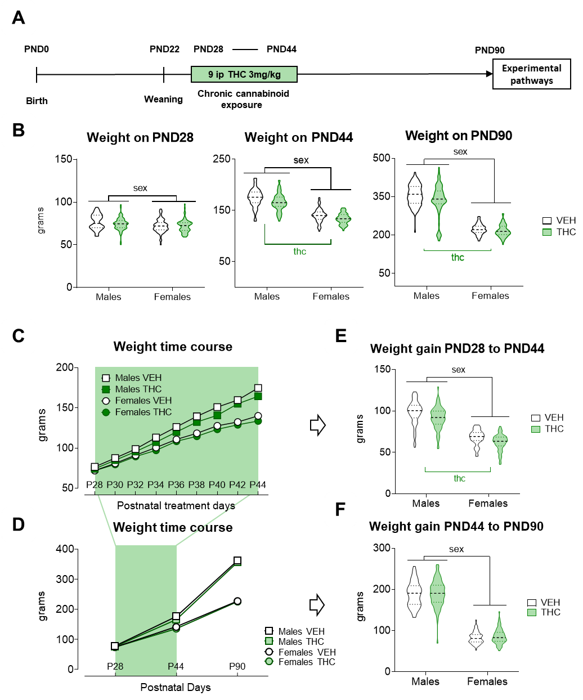Figure S1. Bodyweight evolution. A) Bodyweight in three different time points. Only the expected sex differences were present in first treatment day (PND28) (F_{1,297}=14.686; p<0.000; η_{p}²=0.04) indicating no prior weight bias due to ACE factor. Nonetheless the mean bodyweight was lower THC groups at the end of the treatment (PND44) (F_{1,299}=20.162; p<0.000; η_{p}²=0.06) and at adulthood (PND90) (F_{1,341}=14.686; p=0.004; η_{p}²=0.02) B) Bodyweight time course across chronic treatment and C) Bodyweight time course in the three experimental points selected. D) Net bodyweight gain during treatment (PND44 Weight - PND28 Weight) and E) Net body weight gain during the washout period (Bodyweight on PND90– Bodyweight on PND44). The bodyweight gain during the THC treatment was slightly lower in the groups of THC-treated animals (F_{1.296}=22.585; p<0.000; η_{p}²=0.07). However, only a significant Sex effect (male>female) was found in weight gain during the washout period (F_{1,294}=362.205; p<0.000; η_{p}²=0.51). The data are expressed as the mean±SEM values in addition to individual values in grouped data. Significant effects of the Sex factor are represented by “sex”, ACE effects are represented by “thc”.
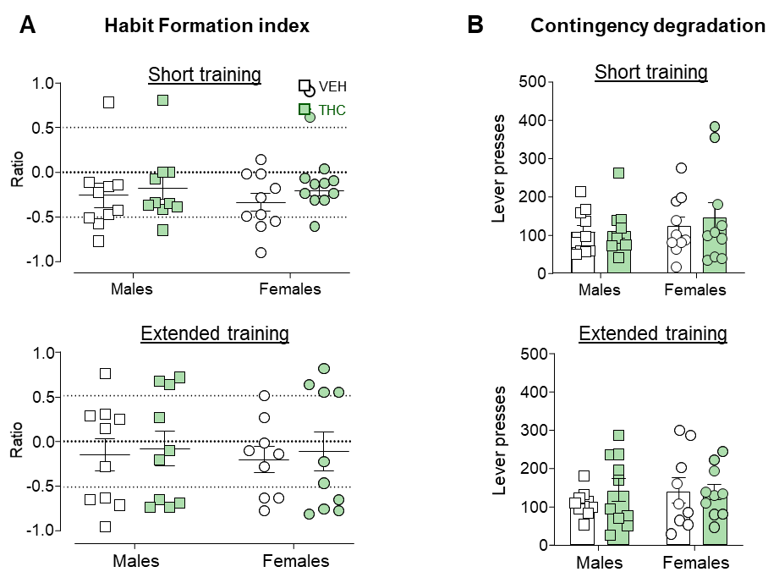
Figure S2. Habit Formation. A) Devaluation index obtained in the outcome devaluation tests. B) Lever presses in the contingency degradation tests. The graphs represent individual values and mean±SEM.
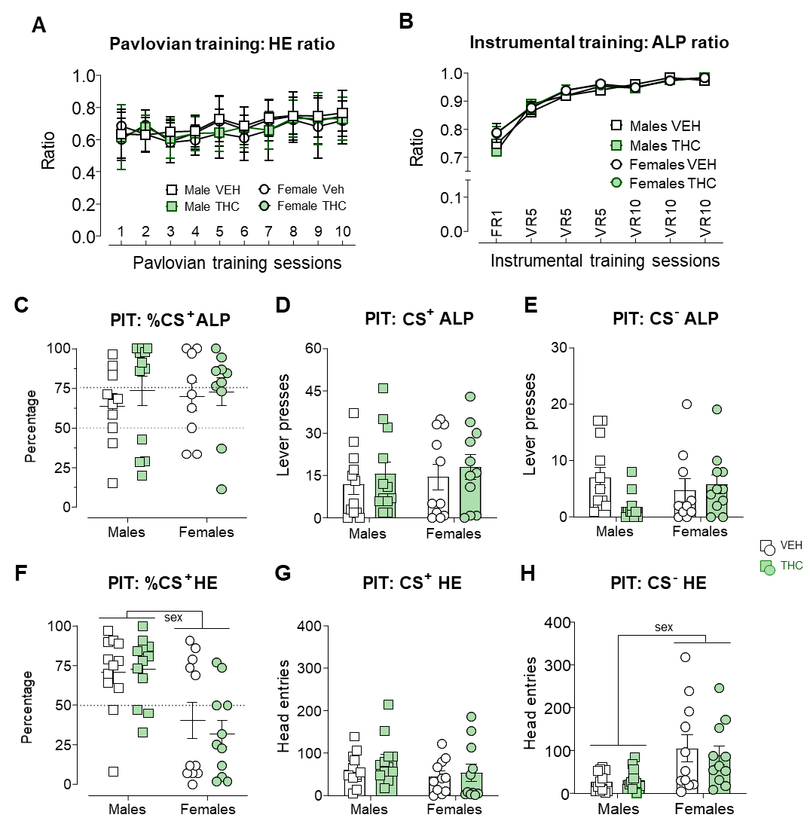
Figure S3: Pavlovian to Instrumental Transfer (PIT) supplementary figures. A) Head entries (HEs) ratio across Pavlovian training sessions. Males and females are plotted separately for the sake of visual clarity. There was a general increase in the amount of HEs during CS⁺ across the sessions (F_{5.7,341.6}=9.657; p=0.000; η_{p}²=0.14). Also, there was a Sex x ACE interaction (F_{5.7,341.6} =2.338; p=0.033; η_{p}²=0.03), but no differences were detected in the analysis of the simple effects. B) Active to inactive Lever Press ratio across training sessions. Males and females plotted separately for the sake of visual clarity. There was a general increase in the discrimination and preference for the AL over the IL across the sessions (F_{2.09,396}=136.664; p=0.000; η_{p}²=0.67). C) Percentage of lever presses during the CS⁺ in the transference test. No differences between groups were detected including animals that did not express PIT (F_{3,43}=1.031; p=0.389; η_{p}²=0.07). D) Total Lever Presses during the CS⁺ in the transference test. No differences between groups were detected (F_{3,42}=0.385; p=0.764; η_{p}²=0.02). E) Total Lever Presses during the CS⁻ in the transference test. F) Percentage of HEs during the CS⁺ in the transference test. Females made relatively fewer HEs during the CS⁺ as compared to the CS⁻ than males (F_{1,45}=18.095; p=0.000; η_{p}²=0.301). The mean percentage of HEs during the CS+ was clearly above 50% in the males, thus indicating clear conditioning of the CS+ while in the females, this value was below 50%. G) Total HEs during the CS+ in the transference test. No differences between groups were detected (F_{3,42} =1.085; p=0.366; η_{p}²=0.07). H) Total head entries during the CS- in the transference test. Females made more HEs during the CS- presentations than the males (F_{1,42}=12.460; p=0.001; η_{p}²=0.22). The data are expressed as the mean±SEM values in addition to individual values in grouped data. Significant effects of factor Sex are represented by “sex”.
Figure S4: 2-Choice Serial Reaction Time Task supplementary figure. A) Number of training days required to reach the baseline sessions. THC animals showed a trend (F_{1,44}=3.888; p=0.055; η_{p}²=0.08) to require fewer days to reach baseline sessions than VEH rats. No significant effect of Sex was detected (F_{1,44}=2.949; p=0.093; η_{p}²=0.06). B) Percentage of premature responses in the final experimental stages. This includes the six baseline sessions, the three long-ITI tests and the re-baseline sessions between them. In the first long-ITI test, a Sex x ACE interaction (F_{1,44}=7.483; p=0.009; η_{p}²=0.14) and further simple effects analysis showed an effect of Sex due to an increase in PreR in females VEH compared to males VEH (F_{1,44}=7.630; p=0.008; η_{p}²=0.14) and a decrease in PreR in Male rats exposed to THC compared to males exposed to VEH (F_{1,44}=5.740; p=0.021; η_{p}²=0.11). Significant effects of ACE in the males (after a significant Sex x ACE interaction) are represented by “thc m”.
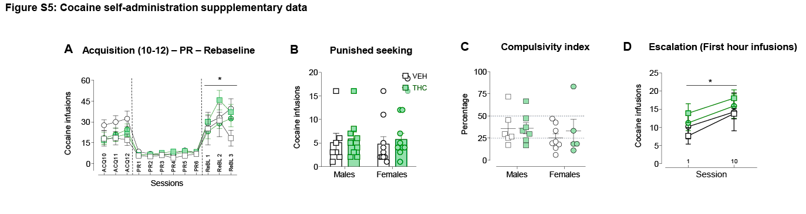
Figure S5: Cocaine self-administration supplementary figure. A) Cocaine infusions depicted from the last three acquisition sessions to the re-baseline phase. After rebaseline sessions animals underwent the punished seeking test. B) Cocaine infusions earned during the compulsivity test. No group differences emerged in this phase. C) Compulsivity index. All groups reduced similarly their intake compared to the first hour of the previous re-baseline session (>50%). D) Escalation of drug consumption. Cocaine infusions earned during the first hour of the first and last extended access sessions. All groups increase escalate their intake similarly (F_{1,20}=4.349; p=0.05; η_{p}²=0.179). Graphs represent Mean±SEM and individual values in discrete session graphs (B and C). Significant effects of ACE are represented by “thc”, Sex by “sex” and Sessions by “*”.
REFERENCES
Bari A, Dalley JW, Robbins TW (2008) The application of the 5-choice serial reaction time task for the assessment of visual attentional processes and impulse control in rats. Nat Protoc 3:759–767 Available at: http://www.ncbi.nlm.nih.gov/pubmed/18451784 [Accessed March 20, 2014].
Fitzpatrick CJ, Morrow JD (2016) Pavlovian Conditioned Approach Training in Rats. J Vis Exp 2016:e53580 Available at: http://www.ncbi.nlm.nih.gov/pubmed/26890678%5Cnhttp://www.pubmedcentral.nih.gov/articlerender.fcgi?artid=PMC4781726.
Frye GD, Breese GR (1981) An evaluation of the locomotor stimulating action of ethanol in rats and mice. Psychopharmacology (Berl) 75:372–379 Available at: https://pubmed.ncbi.nlm.nih.gov/6803283/ [Accessed September 4, 2020].
Grotehermen F (2003) Pharmacokinetics and pharmacodynamics of cannabinoids. Clin Pharmacokinet 42:327–360.
Harte-Hargrove LC, Dow-Edwards DL (2012) Withdrawal from THC during adolescence: sex differences in locomotor activity and anxiety. Behav Brain Res 231:48–59 Available at: http://www.ncbi.nlm.nih.gov/pubmed/22421367 [Accessed August 15, 2014].
Higuera-Matas A, Luisa Soto-Montenegro M, Del Olmo N, Miguéns M, Torres I, José Vaquero J, Sánchez J, García-Lecumberri C, Desco M, Ambrosio E (2008) Augmented acquisition of cocaine self-administration and altered brain glucose metabolism in adult female but not male rats exposed to a cannabinoid agonist during adolescence. Neuropsychopharmacology 33.
Holmes NM, Marchand AR, Coutureau E (2010) Pavlovian to instrumental transfer: A neurobehavioural perspective. Neurosci Biobehav Rev 34:1277–1295 Available at: http://dx.doi.org/10.1016/j.neubiorev.2010.03.007.
Huestis M, Henningfield J, Cone E (1992) Blood cannabinoids. I. Absorption of THC and formation of 11-OH-THC and THCCOOH during and after smoking marijuana. J Anal Toxicol 16:276–282 Available at: https://pubmed.ncbi.nlm.nih.gov/1338215/ [Accessed August 9, 2021].
Kallio MA, Tuimala JT, Hupponen T, Klemelä P, Gentile M, Scheinin I, Koski M, Käki J, Korpelainen EI (2011) Chipster: User-friendly analysis software for microarray and other high-throughput data. BMC Genomics 12.
Mato S, Chevaleyre V, Robbe D, Pazos A, Castillo PE, Manzoni OJ (2004) A single in-vivo exposure to Δ9THC blocks endocannabinoid-mediated synaptic plasticity. Nat Neurosci 7:585–586.
Mato S, Robbe D, Puente N, Grandes P, Manzoni OJ (2005) Presynaptic homeostatic plasticity rescues long-term depression after chronic Δ9-tetrahydrocannabinol exposure. J Neurosci 25:11619–11627.
Paxinos G, Watson C (2007) The Rat Brain in Stereotaxic Coordinates. 6th Edition.
Quinn HR, Matsumoto I, Callaghan PD, Long LE, Arnold JC, Gunasekaran N, Thompson MR, Dawson B, Mallet PE, Kashem MA, Matsuda-Matsumoto H, Iwazaki T, McGregor IS (2008) Adolescent rats find repeated Delta(9)-THC less aversive than adult rats but display greater residual cognitive deficits and changes in hippocampal protein expression following exposure. Neuropsychopharmacology 33:1113–1126 Available at: http://www.ncbi.nlm.nih.gov/entrez/query.fcgi?cmd=Retrieve&db=PubMed&dopt=Citation&list_uids=17581536.
Ranganathan M, D’Souza DC (2006) The acute effects of cannabinoids on memory in humans: a review. Psychopharmacology (Berl) 188:425–444 Available at: http://www.ncbi.nlm.nih.gov/pubmed/17019571 [Accessed July 25, 2013].
Sánchez-Cardoso P, Higuera-Matas A, Martín S, del Olmo N, Miguéns M, García-Lecumberri C, Ambrosio E (2007) Modulation of the endogenous opioid system after morphine self-administration and during its extinction: a study in Lewis and Fischer 344 rats. Neuropharmacology 52:931–948 Available at: http://www.ncbi.nlm.nih.gov/pubmed/17161852 [Accessed July 25, 2013].
Silva L, Black R, Michaelides M, Hurd YL, Dow-Edwards D (2016) Sex and age specific effects of delta-9-tetrahydrocannabinol during the periadolescent period in the rat: The unique susceptibility of the prepubescent animal. Neurotoxicol Teratol 58:88–100.

