Supplementary Figure 1. Heat map of Pearson’s correlations of metabolite fasting and AUC 120 variables in a) the almond and b) cracker groups. In the extremes of the color gradient, red represents a strong positive correlation while blue represents a strong negative correlation. The size of the correlation represents the statistical significance i.e., big rectangle indicates P<0.05, small rectangles indicate P>0.05, missing rectangles indicate that correlations are between the same variables.
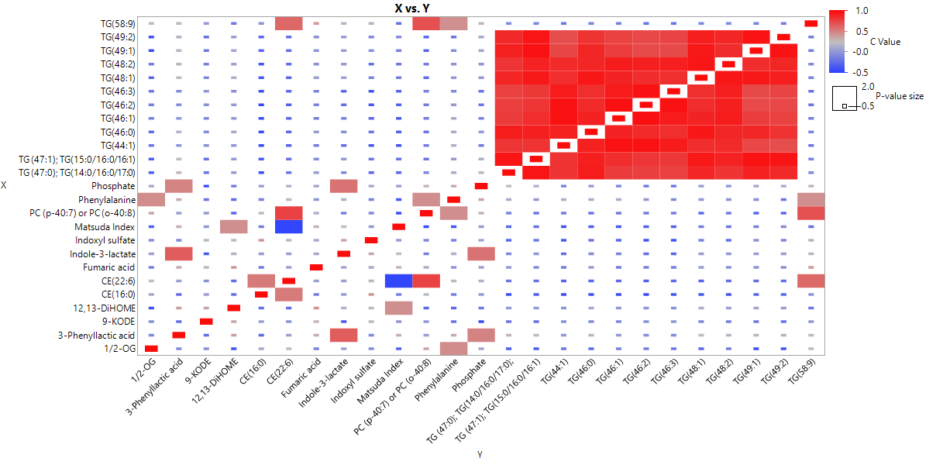
A)

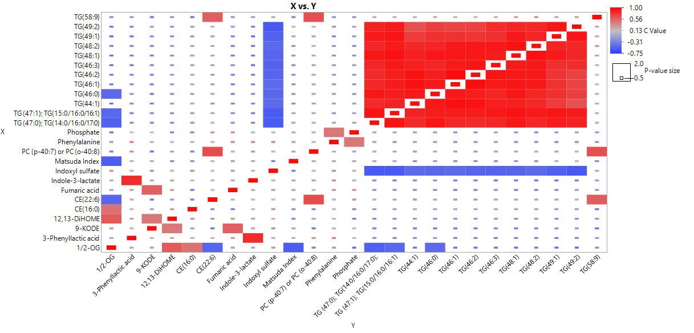
B)

